**Plant Diagnosis Web Project Setup Guide**

**Apache Server setup via XAMPP**

1. At first download XAMPP from the link : <https://www.apachefriends.org/download.html>

Just copy the link and paste then press go or press Enter from Keyboard. After that this window will open in the browser,

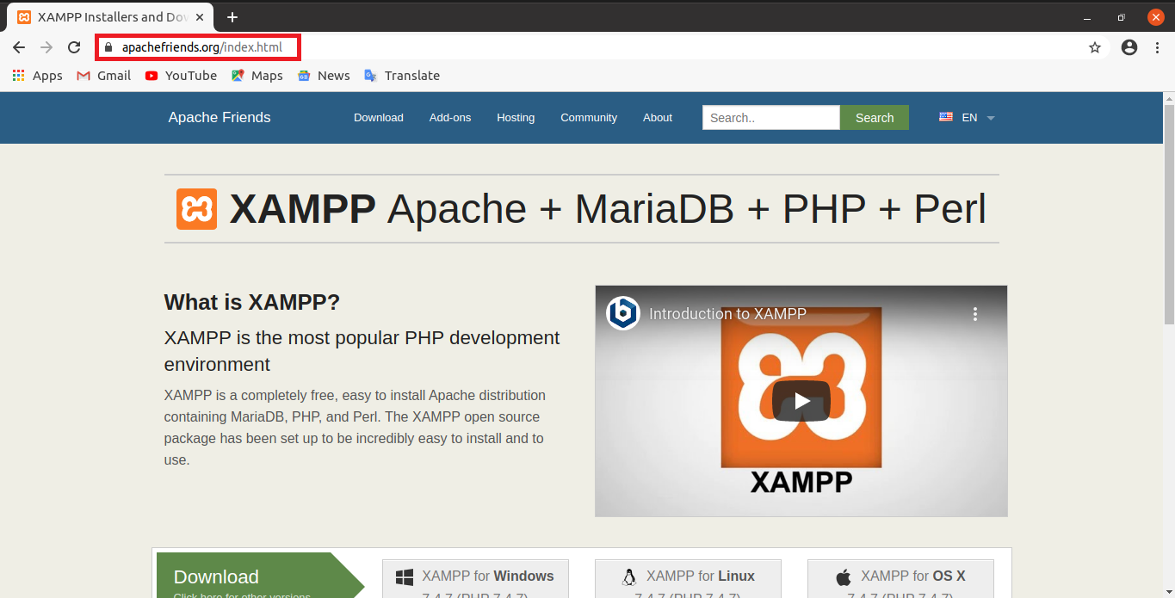

1. Now download simply by clicking the marking button if you are using OS Linux(include any distribution of Linux).

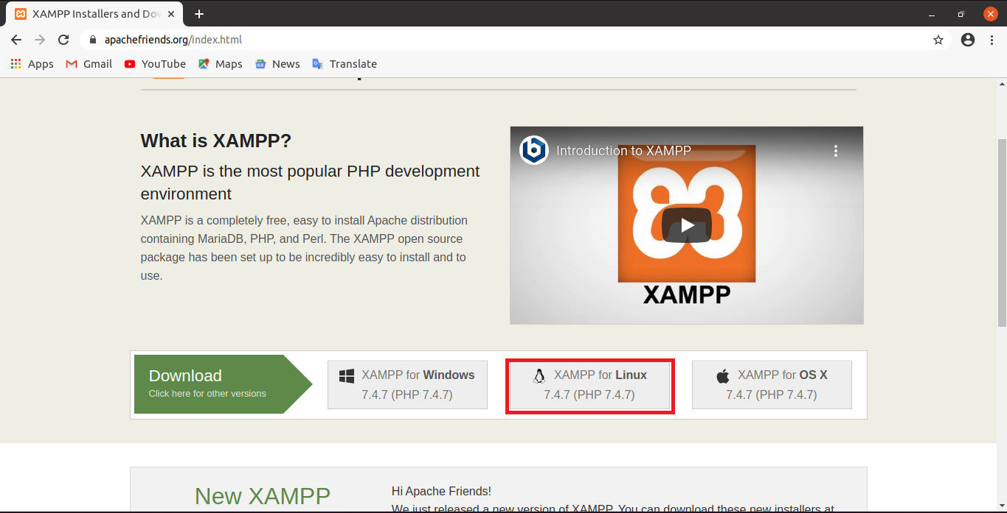

1. If you notice that, this alert shown then just click on “keep” for download.

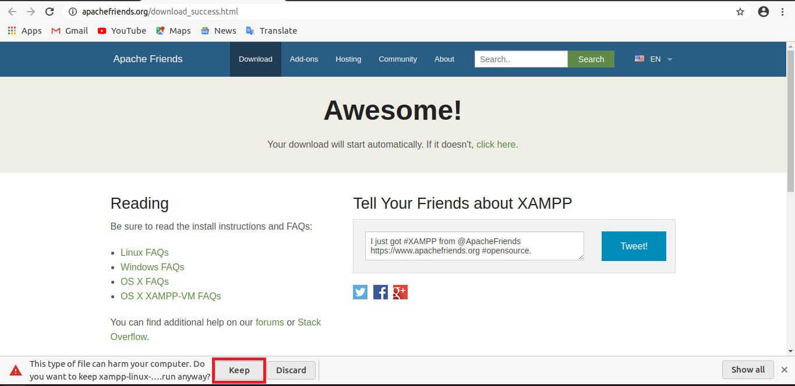

1. After completing download, close the browser and open ‘Terminal’ and follow these ‘Red’ marked commands step by step. We are opening Terminal from Desktop.
2. After change mode linux will asking for password, if you want to install xampp(even any software) then write your password and press ‘Enter’. Then follow next ‘red’ marked commands.

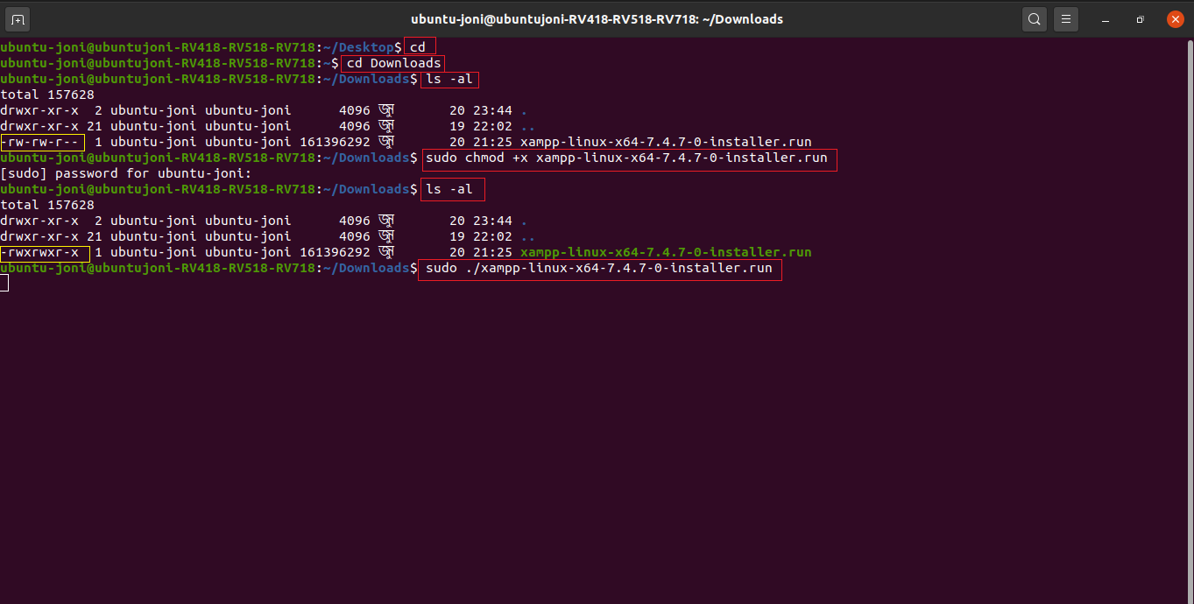

1. Now this window will open and you need to press Next
2. Click on next

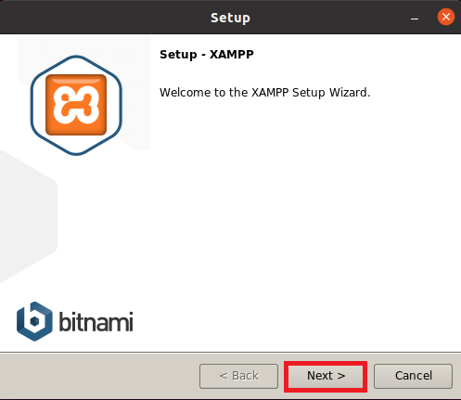

1. Click on next

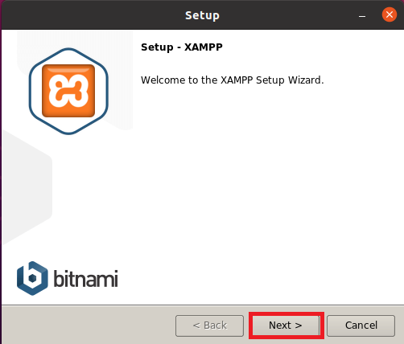

1. Click on next

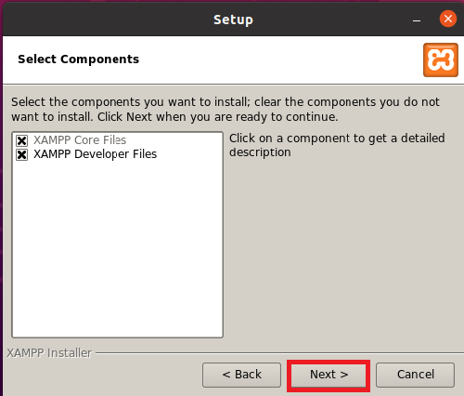

1. Click on next

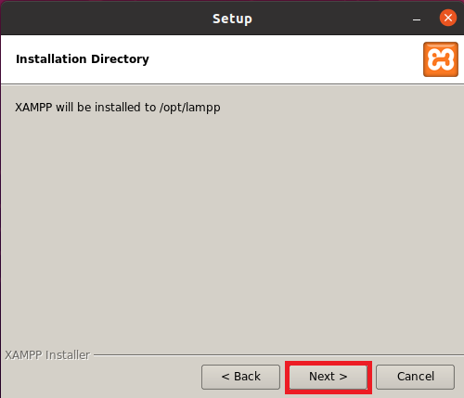

1. Click on next

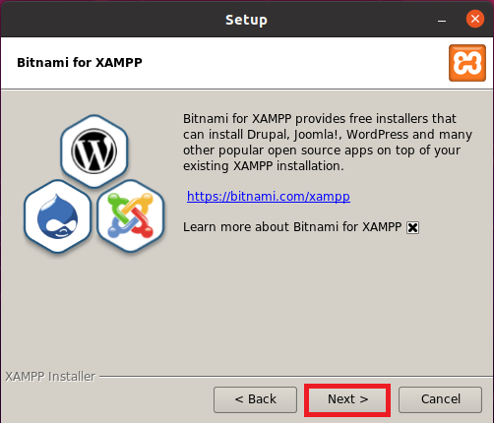

1. Click on next

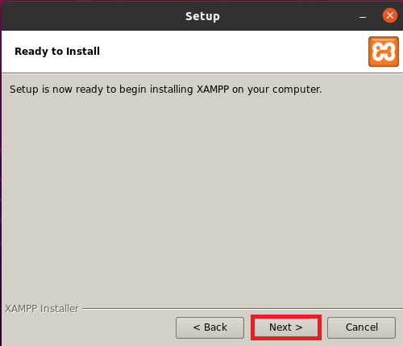

1. Wait for completing installation

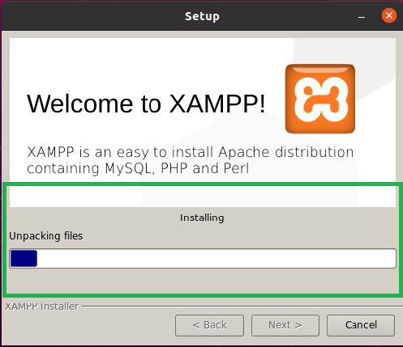

1. Click on Finish and checked the marked check box

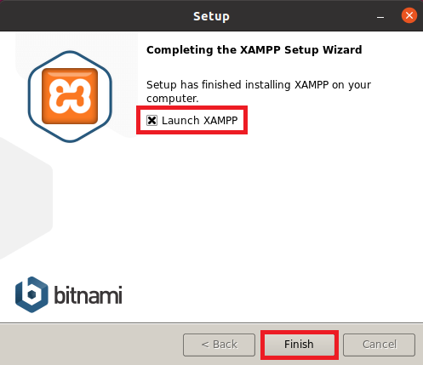

1. Click on Manage Servers

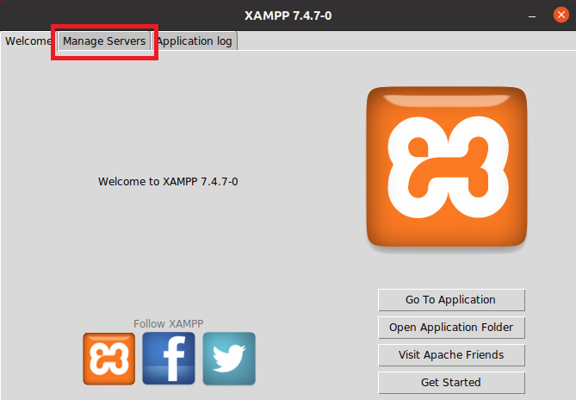

1. Click on Start All

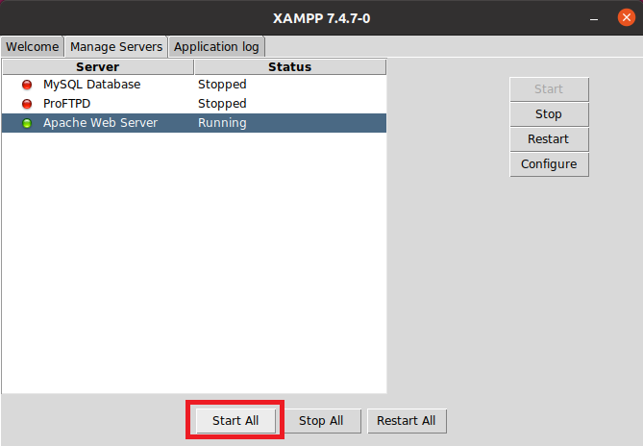

1. Confirm that all servers are started

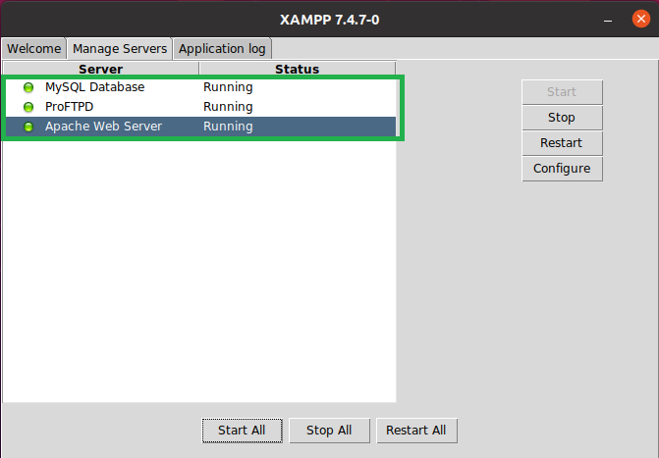

1. If you quite or close your xampp server and want to reopen it then open your terminal and run this command,

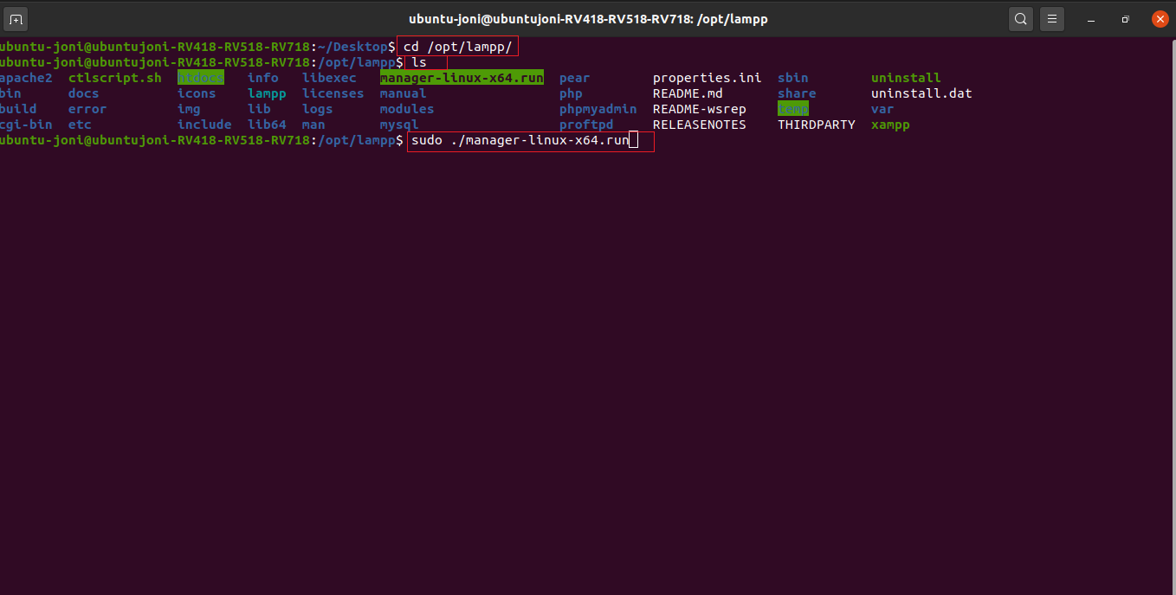

Xampp control panel will open then click on ‘Manage Servers ’

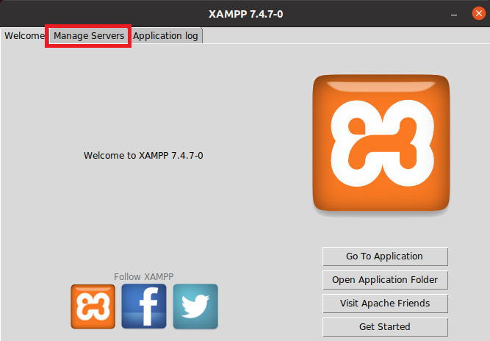

If servers are stop then start them all for run project





**Run PhpMyAdmin and Database setup**

1. Open browser and type “localhost/phpmyadmin” and press Enter

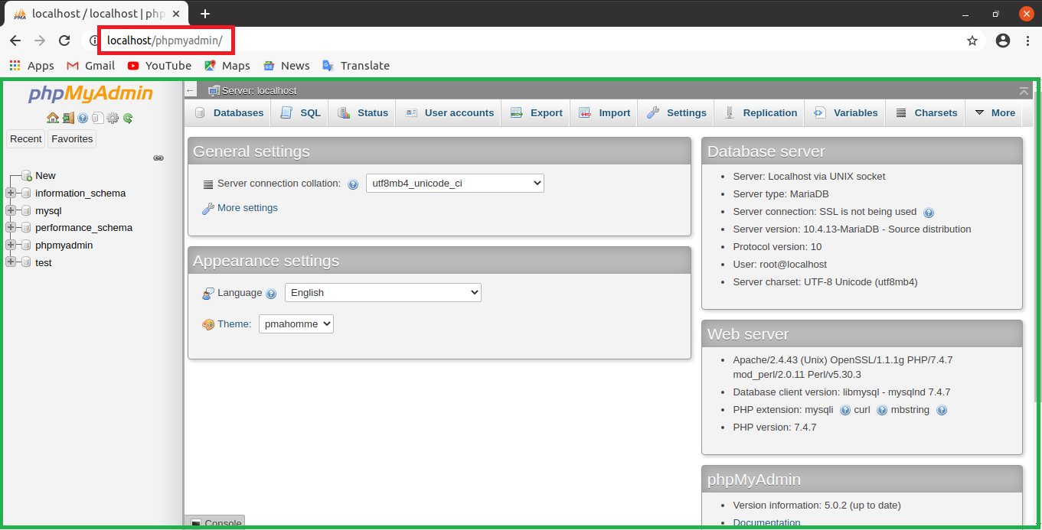

1. Now create Database by clicking on “New” and type database name “pds_web” and click “Create”

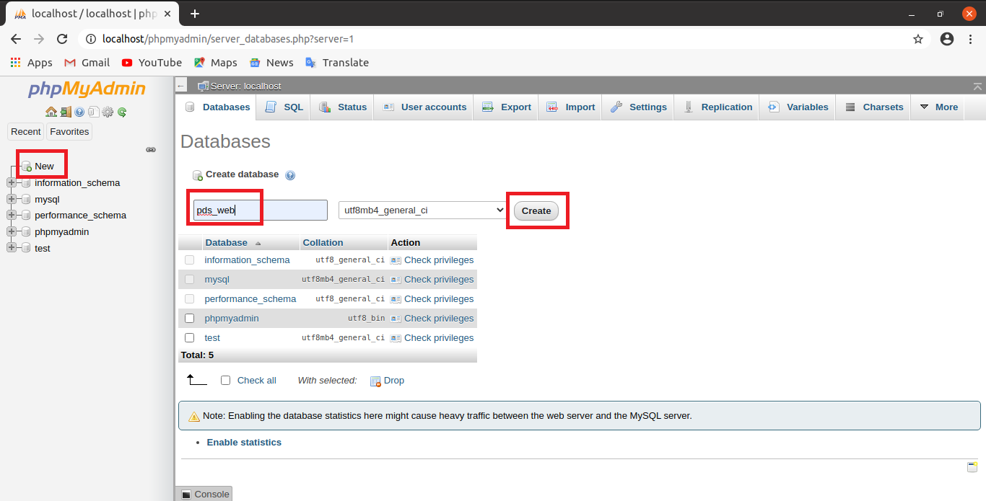

1. Now you find your database that you created named “pds_web” and click on it and click on “import”

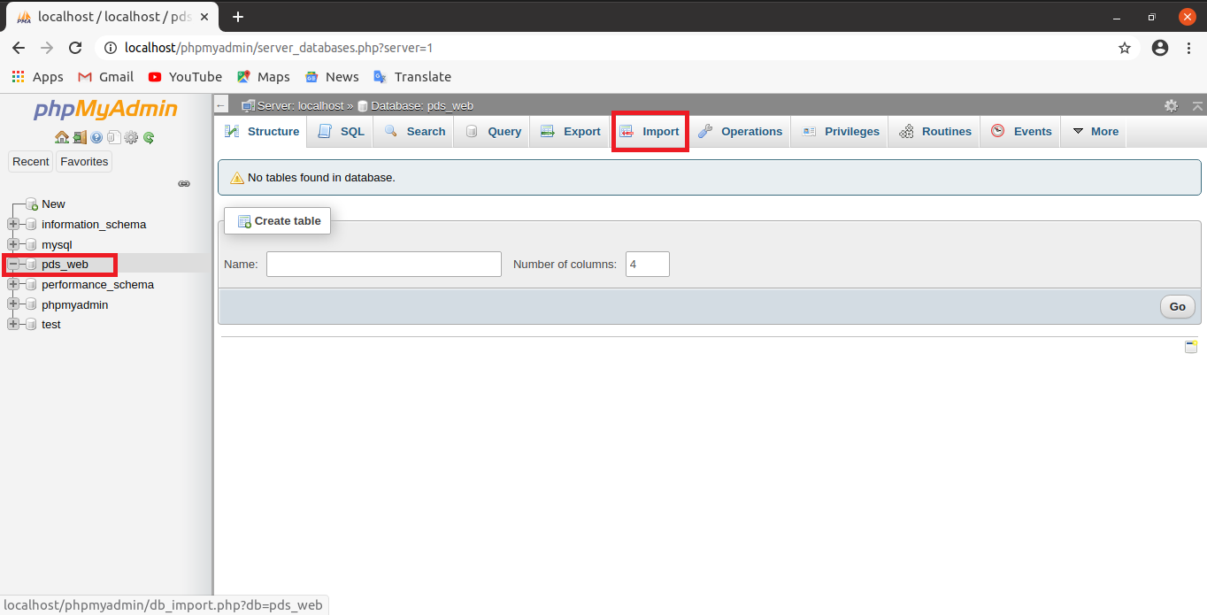

1. Now click on “Choose” to select file pds_web table to import

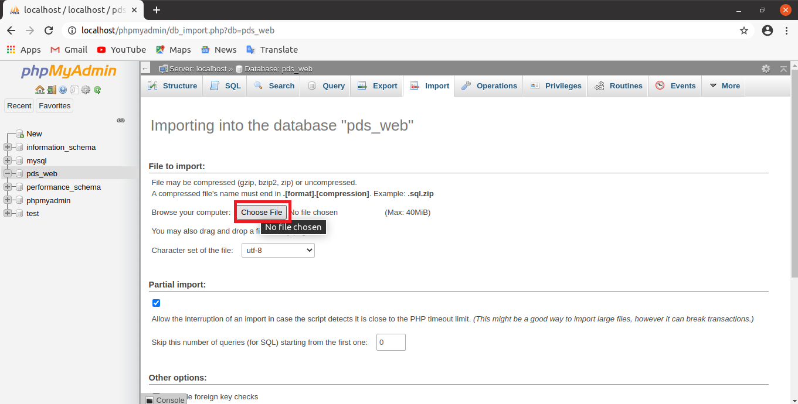

1. Now select the apis.sql table file form the location where you store or download it and click on “Open”

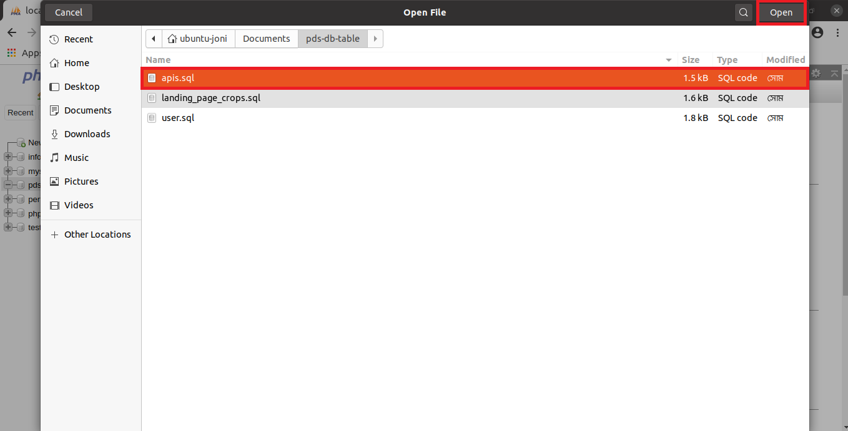

1. Now click on “Go” for Import the selected sql file

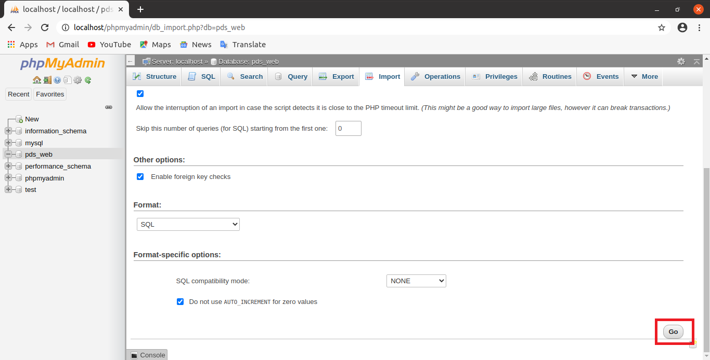

1. Continue Instruction no 3,4,5,6 and Import “user.sql and landing_page_crops.sql table file”

**Project Setup**

1. Now open ‘Terminal’ and write this command and press ‘Enter’, Until this you are unable to download or copy your project in the htdocs(Make sense until you copy/download your project in the htdocs you are unable to run you php project in browser through xampp)

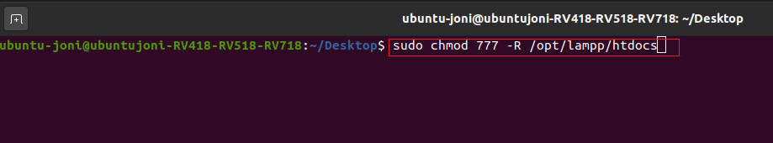

1. Now open browser and write this for run Plant Diagnosis System project, (Red marked box path in our root directory in the htdocs, you need to write here your root directory)

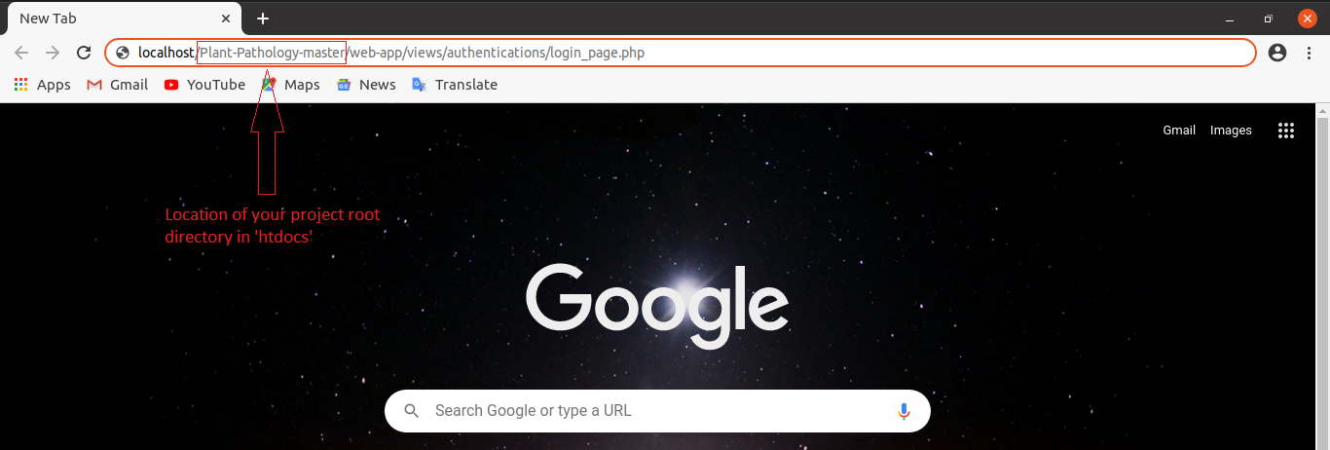

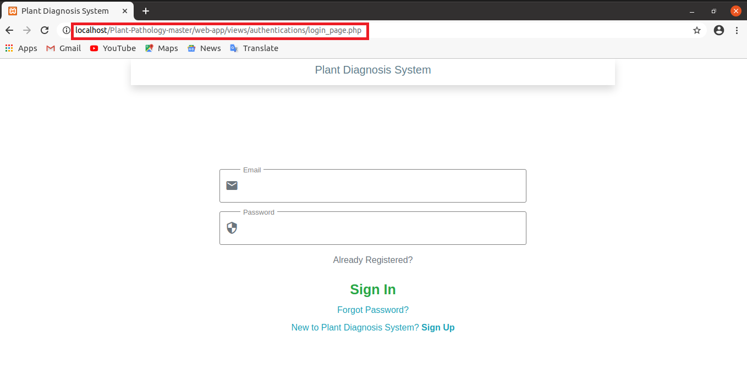

N.B: You can select any IDE for open code like Php_Strom, Intelij_Idea even in VS_Code it’s your choice.