**Plant Diagnosis Web Project Setup Guide**

**Apache Server setup using XAMPP**

1. At first download XAMPP from the link : <https://www.apachefriends.org/download.html>

Just copy the link and paste then press go or press Enter from Keyboard. After that this window will open in the browser,

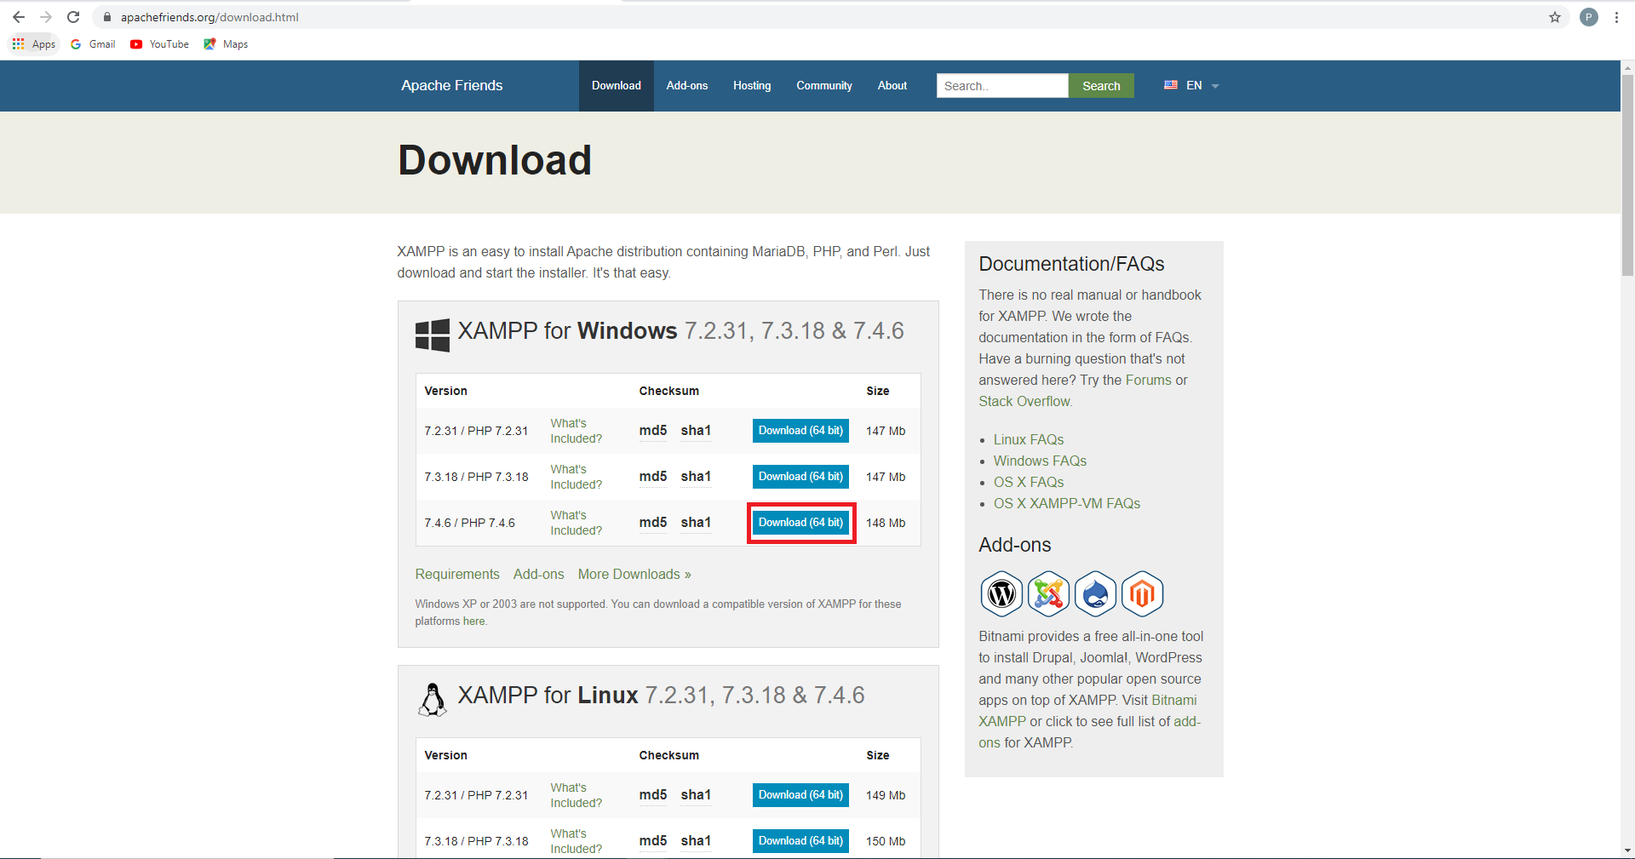

Now download simply by clicking the marking button if you are using OS Windows (here available all OS version Mac, Linux).

1. After completing download find this file from your destination and double click on this file for install.

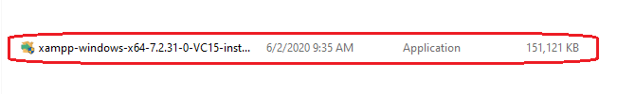

1. Just click next and next for installing, left all configurations defaults and finish Installation.
2. Now find “Type here to search(Windows)” from bottom left corner from your Machine and type “xampp” then press “Open’ as like as this,

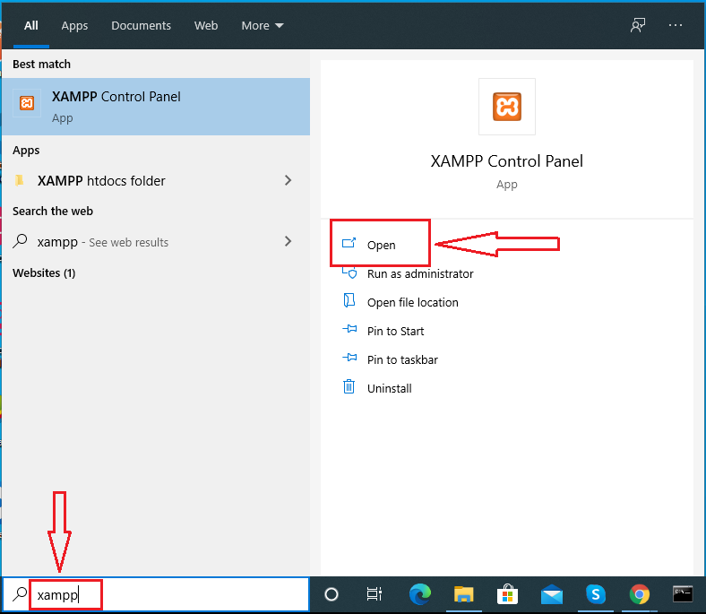

1. Now click start button of “Apache and MySQL” \

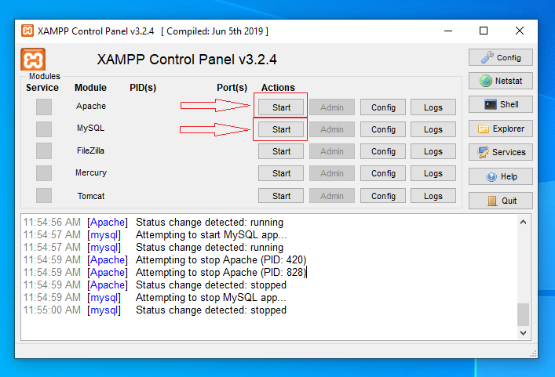

* And the view will be like this

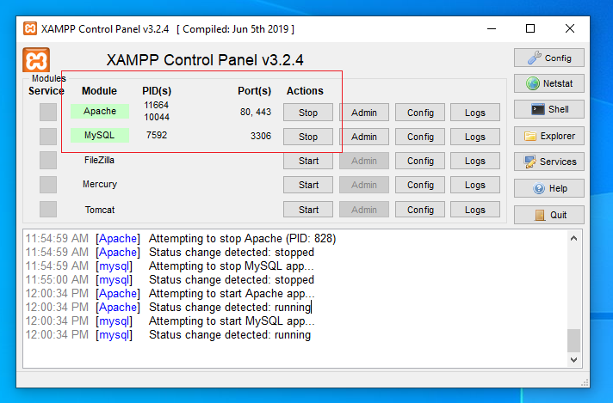

**Run PhpMyAdmin and Database Setup**

1. Open XAMPP control panel and click “Admin” for MySQL and your default browser will run and open phpmyadmin for database,

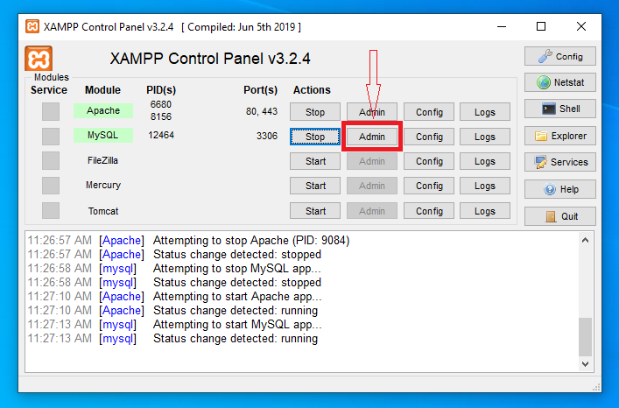

1. Now create Database by clicking on “New” and enter database name “pds_web” and click “Go”

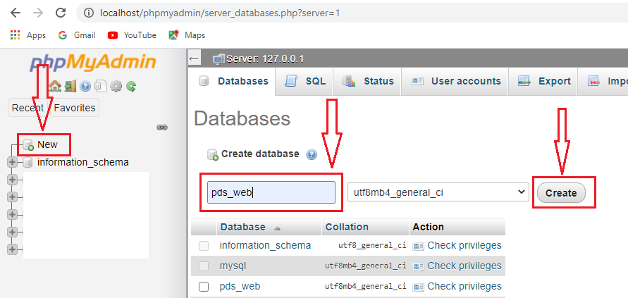

1. Now you find your database that you created named “pds_web” and click on it

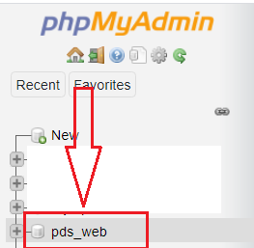

1. And click on “Import”



1. Now Select the sql table file from your machine where you downloaded or store it by clicking “Choose” select file and click “open”

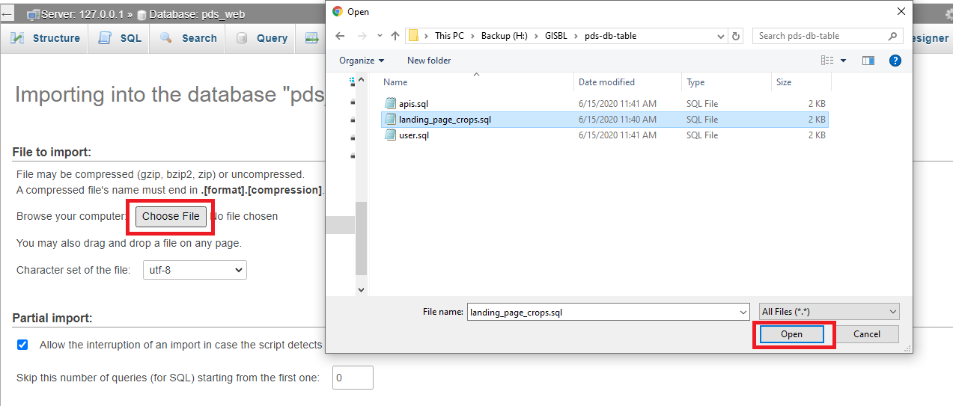

1. Now click on “Go” for Import the selected sql file

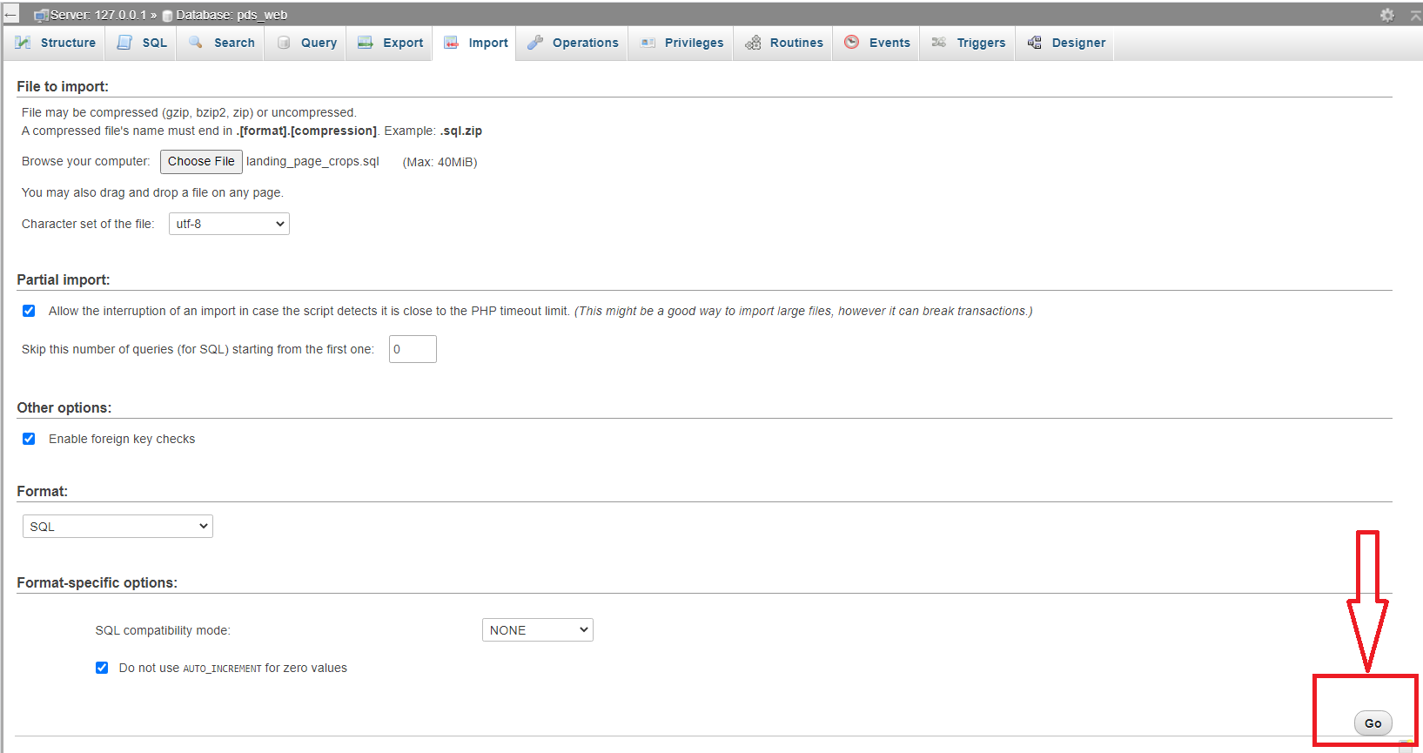

1. Continue Instruction no 3,4,5,6 and Import “user and apis”
2. Now there will three table in the “pds_web”

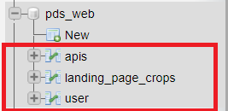

**Project Setup**

1. After successfully Installation of XAMPP you will fund a new folder inside the C-drive on your machine named “xampp”

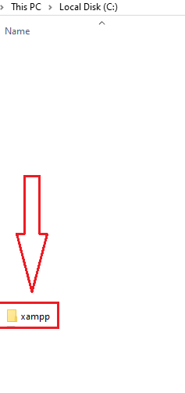

1. Double click on xampp --> find “htdocs” double click to open

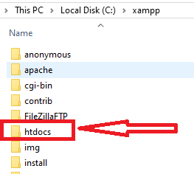

1. Now copy/download the Project here inside “htdocs”



1. Go to a browser and type “localhost/your project location inside htdocs/web-app/views/authentications/login_page.php ”

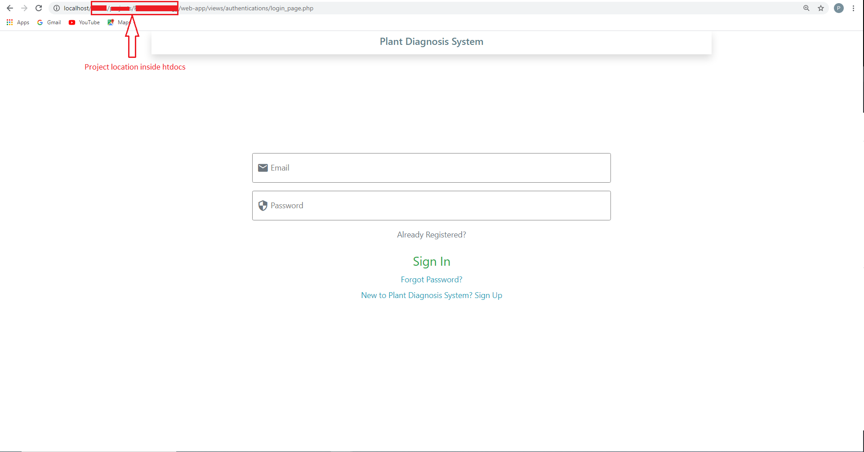

N.B: You can select any IDE for open code like Php_Strome, Intelij_Idea even in VS_Code it’s your choice.