

AIFC Counselling Portal

Spec Document - Stage 1 (MVP)

Table of Contents



[**1** **Introduction 3**](https://docs.google.com/document/d/1-UER07LxBmRNIuJyJzyulCNOAcVkfXJ4RWa_PncW4kk/edit?ts=59eff091&pli=1#heading=h.gjdgxs)

[**1.1** **Overview 3**](https://docs.google.com/document/d/1-UER07LxBmRNIuJyJzyulCNOAcVkfXJ4RWa_PncW4kk/edit?ts=59eff091&pli=1#heading=h.30j0zll)

[**1.2** **Goals and Objectives 3**](https://docs.google.com/document/d/1-UER07LxBmRNIuJyJzyulCNOAcVkfXJ4RWa_PncW4kk/edit?ts=59eff091&pli=1#heading=h.1fob9te)

[**1.3** **Scope 3**](https://docs.google.com/document/d/1-UER07LxBmRNIuJyJzyulCNOAcVkfXJ4RWa_PncW4kk/edit?ts=59eff091&pli=1#heading=h.3znysh7)

[**1.4** **Definitions 3**](https://docs.google.com/document/d/1-UER07LxBmRNIuJyJzyulCNOAcVkfXJ4RWa_PncW4kk/edit?ts=59eff091&pli=1#heading=h.2et92p0)

[**2** **AIFC Counsellor Portal - General Features (Minimum Viable Product) 4**](https://docs.google.com/document/d/1-UER07LxBmRNIuJyJzyulCNOAcVkfXJ4RWa_PncW4kk/edit?ts=59eff091&pli=1#heading=h.tyjcwt)

[**2.1** **Registering to the platform (client/counsellor) 4**](https://docs.google.com/document/d/1-UER07LxBmRNIuJyJzyulCNOAcVkfXJ4RWa_PncW4kk/edit?ts=59eff091&pli=1#heading=h.3dy6vkm)

[**2.2** **Searching for a Counsellor via Catalogue (client) 5**](https://docs.google.com/document/d/1-UER07LxBmRNIuJyJzyulCNOAcVkfXJ4RWa_PncW4kk/edit?ts=59eff091&pli=1#heading=h.1t3h5sf)

[**2.3** **Booking of a Session & Payment (client) 6**](https://docs.google.com/document/d/1-UER07LxBmRNIuJyJzyulCNOAcVkfXJ4RWa_PncW4kk/edit?ts=59eff091&pli=1#heading=h.4d34og8)

[**2.4** **Pre-Appointment Activities (client/counsellor) 7**](https://docs.google.com/document/d/1-UER07LxBmRNIuJyJzyulCNOAcVkfXJ4RWa_PncW4kk/edit?ts=59eff091&pli=1#heading=h.2s8eyo1)

[**2.5** **Attending the Appointment (client/counsellor) 8**](https://docs.google.com/document/d/1-UER07LxBmRNIuJyJzyulCNOAcVkfXJ4RWa_PncW4kk/edit?ts=59eff091&pli=1#heading=h.17dp8vu)

[**2.6** **Post-Appointment Activities (client/counsellor) 9**](https://docs.google.com/document/d/1-UER07LxBmRNIuJyJzyulCNOAcVkfXJ4RWa_PncW4kk/edit?ts=59eff091&pli=1#heading=h.3rdcrjn)

[**2.7** **Logged-in Dashboard for Users (client/counsellor) 10**](https://docs.google.com/document/d/1-UER07LxBmRNIuJyJzyulCNOAcVkfXJ4RWa_PncW4kk/edit?ts=59eff091&pli=1#heading=h.26in1rg)

[**2.8** **Reporting & Administrative Functionality (admin) 11**](https://docs.google.com/document/d/1-UER07LxBmRNIuJyJzyulCNOAcVkfXJ4RWa_PncW4kk/edit?ts=59eff091&pli=1#heading=h.lnxbz9)

[**2.9** **Group Sessions 11**](https://docs.google.com/document/d/1-UER07LxBmRNIuJyJzyulCNOAcVkfXJ4RWa_PncW4kk/edit?ts=59eff091&pli=1#heading=h.35nkun2)

[**2.10** **Log Book Export 13**](https://docs.google.com/document/d/1-UER07LxBmRNIuJyJzyulCNOAcVkfXJ4RWa_PncW4kk/edit?ts=59eff091&pli=1#heading=h.1ksv4uv)

[**2.11** **Landing Page 13**](https://docs.google.com/document/d/1-UER07LxBmRNIuJyJzyulCNOAcVkfXJ4RWa_PncW4kk/edit?ts=59eff091&pli=1#heading=h.44sinio)

[**2.12** **Ticketing & Knowledge-base system 13**](https://docs.google.com/document/d/1-UER07LxBmRNIuJyJzyulCNOAcVkfXJ4RWa_PncW4kk/edit?ts=59eff091&pli=1#heading=h.2jxsxqh)

[**3** **Stage 2 - Additional Features and Functionality 14**](https://docs.google.com/document/d/1-UER07LxBmRNIuJyJzyulCNOAcVkfXJ4RWa_PncW4kk/edit?ts=59eff091&pli=1#heading=h.z337ya)

[**4** **Appendices 15**](https://docs.google.com/document/d/1-UER07LxBmRNIuJyJzyulCNOAcVkfXJ4RWa_PncW4kk/edit?ts=59eff091&pli=1#heading=h.3j2qqm3)

[**4.1** **Appendix 1 – AIFC Portal Sitemap (overall view) 15**](https://docs.google.com/document/d/1-UER07LxBmRNIuJyJzyulCNOAcVkfXJ4RWa_PncW4kk/edit?ts=59eff091&pli=1#heading=h.1y810tw)

[**4.2** **Appendix 2 – Client Sign up Workflow 16**](https://docs.google.com/document/d/1-UER07LxBmRNIuJyJzyulCNOAcVkfXJ4RWa_PncW4kk/edit?ts=59eff091&pli=1#heading=h.4i7ojhp)

[**4.3** **Appendix 3 – Counsellor Sign up Workflow 17**](https://docs.google.com/document/d/1-UER07LxBmRNIuJyJzyulCNOAcVkfXJ4RWa_PncW4kk/edit?ts=59eff091&pli=1#heading=h.1ci93xb)

[**4.4** **Appendix 4 – Login Workflow 18**](https://docs.google.com/document/d/1-UER07LxBmRNIuJyJzyulCNOAcVkfXJ4RWa_PncW4kk/edit?ts=59eff091&pli=1#heading=h.3whwml4)

Revision History

|  |  |  |  |
| --- | --- | --- | --- |
| Version | Date | Name | Description |
| 1 | 05/09/17 | Matthew McInerney & Caitlin Tuckerman | Initial Project Specification Document |
| 2 | 16/10/17 | Matthew McInerney & Caitlin Tuckerman | Addition of Log Book download, Group Sessions, Landing Page, Ticketing System |
| 3 | 25/10/17 | Matthew McInerney & Sherin Daniel | Various Changes made in relation to feedback provided by AIFC |

1. **Introduction**
2. **Overview**

The AIFC Counsellor Portal delivers an online end-to-end platform for counselling, providing clients access to accredited counsellors and mental health support.

The platform allows the user (also known as the client) and counsellor to set up an appointment, participate in an encrypted video chat session through video conferencing partner ZOOM and finalise payment within the platform. The cloud-based nature of the platform allows users to connect without being restricted by geographical and time limitations.

1. **Goals and Objectives**

The main objective of this project is to provide client’s access to affordable, accredited and registered counsellors no matter their situation or geographic location.

1. **Scope**

The AIFC Counsellor Portal will allow users the ability to access AIFC’s accredited counsellors remotely using the secure and encrypted ZOOM conferencing software.

Clients will be able to book, attend and pay for a session remotely through the portal, and then attend follow up sessions in the same manner. This removes many of the restrictions placed when booking a physical appointment, which might otherwise disincline or prevent users from accessing much needed treatment and support.

1. **Definitions**

**AIFC Counsellor Portal** – the product that is being described here; the software system specified in this document.

**Project** – activities that will lead to the production of the AIFC Counsellor Portal application.

**Client** – the person or persons who will interact with the AIFC Counsellor Portal for treatment/counselling.

**Counsellor** – the AIFC accredited counsellor who will be using the system to provide counselling and support to Clients.

**Student –** students accessing the AIFC Counsellor Portal in order attend training/adjustment sessions with a registered supervising counsellor and to complete their logbook hours.

**Admin –** the administration staff working at AIFC to provide support and maintain the AIFC Counsellor Portal.

**Use case** – describes a goal-oriented interaction between the system and an actor. A use case may define several variants called scenarios that result in different paths through the use case and usually different outcomes.

**Scenario** – one path through a user case

**Actor** – user or other software system that receives value from a user case.

**Developer** – the developers of Pursuit Technology who will be developing the system, also sometimes called the supplier.

**Stakeholder** – anyone with an interest in the project and its outcomes. This includes clients, customers, users, developers, testers, managers and executives.

1. **AIFC Counsellor Portal - General Features (Minimum Viable Product)**

The following section details the MVP (Minimum Viable Product) for AIFC’s Counselling platform. The MVP will form Stage 1 of the development process and provide AIFC with a functional platform that can be launched into a production environment. Listed below are features and functionality of the platform defined and accompanied by generic use cases.

1. **Registering to the platform (client/counsellor)**

Clients, Students and Counsellors will register to the platform in similar fashion. Each user role will sign-up via the same registration page and select their desired account-type. Selecting their desired account type (Client, Student, and Counsellor) will direct the registrant to a unique form with varying questions based on their role selected.

**Features to be included:**

* Self-assessment tools (client)
* All Users will add profile and personal information
* Counsellors will upload qualifications, accreditations and availability for approval
* Counsellors profile information including display picture are to be reviewed for approval

|  |  |
| --- | --- |
| Use Case | **1** |
| Description | Client Registers to the platform |
| Actors | New User registering to book their first counselling session |
| Story | Basic Path |
|  | 1. User arrives on the landing page 2. User selects ‘register now’ button OR selects the ‘self-assessment tool’ option   **IF** - The user selects ‘register now’ they are taken directly to the sign-up page  **IF** - User selects ‘self-assessment tool’ they are taken to the self-assessment tool page     - Once self-assessment tool is completed they are taken to the sign-up page         displaying their result and presented an option to the sign-up   1. User agrees to terms and conditions and is directed into the platform 2. User will then fill-in a pre-counselling form containing personal and characteristic information to assist further with selecting counsellors 3. Registration and questionnaires are now complete and the user is directed to the Counsellor Catalogue (Search criteria is pre-filled based on self-assessment/questionnaire responses 4. User is sent an email containing account details |
| **Notes:** | Please see Appendix 2 for Use Case 1 Workflow Diagram |

|  |  |
| --- | --- |
| Use Case | **2** |
| Description | Counsellor Registers to the platform |
| Actors | New Counsellor registering to offer their services |
| Story | Basic Path |
|  | 1. Counsellor arrives on the landing page 2. Counsellor clicks the ‘register now as a Counsellor’ button and is taken to the sign-up page 3. Counsellor fills in personal and profile information in addition to uploading accreditations/credentials 4. Counsellor agrees to terms and conditions 5. Counsellor is sent to a screen notifying that an email will be received once their profile has been approved. 6. Once approval is complete the Counsellor will be emailed login details. |
| **Notes** | Please see Appendix 3 for Use Case 2 Workflow Diagram |

1. **Searching for a Counsellor via Catalogue (client)**

After initial signup the client will be guided through the process of creating an appointment with a counsellor. The client will be redirected to the Counsellor Catalogue and initially be presented with a choice of recommended Counsellors.

Recommended Counsellors will be selected based on the client's self-assessment, answers completed during registration, and selected search criteria.  If Clients do not wish to select a recommended Counsellor they will be presented with the ability to browse the Counsellor Catalogue.

**Features to be included:**

* User is recommended Counsellors based on pre-filled data
* Clients are presented with assistive search criteria
* Clients will select from a list of counsellors and be directed to their profile page
* Clients will be able to view characteristic information, feedback/ratings and accreditations of Counsellors prior to undertaking a booking

|  |  |
| --- | --- |
| Use Case | **3** |
| Description | Client has completed registration and is searching for a counsellor |
| Actors | User navigating and filtering the counsellor catalogue |
| Story | Basic Path: |
|  | 1. User arrives on the counsellor catalogue page by redirection after initial signup or via clicking on ‘Counsellor Catalogue’ within the top navigation menu 2. User is presented with recommended Counsellors based on pre-filled data from self-assessment and questionnaires. User can opt to modify search criteria to filter the counsellors in a different manner. 3. After submitting the search criteria, the user will be directed to a display of counsellors with recommended counsellors chosen by their search criteria and self-assessment and to be displayed at the top of the catalogue in a unique tab 4. User will select their preferred counsellor via selecting the counsellors tile to view the respective profile |

1. **Booking of a Session & Payment (client)**

Once a client has selected a preferred Counsellor and viewed their respective profile they will choose an available time slot to book a session. Available sessions will be displayed within a calendar included in the Counsellors profile. Counsellors will be held accountable to their displayed available sessions. Counsellors will be solely responsible for managing their availabilities and booking a session. This will be included in the T&C which counsellors are required to accept prior to sign up.

After the preferred time slot has been selected by the client they will be directed to an appointment confirmation page. The client will agree to the terms and conditions relating to the appointment and then be guided through to the payment section to complete payment prior to the appointment.

The payment page will present clients with a secure payment gateway containing multiple payment methods. The appointment will be confirmed once payment is completed.

**Features to be included:**

* User will select from available appointments within a calendar on the counsellor’s page
* User will complete payment for appointment via multiple payment methods through a secure gateway
* Counsellors and clients will both be sent confirmation/notification of appointment

|  |  |
| --- | --- |
| Use Case | **4** |
| Description | Client has selected their preferred counsellor & will book and pay for a session |
| Actors | A user that has selected their counsellor and is now on their profile ready to book |
| Story | Basic Path: |
|  | 1. User arrives at the selected counsellors profile page 2. User navigates to the booking calendar within the page 3. User selects a preferred date within the calendar to view available time slots 4. User directed to appointment confirmation page agreeing to related terms and conditions |

1. **Pre-Appointment Activities (client/counsellor)**

Prior to the appointment both the counsellor and client will be sent SMS and email reminders at set intervals reminding them of their upcoming appointment. Clients and Counsellors will be instructed to complete a test call prior to the scheduled appointment to ensure no technical delays or difficulties occur.

**Features to be included:**

* Reminder SMS/email will be sent to client
* Client will be prompted to conduct a test call prior to the session to confirm they will be able to access the appointment

|  |  |
| --- | --- |
| Use Case | **5** |
| Description | Prior to appointment both client and counsellor receive reminders of their upcoming appointment and are prompted to complete a test call |
| Actors | All users involved in an upcoming appointment |
| Story | Basic Path: |
|  | 1. User has booked an appointment has received an email detailing specifics around reminders and pre-call requirements 2. User is sent 3-5 reminders prior to the day of appointment depending on the time between the booking and actual appointment 3. One day out from the appointment the user is sent a reminder via email/SMS to log in and complete a test call 4. User logs in and is prompted by the system to complete a test call 5. After completing the test call the user will be directed to a feedback screen to rate the quality of the call 6. Test call quality information will be stored in a database for reporting in the event of a dispute/refund in relation to a call not working. (e.g. if a user complains that the call did not work however did not complete a test call as required OR a user confirms the test call worked successfully but has selected a refund due to the call not working) 7. If a test call has not been completed automated manual reminders will be sent requiring the client to  complete the test call 8. The second last reminder is sent out 24 hours before appointment date 9. Users receive a final reminder 30 minutes prior to the appointment prompting them to be ready and logged in 5-15 minutes prior to their appointment |

1. **Attending the Appointment (client/counsellor)**

A final reminder will be sent to both client and counsellor within a 30 minute window prior to their appointment. The final reminder will include a link that will invite both users into the video-chat session. Counsellors will be sent a link before the client giving them time to prepare for their session and ensuring they are able to greet the client upon arrival. The Counsellor will receive the link via email and the link will also be accessible via their dashboard. Counsellors will also be sent an SMS reminder for the upcoming appointment.

Both users can either access the appointment directly from the link provided in the reminder or via their logged-in dashboard. Links will be provided for both within reminders.

**Features to be included:**

* Client is sent a link to access the appointment, and can also access the appointment through a button within their logged-in dashboard
* Users are notified when their appointment has begun and is in session
* Users complete appointment through zoom with the ability to choose between a video conference or video conference with voice supplemented by a text-based chat. Text-based chat session on its own cannot be an option.

|  |  |
| --- | --- |
| Use Case | **6** |
| Description | Users have received a final reminder 30 minutes prior to the appointment prompting them to login and be ready. Users are provided a link to attend the appointment. |
| Actors | Both counsellor and client are following the same process to join a session. counsellors are instructed to arrive earlier |
| Story | Basic Path: |
|  | 1. User’s click on the link within the email taking them directly to the appointment (Zoom video-chat) 2. Counsellor arrives before client to prepare and great the client upon arrival 3. Session begins once both client and client agree they are ready to begin 4. Throughout the session client and counsellor can share files via the zoom video chat platform 5. Counsellor tracks time throughout and notifies client when session is near completion 6. Session is complete once client leaves the Zoom Video Chat Application 7. Users are redirected to the post-appointment interface |

1. **Post-Appointment Activities (client/counsellor)**

When the appointment has finished both Client and Counsellor will be sent to the post-appointment interface upon closing the Zoom video-chat application. The purpose of the post-appointment interface will be to provide all users with a platform to provide feedback and the ability to re-book a counselling session.

**Features to be included:**

* Client is sent through to the post-appointment interface
* Client and Counsellor can share post-appointment notes or files, including uploading text files or word documents.
* Client can book another session with the same counsellor or choose a different counsellor
* Counsellor is provided with a section to write notes about the session and client. Written notes are saved to the appointment once the post appointment screen has been completed. Counsellors can access these notes via the ‘past appointments’ section within their dashboard.
* Clients are asked to provide feedback on the quality of the session (Counsellor/Technical)
  + - This includes their enjoyment/acceptance of the system and call-quality
    - Note any technical issues that occurred during the session

|  |  |
| --- | --- |
| Use Case | **7** |
| Description | All All users involved in a session provide feedback and can share resources/information after the appointment in addition to re-booking a session. |
| Actors | Us All users that have just completed a session |
| Story | : Basic Path: |
|  | 1. Client arrives at post appointment interface 2. Client is prompted to provide feedback on the quality of the session both technically and as a service 3. Client provides any other information required by the counsellor via document upload or a provided text-box 4. Client has completed providing feedback and is prompted to re-book with the same counsellor via a calendar interface 5. Client is then redirected to personal dashboard |
| **Story** | Alternative Path: |
|  | 1. Counsellor arrives at post appointment interface 2. Counsellor is prompted to provide feedback on quality of the session technically and the client 3. Counsellor is provided with an area to write notes regarding the meeting and prompted to do so 4. Counsellor can choose to upload and send documents/resources to the client 5. Counsellor can report the client if required 6. Counsellor is then redirected to personal dashboard |

1. **Logged-in Dashboard for Users (client/counsellor)**

After initial booking and upon return visit from clients and counsellors they will be directed to their respective dashboard. The dashboard will provide an overview of upcoming and past appointments, a location to update profile & account settings and an area to contact support. When viewing past appointments clients/counsellors can select an individual appointment and see shared files/notes and post appointment related information attached to the meeting.

Via the dashboard users can view upcoming appointments in either a list or calendar with the option to export upcoming appointments to a calendar of their choice. Clients and Counsellors can also view past appointments via a list view and any associated allowing them to

Features to be included:

* View Current Appointments (Calendar Included)
  + Appointments viewable via list or calendar
  + Confirm appointment
  + Reschedule appointment
  + Export iCal/gCal appointment
  + Link to appointment
* Conduct a video test to Zoom
* Update profile information
* Contact Support

1. **Reporting & Administrative Functionality (admin)**

The counselling platform will require manual administrative functions to monitor usage and approve updates or registrations within the system. Administrators will be provided with a range of various reports on counselling sessions, users and website usage.  Initially Reports will be provided by the Pursuit Technology development team upon request and will be integrated into the platform during stage 2.

Administrators will be required to approve accreditation uploads from all counsellors upon signup. Upon any approval or denial an email can be sent from within the system to notify of an outcome.

Features to be included:

* Reporting
  + Session specific
  + Clients/Counsellor
  + Google Analytics
  + Generic report derived from counselling sessions to date (e.g. info from pre-counselling questionnaire)
* User management
  + An interface to view all users
  + Ability to add/remove users
    - Manual import/export via .csv or form based entry
  + Approve/reject Counsellor’s updated hours request
* Profile information approval
  + Includes: qualifications, picture, public-facing information, availability, price, contact information
* Confirm test call completion
  + Administrator can confirm a test call has completed
* Review session information (if necessary, for flagged sessions etc.)
  + If a counsellor requests to cancel a session an administrator can view this

1. **Group Sessions**

The following outlines the group session feature to be included in the MVP of the NEO Project. Group sessions require modifications to:

* Payment
* Filtering and searching for counsellors
* Counsellor profiles
* Pre and post appointment activities
* Additional screens for accepting/denying appointments

Initial sessions can take between 60-90 minutes leaning further towards 90 minutes for initial group sessions. A 10 minute padding either side of appointments will be included to ensure sessions do not overlap. In the event that members of the group session do not turn up the responsibility will be on the clients. The clients will receive more than enough reminders and confirmation emails to ensure they are aware of an upcoming appointment and whether all group members will or will not be attending.

**Goal/Objective:** Allow multiple people to attend a group session with payment from one client (the organiser).

**Booking of a Group Session for a user**

|  |  |
| --- | --- |
| Use Case | **8** |
| Description | User selects to book a group session via the catalogue search view |
| Actors | All Clients that are to be involved in a group session. |
| Story | Basic Path: |
|  | 1. When booking a session a client filters the catalogue view of counsellors by ‘group session’ availability. 2. When a user attempts to book a counsellor with ‘group session’ availability they will be prompted to include email addresses of other contacts that will be within the appointment. 3. The organising client will pay for all members within the group session 4. Users that have been sent a group session request will receive an email with a link attached. The link will take the clients through to a screen to accept or deny the appointment    1. **IF** the client **denies** the appointment they can send a message saying why they cannot attend.    2. The original organiser can choose to go ahead with the appointment, cancel or reschedule. The original organiser will be sent an email that will take them to a page within their profile to view appointment cancellations and choose to cancel or go ahead.    3. **IF** the client **accepts** the appointment they will be taken to their profile page to import the appointment into their calendar and view more information about the upcoming appointment.       1. **IF** the user has been elected for payment they will pay at this point.       2. **IF** the user does not have an account they will be taken through an account creation process prior to accepting the appointment.   (SMS reminders will be sent to each person of the group; 24 hours prior to the appointment making sure the reminder is not sent between 10pm-6am.) |

**Booking of a Group Session for a Counsellor**

* During sign-up counsellors will select whether they are ok with group sessions and if they click yes or no will determine if they are filtered by the catalogue search view.
* Counsellors may set specific dates and time blocks to be available for group sessions as opposed to one-on-one sessions

**Group Session post-appointment activities**

1. At the end of the appointment the counsellor can select to send resources to any user by selecting their account/username from a list or send additional comments.
2. The original organiser can request to book a group session again and any other user will be directed to a page where they can provide feedback and book a solo session if they would like.
3. **Log Book Export**

Counsellors will be able to export all completed appointments within the platform and their respective time/dates. This feature will be presented to Counsellors via a button within their dashboard labelled ‘Export Sessions for Log Book’. Clicking this button will export all sessions in a PDF or .CSV (Excel) format providing Counsellors with either a basic online logbook they can use or a simple way to view all appointments and write them into their physical log books.

1. **Landing Page**

The Landing Page for the AIFC Portal will include a guided explanation in regards to the purpose/functionality of the platform.

The Landing Page presents the first point of contact with potential clients. The online Counselling process will be explained to any visitor in a short in simplistic manner. Any visitor should be effortlessly introduced to how the platform operates in addition to being guided to self-assessment tools and login/signup locations.

Features to be included in the landing page:

* Simplistic description of the online counselling process offered
* Self-assessment tool that leads into platform sign-up
* Sign-up/Login locations present in the top menu and at the end of the service description (bottom of the page)
* Branding/theme of the website inspired by the current AIFC website but NEO will have its distinct brand image and persona

1. **Ticketing & Knowledge-base system**

The AIFC Counselling Portal will be provided with a ticketing and knowledge-base system to:

* enable clients to log complaints/issues
* allow administrators to log help requests/issues
* allow clients to view and search helpful resources (tip-sheets/informative videos) for using the platform

The system to be used will be the ‘Jira Service Desk’ offered by Atlassian, the same company that will be utilised for project management. More information can be found here (<https://www.atlassian.com/software/jira/service-desk>).

1. **Stage 2 - Additional Features and Functionality**

Features that are not included within stage 1, the MVP are to be rolled out in additional phases based on priority. High priority features that are not included in the MVP include student sessions, advanced group call features and alternative payment methods. Advanced group call features include the ability to split payment.

Listed below are the additional features discussed during scoping that are to be implemented.

**Features to be included:**

* Student related features
  + Student accounts
  + Book training/adjustment sessions with counsellor or supervisor
  + Online Log-book integrated to track practice hours
  + Supervised Counselling sessions
* Group counselling sessions
* Ability for Counsellor to upload files and resources to their dashboard for quick access
* Admins provided the ability to edit landing page content
* Additional payment options (Afterpay, etc.)
* Instant messaging within the platform
* Additional Reports
* Landing Page
  + Addition of News/Blogs sections
* Multi-user payment option
* RSS feed - for the landing page
* A document management system for administrators accessible via the administrative dashboard
* The ability to lock a user out if a serious complaint is lodged against them

1. **Appendices**
2. **Appendix 1 – AIFC Portal Sitemap (overall view)**

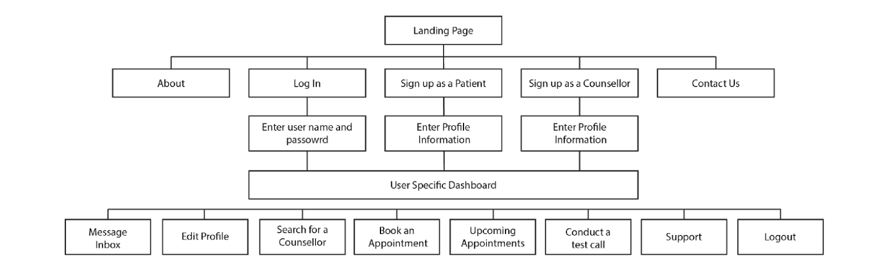

1. **Appendix 2 – Client Sign up Workflow**

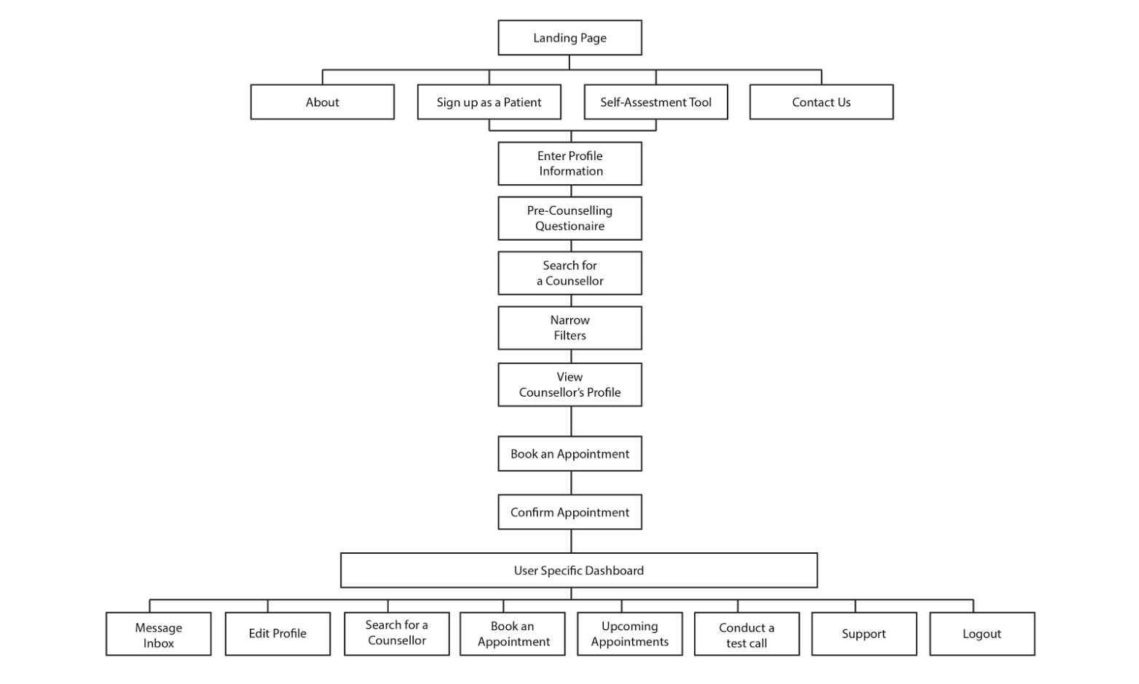

1. **Appendix 3 – Counsellor Sign up Workflow**

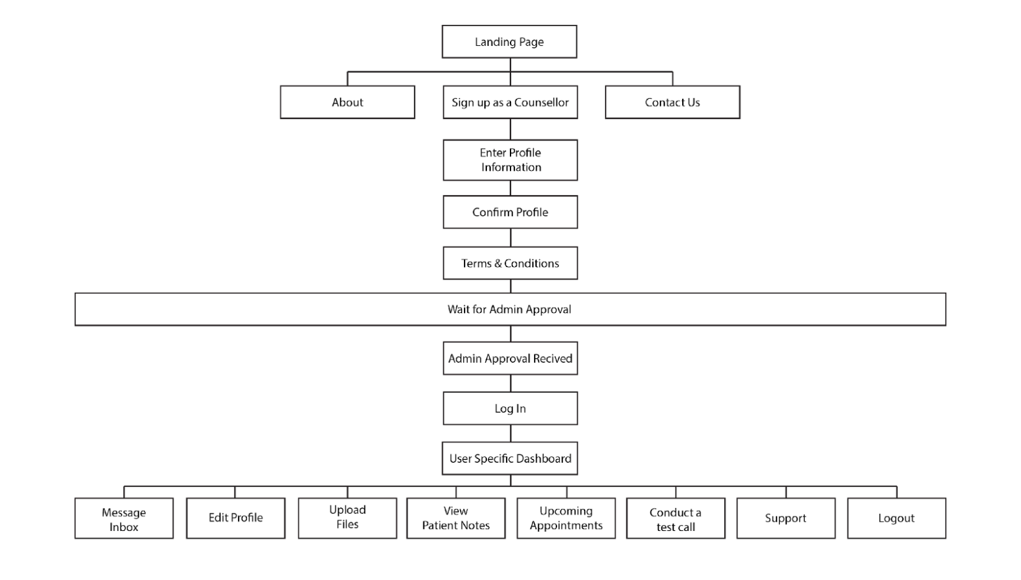

1. **Appendix 4 – Login Workflow**

