AI Rate-Negotiation Agent
Product Requirements Document · Afriex Business Portal
Owner: Ifeanyi Awa · Status: Draft v1 · Date: 26 Sep 2026 · One-pager
PROBLEM
Business clients on the Afriex Business Portal negotiate FX/stablecoin rates today through manual, out-of-band back-and-forth (sales, chat, email). It is slow, inconsistent across clients, hard to audit, and it doesn't scale: high-value clients wait for a human, small clients get no negotiation at all, and every quote ties up a person. We want clients to negotiate a rate conversationally and, once agreed, execute the trade in one continuous flow — without a human in the loop for standard deals, and without ever letting the negotiation drift outside commercially safe bounds.
GOALS & NON-GOALS
Goals
- Conversational negotiation. Let a client ask for a rate on a pair/notional/value date and negotiate in natural language, 24/7, with instant responses.
- Bounded, profitable quoting. Every quote and counter comes from a deterministic pricing engine that respects spread floors, client-specific limits, and a concession ladder — the business never loses money to the agent.
- Straight-through execution. On agreement, move directly into a gated, atomic execution path (rate lock → compliance → hedge → collect → settle → confirm) so a negotiated rate becomes a completed trade without re-keying.
- Auditable by construction. Every RFQ, quote, counter, decision, approval, and execution is logged immutably for compliance and post-trade review.
Non-goals
- The LLM does not set, invent, or approve prices — pricing is owned entirely by the engine.
- Not a market-making or proprietary-trading system; it negotiates client deals within policy, it does not take speculative positions.
- No autonomous execution above configured notional/margin thresholds in early phases — those escalate to a human.
- Not a replacement for KYB/AML — it calls existing compliance, it does not weaken it.
USERS & SCOPE
- Primary users: verified business clients (entities) on the Afriex Business Portal who transact FX/stablecoin corridors and want negotiated rates.
- Secondary users: the Afriex trading/treasury desk (sets policy, handles escalations, monitors) and compliance/finance (audit, reconciliation).
- In scope: conversational RFQ and negotiation, deterministic quoting/countering within policy, human-approval escalation, and atomic gated execution of the agreed trade with ledgering.
- Out of scope (v1): retail/consumer users, exotic instruments and structured products, and any pricing logic that lives outside the engine.
GUARDRAILS
Rule 0 — the LLM never generates a rate. The conversational agent interprets intent and calls the pricing engine; it may quote only numbers the engine returned. It cannot compute, round, “meet in the middle,” or improvise a price under any prompt.
- Engine is the source of truth: floors, spreads, client limits, and the concession ladder are enforced server-side; the engine rejects any move outside them.
- Human-in-the-loop gate: deals above a configurable notional or below a configurable margin escalate to the desk before the client can execute.
- Atomic, idempotent execution: a locked rate either fully executes or cleanly expires; on failure at any step the flow unwinds and notifies — nothing settles on a stale rate.
- Rate locks are time-boxed (quote ID + TTL); an expired lock must be re-quoted, never honoured.
- Compliance is non-bypassable: KYB/AML/sanctions checks run inside the execution path, not around it.
- Least privilege: the agent holds only the tools it needs; execution tools require an authenticated, confirmed client action plus (where applicable) the human gate.
- Full audit: prompts, tool calls, engine decisions, approvals, and outcomes are logged immutably and are replayable.
ARCHITECTURE & FLOW
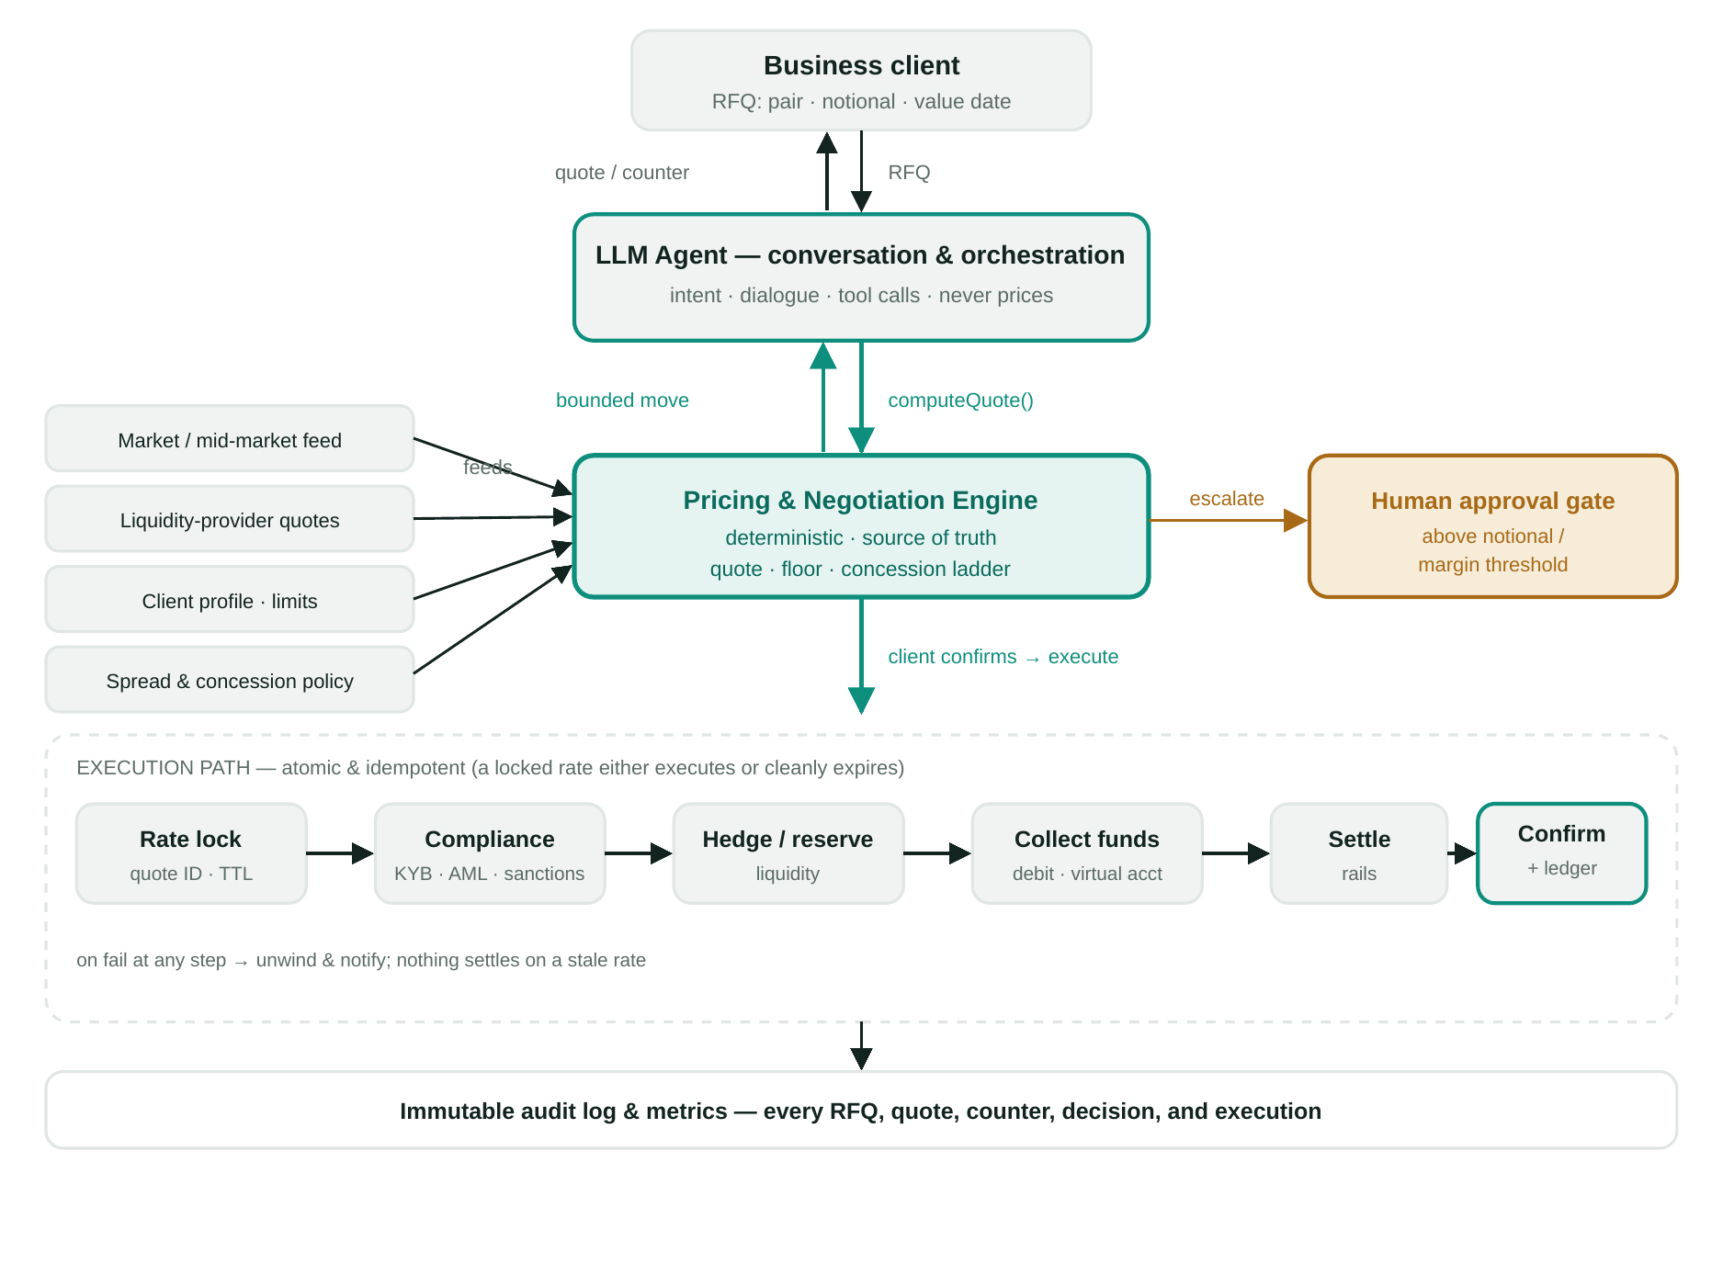
Figure 1 — Agent (conversation) ↔ deterministic pricing & negotiation engine, human-approval gate, and the atomic execution path, all writing to an immutable audit log.
PHASING
Phase | Stage | What the agent does | Autonomy / gate
0 | Instrument | Log every manual negotiation; build the pricing engine + policy as an API. No client-facing agent yet. | None — desk still quotes.
1 | Copilot | Agent drafts quotes/counters from the engine; desk reviews and sends. Learn the conversation patterns. | Human sends every quote.
2 | Bounded autonomy | Agent negotiates directly with clients within tight policy bounds; escalates edge cases. | Auto within limits; gate above.
3 | End-to-end execute | On agreement within bounds, agent runs the full atomic execution path automatically. | Gate only above thresholds.
4 | Optimise | Tune concession ladder, spreads, and limits from outcome data; widen autonomy where safe. | Continuous, policy-governed.
SUCCESS METRICS
- Coverage: % of RFQs handled end-to-end by the agent without human touch (target grows by phase).
- Speed: median time from RFQ to locked rate, and from agreement to settled trade.
- Conversion: quote→trade rate vs. the manual baseline; win-rate on negotiated deals.
- Margin integrity: realised spread vs. floor; zero trades executed below policy floor (hard guardrail).
- Safety: count of out-of-bounds quote attempts blocked by the engine; escalations correctly routed to the gate.
- Reliability: execution success rate; clean-unwind rate on failures; zero settlements on a stale/expired rate.
- Auditability: % of interactions with a complete, replayable audit trail (target 100%).
- Client experience: CSAT/NPS on the negotiation flow; repeat-negotiation rate.
KEY RISKS & MITIGATIONS
- LLM improvises a price / is jailbroken. Rule 0 + server-side engine as sole price source; the agent can only echo engine outputs; adversarial prompt testing.
- Runaway concessions. Concession ladder and margin floor enforced by the engine; per-client and per-session limits; the gate on large or thin-margin deals.
- Execution on a stale rate. Time-boxed locks with TTL; atomic, idempotent execution; re-quote required after expiry.
- Compliance bypass. KYB/AML/sanctions inside the execution path; execution cannot proceed on a failed check.
- Partial settlement / fund loss. Atomic saga with compensating unwind and reconciliation to the ledger at every step.
- Over-automation too early. Phased rollout (copilot → bounded → end-to-end) with human oversight until metrics justify widening autonomy.

