Step1: set up pfsense network adapters 1st WAN 2nd Host-Only(LAN1) 3RD Host-Only

Step2: configure the WAN with dhcp and lan by default takes 192.168.1.1 (preferred to keep as it is ) can be changed but if not needs to change LAN subnet from virtual network editor.

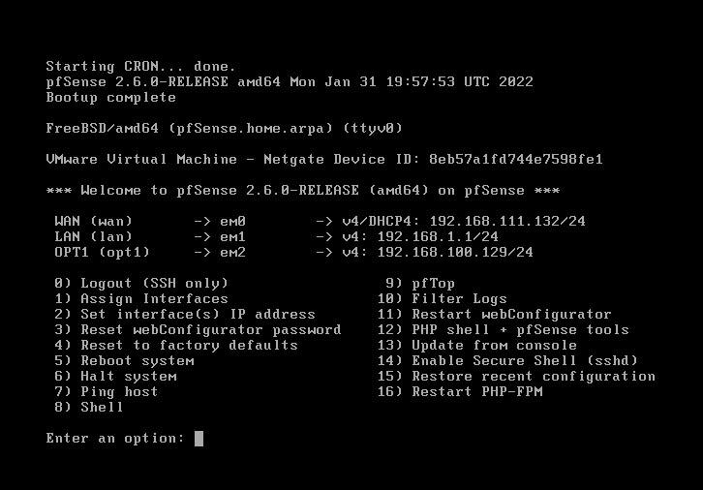

Step3: edit kali’s network adapeter to vmnet1 (LAN1)

Step4: opens kali and go to 192.168.1.1 (if subnet not changed , if changed go to the subnet gateway)

Step5: login with username admin and password pfsense

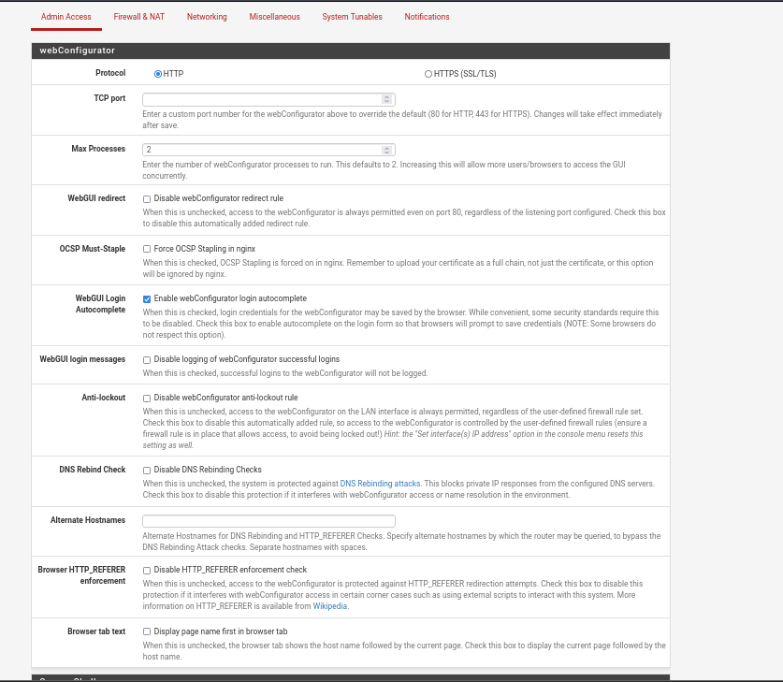

Step6: enter interfaces -> add -> opt1

Step7: go to opt1 from interfaces and configured it’s static ip

Step8: edit meta’s network adapeter to vmnet2 (LAN2)

Step9: opens Metasploit machine and go to network configuration and add mahine’s static ip and gateway (the opt1 gateway ip)

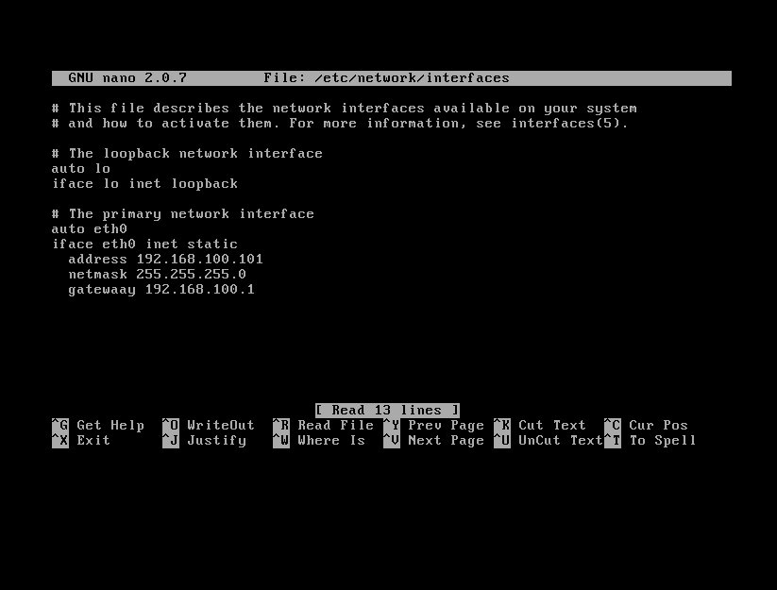

Step10: in pfsense go to rules -> opt1 add rule to open any protocol from opt1 to any destintation (like LAN default rules)

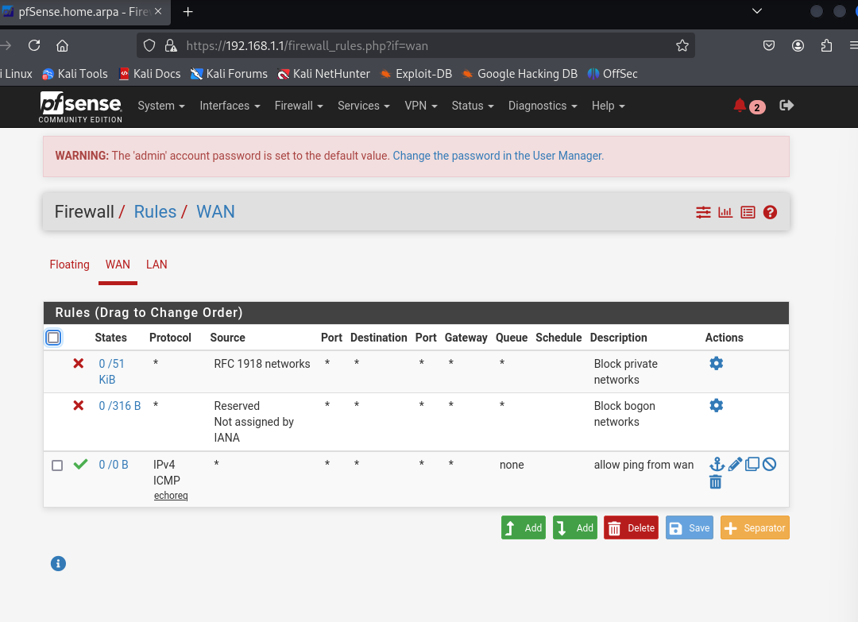

Step10: ping from every machine to another to make sure every thing is fine

Step11: scan with nmap from kali to Metasploit

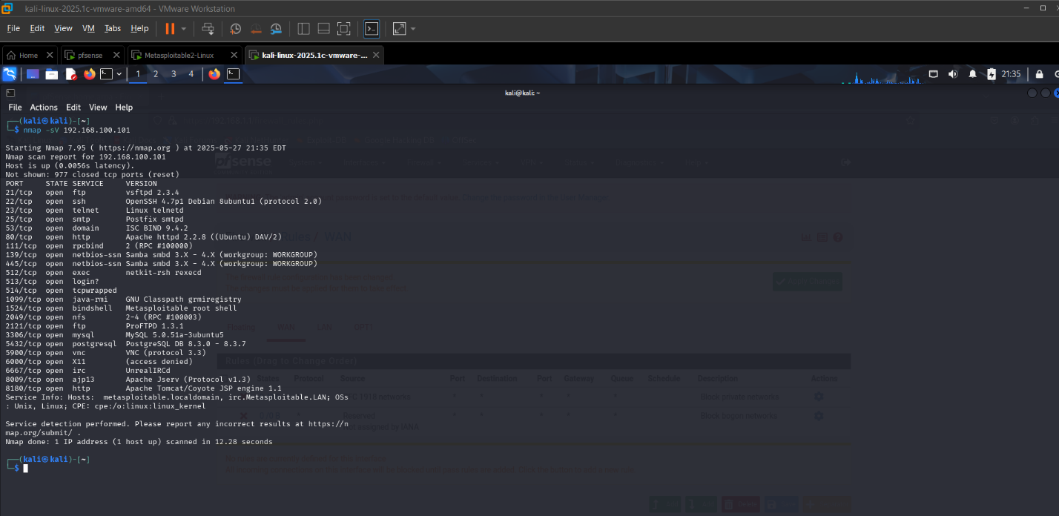

Step13: exploit open ports like ftp and telnet

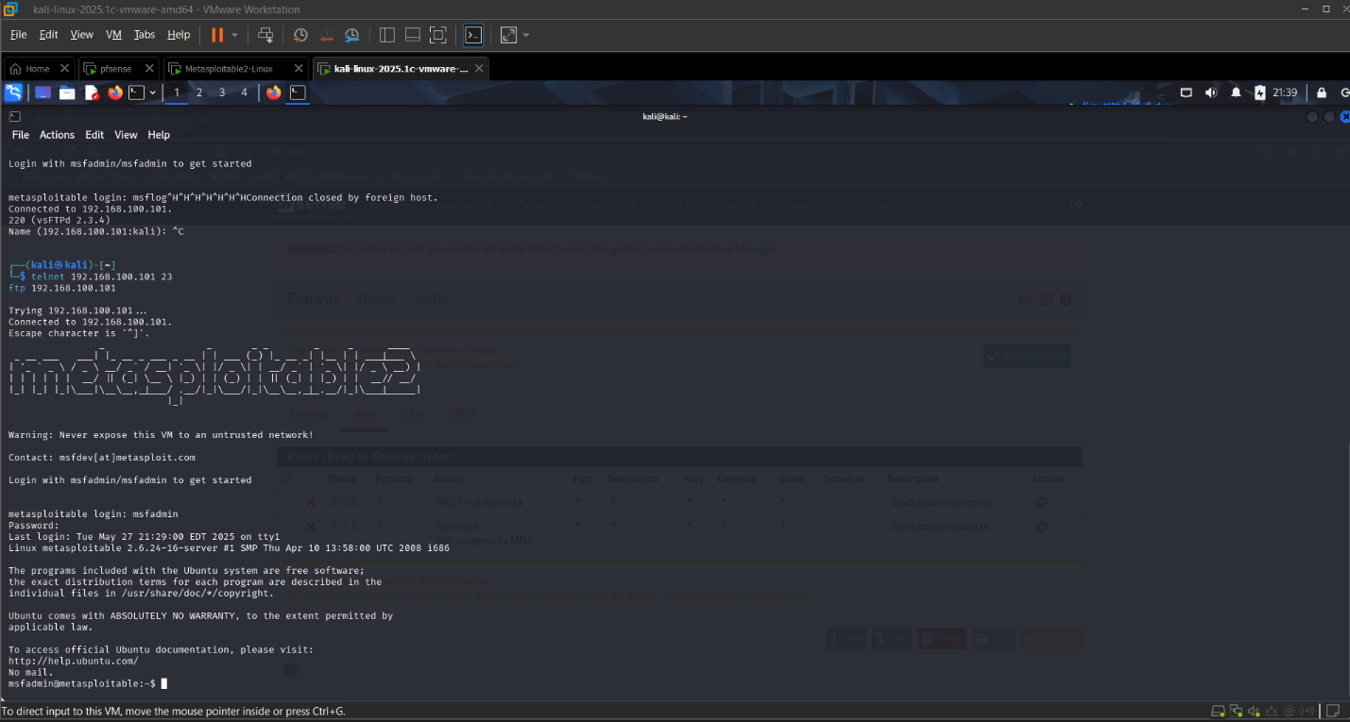

Step14: edit LAN rules to prevent attack on the ports (like ftp 21 ,telnet 23)

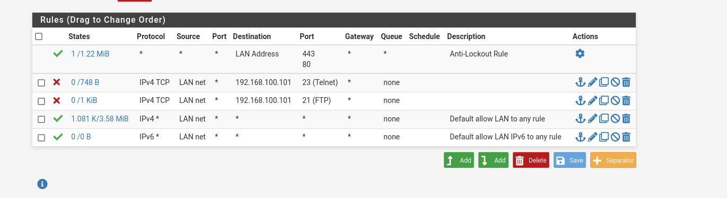

Step15: try rexploit to make sure rules are preventing

