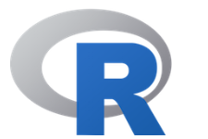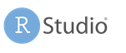

# R starter-kit

*Sine Zambach*

This kit gives you and introduction to installing R, and free resources to get some practice with R.

## Installation

* First thing is to install R (for Linux, Windows and Mac): <https://mirrors.dotsrc.org/cran/>
* Then you should install R-studio, which is a really nice R-editor (choose the free desktop version): <https://www.rstudio.com/products/rstudio/download/>
* Optional for windows: MRO (Microsoft R-Open), should make R run better on windows machines and databases): <https://mran.revolutionanalytics.com/download>

## Get started videos

1. [How to install R](https://youtu.be/cTqGrlaidLI)
2. [Basis of RStudio and reading in files](https://youtu.be/TKc7nZag0OU)

## Readings

### English

* A nice small PDF-manual: <https://cran.r-project.org/doc/manuals/r-release/R-intro.pdf> - and more advanced: <https://cran.r-project.org/manuals.html>
* Tutorials: <http://www.r-tutor.com/r-introduction>
* Wickham and Grolemund, R for data Science: <https://r4ds.had.co.nz/index.html>

### Danish

R-guide by Erik Gahner: <http://erikgahner.dk/Rguide/index.html>

## Other resources

**R-community** in Copenhagen: <https://www.meetup.com/CopenhagenR-useR-Group/>

**Swirl**-package is a build-in tutorial which you can install and use.

**Courses and tutorials**

* Tutorial: From Excel to R: <https://trendct.org/2015/06/12/r-for-beginners-how-to-transition-from-excel-to-r/>
* Fre R-courses on Coursera: <https://www.coursera.org/courses?languages=en&query=r>