COMP 3700-001 Course Project - Iteration 2 – Tests/Screenshots

*\*Below is a list of the new use cases added in Iteration 2. This does not mean that this is all that the program can do, but you can see a few of the test cases we ran to make sure the system works. To see older test cases see the file in the same folder as this one for iteration 1.*

1. As a user (cashier or manager), I want to log in the system

**Title**: Logging in

**Actors**: Manager/Cashier

|  |  |
| --- | --- |
| Actor Action | System Response |
| 1. Open Application | 2. Load main screen  3. Display login interface |
| 3. Input username  4. Input password  5. Click login button | 6. Run login information through login database  7a. IF LOGIN CORRECT: (Continue to 8)  7b. IF LOGIN INCORRECT: Display dialogue screen with message (e.g. "Username/ Password was incorrect") & return to login screen (3)  8. Hide Login Screen and display Manager Employee Screen version if login is identified as a manager and the Cashier Employee Screen version is login is identified as a cashier |

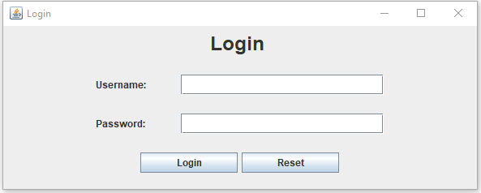

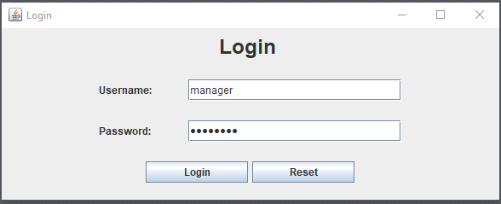

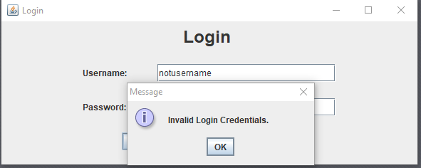

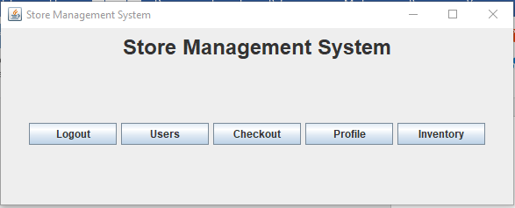

2. As a user, I want to change my login password

**Title**: Changing login password

**Actor**: Manager/Cashier

|  |  |
| --- | --- |
| Actor Action | System Response |
|  | 1. Employee Screen is displayed |
| 2. Click "Edit Profile" button | 3. Display Profile Screen |
| 4. Click "Change Password" | 5. Display Password Confirmation Screen |
| 6. Inputs old password | 7. Runs input through login database  8a. IF LOGIN CORRECT: (Continues to 9)  8b. IF LOGIN INCORRECT: Display dialogue screen with message (e.g. "Password was incorrect") & return to Profile Screen (3)  9. Display Password Change Screen |
| 10. Input new desired password and password confirmation | 11. Check if inputted new password matches the password confirmation.  12a. IF CHECK SUCCESSFUL: (Continue to 13)  12b. IF CHECK FAILS: Display dialogue screen with message (e.g. "Confirmation does not match password") & return to Password Change Screen (9)  13. Update user information in database with new, desired password  14. Display dialogue screen with message (e.g. "Password change successful") |
| 15. Click "OK" | 16. Return to Profile Screen (3) |

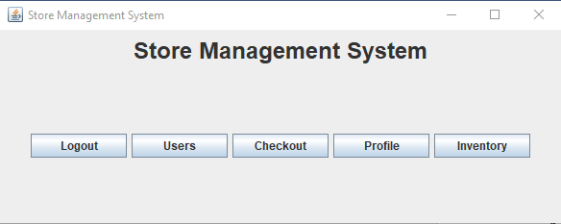

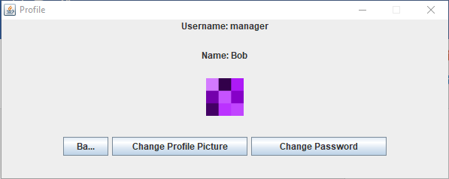

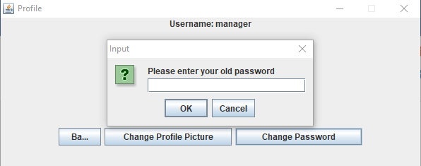

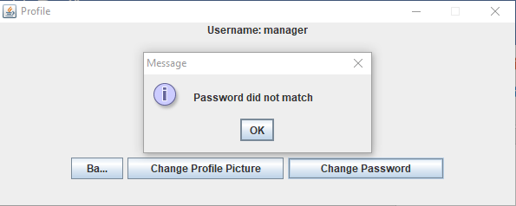

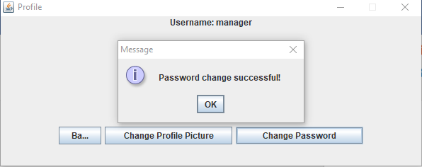

3. As a user, I want to change my display/profile photo

**Title**: Changing display/profile photo

**Actor:** Manager/Cashier

|  |  |
| --- | --- |
| Actor Action | System Response |
|  | 1. Employee Screen is displayed |
| 2. Click "Edit Profile" button | 3. Display Profile Screen |
| 4. Click "Change Photo" | 5. Display Photo Upload Screen |
| 6. Input desired photo file | 7. Check if inputted file is a valid photo file  8a. IF FILE IS VALID: (Continue to 9)  8b. IF FILE ISN'T VALID: Display dialogue screen with message (e.g. "File is not valid") & return to Photo Upload Screen (5)  9. Update user information in database with the new photo  10. Display dialogue screen with message (e.g. "Profile photo change successful") |
| 15. Click "OK" | 16. Return to Profile Screen (3) |





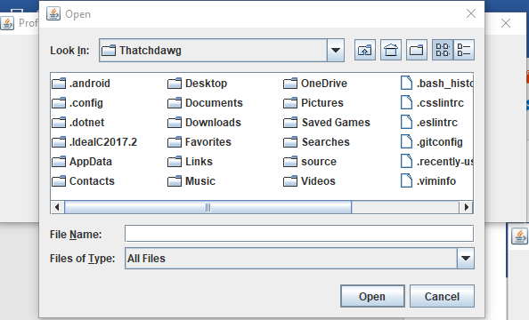

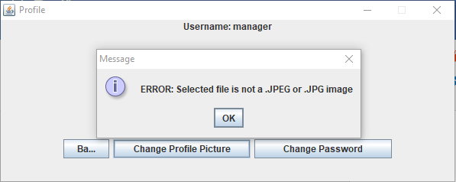

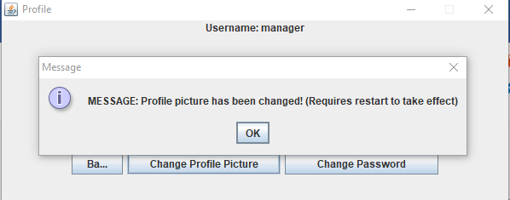

4. As a manager, I want to create a new user, assign role (e.g. manager or cashier), generate a default password for a new user

**Title**: Create a new user

**Actor**: Manager

|  |  |
| --- | --- |
| Actor Action | System Response |
| 1. Manager Logs in | 2. Manager Employee Screen is displayed |
| 3. Clicks "Create new user" button | 4. Displayers New User Screen |
| 5. Inputs new user information (username, name, role, etc.) | 6. Verifies inputted information is valid for an employee  7a. IF INFORMATION IS VALID: (Continues to 8)  7b. IF INFORMATION ISN'T VALID: Display error message (e.g. "[Element] is not valid") and return to previous New User Window (5)  8. Display a confirmation screen |
| 9. Click "Confirm" button | 10. Updates database with new employee information, set new user password to a default (e.g. 'Password123') and assign a default profile photo  11. Returns to Manager Employee Screen (2) |

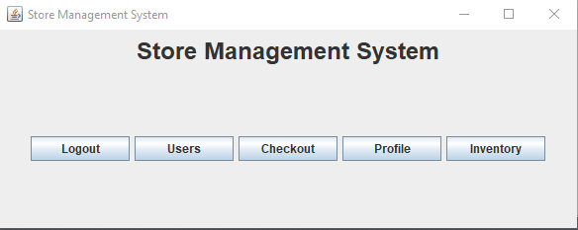

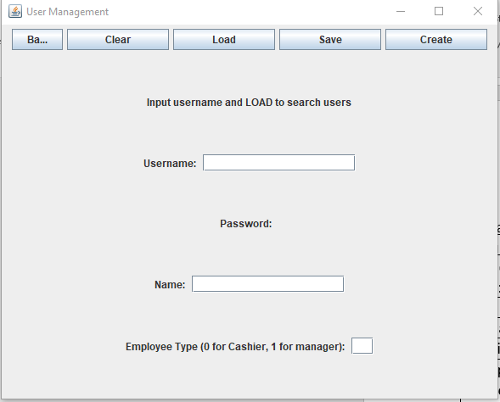

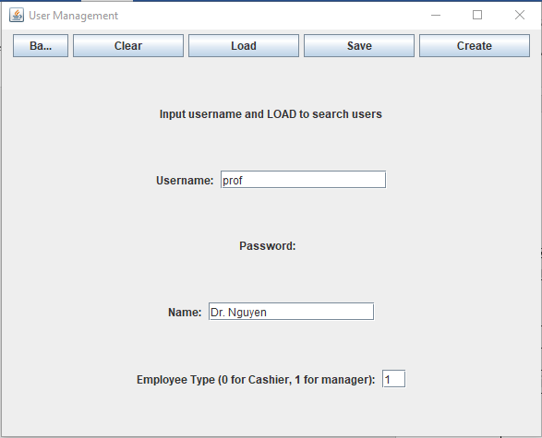

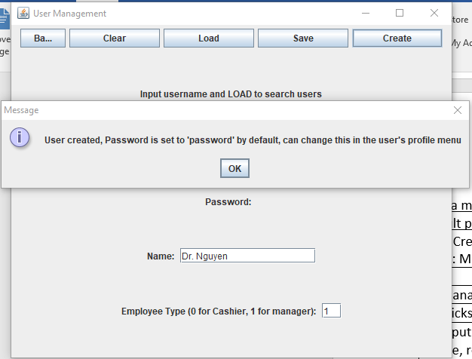

5. As a manager, I want to view and sort the business report: e.g., what products are sold, how many units, how much revenue...

**Title**: View the business report

**Actor**: Manager

|  |  |
| --- | --- |
| Actor Action | System Response |
| 1. Manager logs in | 2. Manager Employee Screen is displayed |
| 3. Clicks "Business Report" button | 4. Analyzes database, pulls desired information and displays it to a table on a Report Screen |
| 5. May select a sort option | 6a. IF SORT OPTION SELECTED: rearranges displayed information depending on the category shown. |
| 7. Clicks "Close report" button | 8. Returns to Manager Employee Screen (2) |

