|  |  |
| --- | --- |
| Actor Action | System Response |
| 1. Select “Checkout” option in the main screen. | 1. Show the checkout screen for a new order. |
| 1. Select “Add New Item” | 1. Shows dialog prompting user to enter item id and quantity. |
| 1. User enters id into field, and then enters the quantity of items. | 1. Search internal database (excel sheet) for item information and subtract the item(s) from the inventory. Display item details on screen. |
| 1. Repeat step 3 for remaining items. | 1. Repeat step 4 for new item. |
| 1. Select “Finish and Pay” | 1. Future functionality in later release…. For now, user is greeted by message reminding them that payment processing will be added later. |

# Authors: Alec Goodner/Thatcher Rickertsen

*Below follows use cases and screenshots of the application related to the use cases. The application has more functionality than is just represented here, but only the three main use cases are described in this document.*

**Title: Checking Out a Customer**

**Actor: Cashier**

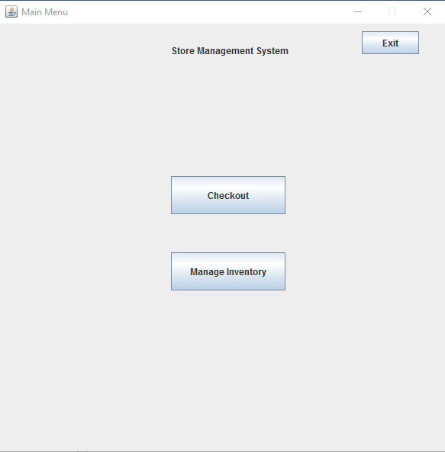

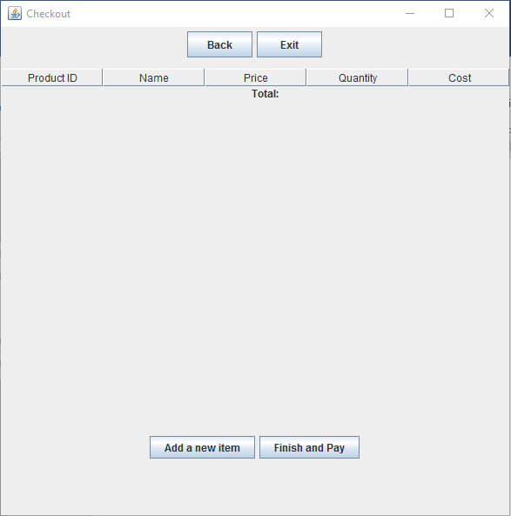

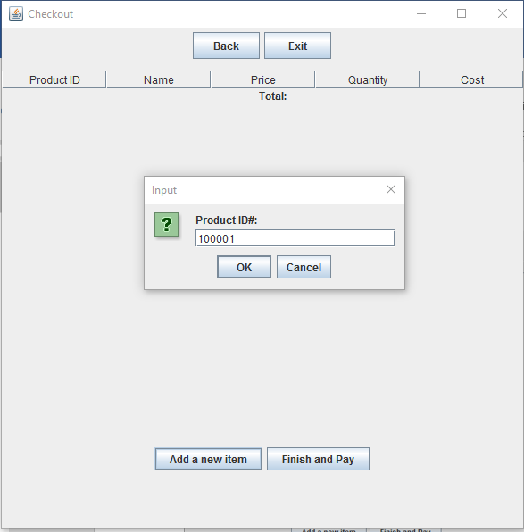

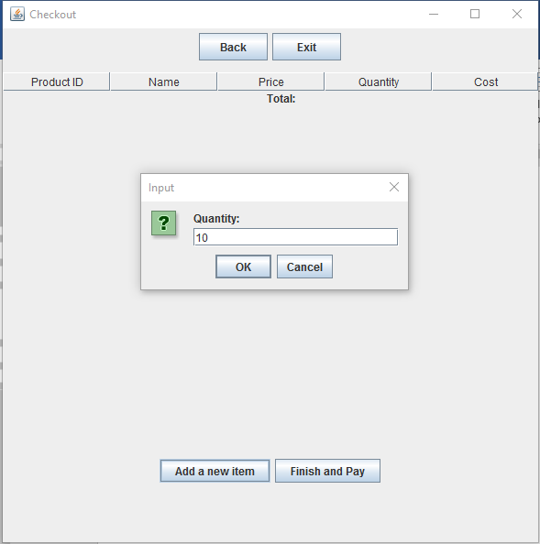

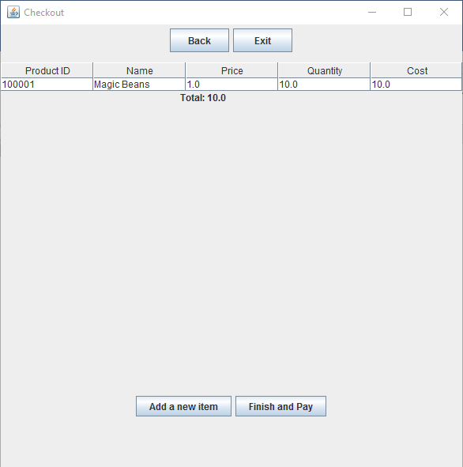

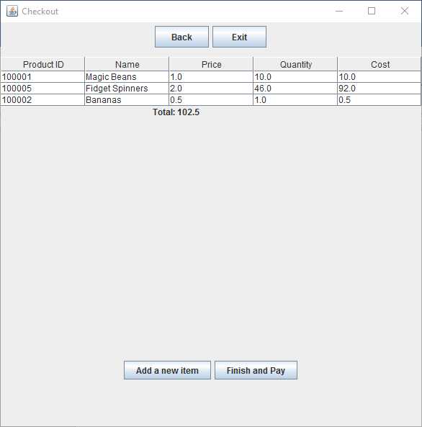

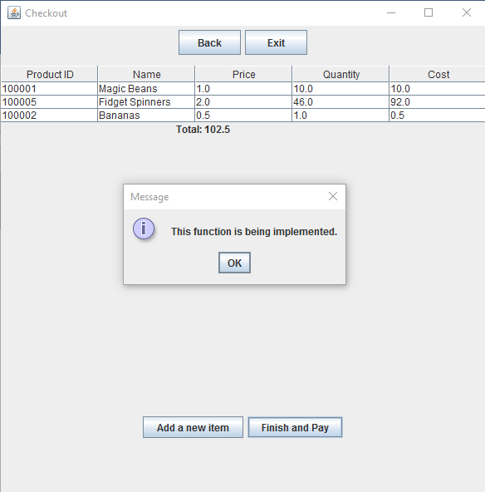

**Title: Updating an Existing Product**

**Actor: Employee**

|  |  |
| --- | --- |
| User Action | System Response |
| 1. Employee selects “Manage Inventory” | 1. Display options related to managing the store’s inventory. |
| 1. Employee selects “View Inventory” | 1. System displays a list of known items within the store’s inventory. |
| 1. Employee selects button related to the item that they wish to modify. | 1. Add/Update item menu is displayed with detailed information about the selected item. |
| 1. Employee selects “change” next to the field they wish to change. | 1. Dialog box opens prompting user to enter the new value for the field. |
| 1. User enters data and clicks “OK” | 1. Data is saved and item is updated within the SQL database. |

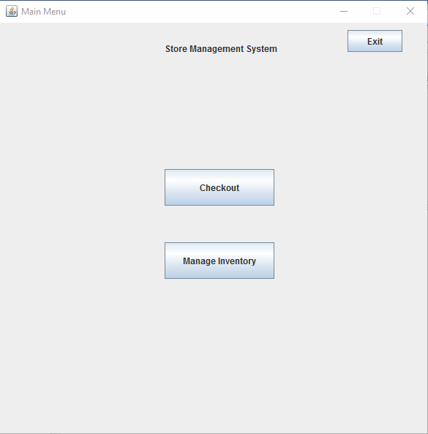

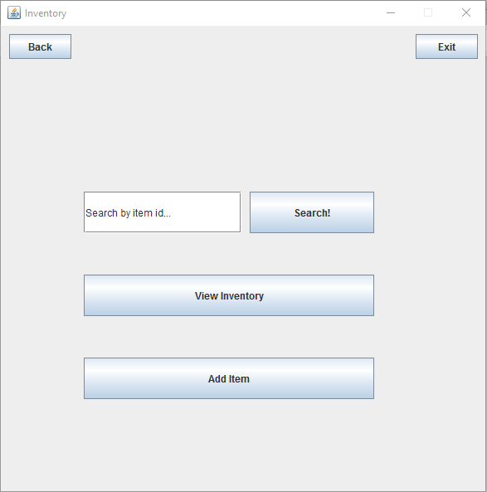

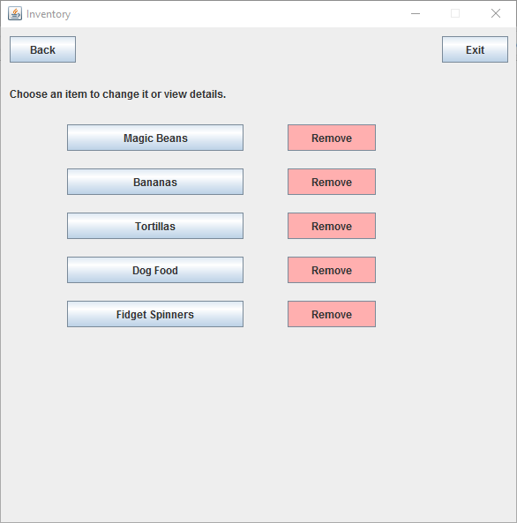

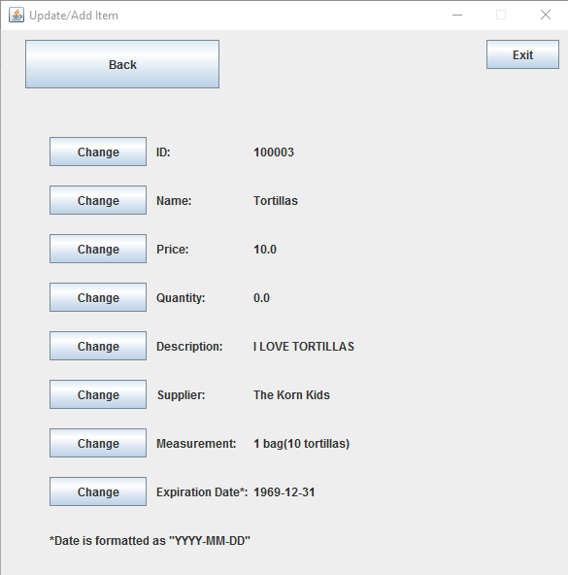

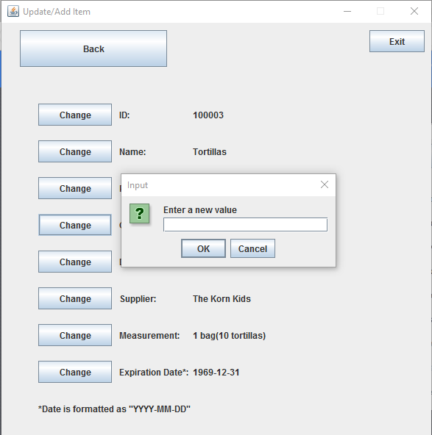

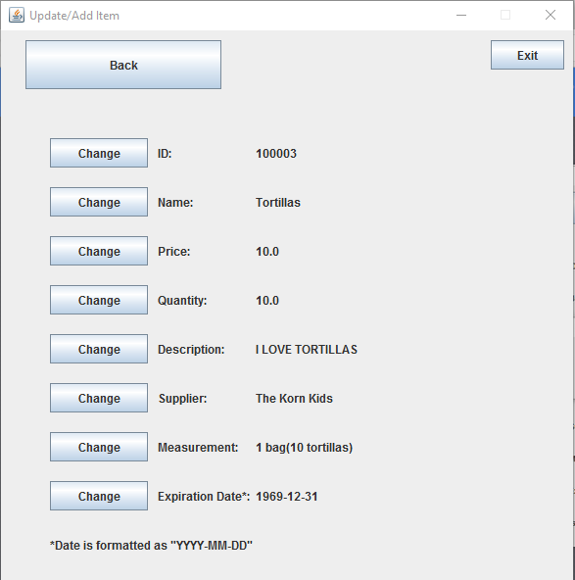

**Title: Adding a New Product**

**Actor: Employee**

|  |  |
| --- | --- |
| User Action | System Response |
| 1. Employee opens application | 1. System displays main menu for user. |
| 1. Employee selects “Manage Inventory” | 1. Inventory management screen opens with various options. |
| 1. Employee selects “Add item” | 1. New item is created in database with a distinct id, and default values entered for the various data fields. |
| 1. Employee selects “Change” for each field of data, and changes it to match information about the new item. | 1. Product is updated in the SQL database. |
| 1. Employee selects “back” to return to the inventory screen. | 1. New item is displayed along with old ones and behaves the same as any other item. |

