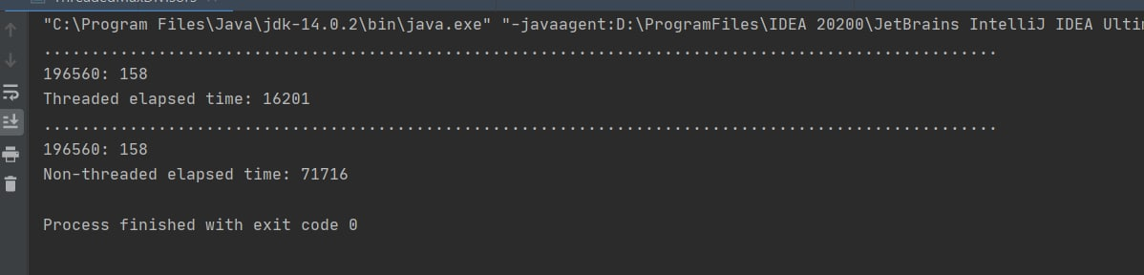Question 1: **In the absence of synchronization, why does this happen? What sequence of events is occurring that causes these errors to be raised?**

Because of we have four MiddleMans working with common resourse as generalPurposeQueue we need to synchronize their access to the common resource. Otherwise we get uncontrolled access in which several threads can try to remove the last element from generalPurposeQueue at the same time.

Question 2: **Even though the block isn’t synchronized, and even though the queue is a regular LinkedList that doesn’t support concurrency protection, why is there never a situation where the MAX_QUEUE_SIZE constraint is violated?**

We have only one Producer, which means there is no uncontrolled access to the MAX_QUEUE_SIZE variable.