Time-Anchored Testimony
  - The Technical Architecture of an AI-Curated Civil Rights Oral History Archive
The Spoken History Project (spokenhistory.org)
2026-06-10
Table of Contents

Time-Anchored Testimony: The Technical Architecture of an AI-Curated Civil Rights Oral History Archive
Status: living technical reference. Quantitative claims were independently re-derived against the repository at commit 78a113f on 2026-06-10 unless a different as-of date is stated. Counts that track a growing corpus (vector totals, catalog sizes) are snapshots and carry their dates. Appendix A inventories every number with its source artifact.

Abstract
The Library of Congress Civil Rights History Project collection, produced with the Smithsonian National Museum of African American History and Culture, holds roughly 250 hours of oral history video: first-person testimony from the people who lived and led the American civil rights movement. The legacy presentation of that collection is an item-level catalog, a flat PDF or XML transcript per interview whose only temporal structure is an occasional coarse marker, and a multi-hour video stream with no internal index; nothing aligns the text to the video at the level of an utterance. This paper describes the architecture of an open-source system that transforms 140 of those interviews into a time-anchored, citation-grade, semantically navigable public resource. The pipeline transcribes each interview with Whisper ASR to obtain a millisecond-resolution temporal grid, then heals the error-prone ASR text word by word against the Library of Congress's own published transcripts, fetched through the LoC API, producing a corpus that carries both the institution's textual authority and the ASR layer's temporal resolution, an artifact neither source possessed alone. On that substrate the system builds cue-aligned chapter segmentation (4,932 chapters in 1,387 named parts), a fail-closed dual-model publication gate for AI-generated metadata, a semantic retrieval index of 16,759 vectors with audit provenance riding on every audited passage, derived knowledge structures computed from the embedding space (interview constellations, concept axes, influence graphs), human exploration surfaces in which any moment of testimony is a shareable URL, and a public Model Context Protocol server that lets any AI assistant perform citation-grade primary-source research against the archive. We describe each layer, quantify its coverage with independently verified figures, and argue that the combination enables modes of information exploration and learning that were not possible with legacy archive technology.

1. Introduction: The Legacy Baseline
Consider a high school student who wants to hear what marchers saw on the Edmund Pettus Bridge, a teacher assembling a lesson on Freedom Summer, or a researcher checking whether a quotation attributed to a SNCC organizer is real. Before this project, the Library of Congress presentation of the Civil Rights History Project offered each of them the same three disconnected objects per interview:
- A catalog record searchable by title and subject heading at whole-item granularity. A query like "nonviolence as theology" can at best surface a whole multi-hour item (it does, in fact, return the right interview); it cannot say where in those hours the theme appears, because the catalog indexes descriptions of interviews, not the testimony inside them.
- A flat transcript published as a PDF or TEI2 XML file. The text is authoritative and carefully edited, but it carries no machine-actionable timestamps. The most temporal structure an LoC transcript offers is a coarse editorial marker: a bracketed timecode every five minutes in the XML editions, a START OF RECORDING flag in some PDF editions. The Aaron Dixon transcript, for example, is 540 speaker turns whose only time anchors are 29 five-minute markers; nothing is anchored at the level of an utterance.
- A multi-hour video stream with no internal index. Finding a remembered moment means scrubbing; citing one means writing down a timecode by hand and hoping the reader can find it again.
Nothing connects these objects. The transcript cannot take you to the moment in the video where a sentence was spoken; the video cannot show you the sentence being spoken; the catalog cannot see inside either. Across roughly 250 hours of testimony, the practical effect is that the collection is public but not explorable: only a researcher with institutional patience can use it, and nobody can cite it at the granularity at which history actually lives, the individual spoken sentence.
The thesis of this paper is an engineering claim: every capability described in the following sections reduces to making a moment of testimony addressable (a stable identifier you can share), verifiable (a citation chain back to the Library of Congress, with the system's own confidence about its text stated honestly), and semantically reachable (findable by meaning, not just by keyword). The architecture achieves this with a deliberate division of labor. Deterministic, auditable mechanisms own everything that can be wrong as a matter of fact: timestamps, transcript text, citations, licenses. Generative AI is confined to layers where it adds interpretive value (summaries, chapter titles, thematic structure), and even there it operates behind a fail-closed publication gate scored by two independent model families. The system's posture toward its own output is institutional: the Smithsonian and the Library of Congress evaluate this work on hallucination rigor, so the quality bar throughout is publication grade, not demo grade.
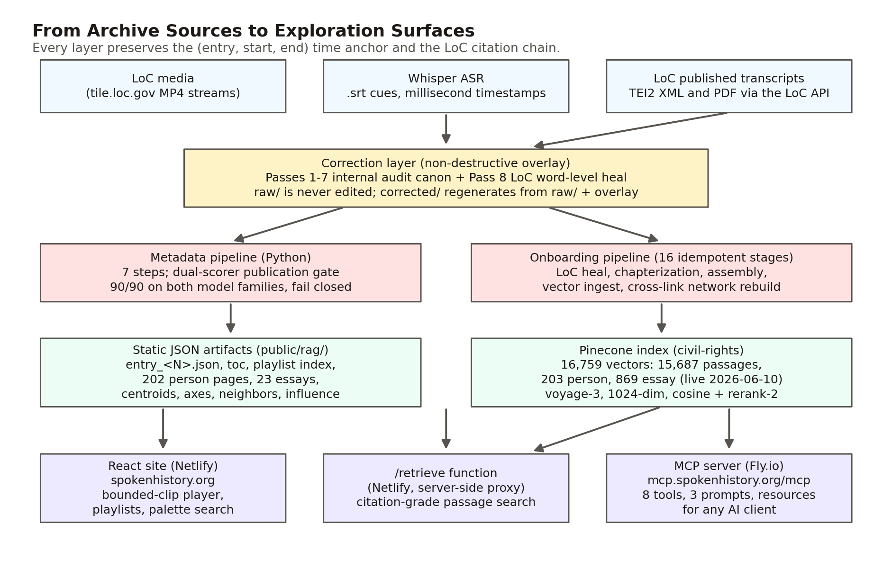

2. The Corpus and Its Provenance
The corpus comprises 140 interviews from the Library of Congress Civil Rights History Project collection (American Folklife Center, AFC 2010/039), produced in collaboration with the Smithsonian NMAAHC. Entry identifiers span 1 to 142 with two deliberate gaps (31, a duplicate identifier whose interview is carried as the joint entry 75, and 95, a multi-speaker joint interview whose source directory arrived empty), a detail worth recording because computing the corpus size from the maximum identifier is a recurring error. The full LoC collection is approximately 145 items; this corpus holds the 140 with usable transcripts, roughly 250 hours of video and two million words of spoken testimony (1.98 million words in the corrected transcripts; the LoC editions of the same interviews run 2.16 million). Some project materials describe the collection as 600 or more hours; the published collection's own time-anchored data measures a factor of 2.5 lower, and this paper uses the measured figures throughout.
The repository is organized as five subsystems: a React 18 frontend (src/), Firebase Cloud Functions (functions/), a standalone Python metadata-generation pipeline (Metadata Generation System/), a Node MCP server (mcp-server/), and the data-build scripts (scripts/, rag/, transcripts/). The deployed site at spokenhistory.org is static-JSON-backed: the render path reads per-interview JSON committed to the repository and served by Netlify, with the Pinecone vector index behind a server-side function for semantic search. The interview render path has no database dependency (a Firestore backend serves the movement timeline and parts of the federated search, and those sources fail soft), so the exploration surface degrades gracefully because most of it is files.
Two provenance populations matter throughout this paper. The original 127 audit-able entries went through the full internal audit cascade described in Section 4 before the Library of Congress healing pass existed. Entries onboarded after 2026-05-25 go through the streamlined deterministic pipeline of Section 6 and carry streamlined-ingestion provenance instead (ingestion-loc-verified on the nine 2026-05-25 onboards). Every passage the system shows a reader carries this provenance, machine-readable, end to end, with one known gap: the four entries onboarded 2026-05-31 still carry a placeholder value on their search vectors pending a metadata backfill (Section 14).

3. The Time Anchor: From ASR Cue to Citable URL
The foundational design decision in the entire system is that a moment of testimony is identified by the tuple (entry number, start seconds, end seconds), and that tuple is a URL:
/interview/<entry>?t=<startSeconds>&end=<endSeconds>
The client utility that builds these links states the invariant as the design center (src/utils/clipLink.js). Everything else in the system either produces these tuples or consumes them.
The temporal grid comes from Whisper ASR. Each interview was transcribed into a triple of formats (.srt, .txt, .vtt); the SubRip .srt file is the canonical substrate because its cues carry comma-millisecond timestamps (00:01:24,000 --> 00:01:41,000) at roughly five-second granularity across the recording. The corrected transcript directory for each entry preserves all three formats plus a provenance manifest.
Above the cues sits an authored segmentation layer. A deterministic script collapses the corrected SRT into approximately 40-second cue blocks whose boundary timestamps are copied verbatim from the first and last cue of each block (scripts/extract_blocks.py). A chapter specification is then authored over those blocks in a supervised editorial pass (titles, topics, and summaries are model-drafted and human-reviewed), and scripts/expand_chapters.py expands it into chapters whose start_time and end_time are the verbatim cue-block timestamps, validating that the specification covers every block with no gaps and no overlaps. This separation is load-bearing for the project's hallucination posture: the language model authors chapter titles, topics, and summaries, but it never authors a timestamp. Time anchors are deterministic all the way down to Whisper's cue boundaries.
Chapters carry a forward-filled part field that groups them into named parts, so a two-and-a-half-hour interview reads as a scannable outline. Corpus-wide, as of 2026-06-10, the segmentation comprises 4,932 chapters grouped into 1,387 parts across the 140 interviews, and scripts/build_playlist_index.py turns every chapter into a playable clip in a static index, so the playlist system works with no database at all. Both the Python index builder and the client-side parser deliberately truncate the millisecond suffix when deriving integer seconds: millisecond precision survives in the entry JSON and the playlist index as SRT strings, while URL-layer addressing is second-precision.
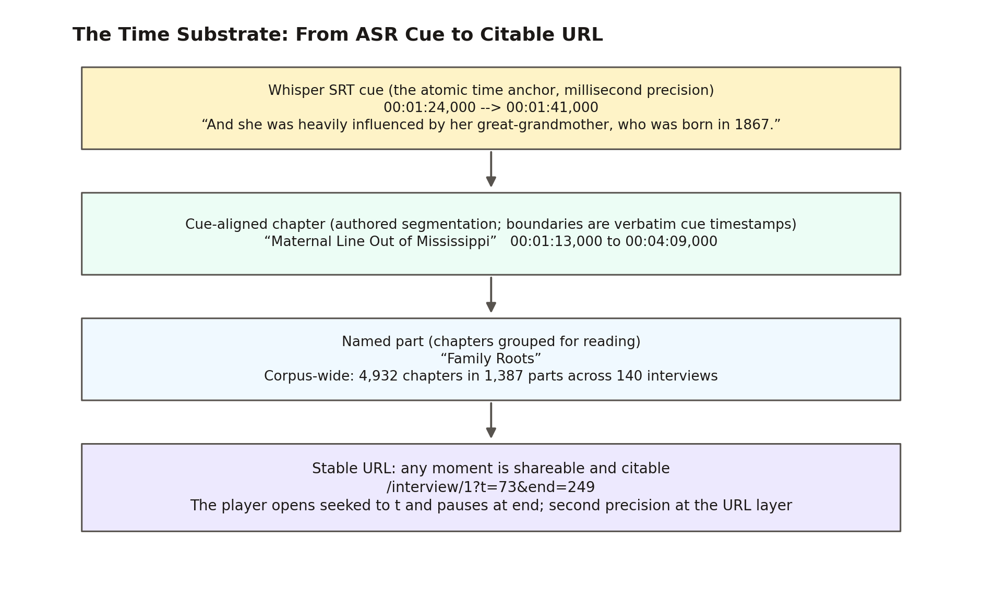
The last link in the chain is playback. The LocVideoEmbed component plays the Library of Congress's own MP4 streams from tile.loc.gov, preserving media provenance, but bounds them: given (t, end) it registers the seek before any play() call and begins playback only once data at the seek target is ready, so the network fetch range-jumps to the clip rather than buffering from time zero. The difference is not cosmetic; for a deep clip in a 1.9 GB interview file, sequential buffering would pull roughly 1.4 GB before playback began. When playback crosses the end mark the player pauses once and disarms, so a curious listener can keep going. The component exposes an imperative handle (seek, getCurrentTime) so an interview page re-targets one long-lived video element instead of mounting a second multi-hour player, and the page records the playing chapter or part in the address bar via history.replaceState, so the URL tracks playback section by section, while a separate "Copy link to this moment" control reads the live playhead to mint a second-precision link. (The deployed app is hash-routed, so an absolute share link takes the form spokenhistory.org/#/interview/...; this paper uses the path form as route shorthand.)
What this layer makes possible, on its own, is the collapse of the citation problem for audiovisual primary sources. A quotation is no longer "somewhere in interview N"; it is /interview/17?t=1835&end=1975 (entry 17, the chapter titled "His Father's Signature"), a link that opens the Library of Congress's own recording at the quoted sentence and stops when it ends.

4. Bootstrapping Trust: The Internal Audit Cascade
Whisper's output reads fluently and is mostly correct, which is precisely what makes it dangerous. The errors it does make are concentrated, categorically, in proper nouns: the names of people, places, and organizations, which is exactly where an oral history archive's institutional credibility lives. Documented examples from this corpus include the interviewer David Cline rendered as "David Klein" across 33 of the corpus's interviews, Martin Luther King Jr. as "Margaret the King," the Audubon Ballroom (the site of Malcolm X's assassination) as "auto bomb bar room," Stokely Carmichael as "Stoke and Carmichael" (Whisper invented a second speaker), Eldridge Cleaver as "Elders Cleaver" eight times in a single transcript, and a merged identity, "Paul Hoffman Robeson," that fused two different men named Paul into one (this one surfaced in a corrected transcript during the audit itself and was caught only by the cascade's final review pass). These are not typos a spell checker would flag. They are confident, fluent, categorical mismatches.
Between 2026-05-21 and 2026-05-25 the project ran a seven-pass internal audit cascade over the original 127 audit-able entries (135 source directories minus a skip set of empty or failed transcriptions). Its architecture has three durable properties.
Non-destructive overlay. Raw transcripts in transcripts/raw/ are never edited. Corrections accumulate as rows in a single master overlay document, transcripts/CLEANED_TRANSCRIPTS_REVIEW.md (12.9 MB and 66,565 lines as of 2026-06-10), and a deterministic apply script replays the overlay onto the raw files to produce transcripts/corrected/, which is what every downstream system reads. The entire correction history is therefore reversible and re-derivable: raw plus overlay reproduces the audited corrections deterministically (a small set of position-specific heals lives in per-entry audit artifacts instead; see Section 5).
Row-level provenance. Every correction row is keyed to the pass and entry that produced it (1.42, 17.P2.3, 66.P8.4), carries the claimed Whisper rendering, the canonical reading, a confidence tier (high / medium / low / correct / speaker-originating / flagged-for-adversarial-review), and source attribution. The speaker-originating tier deserves note: when the speaker misremembers a fact, the transcript preserves what was said and the tier records that the divergence originates with the speaker, not the machine. A flat transcript treats every token as equally trustworthy; this vocabulary does not.
Measured rather than asserted completeness. Successive passes recorded their net-new yield, producing a diminishing-returns curve from which the project estimates capture rates (roughly 60% for one pass, 85% for two, 92% for three). These are explicitly first-order estimates, never validated against independent ground truth, and the audit trail honestly records the case where prediction failed: a pre-Pass-4 saturation estimate of fewer than two new catches per entry was overshot by a factor of ten (about 2,500 net-new catches) when Pass 4 changed methodology. There is no single "number of corrections" for the cascade; the honest accounting is per definition: roughly 14,500 correction rows authored across the seven passes (as of 2026-05-25), 16,214 rows parsed by the corpus-global sweep (which counts some bookkeeping rows), and 6,933 corrections actually applied to the corrected output, with most of the remainder being informational annotations rather than text edits.
The cascade also audited itself. Layer 5, the first corpus-global pass, fuzzy-verified that every high-confidence correction row's claimed Whisper rendering actually occurs in the raw transcript it cites, and found 939 phantom rows, with parallel multi-entry supervisor agents fabricating plausible-looking patterns as the dominant source. (The same parallel-supervisor root cause had already surfaced as misfiled rows in earlier passes, which is what drove Pass 4's strict one-transcript-per-agent isolation; Layer 5's phantom census confirmed the diagnosis.) 770 phantoms were physically removed. The audit's own process failures (work left uncommitted, stale input slices, an apply step that silently skipped five entries due to a Markdown header collision) are documented as findings in the same trail. The cascade's lasting products are the substrate the modern pipeline depends on: a ground-truth fact corpus the cascade grew to 140 entries (since expanded to 378), a 792-pattern extension to the recurring Whisper failure catalog, and the audit canon that the Library of Congress healing pass treats as protected prior knowledge.
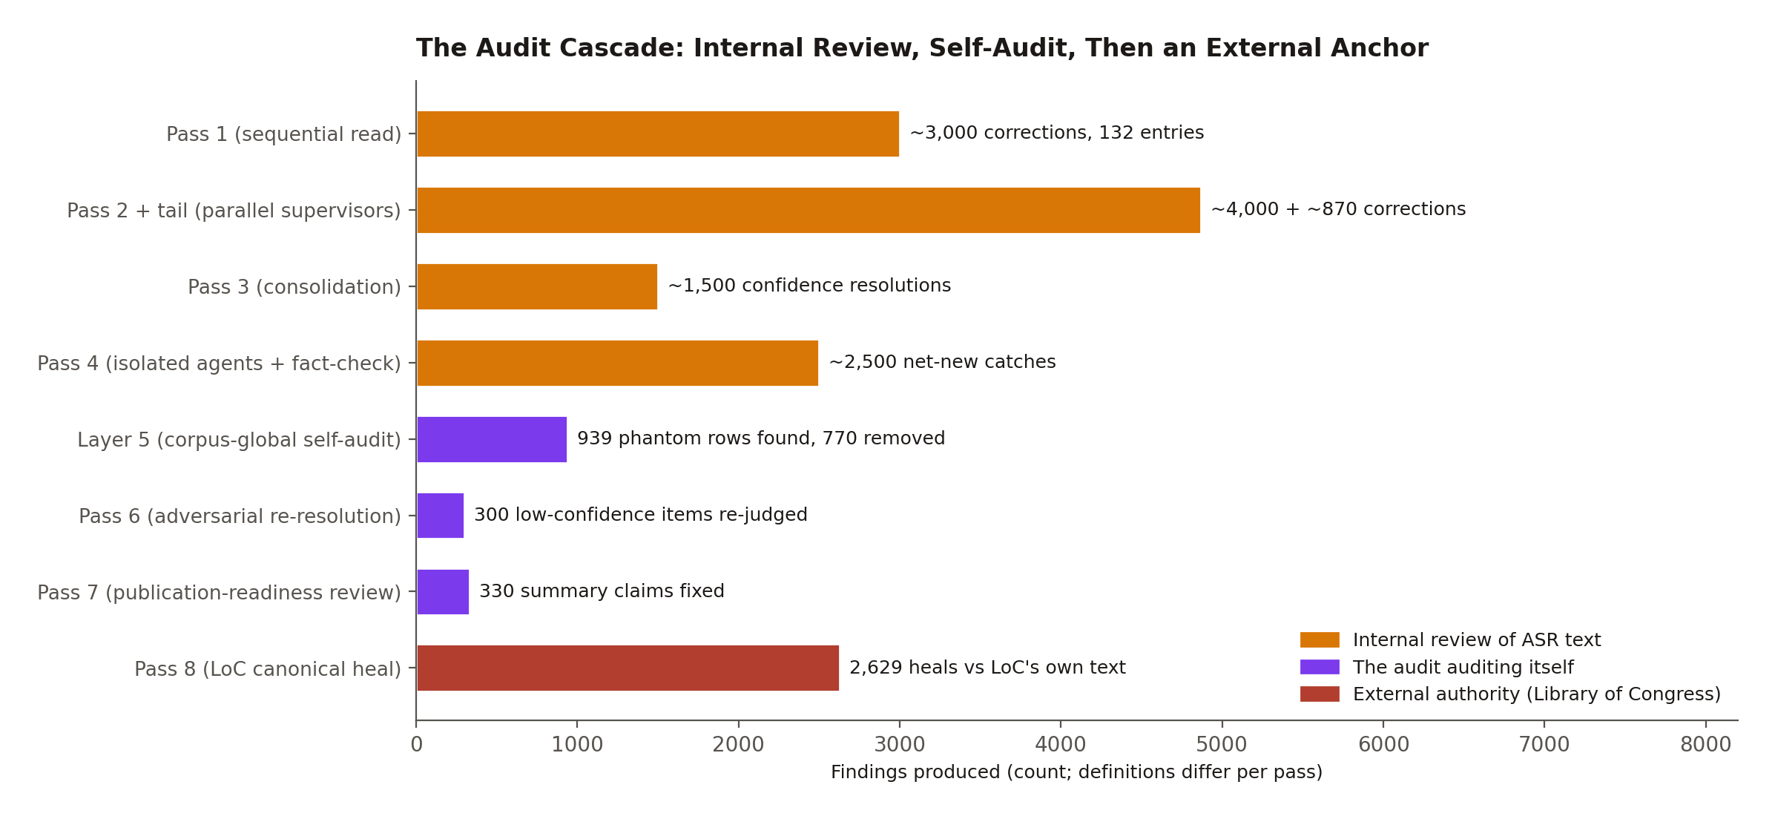
One economic note matters for anyone considering reproducing this approach: the internal cascade cost more than one thousand dollars in model tokens by the project's own accounting, and the project's retrospective judges its final pass (a publication-readiness review whose transcript-level corrective yield was three correction rows) extraordinarily expensive relative to that yield. The cascade is retired for new transcripts. What replaced it is the subject of the next section, and the replacement costs almost nothing because it stops guessing.

5. The Centerpiece: Healing ASR Text Against the Library of Congress
Pass 8, the Library of Congress canonical-archive cross-reference, is the architectural heart of the system and the clearest illustration of its philosophy. The observation that motivates it is simple. The Library of Congress publishes an authoritative transcript for every interview in this corpus: institutionally edited text, but with no usable timestamps. The project's Whisper layer has the opposite profile: a millisecond-resolution temporal grid, but phonetic errors on exactly the names that matter. For entry 1, the two artifacts are 540 untimed speaker turns (LoC) versus 1,944 timestamped cues (Whisper) covering the same two hours and twenty-eight minutes of speech. Neither artifact alone supports a citation-grade, time-anchored archive. Word-level alignment of the two produces one that does.
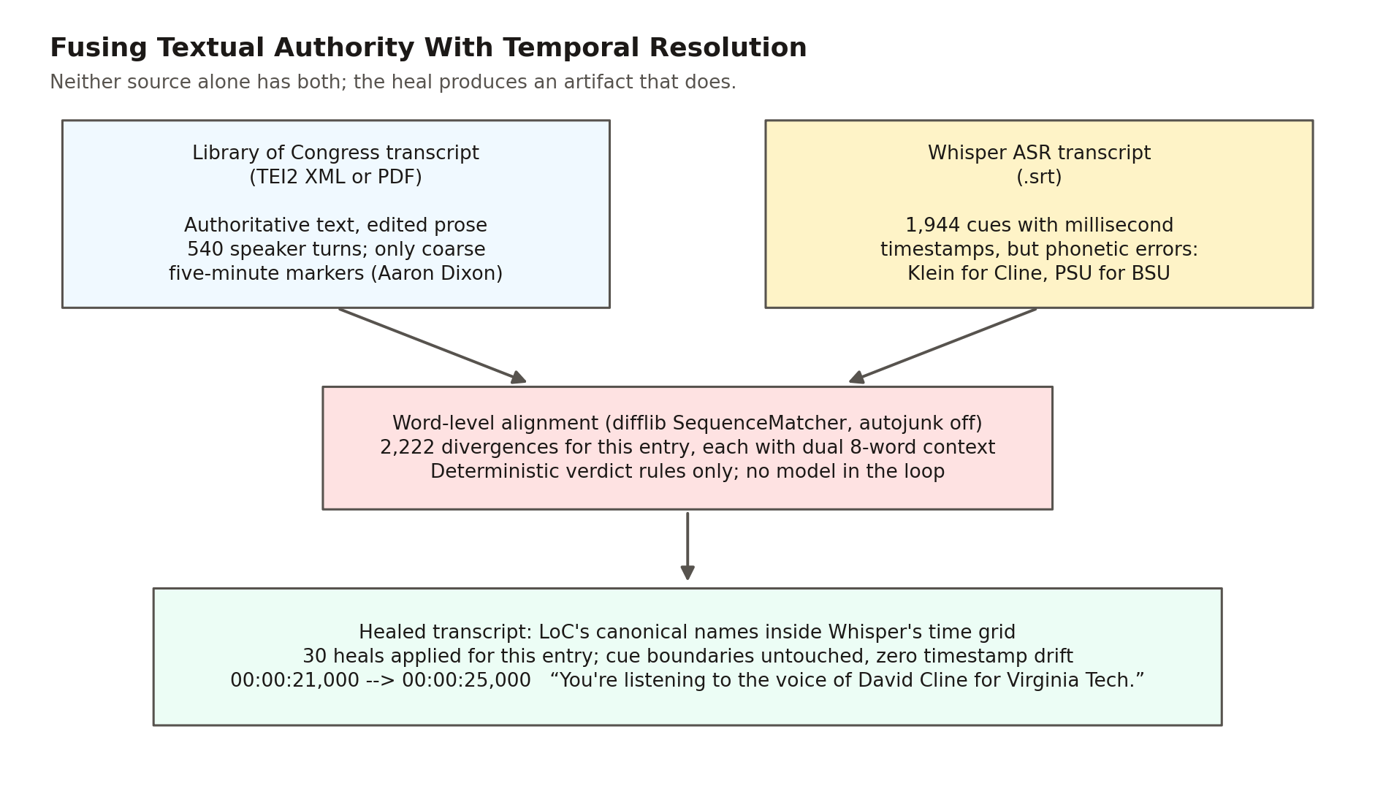
The mechanism, implemented across transcripts/loc_healing/ (the resolver scripts plus heal_one_entry.py), runs in three phases per entry.
Resolve. resolve_loc_items.py finds the interview's LoC item through the collection search API, scoring candidates by title prefix and per-contributor name-pair containment (the scoring that distinguishes Aaron Dixon from his brother Elmer Dixon, also in the collection), and downloads the TEI2 XML transcript from tile.loc.gov. Where LoC published no XML, a fallback resolver downloads the transcript PDF and extracts text with pypdf; a direct-resolve helper handles catalog spelling discrepancies (LoC's "Newson" versus the project's "Newsom"). All LoC access is strictly linear with a 1.5-second polite delay per request and an identifying user agent; the project treats respectful API citizenship toward the source institution as a hard operational rule. A finding worth recording for other archive projects: of 127 entries, not one was audio-only. Every interview in the LoC Civil Rights History Project collection has at least a PDF transcript, even though only some have machine-readable XML; 92 entries healed from XML and 35 from extracted PDF text at the 2026-05-25 coverage report, and the split is 104 XML and 36 PDF across today's 140 entries.
Align and classify. The healer flattens the SRT cues into a single word stream, recording each cue's start and end word positions so any alignment span maps back to specific cues. It normalizes Unicode (LoC's smart quotes, dashes, and ellipses to ASCII) so encoding alone never registers as a divergence, then runs difflib.SequenceMatcher with autojunk disabled over the normalized token streams of the two transcripts. Every non-equal opcode, less a noise filter that drops spans differing only in punctuation, becomes a divergence record carrying both token spans, eight-word context windows from both sources, and the overlapping cue indices. A closed set of deterministic rules then classifies each divergence. No model is called anywhere in this loop. The only class that modifies text, ASR_ERROR_HEAL, fires for a single capitalized token against a single capitalized token whose lowercase similarity ratio falls in the band [0.55, 0.95): close enough to be ASR phonetic confusion, far enough not to be mere orthography. Contractions, number-word renderings, function-word insertions and deletions of up to two words, LoC's bracketed stage directions ([laughs], [inaudible]), and hyphenated false starts all classify as preserve-ours. Everything the rules cannot classify defaults to NEEDS_SME_REVIEW and is preserved verbatim.
One guard deserves its own paragraph. The audit-canon safeguard checks, before applying any heal, whether the project's token was itself promoted by a prior audit pass; if so, the verdict becomes UNCLEAR rather than a heal. The system never lets the external authority silently reverse a decision its own audit already made deliberately. This safeguard verifiably prevented the auto-reversal of audit-confirmed readings (in entry 1 alone: "Madison Valley," which LoC's own transcript renders "Harrison Valley"; here the error runs in the opposite direction, with the external authority carrying the mistaken reading the internal audit had already corrected). Every such firing is rolled up into a standing report, transcripts/loc_healing/AUDIT_VS_LOC_DISAGREEMENTS.md: 710 conflicts across 114 entries as of 2026-05-25, grouped for subject-matter-expert adjudication into four categories that themselves teach something about archival truth: genuinely different people, spelling variants, style choices, and, candidly, Whisper-error leakage into the project's own audit canon. The legacy archive has no mechanism even to detect that two authorities disagree about a name. Here the disagreement is a first-class, reviewable artifact.
Apply, surgically. Heals are applied inside existing cue boundaries only: the applier replaces the first contiguous normalized-token match within the cue's text lines, preserving LoC's casing, and never touches a timestamp line. Zero timestamp drift is structural rather than aspirational, because the SRT writer re-emits each cue's parsed timestamp line verbatim and the VTT regenerates one-to-one from the healed SRT; a verify step additionally enforces SRT/VTT cue-count parity and fails loudly on mismatch. The temporal grid that Section 3 built everything on is therefore invariant under text correction, which is exactly why text fidelity and time fidelity can be improved independently.
The numbers describe a deliberately conservative instrument. Across the current 140-entry corpus as of 2026-06-10, alignment detected 185,091 divergences; the pipeline applied 2,629 heals (1.4%), preserved 49,829 divergences verbatim as LoC editorial smoothing or speaker disfluency, and deferred 132,633 to expert review, with zero apply failures and zero cue-count failures. The 1.4% figure is the design, not a shortfall: Pass 8 does not make the project's transcript match LoC's. LoC's editors expand contractions, drop the "you know"s and false starts, and smooth oral speech into prose. The project deliberately preserves the verbatim spoken layer that those edits erase, while importing LoC's authority on the proper nouns where ASR actually fails. Scholars of oral speech get the verbatim record; citation consumers get LoC-canonical names wherever the conservative rules can apply them; both inherit the same untouched time grid. Each healed entry also emits a per-entry institutional audit artifact (transcripts/pass8_stage/entry_NNN_slug.md) documenting every heal with its reasoning, alongside per-category totals and excerpts of the preserved and flagged tables (the complete itemization lives in the machine-readable per-entry divergence stream), and 2,518 heals were backported as correction-table rows into the master overlay so the corrected corpus regenerates deterministically from raw input plus the overlay. (The backported count is intentionally lower than the applied count: position-specific heals whose disambiguating context could not be made unique stay in the per-entry artifacts rather than risk corrupting other occurrences through the overlay's substring replay.)
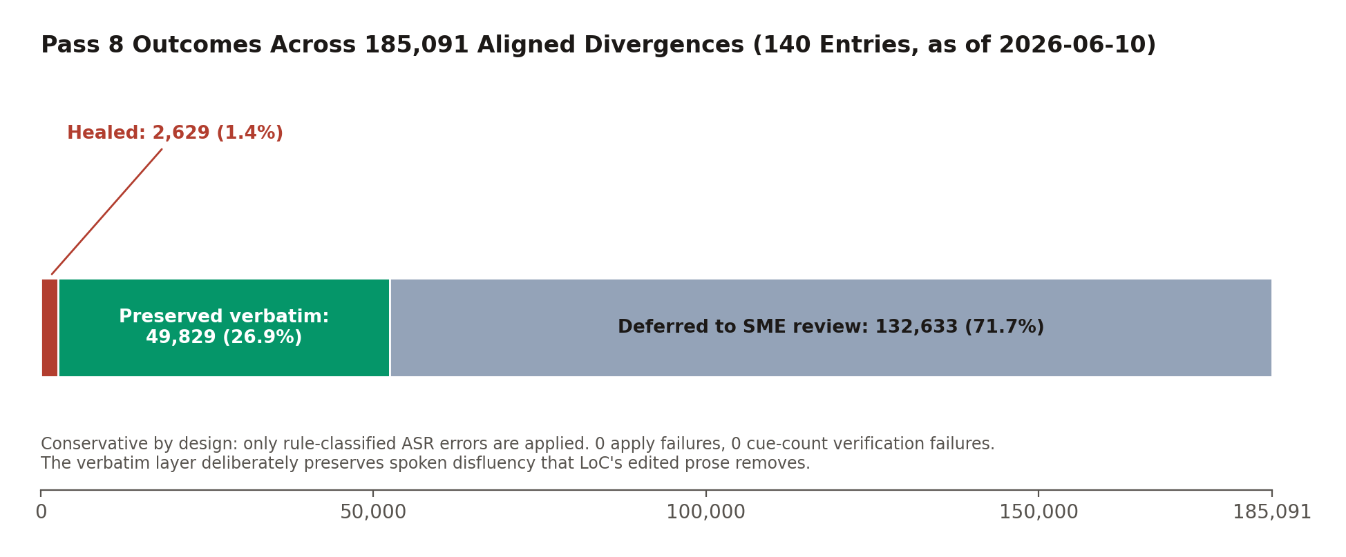
It is worth stating plainly what was novel here relative to the internal cascade it replaced: the correction authority changed from model consensus to a primary external source, the cost per entry collapsed (deterministic alignment is effectively free, versus a token bill north of a thousand dollars for the stochastic passes), and the failure mode changed from "plausible guess" to "preserved verbatim and flagged." For an institution evaluating AI-assisted archival work, that last change is the important one. The pipeline is incapable of inventing a reading; the worst it can do is decline to fix one.

6. Industrializing Onboarding: One Command per Interview
The seven-pass cascade was a discovery process; what it discovered is codified in transcripts/ingestion/onboard_interview.py, the master pipeline that carries a new interview from raw Whisper output to full presence on the live site:
python transcripts/ingestion/onboard_interview.py "<Subject>_interview_<YYYYMMDD>_<HHMMSS>"
The pipeline has sixteen named stages in execution order: locate, bootstrap, resolve, heal, number, video, blocks, chapters, summary, assemble, ingest, person, indexes, network, audit, and status. (Project prose in two places still calls it fifteen-stage; the STAGES list in the code is authoritative, and the final stage is a print-only report.) Stages with durable per-entry outputs check for their own artifact and skip work already done, while the assembly and index stages rewrite their outputs deterministically from current inputs, so the command is idempotent in effect: safe to interrupt, safe to re-run. Entry numbering appends after the maximum existing identifier so the historical gaps at 31 and 95 are never reused.
Two inputs are deliberately authored by a person, and the pipeline hard-stops (exit code 2) with authoring instructions until they exist: the parts-grouped chapter specification (stage 8) and a two-to-three-paragraph interview summary (stage 9). This is a considered position about where human judgment belongs, not an automation gap. The Smithsonian and LoC bar requires reviewable segmentation and a citation-bearing summary; the pipeline runs everything mechanical and stops exactly where accountable authorship matters. (A third authored artifact, the person reference page, is scaffolded as a stub in stage 12 and written later; it does not block.)
Stage 4 reuses the Pass 8 healer verbatim, so a new transcript is corrected the deterministic way on arrival, never through the retired guesswork passes. Stage 14, added 2026-06-01, closes the loop that earlier onboarding left open: it rebuilds the entire derived cross-link layer (per-entry semantic neighbors, centroids and the constellation, concept axes, influence and event networks, panels, capsules, and the people index) in enforced dependency order, with the credentialed Pinecone-dependent rebuilds gated on the presence of API keys and a --skip-networking opt-out that prints the exact commands to finish later. A single failing builder warns and never aborts the rest. Two artifacts remain deliberately editorial and manual (guided tours and the quote rotation), and one structural step is honestly documented as not yet scripted: the k-means cluster rebuild renames existing clusters but does not re-run the clustering, so a new entry joins the cluster structure only when that separate step runs.
Format adapters cover non-Whisper input (WhisperX JSON, PDF-only, plain text), with an explicitly discouraged synthesized-timestamp fallback for text-only sources, discouraged because it degrades the per-cue timing that the playlist layer depends on; an interview ingested that way is second-class in precisely the dimension this architecture exists to provide. And when an interview is not in LoC's collection at all, the documented fallback protocol marks the manifest loc_healing: {status: "no_loc_item"} (a case the 140-entry corpus has not yet produced), because honest provenance includes recording that the gold-standard correction could not run.
Cataloging an oral history into a navigable, searchable, cross-linked form was a months-scale manual effort under legacy practice. Here it is minutes of compute, two short authored documents, and an audit chain (manifest provenance, LoC resolution record, divergence stream, stage file, audit-trail note) that a reviewer can replay end to end.

7. Generating Metadata Under a Fail-Closed Gate
The interpretive layer (interview summaries, chapter summaries, topics, engagement metadata) is generated by a seven-step Python pipeline: upload and blocking, topic labeling, table-of-contents building, chapterization, summarization, tuning, and engagement scoring. This is the one place in the system where a language model writes prose a reader will see, and it is correspondingly the most defended.
Generation is grounded before it begins: get_relevant_facts scans the transcript against the ground-truth corpus (civil_rights_facts.json, 378 entries and 396 aliases as of 2026-06-10, validated by a schema-and-collision checker that exits cleanly on the current tree), using word-boundary-anchored regex so a short alias like SCLC cannot false-match inside another word, and injects the matched facts into every generation and regeneration prompt (the scoring side instead carries the interviewee's primary-source reference material). The original quality loop scores each draft against a standardized two-dimension rubric (accuracy and quality, each 0 to 100, with an explicit penalty of five points per fabricated claim) and scores up to three attempts (the initial draft plus at most two regenerations) against an 80/80 bar; the thresholds throughout this section are configured defaults. That loop's documented history is the reason the rest of the gate exists: it kept the best of three attempts even when none passed, and its scoring prompts are deliberately lenient, which let hallucinations through.
The May 2026 overhaul added three independent layers, dispatched behind a USE_DUAL_SCORING feature flag (the gate roughly doubles per-summary API cost, so it is opt-in by configuration rather than always-on):
- A cross-family independent scorer. Claude Opus, a different model family from the OpenAI generator, scores the final result against the identical rubric, eliminating the blind spot of a model family grading its own homework. Publication requires at least 90/90 from both scorers independently, and additionally zero unsupported claims from the Claude pass, whose unsupported-claim taxonomy (hallucination, overreach, uncertain) treats even an "uncertain" flag as blocking. The 80/80 tuning bar and the 90/90 publication bar are intentionally decoupled: the loop iterates at its historical threshold, then the stricter gate judges the final artifact.
- A per-claim citation audit. citation_check.py maps every factual claim in a summary to the specific transcript passage that establishes it, with a three-way status (supported, partially supported, unsupported) and instructions against benefit-of-the-doubt. Any non-supported claim blocks publication, and an audit that fails to run blocks publication too, with the decision path tagged so a reviewer can see the audit errored rather than passed.
- A human review queue. Disagreement between the scorers (one passes, one fails) is not averaged, majority-voted, or tie-broken by a third model call; it routes to a Firestore review queue with both scorers' full output and severity-tagged flags, where a human approves, rejects, or sends back for revision, with reviewer identity and edits recorded. The queue is the escalation surface, not the gate itself: if Firestore is unreachable, the enqueue degrades gracefully and the not-publishable verdict stands.
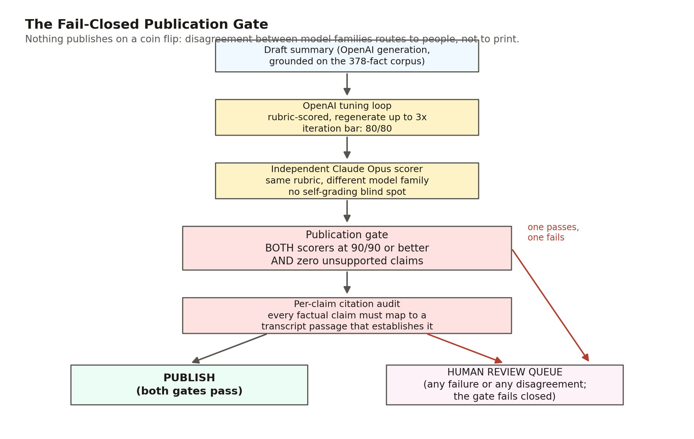
The defensive engineering extends to the type level, in a pattern replicated across all three scoring modules: malformed model output is coerced rather than crashed on. A score arriving as a numeric string or float is recovered to its integer value; a boolean, null, or unparseable value falls to zero, which fails the 90 threshold; a claims list arriving as a non-list becomes an empty list, with the blocking signal for that field carried by the score thresholds and the independent citation audit. A gate that crashes open is not a gate; these coercions make the failure direction a design property. Two honest scope notes belong in any description of this system: both scorers evaluate against a 12,000-character transcript window (matched between families so the comparison is apples-to-apples), not the full multi-hour transcript; and both are instructed to tolerate ASR garbling, so a summary's correct real name counts as supported when the transcript's rendering is a documented Whisper mangling of it. The reviewer who triages the queue sees a 6,000-character excerpt, deliberately wider than the flagged passage, so context travels with the flag.

8. The Semantic Substrate: Embeddings, Retrieval, and the Citation Payload
Everything described so far makes the corpus correct and addressable. The semantic layer makes it reachable by meaning. The healed .srt transcripts are chunked time-aware (consecutive cues aggregated until roughly 60 seconds or 1,400 characters, whichever comes first, with start and end seconds carried on every chunk), embedded with Voyage voyage-3 (1,024 dimensions), and upserted into a Pinecone serverless index named civil-rights under cosine similarity. Vector identifiers are deterministic and content-hashed, so re-ingest after a correction is idempotent: unchanged chunks short-circuit without an embedding call, and the index provably tracks the current correction overlay rather than a stale snapshot. Only the .srt layer is indexed; an early ingest that also embedded the .txt and .vtt renderings produced duplicate hits and timestamp-less results, and the 2026-05-25 prune that enforced the SRT-only rule dropped the index from 40,710 vectors to 15,464, a 62% reduction that made every retrieval result time-anchored by construction.
A live query against the index on 2026-06-10 counts 16,759 vectors: 15,687 transcript passages, 203 person-page vectors, and 869 essay segments (the latter two populations are described in Section 11; the three prefix counts sum exactly to the total, and the person-page figure is 202 catalog pages plus one stray vector embedded from the catalog's own index file, a known ingest quirk slated for cleanup). Each transcript vector's metadata is designed for institutional review at answer time, with no second lookup: the verbatim passage text, entry number and interviewee, start and end seconds, the entry's audit provenance and (for the 136 entries with completed tier assignment) the inferential-uncertainty tier and score, and the Library of Congress catalog URL.
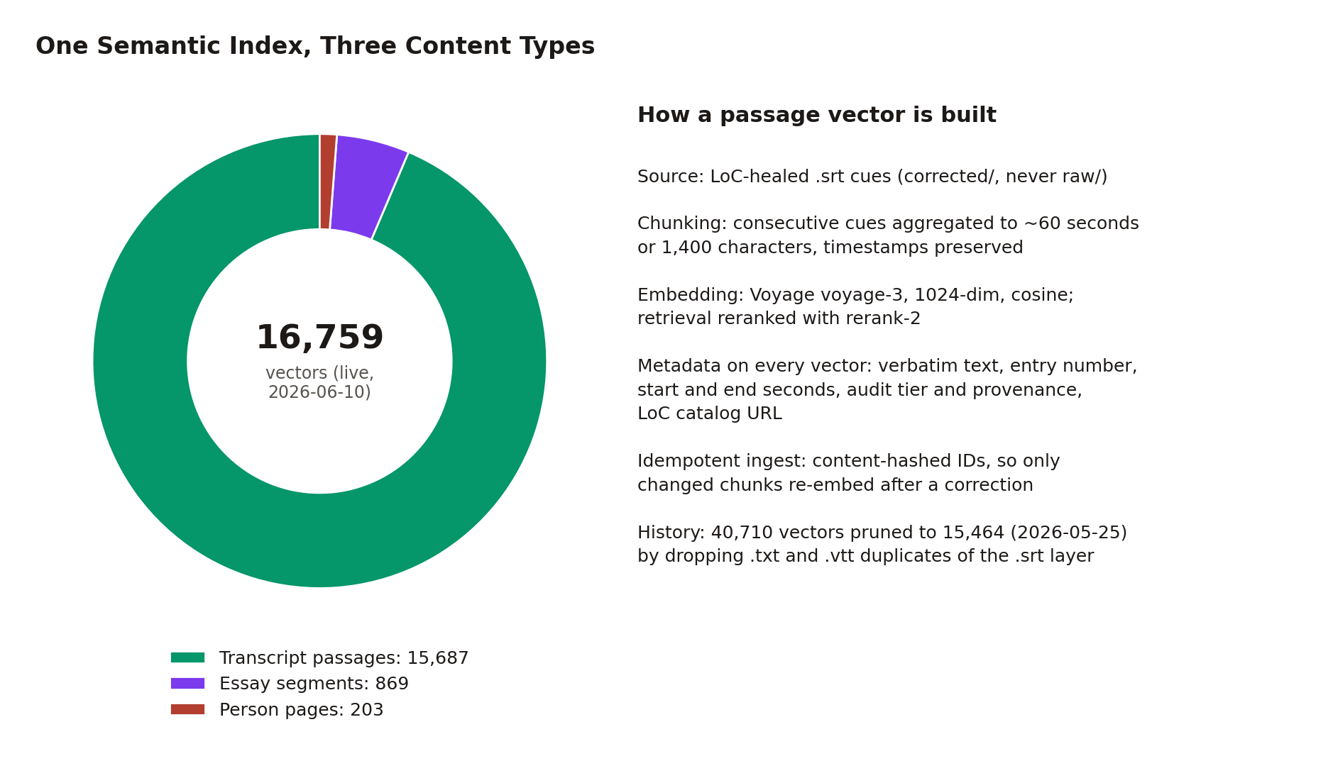
Retrieval is two-stage. A server-side Netlify function (netlify/functions/retrieve.mjs, which keeps the Pinecone and Voyage keys out of the client bundle) embeds the query in Voyage's query mode, runs a dense Pinecone top-K search (default 30 candidates), then reranks with the rerank-2 cross-encoder down to the requested top N (default 8). Two request options matter for research workflows: entry_number scopes the search to one interview, and dedupeByEntry keeps only the best post-rerank passage per interview, over-fetching four-fold so the result is still N distinct interviews (joint interviews count as one). That option is the mechanical heart of the polyphonic research patterns in Section 12: one query, many witnesses, no synthesis.
What comes back is the system's signature object, the citation payload: the verbatim text, the entry and interviewee, the LoC item URL, start and end timestamps in both seconds and HH:MM:SS strings, the entry's provenance and uncertainty tier with a plain-English fidelity note, both retrieval scores (cosine and, in the default reranked configuration, the cross-encoder score), and a pre-formatted Chicago-style archival citation naming the Civil Rights History Project, the American Folklife Center, the Library of Congress, and the Smithsonian NMAAHC, with the catalog URL and the timestamp range. The same payload shape is emitted by the Netlify function and the MCP server, and reconstructed from the precomputed JSON by a client-side adapter, a deliberate single contract maintained in three implementations (the precomputed leg omits the pre-formatted citation and resolves tier fields from per-entry audit data). The client adds one more defense: by default, retrieval excludes the person and essay vector populations through a metadata filter, so the passage-search experience never mixes content types unless a surface opts in.
Cost discipline is part of the architecture's portability argument: the substrate decision record chose Pinecone's flat-rate Builder tier plus Voyage over self-hosted alternatives primarily on the team-handoff criterion (academic partners without AI-ops capacity), the retrieval substrate's ceiling (Pinecone plus Voyage) is on the order of 22 to 25 dollars per month at current usage, the scale-to-zero MCP host adds at most 5 to 10 dollars, a full re-embed costs well under a dollar (the runbook budgets about 80 cents; the measured corpus is roughly 2.6 million transcript tokens, about 16 cents at the 2026-05-22 rate), the swap surface to a different vector store is about 200 lines of adapter, and there is no chatbot anywhere in the system: every surface either reads static JSON or makes a bounded retrieval call.

9. Derived Knowledge Structures: What the Embedding Space Knows
The vector index supports more than search. A family of precomputed, static JSON artifacts under public/rag/ extracts standing structure from the embedding geometry, each one consumed by a visualization surface with zero runtime cost, most of them drilling down, on click, to the same citation payloads as everything else (the event network drills instead to bounded clips and interview pages), so the discovery layer never abandons the evidence layer.
The atomic representation is the entry centroid: the mean of up to 30 sampled chunk vectors per interview, L2-normalized so cosine similarity reduces to dot product. From centroids flow four structures:
- The constellation (Figure 8): a dependency-free two-dimensional PCA of the 140 centroids by power iteration, rendered as a literal map of the corpus with each interview colored by its audit tier, so the trust substrate is visible inside the discovery surface. Figure 8 renders the shipped artifact; on the live site the per-interview scatter was retired from navigation, and the projection now positions the Themes map's cluster bubbles and feeds tier data site-wide. (The artifact self-documents PCA's limits and names UMAP as the production-grade upgrade path; a separate UMAP projection exists and the two are not interchangeable.)
- Entry-level neighbors: each interview's top-5 most similar other interviews with cosine scores. The shipped artifact covers 136 of the 140 entries with full neighbor arrays (the four entries onboarded 2026-05-31 carry metadata stubs pending a neighbors rerun: pure local math over the shipped centroids, deferred because the same script also re-runs the k-means cluster structure). The flagship example is the corpus's own family structure rediscovered by geometry: Aaron Dixon's nearest neighbor is his brother Elmer Dixon at cosine 0.9286.
- Concept axes (Figure 9): for each of seven named tensions (nonviolence as theology versus armed self-defense, sacred versus secular, local versus national, and four more), an axis vector is the normalized difference of the Voyage embeddings of two long prose pole descriptions, and each interview's position is the dot product of its centroid with that axis. Positions are corpus-relative: the observed raw range (for the nonviolence axis, roughly -0.097 to 0.070) is stretched to [-1, 1], so a +1 means "the most pole-A voice in this corpus," never an absolute ideological measurement. The 1,024-dimensional axis vectors are persisted in the artifact so a client can project new query embeddings onto the same axes.
- Thematic clusters: a seeded k-means (k=30, 12 restarts) over the centroids, run at the 136-entry corpus state with the four newest entries folded in by nearest-centroid assignment, and cluster names authored by a model afterward; the geometry is pure math, the labels are editorial.
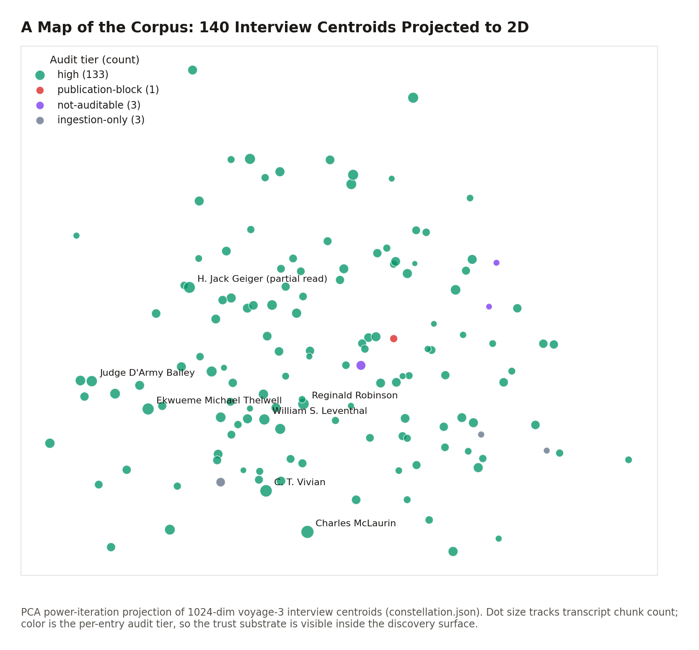
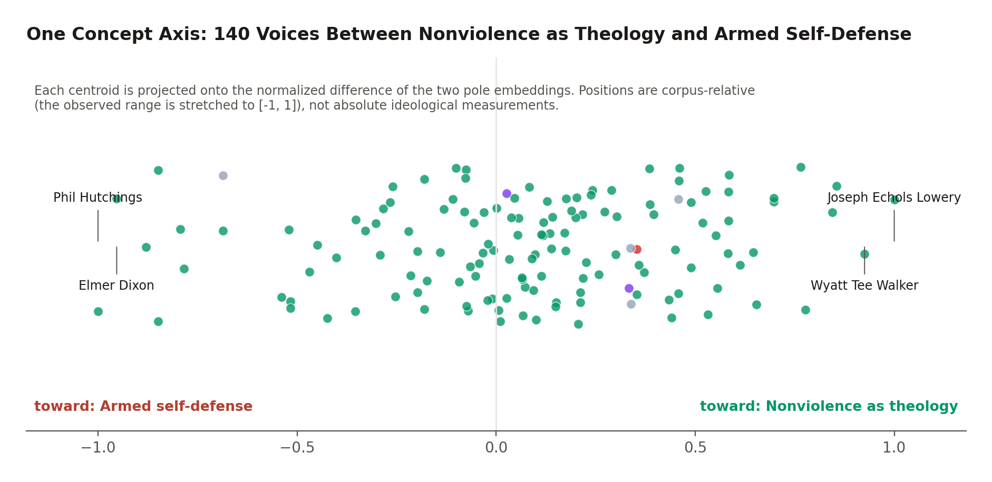
Below the entry level, a per-chunk precompute gives every transcript passage its top-5 most similar passages from other interviews, with text previews, timestamps, and LoC URLs (140 per-entry files under public/rag/related/, covering all current entries). This is lateral navigation through 250 hours of testimony at paragraph granularity: from any moment, the system knows which moments in other lives rhyme with it.
Two complementary structures are deliberately not embedding-derived, and the distinction is part of the system's honesty. The influence graph (Figure 10) is built by conservative full-name string matching of every interviewee's name across every other transcript, plus retrieval-derived passages for fifteen external figures (name-anchored semantic queries, reranked; topically aligned with the figure rather than string-verified to name them); last-name-only matching was rejected because surnames like Young, Long, and King are common words, so the interviewee-to-interviewee edges intentionally undercount. Its payoff is structural: figures who were never interviewed (Ella Baker, Bayard Rustin, Fannie Lou Hamer) become first-class nodes reachable through quoted memory, the secondhand-as-primary-source pattern made navigable. The event network aggregates only the chapter metadata's explicit event tags; as its own generated note says, nothing is inferred.
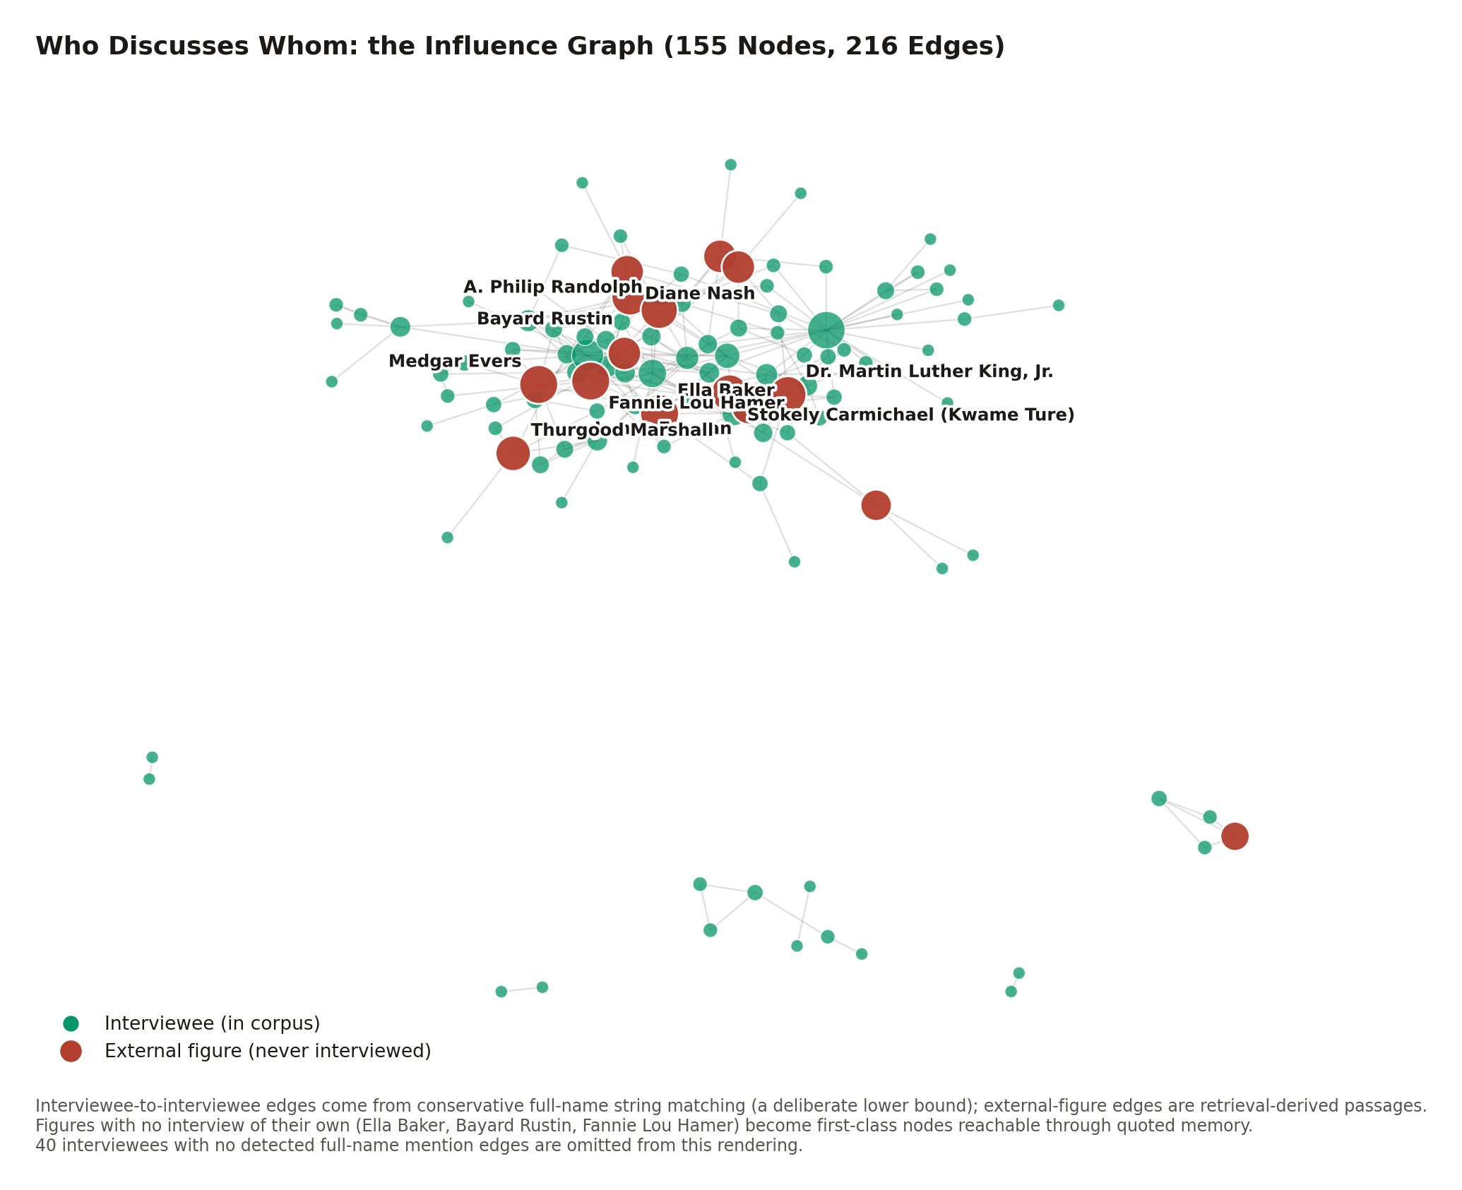
A finding aid can tell you an interview exists. None of these structures has a finding-aid analog: where a voice sits among its peers, which debate it leans into, who remembers whom. The embedding space carries information the catalog never recorded, and the architecture's contribution is to surface it without ever letting it float free of citations. One reproducibility caveat applies to the whole family: centroid sampling and the PCA initialization are unseeded, so regenerating these artifacts reproduces the structure statistically but not bit-identically; the shipped artifacts are the citable snapshots.

10. Exploration Surfaces: How a Learner Moves Through 250 Hours
The frontend's design center is the same tuple as everything else: every surface funnels into the bounded-clip player, and every unit of meaning is a URL.
Curated structure. A director-authored taxonomy (src/data/archiveThemes.js) organizes the corpus as Collection, Theme, Playlist, Video Clips: 13 themes and 95 playlists as of 2026-06-10, every playlist query machine-verified non-empty against the 4,932-clip index. Playlists are auto-advancing sequences of bounded clips assembled across interviews, the juxtaposition the legacy archive could never perform: twenty voices on school desegregation, each clip playing only its own span. Lateral movement is layered on top: a "Recommended Clips" rail ranks the most semantically similar absent interviews via the entry-level neighbors (interview-level cosine, each represented by its longest clip; per-clip precision is the documented upgrade path), "Related Playlists" deterministically offers two same-theme siblings plus one cross-theme pick, and the historic figures discussed in the playing interview link to their reference pages in a new tab, so the video never stops.
Federated search. A command palette (Cmd/Ctrl+K or /, mounted once at the application root so it works on every route) fans a single query out in parallel across six sources: the static people and essays catalogs, two live Firestore collections (timeline events, topics), Pinecone semantic passages, and a circuit-breaker-guarded vector arm (currently dark pending Cloud Function deployment) that retires itself after two failures. Each source races its own timeout and fails soft; a dead source drops its result group and the rest render. The design rule for transcript hits is the project's epistemology in miniature: results show evidence, not prose, the verbatim matched passage in quotation marks with a relevance percentage, never a model-written summary of what was found, and selecting one lands the reader inside the bounded clip, listening.
Reading surfaces. The per-interview page leads with the video and the verification badge, renders parts and chapters as a clickable outline, accepts deep-link arrival (?t=, #chapter-N, #part-N) by opening the containing part and cueing the bounded span, and mirrors the playing chapter or part into the address bar. The K-12 curriculum generator tunes a lesson to any grade band, ramps quantity and difficulty with grade, builds every activity from bounded primary-source clips, and mirrors the selected grade into the URL so a teacher shares exactly what they see. A transparency page (/machine-audit) explains the pipeline, the dual-scorer gate, and the LoC cross-reference, reads its tier counts live from the corpus data so its numbers cannot go stale, and discloses that where LoC's edited transcript and the verbatim text differ, both readings are preserved. Accessibility is enforced at the token layer rather than per-component: a documented dual-red contrast system (the brand red fails AA for body text and is therefore restricted to large text; a darker red passes AA at roughly 4.8:1), a global focus-visible double outline, reduced-motion collapse, and an explicit animation-pause preference.

11. The Reference Layers: People and Essays
Two content layers extend the archive beyond the interviews themselves, both governed by the same discipline: nothing reaches the reader without a citation chain, and the machine checks the chain.
The people catalog (public/rag/people/, 202 pages as of 2026-06-10: 165 interviewees and 37 external figures) gives every named individual a citation-bearing reference page that functions as an integration hub. Each page leads with an ai_reading: a specific, embedding-derived observation (an unexpected high-cosine neighbor, a concept-axis position that complicates the public framing, a surprising influence edge), always written as what the model finds, never as historical fact. The biographical paragraph that follows anchors every factual claim with a [src: N] reference into a prioritized source list: LoC item pages first, then other primary-source institutional archives, scholarly references after, and Wikipedia last or absent. Measured practice is stricter than the policy: across all 1,093 source entries in the catalog, zero cite wikipedia.org. The pages' primary substance is 1,021 verbatim interview quotes, each carrying its entry, start timestamp (an end timestamp on all but 11), audit tier, and LoC URL, and each machine-verified by a fail-closed gate (scripts/verify_person_snippets.py) that requires the quote to be a contiguous word sequence in the cited healed transcript; the gate passes 1,021 of 1,021 on a live run as of 2026-06-10. A second gate (scripts/audit_axis_labels.py) cross-checks every "leans toward" claim in the prose against the actual sign of the page's concept-axis position; its current state is discussed honestly in Section 14.
The essays layer (public/rag/essays/, 23 hosted works as of 2026-06-01) reproduces period primary texts in full: the fourteen essays of Du Bois's The Souls of Black Folk, the seven essays of The Negro Problem, Anna Julia Cooper, and Ida B. Wells, nine authors and 198,988 words spanning 1892 to 1903, with zero AI-generated essay prose anywhere in the layer. The controlling rule is a deterministic license gate built on one legal observation: embedding a text into a search index is a derivative use, so No-Derivatives licenses are categorically incompatible regardless of how "open" they look, while public-domain and derivative-permitting licenses qualify. The gate is data-encoded in the curation manifest, enforced by an intake script with machine-readable exit codes that records refusals rather than silently flipping them, and re-checked by an idempotent onboarding pipeline that mirrors the interview pipeline's design. A generated provenance report lists every hosted essay with its citation, license, and canonical source: the legality of reproduction is itself an auditable artifact. The essays are chunked into the same Pinecone index as the testimony (869 segments as of the seed ingest), excluded from passage search by default and opt-in for cross-content queries, which enables a research move the legacy stack could not express: one semantic query connecting an 1895 Wells-Barnett argument to a 2011 oral-history memory, across formats and across a century.

12. The Archive as an API: Agentic Access Through MCP
The final access layer generalizes everything above beyond this project's own frontend. A public Model Context Protocol server (deployed on Fly.io at https://mcp.spokenhistory.org/mcp, with the Fly-native URL as an alternate) exposes the archive to any MCP-compatible AI client: Claude Desktop, claude.ai, Codex, or anything that speaks the protocol. It is free, read-only, requires no login or API key, logs request metadata but never query text, and is rate-limited per IP (a token bucket of burst 30, refilling one per second) explicitly as a cost guard rather than a security boundary. The service scales to zero between uses and runs on a 256 MB shared-CPU instance; the marginal cost of making a national archive agent-readable is tens of dollars a month.
The surface, live-verified against the deployed endpoint on 2026-06-10, is eight tools, three prompts, four resources, and one resource template. Five primitives (search_transcripts, get_transcript, list_leaders, list_people, list_essays) expose retrieval and the rosters; three research-pattern tools compose them into scholarly moves:
- compare_perspectives({topic}) returns one passage per distinct interview on a topic (the dedupe mechanism of Section 8), with framing that explicitly forbids synthesis: the polyphonic record is the point.
- trace_evolution({interviewee, topic}) resolves the name against the roster, scopes retrieval to that interview, and returns passages in chronological order.
- source_for_claim({claim}) retrieves passages framed for SUPPORTS, COMPLICATES, or CONTRADICTS labeling against a stated claim, the quote-verification workflow as a single call.
The same three patterns are dual-registered as MCP prompts because clients differ in what they route to the model, and MCP resources (civilrights://corpus/overview, the rosters, and a per-entry transcript template) let an agent ground itself in the archive's actual extent and provenance before asking anything. Every passage an external AI receives carries the full citation payload of Section 8, including the audit tier and fidelity note, so a third-party assistant can disclose exactly how thoroughly the transcript behind a quotation was verified, and emit a publication-ready Chicago citation, without either party trusting the other's prose. A live smoke query during verification (search_transcripts({query: "nonviolence as theology", limit: 1, dedupe_by_entry: true})) returned Joseph Echols Lowery, entry 66, LoC item 2015669122, timestamps 00:26:57 to 00:27:56, provenance audit-original, tier high, and the full formatted citation: the whole architecture, in one tool call.
Engineering details that keep the surface trustworthy: the pure logic is split into a side-effect-free module with ten unit tests; rosters are baked into the image at build time (Pinecone cannot cheaply enumerate distinct interviewees) and a CI drift check fails the build if a corpus change would ship a stale roster; deploys are push-to-deploy from the repository, so the live surface tracks the audited corpus automatically (the roster data, that is; a few prose description strings inside the tool definitions lag the corpus count and are noted for cleanup).
Legacy archives are opaque to AI agents, which matters now because agents are becoming how a meaningful share of research starts. This layer makes the archive a citable data source for that world rather than scraping fodder, with provenance attached to every sentence it hands out.

13. What Legacy Technology Could Not Do
Each section above ended with a capability; this section assembles them. The contrast below is with the legacy presentation of the same collection (catalog records, flat PDF/XML transcripts, unindexed video), using this corpus's verified figures.
Capability | Legacy presentation | This system
Find testimony by meaning | Catalog keyword search over item metadata | Semantic search over 15,687 time-anchored passages, reranked, with dedupeByEntry for many-voices queries
Address a moment | Item-level URL for a multi-hour video | /interview/N?t=&end= for any of 4,932 chapters, any search hit, any quote, down to the sentence
Verify a quotation | Read the PDF, scrub the video | 1,021 catalog quotes machine-verified verbatim against healed transcripts; any passage replays as a bounded clip from LoC's own stream
Trust the transcript | One unversioned text, error rate unknown and unstated | Dual-fidelity record: LoC-authoritative names inside a verbatim ASR layer, 185,091 divergences individually classified (heal, preserve verbatim, or defer to expert review), per-entry uncertainty tiers stated on every result the audit metadata covers (Section 14)
See structure | A finding aid listing interviews | Constellation, 7 concept axes, 30 clusters, per-passage cross-interview neighbors, an influence graph with never-interviewed figures as nodes
Assemble teaching material | Manual excerpting, no time anchors | 95 curated cross-interview playlists; a grade-tuned K-12 lesson generator built from bounded primary-source clips
Cite properly | Hand-compose from catalog metadata | Pre-formatted Chicago citation with LoC item URL and timestamp range on every payload, in the UI and over the API
Machine access | None; scraping | A public MCP server: 8 tools, citation-grade payloads, audit provenance on every audited passage (Section 14)
Institutional accountability | Trust the archive | A replayable audit chain: raw plus overlay regenerates the corpus; per-entry stage files; a standing report of every disagreement with the source institution
The learning scenarios from Section 1 resolve concretely. The student types a question in the command palette and lands inside a bounded clip of a witness answering it, with the catalog citation one click away. The teacher opens a playlist where twenty voices take turns on Freedom Summer, or lets the curriculum generator build the lesson, and every artifact she shares is a URL that plays exactly what she vetted. The researcher hands the claim to source_for_claim and receives passages with citation framing that directs the assistant to label each as supporting, complicating, or contradicting it, each with the timestamp, the audit tier, and the LoC item to check against. None of these interactions was expressible against the legacy stack at any price in patience, because the objects they operate on (the addressable moment, the verified quote, the polyphonic result set) did not exist.

14. Limitations and Residual Uncertainty
A system whose argument is honesty must be honest about itself. The limitations below are stated with the same specificity as the capabilities.
Residual transcript error is quantified, not eliminated. 132,633 divergences await expert review; the audit tiers exist precisely because the unreviewed tail is real. The per-entry tier distribution as of 2026-06-10 is 133 entries at high (cross-referenced line by line against the LoC published transcript), 3 not-auditable (inherent audio limits), 3 ingestion-only (the streamlined path, awaiting deeper audit), and 1 publication-block. The capture-rate estimates for the internal cascade (60/85/92%) are first-order extrapolations from a diminishing-returns curve, never validated against independent ground truth, and the record includes a saturation prediction that missed by a factor of ten.
The gates fire, which is the point. On a live run during the verification pass for this paper, the snippet gate passed 1,021 of 1,021, but the axis-label gate failed with 10 mismatches across 8 pages, all at near-zero axis positions (absolute normalized position at most 0.21), consistent with a later spectrum regeneration drifting near-center entries across the sign boundary after the prose was written. The flagged pages await re-wording or re-pinning. A reader should treat this as the verification machinery working as designed: the failure is visible, located, and bounded, rather than silent.
Some structures lag the corpus. Entry-level neighbors cover 136 of 140 entries pending a precompute rerun; the k-means cluster structure predates the four newest entries (they are folded in by nearest-centroid assignment); the four newest entries (139-142, onboarded 2026-05-30 and 31) carry placeholder provenance and no audit-tier metadata on their Pinecone vectors, so tier-filtered retrieval silently excludes them; recommendation rails are interview-precise, not clip-precise; and the healer stamps a hardcoded 2026-05-25 date into post-report heal records, a known falsified-date bug awaiting a one-line fix. Each gap has a documented, mechanical closure path.
Known scope boundaries. Scoring windows truncate long transcripts (12,000 characters for both scorers); the dual gate is feature-flagged, not unconditional; retrieval is dense-only, with hybrid sparse fusion documented as future work; concept-axis positions are corpus-relative; the influence graph undercounts by design; deep-link autoplay is subject to browser gesture policy (the clip is always cued and bounded even when the browser holds playback); and ai_reading observations are statements about embedding geometry, not historiography. Editorial layers (guided tours, the quote rotation) remain deliberately human.
Methodological caveats for citation. Counts in this paper carry as-of dates because the corpus grows; several project documents lag the artifacts they describe (the authoritative values are the measured ones inventoried in Appendix A); and the live Pinecone totals require credentials to re-derive, so the offline reader must rely on the dated snapshots recorded here.

15. Conclusion
The architecture described here is, at bottom, three commitments held simultaneously. First, time is the substrate: a millisecond grid from ASR, preserved invariant under every later correction, makes the moment of testimony the system's atomic unit, and a URL. Second, authority is borrowed, not asserted: the text heals against the Library of Congress's own published transcripts through a deterministic, model-free aligner that would rather flag than guess, and every disagreement with the source institution is a reviewable artifact. Third, generative AI is confined and gated: models write only interpretive prose, with the metadata pipeline's prose behind a two-family 90/90 gate and per-claim citation audit that fails closed to humans, and the reference-page prose behind its own fail-closed verbatim-quote and axis-label gates.
The result inverts the usual anxiety about AI in cultural institutions. The system does not ask the reader to trust a model; it uses models where they help and shows its work everywhere: provenance and a tier on every audited passage vector (with the Section 14 gap stated rather than hidden), a citation on every payload, an audit trail a reviewer can replay from raw bytes. What that rigor buys is not just safety but capability. Because every moment is addressable, the archive is shareable at the granularity of a sentence. Because the text carries institutional authority inside ASR timing, search results are simultaneously trustworthy and playable. Because structure is computed honestly from the embedding space, the corpus exhibits relationships no finding aid recorded. And because all of it is exposed through an open protocol, the same capabilities extend to every AI assistant, which is increasingly where learning begins.
The pattern is portable. Any oral history archive with a published reference transcript and recoverable audio can run the same play: transcribe for time, align for authority, heal deterministically, gate the generative layer, and address everything. The Civil Rights History Project corpus, 140 interviews and roughly two million words of testimony from the people who made the movement, now demonstrates what that unlocks: an archive that does not merely store its voices but lets anyone, human or machine, find the exact moment a voice said the thing that matters, hear it, and cite it.

Appendix A: Verified Quantitative Inventory
Every figure in this paper, with its source artifact and verification status. "Verified 2026-06-10" means independently re-derived against the working tree at commit 78a113f (or a live endpoint) during the adversarial verification pass for this paper.
Figure | Value | Source | Status
Interviews in corpus | 140 (IDs 1-142, gaps at 31 and 95) | public/rag/toc.json (count, rechaptered_count) | Verified 2026-06-10
Collection scale | ~250 hours of video (toc.json durations sum to 250.9 h; chapter coverage 239.0 h) and ~2.0M transcribed words in the 140 holdings; full LoC collection ~145 items. Project docs' "600+ hours / ~5M words" could not be reconciled against measured holdings | public/rag/toc.json, corrected transcript word counts | Verified 2026-06-10
Chapters / parts | 4,932 chapters in 1,387 parts | public/rag/toc.json sums | Verified 2026-06-10
Playable clips | 4,932 (one per chapter) | public/rag/playlist_index.json | Verified 2026-06-10
Entry 1 scale | 67 chapters, 8 parts, 8,871-second video; 21,880 our words vs 21,077 LoC; 1,944 cues vs 540 turns; 2,222 divergences, 30 heals | entry_1.json, Aaron_Dixon.divergences.json | Verified 2026-06-10
Master overlay | 12.9 MB, 66,565 lines | transcripts/CLEANED_TRANSCRIPTS_REVIEW.md | Verified 2026-06-10
Cascade row counts | ~14,500 rows authored (2026-05-25); 16,214 parsed by Layer 5; 6,933 applied | lessons_learned.md, transcripts/AUDIT_TRAIL.md | Documentary (dated)
Layer 5 self-audit | 939 phantom rows found; 770 removed | transcripts/AUDIT_TRAIL.md | Verified 2026-06-10
Whisper failure catalog | 792 unique patterns | transcripts/AUDIT_TRAIL.md (Phase 1b) | Documentary
Ground-truth corpus | 378 entries, 396 aliases; validator exit 0 | civil_rights_facts.json, scripts/validate_facts.py | Verified 2026-06-10 (live run)
Pass 8 coverage (report) | 127/127 healed; 92 XML, 35 PDF; 0 audio-only | transcripts/loc_healing/COVERAGE_REPORT.md | As of 2026-05-25
Pass 8 source split (current) | 104 XML, 36 PDF | transcripts/loc_healing/divergences/ | Verified 2026-06-10
Pass 8 outcomes (current corpus) | 185,091 divergences; 2,629 healed (1.4%); 49,829 preserved; 132,633 deferred; 0 apply failures; 0 cue-count failures | transcripts/corrected/*/manifest.json, cross-checked against divergences JSONs | Verified 2026-06-10 (two independent derivations agree exactly)
Auto-heal band | similarity ratio in [0.55, 0.95), single capitalized token | heal_one_entry.py | Verified 2026-06-10
LoC API discipline | linear, 1.5 s/request | resolve_loc_items.py, onboard_interview.py | Verified 2026-06-10
Audit-vs-LoC disagreements | 710 across 114 entries (report); 711 live | AUDIT_VS_LOC_DISAGREEMENTS.md; divergences JSONs | As of 2026-05-25 / 2026-06-10
Backported P8 rows | 2,518 | master overlay row count | Verified 2026-06-10
Onboarding stages | 16 named stages; hard stops at stages 8 and 9 | onboard_interview.py STAGES | Verified 2026-06-10
Cascade token cost | more than $1,000 | transcripts/ingestion/ONBOARDING_REVIEW.md | Documentary
Publication gate | tuning 80/80 (3 attempts); publication 90/90 both families plus zero unsupported claims; rubric penalty 5 points per invented claim | tuning.py, claude_scorer.py, StandardizedRubric_1.md | Verified 2026-06-10
Scoring window / review excerpt | 12,000 chars / 6,000 chars | claude_scorer.py, review_queue.py | Verified 2026-06-10
Vector index (live) | 16,759 total = 15,687 passages + 203 person (202 pages + 1 stray index-derived vector) + 869 essay | Pinecone civil-rights live query | Verified 2026-06-10 (prefix counts sum exactly to total)
Prune history | 40,710 to 15,464 (-62%), 25,246 duplicates dropped | commit 3bfcc07, rag/shared.mjs | Documentary (2026-05-25)
Chunking | ~60 s / 1,400 chars (time-aware); 1,100 chars / 180 overlap (text); ~280 words (essays) | rag/chunker.mjs, rag/ingest.mjs | Verified 2026-06-10
Models | voyage-3 (1024-dim, cosine), rerank-2 | rag/shared.mjs, index spec | Verified 2026-06-10
Retrieval defaults | topK 30, topN 8 (max 50), query cap 4,000 chars, 4x dedupe over-fetch | netlify/functions/retrieve.mjs | Verified 2026-06-10
Infra cost | ~$22-25/month retrieval substrate; ~$0.80 budgeted full re-embed (measured ~$0.16) | docs/RAG_SUBSTRATE_DECISION.md (monthly); rag/OPERATIONS.md (re-embed) | Documentary (2026-05-22)
Tier distribution | high 133, not-auditable 3, ingestion-only 3, publication-block 1 | pipeline_output/entry_*.json | Verified 2026-06-10
Centroids / constellation | 140 centroids (mean of <=30 chunks, L2-normalized); PCA power iteration | centroids.json, constellation.json, precompute.mjs | Verified 2026-06-10
Concept axes | 7 axes, 140 positions each; nonviolence raw range [-0.0968, 0.0695]; most pole-A voice Joseph Echols Lowery | ideological_spectrums.json | Verified 2026-06-10
Neighbors | top-5 arrays for 136 of 140 entries; Aaron Dixon to Elmer Dixon 0.9286 | summaries/neighbors.json | Verified 2026-06-10
Clusters | k=30, seed 42, 12 restarts over 136 centroids; 140 members shipped (139-142 by nearest-centroid assignment) | clusters.json, clusters_raw.json, precompute_clusters_neighbors.py | Verified 2026-06-10
Influence graph | 155 nodes (140 + 15 external), 216 edges | summaries/influence.json | Verified 2026-06-10
Per-chunk related | 140 files, top-5 per chunk, cross-entry only | public/rag/related/ | Verified 2026-06-10
Event network | 67 events, 123 people, 581 edges; deterministic | summaries/event_network.json | Verified 2026-06-10
Frontend taxonomy | 13 themes, 95 playlists, 0 empty | src/data/archiveThemes.js vs playlist_index.json | Verified 2026-06-10
Federated search | 6 sources, per-source timeouts, circuit breaker at 2 failures | src/services/federatedSearch.js | Verified 2026-06-10
People catalog | 202 pages (165 + 37); 1,021 snippets (700 self, 321 about) on 177 pages; 1,093 sources, 0 Wikipedia | public/rag/people/*.json | Verified 2026-06-10
Snippet gate | 1,021/1,021 pass, exit 0 | scripts/verify_person_snippets.py | Verified 2026-06-10 (live run)
Axis-label gate | 10 mismatches, 8 pages, exit 1; all positions <= 0.21 absolute | scripts/audit_axis_labels.py | Verified 2026-06-10 (live run)
Essays | 23 hosted, 9 authors, 10 topics, 198,988 words; manifest 27 rows (23 hosted, 4 candidate) | public/rag/essays/manifest.json, index.json, sources report | Verified 2026-06-10
Essay vectors | 869 | commit 2888a3c; live prefix count | As of 2026-06-01 seed ingest; live-confirmed 2026-06-10
MCP surface | 8 tools, 3 prompts, 4 resources + 1 template; version 0.2.0 | live tools/list etc. on mcp.spokenhistory.org | Verified 2026-06-10 (live probe)
MCP smoke result | entry 66 Lowery, LoC item 2015669122, 00:26:57-00:27:56, tier high, full citation | live search_transcripts call | Verified 2026-06-10 (live probe)
MCP rate limit / VM | burst 30, 1/sec refill; shared-cpu-1x 256 MB, scale-to-zero | server.mjs, fly.toml | Verified 2026-06-10
MCP tests | 10/10 pass | mcp-server/test/lib.test.mjs (run from package dir) | Verified 2026-06-10 (live run)

Appendix B: Reproducibility Notes
The paper's claims can be re-derived from a checkout of the repository (aigamma/spokenhistory.org). Representative commands, run from the repository root:
# Corpus count and segmentation
python -c "import json; t=json.load(open('public/rag/toc.json')); \
print(t['count'], sum(i['chapter_count'] for i in t['interviews']), \
sum(i['part_count'] for i in t['interviews']))"
# Pass 8 outcome totals (sums over per-entry manifests)
python - <<'EOF'
import json, glob
tot = {'divergence_count':0,'healed_count':0,'preserved_verbatim_count':0,
'unresolved_count':0,'apply_failure_count':0}
for m in glob.glob('transcripts/corrected/*/manifest.json'):
b = json.load(open(m, encoding='utf-8')).get('loc_healing') or {}
for k in tot: tot[k] += b.get(k, 0) or 0
print(tot)
EOF
# Ground-truth corpus validation
cd "Metadata Generation System" && python scripts/validate_facts.py
# People-catalog quote gate and axis-label gate (live oracles)
python scripts/verify_person_snippets.py
python scripts/audit_axis_labels.py
# MCP unit tests
cd mcp-server && node --test
# Regenerate this paper's figures from live repository data
python docs/figures/technical-paper/generate_figures.py
The governance documents that carry the full audit history are transcripts/AUDIT_TRAIL.md (longitudinal session log and the inferential scoring framework), transcripts/OPEN_PROBLEMS.md (the punch list), transcripts/CLEANED_TRANSCRIPTS_REVIEW.md (the correction overlay), transcripts/loc_healing/COVERAGE_REPORT.md and AUDIT_VS_LOC_DISAGREEMENTS.md (Pass 8), and the per-entry stage files under transcripts/pass*_stage/. The DOCX edition of this paper regenerates from this Markdown source with pandoc 3.10: pandoc docs/TECHNICAL_PAPER.md -o docs/TECHNICAL_PAPER.docx --from gfm+yaml_metadata_block --toc --toc-depth=2 --resource-path=docs (run from the repository root). The figures regenerate from repository data via the script above, so both stay reproducible as the corpus grows.
Produced for the Spoken History Project, 2026-06-10. Live site: spokenhistory.org. MCP endpoint: mcp.spokenhistory.org/mcp. Collection: Civil Rights History Project, American Folklife Center, Library of Congress, in collaboration with the Smithsonian National Museum of African American History and Culture.

