Zabbix offers two types of communication (items):
The first(default) is “Zabbix agent” aka “Passive check”:
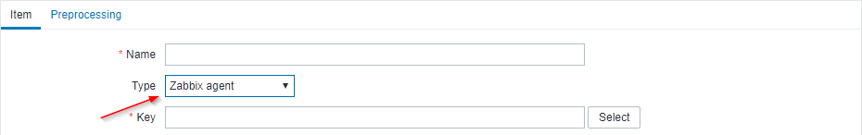
In Passive check the only thing that matters is the IP address of host.
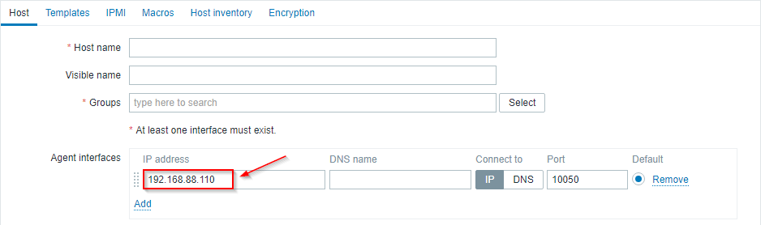

We are also providing “Zabbix agent (active)” aka “Active check”:

The only thing that matters in “Active check” is what is the name of host (case sensitive)
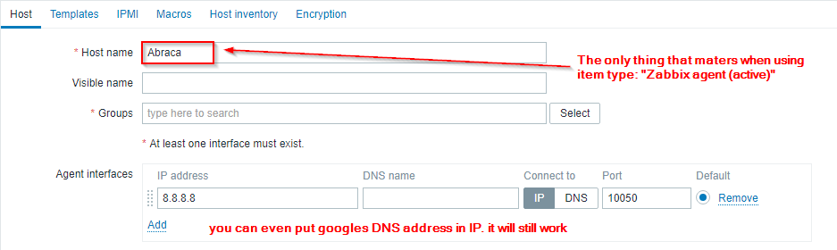
But how does the agent knows what “Active checks” it should perform? It is easy! We set the name of agent “Hostname=” to match 1:1 with frontend
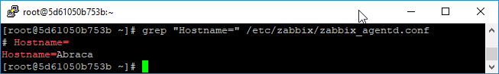
Whenever we have configured an item with type “Zabbix agent (active)”

