Wazuh SIEM Home Lab
Windows Brute-Force Detection and Investigation
SOC Detection Engineering | Threat Hunting | Attack Simulation
Project | LAB-1 — Wazuh Windows Brute-Force Detection Lab
Environment | VirtualBox — Ubuntu 22.04 (Wazuh Manager), Windows 10 Agent + Sysmon, Kali Linux (Attacker)
Wazuh Manager IP | 192.168.56.101
Target Host | DESKTOP-T6T1N2V (Windows 10 / Server 2019 build 19041)
Domain | HopeLabs.Local
Tooling | Wazuh 4.x, Sysmon, CrackMapExec (SMB), Sigma (sigma-cli), nano / XML rule authoring
Author | Aigbokhaode Hope Imomoh
Prepared by Aigbokhaode Hope Imomoh

1. Project Overview
This report documents the setup and testing of a Wazuh SIEM home lab built to monitor a Windows endpoint and detect repeated failed authentication attempts. The lab consists of an Ubuntu Wazuh manager, a Windows endpoint running the Wazuh agent and Sysmon, and a Kali Linux system used to generate controlled SMB authentication activity with CrackMapExec.
The main purpose of the exercise was to go beyond the default rules and build a working detection from the ground up. I created and tested custom Wazuh rules, generated authentication failures from the attacker machine, reviewed the resulting alerts in Threat Hunting, and tested the conversion of Sigma rules into the Wazuh/OpenSearch Lucene format.

1.1 Objectives
- Build a multi-VM lab in VirtualBox with a Wazuh manager, Windows endpoint and Kali Linux attacker.
- Configure Sysmon on the Windows endpoint to provide additional event and process telemetry.
- Create custom Wazuh rules for Windows failed logons and repeated authentication attempts.
- Generate controlled SMB authentication attempts from Kali Linux using CrackMapExec.
- Validate the alerts in the Wazuh Threat Hunting dashboard and review the associated rule groups and compliance mappings.
- Test Sigma rule conversion using the Wazuh OpenSearch Lucene pipeline and document any limitations.

1.2 Lab Topology
Role | OS / Platform | IP Address | Purpose
SIEM Manager | Ubuntu 22.04 (VirtualBox) | 192.168.56.101 | Wazuh manager, indexer, dashboard, rule engine
Monitored Endpoint | Windows 10 (DESKTOP-T6T1N2V) | 192.168.56.116 | Wazuh agent + Sysmon, attack target
Attacker | Kali Linux | 192.168.56.x | CrackMapExec brute-force simulation, Sigma rule testing

2. Wazuh Dashboard — Baseline Visibility
After the Wazuh manager and Windows agent were configured, I first confirmed that the endpoint was sending events to the manager. The Threat Hunting dashboard showed DESKTOP-T6T1N2V actively reporting. In the 24-hour view used during testing, the dashboard displayed 22,069 total events and 21,898 level-12-or-above alerts. The same view also showed the authentication activity generated during the lab.
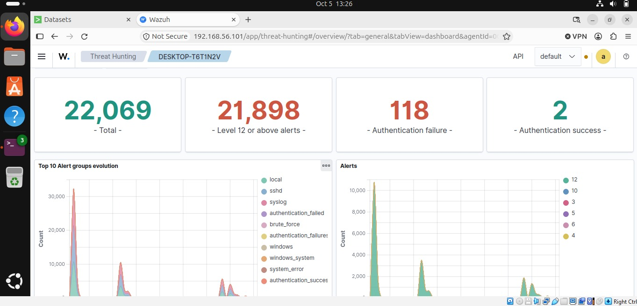
Figure 1 — Threat Hunting dashboard: 22,069 total hits for DESKTOP-T6T1N2V over 24 hours, dominated by Windows Failed Logon and Multiple Failed Logons alerts.
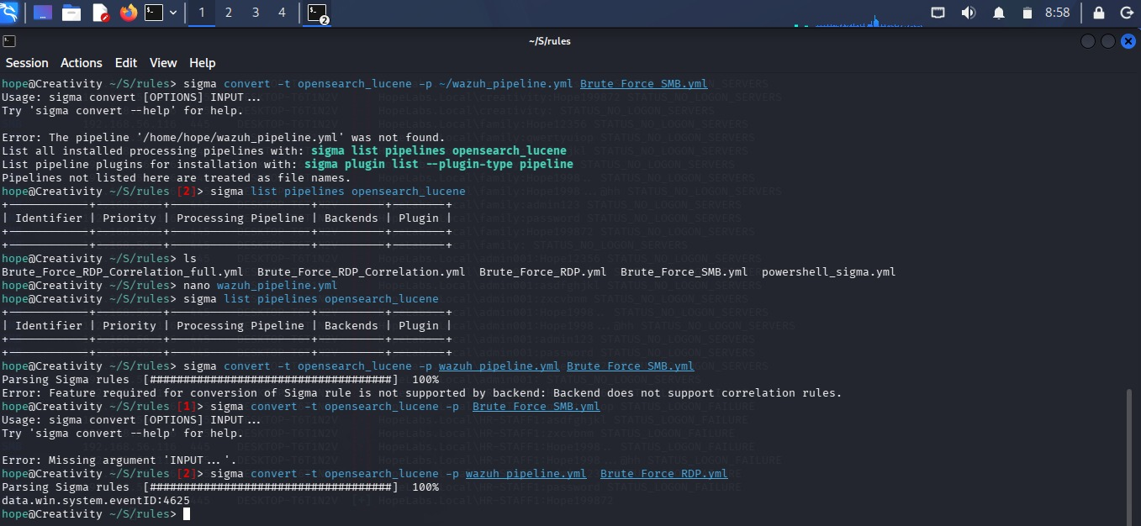
Figure 2 — Summary KPIs: 22,069 total events, 21,898 level-12+ alerts, 118 authentication failures, and 2 authentication successes logged for the target host.
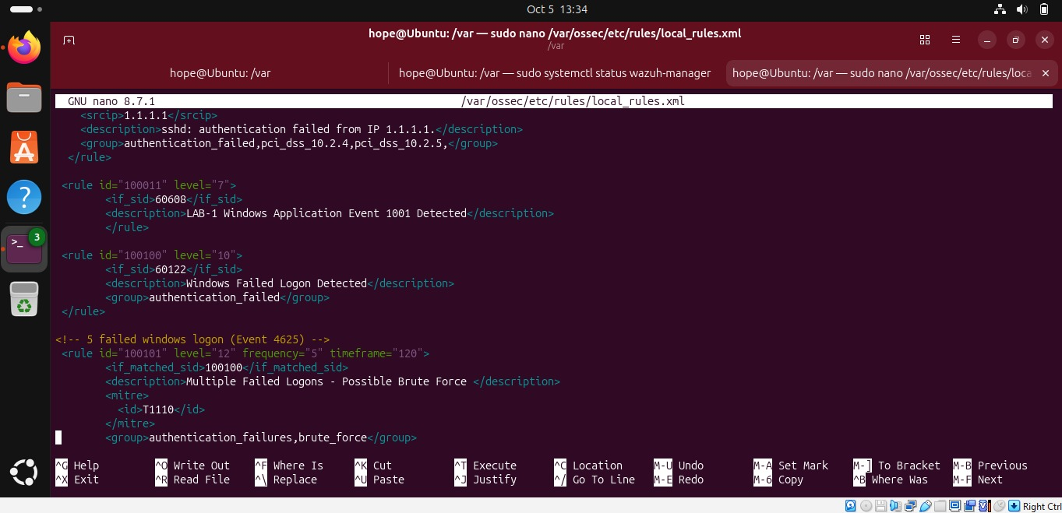
Figure 3 — Alert groups evolution over time: two large spikes in local/sshd/syslog/authentication_failed activity correspond to the two brute-force simulation runs against the host.
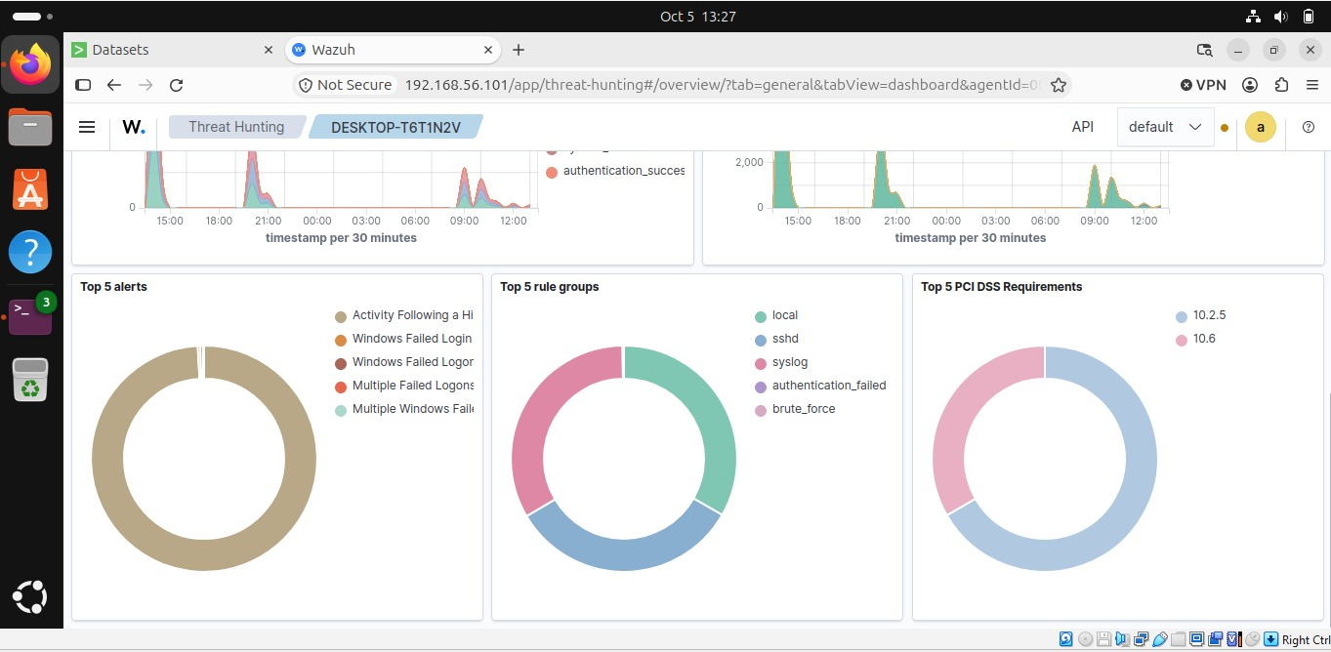
Figure 4 — Top 5 alerts (Multiple Failed Logons dominant), Top 5 rule groups (local, sshd, syslog, authentication_failed, brute_force), and Top 5 PCI DSS requirements mapped (10.2.5 and 10.6), confirming the custom rules are correctly tagged for compliance reporting.

3. Custom Detection Rule Engineering
The default rules were not sufficient for the specific repeated Windows logon pattern I wanted to detect. I therefore added custom rules to /var/ossec/etc/rules/local_rules.xml on the Wazuh manager. The rules were built in stages, starting with a single failed-logon event and then adding frequency-based correlation.

3.1 Baseline SSH Authentication Rule
I used the default example rule in local_rules.xml as a starting point and confirmed that the rule file was working before adding the Windows-specific detections.
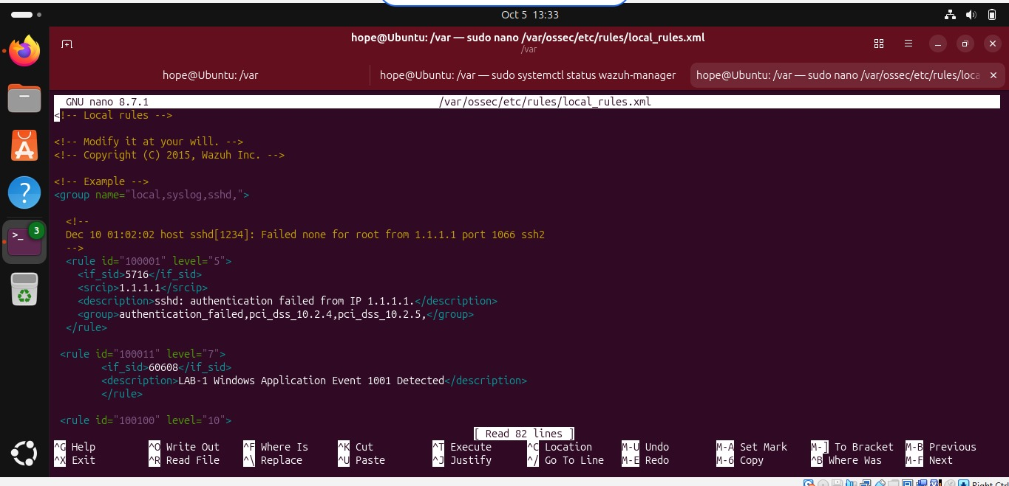
Figure 5 — local_rules.xml opened in nano on the Wazuh manager, showing the default example group and rule 100001 (sshd authentication failure, PCI DSS 10.2.4 / 10.2.5) used as the starting template.

3.2 Windows Event Detection Rules
Two additional atomic rules were added to cover Windows-specific telemetry:
- Rule 100011 (level 7) — fires on Sysmon/Windows Application Event ID 1001, labeled "LAB-1 Windows Application Event 1001 Detected", used as an early warning / low-severity marker.
- Rule 100100 (level 10) — fires on Windows Security Event ID 4625 (if_sid 60122), labeled "Windows Failed Logon Detected" and tagged to the authentication_failed group. This is the atomic building block every failed interactive or network logon triggers.
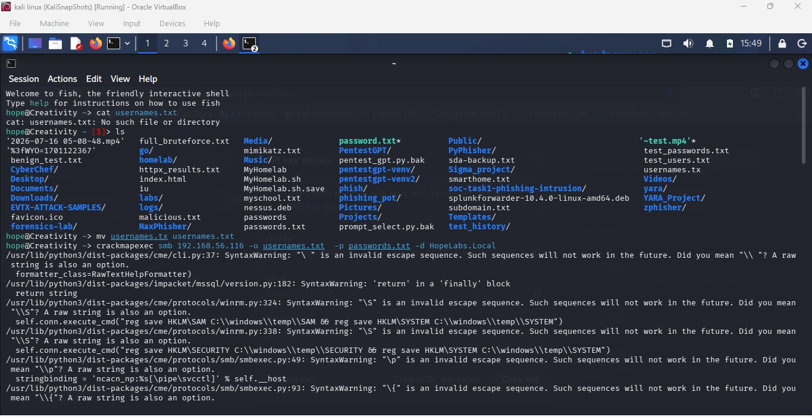
Figure 6 — Rule 100100 defined: triggers on if_sid 60122 (Windows failed logon / Event 4625) at severity level 10, tagged to the authentication_failed group.

3.3 Brute-Force Correlation Rule
The main correlation rule is 100101. It raises the severity when five failed-logon detections from rule 100100 occur within 120 seconds. The resulting alert is a level-12 "Multiple Failed Logons - Possible Brute Force" event. I also mapped the rule to MITRE ATT&CK T1110 (Brute Force) and placed it in the authentication_failures and brute_force groups.
<rule id="100101" level="12" frequency="5" timeframe="120">
<if_matched_sid>100100</if_matched_sid>
<description>Multiple Failed Logons - Possible Brute Force</description>
<mitre>
<id>T1110</id>
</mitre>
<group>authentication_failures,brute_force</group>
</rule>
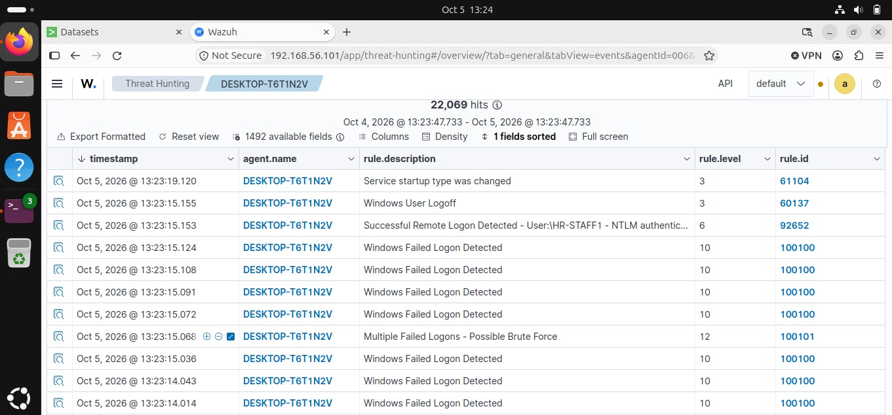
Figure 7 — Rule 100101 fully defined in local_rules.xml: frequency="5" timeframe="120" correlates five hits of rule 100100 into a level-12 brute-force alert, mapped to MITRE T1110.
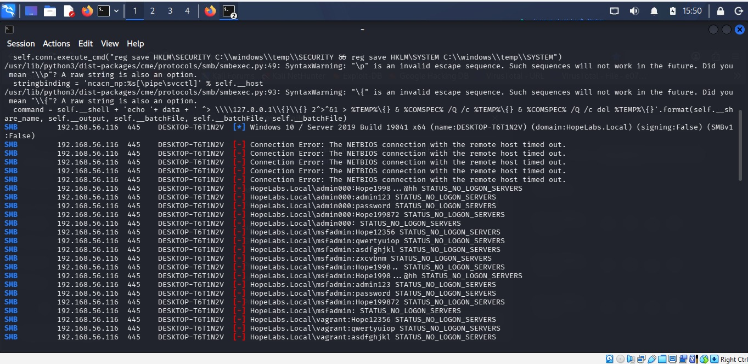
Figure 8 — Final view of the rule chain in local_rules.xml: 100011 → 100100 → 100101, showing the escalation path from a single Windows event to a correlated brute-force verdict.

4. Attack Simulation — SMB Brute-Force with CrackMapExec
To test the rules, I generated controlled SMB authentication attempts from Kali Linux against the Windows endpoint at 192.168.56.116 over TCP port 445. CrackMapExec was used with prepared username and password lists against the HopeLabs.Local domain. The purpose was to create the failed-logon events required to test the correlation rule.

4.1 Attack Preparation
Username and password wordlists were staged on the Kali box and CrackMapExec was invoked against the Windows host's SMB service, targeting the HopeLabs.Local domain:
crackmapexec smb 192.168.56.116 -u usernames.txt -p passwords.txt -d HopeLabs.Local
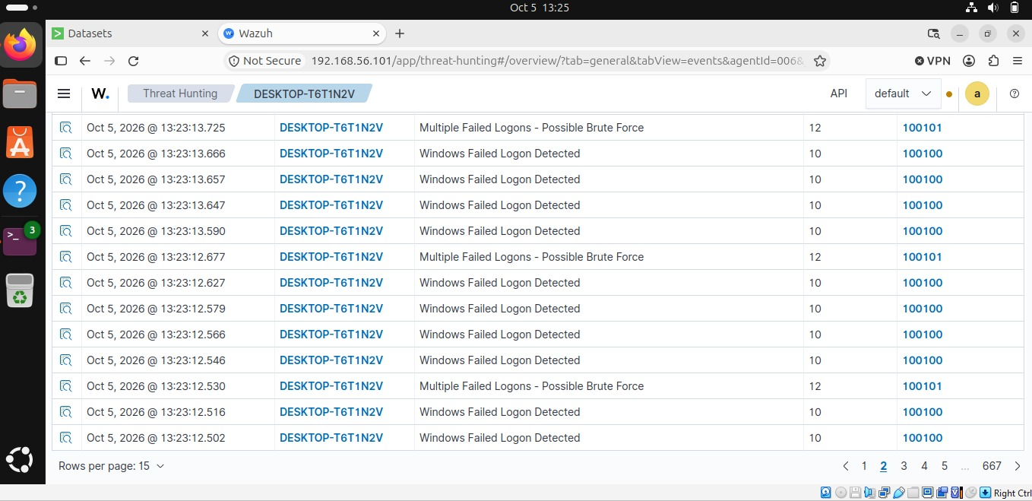
Figure 9 — Kali Linux terminal: wordlists staged, username file renamed, and CrackMapExec SMB brute-force launched against 192.168.56.116 with domain HopeLabs.Local.

4.2 Attack Execution & Account Enumeration
The test included several candidate accounts, including admin000, msfadmin, vagrant, kali, ubuntu, creativity, family, admin001 and HR-STAFF1. Most attempts returned STATUS_NO_LOGON_SERVERS or STATUS_LOGON_FAILURE. These failed attempts generated the Windows authentication telemetry required by rules 100100 and 100101.
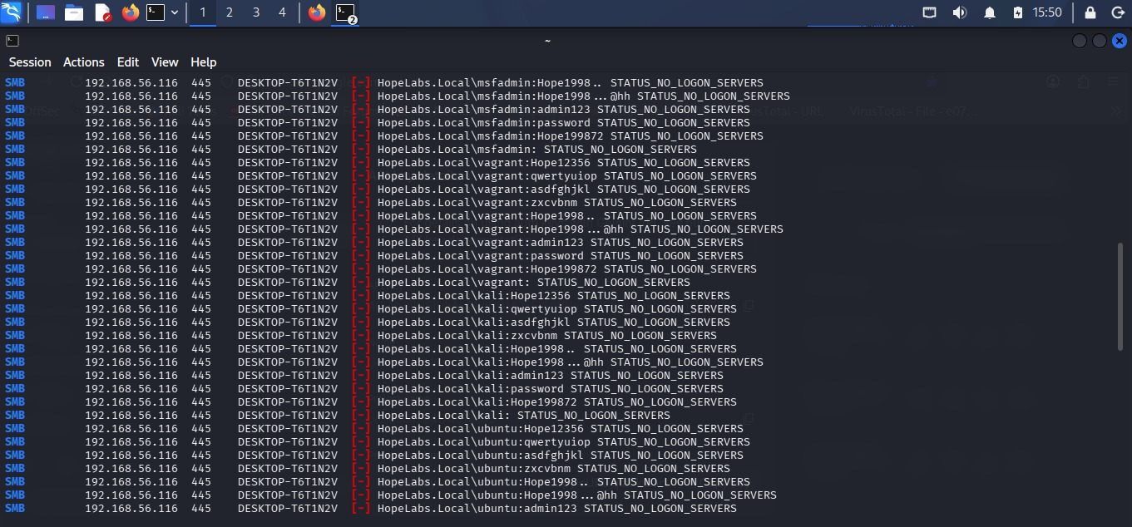
Figure 10 — CrackMapExec output sweeping multiple candidate accounts over SMB; the final line shows a successful authentication: HR-STAFF1:Hope199872 returning [+] on DESKTOP-T6T1N2V.

4.3 Result
The test also produced a successful authentication for HR-STAFF1 using the password recorded in the lab output. More importantly for the detection exercise, the Windows endpoint recorded the failed attempts as Security Event ID 4625, which were then processed by the custom Wazuh rules.

5. Detection Validation in Wazuh
After generating the authentication activity, I reviewed the Wazuh Threat Hunting results to confirm that the custom rules were firing as expected.
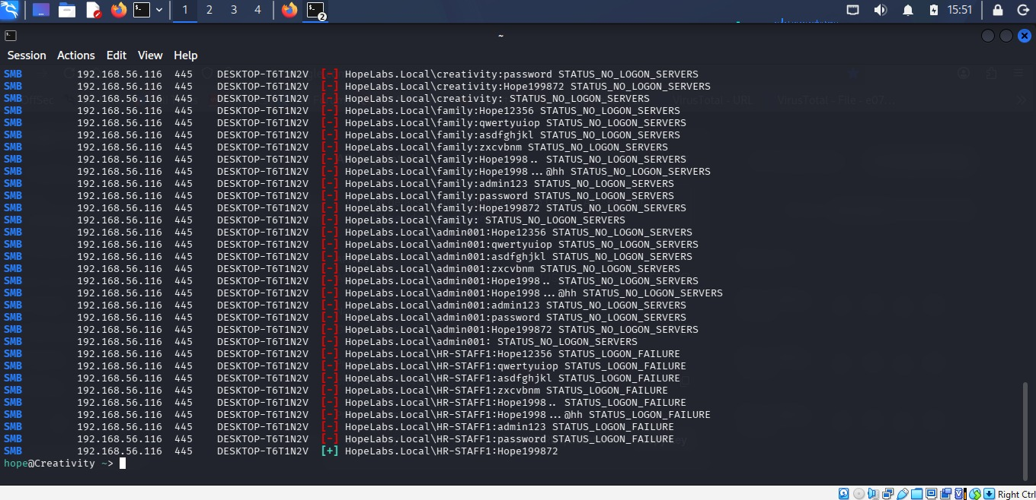
Figure 11 — Live events table: a dense run of "Windows Failed Logon Detected" (level 10, rule 100100) events, interleaved every five hits with a "Multiple Failed Logons — Possible Brute Force" (level 12, rule 100101) correlation alert — exactly the escalation pattern the rule was designed to produce.
A second events view showed that the same pattern continued across the larger result set rather than appearing only during one short burst.
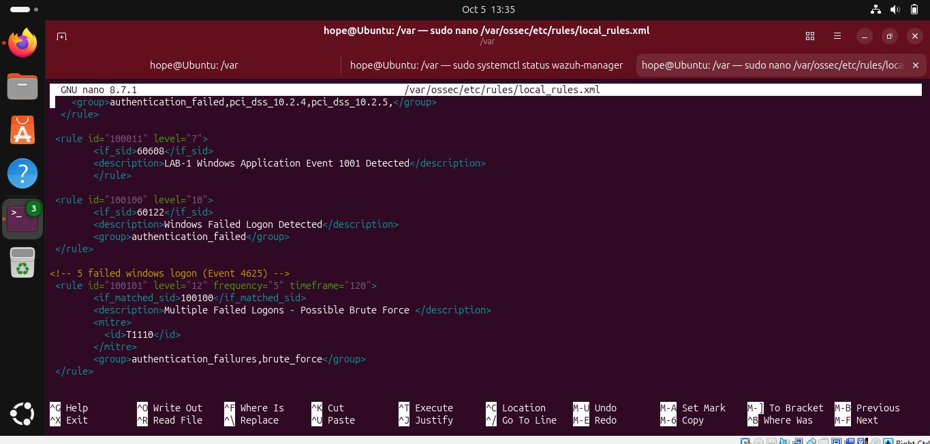
Figure 12 — Confirmed pattern repeats across the dataset: every fifth "Windows Failed Logon Detected" event is followed by a "Multiple Failed Logons - Possible Brute Force" level-12 alert, validating the frequency="5" / timeframe="120" logic in rule 100101.

6. Sigma Rule Conversion for Wazuh / OpenSearch
I also tested Sigma rules to see how they could be used with the Wazuh/OpenSearch Lucene pipeline. The test included Brute_Force_SMB.yml, Brute_Force_RDP.yml and Brute_Force_RDP_Correlation.yml. The conversion test showed that the backend could handle an individual detection but could not directly convert a Sigma correlation rule.
# Attempt against a correlation rule fails — expected limitation:
sigma convert -t opensearch_lucene -p wazuh_pipeline.yml Brute_Force_SMB.yml
> Error: Feature required for conversion of Sigma rule is not supported
> by backend: Backend does not support correlation rules.
# Converting a single-event (non-correlation) Sigma rule succeeds:
sigma convert -t opensearch_lucene -p wazuh_pipeline.yml Brute_Force_RDP.yml
> data.win.system.eventID:4625
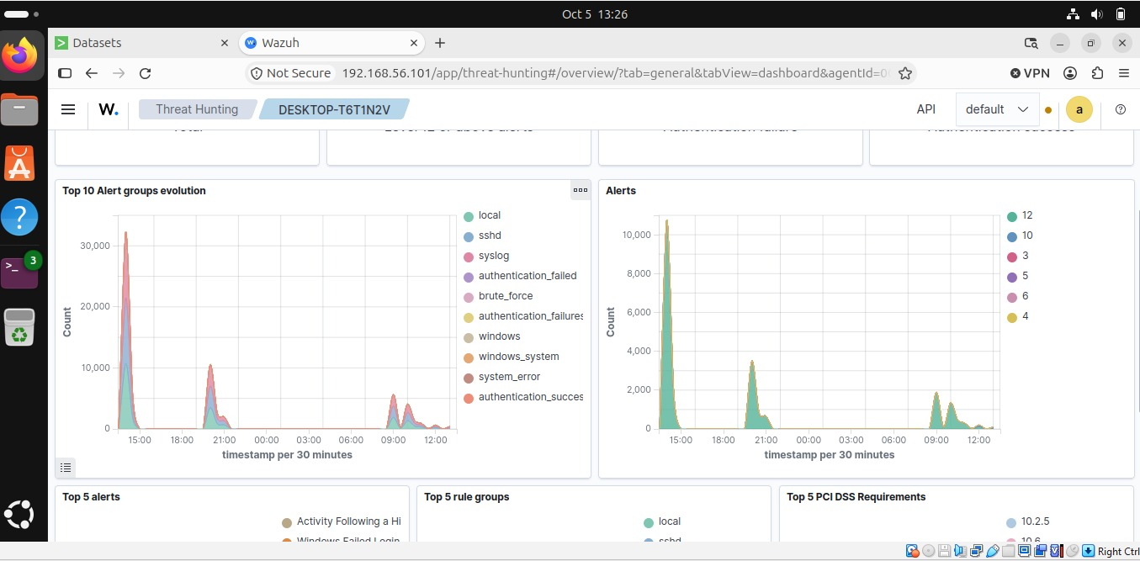
Figure 13 — sigma-cli on Kali: converting Brute_Force_SMB.yml (a correlation rule) against the custom wazuh_pipeline.yml fails with a clear backend limitation, while Brute_Force_RDP.yml converts cleanly to a Lucene query on data.win.system.eventID:4625.

Result
The practical result from this test was that the correlation logic had to be implemented natively in Wazuh. This is why rule 100101 uses Wazuh frequency and timeframe conditions instead of relying on an automatic Sigma conversion.

7. Summary & Skills Demonstrated
This lab covered the main stages of a basic detection engineering workflow: building the monitoring environment, creating custom rules, generating test activity, reviewing the alerts and testing an additional detection format.

Skills demonstrated
- SIEM deployment & agent management (Wazuh manager + Windows/Sysmon agent in VirtualBox)
- Custom detection rule authoring in Wazuh XML (atomic rules + frequency-based correlation rules)
- MITRE ATT&CK mapping (T1110 — Brute Force) and PCI DSS control mapping (10.2.5, 10.6)
- Offensive simulation with CrackMapExec (SMB brute-force / password spray) to generate realistic telemetry
- Threat hunting & alert triage using the Wazuh dashboard (events view, dashboard KPIs, rule-group breakdowns)
- Sigma rule conversion to OpenSearch Lucene via sigma-cli, including diagnosing backend feature limitations

Next steps
- Add automated active-response (e.g., temporary firewall block) triggered by rule 100101.
- Extend correlation coverage to RDP (Event 4625 over 3389) and VPN authentication logs.
- Build a Wazuh active-response script to disable an account after repeated brute-force detections.

