Java Core Questions
1. What does constructor mean?
A constructor is a special method that is used to initialize objects. The constructor is called when an object of a class is created.
public class Student {
String name;
char gender;
int age;
public Student (String n, char gender, int age){
this.name = n;
this.gender = gender;
this.age = age;
}
}
2. What is JVM, JDK, JRE and how do they differ from each other?
JDK (Java Development Kit) is a software development kit, JRE (Java Runtime Environment) is a software bundle(комплект, пакет) that allows Java program to run, JVM (Java Virtual Machine) is an environment for executing bytecode.
JDK | JRE | JVM
Primarily assists in executing codes. It primarily functions in development. | Has a major responsibility for creating an environment for the execution of code.  functionality | Specifies all of the implementations. It is responsible for providing all of these implementations to the JRE
For every different platform you require a different JDK. | Same as JDK  platform dependency | You won’t require a different JVM for every different platform.
Various tools .JDK contains JRE | Has supporting files for JV, and the class libraries | Doesn’t consist of any tools  tools
Converts the code into bytecodes.  Why it is used? | To run applets,uses crucial package classes like util, math, awt. | Provides with platform-independency, comes with Just-in-Time(JIT) compiler for converting code to a low-level machine language, runs faster than any applications.
3. Difference between Abstract class and Interface. When should you use an abstract class and when should you use an interface?
An abstract class allows you to create functionality that subclasses can implement or override. An interface only allows you to define functionality, not implement it. And whereas a class can extend only one abstract class, it can take advantage of multiple interfaces.
Abstract class vs Interface
- Type of methods: Interface can have only abstract methods. An abstract class can have abstract and non-abstract methods.
- Final Variables: Variables declared in a Java interface are by default final. An abstract class may contain non-final variables.
- Type of variables: Abstract class can have final, non-final, static and non-static variables. The interface has only static and final variables.
- Implementation: Abstract class can provide the implementation of the interface. Interface can’t provide the implementation of an abstract class.
- Inheritance vs Abstraction: A Java interface can be implemented using the keyword “implements” and an abstract class can be extended using the keyword “extends”.
- Multiple implementations: An interface can extend another Java interface only, an abstract class can extend another Java class and implement multiple Java interfaces.
4. Which class is the superclass for all the classes?
The class named Object is the super class of every class in Java.

Example
public class Test {
public static void main(String args[]){
Test obj = new Test();
Class cls = obj.getClass().getSuperclass();
System.out.println(cls.getName());
}
}

Output
Since the Object class is the super class of all classes it displays the name of the object class as shown below.
java.lang.Object
5. Difference between object and primitive data types?
Properties | Primitive data types | Objects
Origin | Pre-defined data types | User-defined data types
Stored structure | Stored in a stack | Reference variable is stored in stack and the original object is stored in heap
When changes are made in the copied variable | Change does not reflect in the original ones. | Changes reflected in the original ones.
Default value | Primitive datatypes do not have null as default value | The default value for the reference variable is null
Example | byte, short, int, long, float, double, char, boolean | array, string class, interface etc.
6. What are the main concepts of OOPs in Java?
How Abstraction Works
Data abstraction is the process of hiding certain details and showing only essential information to the user. Abstraction can be achieved with either abstract classes or interfaces

How Encapsulation Works
Encapsulation refers to the bundling of fields and methods inside a single class. It prevents outer classes from accessing and changing fields and methods of a class. This also helps to achieve data hiding.

How Inheritance Works
Inheritance allows us to create a new class from an existing class. The new class that is created is known as subclass (child or derived class) and the existing class from where the child class is derived is known as superclass (parent or base class).

How Polymorphism Works
polymorphism in Java allows us to perform the same action in many different ways.Two more examples of polymorphism in Java are method overriding and method overloading.(In Java, two or more methods may have the same name if they differ in parameters (different number of parameters, different types of parameters, or both).
7. Why is Inheritance used in Java?
Java Inheritance provides a reusability mechanism in object-oriented programming for the users to reuse the existing code within the new applications.
8. What is Interface?
An interface in Java is a blueprint(план)
of a class. It has static constants and abstract methods. It cannot have a method body.

Why use Java interface?
- It is used to achieve abstraction.
- By interface, we can support the functionality of multiple inheritance.
- It can be used to achieve loose coupling(подход к соединению компонентов в системе или сети таким образом, чтобы эти компоненты, также называемые элементами, зависели друг от друга в минимально возможной степени).
9. What are the access modifiers?
Access modifiers are keywords that can be used to control the visibility of fields, methods, and constructors in a class. The four access modifiers in Java are public, protected, default, and private.
- Private: We can access the private modifier only within the same class
- Default: We can access the default modifier only within the same package. And also, if we do not specify any access modifier it will automatically consider it as default.
- Protected: We can access the protected modifier within the same package and also from outside the package with the help of the child class. If we do not make the child class, we cannot access it from outside the package. So inheritance is a must for accessing it from outside the package.
- Public: We can access the public modifier from anywhere.
10.What is InputStream and OutputStream?
The connection between a program and a data source or destination is called a stream.
An input stream handles data flowing into a program. An output stream handles data flowing out of a program.
11.What are Loops in Java? What are the three types of loops?
loops are used to repeat a block of code.
- while loop: A while loop allows code to be executed repeatedly based on a given Boolean condition. The while loop can be thought of as a repeating if statement.
Syntax :
while (boolean condition)
{
loop statements...
}
- for loop: a for statement consumes the initialization, condition and increment/decrement in one line.
Syntax:
for (initialization condition; testing condition;
increment/decrement)
{
statement(s)
}
- do while: do while loop is similar to while loop with only difference that it checks for condition after executing the statements.
Syntax:
do
{
statements..
}
while (condition);
12.Can the main() method in Java return any data?
As the main() method doesn't return anything, its return type is void. As soon as the main() method terminates, the java program terminates too.
13.What is a "local class"? What are its features?
Local Classes are the inner classes that are defined inside a block.
The scope of the local inner class is restricted to the block they are defined in.
- A local inner class cannot be instantiated from outside the block where it is created in.
- Till JDK 7, the Local inner class can access only the final local variable of the enclosing block. However, From JDK 8, it is possible to access the non-final local variable of enclosing block in the local inner class.
- A local class has access to the members of its enclosing class.
- Local inner classes can extend an abstract class or implement an interface.
14.What are "anonymous classes"? Where are they applied?
Anonymous classes are inner classes with no name. Since they have no name, we can't use them in order to create instances of anonymous classes. We may either extend an existing class or implement an interface. You use an anonymous class in cases where you want to create some object to use it only once (so it's not worthwhile to give a name to the type, put it in its own file, etc.).
15.What is this keyword in java?
The this keyword refers to the current object in a method or constructor. The most common use of the this keyword is to eliminate the confusion between class attributes and parameters with the same name (because a class attribute is shadowed by a method or constructor parameter).
16.What is method override?
If subclass (child class) has the same method as declared in the parent class, it is known as method overriding in Java.

Usage of Java Method Overriding
- Method overriding is used to provide the specific implementation of a method which is already provided by its superclass.
- Method overriding is used for runtime polymorphism

Rules for Java Method Overriding
- The method must have the same name as in the parent class
- The method must have the same parameter as in the parent class.
- There must be an IS-A relationship (inheritance).
17.What is a POJO class? Give an example of such a class.
POJO in Java stands for Plain Old Java Object. It is an ordinary object. The POJO file does not require any special classpath. It increases the readability & re-usability of a Java program. Generally, a POJO class contains variables and their Getters and Setters.
the POJO files do not have any special restrictions.

Example:
POJO class is used to define the object entities. For example, we can create an Employee POJO class to define its objects.
Employee.java:
- // POJO class Exmaple
- package Jtp.PojoDemo;
- public class Employee {
- private String name;
- private String id;
- private double sal;
- public String getName() {
- return name;
- }
- public void setName(String name) {
- this.name = name;
- }
- public String getId() {
- return id;
- }
- public void setId(String id) {
- this.id = id;
- }
- public double getSal() {
- return sal;
- }
- public void setSal(double sal) {
- this.sal = sal;
- }
- }
18.How to compare two strings in Java and/or sort them?
String equality is defined in equals()method and compare Strings alphabetically. When you compare two strings using the == operator. It will only return true if both reference variables are pointing to the same objects, like in the case of interned string or String literals. Otherwise, it will return false, even if the content of String remain same. equals() method comes with another flavor called equalsIgnoreCase(),which should be used to perform case insensitive equality check.
19.Talk about iterators and their uses.
Iterators in Java are used in the Collection framework to retrieve(извлекать) elements one by one. We can apply it to any Collection object. By using Iterator, we can perform both read and remove operations.
What are types of iterators?
- Input iterator.
- Output iterator.
- Forward iterator.
- Bidirectional iterator.
- Random access iterator.
20.What is the hierarchy of collections in Java Collection Framework?
The hierarchy of the entire collection framework consists of four core interfaces such as Collection, List, Set, Map, and two specialized interfaces named SortedSet and SortedMap for sorting.All the interfaces and classes for the collection framework are located in java.util package.
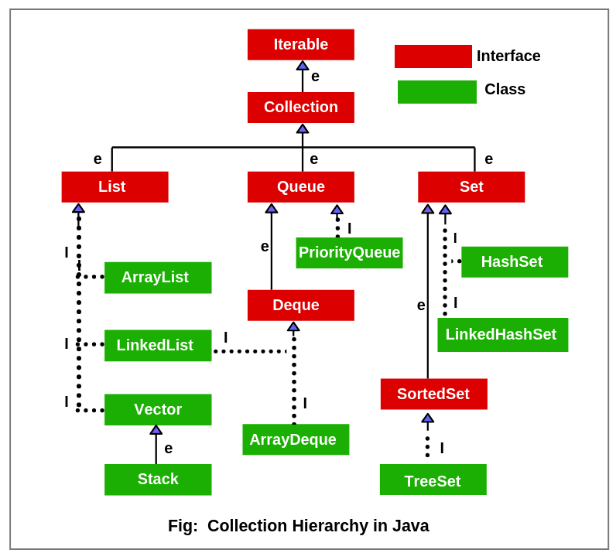
21.Difference between ArrayList and LinkedList?
ArrayList and LinkedList both implement the List interface and maintain insertion order. Both are non-synchronized classes.
ArrayList | LinkedList
1) ArrayList internally uses a dynamic array to store the elements. | LinkedList internally uses a doubly linked list to store the elements.
2) Manipulation with ArrayList is slow because it internally uses an array. If any element is removed from the array, all the other elements are shifted in memory. | Manipulation with LinkedList is faster than ArrayList because it uses a doubly linked list, so no bit shifting is required in memory.
4) ArrayList is better for storing and accessing data. | LinkedList is better for manipulating data.
5) The memory location for the elements of an ArrayList is contiguous. | The location for the elements of a linked list is not contagious.
7) To be precise, an ArrayList is a resizable array. | LinkedList implements the doubly linked list of the list interface.
22.Why is the delete function faster in the linked list than an ArrayList?
Deletion in linked list is fast because it involves only updating the next pointer in the node before the deleted node and updating the previous pointer in the node after the deleted node.
23.What is the purpose of the hashCode() method?
The purpose of the hashCode() method is to provide a numeric representation of an object's contents so as to provide an alternate mechanism to loosely identify it. By default the hashCode() returns an integer that represents the internal memory address of the object.
24.Difference between Equals and HashCode in Java?
The difference in equals and hashCode in Java is that the equals is used to compare two objects while the hashCode is used in hashing to decide which group an object should be categorized into.
25.Why is synchronization needed? Explain with an appropriate example.
Synchronization in java is the capability to control the access of multiple threads to any shared resource. In the Multithreading concept, multiple threads try to access the shared resources at a time to produce inconsistent results. The synchronization is necessary for reliable communication between threads.

Why we use Synchronization
- Synchronization helps in preventing thread interference.
- Synchronization helps to prevent concurrency problems.

Types of Synchronization
- Process Synchronization
- Thread Synchronization
Thread synchronization has two types, they are:
1.Mutual Exclusive:
2. Cooperation (Inter Thread Communication in java)
26.What is multithreading? Why is it important?
Multithreading is the ability of a program or an operating system to enable more than one user at a time without requiring multiple copies of the program running on the computer.
Benefits of Multithreading*
- Improved throughput. ...
- Simultaneous and fully symmetric use of multiple processors for computation and I/O.
- Superior application responsiveness. ...
- Improved server responsiveness. ...
- Minimized system resource usage. ...
- Program structure simplification. ...
- Better communication.
27.What's the difference between thread and process?
The main difference between process and thread is that a process is a program in execution whereas, a thread is part of that running process. Process and thread share a relationship where a process provides an environment for the execution of the thread. A process can contain multiple threads.
28.What is the difference between the start() and run() methods?
in Thread start creates a new thread while the run doesn't create any thread and simply executes in the current thread.
29.Difference Between wait() and notify() in Java.
The wait() method causes the current thread to wait until another thread invokes the notify() or notifyAll() methods for that object. The notify() method wakes up a single thread that is waiting on that object's monitor. The notifyAll() method wakes up all threads that are waiting on that object's monitor.
30.What is deadlock?
Deadlock in Java is a condition where two or more threads are blocked forever, waiting for each other. This usually happens when multiple threads need the same locks but obtain them in different orders. Multithreaded Programming in Java suffers from the deadlock situation because of the synchronized keyword.

