Name / Имя: ____________________ | Class: ___________ | Date: ____________
Laboratory Work No. 2 · Drops on a coin
Aim: observe how water molecules stick together (cohesion) and stick to the coin (adhesion).
Materials | Safety
- a glass of water  - a dropper (pipette)  - a coin  - a paper towel | - Keep water away from sockets and devices.  - Wipe spills at once.  - Wash your hands after the lab.
1 · Pre-lab questions · Вопросы до работы
a) What is cohesion?
b) What other properties does water have?
2 · Predict · Предскажи
I predict ______ drops will stay on the coin before the water spills, because ________________________________
3 · Procedure · Ход работы
- Put the coin on a flat surface. Dry it with the towel.  - Fill the dropper with water.  - Slowly drip water onto the coin — one drop at a time.  - Count the drops. Write the number when the coin is full.  - Keep dripping. Write the number when the water spills.  - Dry the coin. Repeat (trial 2, trial 3). Swap roles. | 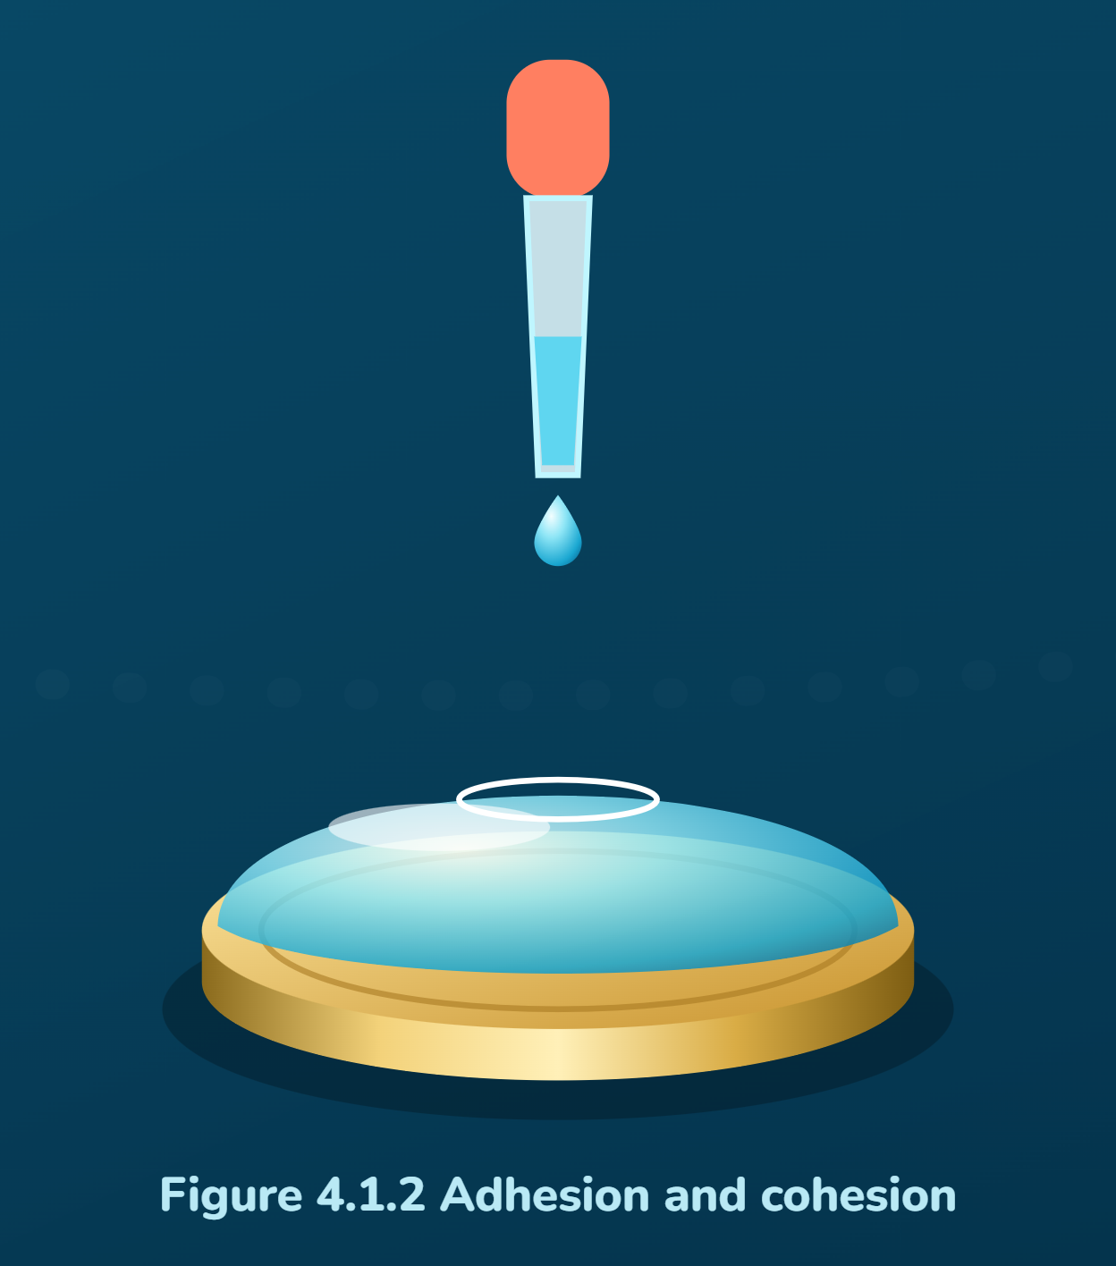  Figure 4.1.2 Adhesion and cohesion

4 · Results · Результаты
Write the real number of drops you counted.
Trial | Drops when the coin is full | Drops when the water spills
1
2
3
Mean (average)
Class results (from the board): lowest ______ highest ______ mean ______
Draw the water on the coin from the side. Label: coin, water, surface.
5 · Post-lab questions · Вопросы после работы
1. Why did the water on the coin not spill?
The water did not spill because ______________________________________
2. In which processes is this property used? How does it help living organisms?
3. What would happen if water molecules could not stick to each other?
If water molecules could not stick together, then ______________________
4. Why were the numbers of different pairs not the same? Give one reason.

