Name / Имя: ____________________ | Class: ___________ | Date: ____________
Vocabulary Словарь · Вода
Read the word. Look at the picture. Say it in English. Keep this sheet on your desk during the lesson.
 | English | Русский | Meaning (simple English)
 | solvent | растворитель | a liquid in which solids dissolve
 | dissolve | растворяться | a solid mixes into a liquid and we cannot see it
 | surface tension | поверхностное натяжение | a property of the surface of a liquid that allows it to resist an external force
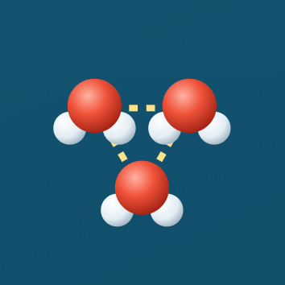 | cohesion | когезия (сцепление) | water molecules stick to each other
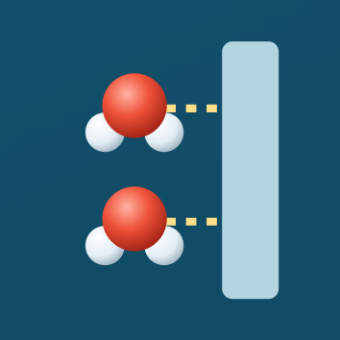 | adhesion | адгезия (прилипание) | water molecules stick to other molecules
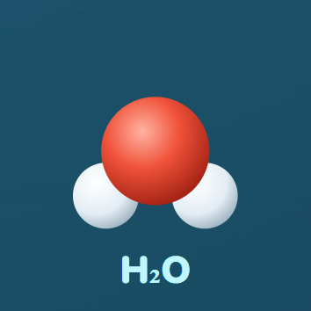 | molecule | молекула | a very small particle; a water molecule is H₂O
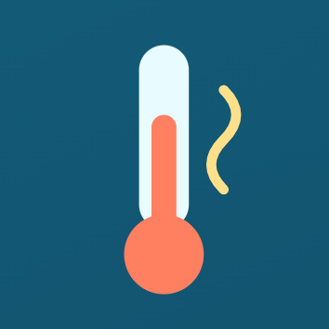 | specific heat capacity | удельная теплоёмкость | the energy needed to raise the temperature of 1 g of a substance by 1 °C
 | density | плотность | how much mass is packed into a space
 | melting | плавление | solid ice turns into liquid water (0 °C)
 | boiling | кипение | liquid water turns into water vapour (100 °C)
 | water vapour | водяной пар | water as a gas
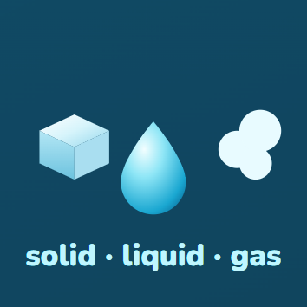 | states of water | состояния воды | solid (ice), liquid (water), gas (vapour)

Practice 1 · Fill the gaps · Заполни пропуски
Word bank: solvent · cohesion · adhesion · melts · boils · floats

- Water is a ______: many solids dissolve in it.
- Water molecules stick to each other. This is ______.
- Water sticks to the glass. This is ______.
- Ice ______ at 0 °C.
- Water ______ at 100 °C.
- Ice is less dense than water, so it ______.
Practice 2 · English → Русский · Переведи
English | Русский (write)
solvent
cohesion
specific heat capacity
boiling
Practice 3 · My sentence · Моё предложение
Write one sentence. Use two words from this sheet.

