Name / Имя: ____________________ | Class: ___________ | Date: ____________
Vocabulary Словарь · Химические элементы в организме человека
Read the word. Look at the picture. Say it in English. Keep this sheet on your desk during the lesson.
 | English | Русский | Meaning (simple English)
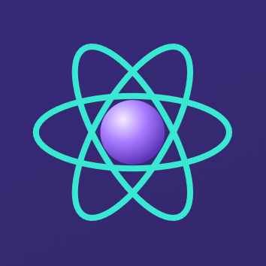 | element | элемент | a substance that cannot be divided into other substances by chemical reactions
 | bioelements | биоэлементы | the units which living things are made of
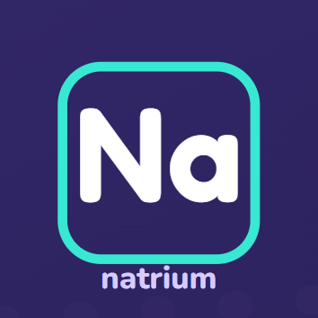 | chemical symbol | химический символ | 1–2 letters for an element; Na comes from Latin natrium
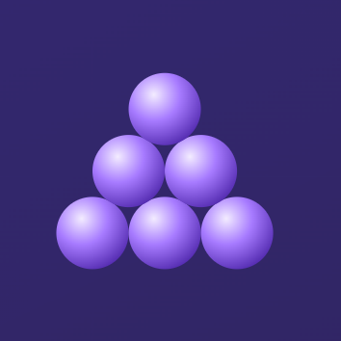 | macroelement | макроэлемент | an element needed in large amounts
 | microelement | микроэлемент | an element needed in small (trace) amounts
 | deficiency | недостаток (дефицит) | not enough of something the body needs
 | calcium (Ca) | кальций | in bones and teeth; muscle contraction; blood clotting
 | phosphorus (P) | фосфор | in bones, teeth and nucleic acids; energy transmission
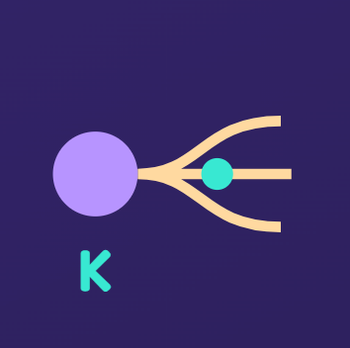 | potassium (K) | калий | main role in the nervous system
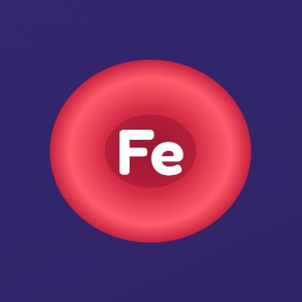 | iron (Fe) | железо | part of hemoglobin in the blood
 | iodine (I) | йод | main component of the thyroid hormones
 | hemoglobin | гемоглобин | a protein in the blood that transports oxygen

Practice 1 · Fill the gaps · Заполни пропуски
Word bank: hemoglobin · macroelement · microelement · teeth · deficiency · thyroid

- Iron is a part of ______, which carries oxygen in the blood.
- An element that the body needs in large amounts is a ______.
- Iodine is needed in very small amounts. It is a ______.
- Calcium and phosphorus are found in bones and ______.
- Not enough of an element is called a ______.
- Iodine is the main component of the ______ hormones.
Practice 2 · English → Русский · Переведи
English | Русский (write)
element
macroelement
calcium (Ca)
iron (Fe)
Practice 3 · My sentence · Моё предложение
Write one sentence. Use two words from this sheet.

