Name / Имя: ____________________ | Class: ___________ | Date: ____________
Laboratory Work No. 3 · Testing for organic molecules
Aim: find out which foods contain carbohydrates (starch), lipids and proteins.
Safety check · tick each box · Техника безопасности
✓ | Rule
☐ | I wear gloves and eye protection when reagents are used.
☐ | I never taste the food samples.
☐ | Only the teacher pours iodine solution and Biuret reagent.
☐ | I tell the teacher about spills at once.
☐ | I wash my hands after the lab.
☐ | I told the teacher if I am allergic to egg or olives.
1 · Pre-lab questions · Вопросы до работы
a) Why do we need carbohydrates?
b) What is the role of proteins?
c) What is the importance of fats?
2 · Predict · Предскажи
Food | I think it contains… (carbohydrate / lipid / protein) | Because…
potato
apple
olive
egg white

3 · Procedure · Ход работы
Test | What to do | Result rule
A · Paper test (lipids)  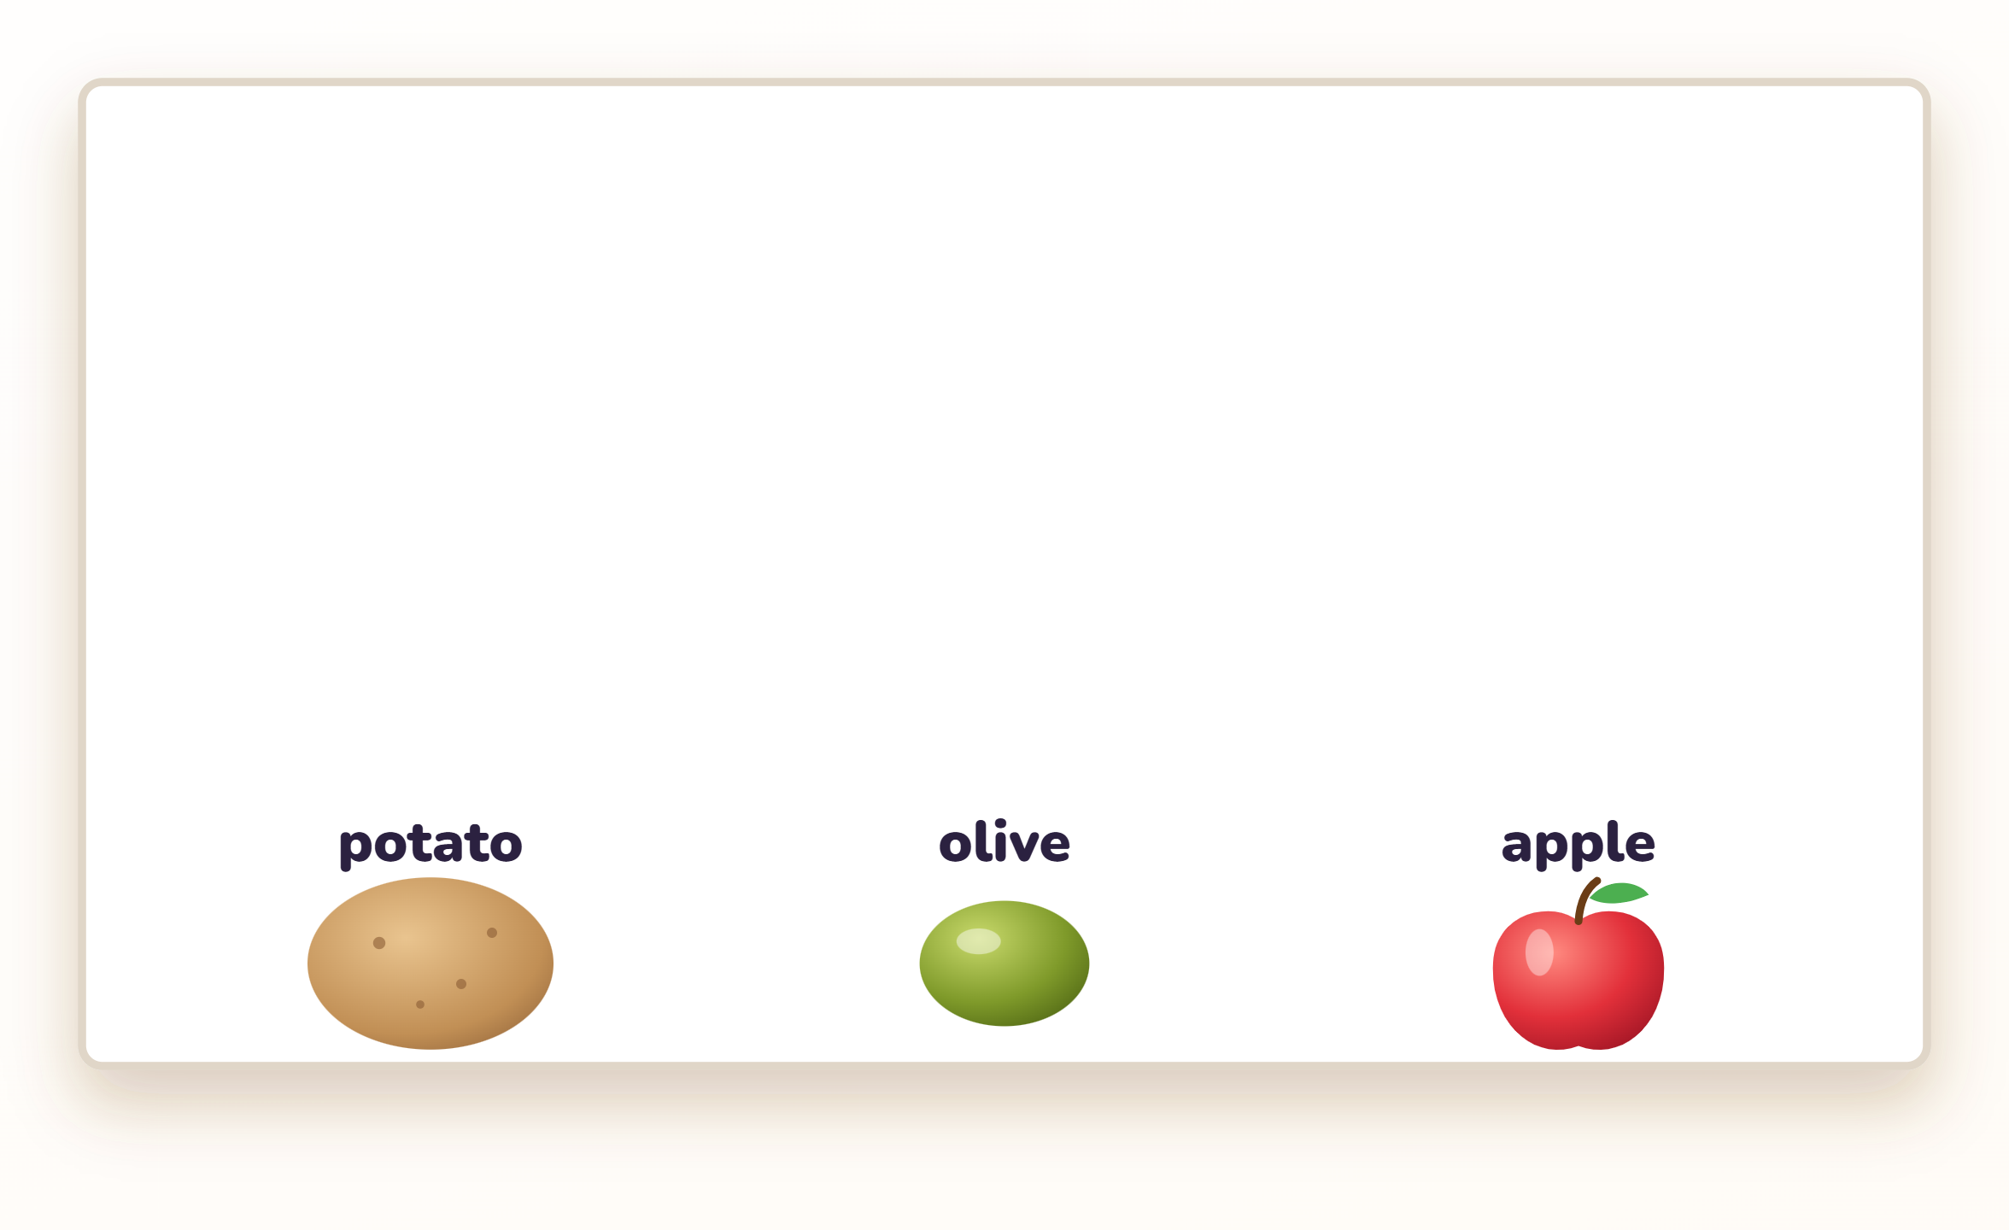 | - Squeeze and knead potato, olive and apple separately on white paper until wet.  - Clean off the food. Let the paper dry for 10–15 minutes.  - Hold the paper up to the light. Compare the traces. | If the food contains fat, the trace is transparent.
B · Iodine test (carbohydrates)  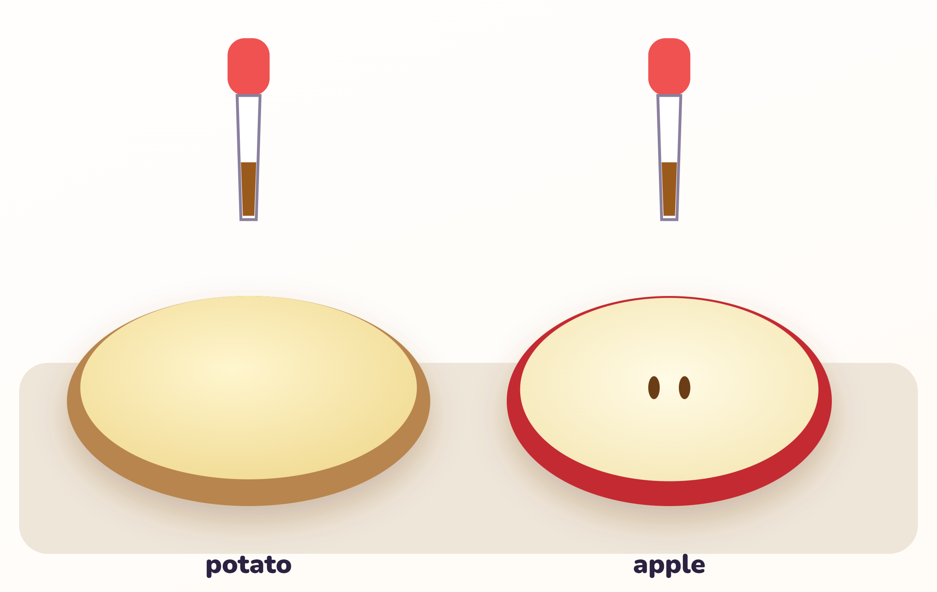 | - The teacher cuts the potato and apple in half.  - Add a few drops of iodine solution to each.  - Write the colour you see. | With carbohydrate (starch), colour changes from brown to blue or black.
C · Biuret test (proteins)  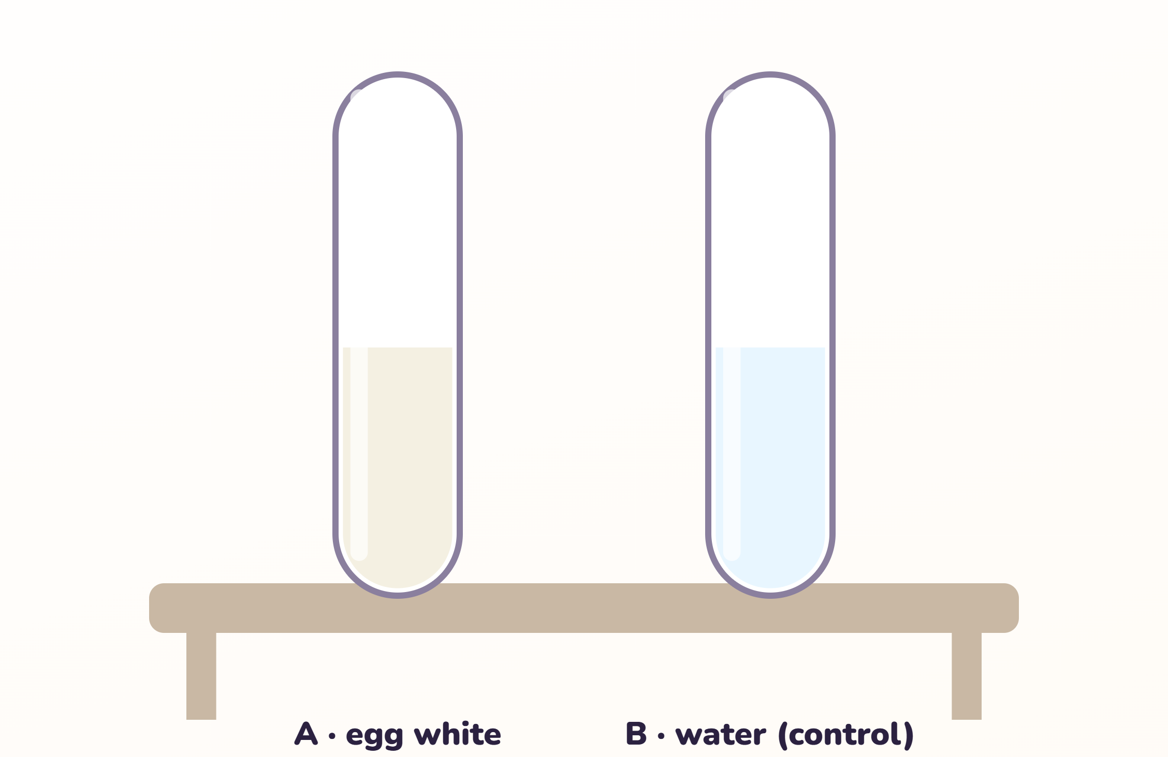 | - Put 2 ml raw egg white in a test tube.  - The teacher adds 2 ml Biuret reagent. Mix.  - Write the result. Compare with water. | With protein, colour changes from blue to purple.
Start test A first — the paper needs time to dry.

4 · Observations · Наблюдения
Write what you saw. Do not copy from the board.
Test | Food | Colour / trace I saw | Compound present? (yes / no)
Iodine | potato
Iodine | apple
Paper | potato
Paper | olive
Paper | apple
Biuret | egg white
Biuret | water (control)
5 · Explain · Объясни
I observed ______________. This suggests ______________ because ______________.
6 · Post-lab questions · Вопросы после работы
1. What foods contain carbohydrates?
2. What foods are rich in protein?
3. From what foods do we get fat?
4. Which result was hard to see? How could we make the test fairer?

