Name / Имя: ____________________ | Class: ___________ | Date: ____________
Vocabulary Словарь · Органические соединения
Read the word. Look at the picture. Say it in English. Keep this sheet on your desk during the lesson.
 | English | Русский | Meaning (simple English)
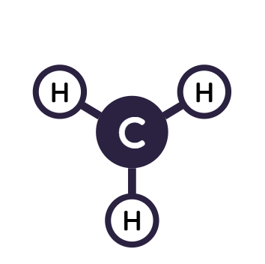 | organic compound | органическое соединение | a compound that contains carbon and hydrogen
 | carbohydrate | углевод | organic compound with C, H, O (sugars); main source of energy
 | protein | белок | basic building organic compound of the body (C, H, O, N, S)
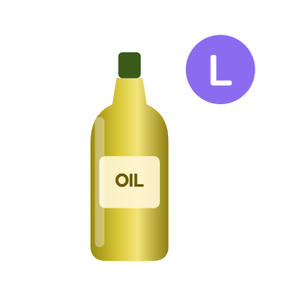 | lipid (fat) | липид (жир) | stores the most energy; insoluble in water
 | energy | энергия | what living things need to move, grow and work
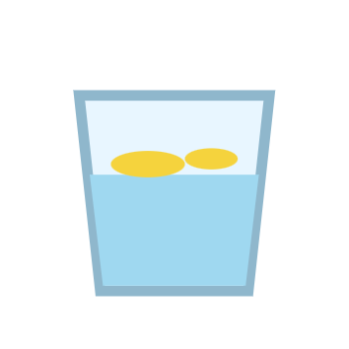 | insoluble | нерастворимый | does not dissolve in water
 | iodine solution | йодный раствор | brown liquid; turns blue-black with starch
 | Biuret reagent | биуретовый реактив | blue liquid; turns purple with protein
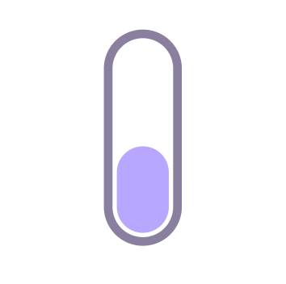 | test tube | пробирка | a small glass tube for experiments
 | pipette | пипетка | a tool that adds a few drops
 | transparent spot | прозрачное пятно | a mark on paper that lets light through
 | colour change | изменение цвета | the colour becomes different — a sign of a reaction

Practice 1 · Fill the gaps · Заполни пропуски
Word bank: protein · starch · transparent · insoluble · energy · carbon

- Biuret reagent turns purple when the food contains ______.
- Iodine solution turns blue-black with ______ (a carbohydrate).
- Oil leaves a ______ spot on paper.
- Lipids are ______ in water.
- Carbohydrates are the main source of ______.
- Organic compounds contain ______ and hydrogen.
Practice 2 · English → Русский · Переведи
English | Русский (write)
organic compound
lipid (fat)
iodine solution
pipette
Practice 3 · My sentence · Моё предложение
Write one sentence. Use two words from this sheet.

