Name / Имя: ____________________ | Class: ___________ | Date: ____________
Vocabulary Словарь · Недостаток макроэлементов у растений
Read the word. Look at the picture. Say it in English. Keep this sheet on your desk during the lesson.
 | English | Русский | Meaning (simple English)
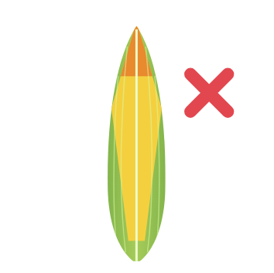 | deficiency | недостаток | not enough of a needed element
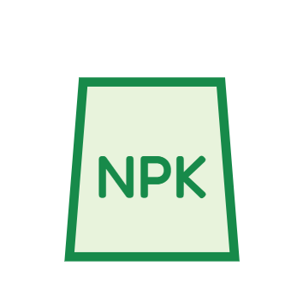 | fertilizer | удобрение | a natural or artificial substance added to soil to help plants grow better
 | macroelement | макроэлемент | an element needed in large amounts (e.g. N, P, K)
 | organic fertilizer | органическое удобрение | natural: from plant or animal products (manure, compost)
 | inorganic fertilizer | неорганическое удобрение | synthetic: made in a factory
 | synthetic | синтетический | made artificially by combining separate elements
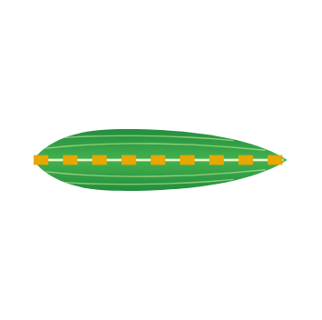 | vein | жилка | a thin line in a leaf that carries water
 | edge (margin) | край листа | the outside line of a leaf
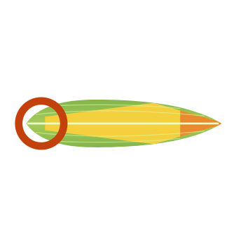 | tip | кончик листа | the end of the leaf
 | pale / dark | бледный / тёмный | light colour / deep colour
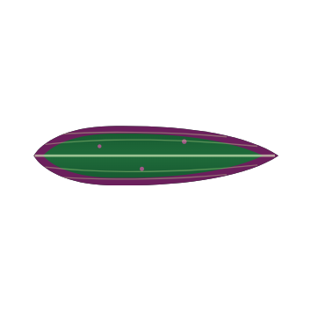 | spots | пятна | small marks of a different colour
 | ripen | созревать | a fruit becomes ready to eat

Practice 1 · Fill the gaps · Заполни пропуски
Word bank: organic · inorganic · veins · deficiency · edge · ripen

- Manure and compost are ______ fertilizers.
- Superphosphate is made in a factory. It is an ______ fertilizer.
- The thin lines in a leaf are called ______.
- When a plant does not get enough nitrogen, it has a nitrogen ______.
- The outside line of a leaf is the ______.
- Without enough phosphorus, fruits do not ______.
Practice 2 · English → Русский · Переведи
English | Русский (write)
deficiency
organic fertilizer
vein
pale / dark
Practice 3 · My sentence · Моё предложение
Write one sentence. Use two words from this sheet.

