Name / Имя: ____________________ | Class: ___________ | Date: ____________
Leaf detectives · Match the description
Textbook Activity p. 63. Work in pairs. Read each description. Underline the key words.
Figure 4.4.1 · Nutrient deficiency in plants · Недостаток питательных веществ
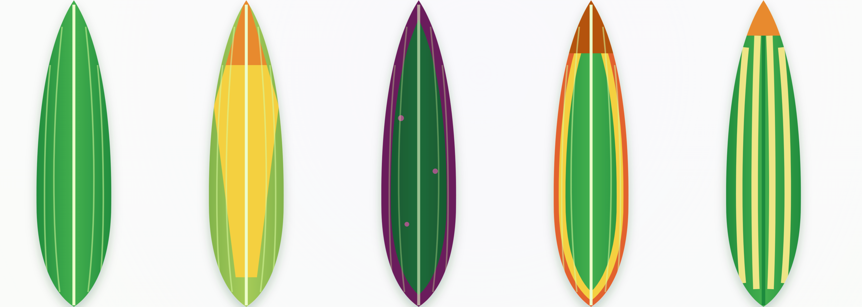
healthy | nitrogen (N) | phosphorus (P) | potassium (K) | magnesium (Mg)
Task A · Match · Сопоставь
Choose from: A Phosphorus deficiency B Magnesium deficiency C Nitrogen deficiency D Potassium deficiency
Description | Letter | Key words that helped me
1. The old leaves turn brownish-yellow and gradually disappear. Yellowing of the leaves begins with the leaf veins.
2. The colour of the old leaves turns dark green. Brown and pink spots appear on the leaves and then turn into holes.
3. The leaves turn yellow and later dry out at the tips and edges. Brown spots appear on the edges.
4. Pale yellow spots appear between the veins. Large nerves (veins) and leaf margins are green. The edge of the leaf is bent and the leaf shape is domed.
I chose ___ for description ___ because it says “______________”.

Task B · Organic or inorganic? · Органическое или неорганическое?
Fertilizer | Organic or inorganic?
manure
superphosphate
compost
potassium chloride
guano
ammonium sulfate
Task C · Plant doctor · Доктор растений
A tomato plant has few, small leaves, and its fruits do not ripen.
a) Which element is missing?
b) Which fertilizer could help? Why?
Task D · Think about it · Подумай
Is “more fertilizer” always better for plants? Give one reason.
I think ______ because ____________________________________________

