ECM-fiber-graph MATLAB GUI

The pipeline including Gabor detection, graph-based fiber representation and parametric maps analysis can be tested through a MATLAB-based graphical user interface (GUI), (Figure 1), which can run on MATLAB versions starting from 2015a onwards.

**Disclaimer**: The current app version can only be run on machines with MATLAB installed. Next steps can include the development of a standalone application that would not require prior installation of MATLAB.

Files should typically be stored for analysis in the following formats: ‘jpg/jpeg’, ‘tif’, ‘png’, etc.

Most tests have been performed on average sample size smaller or equal to 1024x1024 pixels. Skeleton Reconnection is a time-consuming step which is deemed optional.

After downloading the project on a local machine, the user can run the GUI (ECM_fiber_graph.fig) to test intermediate steps of the methods of one sample image, and additional parallel testing of multiple images. Results are stored as either .png files or .csv files, as detailed below.

We recommend testing on one/few samples visualizing the intermediate steps (e.g. Fiber extraction pipeline, followed by Fiber features and parametric maps), before deciding to apply the whole analysis on groups of images with Batch processing.

Figure 1. Graph-based fiber analysis GUI application

**Start: select image**

Test sample images are found in the *ECM_fiber_graph/sample_img* directory which can be selected once Start:select image button is pressed and directory explorer is enabled. The user is then presented with a selection prompt (Figure 2) to indicate the type of image previously selected. (E.g. fluorescent or SHF microscopy images typically show a darker background with lighter structures of interest, other stainings can show a light background with the main objects at lower levels of color/intensity).

Figure 2. Image type selection

**Fiber extraction pipeline**

The fiber extraction pipeline is divided into multiple steps (Figure 3) and can be tested on one sample image that has been previously loaded with ‘Start:select’ image button. The results of these steps will be directly stored as .png files in a pre-created directory, *ECM_fiber_graph/stats/img/’file_name’*.

1. First step is represented by fiber enhancement with Gabor filters (with predefined filters to cover a wide range of fiber features).
2. Step 2 refers to the creation of a fiber morphological skeleton and its associated skeleton graph network (collection of nodes connected by edges; nodes can represent crossing fibers (2D representation) or fiber ends).
3. Step 3 is entirely optional, depending on the quality of skeletonization observed in during step 3. Briefly, the principle behind is to reconnect fibers that might have been mis-represented before, within a certain predefined radius. This step will attempt to mitigate the artefacts arising from previous step, and will typically result in a less fragmented, more connected network, but will be time-consuming. This is important to remember when consider the batch processing step.
4. The fourth step will assign a simplified graph network to the previous skeleton, where fibers are represented here through straight lines connecting previously detected nodes.

**Fiber features and parametric maps**

The second panel can be accessed once fiber analysis has been performed, and relevant features can be extracted.

1. By selecting Gabor skeleton and Gabor graph-based features buttons, two different maps will be created respectively. These represent the local fiber thickness and orientation of the morphological skeleton and graph-based representation. Additionally, graph-based local properties of each fiber will be stored in a .csv file, located at *ECM_fiber_graph/stats/graph/’file_name.csv’*.
2. Selecting pore features will save various morphological shape characteristics of pores, such as area, eccentricity, perimeter, orientation, in a .csv file, located at *ECM_fiber_graph/stats/pores/’file_name.csv’*.
3. The parametric maps panel creates the extrapolated and dense fiber length and pore isotropy maps, such as described in the main paper. The resuls are stored in *ECM_fiber_graph/stats/img/’file_name’*.

**Batch processing**

To apply the fiber extraction - feature extraction - map analysis pipeline to multiple images in parallel, the user can press ‘select files’ button and subsequently select a folder, and not directly a file (e.g. *ECM_fiber_graph/sample_img/sample_batch*.) by opening it from the directory explorer. The test folder sample_batch contains a few images already; the user can create a different directory or simply place all images intended for analysis in this one. The user will be asked to confirm the acquisition type for all images.

Additionally, the user can choose whether to consider additional skeleton reconnection. Prior to batch processing, it is recommended to visualize the intermediate steps including fiber reconnexion and deciding if it is needed (e.g. it significantly improves the fiber representation quality) during batch-processing, as it is a time-consuming step.

The result of this analysis (mostly quantitative) are also stored in the stats sub-folder.

To restart the analysis and reset the data values, the user can press ‘reset’. This will close all figures and re-open the GUI application.

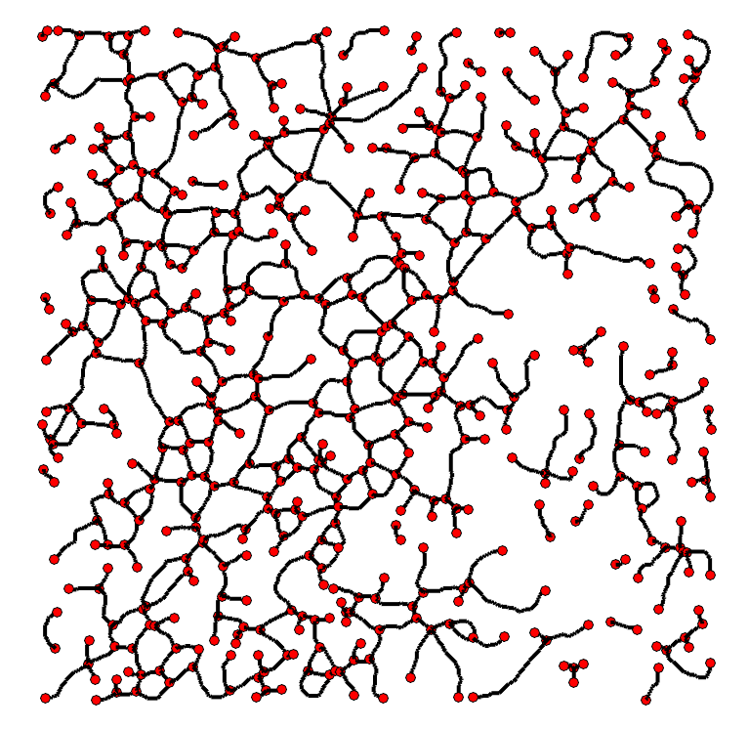

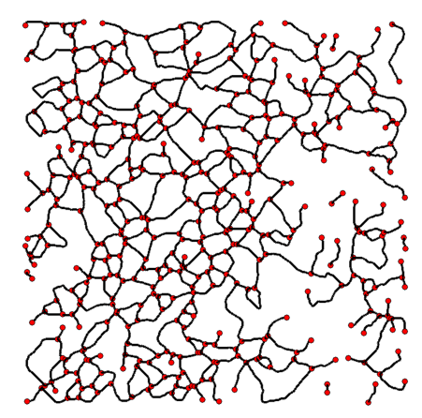

Figure . Results of the pipeline test to one image sample. First row depicts the test sample and fiber detection with Gabor filters after Step1. Second row shows the morphological skeleton and associated graph (Step2). Third row shows the reconnected fibers results (Step3) and associated simplified graph-based representation (Step4). Fourth row illustrates the parametric fiber length and pore isotropy maps. Fifth and sixth rows illustrate fiber thickness and local fiber orientation map for both the morphological skeleton and the graph-based representation of fibers.