Step 1: Run this in Command Prompt or PowerShell:
winget install OpenJS.NodeJS.LTS
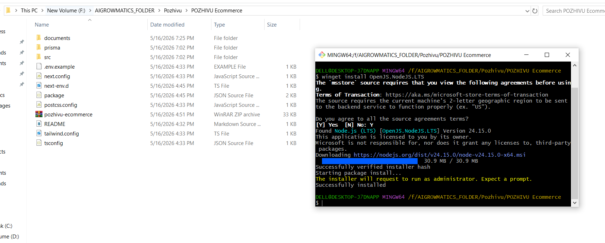

Step 2: Then close the terminal, open a new one, and check:
cd /d C:\Users\DELL\Documents\Codex\2026-05-16\files-mentioned-by-the-user-pozhivu\pozhivu-ecommerce
npm install
npm run dev

Step 3: Then open:
http://localhost:3000

