# Problem of extreme values in stock prices

As we know, the stock prices in DataStream produce very extreme values for the Target Price Expected Return(TPER) when we divide an analyst target price over the stock price: $TPER=TP/P−1$

The following stocks have adjusted price of 2 cents which seems to be a database anomaly as I downloaded various times and got the same result:

## Date Stock priceAdj  
## 1: 2003-07-24 CNC 0.02  
## 2: 2006-10-31 SGI 0.02  
## 3: 2007-09-10 DAL 0.02

I, then, turn to another stock price database from finance.yahoo.com. Surprisingly, this source has different prices for the same stocks:

## Date Stock priceAdj yahoo meanPT  
## 1: 2003-07-24 CNC 0.02 14.51 14.5  
## 2: 2006-10-31 SGI 0.02 31.01 31.0  
## 3: 2007-09-10 DAL 0.02 17.29 20.0

Notice, that average price target (meanPT) for the sames stock is very close to the values of the yahoo prices. Giving the fact that yahoo seems to have a better stock prices information, I have created three stock prices sets. One is the DataStream (DS), for the second, I completely substitute all prices in my analysis by the yahoo (YH) prices, and third is replaced prices only for anomalous stocks with the yahoo (Fix) prices. Here are plots of TPER for each of the sets:

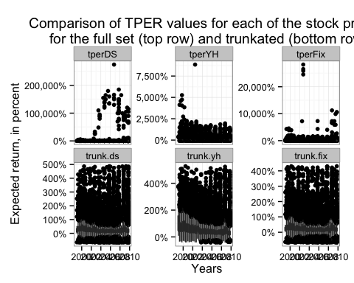

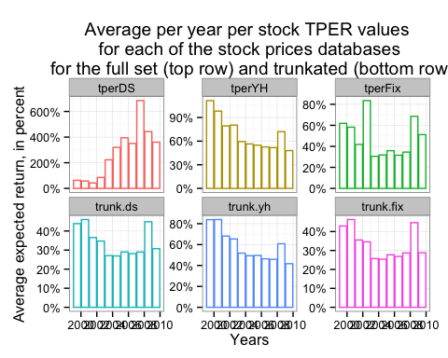

Looking at average per year plot, observe that the Fix dataset seems cured the anomaly in the DataStream sets as values mostly uniformly distributed. Now we have two options whether to switch completely to the yahoo prices or to use yhaoo prices for the selected stocks and keep all others from the DataStream.