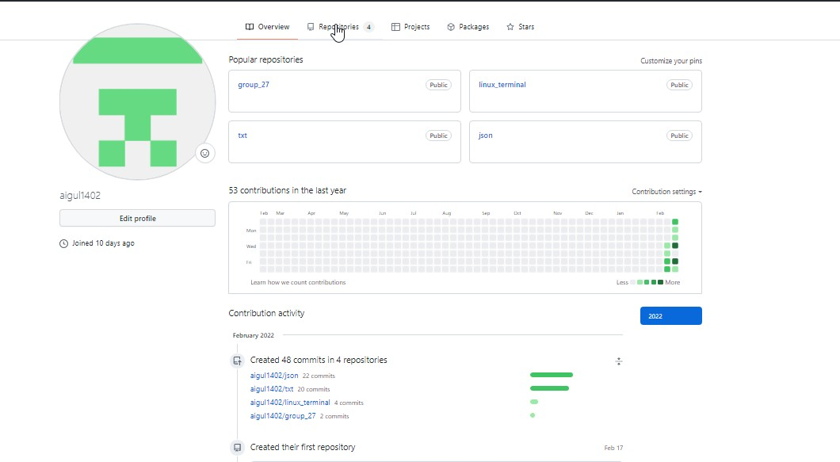1)

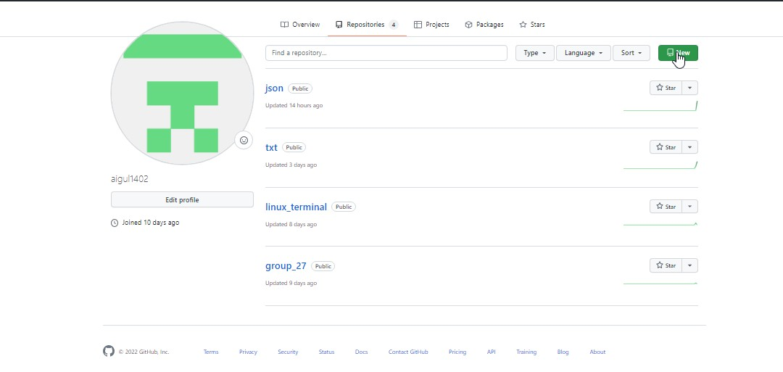

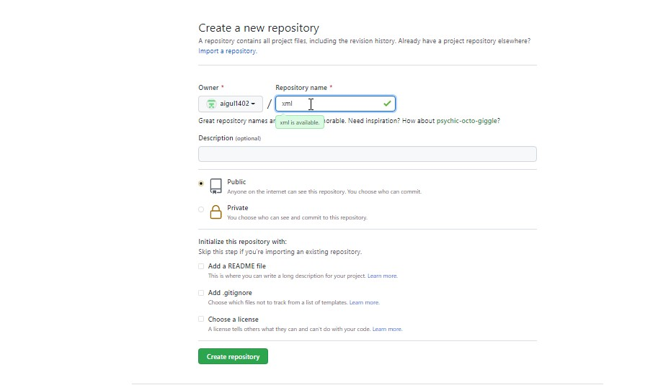

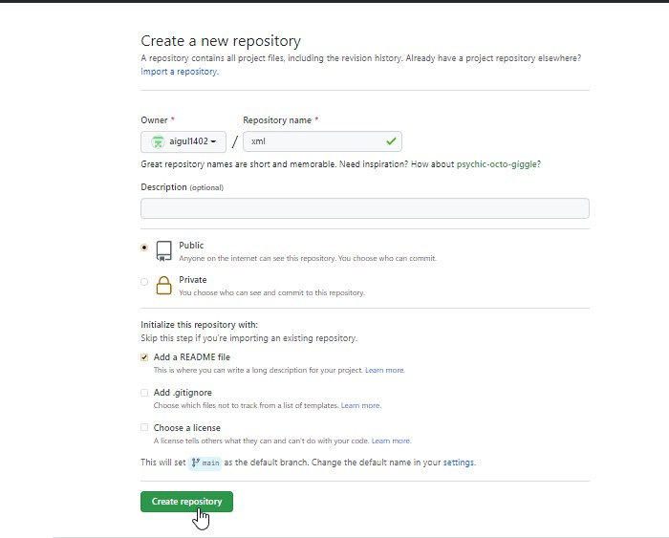

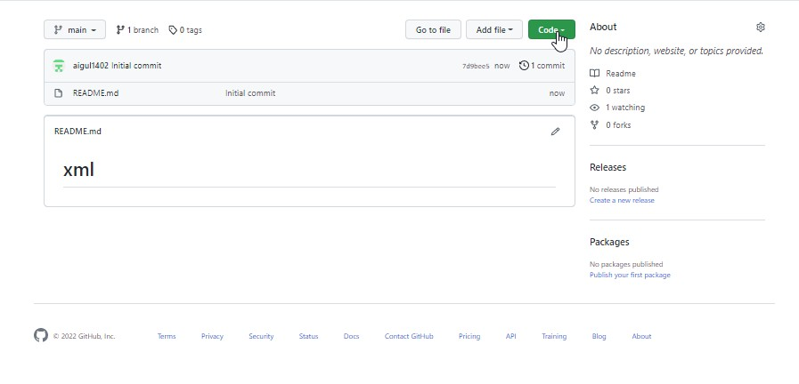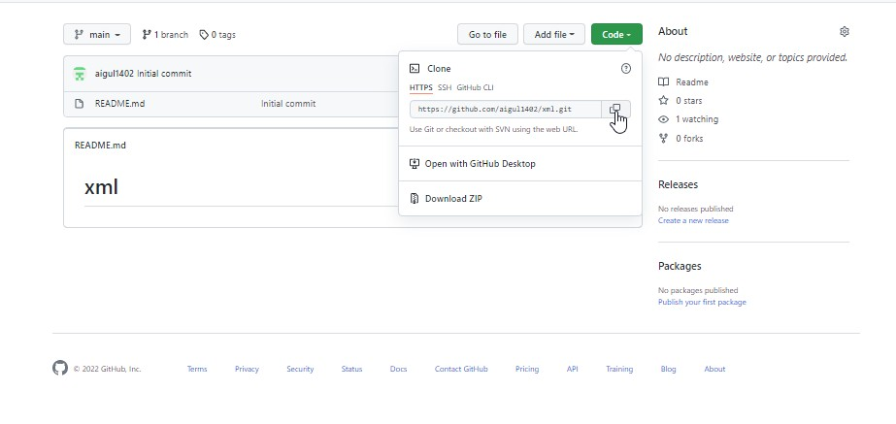

2) Пользователь@DESKTOP-7069A0U MINGW64 ~

$ git clone https://github.com/aigul1402/xml.git

Cloning into 'xml'...

remote: Enumerating objects: 3, done.

remote: Counting objects: 100% (3/3), done.

remote: Total 3 (delta 0), reused 0 (delta 0), pack-reused 0

Receiving objects: 100% (3/3), done.

Пользователь@DESKTOP-7069A0U MINGW64 ~

$ mv xml/ GitHub/

Пользователь@DESKTOP-7069A0U MINGW64 ~

$ cd GitHub/

Пользователь@DESKTOP-7069A0U MINGW64 ~/GitHub

$ cd xml/

3) Пользователь@DESKTOP-7069A0U MINGW64 ~/GitHub/xml (main)

$ touch new.xml

Пользователь@DESKTOP-7069A0U MINGW64 ~/GitHub/xml (main)

$ ls

README.md new.xml

Пользователь@DESKTOP-7069A0U MINGW64 ~/GitHub/xml (main)

$ git status

On branch main

Your branch is up to date with 'origin/main'.

Untracked files:

(use "git add <file>..." to include in what will be committed)

new.xml

nothing added to commit but untracked files present (use "git add" to track)

4) Пользователь@DESKTOP-7069A0U MINGW64 ~/GitHub/xml (main)

$ git add new.xml

5) Пользователь@DESKTOP-7069A0U MINGW64 ~/GitHub/xml (main)

$ git commit -m "add new.xml"

[main 1dccf46] add new.xml

1 file changed, 0 insertions(+), 0 deletions(-)

create mode 100644 new.xml

6) Пользователь@DESKTOP-7069A0U MINGW64 ~/GitHub/xml (main)

$ git push

Enumerating objects: 4, done.

Counting objects: 100% (4/4), done.

Delta compression using up to 4 threads

Compressing objects: 100% (2/2), done.

Writing objects: 100% (3/3), 287 bytes | 287.00 KiB/s, done.

Total 3 (delta 0), reused 0 (delta 0), pack-reused 0

To https://github.com/aigul1402/xml.git

7d9bee5..1dccf46 main -> main

7) Пользователь@DESKTOP-7069A0U MINGW64 ~/GitHub/xml (main)

$ vim new.xml

Пользователь@DESKTOP-7069A0U MINGW64 ~/GitHub/xml (main)

$ cat new.xml

<about>

<name>Aigul</name>

<age>31</age>

<animals>1</animals>

<salary>100000</salary>

</about>

Пользователь@DESKTOP-7069A0U MINGW64 ~/GitHub/xml (main)

$ git status

On branch main

Your branch is up to date with 'origin/main'.

Changes not staged for commit:

(use "git add <file>..." to update what will be committed)

(use "git restore <file>..." to discard changes in working directory)

modified: new.xml

no changes added to commit (use "git add" and/or "git commit -a")

Пользователь@DESKTOP-7069A0U MINGW64 ~/GitHub/xml (main)

$ git add new.xml

warning: LF will be replaced by CRLF in new.xml.

The file will have its original line endings in your working directory

Пользователь@DESKTOP-7069A0U MINGW64 ~/GitHub/xml (main)

$ git commit -am "change new.xml"

[main 3d0f0e1] change new.xml

1 file changed, 6 insertions(+)

8) Пользователь@DESKTOP-7069A0U MINGW64 ~/GitHub/xml (main)

$ git push

Enumerating objects: 5, done.

Counting objects: 100% (5/5), done.

Delta compression using up to 4 threads

Compressing objects: 100% (3/3), done.

Writing objects: 100% (3/3), 361 bytes | 361.00 KiB/s, done.

Total 3 (delta 0), reused 0 (delta 0), pack-reused 0

To https://github.com/aigul1402/xml.git

1dccf46..3d0f0e1 main -> main

9) Пользователь@DESKTOP-7069A0U MINGW64 ~/GitHub/xml (main)

$ touch preferences.xml

Пользователь@DESKTOP-7069A0U MINGW64 ~/GitHub/xml (main)

$ ls

README.md new.xml preferences.xml

10) Пользователь@DESKTOP-7069A0U MINGW64 ~/GitHub/xml (main)

$ vim preferences.xml

Пользователь@DESKTOP-7069A0U MINGW64 ~/GitHub/xml (main)

$ cat preferences.xml

<preferences>

<favorite_movie>Почему он?</favorite_movie>

<favorite_serial>Теория Большого Взрыва</favorite_serial>

<favorite_food>жаренная картошка</favorite_food>

<favorite_time_in_year>зима</favorite_time_in_year>

<country>Амстердам</country>

</preferences>

11) Пользователь@DESKTOP-7069A0U MINGW64 ~/GitHub/xml (main)

$ touch skills.xml

Пользователь@DESKTOP-7069A0U MINGW64 ~/GitHub/xml (main)

$ ls

README.md new.xml preferences.xml skills.xml

Пользователь@DESKTOP-7069A0U MINGW64 ~/GitHub/xml (main)

$ vim skills.xml

Пользователь@DESKTOP-7069A0U MINGW64 ~/GitHub/xml (main)

$ cat skills.xml

<skills>

<a>theory</a>

<b>client-server</b>

<c>http</c>

<d>respondes_code</d>

<e>structure_selects</e>

<f>json</f>

<j>xml</j>

<h>etc</h>

</skills>

Пользователь@DESKTOP-7069A0U MINGW64 ~/GitHub/xml (main)

$ git status

On branch main

Your branch is up to date with 'origin/main'.

Untracked files:

(use "git add <file>..." to include in what will be committed)

preferences.xml

skills.xml

nothing added to commit but untracked files present (use "git add" to track)

12) Пользователь@DESKTOP-7069A0U MINGW64 ~/GitHub/xml (main)

$ git add .

warning: LF will be replaced by CRLF in preferences.xml.

The file will have its original line endings in your working directory

warning: LF will be replaced by CRLF in skills.xml.

The file will have its original line endings in your working directory

Пользователь@DESKTOP-7069A0U MINGW64 ~/GitHub/xml (main)

$ git commit -m "add preferences, skills"

[main 072a5cb] add preferences, skills

2 files changed, 17 insertions(+)

create mode 100644 preferences.xml

create mode 100644 skills.xml

13) Пользователь@DESKTOP-7069A0U MINGW64 ~/GitHub/xml (main)

$ git push

Enumerating objects: 5, done.

Counting objects: 100% (5/5), done.

Delta compression using up to 4 threads

Compressing objects: 100% (4/4), done.

Writing objects: 100% (4/4), 685 bytes | 685.00 KiB/s, done.

Total 4 (delta 0), reused 0 (delta 0), pack-reused 0

To https://github.com/aigul1402/xml.git

3d0f0e1..072a5cb main -> main

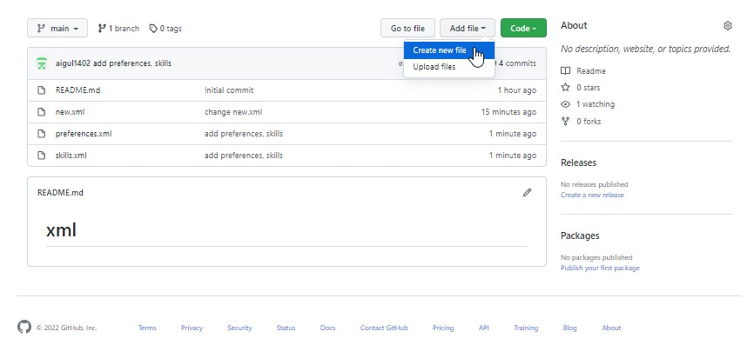14)

15)

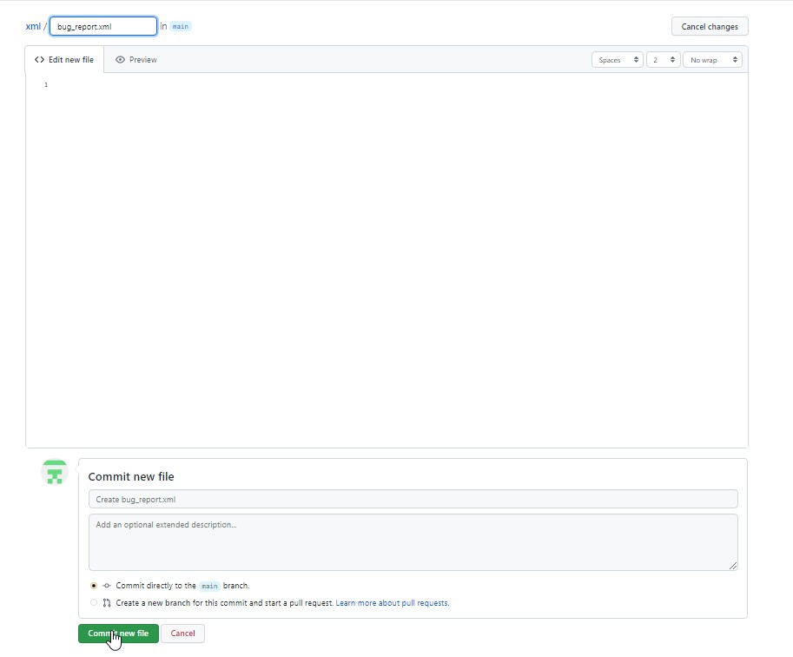

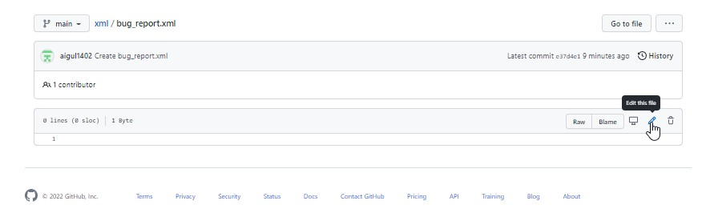

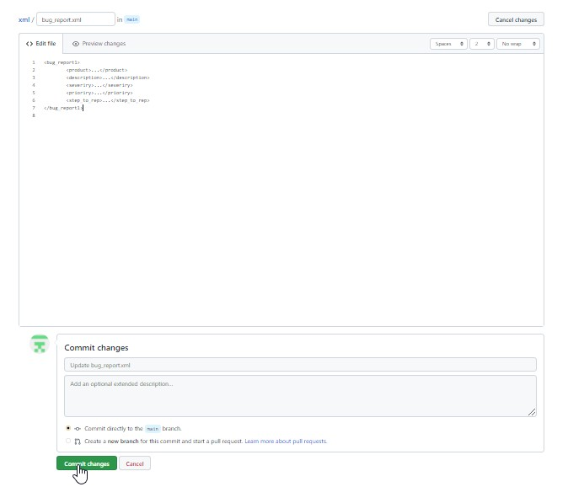16)

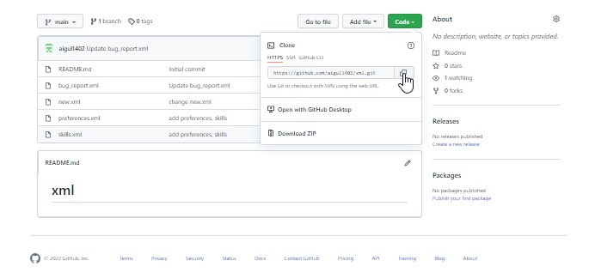

18) Пользователь@DESKTOP-7069A0U MINGW64 ~/GitHub/xml (main)

$ git clone https://github.com/aigul1402/xml.git

Cloning into 'xml'...

remote: Enumerating objects: 19, done.

remote: Counting objects: 100% (19/19), done.

remote: Compressing objects: 100% (15/15), done.

remote: Total 19 (delta 3), reused 8 (delta 0), pack-reused 0

Receiving objects: 100% (19/19), done.

Resolving deltas: 100% (3/3), done.

Пользователь@DESKTOP-7069A0U MINGW64 ~/GitHub/xml (main)

$ ls

README.md new.xml preferences.xml skills.xml xml/

Пользователь@DESKTOP-7069A0U MINGW64 ~/GitHub/xml (main)

$ cd xml

Пользователь@DESKTOP-7069A0U MINGW64 ~/GitHub/xml/xml (main)

$ ls -la

total 17

drwxr-xr-x 1 Пользователь 197121 0 Feb 27 02:18 ./

drwxr-xr-x 1 Пользователь 197121 0 Feb 27 02:18 ../

drwxr-xr-x 1 Пользователь 197121 0 Feb 27 02:18 .git/

-rw-r--r-- 1 Пользователь 197121 5 Feb 27 02:18 README.md

-rw-r--r-- 1 Пользователь 197121 211 Feb 27 02:18 bug_report.xml

-rw-r--r-- 1 Пользователь 197121 133 Feb 27 02:18 new.xml

-rw-r--r-- 1 Пользователь 197121 346 Feb 27 02:18 preferences.xml

-rw-r--r-- 1 Пользователь 197121 157 Feb 27 02:18 skills.xml