Evidence: Model Evaluation Screenshots

Adult Income – XGBoost
- Metrics: see paper Results section.
- Confusion Matrix:
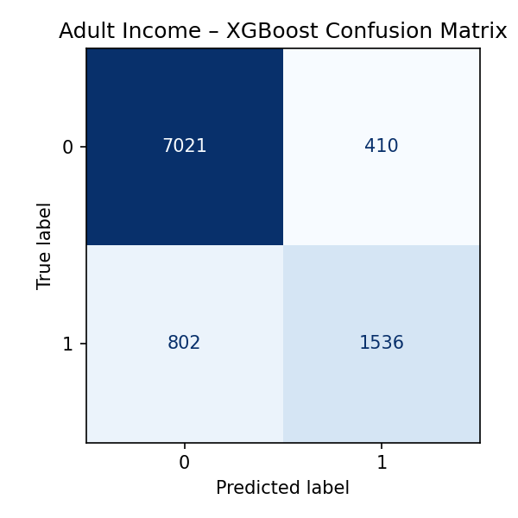
Adult XGBoost Confusion Matrix

Titanic – Naive Bayes
- Metrics: see paper Results section.
- Confusion Matrix:
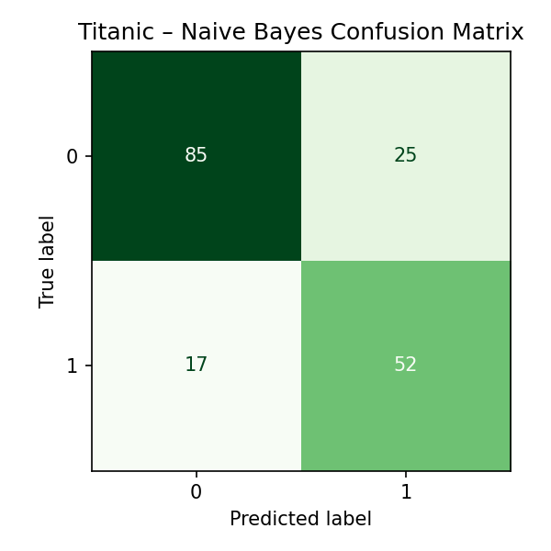
Titanic NB Confusion Matrix

