1.表示年月日类型:java.sql.Date, 对应MySQL的date类型。

2.表示时分秒类型:java.sql.Time, 对应MySQL的time类型。

3.表示年月日时分秒类型:java.sql.Timestamp, 对应MySQL的timestamp类型。

4.编写SqlTime.java, 打印java.sql的几个日期类型, java.sql.Timestamp是有毫秒数的, MySQL的timestamp没有毫秒数。

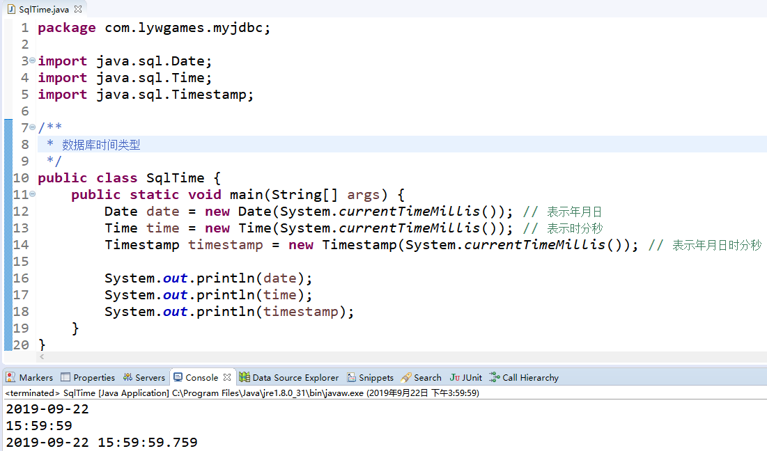

5.编写RiQiDaoImpl.java, 进行表的创建、插入数据、查找数据和删除表

|  |
| --- |
| package com.lywgames.dao.impl;  import java.sql.Connection;  import java.sql.PreparedStatement;  import java.sql.ResultSet;  import java.sql.SQLException;  import java.sql.Time;  import java.sql.Timestamp;  import java.sql.Date;  import com.lywgames.dao.RiQiDao;  import com.lywgames.util.JDBCUtil;  public class RiQiDaoImpl implements RiQiDao {  @Override  public void createTable() {  Connection conn = null;  PreparedStatement ps = null;    try {  conn = JDBCUtil.getConn();    String sql = "create table riqi(id int(11) not null auto_increment, regDate date default null, regTime time default null, reg timestamp default null, primary key(id))";  ps = conn.prepareStatement(sql);  ps.executeUpdate();  } catch (SQLException e) {  e.printStackTrace();  }finally {  JDBCUtil.release(conn, ps);  }  }  @Override  public void insert(Date date, Time time, Timestamp ts) {  Connection conn = null;  PreparedStatement ps = null;    try {  conn = JDBCUtil.getConn();    String sql = "insert into riqi values (null, ?, ?, ?)";  ps = conn.prepareStatement(sql);  ps.setDate(1, date);  ps.setTime(2, time);  ps.setTimestamp(3, ts);  ps.execute();  } catch (SQLException e) {  e.printStackTrace();  }finally {  JDBCUtil.release(conn, ps);  }  }  @Override  public void findAll() {  Connection conn = null;  PreparedStatement ps = null;  ResultSet rs = null;    try {  conn = JDBCUtil.getConn();    String sql = "select * from riqi";  ps = conn.prepareStatement(sql);  rs = ps.executeQuery();  while(rs.next()) {  System.out.println(rs.getInt(1) + " " + rs.getDate(2) + " " + rs.getTime(3) + " " + rs.getTimestamp(4));  }  } catch (SQLException e) {  e.printStackTrace();  }finally {  JDBCUtil.release(conn, ps);  }  }  @Override  public void dropTable() {  Connection conn = null;  PreparedStatement ps = null;    try {  conn = JDBCUtil.getConn();    String sql = "drop table riqi";  ps = conn.prepareStatement(sql);  ps.execute();  } catch (SQLException e) {  e.printStackTrace();  }finally {  JDBCUtil.release(conn, ps);  }  }  } |

6.运行程序, 查询结果

