1.新建一个LoadOnStartup的Web项目

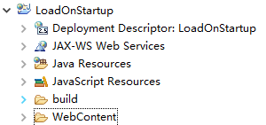

2.在WebContent下新建一个index.html

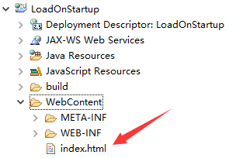

3.编写index.html

|  |
| --- |
| <!DOCTYPE html>  <html>  <head>  <meta charset="UTF-8">  <title>Life Cycle</title>  </head>  <body>  <h1>Life Cycle</h1>  </body>  </html> |

4.新建一个LoadOnStartup.java类

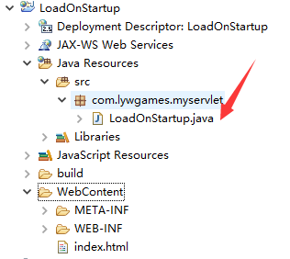

5.编写LoadOnStartup.java

|  |
| --- |
| package com.lywgames.myservlet;  import java.io.IOException;  import javax.servlet.Servlet;  import javax.servlet.ServletConfig;  import javax.servlet.ServletException;  import javax.servlet.ServletRequest;  import javax.servlet.ServletResponse;  public class LoadOnStartup implements Servlet {  public LoadOnStartup(){  System.out.println("LoadOnStartup");  }  @Override  public void init(ServletConfig config) throws ServletException {  System.out.println("LoadOnStartup init");  }  @Override  public void service(ServletRequest req, ServletResponse res) throws ServletException, IOException {  System.out.println("LoadOnStartup service");  }  @Override  public void destroy() {  System.out.println("LoadOnStartup destroy");  }  @Override  public ServletConfig getServletConfig() {  return null;  }  @Override  public String getServletInfo() {  return null;  }  } |

1. 在web.xml里配置servlet, 注意配置

<load-on-startup>10</load-on-startup>

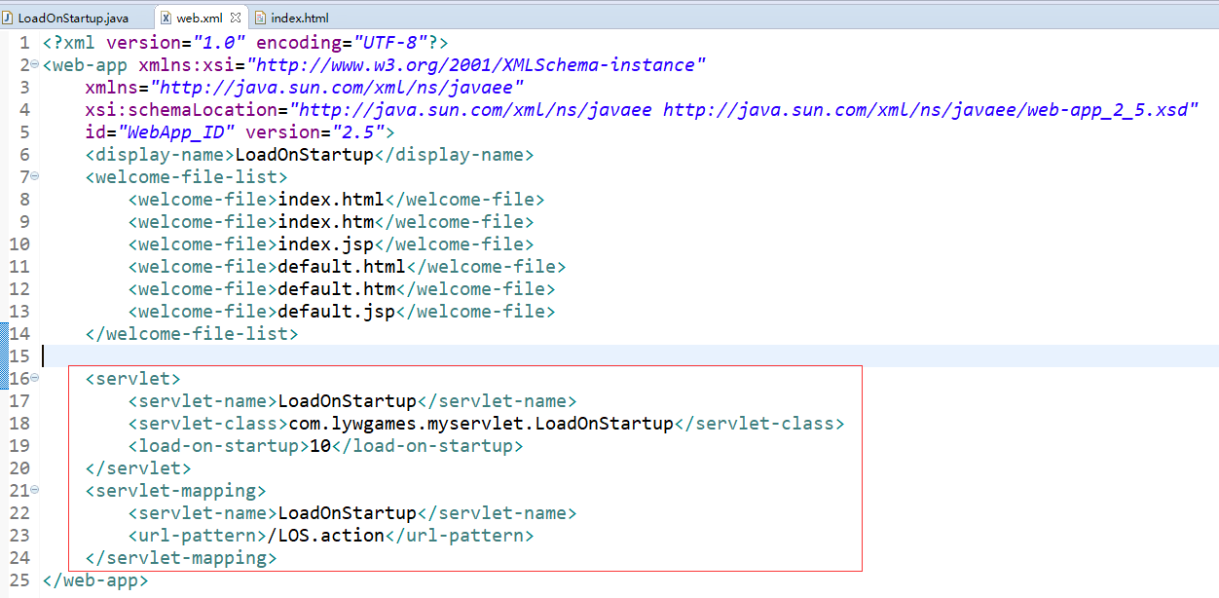

7.运行项目, 在Tomcat7启动之前就打印了我们的构造方法和init方法

