1. Servlet、GenericServlet和HttpServlet的继承关系:

Servlet (接口)

|

|

GenericServlet

|

|

HttpServlet (用于处理http的请求)

1. 在Eclipse使用Ctrl+T快捷键查看Servlet、GenericServlet和HttpServlet的继承关系:

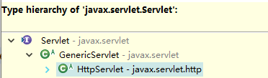

3.新建一个HelloWorldHttpServlet的Web工程

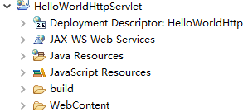

4.在WebContent下新建一个index.html

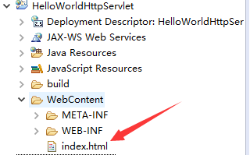

5.编写index.html

|  |
| --- |
| <!DOCTYPE html>  <html>  <head>  <meta charset="UTF-8">  <title>Hello World HttpServlet</title>  </head>  <body>  <h1>Hello World HttpServlet</h1>  </body>  </html> |

6.新建一个HelloWorldHttpServlet.java类

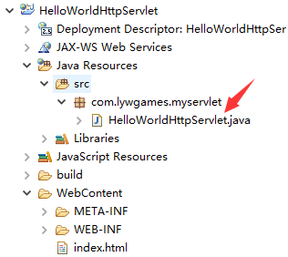

7.编写HelloWorldHttpServlet.java, 这里我们不再实行Servlet接口, 而是继承HttpServlet这个抽象类

|  |
| --- |
| package com.lywgames.myservlet;  import java.io.IOException;  import javax.servlet.ServletException;  import javax.servlet.http.HttpServlet;  import javax.servlet.http.HttpServletRequest;  import javax.servlet.http.HttpServletResponse;  public class HelloWorldHttpServlet extends HttpServlet {  private static final long serialVersionUID = 1L;  @Override  protected void doGet(HttpServletRequest req, HttpServletResponse resp) throws ServletException, IOException {  System.out.println("doGet");  }    @Override  protected void doPost(HttpServletRequest req, HttpServletResponse resp) throws ServletException, IOException {  doGet(req, resp);  }  } |

8.在web.xml里配置servlet

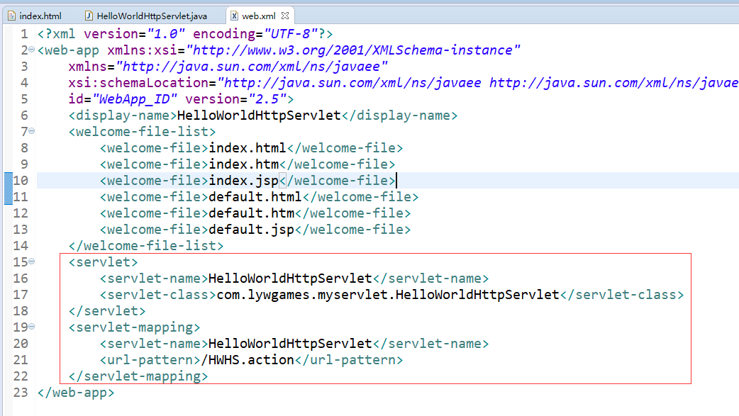

1. 运行项目, 在浏览器的地址栏中输入:

http://localhost:8080/HelloWorldHttpServlet/HWHS.action访问几次

