1. ServletConfig: 可以获取servlet的一些配置信息。

2.新建一个UseServletConfig的Web工程

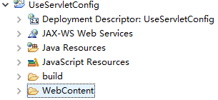

3.在WebContent下新建一个index.html

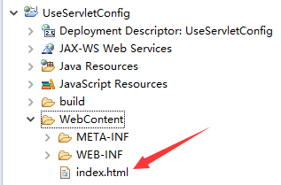

4.编写index.html

|  |
| --- |
| <!DOCTYPE html>  <html>  <head>  <meta charset="UTF-8">  <title>Use Servlet Config</title>  </head>  <body>  <h1>Use Servlet Config</h1>  </body>  </html> |

5.新建一个UseServletConfig.java

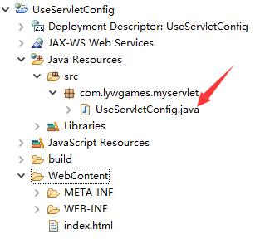

6.编写UseServletConfig.java

|  |
| --- |
| package com.lywgames.myservlet;  import java.io.IOException;  import java.util.Enumeration;  import javax.servlet.ServletConfig;  import javax.servlet.ServletException;  import javax.servlet.http.HttpServlet;  import javax.servlet.http.HttpServletRequest;  import javax.servlet.http.HttpServletResponse;  public class UseServletConfig extends HttpServlet {  private static final long serialVersionUID = 1L;  @Override  protected void doGet(HttpServletRequest req, HttpServletResponse resp) throws ServletException, IOException {  // ServletConfig: 可以获取servlet的一些配置信息。    //1. 得到servlet配置对象, 专门用于获取配置在servlet的信息  ServletConfig servletConfig = getServletConfig();  //2. 获取到的是配置servlet里面servlet-name的文本内容  String servletName = servletConfig.getServletName();  System.out.println("servletName = " + servletName);    //3. 可以获取具体的某一个参数。  String address = servletConfig.getInitParameter("address");  System.out.println("address = " + address);    //4. 获取所有的参数名称  Enumeration<String> names = servletConfig.getInitParameterNames();  //5. 遍历取出所有的参数名称  while (names.hasMoreElements()) {  String key = (String) names.nextElement();  String value = servletConfig.getInitParameter(key);  System.out.println("key = " + key + ", value = "+value);  }  }    @Override  protected void doPost(HttpServletRequest req, HttpServletResponse resp) throws ServletException, IOException {  doGet(req, resp);  }  } |

7.在web.xml里配置servlet, 并且配置一些初始化信息

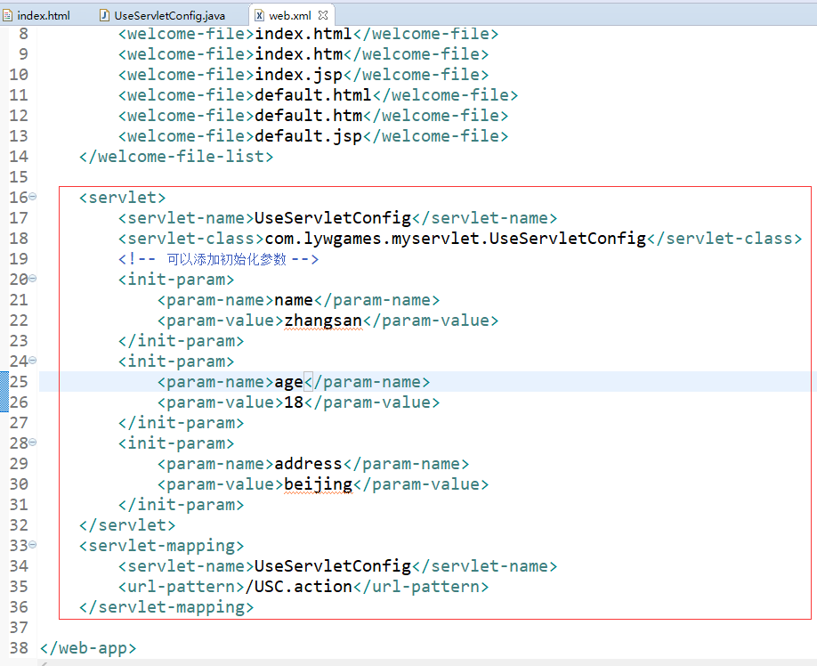

1. 在浏览器地址栏中输入:

http://localhost:8080/UseServletConfig/USC.action访问一下

