一.HttpServletRequest对象

1.HttpServletRequest对象封装了客户端提交过来的一切数据。

2.HttpServletRequest对象请求头信息

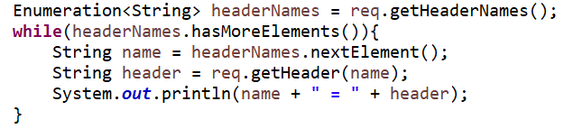

3.HttpServletRequest对象客户端提交过来的数据

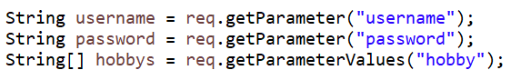

4.HttpServletRequest对象客户端提交过来的数据集合

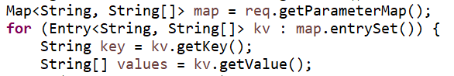

二.HttpServletRequest对象示例

1.新建一个UseHttpServletRequest的Web工程

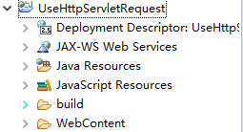

2.在WebContent下新建一个index.html

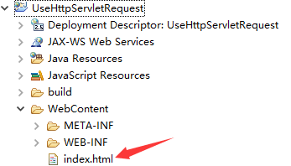

3.编写index.html

|  |
| --- |
| <!DOCTYPE html>  <html>  <head>  <meta charset="UTF-8">  <title>HttpServletRequest</title>  </head>  <body>  <form action="UHSR.action" method="get">  用户名:<input type="text" name="username" /><br />  密&nbsp;&nbsp;&nbsp;&nbsp;码:<input type="password" name="password" /><br />  爱&nbsp;&nbsp;&nbsp;&nbsp;好:<input type="checkbox" name="hobby" value="1">读书  <input type="checkbox" name="hobby" value="2">游泳<input type="checkbox" name="hobby" value="3">美食<br />  <input type="submit" value="登录">  </form>  </body>  </html> |

4.新建一个UseHttpServletRequest.java类

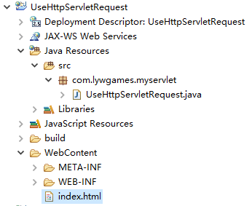

5.编写UseHttpServletRequest.java

|  |
| --- |
| package com.lywgames.myservlet;  import java.io.IOException;  import java.util.Enumeration;  import java.util.Map;  import java.util.Map.Entry;  import javax.servlet.ServletException;  import javax.servlet.http.HttpServlet;  import javax.servlet.http.HttpServletRequest;  import javax.servlet.http.HttpServletResponse;  public class UseHttpServletRequest extends HttpServlet {  private static final long serialVersionUID = 1L;  // 获取请求头信息  private void getHeaders(HttpServletRequest req, HttpServletResponse resp){  Enumeration<String> headerNames = req.getHeaderNames();  while(headerNames.hasMoreElements()){  String name = headerNames.nextElement();  String header = req.getHeader(name);  System.out.println(name + " = " + header);  }  }    @Override  protected void doGet(HttpServletRequest req, HttpServletResponse resp) throws ServletException, IOException {  getHeaders(req, resp);    String username = req.getParameter("username");  String password = req.getParameter("password");  String[] hobbys = req.getParameterValues("hobby");  StringBuffer sb = new StringBuffer();  sb.append("[");  for (int i = 0; i < hobbys.length; i++) {  if(i != 0){  sb.append(",");  }  sb.append(hobbys[i]);  }  sb.append("]");    System.out.println("username = " + username + " password = " + password + " hobby = " + sb.toString());    StringBuilder buffer = new StringBuilder();  Map<String, String[]> map = req.getParameterMap();  for (Entry<String, String[]> kv : map.entrySet()) {  String key = kv.getKey();  String[] values = kv.getValue();  if(values.length <= 1){  buffer.append(key + " = " + values[0]);  }else{  buffer.append(key + " = [");  for (int i = 0; i < values.length; i++) {  if(i != 0){  buffer.append(",");  }  buffer.append(values[i]);  }  buffer.append("]");  }  buffer.append(" ");  }  System.out.println(buffer.toString());  }    @Override  protected void doPost(HttpServletRequest req, HttpServletResponse resp) throws ServletException, IOException {  doGet(req, resp);  }  } |

6.编写web.xml

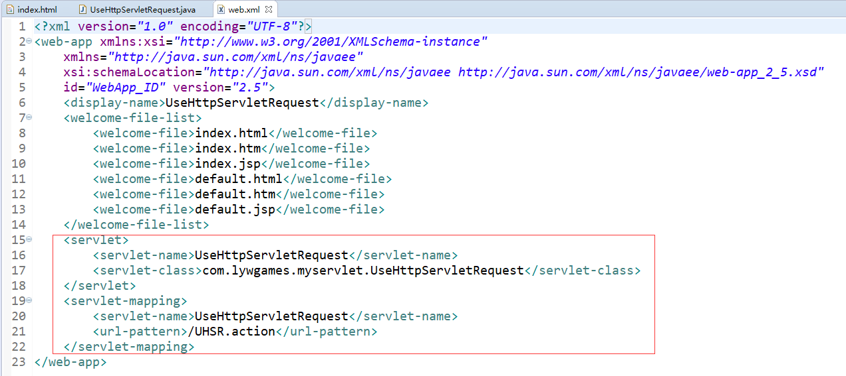

7.发布运行UseHttpServletRequest工程

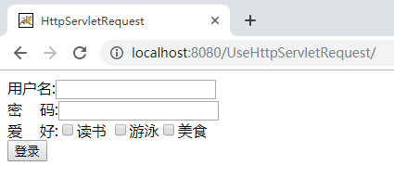

8.输入用户信息

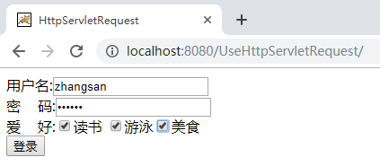

1. 点击登录按钮, 控制台打印信息

