一.HttpServletResponse的作用

1.HttpServletResponse返回数据给客户端。

2.HttpServletResponse的getWriter()方法, 向客户端输出字符流。

3.HttpServletResponse的getOutputStream()方法, 向客户端输出字节流。

二.新建一个Web工程向客户端输出字符流和字节流

1.新建一个UseHttpServletResponse的Web工程

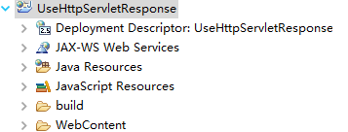

2.新建GetWriter.java和GetOutputStream.java向客户端输出字节流和字符流

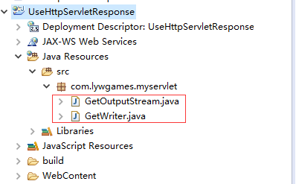

3.编写GetWriter.java

|  |
| --- |
| package com.lywgames.myservlet;  import java.io.IOException;  import javax.servlet.ServletException;  import javax.servlet.http.HttpServlet;  import javax.servlet.http.HttpServletRequest;  import javax.servlet.http.HttpServletResponse;  public class GetWriter extends HttpServlet {  private static final long serialVersionUID = 1L;  @Override  protected void doGet(HttpServletRequest req, HttpServletResponse resp) throws ServletException, IOException {  StringBuilder sb = new StringBuilder();  sb.append("<!DOCTYPE html>").append("\r\n");  sb.append("<html>").append("\r\n");  sb.append("<head>").append("\r\n");  sb.append("<meta charset='UTF-8'>").append("\r\n");  sb.append("<title>HttpServletResponse GetWriter</title>").append("\r\n");  sb.append("</head>").append("\r\n");  sb.append("<body>").append("\r\n");  sb.append("<h1>HttpServletResponse GetWriter</h1>").append("\r\n");  sb.append("</body>").append("\r\n");  sb.append("</html>");  // HttpServletResponse的getWriter()方法, 向客户端输出字符流  resp.getWriter().println(sb.toString());  }    @Override  protected void doPost(HttpServletRequest req, HttpServletResponse resp) throws ServletException, IOException {  doGet(req, resp);  }  } |

4.编写GetOutputStream.java

|  |
| --- |
| package com.lywgames.myservlet;  import java.io.IOException;  import javax.servlet.ServletException;  import javax.servlet.http.HttpServlet;  import javax.servlet.http.HttpServletRequest;  import javax.servlet.http.HttpServletResponse;  public class GetOutputStream extends HttpServlet {  private static final long serialVersionUID = 1L;  @Override  protected void doGet(HttpServletRequest req, HttpServletResponse resp) throws ServletException, IOException {  StringBuilder sb = new StringBuilder();  sb.append("<!DOCTYPE html>").append("\r\n");  sb.append("<html>").append("\r\n");  sb.append("<head>").append("\r\n");  sb.append("<meta charset='UTF-8'>").append("\r\n");  sb.append("<title>HttpServletResponse GetOutputStream</title>").append("\r\n");  sb.append("</head>").append("\r\n");  sb.append("<body>").append("\r\n");  sb.append("<h1>HttpServletResponse GetOutputStream</h1>").append("\r\n");  sb.append("</body>").append("\r\n");  sb.append("</html>");    // HttpServletResponse的getOutputStream()方法, 向客户端输出字节流  resp.getOutputStream().write(sb.toString().getBytes());  }    @Override  protected void doPost(HttpServletRequest req, HttpServletResponse resp) throws ServletException, IOException {  doGet(req, resp);  }  } |

5.编写web.xml

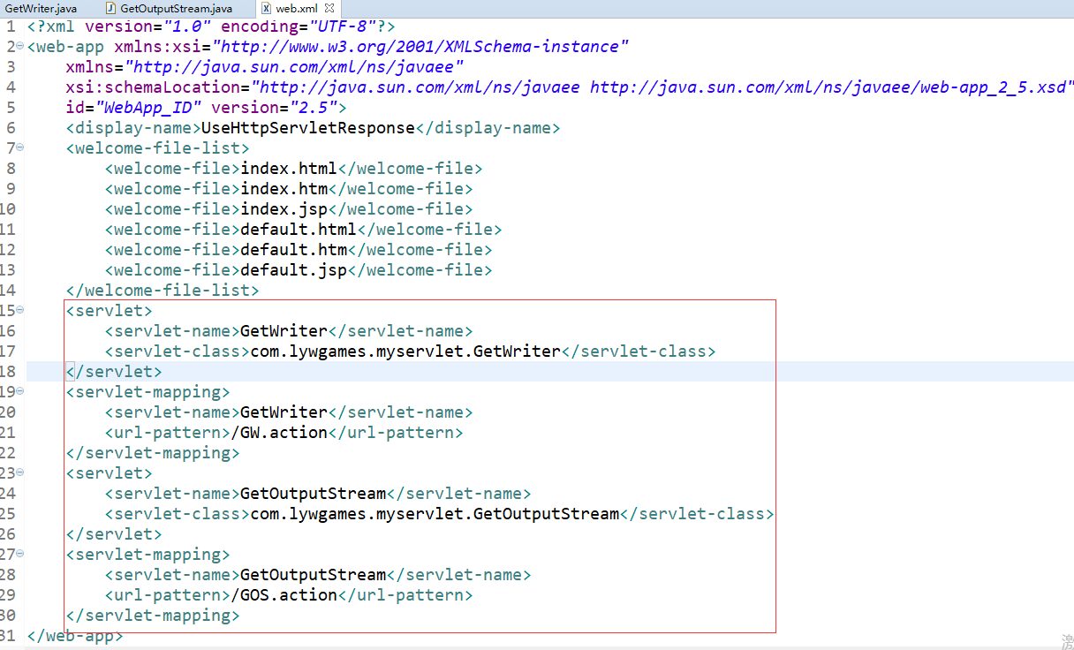

6.部署运行

(1).向客户端输出字符流

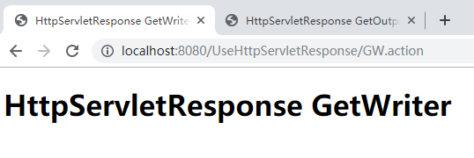

(2).向客户端输出字节流

