二.HttpServletResponse响应乱码处理

1.新建一个ResponseLuanMa的Web工程

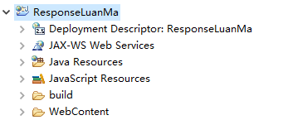

2.使用meta设置网页编码为GB2312

(1).新建一个GWMetaGB2312.java类, 使用字符流响应客户端

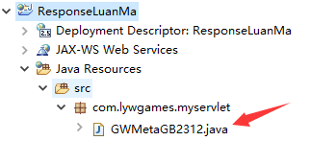

(2).编写GWMetaGB2312.java

|  |
| --- |
| package com.lywgames.myservlet;  import java.io.IOException;  import javax.servlet.ServletException;  import javax.servlet.http.HttpServlet;  import javax.servlet.http.HttpServletRequest;  import javax.servlet.http.HttpServletResponse;  public class GWMetaGB2312 extends HttpServlet {  private static final long serialVersionUID = 1L;  @Override  protected void doGet(HttpServletRequest req, HttpServletResponse resp) throws ServletException, IOException {  StringBuilder sb = new StringBuilder();  sb.append("<!DOCTYPE html>").append("\r\n");  sb.append("<html>").append("\r\n");  sb.append("<head>").append("\r\n");  // 设置网页编码为GB2312  sb.append("<meta charset='GB2312'>").append("\r\n");  sb.append("<title>HttpServletResponse 字符流相应中文乱码</title>").append("\r\n");  sb.append("</head>").append("\r\n");  sb.append("<body>").append("\r\n");  sb.append("<h1>HttpServletResponse 字符流相应中文乱码</h1>").append("\r\n");  sb.append("</body>").append("\r\n");  sb.append("</html>");  // 字符流响应客户端  resp.getWriter().println(sb.toString());  }    @Override  protected void doPost(HttpServletRequest req, HttpServletResponse resp) throws ServletException, IOException {  doGet(req, resp);  }  } |

(3).编写web.xml

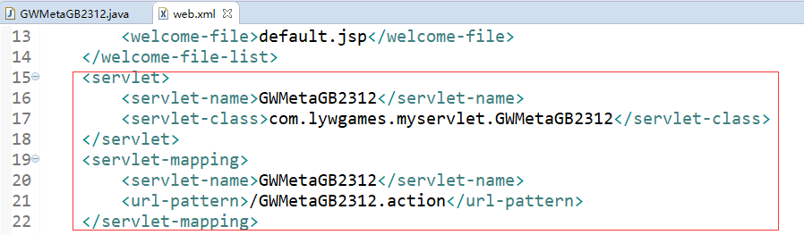

(4).部署运行, 网页的中文显示乱码

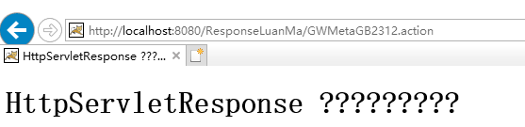

(5).查看网页编码是GB2312, 就是我们在meta中设置的编码

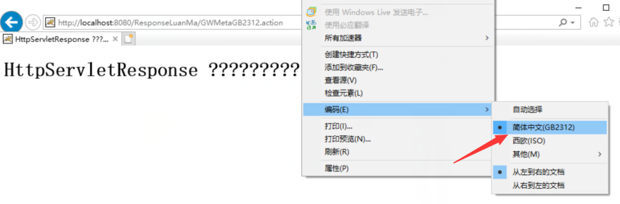

2.使用meta设置网页编码为UTF-8

(1).新建一个GWMetaUTF8.java类, 使用字符流响应客户端

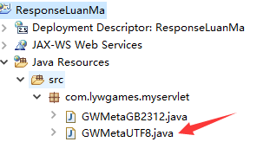

(2).编写GWMetaUTF8.java类

|  |
| --- |
| package com.lywgames.myservlet;  import java.io.IOException;  import javax.servlet.ServletException;  import javax.servlet.http.HttpServlet;  import javax.servlet.http.HttpServletRequest;  import javax.servlet.http.HttpServletResponse;  public class GWMetaUTF8 extends HttpServlet {  private static final long serialVersionUID = 1L;  @Override  protected void doGet(HttpServletRequest req, HttpServletResponse resp) throws ServletException, IOException {  StringBuilder sb = new StringBuilder();  sb.append("<!DOCTYPE html>").append("\r\n");  sb.append("<html>").append("\r\n");  sb.append("<head>").append("\r\n");  // 设置网页编码为UTF-8  sb.append("<meta charset='UTF-8'>").append("\r\n");  sb.append("<title>HttpServletResponse 字符流相应中文乱码</title>").append("\r\n");  sb.append("</head>").append("\r\n");  sb.append("<body>").append("\r\n");  sb.append("<h1>HttpServletResponse 字符流相应中文乱码</h1>").append("\r\n");  sb.append("</body>").append("\r\n");  sb.append("</html>");  // 字符流响应客户端  resp.getWriter().println(sb.toString());  }    @Override  protected void doPost(HttpServletRequest req, HttpServletResponse resp) throws ServletException, IOException {  doGet(req, resp);  }  } |

(3).编写web.xml

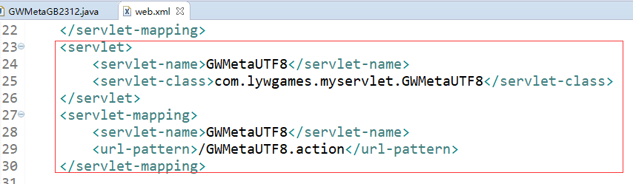

(4).部署运行, 网页的中文显示乱码

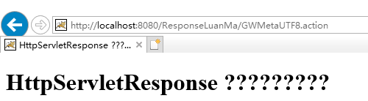

(5).查看网页编码是UTF-8, 就是我们在meta中设置的编码

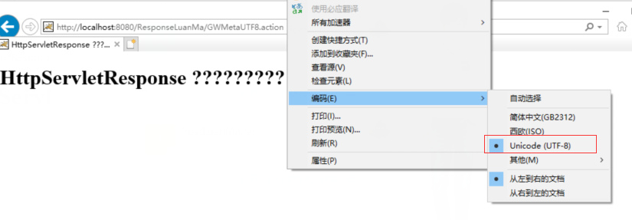

3.使用HttpServletResponse的setCharacterEncoding设置字符编码GB2312

(1).新建一个GWSetCharacterEncodingGB2312.java类, 使用字符流响应客户端

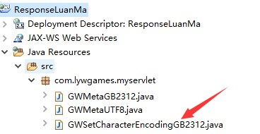

(2).编写GWSetCharacterEncodingGB2312.java类

|  |
| --- |
| package com.lywgames.myservlet;  import java.io.IOException;  import javax.servlet.ServletException;  import javax.servlet.http.HttpServlet;  import javax.servlet.http.HttpServletRequest;  import javax.servlet.http.HttpServletResponse;  public class GWSetCharacterEncodingGB2312 extends HttpServlet {  private static final long serialVersionUID = 1L;  @Override  protected void doGet(HttpServletRequest req, HttpServletResponse resp) throws ServletException, IOException {  StringBuilder sb = new StringBuilder();  sb.append("<!DOCTYPE html>").append("\r\n");  sb.append("<html>").append("\r\n");  sb.append("<head>").append("\r\n");  sb.append("<meta>").append("\r\n");  sb.append("<title>HttpServletResponse 字符流相应中文乱码</title>").append("\r\n");  sb.append("</head>").append("\r\n");  sb.append("<body>").append("\r\n");  sb.append("<h1>HttpServletResponse 字符流相应中文乱码</h1>").append("\r\n");  sb.append("</body>").append("\r\n");  sb.append("</html>");    // 相应给客户端的字符编码GB2312  resp.setCharacterEncoding("GB2312");  // 字符流响应客户端  resp.getWriter().println(sb.toString());  }    @Override  protected void doPost(HttpServletRequest req, HttpServletResponse resp) throws ServletException, IOException {  doGet(req, resp);  }  } |

(3).编写web.xml

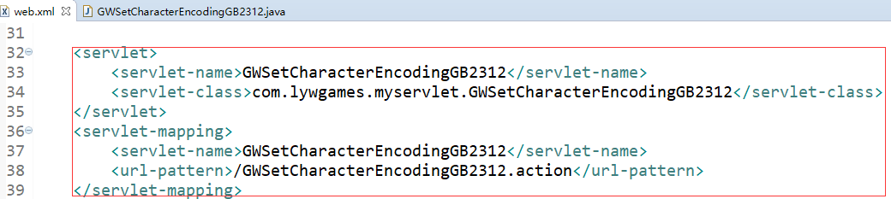

(4).部署运行, 网页的中文显示正常

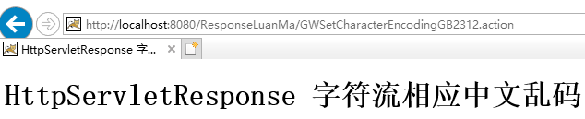

(5).查看网页编码是GB2312, 但是我们并没有设置网页编码

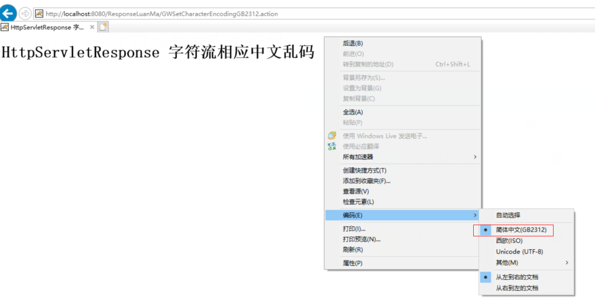

4.使用HttpServletResponse的setCharacterEncoding设置字符编码UTF-8

(1).新建一个GWSetCharacterEncodingUTF8.java类, 使用字符流响应客户端

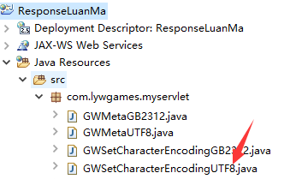

(2).编写GWSetCharacterEncodingUTF8.java类

|  |
| --- |
| package com.lywgames.myservlet;  import java.io.IOException;  import javax.servlet.ServletException;  import javax.servlet.http.HttpServlet;  import javax.servlet.http.HttpServletRequest;  import javax.servlet.http.HttpServletResponse;  public class GWSetCharacterEncodingUTF8 extends HttpServlet {  private static final long serialVersionUID = 1L;  @Override  protected void doGet(HttpServletRequest req, HttpServletResponse resp) throws ServletException, IOException {  StringBuilder sb = new StringBuilder();  sb.append("<!DOCTYPE html>").append("\r\n");  sb.append("<html>").append("\r\n");  sb.append("<head>").append("\r\n");  sb.append("<meta>").append("\r\n");  sb.append("<title>HttpServletResponse 字符流相应中文乱码</title>").append("\r\n");  sb.append("</head>").append("\r\n");  sb.append("<body>").append("\r\n");  sb.append("<h1>HttpServletResponse 字符流相应中文乱码</h1>").append("\r\n");  sb.append("</body>").append("\r\n");  sb.append("</html>");  // 相应给客户端的字符编码UTF-8  resp.setCharacterEncoding("UTF-8");  // 字符流响应客户端  resp.getWriter().println(sb.toString());  }    @Override  protected void doPost(HttpServletRequest req, HttpServletResponse resp) throws ServletException, IOException {  doGet(req, resp);  }  } |

(3).编写web.xml

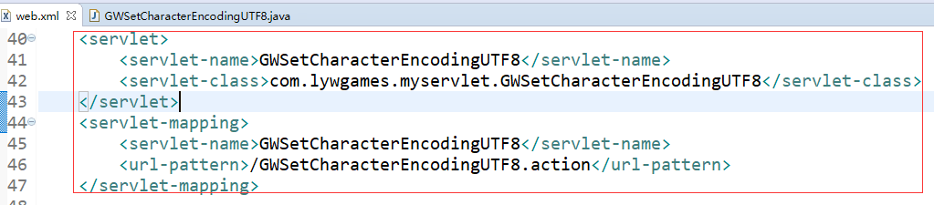

(4).部署运行, 网页的中文显示乱码

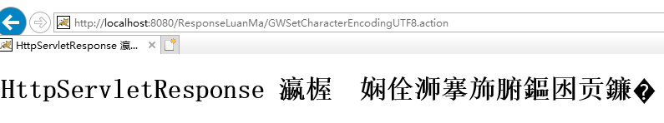

(5).查看网页编码是GB2312, 但是我们并没有设置网页编码

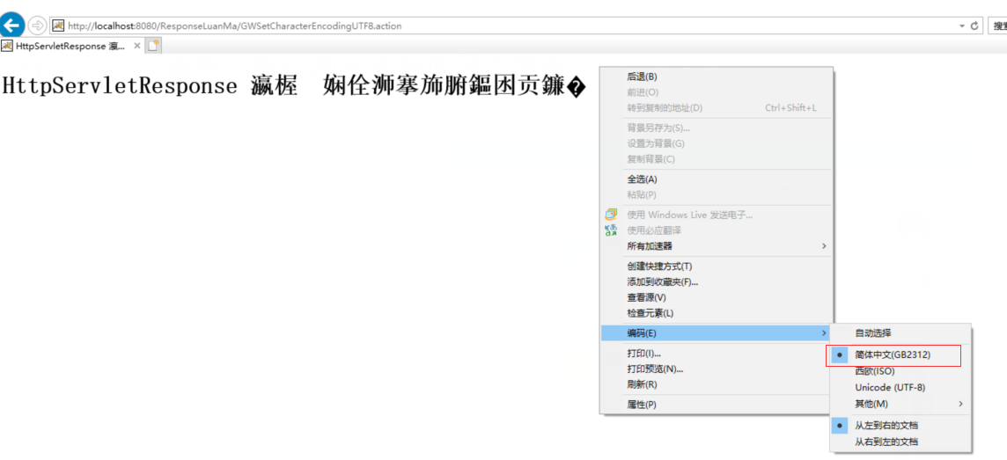

1. .这是我们在浏览器中手动设置编码为UTF-8, 网页的中文显示正常

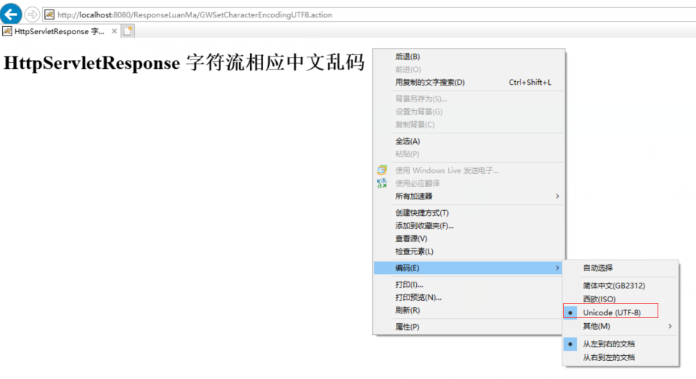

(7).或者, 我们在meta中设置网页编码为UTF-8

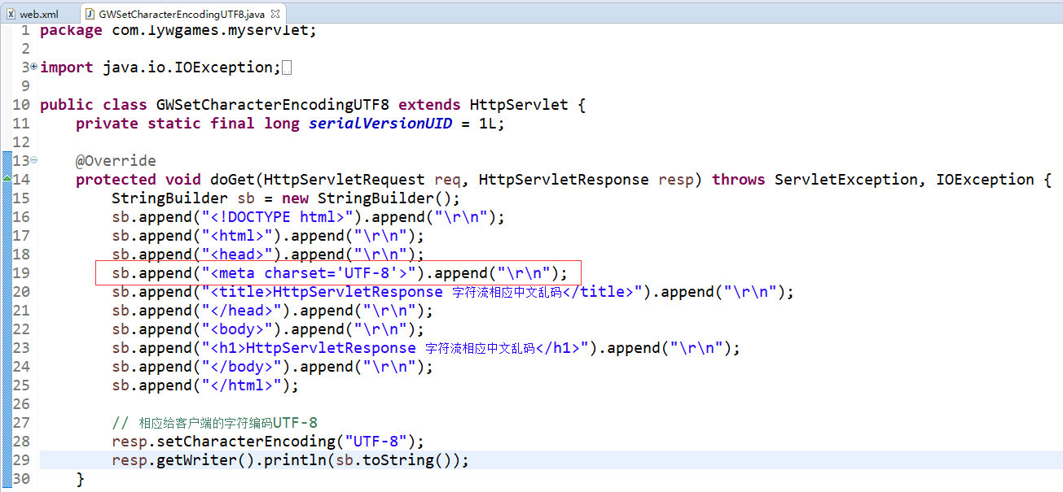

(8).我们在meta中设置网页编码为UTF-8, 重新访问, 网页中文显示正常, 网页编码显示为UTF-8, 其中我们并没有手动在浏览器中设置网页编码。

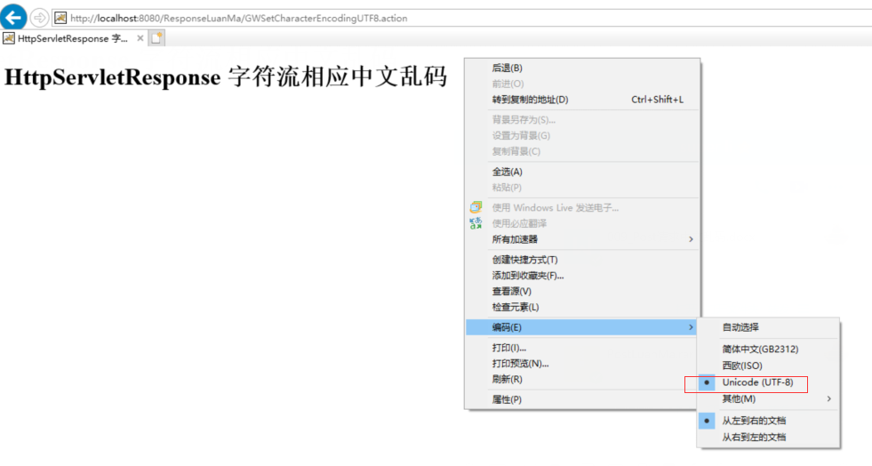

(9).从上面的例子中我们大概知道, 要想相应的中文数据在浏览器中显示正常, 需要设置网页编码和字符编码统一为GB2312或者UTF-8, 推荐使用UTF-8。

5.使用HttpServletResponse的setHeader("Content-Type", "text/html; charset=GB2312"), 相应客户端的内容类型是text/html 编码是GB2312(包含字符编码和网页编码)。

(1).新建一个GWSetHeaderGB2312.java类, 使用字符流响应客户端

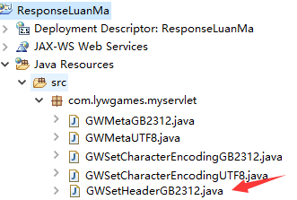

(2).编写GWSetHeaderGB2312.java类

|  |
| --- |
| package com.lywgames.myservlet;  import java.io.IOException;  import javax.servlet.ServletException;  import javax.servlet.http.HttpServlet;  import javax.servlet.http.HttpServletRequest;  import javax.servlet.http.HttpServletResponse;  public class GWSetHeaderGB2312 extends HttpServlet {  private static final long serialVersionUID = 1L;  @Override  protected void doGet(HttpServletRequest req, HttpServletResponse resp) throws ServletException, IOException {  StringBuilder sb = new StringBuilder();  sb.append("<!DOCTYPE html>").append("\r\n");  sb.append("<html>").append("\r\n");  sb.append("<head>").append("\r\n");  sb.append("<meta>").append("\r\n");  sb.append("<title>HttpServletResponse 字符流相应中文乱码</title>").append("\r\n");  sb.append("</head>").append("\r\n");  sb.append("<body>").append("\r\n");  sb.append("<h1>HttpServletResponse 字符流相应中文乱码</h1>").append("\r\n");  sb.append("</body>").append("\r\n");  sb.append("</html>");    // 相应客户端的内容类型是text/html 编码是GB2312(包含字符编码和网页编码)  resp.setHeader("Content-Type", "text/html; charset=GB2312");  // 字符流响应客户端  resp.getWriter().println(sb.toString());  }    @Override  protected void doPost(HttpServletRequest req, HttpServletResponse resp) throws ServletException, IOException {  doGet(req, resp);  }  } |

(3).编写web.xml

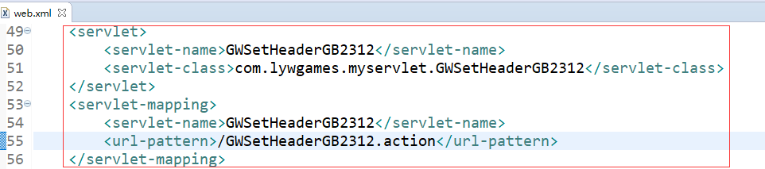

(4).部署运行, 网页的中文显示正常

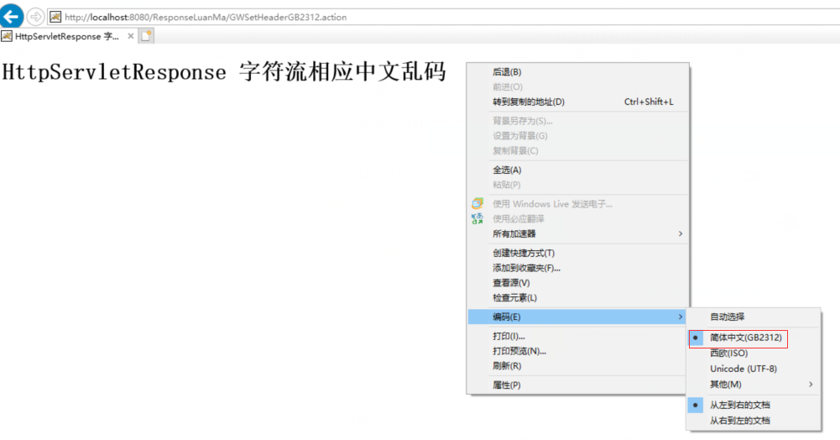

6.使用HttpServletResponse的setHeader("Content-Type", "text/html; charset=UTF8"), 相应客户端的内容类型是text/html 编码是UTF8(包含字符编码和网页编码)。

(1).新建一个GWSetHeaderUTF8.java类, 使用字符流响应客户端

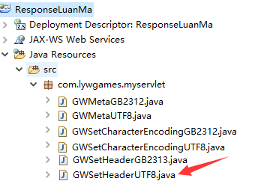

(2).编写GWSetHeaderUTF8.java类

|  |
| --- |
| package com.lywgames.myservlet;  import java.io.IOException;  import javax.servlet.ServletException;  import javax.servlet.http.HttpServlet;  import javax.servlet.http.HttpServletRequest;  import javax.servlet.http.HttpServletResponse;  public class GWSetHeaderUTF8 extends HttpServlet {  private static final long serialVersionUID = 1L;  @Override  protected void doGet(HttpServletRequest req, HttpServletResponse resp) throws ServletException, IOException {  StringBuilder sb = new StringBuilder();  sb.append("<!DOCTYPE html>").append("\r\n");  sb.append("<html>").append("\r\n");  sb.append("<head>").append("\r\n");  sb.append("<meta>").append("\r\n");  sb.append("<title>HttpServletResponse 字符流相应中文乱码</title>").append("\r\n");  sb.append("</head>").append("\r\n");  sb.append("<body>").append("\r\n");  sb.append("<h1>HttpServletResponse 字符流相应中文乱码</h1>").append("\r\n");  sb.append("</body>").append("\r\n");  sb.append("</html>");  // 相应客户端的内容类型是text/html 编码是UTF-8(包含字符编码和网页编码)  resp.setHeader("Content-Type", "text/html; charset=UTF-8");  // 字符流响应客户端  resp.getWriter().println(sb.toString());  }    @Override  protected void doPost(HttpServletRequest req, HttpServletResponse resp) throws ServletException, IOException {  doGet(req, resp);  }  } |

(3).编写web.xml

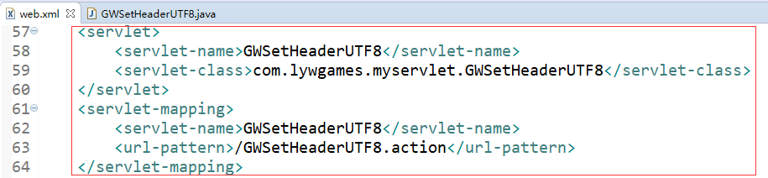

1. .部署运行, 网页的中文显示正常

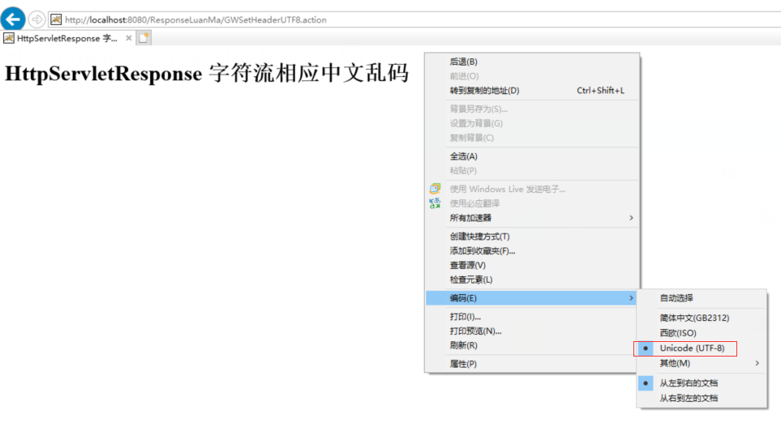

1. 用HttpServletResponse的setContentType("text/html;charset=GB2312")

, 相应客户端的内容类型是text/html 编码是GB2312(包含字符编码和网页编码)。推荐使用setContentType方法。

(1).新建一个GWSetContentTypeGB2312.java类, 使用字符流响应客户端

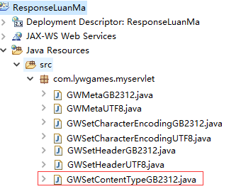

(2).编写GWSetContentTypeGB2312.java类

|  |
| --- |
| package com.lywgames.myservlet;  import java.io.IOException;  import javax.servlet.ServletException;  import javax.servlet.http.HttpServlet;  import javax.servlet.http.HttpServletRequest;  import javax.servlet.http.HttpServletResponse;  public class GWSetContentTypeGB2312 extends HttpServlet {  private static final long serialVersionUID = 1L;  @Override  protected void doGet(HttpServletRequest req, HttpServletResponse resp) throws ServletException, IOException {  StringBuilder sb = new StringBuilder();  sb.append("<!DOCTYPE html>").append("\r\n");  sb.append("<html>").append("\r\n");  sb.append("<head>").append("\r\n");  // 网页编码GB2312  sb.append("<meta charset='GB2312'>").append("\r\n");  sb.append("<title>HttpServletResponse 字符流相应中文乱码</title>").append("\r\n");  sb.append("</head>").append("\r\n");  sb.append("<body>").append("\r\n");  sb.append("<h1>HttpServletResponse 字符流相应中文乱码</h1>").append("\r\n");  sb.append("</body>").append("\r\n");  sb.append("</html>");    // 相应客户端的内容类型是text/html 编码是GB2312(包含字符编码和网页编码)  resp.setContentType("text/html;charset=GB2312");  // 字符流响应客户端  resp.getWriter().println(sb.toString());  }    @Override  protected void doPost(HttpServletRequest req, HttpServletResponse resp) throws ServletException, IOException {  doGet(req, resp);  }  } |

(3).编写web.xml

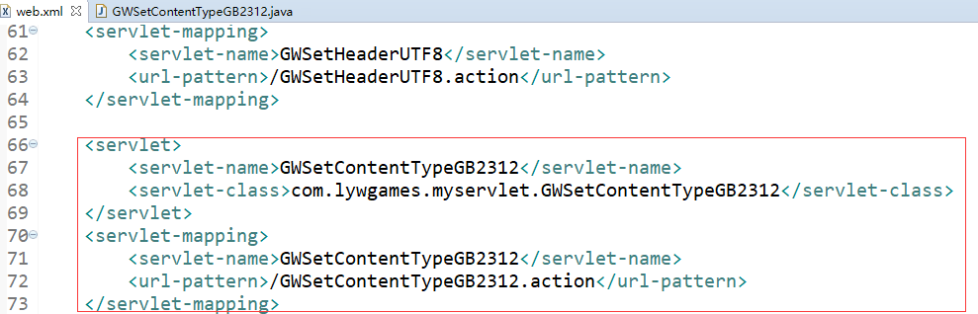

(4).部署运行, 网页的中文显示正常

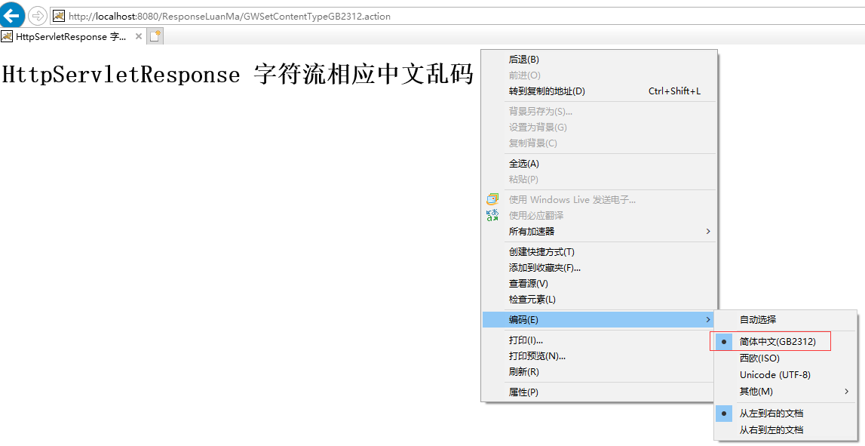

8.用HttpServletResponse的setContentType("text/html;charset=UTF8"), 相应客户端的内容类型是text/html 编码是UTF8(包含字符编码和网页编码)。

(1).新建一个GWSetContentTypeUTF8.java类, 使用字符流响应客户端

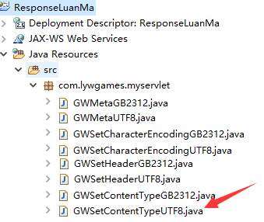

(2).编写GWSetContentTypeUTF8.java类

|  |
| --- |
| package com.lywgames.myservlet;  import java.io.IOException;  import javax.servlet.ServletException;  import javax.servlet.http.HttpServlet;  import javax.servlet.http.HttpServletRequest;  import javax.servlet.http.HttpServletResponse;  public class GWSetContentTypeUTF8 extends HttpServlet {  private static final long serialVersionUID = 1L;  @Override  protected void doGet(HttpServletRequest req, HttpServletResponse resp) throws ServletException, IOException {  StringBuilder sb = new StringBuilder();  sb.append("<!DOCTYPE html>").append("\r\n");  sb.append("<html>").append("\r\n");  sb.append("<head>").append("\r\n");  // 网页编码UTF-8  sb.append("<meta charset='UTF-8'>").append("\r\n");  sb.append("<title>HttpServletResponse 字符流相应中文乱码</title>").append("\r\n");  sb.append("</head>").append("\r\n");  sb.append("<body>").append("\r\n");  sb.append("<h1>HttpServletResponse 字符流相应中文乱码</h1>").append("\r\n");  sb.append("</body>").append("\r\n");  sb.append("</html>");  // 相应客户端的内容类型是text/html 编码是UTF-8(包含字符编码和网页编码)  resp.setContentType("text/html;charset=UTF-8");  // 字符流响应客户端  resp.getWriter().println(sb.toString());  }    @Override  protected void doPost(HttpServletRequest req, HttpServletResponse resp) throws ServletException, IOException {  doGet(req, resp);  }  } |

(3).编写web.xml

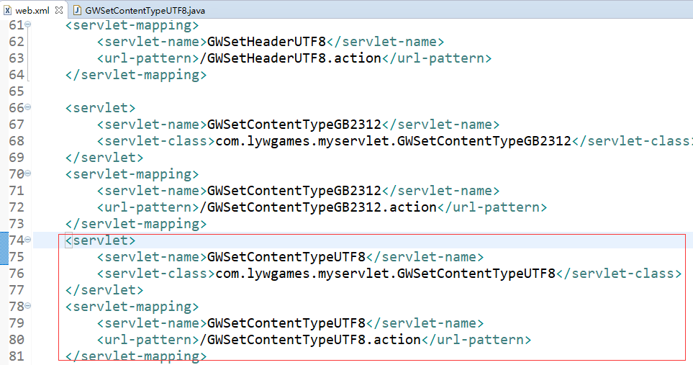

1. .部署运行, 网页的中文显示正常

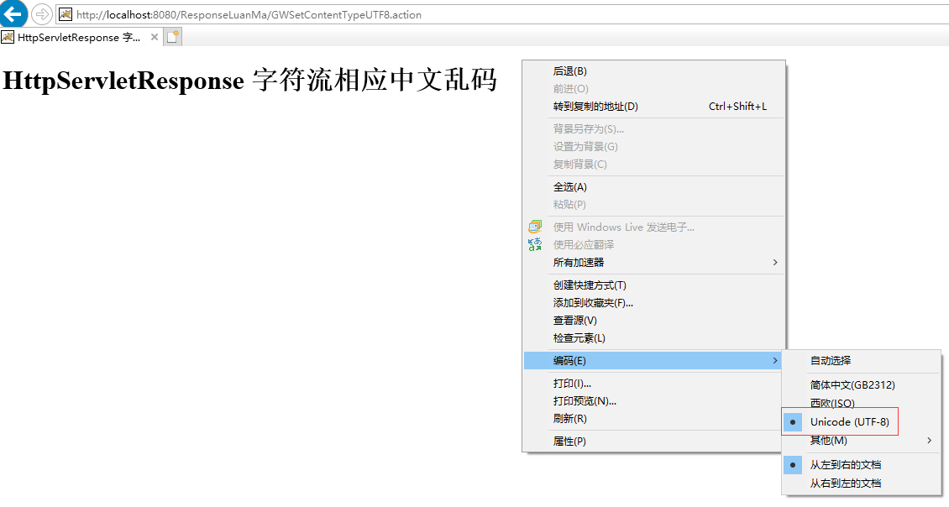

9.使用字节流响应数据, 字节流默认字符编码是UTF-8

(1).新建类GetOutputStreamLuanMa.java

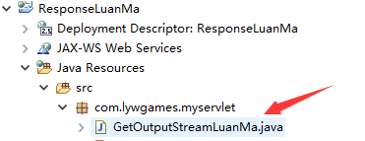

(2).编写GetOutputStreamLuanMa.java

|  |
| --- |
| package com.lywgames.myservlet;  import java.io.IOException;  import javax.servlet.ServletException;  import javax.servlet.http.HttpServlet;  import javax.servlet.http.HttpServletRequest;  import javax.servlet.http.HttpServletResponse;  public class GetOutputStreamLuanMa extends HttpServlet {  private static final long serialVersionUID = 1L;  @Override  protected void doGet(HttpServletRequest req, HttpServletResponse resp) throws ServletException, IOException {  StringBuilder sb = new StringBuilder();  sb.append("<!DOCTYPE html>").append("\r\n");  sb.append("<html>").append("\r\n");  sb.append("<head>").append("\r\n");  sb.append("<meta charset='UTF-8'>").append("\r\n");  sb.append("<title>HttpServletResponse 字节流相应中文乱码</title>").append("\r\n");  sb.append("</head>").append("\r\n");  sb.append("<body>").append("\r\n");  sb.append("<h1>HttpServletResponse 字节流相应中文乱码</h1>").append("\r\n");  sb.append("</body>").append("\r\n");  sb.append("</html>");    // 字节流, 默认字符编码是UTF-8  resp.getOutputStream().write(sb.toString().getBytes());  }    @Override  protected void doPost(HttpServletRequest req, HttpServletResponse resp) throws ServletException, IOException {  doGet(req, resp);  }  } |

(3).编写web.xml

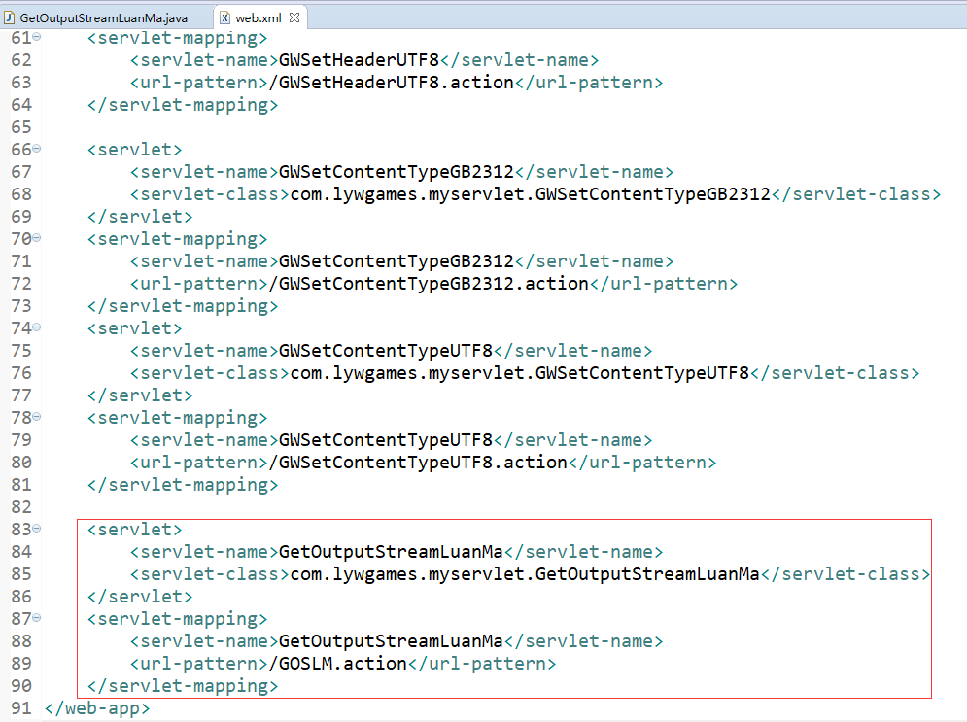

(4).部署运行

