一.Servlet上下文

1.每个web工程都只有一个ServletContext对象。也就是在同一个web工程里,所有的servlet获取到的这个类的对象都是同一个。

2.获取上下文对象:ServletContext context = getServletContext();

3.ServletContext 的作用

(1). 获取全局配置参数;

(2). 获取web工程中的资源;

(3). 存取数据, servlet间共享数据。

4.ServletContext何时创建: 服务器启动的时候， 会为托管的每一个web应用程序, 创建一个ServletContext对象。

5.ServletContext何时销毁: 从服务器移除托管或者是关闭服务器。

6.ServletContext 的作用范围: 只要在这个项目里面, 都可以取。

二.ServletContext 获取全局配置参数

1.新建一个UseServletContext的Web工程

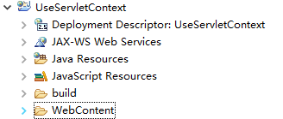

2.在下WebContent新建一个index.html

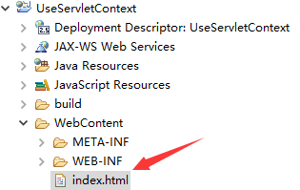

3.编写index.html

|  |
| --- |
| <!DOCTYPE html>  <html>  <head>  <meta charset="UTF-8">  <title>servlet上下文</title>  </head>  <body>  <a href="GetContextParam.action">获取全局配置参数</a><br/>  </body>  </html> |

4.新建一个GetContextParam.java类

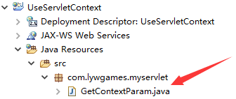

5.编辑GetContextParam.java

|  |
| --- |
| package com.lywgames.myservlet;  import java.io.IOException;  import javax.servlet.ServletContext;  import javax.servlet.ServletException;  import javax.servlet.http.HttpServlet;  import javax.servlet.http.HttpServletRequest;  import javax.servlet.http.HttpServletResponse;  public class GetContextParam extends HttpServlet {  private static final long serialVersionUID = 1L;  @Override  protected void doGet(HttpServletRequest req, HttpServletResponse resp) throws ServletException, IOException {  // 获取ServletContext对象  ServletContext servletContext = getServletContext();  // 获取全局配置参数  String address = servletContext.getInitParameter("address");  System.out.println("address = " + address);  }    @Override  protected void doPost(HttpServletRequest req, HttpServletResponse resp) throws ServletException, IOException {  doGet(req, resp);  }  } |

6.编辑web.xml

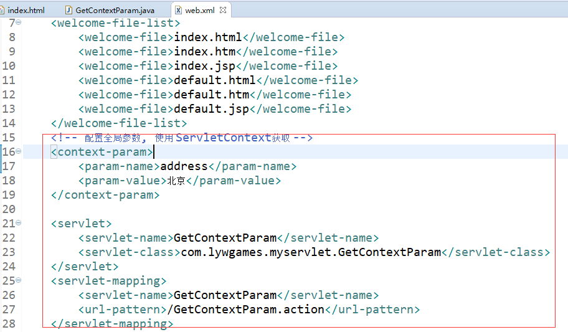

7.部署运行

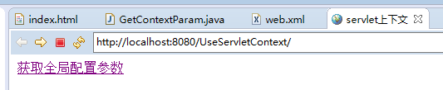

8.点击”获取全局配置参数”超链接, 控制台打印

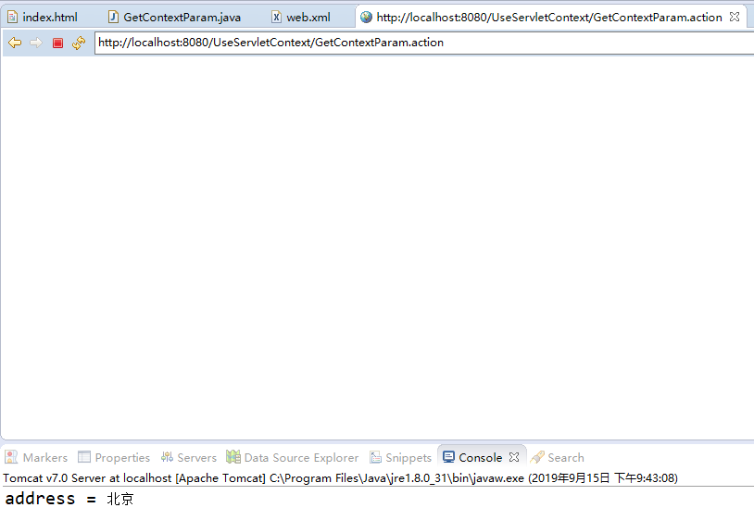

三.ServletContext 获取资源

1.在WebContent目录下, 新建一个file目录, 放入config.properties文件, 文件内容如下图:

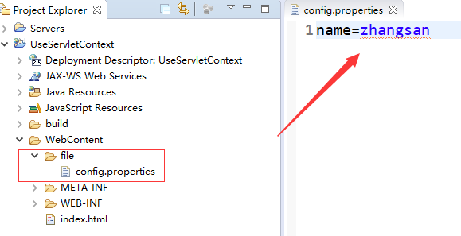

2.servletContext.getRealPath("/"): 工程在tomcat里面的根目录。

C:\Users\lywgames\Desktop\software\apache-tomcat-7.0.52\wtpwebapps\UseServletContext\

3.新建一个GetResources.java类

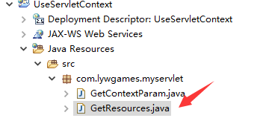

4.编辑GetResources.java, 使用getRealPath获取资源

|  |
| --- |
| package com.lywgames.myservlet;  import java.io.FileInputStream;  import java.io.IOException;  import java.util.Properties;  import javax.servlet.ServletContext;  import javax.servlet.ServletException;  import javax.servlet.http.HttpServlet;  import javax.servlet.http.HttpServletRequest;  import javax.servlet.http.HttpServletResponse;  public class GetResources extends HttpServlet {  private static final long serialVersionUID = 1L;  @Override  protected void doGet(HttpServletRequest req, HttpServletResponse resp) throws ServletException, IOException {  // 获取ServletContext对象  ServletContext servletContext = getServletContext();  /* servletContext.getRealPath("/"): 工程在tomcat里面的根目录。  * C:\Users\lywgames\Desktop\software\apache-tomcat-7.0.52\wtpwebapps\UseServletContext\  */  // 获取给定的文件在服务器上面的绝对路径  String realPath = servletContext.getRealPath("file/config.properties");  Properties properties = new Properties();  properties.load(new FileInputStream(realPath));  System.out.println("name = " + properties.getProperty("name"));  }    @Override  protected void doPost(HttpServletRequest req, HttpServletResponse resp) throws ServletException, IOException {  doGet(req, resp);  }  } |

5.编写web.xml

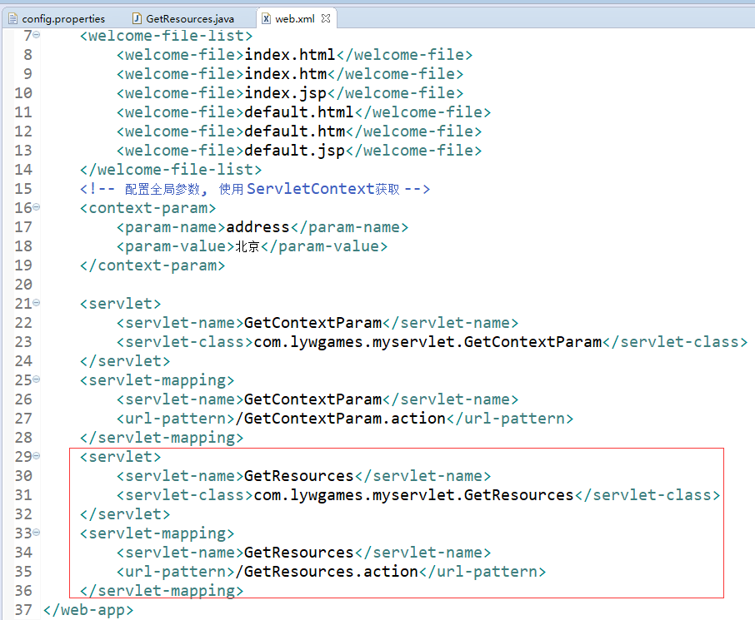

6.编辑index.html

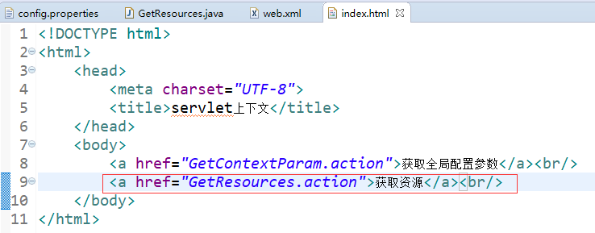

7.部署运行项目

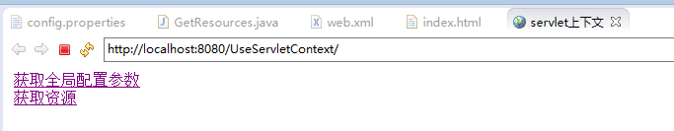

8.点击”获取资源”超链接, 控制台打印

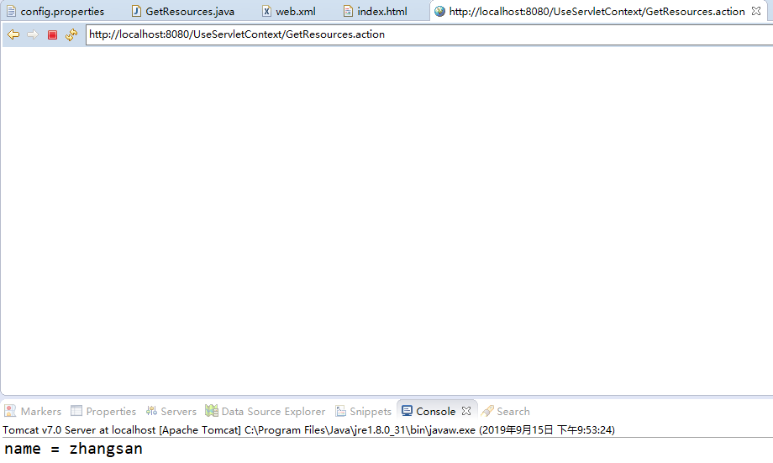

1. 使用servletContext.getResourceAsStream获取资源, 继续编辑我们的GetResources.java

|  |
| --- |
| package com.lywgames.myservlet;  import java.io.FileInputStream;  import java.io.IOException;  import java.io.InputStream;  import java.util.Properties;  import javax.servlet.ServletContext;  import javax.servlet.ServletException;  import javax.servlet.http.HttpServlet;  import javax.servlet.http.HttpServletRequest;  import javax.servlet.http.HttpServletResponse;  public class GetResources extends HttpServlet {  private static final long serialVersionUID = 1L;  public void getRealPath() throws ServletException, IOException {  // 获取ServletContext对象  ServletContext servletContext = getServletContext();  /* servletContext.getRealPath("/"): 工程在tomcat里面的根目录。  * C:\Users\lywgames\Desktop\software\apache-tomcat-7.0.52\wtpwebapps\UseServletContext\  */  // 获取给定的文件在服务器上面的绝对路径  String realPath = servletContext.getRealPath("file/config.properties");  Properties properties = new Properties();  properties.load(new FileInputStream(realPath));  System.out.println("name = " + properties.getProperty("name"));  }    @Override  protected void doGet(HttpServletRequest req, HttpServletResponse resp) throws ServletException, IOException {  // 获取ServletContext对象  ServletContext servletContext = getServletContext();  // servletContext.getResourceAsStream使用工程在tomcat里面的根目录。  InputStream is = servletContext.getResourceAsStream("file/config.properties");  Properties properties = new Properties();  properties.load(is);  System.out.println("name = " + properties.getProperty("name"));  }    @Override  protected void doPost(HttpServletRequest req, HttpServletResponse resp) throws ServletException, IOException {  doGet(req, resp);  }  } |

10.类路径相对的是classes目录

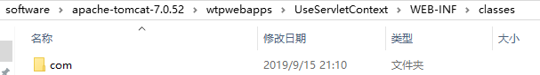

11.使用类路径获取资源, 继续编辑我们的GetResources.java

|  |
| --- |
| package com.lywgames.myservlet;  import java.io.FileInputStream;  import java.io.IOException;  import java.io.InputStream;  import java.util.Properties;  import javax.servlet.ServletContext;  import javax.servlet.ServletException;  import javax.servlet.http.HttpServlet;  import javax.servlet.http.HttpServletRequest;  import javax.servlet.http.HttpServletResponse;  public class GetResources extends HttpServlet {  private static final long serialVersionUID = 1L;  public void getRealPath() throws ServletException, IOException {  // 获取ServletContext对象  ServletContext servletContext = getServletContext();  /* servletContext.getRealPath("/"): 工程在tomcat里面的根目录。  * C:\Users\lywgames\Desktop\software\apache-tomcat-7.0.52\wtpwebapps\UseServletContext\  */  // 获取给定的文件在服务器上面的绝对路径  String realPath = servletContext.getRealPath("file/config.properties");  Properties properties = new Properties();  properties.load(new FileInputStream(realPath));  System.out.println("name = " + properties.getProperty("name"));  }    public void getResourceAsStream() throws ServletException, IOException {  // 获取ServletContext对象  ServletContext servletContext = getServletContext();  // servletContext.getResourceAsStream使用工程在tomcat里面的根目录。  InputStream is = servletContext.getResourceAsStream("file/config.properties");  Properties properties = new Properties();  properties.load(is);  System.out.println("name = " + properties.getProperty("name"));  }    @Override  protected void doGet(HttpServletRequest req, HttpServletResponse resp) throws ServletException, IOException {  // 类路径相对于classes路径:C:\Users\lywgames\Desktop\software\apache-tomcat-7.0.52\wtpwebapps\UseServletContext\WEB-INF\classes  InputStream is = this.getClass().getClassLoader().getResourceAsStream("../../file/config.properties");  Properties properties = new Properties();  properties.load(is);  System.out.println("name = " + properties.getProperty("name"));  }    @Override  protected void doPost(HttpServletRequest req, HttpServletResponse resp) throws ServletException, IOException {  doGet(req, resp);  }  } |

四.ServletContext存取数据, servlet间共享数据

1.新建CunQuData.java和OutLoginCount.java

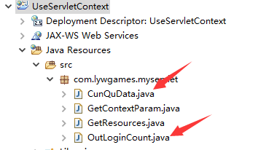

2.编辑CunQuData.java

|  |
| --- |
| package com.lywgames.myservlet;  import java.io.IOException;  import javax.servlet.ServletContext;  import javax.servlet.ServletException;  import javax.servlet.http.HttpServlet;  import javax.servlet.http.HttpServletRequest;  import javax.servlet.http.HttpServletResponse;  public class CunQuData extends HttpServlet {  private static final long serialVersionUID = 1L;  @Override  protected void doGet(HttpServletRequest req, HttpServletResponse resp) throws ServletException, IOException {  // 获取ServletContext对象  ServletContext servletContext = getServletContext();    Object loginCount = servletContext.getAttribute("loginCount");  if(loginCount != null){  servletContext.setAttribute("loginCount", (((int)loginCount) + 1));  }else{  servletContext.setAttribute("loginCount", 1);  }    resp.sendRedirect("OutLoginCount.action");  }    @Override  protected void doPost(HttpServletRequest req, HttpServletResponse resp) throws ServletException, IOException {  doGet(req, resp);  }  } |

3.编辑OutLoginCount.java

|  |
| --- |
| package com.lywgames.myservlet;  import java.io.IOException;  import javax.servlet.ServletContext;  import javax.servlet.ServletException;  import javax.servlet.http.HttpServlet;  import javax.servlet.http.HttpServletRequest;  import javax.servlet.http.HttpServletResponse;  public class OutLoginCount extends HttpServlet {  private static final long serialVersionUID = 1L;  @Override  protected void doGet(HttpServletRequest req, HttpServletResponse resp) throws ServletException, IOException {  // 获取ServletContext对象  ServletContext servletContext = getServletContext();  int loginCount = (int)servletContext.getAttribute("loginCount");    StringBuilder sb = new StringBuilder();  sb.append("<!DOCTYPE html>").append("\r\n");  sb.append("<html>").append("\r\n");  sb.append("<head>").append("\r\n");  // 网页编码UTF-8  sb.append("<meta charset='UTF-8'>").append("\r\n");  sb.append("<title>登录次数</title>").append("\r\n");  sb.append("</head>").append("\r\n");  sb.append("<body>").append("\r\n");  sb.append("<h1>登录次数:").append(loginCount).append("</h1>").append("\r\n");  sb.append("</body>").append("\r\n");  sb.append("</html>");  // 相应客户端的内容类型是text/html 编码是UTF-8(包含字符编码和网页编码)  resp.setContentType("text/html;charset=UTF-8");  // 字符流响应客户端  resp.getWriter().println(sb.toString());  }    @Override  protected void doPost(HttpServletRequest req, HttpServletResponse resp) throws ServletException, IOException {  doGet(req, resp);  }  } |

4.编辑index.html

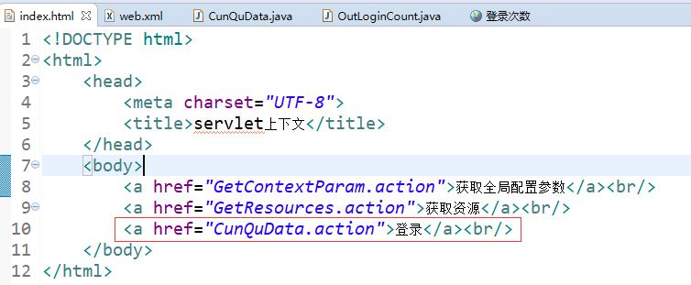

5.编辑web.xml

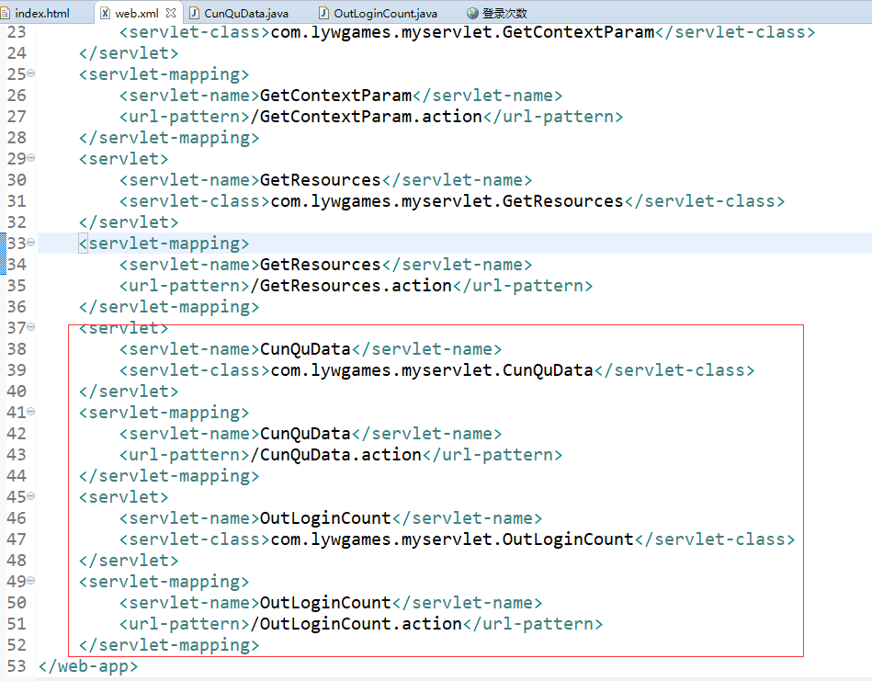

6.部署运行项目

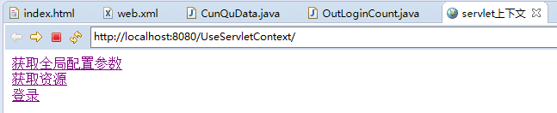

7.多点击几次登录, 显示登录次数

