一.使用Tomcat默认的servlet去下载静态资源

1.直接以超链接的方式下载, 不写任何代码, 就能够下载东西下来。

<a href="Download/shake.wav">shake.wav</a><br/>

<a href="Download/logo.png">logo.png</a><br/>

<a href="Download/apache-tomcat7.zip">apache-tomcat7.zip</a>

2.Tomcat里面有一个默认的。这个DefaultServlet 专门用于处理放在Tomcat服务器上的静态资源。

3.新建一个Download的Web工程

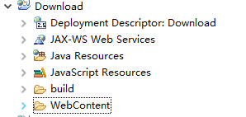

4.在WebContent下新建一个Download的目录, 放入几个文件

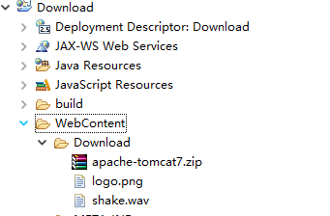

5.新建一个index.html

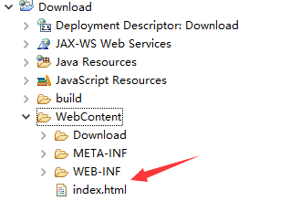

6.编写index.html

|  |
| --- |
| <!DOCTYPE html>  <html>  <head>  <meta charset="UTF-8">  <title>下载</title>  </head>  <body>  <a href="Download/shake.wav">shake.wav</a><br/>  <a href="Download/logo.png">logo.png</a><br/>  <a href="Download/apache-tomcat7.zip">apache-tomcat7.zip</a><br/>  </body>  </html> |

7.部署运行

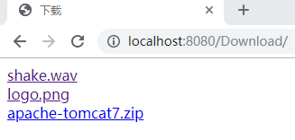

8.点击shake.wav, chrome浏览器在网页中打开了它

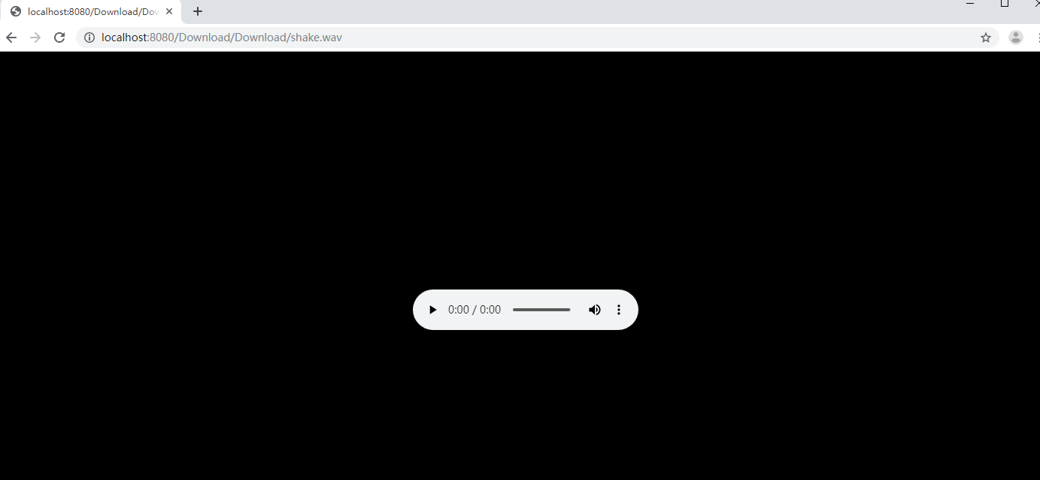

9.点击logo.png, chrome浏览器在网页中打开了它

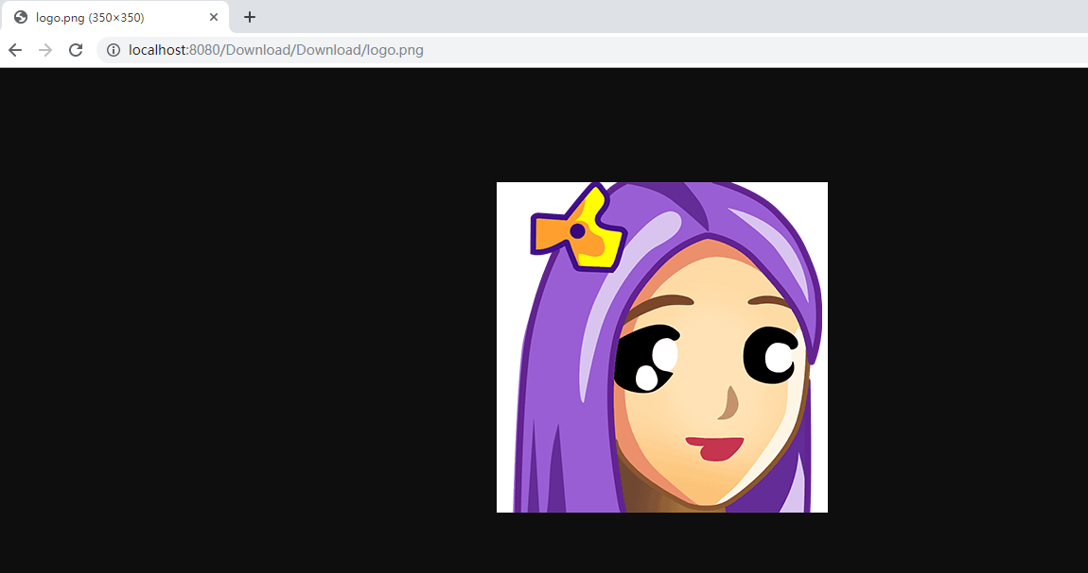

10.点击apache-tomcat7.zip, 进行下载

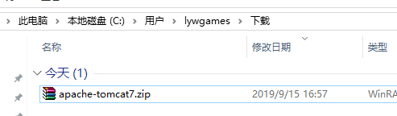

二.使用自己的Servlet去下载文件, 而不是展示

1.编写index.html

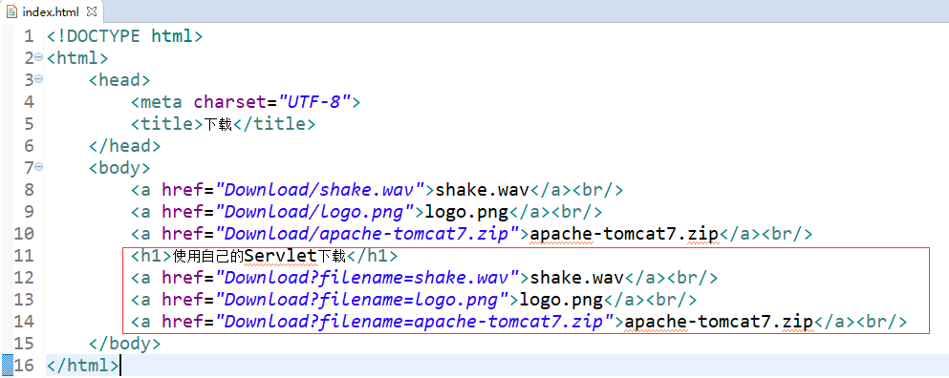

2.新建一个Download.java类

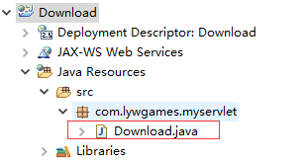

3.编写Download.java类

|  |
| --- |
| package com.lywgames.myservlet;  import java.io.FileInputStream;  import java.io.IOException;  import java.io.InputStream;  import java.io.OutputStream;  import javax.servlet.ServletException;  import javax.servlet.http.HttpServlet;  import javax.servlet.http.HttpServletRequest;  import javax.servlet.http.HttpServletResponse;  public class Download extends HttpServlet {  private static final long serialVersionUID = 1L;  @Override  protected void doGet(HttpServletRequest req, HttpServletResponse resp) throws ServletException, IOException {  // 获取文件名字  String filename = req.getParameter("filename");  // 让浏览器收到这份资源的时候, 以下载的方式提醒用户, 而不是直接展示。  resp.setHeader("Content-Disposition", "attachment; filename="+filename);  // 获取这个文件在Tomcat里面的绝对路径地址  String path = getServletContext().getRealPath("Download/" + filename);    InputStream is = new FileInputStream(path);  OutputStream os = resp.getOutputStream();  int len = 0 ;  byte[] buffer = new byte[1024];  while((len = is.read(buffer)) != -1){  os.write(buffer, 0, len);  }  os.close();  is.close();  }    @Override  protected void doPost(HttpServletRequest req, HttpServletResponse resp) throws ServletException, IOException {  doGet(req, resp);  }  } |

4.编写web.xml

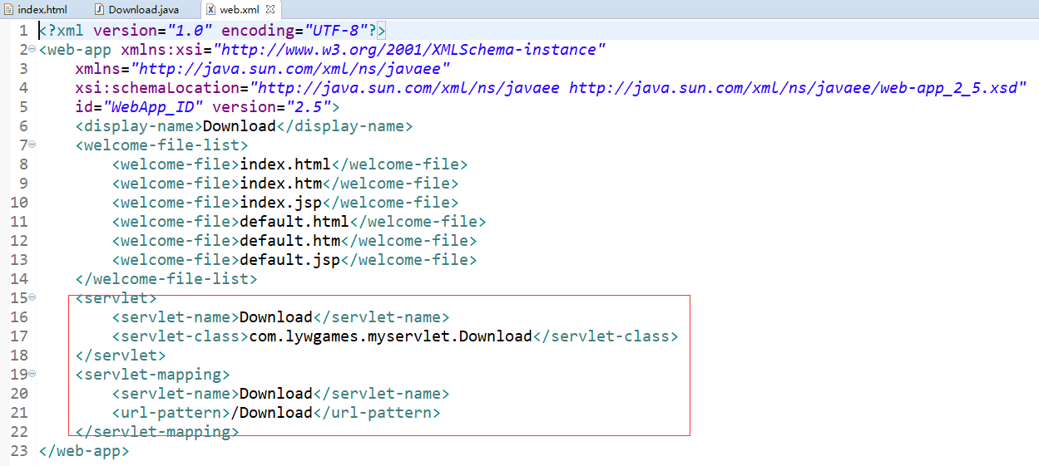

5.部署运行项目, png和wav文件也可以下载

