一.中文文件下载

1.新建一个DownloadLuanMa的Web工程

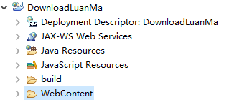

2.在WebContent下新建一个Download目录, 下面放一个中文文件

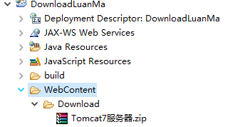

3.新建一个index.html

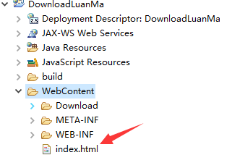

4.编写index.html

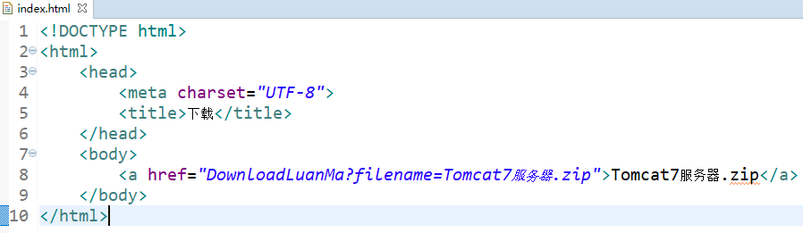

5.新建一个DownloadLuanMa.java类

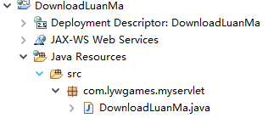

6.编写DownloadLuanMa.java

|  |
| --- |
| package com.lywgames.myservlet;  import java.io.FileInputStream;  import java.io.IOException;  import java.io.InputStream;  import java.io.OutputStream;  import javax.servlet.ServletException;  import javax.servlet.http.HttpServlet;  import javax.servlet.http.HttpServletRequest;  import javax.servlet.http.HttpServletResponse;  public class DownloadLuanMa extends HttpServlet {  private static final long serialVersionUID = 1L;    @Override  protected void doGet(HttpServletRequest req, HttpServletResponse resp) throws ServletException, IOException {  // 获取文件名字  String filename = new String(req.getParameter("filename").getBytes("ISO8859-1"), "UTF-8");  // 让浏览器收到这份资源的时候, 以下载的方式提醒用户, 而不是直接展示。  resp.setHeader("Content-Disposition", "attachment; filename="+filename);  // 获取这个文件在Tomcat里面的绝对路径地址  String path = getServletContext().getRealPath("Download/" + filename);    InputStream is = new FileInputStream(path);  OutputStream os = resp.getOutputStream();  int len = 0 ;  byte[] buffer = new byte[1024];  while((len = is.read(buffer)) != -1){  os.write(buffer, 0, len);  }  os.close();  is.close();  }    @Override  protected void doPost(HttpServletRequest req, HttpServletResponse resp) throws ServletException, IOException {  doGet(req, resp);  }  } |

5.编写web.xml

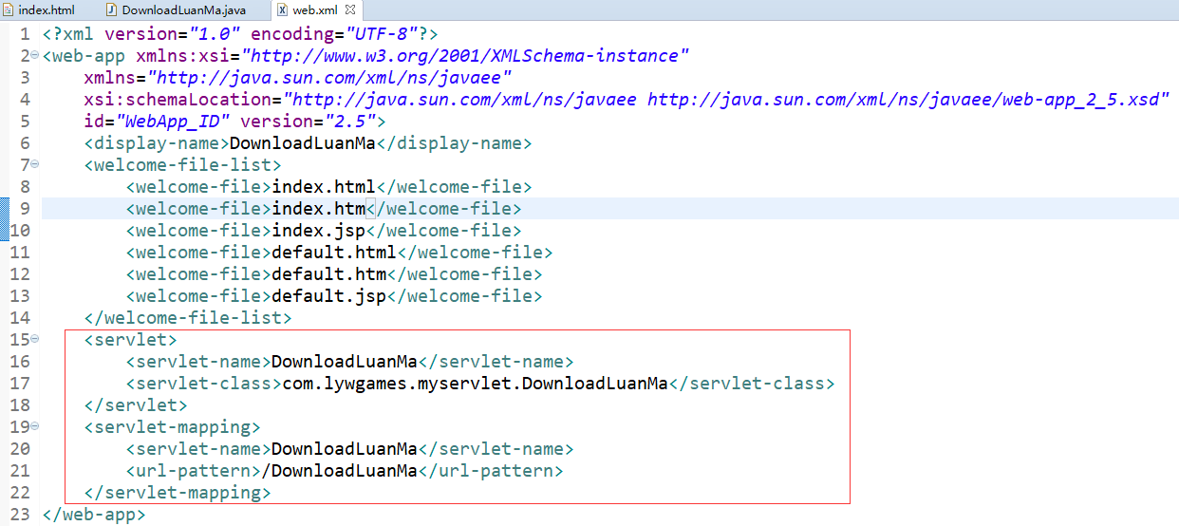

6.部署访问

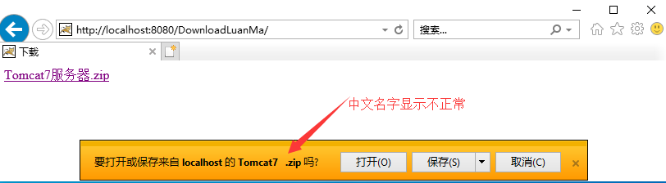

1. 解决中文乱码

1.浏览器接受到我们的中文文件名字, 会进行一次URLDecoder的解码, 因此我们在返回文件名字的时候需要一次URLEncoder的编码。

2.如果是IE或者Chrome, 使用的是URLDecoder的解码方式。 如果是Firefox, 使用Base64的解码方式。因此我们在返回文件名字的时候需要针对浏览器类型, 给中文文件名字进行URLEncoder或者BASE64Encoder的编码。

3.修改我们的DownloadLuanMa.java

|  |
| --- |
| package com.lywgames.myservlet;  import java.io.FileInputStream;  import java.io.IOException;  import java.io.InputStream;  import java.io.OutputStream;  import java.io.UnsupportedEncodingException;  import java.net.URLEncoder;  import javax.servlet.ServletException;  import javax.servlet.http.HttpServlet;  import javax.servlet.http.HttpServletRequest;  import javax.servlet.http.HttpServletResponse;  import sun.misc.BASE64Encoder;  public class DownloadLuanMa extends HttpServlet {  private static final long serialVersionUID = 1L;  public static String base64EncodeFileName(String fileName) {  BASE64Encoder base64Encoder = new BASE64Encoder();  try {  return "=?UTF-8?B?" + new String(base64Encoder.encode(fileName.getBytes("UTF-8"))) + "?=";  } catch (UnsupportedEncodingException e) {  e.printStackTrace();  throw new RuntimeException(e);  }  }    @Override  protected void doGet(HttpServletRequest req, HttpServletResponse resp) throws ServletException, IOException {  // 获取文件名字  String filename = new String(req.getParameter("filename").getBytes("ISO8859-1"), "UTF-8");  // 获取来访的客户端类型  String clientType = req.getHeader("User-Agent");  System.out.println(clientType + "\r\n" + base64EncodeFileName(filename));  // 让浏览器收到这份资源的时候, 以下载的方式提醒用户, 而不是直接展示。  if(clientType.contains("Firefox")){  resp.setHeader("Content-Disposition", "attachment; filename="+base64EncodeFileName(filename));  }else{  resp.setHeader("Content-Disposition", "attachment; filename="+URLEncoder.encode(filename, "UTF-8"));  }  // 获取这个文件在Tomcat里面的绝对路径地址  String path = getServletContext().getRealPath("Download/" + filename);  InputStream is = new FileInputStream(path);  OutputStream os = resp.getOutputStream();  int len = 0 ;  byte[] buffer = new byte[1024];  while((len = is.read(buffer)) != -1){  os.write(buffer, 0, len);  }  os.close();  is.close();  }    @Override  protected void doPost(HttpServletRequest req, HttpServletResponse resp) throws ServletException, IOException {  doGet(req, resp);  }  } |

4.部署运行, 使用IE浏览器下载, 中文名字显示正常

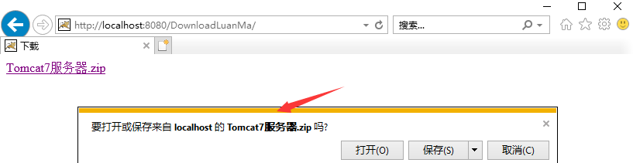

5.使用Chrome浏览器下载, 中文名字显示正常

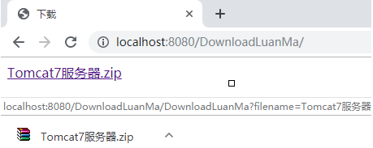

6.使用Firefox浏览器下载, 中文名字显示正常

