|  |  |
| --- | --- |
| Risultati immagini per Dipartimento ingegneria dell'informazione pisa | Risultati immagini per UNIVERSITÃ  DI PISA |

18 febbraio 2018

|  |
| --- |
|  |
| Two Wheels Instrument Station Tester (TWIST) |
|  |
| User Manual |

Two Wheels Instrument Station Tester (TWIST)

User Manual

Summary

1 Hardware Framework 2

1.2 TWIST specification 3

2 Installing Procedure 3

3. Test execution 5

3.1 Procedural test definition 5

3.2 Starting phase 6

3.3 Periodic acquisition phase 8

3.4 Ending phase 9

4.Data extraction 11

# 1 Hardware Framework

9

8

7

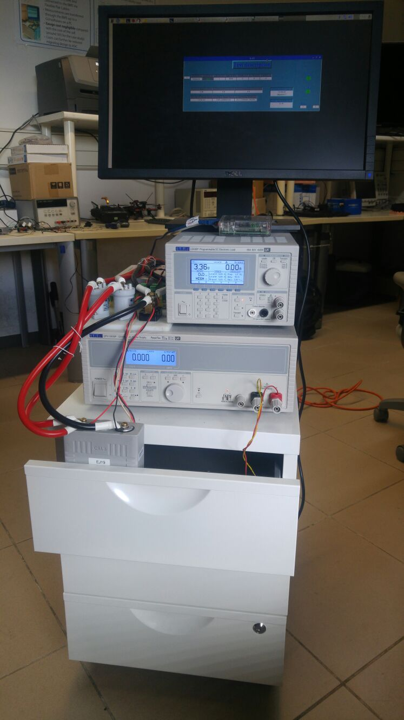

1

4

2

3

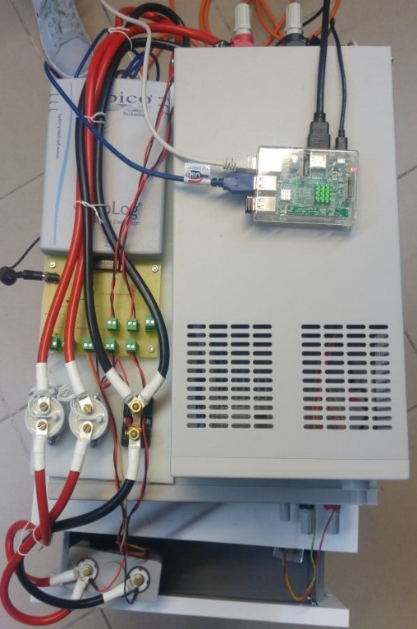

5

6

Figure 1: Hardware framework

|  |  |  |
| --- | --- | --- |
|  | Components | Specification |
| 1 | LCD Screen |  |
| 2 | Electronic LD400P[1] | Max input: 80A;80V  Max Power: 400W  Setting Accuracy (CC): ±0.2% ±30mA  Setting Accuracy (CV): ±0.2% ± 2digits |
| 3 | Electronic charger QPX1200SP[2] | Max output: 50A;60V  Max Power: 1200W  Setting Accuracy (CC): 0.3% ± 20mA  Setting Accuracy (CV): 0.1% ± 2mV |
| 4 | Cell under test typology | Capacity: 0 – 80Ah  Voltage range: 0-5V |
| 5 | DAQ PicoLog[3] | 16 channels  Max input voltage: ± 1250mV  Measure Accuracy: 0.1% ± 36µV (input voltage set to ± 1250mV) |
| 6 | Raspberry Pi 3 B |  |
| 7 | Shunt-Resistor[4] | Murata 3020-01108-0 Scale Factor 100 mV/100 A |
| 8 | Relays[5] | KILOVAC LEV100 Coil voltage:12V Max Continues Current: 100A |
| 9 | Temperature Sensor[6] | LM35 Scale factor: 10 mV/°C |

## 1.2 TWIST specification

|  |  |
| --- | --- |
| Supported test typology: | Pulse Current Test (PCT)  Hybrid Pulse Current Test (HPCT) |
| Input voltage: | 0 – 4.5V |
| Max discharging current: | 80A |
| Max charging current: | 50A |
| Max sampling frequency: | 2Hz |
| Voltage Accuracy[7]: | Offset = 21.5uV, Gain = 0.2% |
| Current Accuracy[8]: | Offset = 1.256 mA, Gain = 0.075% |

# 2 Installing Procedure

1. Install *Python3.4* repository on Raspbian OS. Follow the indication at <https://docs.python.org/3.4/installing/index.html>.
2. Transfer TWIST folder in Raspbian OS on Raspberry Pi 3 model B.
3. Install Picolog-ADC-24 driver (***libusbdrdaq*** package) according to the procedure indicated at <https://www.picotech.com/support/topic14649.html>. If the installing procedure has not terminated with errors, you can find the *“libpicohrdl.so”,”libpicohrsl.so.2”* and *“libpicohardl.so.2.0.0”* files, at Raspberry absolute path *“/opt/picoscope/lib”*;
4. Copy the *“libpicohrdl.so”, ”libpicohrdl.so.2”* and *“libpicohardl.so.2.0.0”* files in *“./TWIST/SW/Sources/C++_sources”;*
5. Open *Geany* or an equivalent g++ Integrated Development Environment (IDE).
6. Click on *Build* menu and then on *Set building commands* one;
7. Enter “*g++ -Wall -c “%f” init.cc*” and “*g++ -Wall -o “%e” main.o init.o libpicohrdl.so*”, in *Compile* and *Build* fields, respectively;
8. Start first the compiling, and then the building procedure through the *Build menu* of Geany IDE;
9. Type from command line: *sudo chmod +x < path of main.py >;*

Note: main.py is at *“./TWIST/SW/Sources/Python_sources”.*

1. Change the default LAN interface settings of LOAD (LD400P) and CHARGER (QPX1200SP) according with the IP addresses and the port numbers contained in *“./TWIST/SW/Setting_file/loadinfo.txt”* and *“./TWIST/SW/Setting_file/chargeinfo.txt”*, files, respectively[9] [10];
2. Change the IP address of Raspberry PI with another that has the same prefix of load and charger one according to the procedure described in <https://www.raspberrypi.org/learning/networking-lessons/rpi-static-ip-address/>;
3. Click on TWIST icon with mouse’s right button in “./TWIST/SW”, and select *Text-Editor* menu bar. Finally, insert in “*Icon=”* and *“–working-directory=”* fields, the new ABSOLUTE PATH of TWIST icon picture and of main.py, respectively (see Figure 3);

Note: the icon’s picture is available at *“./TWIST/Docs/Icon*

Figure 2:./TWIST/SW folder view

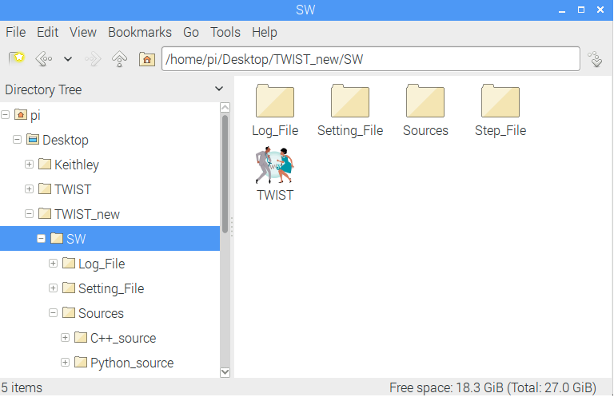

Figure 3:Text Editor of TWIST Icon

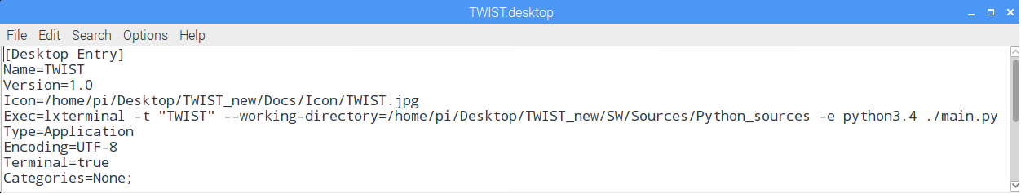

If the procedure is correctly done, the TWIST icon aspect will be like that shown in Figure 2.

Note: Repeat the step number 4, every time that the TWIST folder absolute path changes.

# 3. Test execution

## **3.1 Procedural test definition**

Before starting the test characterization of a Li-ion cell, the operator must define the test protocol trough a specific file named “Step-file”. The file is available at “./TWIST/SW/Step_file”. The textual commands are divided in two typologies: commands and comments.

The first category produces actions on the cell through the LD400P and QPX1200SP, and it is composed by seven fields:

|  |  |  |  |  |  |  |
| --- | --- | --- | --- | --- | --- | --- |
| *TYPE* | *LOG_EN* | *SAMP_TIME* | *TEST_LEN* | *TEST_I* | *TEST_V* | *STOP_I* |

* + *TYPE s*pecifies the type of operation to perform over the cell under test, and it can assume three values:
    - * *Charge,* define a cell charging phase.
      * *Discharge,* define a cell discharging phase.
      * *Measure,* define a rest cell period*.*
  + *LOG_EN* can assume two values*:*
    - * *0* means that anyLog-files will be generated at the end of test step*.*
      * *1* means that Log-files will be generated at the end of test step*.*
  + *SAMP_TIME* specifies the LD400P and QPX1200SP sampling time in seconds. Anyway, the DAQ Picolog sampling time is always fixed to 0.5s.
  + *TEST_LEN* specify the total step duration in seconds. Moreover, it can assume the value of ‘-1’. In this case, the temporal stop condition “TEST_LEN” is no longer relevant.
  + *TEST_I* specifies the charging or discharging current amplitude in ampere*.*
  + *TEST_V* specifies the upper or lower lithium-ion cell cut-off according to the step “TYPE”, in voltage*.*
  + *STOP_I* specifies the current stop condition. If the current amplitude goes below STOP_I value, the test ends.

The Second instruction type are preceded by # character, and they are ignored from the program execution. In Figure 4 a Step file instance is shown.

Note: to set the cell temperature range, the user could modify *TempRange* parameters contained in textual file at “./TWIST/SW/Setting_file/picologinfo.txt”.



Figure 4: A step file instance

## 3.2 Starting phase

To start the test, the operator must click on TWIST icon. After that the LXTerminal showed in Figure 5 will open.

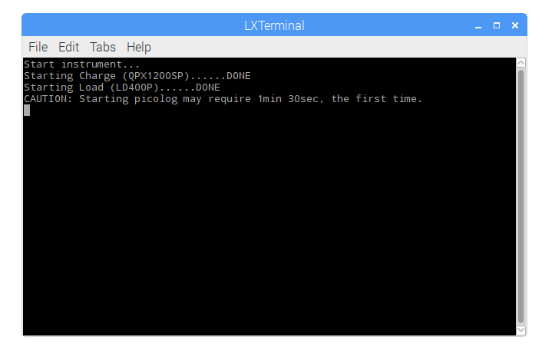

Figure 5: LXTerminal

After the instruments initialization phase, the software asks to the user to select three folder paths. First, the operator chooses the Step-file path as show in Figure 6.

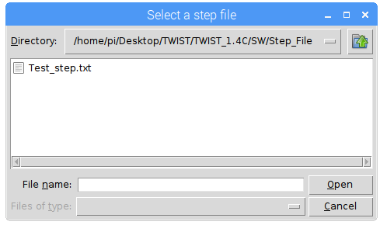

Figure 6: step-file choosing

Then, the operator chooses the Log-files paths for: TTi-instruments and Picolog DAQ as shown in Figure 7 and Figure 8, respectively

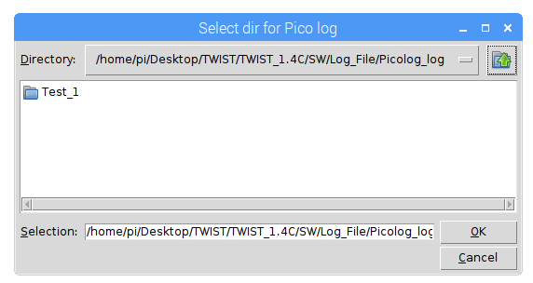

Figure 7: Picolog file-log destination choosing

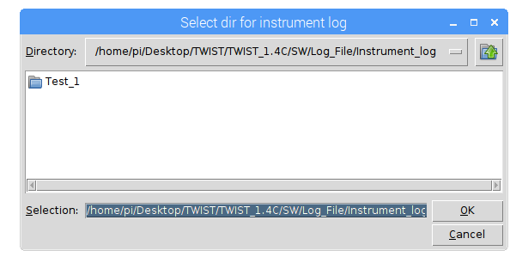

Figure 8:LD400P and QPX1220SP Log-files destination choosing

## **3.3 Periodic acquisition phase**

After starting phase operations, the program enters in the periodic acquisition of voltage, current and temperature of the cell under test. During this phase, the Graphical User Interfaces (GUI) represented in Figure 9 are opened.

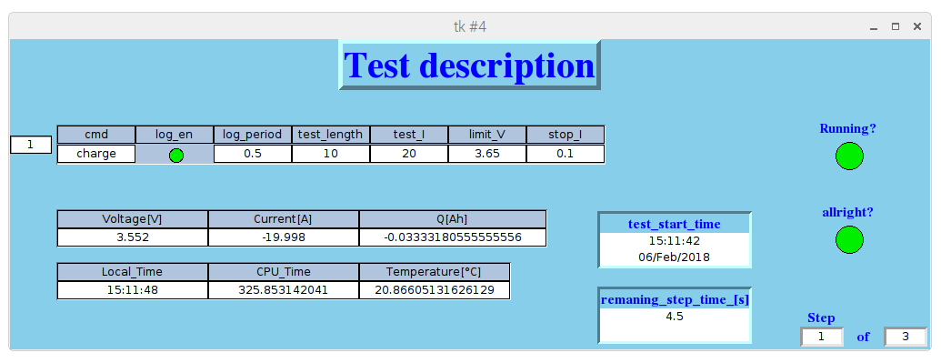

1

2

3

6

7

5

8

4

Figure 9: GUI interface

|  |  |
| --- | --- |
| 1 | Identifier number of the step-file raw in execution |
| 2 | Real-time cell measurement done by TTi-instruments |
| 3 | Time information and temperature measurements provide by Picolog DAQ |
| 4 | Test starting Date and Time in hh:mm:ss |
| 5 | Remaining time before the current step ending. |
| 6 | *Running?* LED indicates the test executing state of the test: if GREEN the test is still running; if RED the test is stopped. |
| 7 | *Allright?* LED indicates the presence of SW/HW error: if GREEN any errors are still happened else, if RED an error is occurred. |
| 8 | Step number indicators |

## **3.4 Ending phase**

The test can stop without or with HW/SW errors. In the first case, on LXTerminal the message *“GOOD NEWS: Test ends correctly.”* is reported, and only the “Running?” LED is RED, as shown in Figure 10.

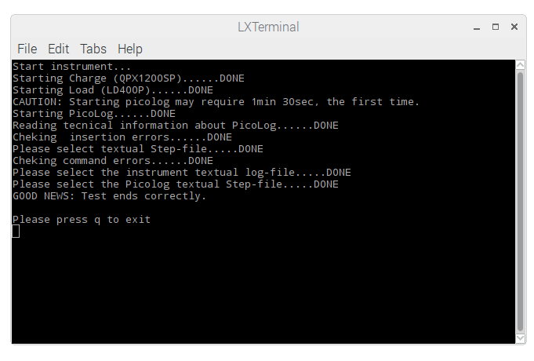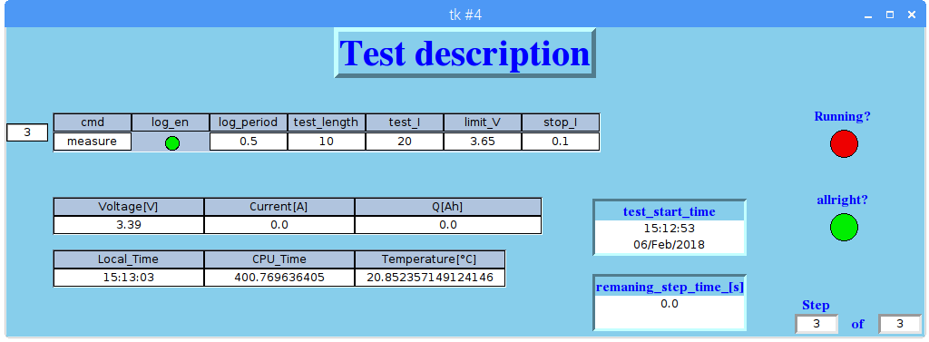

Figure 10: (UP) GUI interface, (DOWN) LXTermianl ending state

In the second case, when an HW/SW error has occurred, on LXTerminal an error message shows an identifying error number and the name of python function within the error has occurred. At the same time, the *“Running”* and *“Allright?”* LEDs are both RED. An instance of this condition is shown in Figure 11.

To understand the meaning of the error number identifier, the operator must read the Table 1 where, the correlations between number identifier an error typology are shown.

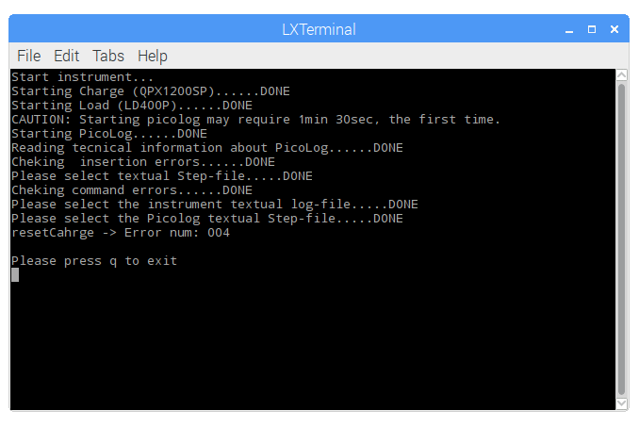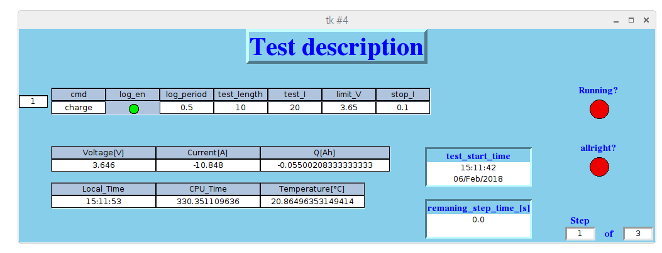

Figure 11: GUI INTERFACE ENDING STATE with error; (DOWN) LXTERMINAL ENDING STATE with error;

Table 1: Error number

|  |  |
| --- | --- |
| Error Number | Error meaning |
| 1 | Timeout exception occurred |
| 2 | Connection failed |
| 3 | Model name not match |
| 4 | Some problem are occurred on instruments configuration, retry |
| 5 | Trip error on charger |
| 6 | Python miss an Ack response |
| 7 | Position of digital pin is incorrect (the available range is from 1 to 4) |
| 8 | Analog channel number is incorrect (the available range is from 1 to 8) |
| 9 | Relays positions are overlapping |
| 10 | Relays voltage threshold must be positive |
| 11 | The number of bit used in Picolog ADC-Channel conversion must be positive |
| 12 | Tmin,Tmax values must be positive |
| 13 | Tmin must be smaller than Tmax |
| 14 | The number of columns of command raw must be 7 |
| 15 | TestLength must be bigger than 0,5s |
| 16 | TestLength mast be multiple of sample time |
| 17 | Sample time range is from 0,5s to 5 s |
| 18 | Sample time must be a multiple of 0,5s |
| 19 | TestLength must be bigger than sample time |
| 20 | Writing errors in command raw, the correct types are "charge","discharge","measure" |
| 21 | LOG_EN must be 1 or 0 |
| 22 | Sharing buffer between dataAcquisition thread and main thread is empty |
| 23 | Sharing buffer between dataAcquisition thread and main thread is full |
| 24 | CAUTION: Safe temperature range exceeding |
| 25 | CAUTION: Some issues is present on relay state, checking hardware is required |
| 26 | CAUTION: Some issues is present on powerline, checking hardware is required |

# 4.Data extraction

When test ending, all Log-files are saved in the paths previously chose by the user. For each step, two type of Log-files are generated: one by TTi instruments and one by Picolog DAQ; as shown in Figure 12 and Figure 13.



Figure 12: TTi instruments file log view



Figure 13 Picolog DAQ Log-file view

As shown in Figure 13, the data acquired by Picolog ADC-24 are shown as a 32bit integer. The integer represents the Picolog ADC-24 Analog-Digital Converter (ADC) coding. To decoding these values, the equation (1) is need.

where:

-*Vrangein* is the Picolog ADC-channels voltage input range (it is chosen of ± 1.250 mV, so Vrangein = 2500 mV);

-*Nbit* is the conversion bit number of ADC-Channels (24bit);

-*Coeff* is a coefficient which value change according with the kind of measurement that a single ADC-Channel has to performe (the Coeff values are reported in Table 2 and Table 3).

The Coeff’s values are strictly dependent to the hardware framework of the system. In this case the values are correlated to the use of:

* A 4 time voltage divider in the cell voltage measurement path (See the file source of hardware at *“./TWIST/HW”;*
* A shunt-resistor with a scale factor of 1 mV/A (sensor for current measurement);
* LM35 sensor for cell temperature measurement with a scale factor of 10 mV/°C

Table 2: Coeff values

|  |  |
| --- | --- |
| Measurement type (ADC-Channel ID) | Coeff Values |
| Voltage (C1, C4) |  |
| Current (C3) |  |
| Temperature (C5) |  |

The Coeff’s values are strictly dependent to the hardware framework of the system. In this case the values are correlated to the use of:

* A 4 time voltage divider in the cell voltage measurement path (See the file source of hardware at *“./TWIST/HW”;*
* A shunt-resistor with a scale factor of 1 mV/A (sensor for current measurement);
* LM35 sensor for cell temperature measurement with a scale factor of 10 mV/°C4.

Table 3: ADC-Channel setting information

|  |  |  |  |
| --- | --- | --- | --- |
| Num of channel ID (SW) | Physical channel (HW) | Channel input mode | Measurement typology |
| C1 | Ch1 | Single-ended | Cell voltage |
| C2 | Ch2 | Single-ended | Free (not used) |
| C3 | Ch3(-), Ch4 (+) | Differential-ended | Cell current |
| C4 | Ch5 | Single-ended | Cell voltage |
| C5 | Ch6 | Single-ended | Cell temperature |
| C6 | Ch7 | Single-ended | Free (not used) |
| C7 | Ch8 | Single-ended | Charging relay state |
| C8 | Ch9 | Single-ended | Discharging relay state |

1. See datasheet [LD400P](Instruments_datasheet/LD400+LD400P_Instruction_Manual-Iss2.pdf).
2. See [QPX1200SP](Instruments_datasheet/QPX1200S+SP_Instruction_Manual-Iss8.pdf) datasheet.
3. See PicoLog [ADC-24](Instruments_datasheet/adc20-adc24-high-resolution-data-logger-users-guide.pdf) datasheet.
4. See [Murata datasheet](Instruments_datasheet/shunt-resistor.pdf)
5. See relays [datasheet](Instruments_datasheet/relays.pdf)
6. See temperature sensor [datasheet](Instruments_datasheet/temperature-sensor.pdf)
7. See Article.
8. See Article.
9. See [LD400P](Instruments_datasheet/LD400+LD400P_Instruction_Manual-Iss2.pdf) user-manual p. 36.
10. See [QPX1200SP](Instruments_datasheet/QPX1200S+SP_Instruction_Manual-Iss8.pdf) user manual p.11.