

ProfMarket ©

Official Documentation



May 31, 2020

Profmarket

Burgas

Contents

1. Theme 2

2. Authors 2

3. Resume 2

3.1. Our Goals 2

3.2. Realization 2

3.3. Complexity level 2

3.4. Description 3

Figure 1 - Register system 4

Figure 2 - Job offer creation 5

# Theme

* “My dream job”

# Authors

* Alexander Igorov Hristov – [aihristov18@codingburgas.bg](mailto:aihristov18@codingburgas.bg) – Team Manager
* Martin Valentinov Atanasov – [mvatanasov18@codingburgas.bg](mailto:mvatanasov18@codingburgas.bg) – Designer
* Ivan Ivanov Dimov – [IIDimov18@codingburgas.bg](mailto:IIDimov18@codingburgas.bg) – Lead Developer
* Kristian Asenov Milanov – [kamilanov18@codingburgas.bg](mailto:kamilanov18@codingburgas.bg) – Developer/Designer

# Resume

# Our Goals

* Provide a safe and reliable way for our clients and visitors to find job opportunities that suit them best.

# Realization

* 1st step – the creation of a main page using HTML/CSS
* 2nd step – login and register system for businesses using PHP
* 3rd step – making up an overall theme and design for the site
* 4th step – creating the functionality of the site using a combination of HTML/CSS/JS and PHP.

# Complexity level

* We use a variety of technologies in order to bring this project to life.
* We use PHP, SQL and Laravel[1] in order to create the login/register and listings systems.
* We use HTML/CSS/JS for the structure and design of the platform.

# Description

* ProfMarket© is a website created by a small team of 9th graders which aims to assist people in finding job opportunities by providing them with a safe and reliable platform.
* Visitors of the site will have the opportunity to view various job offers posted by companies.
* Verified companies will have the option to make a registration on our site which allows them to post job listings that are viewed by our clients.

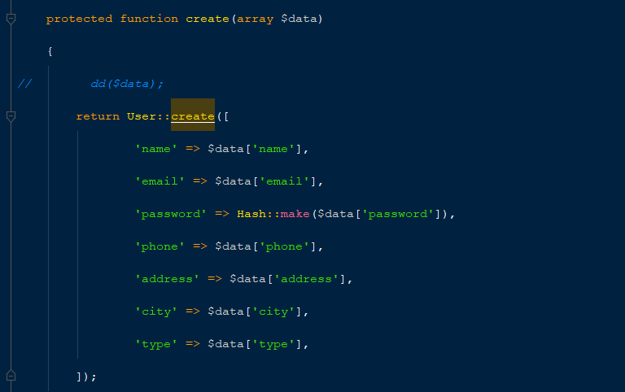

Figure 1 - Register system

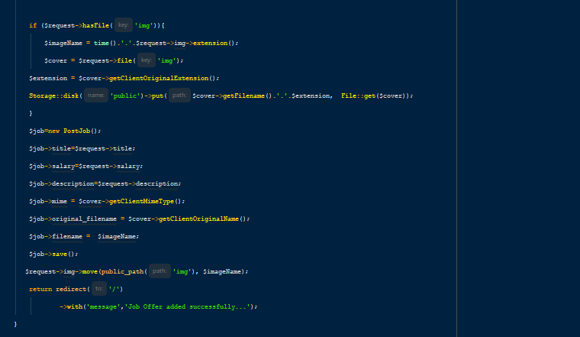

Figure 2 - Job offer creation

1. Laravel – PHP framework