

**SOFTWARE REQUIREMENT SPECIFICATION**

**Clothing online shop– HES1234**

– Hanoi, August 2023 –

# Record of Changes

|  |  |  |  |  |
| --- | --- | --- | --- | --- |
| Version | Date | A* M, D | In charge | Change Description |
| V1.0 | 15/2 |  |  |  |
| V1.0 | 16/2 |  |  |  |
|  |  |  |  |  |
|  |  |  |  |  |
|  |  |  |  |  |
|  |  |  |  |  |
|  |  |  |  |  |
|  |  |  |  |  |
|  |  |  |  |  |
|  |  |  |  |  |
|  |  |  |  |  |
|  |  |  |  |  |
|  |  |  |  |  |

*A - Added M - Modified D - Deleted

Table of Contents

Record of Changes 2

I. Product Overview 5

1.1. Product Vision 5

1.2. Product Context 5

1.3. Major Features 6

1.4. User Requirements 6

1.4.1 Actors List 6

1.4.2 Use Cases 7

1.5. Assumptions & Dependencies 8

1.6. Limitations and Exclusions 8

1.7. Business Rules 8

II. Use Case Specifications 9

2.1. Order Meals Feature 9

2.1.1 Order a Meal 9

2.1.2 Change Meal Order 11

2.1.3 Cancel Meal Order 11

2.2. Meal Subscriptions Feature 11

2.2.1 Register for Payroll Deduction 11

2.2.2 <<Next Use Case Name..>> 12

2.3. <<Next Feature Name..>> 12

2.3.1 <<Use Case Name>> 12

2.3.2 … 12

III. Functional Requirements 13

3.1. System Functional Overview 13

3.1.1 Screens Flow 13

3.1.2 Screen Descriptions 13

3.1.3 Screen Authorization 13

3.1.4 n-Screen Functions 14

3.2. Data model 14

3.2.1 Entity class diagram 14

3.2.2 Entity Description 14

3.3. <<Feature Name 1>> 15

3.3.1 <<Function Name 1>> 15

3.2 <<Function Name 2>> 15

3.3 <<Feature Name 2>> 15

IV. Non-Functional Requirements 16

4.1. External Interfaces 16

4.2. Quality Attributes 16

4.2.1 Usability 16

4.2.2 Reliability 16

4.2.3 Performance 16

4.2.4 … 16

# I. Product Overview

## 1.1. Product Vision

For fashion enthusiasts and shoppers worldwide, the Online Clothes Shopping platform is a cutting-edge web and mobile application that redefines the way people discover, explore, and purchase clothing items. By providing a seamless and personalized shopping experience, this platform empowers users to effortlessly browse through a vast collection of trendy and high-quality garments from various brands and designers. With features such as detailed product descriptions, virtual fitting rooms, and real-time customer reviews, the Online Clothes Shopping platform not only simplifies the purchasing process but also enhances customer satisfaction and confidence in their buying decisions. By bridging the gap between fashion enthusiasts and their desired garments, this platform creates a global community of fashion-forward individuals, enabling them to express their unique style, stay up-to-date with the latest fashion trends, and ultimately transform the way the world shops for clothes.

## 1.2. Product Context

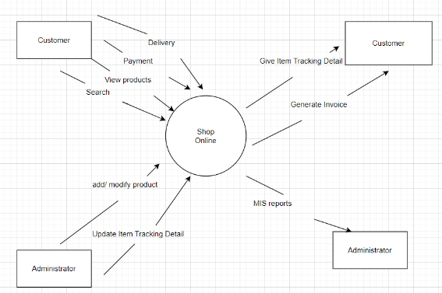

## 1.3. Major Features

FE-01:  Shopping cart system for users to save the products they want to buy

FE-02:  Users can pay for orders with cash or use a third-party payment service.

FE-03:  Create, view, modify, delete, and classify for product

FE-04:  The system allows users  view order  history

FE-05:   Product sort blog, product order by create time, search product, search blog

FE-06:  Create, view, modify, delete, and classify for Blog

FE-07:  The system allows employees to interact directly with customers using 3rd party software

FE-08:   Users can send feedback after each purchase

FE-09:   The system allows users to login, register, edit profiles

FE-09:   Provide system access through smartphone, tablet, and Internet

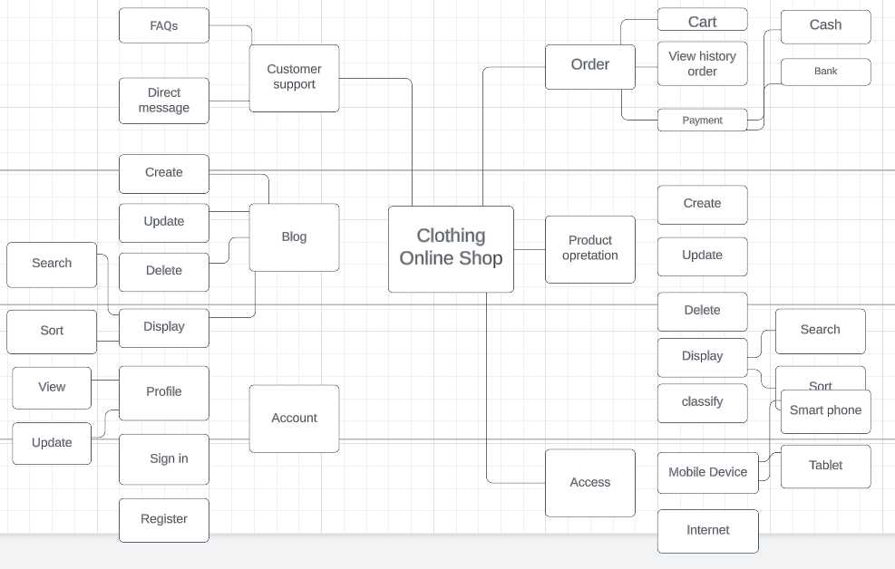

## 1.4. User Requirements

1

|  |  |  |
| --- | --- | --- |
| **#** | **Actor** | **Description** |
| 1 | Administrator | The person responsible for managing and maintaining the clothing online shop's backend system and database. |
| 2 | Customer | The end-user who interacts with the clothing online shop to browse, search for, and purchase clothes. |
| 3 | Seller | The person responsible for providing the clothing items for sale and managing the fulfillment process, ensuring that customers receive high-quality products and services. |
| 4 | Payment Gateway | The third-party payment service that processes payments made by the customer. |
| 5 | Customer Support | The customer support service that provides assistance to customers with issues, questions and concerns. |

### 1.4.2 Use Cases

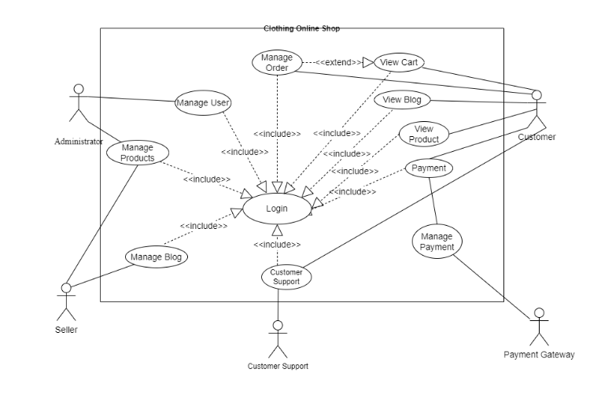

|  |  |  |  |
| --- | --- | --- | --- |
| **ID** | **Feature** | **Use Case** | **Description** |
| 01 | Manage Order | View cart | Customers can see the list of products in cart. |
| 02 | Manage Order | Add cart | Customers can add products cart. |
| 03 | Manage Order | Remove cart | Customers can remove products into cart. |
| 04 | Manage Order | View history orders | Customers can see their previous orders, |
| 05 | Manage Order | Payment | Customers can purchase their orders in cart through cash or bank. |
| 06 | Products Operation | Add products | Sellers (or Administrators) can add new products. |
| 08 | Products Operation | Update products | Sellers (or Administrators) can update the existing products. |
| 09 | Products Operation | Remove products | Sellers (or Administrators) can delete new products. |
| 10 | Products Operation | Search products | Customers can search products. |
| 11 | Products Operation | Sort products | Customers can sort by alphabetical name (or date) products. |
| 12 | Products Operation | Classify products | Customers can find products through categories |
| 13 | Products Operation | View products | Customers can see the detail description of the product |
| 14 | Blog Operation | Add blogs | Sellers (or Administrators) can add new blogs |
| 15 | Blog Operation | Update blogs | Sellers (or Administrators) can update the existing blogs. |
| 16 | Blog Operation | Remove blogs | Sellers (or Administrators) can delete new blogs. |
| 17 | Blog Operation | Search blogs | Customers can search blogs about the product |
| 18 | Blog Operation | Sort blogs | Customers can sort blogs based on date. |
| 19 | Account Management | View profile | Customers (or Sellers) can see their or other account profiles. |
| 20 | Account Management | Update profile | Customers (or Sellers) can update their profiles. |
| 21 | Account Management | Register | Customers (or Sellers) can create new accounts. |
| 22 | Customer Support | FAQs | Customers ask support questions through FAQs, and sellers can answer through it. |
| 23 | Customer Support | Direct messages | Customers ask support questions directly to sellers, and sellers can support them. |

## 1.5. Assumptions & Dependencies

-AS-1: Customers have access to the internet and possess the necessary devices (such as smartphones, tablets, or computers) to browse and make purchases on the online shop.

-AS-2: The online shop will provide accurate and up-to-date product information, including pricing, sizes, colors, and availability.

-AS-3: Customers are familiar with the concept of online shopping and feel comfortable making purchases through a website.

-AS-4: Customers will trust the security measures implemented by the online

-DE-1: The online shop relies on a stable and secure internet connection to

-DE-2: The online shop requires regular updates and maintenance to address software vulnerabilities, ensure compatibility with new devices and browsers, and enhance user experience.

-DE-3: The online shop's functionality and performance depend on the underlying technology stack, including web servers, databases, and content delivery networks.

-DE-4: The integration of your online store with a reliable and efficient payment service provider is critical to ensuring on-time and accurate response to payments.

## 1.6. Limitations and Exclusions

-Multilingual user interface: The online store system does not support multilingual user interface. Customers will only be able to use the user interface provided in a specific language.

-Updating delivery schedule: The online store system does not update detail delivery schedule, but only provide the estimated delivery time

-Integration with social networks: The online store system does not integrate directly with social networks such as Facebook, Instagram or Twitter. Product sharing or shopping will not be directly connected to these social platforms.

-Ability to create and customize products: The online store system does not offer the ability to create custom products or customize clothing patterns. Customers will only be able to purchase pre-designed and pre-made products.

-Direct phone ordering support: The system does not provide direct phone ordering support. Customers can only order through the online store's website.

## 1.7. Business Rules

|  |  |  |
| --- | --- | --- |
| **ID** | **Category** | **Rule Definition** |
| BR-01 | Constraints | The online shop will operate 24/7, allowing customers to make purchases at any time. |
| BR-02 | Constraints | Orders must be placed using valid payment methods accepted by the online shop. |
| BR-03 | Constraints | The system must support multiple users accessing the website simultaneously without significant performance degradation or loss of functionality. |
| BR-04 | Operations | Staff members are responsible for regularly conducting inventory checks to ensure accurate product quantity and size information on the website. |
| BR-05 | Delivery | The online shop guarantees to deliver the purchased items within 10-15 business days from the date of order confirmation. |
| BR-06 | Delivery | In the event of any unexpected delay in delivery, the online shop will notify the customer promptly and provide an estimated revised delivery timeframe. |
| BR-07 | Computations | Order total is calculated as the sum of the prices of selected items, including applicable taxes, shipping fees, and any discounts. |
| BR-08 | Operations | Employees who wish to participate in payroll deductions for company purchases need to file a claim with Human Resources or follow the process prescribed by the company. |
| BR-09 | Customer  feedback | Customer reviews and ratings will be displayed on the website, allowing customers to provide feedback and information about their experiences with the products or services. |
| BR-10 | Facts | Customers must create an account and provide accurate and up-to-date personal information for order processing and delivery purposes. |

# II. Use Case Specifications

### 2.1 Add Carts

|  |  |  |  |
| --- | --- | --- | --- |
| ID and Name: | **UC-01 Add Carts** | | |
| Created By: | Phạm Tiến Quang | Date Created: | 4/6/23 |
| Primary Actor: | Customer | Secondary Actors: | Cart |
| Description: | This use case describes the process of adding a product to the cart by the customer. | | |
| Trigger: | A Patron indicates that he wants to order a meal | | |
| Preconditions: | PRE-1. The customer must be logged in to their account.  PRE-2. The customer must have selected a product they wish to purchase. | | |
| Postconditions: | POST-1. The product is added to the customer's cart and the cart is updated with the new product information. | | |
| Normal Flow: | 1. The customer selects the desired product and clicks the "Add to Cart" button.  2. The system checks the availability of the product and adds it to the customer's cart.  3. The system displays the updated cart with the added product.  4. The customer may continue shopping or proceed to checkout. Patron either confirms meal order (continue normal flow) or requests to modify meal order (return to step 2). | | |
| Alternative Flows: | - If the product is not available, the system displays an error message and the product is not added to the cart.  - If the customer attempts to add a product that is already in their cart, the system increases the quantity of the product in the cart instead of adding a new item. | | |
| Exceptions: | 1. Product out of stock: If the product is out of stock, the system should display an error message and prevent the customer from adding the product to their cart.  2. Invalid product information: If the product information is invalid or incomplete, the system should display an error message and prevent the customer from adding the product to their cart.  3. System error:  If there is a system error or outage during the process of adding the product to the cart, the system should display an error message and prompt the customer to try again later.. | | |
| Priority: | High | | |
| Frequency of Use: | Multiple times per day by customers. | | |
| Business Rules: | BR-1, BR-3, BR-10 | | |
| Other Information: | 1.      The system should display the product name, price, and quantity in the cart after it has been added.  2.      The system should display an error message if the customer attempts to add a product that is no longer available or has been discontinued.  3.      The system should allow the customer to view their total order amount and any applicable taxes or fees before they proceed to checkout.  4.      The system should allow the customer to apply any relevant discounts or promotional codes to their order before they proceed to checkout. | | |
| Assumptions: | The system will be able to handle a high volume of requests and will not experience significant downtime or errors. | | |

### 2.2 View Order History

|  |  |  |  |
| --- | --- | --- | --- |
| ID and Name: | UC-04 View Order History | | |
| Created By: | Phạm Tiến Quang | Date Created: | 4/6/23 |
| Primary Actor: | Customer | Secondary Actors: |  |
| Description: | This use case describes the process of a customer viewing their own profile information. | | |
| Preconditions: | PRE-1. The customer must be logged in to their account.PRE-2. The customer must have made at least one purchase on the website or application. | | |
| Postconditions: | POST-1. The customer is able to view their order history and obtain copies of their order information as desired. | | |
| Normal Flow: | 1. The customer clicks on the "Order History" or "My Orders" button.2. The system displays a list of the customer's previous orders, including the order date, order number, and total order amount.3. The customer can click on a specific order to view more detailed information, such as the order items, shipping and billing addresses, and payment information.4. The customer can click on the "Print" or "Download" button to obtain a copy of the order information. | | |
| Alternative Flows: | - If the customer has not yet made any purchases, the system will display a message indicating that there is no order history available.- If the customer has made purchases but cannot see their order history, the system may be experiencing technical difficulties and the customer should contact customer support for assistance. | | |
| Exceptions: | - No order history found: If the customer has not yet made any purchases, the system should display a message indicating that there is no order history available.- Database error: If there is a database error or outage during the process of retrieving the order history, the system should display an error message and prompt the customer to try again later.- Incomplete order history: If the order history information is incomplete or inaccurate, the system should display an error message and prompt the customer to contact customer support for assistance.- System error: If there is a system error or outage during the process of viewing the order history, the system should display an error message and prompt the customer to try again later. | | |
| Priority: | Medium | | |
| Frequency of Use: | Multiple times per month or year by customers | | |
| Business Rules: | BR-4, BR-10 | | |
| Other Information: | 1. The system should display the order number, date, and total order amount for each order in the order history list.2. The system should allow the customer to sort the order history list by date, order number, or total order amount.3. The system should allow the customer to filter the order history list by a specific date range or order status (e.g. shipped, delivered, cancelled).4. The system should allow the customer to click on a specific order to view more detailed information, such as the order items, shipping and billing addresses, and payment information.5. The system should allow the customer to request a return or exchange for a specific order directly from the order history page.6. The system should display an error message if the customer attempts to view order history that does not belong to them or if they are not logged in to their account. | | |

# 2.3 Add Products

|  |  |  |  |
| --- | --- | --- | --- |
| ID and Name: | **UC-03- Add Products** | | |
| Created By: | Nguyen Thien An | Date Created: | 3/6/23 |
| Primary Actor: | Seller (or Admin) | Secondary Actors: | Product |
| Description: | Sellers (or Administrators) access the Clothing Online Shop, add new products to the system by providing detailed product information. | | |
| Trigger: | Seller (or Admin) indicates a new product to be added. | | |
| Preconditions: | PRE-1. Seller (or Administrator) is logged into the system.  PRE-2. Sellers or Administrators have the necessary permissions to add products. | | |
| Postconditions: | POST-1. New products are added to the system.  POST-2. The changes made to the product are reflected in the online shop. | | |
| Normal Flow: | 1.Seller (or Administrator) access to the Clothing Online Shop.  2. The system displays the interface to add products.  3. Seller (or Admin) provides detailed product information such as name, description, price, image, and available quantity.  4. Seller (or Admin) confirms the addition of the product.  5. The system checks the validity of the entered information.  6. The system updates information of products in the system.  7. The system displays a message confirming the successful addition of products. | | |
| Alternative Flows: | **1.0 Seller (or Admin) did not provide enough details for the product.**  1.1     The system displays an error message asking the seller (or Administrator) to provide full information.  1.2      Go back to step 3 of the main thread.  **2.0 Add Product with Special Promotion:**  2.1   Sellers or Administrators can add a new product with a special promotion, such as a discounted price or a buy-one-get-one offer.  2.2     The sequence of steps remains the same as in the main course, with an additional step to specify the promotion details.  **3.0 Bulk Product Upload:**  3.1   Sellers or Administrators can upload a CSV file or use an automated process to add multiple products at once.  3.2     The sequence of steps may vary, including steps to select the bulk upload option, provide the file or specify the data source, and validate the uploaded products. | | |
| Exceptions: | **1.0.E1 The system detects that the provided product information is invalid.**  1.1 The system informs the seller about the specific errors or missing information in the product details.  1.2 If the seller corrects the product information, the use case continues with adding the product.  1.3 If the seller cancels the process of adding the product, the use case is terminated.  **2.0.E2 Product already exists:**  2.1 The system informs the seller that the product exists and suggests verifying the product information.  2.2 If the seller wants to continue adding the product, the use case returns to step 3 of the normal flow.  2.3 If the seller cancels the process of updating the product, the use case is terminated.  **3.0.E3 System error:**  3.1 The system displays an error message notifying the seller about the issue and advises them to try again later.  3.2 If the seller chooses to continue, they can retry the process. If the error persists, they may need to seek technical support. | | |
| Priority: | High | | |
| Frequency of Use: | Approximately 50 times per week. Sellers or Administrators may add new products multiple times during a week to continuously update the online shop's inventory and offerings. | | |
| Business Rules: | BR-01, BR-02, BR-03, BR-04, BR-08 | | |
| Other Information: | 1.     Seller or Admin shall be able to cancel the Adding product process at any time prior to confirming it.  2.      Seller or Admin shall be able to view all products he added within the previous six months. | | |
| Assumptions: | -The online shop system is accessible and functional.  -Sellers/Administrators have valid user accounts and necessary permissions to add products.  -The online shop has sufficient storage capacity to accommodate new products.  -The product categories and attributes are predefined and available for selection during the product addition process.  -Sellers/Administrators are knowledgeable about the product addition process and have been trained on how to use the system effectively. | | |

2.4Update Products

|  |  |  |  |
| --- | --- | --- | --- |
| ID and Name: | **UC-04- Update Products** | | |
| Created By: | Nguyen Thien An | Date Created: | 3/6/23 |
| Primary Actor: | Seller (or Admin) | Secondary Actors: | Product |
| Description: | This use case allows sellers or administrators to update existing products in the online shop. | | |
| Trigger: | Sellers or Administrators indicate the intention to update a product. | | |
| Preconditions: | PRE-1. Sellers or Administrators are logged into the system.  PRE-2. Sellers or Administrators have the necessary permissions to update products. | | |
| Postconditions: | POST-1. The selected product is successfully updated with the new information.  POST-2. The changes made to the product are reflected in the online shop. | | |
| Normal Flow: | 1. Sellers or Administrators access the product management section of the online shop.  2. Sellers or Administrators search for the specific product they want to update.  3. Sellers or Administrators select the desired product from the search results.  4. Sellers or Administrators modify the relevant details of the product, such as name, description, price, category, and images.  5. Sellers or Administrators save the updated product information.  6. The system validates the entered data and checks for any errors or missing information.  7. If there are no errors, the system updates the product information in the online shop.  8. The system displays a confirmation message to Sellers or Administrators indicating that the product has been successfully updated. | | |
| Alternative Flows: | **1.1 Order multiple identical meals**  1.      Patron requests a specified number of identical meals. (see 1.1.E1)  2.      Return to step 4 of normal flow.  **1.2 Order multiple meals**  1.      Patron asks to order another meal.  2.       Return to step 1 of normal flow. | | |
| Exceptions: | **1.0.E1 If there are errors or missing information in the entered data:**  - The system displays error messages indicating the specific issues with the data.  -Sellers or Administrators can correct the errors and resubmit the updated product information.  -Return to step 6 of the normal flow.  **2.0.E2 Product not found:**  - The system informs the seller that the product does not exist and suggests verifying the product information.  - If the seller wants to continue updating the product, the use case returns to step 2 of the normal flow.  - If the seller cancels the process of updating the product, the use case is terminated.  **3.0.E3 System error:**  - The system displays an error message notifying the seller about the issue and advises them to try again later.  - If the seller chooses to continue, they can retry the process. If the error persists, they may need to seek technical support. | | |
| Priority: | High | | |
| Frequency of Use: | Approximately 30 times per week. Sellers or Administrators may update existing products to modify their details, such as price, description, or availability, based on changes in stock or business requirements. | | |
| Business Rules: | BR-01, BR-02, BR-03, BR-04, BR-08 | | |
| Other Information: | 1.     Seller or Admin shall be able to cancel the Updating product process at any time prior to confirming it.  2.      Seller or Admin shall be able to view all products he updated within the previous six months. | | |
| Assumptions: | -The online shop system is accessible and functional.  -Sellers/Administrators have valid user accounts and necessary permissions to update products.  -The products to be updated are already existing in the online shop.  -Sellers/Administrators are knowledgeable about the product update process and have been trained on how to use the system effectively. | | |

# 2.5Purchase Items

|  |  |  |  |
| --- | --- | --- | --- |
| ID and Name: | **UC-05 Purchase Items** | | |
| Created By: | Nguyen Van Phong | Date Created: | 4/6/23 |
| Primary Actor: | Customer | Secondary Actors: | Payment Gateway, Inventory Management System |
| Description: | A customer wants to purchase items from the online clothes shop and complete the transaction securely. | | |
| Trigger: | The customer indicates their intention to purchase items. | | |
| Preconditions: | PRE-1: The customer has a valid account on the online clothes shop website.  PRE-2: The desired items are in stock and available for purchase. | | |
| Postconditions: | POST-1: The customer receives an order confirmation with the details of the purchased items.   POST-2: The inventory is updated to reflect the purchased items. | | |
| Normal Flow: | 1. The customer logs into their account on the online clothes shop website.  2. The customer browses the available items and selects the desired products.  3. The customer adds the selected items to their shopping cart.  4. The customer reviews the shopping cart to ensure the correct items,  quantities, and prices.  5. The customer proceeds to the checkout process.  6. The system prompts the customer to provide the shipping address and  contact details.  7. The customer enters the required information and proceeds to the payment  step.  8. The customer selects a preferred payment method.  9. The system redirects the customer to the chosen payment gateway to  complete the transaction securely.  10.The customer provides the necessary payment details on the payment  gateway's secure page.  11.The payment gateway processes the payment and notifies the system of the  transaction status.  12.The system confirms the successful payment and generates an order  confirmation.  13.The customer receives the order confirmation via email, including the details  of the purchased items and the shipping information.  14.The system updates the inventory to reflect the purchased items, reducing the  available quantities.  15.The system generates an order number for reference.  16.The customer's shopping cart is emptied, ready for their next shopping  session. | | |
| Alternative Flows: | None | | |
| Exceptions: | If the customer encounters an error during the checkout process:  a. The system displays an error message and prompts the customer to review the entered information or try again later.  b. The customer can contact customer support for assistance.  If the payment transaction fails:  a. The system informs the customer about the failed transaction and provides alternative payment options.  b. The customer can try again with a different payment method or contact customer support for further assistance. | | |
| Priority: | High | | |
| Frequency of Use: | Varies based on customer shopping activities. | | |
| Business Rules: | BR-1: The customer must provide valid and accurate shipping and contact information.  BR-2: The available payment methods are clearly displayed and supported by the online clothes shop.  BR-3: The payment gateway must securely process the customer's payment information.  BR-4: The purchased items must be deducted from the inventory upon successful payment. | | |
| Other Information: | 1.The online clothes shop provides detailed product information, including pricing, sizes, and available colors.  2.The customer can apply any applicable discounts or promotional codes during the checkout process.  3.The online clothes shop website ensures the security and confidentiality of customer information during the transaction. | | |
| Assumptions: | 1.The online clothes shop has a well-functioning payment gateway integration.  2.The inventory management system is updated in real-time to reflect available stock levels.  3.The customer service team is available to assist customers with any issues encountered during the purchase process. | | |

2.6Process Payment

|  |  |  |  |
| --- | --- | --- | --- |
| ID and Name: | **UC-06 Process Payment** | | |
| Created By: | Nguyen Van Phong | Date Created: | 4/6/23 |
| Primary Actor: | Customer | Secondary Actors: | Payment Gateway, Order Management System |
| Description: | A customer wants to securely process the payment for the items in their shopping cart and complete the transaction. | | |
| Trigger: | The customer indicates their intention to proceed with the payment. | | |
| Preconditions: | PRE-1: The customer has added items to their shopping cart.  PRE-2: The customer has provided valid shipping and contact information. | | |
| Postconditions: | POST-1: The payment is successfully processed.  POST-2: The order management system updates the order status. | | |
| Normal Flow: | 1. The customer reviews the items in their shopping cart.  2. The customer proceeds to the checkout process.  3. The system prompts the customer to select a payment method.  4. The customer chooses a preferred payment method.  5. The system redirects the customer to the chosen payment gateway.  6. The customer provides the necessary payment details on the payment gateway's secure page.  7. The payment gateway processes the payment transaction.  8. The payment gateway sends a notification to the system regarding the transaction status.  9. The system receives the notification and updates the order status accordingly.  10. The system generates an order confirmation and sends it to the customer via email.  11. The customer receives the order confirmation, confirming the successful payment and providing details of the purchased items and shipping information. | | |
| Alternative Flows: | None | | |
| Exceptions: | 1. If the payment transaction fails:     a. The system informs the customer about the failed transaction and provides alternative payment options.     b. The customer can try again with a different payment method or contact customer support for further assistance. | | |
| Priority: | High | | |
| Frequency of Use: | Varies based on customer shopping activities. | | |
| Business Rules: | - BR-1: The available payment methods are clearly displayed and supported by the online clothes shop.  - BR-2: The payment gateway must securely process the customer's payment information.  - BR-3: The order management system updates the order status based on the payment transaction. | | |
| Other Information: | 1. The online clothes shop ensures the security and confidentiality of customer information during the payment process.  2. The payment gateway integration follows industry standards for secure payment processing. | | |
| Assumptions: | 1. The online clothes shop has a well-functioning payment gateway integration.  2. The order management system is updated in real-time to reflect the payment status of each order.  3. The customer service team is available to assist customers with any issues encountered during the payment process. | | |

2.7 Update Profile

|  |  |  |  |
| --- | --- | --- | --- |
| ID and Name: | **UC-07 Update Profile** | | |
| Created By: | Bùi Đức Toàn | Date Created: | 03/6/23 |
| Primary Actor: | User | Secondary Actors: |  |
| Description: | This use case describes the process of updating a user's profile information within an online system. It allows users to modify their personal details, such as name, email address, contact information, and other relevant information stored in their profile. This use case ensures that users can easily and accurately manage their profile information to keep it up to date. | | |
| Trigger: | An user indicates that he wants to change personal  information. | | |
| Preconditions: | PRE-1. The user is authenticated and logged into the online system.  PRE-2. The user has access permissions to modify their profile information. | | |
| Postconditions: | POST-1. The user's profile information in the online system is updated with the modifications made by the user.  POST-2. The user is notified of the successful update of their profile information. | | |
| Normal Flow: | 1. The user navigates to the profile settings or account management section of the online system. 2. The user selects the option to update their profile information. 3. The online system displays the current profile information for the user, pre-populated in the corresponding input fields. 4. The user modifies the desired fields, such as name, email address, contact information, or any other relevant details. 5. The user saves the changes or submits the updated profile information. 6. The online system validates the modified information for accuracy and completeness. 7. If any validation errors occur, the online system displays appropriate error messages to the user, indicating the specific fields that require correction. 8. Once the updated profile information passes validation, the online system updates the user's profile data in the system's database. 9. The online system confirms the successful update and displays a notification or confirmation message to the user. 10. The user can review the updated profile information on their profile page or within their account settings. | | |
| Alternative Flows: | * If the user cancels the profile update process before saving the changes, the online system discards the modifications and returns the user to the previous profile view without any changes. * If the user encounters any technical issues or errors during the profile update process, the online system displays an error message and allows the user to retry or contact support for assistance. * If the user attempts to modify sensitive information that requires additional verification, such as a password change or financial details, the online system may prompt the user to go through an additional authentication step or follow specific security protocols. | | |
| Exceptions: | * If the user's modified profile information violates any system rules, such as using an invalid email format or exceeding character limits, the online system rejects the changes and prompts the user to correct the relevant fields. * If the user's modified profile information conflicts with existing records, such as an email address already associated with another user account, the online system notifies the user and requests a different value. * If the online system encounters any technical issues or database errors while updating the profile information, the system administrators are alerted, and the error is resolved as soon as possible to ensure data consistency and system stability. | | |
| Priority: | High | | |
| Frequency of Use: | Approximately 30 times per week. | | |
| Business Rules: | BR-01, BR-03, BR-10 | | |
| Other Information: |  | | |
| Assumptions: | 1. The online system has a user profile module that securely stores and manages user profile information. 2. The user profile information is stored in a reliable and scalable database or data storage system. 3. The user interface of the online system provides a user-friendly and intuitive way for users to update their profile information. 4. The online system implements appropriate security measures, such as encryption and access controls, to protect user profile data from unauthorized access or tampering. 5. The online system performs validation checks on user-provided profile information to ensure data integrity and adherence to predefined rules. 6. The online system provides error handling mechanisms to handle any exceptions or unexpected scenarios that may occur during the profile update process. 7. The online system allows users to review their updated profile information before finalizing the changes. 8. The online system provides clear instructions and guidance to users on how to update their profile information. 9. The online system maintains a backup or revision history of user profile information, allowing for rollbacks or retrieval of previous versions if needed. | | |

2.8 Register

|  |  |  |  |
| --- | --- | --- | --- |
| ID and Name: | **UC-08 Register** | | |
| Created By: | Bùi Đức Toàn | Date Created: | 06/03/23 |
| Primary Actor: | User | Secondary Actors: |  |
| Description: | This use case describes the process of registering a new user in an online system. It enables individuals to create an account and provide necessary information to access and utilize the system's features and functionalities. | | |
| Trigger: | Users indicate that they want to sign up for an account. | | |
| Preconditions: | PRE-1. The user has access to the shopping online system's registration interface.  PRE-2. The user has a valid email address or other required credentials to complete the registration process. | | |
| Postconditions: | POST-1. The user's account is successfully registered and activated in the online system.  POST-2. The user can log in using the registered credentials and access the system's features and functionalities. | | |
| Normal Flow: | 1. The user accesses the registration interface of the online system. 2. The user enters the required registration information, such as username, email address, password, and any other mandatory fields. 3. The online system validates the provided information, checking for completeness, format, and uniqueness of email address and username. 4. If any validation errors occur, the online system displays appropriate error messages to the user, indicating the specific fields that require correction. 5. Once the provided information passes validation, the online system creates a new user account and stores the registration data in the system's database. 6. The online system generates a verification email or confirmation message and sends it to the user's provided email address. 7. The user receives the verification email and follows the instructions to verify their email address and activate the account. 8. The online system verifies the user's email address and updates the account status to "active" in the system. 9. The online system displays a confirmation message to the user, informing them that the registration process is complete. 10. The user can now log in using the registered credentials and access the features and functionalities of the online system. | | |
| Alternative Flows: | * If the user cancels the registration process, the online system discards the entered information, and no account is created. * If the user encounters any technical issues or errors during the registration process, the online system displays an error message and allows the user to retry or contact support for assistance. | | |
| Exceptions: | * If the user enters invalid or incomplete registration information, such as an invalid email format or a password that does not meet the system's requirements, the online system rejects the registration and prompts the user to correct the relevant fields. * If the user's entered email address or username already exists in the system, indicating a duplicate registration, the online system notifies the user and requests a different value. * If the user does not receive the verification email, the online system provides options for resending the email or contacting support for further | | |
| Priority: | High | | |
| Frequency of Use: | Approximately 50 times per week. | | |
| Business Rules: | BR-01, BR-03, BR-10 | | |
| Other Information: |  | | |
| Assumptions: | 1. The online system provides a registration functionality that allows users to create new accounts. 2. The registration process requires users to provide necessary information, such as username, email address, password, and any other mandatory fields. 3. The online system securely stores user registration data and encrypts passwords to protect user privacy and prevent unauthorized access. 4. The online system performs validation checks on user-provided registration data to ensure data integrity and adherence to predefined rules. 5. The online system has mechanisms in place to prevent duplicate registrations, such as checking if the email address or username already exists in the system. 6. The online system sends a verification email or confirmation message to the user to validate their email address and activate the account. 7. The user interface of the online system provides clear instructions and guidance to users on how to complete the registration process. 8. The online system implements appropriate security measures, such as captcha or anti-bot mechanisms, to prevent automated or malicious registrations. 9. The online system provides error handling mechanisms to handle any exceptions or unexpected scenarios that may occur during the registration process. | | |

# 2.9 Add Blogs

|  |  |  |  |
| --- | --- | --- | --- |
| ID and Name: | **UC-09- Add Blogs** | | |
| Created By: | Phan Thành Đạt | Date Created: | 4/6/23 |
| Primary Actor: | Seller (or Admin) | Secondary Actors: |  |
| Description: | Sellers (or Administrators) access the Clothing Online Shop, add new blogs to the system by providing detailed blog information. | | |
| Trigger: | Seller (or Admin) indicates a new blog to be added. | | |
| Preconditions: | PRE-1. Seller (or Administrator) is logged into the system.  PRE-2. Sellers or Administrators have the necessary permissions to add products. | | |
| Postconditions: | POST-1. New blogs are added to the system.  POST-2. The changes made to the blog are reflected in the online shop. | | |
| Normal Flow: | 1.Seller (or Administrator) access to the Clothing Online Shop.  2. The system displays the interface to add blog  3. Seller (or Admin) provides detailed blogs information such as name, text content, images.  4. Seller (or Admin) confirms the addition of the blog.  5. The system checks the validity of the entered information.  6. The system updates information of blogs in the system.  7. The system displays a message confirming the successful addition of blog. | | |
| Alternative Flows: | **1.0 Seller (or Admin) did not provide enough details for the blog.**  1.1 The system displays an error message asking the seller (or Administrator) to provide full information.  1.2 Go back to step 3 of the main thread. | | |
| Exceptions: | **1.0.E1 The system detects that the provided blog information is invalid.**  1.1 The system informs the seller about the specific errors or missing information in the blog details.  1.2 If the seller corrects the bloginformation, the use case continues with adding the blog.  1.3 If the seller cancels the process of adding the blog, the use case is terminated.  **2.0.E2 System error:**  3.1 The system displays an error message notifying the seller about the issue and advises them to try again later.  3.2 If the seller chooses to continue, they can retry the process. If the error persists, they may need to seek technical support. | | |
| Priority: | High | | |
| Frequency of Use: | Approximately 1 times per month. The frequency of use of add blog will not happen very often, blog or collections are only released with very low frequency | | |
| Business Rules: | BR-01, BR-02, BR-03, BR-04, BR-08 | | |
| Other Information: | 1. Seller or Admin shall be able to cancel the Adding blog process at any time prior to confirming it.  2. Seller or Admin shall be able to view blog posted by who. | | |
| Assumptions: | -The online shop system is accessible and functional.  -Sellers/Administrators have valid user accounts and necessary permissions to add blog.  -The online shop has sufficient storage capacity to accommodate new blog.  -The product categories and attributes are predefined and available for selection during the blog addition process.  -Sellers/Administrators are knowledgeable about the product addition process and have been trained on how to use the system effectively. | | |

2.10Add FeedBack

|  |  |  |  |
| --- | --- | --- | --- |
| ID and Name: | **UC-10- Add FeedBack** | | |
| Created By: | Phan Thành Đạt | Date Created: | 4/6/23 |
| Primary Actor: | Customer | Secondary Actors: | System feedback |
| Description: | This use case allows customer add feedback for specific product after purchase in the online shop | | |
| Trigger: | customer indicate the intention to a product that they want add feedback. | | |
| Preconditions: | PRE-1. Customer are logged into the system.  PRE-2. Customer bought the product want to add feedback | | |
| Postconditions: | POST-1. The list feedback of product is successfully updated with the new information.  POST-2. The changes made of feedback are reflected in the online shop. | | |
| Normal Flow: | 1. Customer accesses the add-on review after purchasing that product.  2. The system displays the interface to add feedback  3. Customer provides information text for feedback  4. Customer confirms the addition of the feedback.  5. The system checks the validity of the entered information.  6. The system updates information of feedback in the system.  7. The system displays a message confirming the successful addition of feedback | | |
| Alternative Flows: | **1.0 Customer provide empty details for the feedback.**  1.1 The system displays an error message asking the customer to provide full information.  1.2 Go back to step 3 of the main thread | | |
| Exceptions: | **1.0.E1 If there are errors or missing information in the entered data:**  - The system displays error messages indicating the specific issues with the data.  -Sellers or Administrators can correct the errors and resubmit the updated feedback information.  -Return to step 6 of the normal flow.  **2.0.E2 System error:**  - The system displays an error message notifying the seller about the issue and advises them to try again later.  - If the seller chooses to continue, they can retry the process. If the error persists, they may need to seek technical support. | | |
| Priority: | High | | |
| Frequency of Use: | Approximately 500 times per day. Customer can add feedback continuously after each purchase | | |
| Business Rules: | BR-01, BR-02, BR-03, BR-04, BR-08 | | |
| Other Information: | 1. Customer shall be able to view all feedback he add | | |
| Assumptions: | -The online shop system is accessible and functional.  -Customer have valid user accounts and necessary permissions to add feedback. | | |

# III. Functional Requirements

## 3.1. System Functional Overview

*[Provide functionality overview of software system: screen flow, screen descriptions, system user roles, screen authorization, non-screen functions, ERD]*

### 3.1.1 Screens Flow

*[This part shows the system screens and the relationship among screens. You can draw the Screens Flow for the system in the form of diagram as below. Please note that beside the normal flat screen, we might have the oval notation for pop-up screen (Import Order) or a screen with multiple information tab (Order Details), etc. You may also use text or background format for different visuality purpose]*

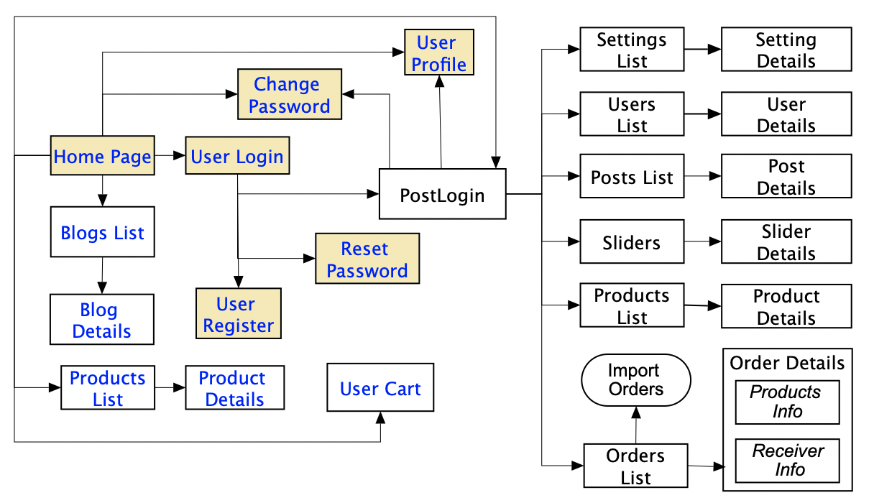

### 3.1.2 Screen Descriptions

*[Provide the descriptions for the screens in the Screens Flow above]*

|  |  |  |  |
| --- | --- | --- | --- |
| **#** | **Feature** | **Screen** | **Description** |
| 1 | Order Meals | Create Order | <<Screen Brief description>> |
| 2 | Order Meals | Change Order |  |
| 3 | .. |  |  |

### 3.1.3 Screen Authorization

*[Provide the system roles authorization to the system features (down to screens, and event to the screen activities if applicable) in the table form as below – replace Role-Name1, Role-Name2,… with your specific system user role names]*

|  |  |  |  |  |
| --- | --- | --- | --- | --- |
| **Screen** | **Role-Name1** | **Role-Name2** | **Role-Name3** | **…** |
| <<Screen Name1>> | X |  | X | X |
| <<Screen Activity>> |  |  | X | X |
| <<Screen Name2>> | X |  | X |  |
| Query All Data | X |  |  |  |
| Query Own Data |  |  | X |  |
| Query Managed Data |  |  | X |  |
| Add New Data |  |  | X | X |
| Update All Data |  |  |  | X |
| Update Own Data |  |  |  | X |
| Update Managed Data |  |  |  | X |
| Delete Data |  |  |  |  |
| … |  |  |  |  |

### 3.1.4 n-Screen Functions

*[Provide the descriptions for the non-screen system functions, i.e batch/cron job, service, API, etc.]*

|  |  |  |  |
| --- | --- | --- | --- |
| **#** | **Feature** | **System Function** | **Description** |
| 1 | <<Feature Name>> | <<Function Name1>> | <<Function Name1 Description>> |
| 2 | … |  |  |

### 3.2. Data model

### 3.2.1 Entity class diagram

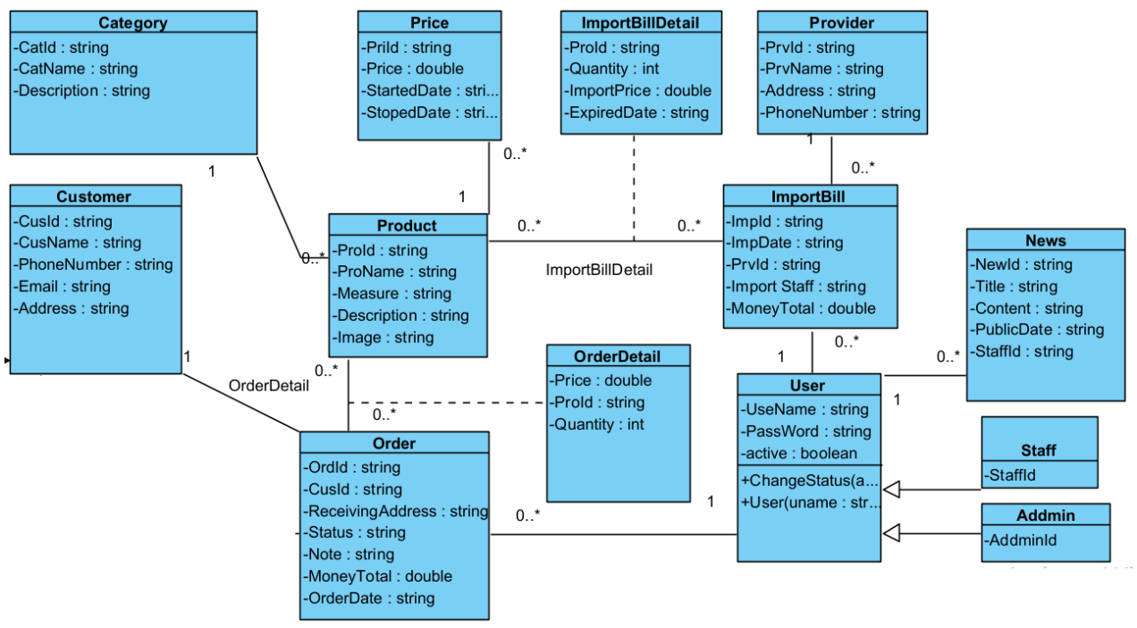

### 3.2.2 Entity Description

|  |  |  |
| --- | --- | --- |
| **#** | **Entity** | **Description** |
| 1 | User |  |
| 2 | Meal |  |
| 3 | Meal Subscription |  |
| 4 | … |  |

## 3.3. <<Feature Name 1>>

### 3.3.1 <<Function Name 1>>

*[A function can be a screen or a non-screen function (listed in the part 3.1.5 above). In this part, you need to provide the details on the related function, focus on mentioning below information*

* *Function trigger: how this function is triggered (navigation path, a timing frequency, etc.*
* *Function description: actors/roles, purpose, interface, data processing, etc.*
* *Screen layout: mock-up prototype of the screen, sample below is for Manage Products screen*

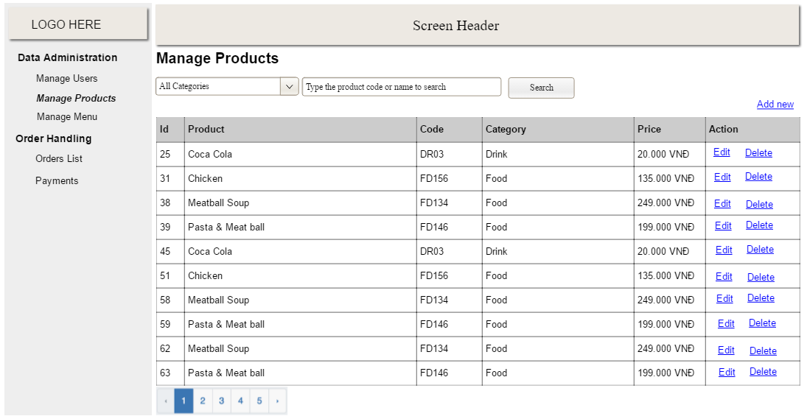

* *Function Details: provide explanation for the data, validation, business rules, functionalities (for both normal cases and abnormal cases), etc. of the function so that the reader can image how it work.*

*]*

### 3.2 <<Function Name 2>>

…

### 3.3 <<Feature Name 2>>

…

# IV. Non-Functional Requirements

## 4.1. External Interfaces

*[This section provides information to ensure that the system will communicate properly with users and with external hardware or software/system elements.]*

## 4.2. Quality Attributes

*[List all the required system characteristics (quality attributes) specification. Some of the possible attributes are provided with the guide/descriptions are mentioned here]*

### 4.2.1 Usability

*[This section includes all those requirements that affect usability. For example, specify the required training time for a normal users and a power user to become productive at particular operations specify measurable task times for typical tasks or base the new system’s usability requirements on other systems that the users know and like specify requirement to conform to common usability standards, such as IBM’s CUA standards Microsoft’s GUI standards]*

### 4.2.2 Reliability

*[Requirements for reliability of the system should be specified here. Some suggestions follow:*

*Availability—specify the percentage of time available ( xx.xx%), hours of use, maintenance access, degraded mode operations, and so on.*

*Mean Time Between Failures (MTBF) — this is usually specified in hours, but it could also be specified in terms of days, months or years.*

*Mean Time To Repair (MTTR)—how long is the system allowed to be out of operation after it has failed?*

*Accuracy—specifies precision (resolution) and accuracy (by some known standard) that is required in the system’s output.*

*Maximum Bugs or Defect Rate—usually expressed in terms of bugs per thousand lines of code (bugs/KLOC) or bugs per function-point( bugs/function-point).*

*Bugs or Defect Rate—categorized in terms of minor, significant, and critical bugs: the requirement(s) must define what is meant by a “critical” bug; for example, complete loss of data or a complete inability to use certain parts of the system’s functionality.]*

### 4.2.3 Performance

*[The system’s performance characteristics are outlined in this section. Include specific response times. Where applicable, reference related Use Cases by name.*

*Response time for a transaction (average, maximum)*

*Throughput, for example, transactions per second*

*Capacity, for example, the number of customers or transactions the system can accommodate*

*Resource utilization, such as memory, disk, communications, and so forth.]*

### 4.2.4 …