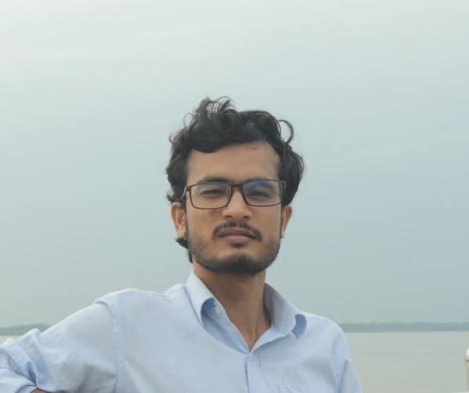

Matlab

C/C++

ML

Python

**Top Skills**

www.github.com/aiimranh

www.linkedin.com/in/aiimranh

aiimranh.in@gmail.com

01710020055 (mobile)

**Contact**

KUET, Khulna (present)

Hospital Road, Amtali, Barguna

**Address**

Student at KUET | Python | Machine Learning Enthusiast

**MD. IMRAN**

(Jan 2019 - Current)

Under-graduation, Electronics and Communication Engineering

(Jan 2013 – April 2018)

Science

(Jan 2013 – April 2018)

Science

* Amtali A.K. Pilot High School
* Amtali Govt. College
* Khulna University of Engineering and Technology

**Education**

I am interested in Machine Learning and Deep Learning. I am a hardworking Python Programmer with proven Microsoft Office skills and minute attention to detail. To enhance my technical and management skills, get a challenging career in the Engineering domain, and contribute to the company's growth as well as personal growth. In addition to this, I would love to learn new skills and explore new working areas.

**Summary**