HIJAB CATALOGUE WEB APPLICATION WITH COLOR SEARCH FUNCTIONALITY

NORAIN AQILAH BINTI SHAMSUDDIN

FACULTY OF COMPUTING AND INFORMATICS UNIVERSITI MALAYSIA SABAH

2025

HIJAB CATALOGUE WEB APPLICATION WITH COLOR SEARCH FUNCTIONALITY

NORAIN AQILAH BINTI SHAMSUDDIN

THESIS SUBMITTED IN FULFILLMENT FOR THE BACHELOR’S DEGREE OF COMPUTER SCIENCE

(DATA SCIENCE)

FACULTY OF COMPUTING AND INFORMATICS UNIVERSITI MALAYSIA SABAH

2025

ABSTRACT

The growth of modest fashion industry especially in hijab fashion has led to an increase in online shopping platforms and websites catering to this market. However, the data fragmentation across different brands’ websites and online marketplaces only allows limited product search coverage and limited product recommendations. Other shortcomings observed are limited filter criteria and lack of quick access. This project proposes a centralized hijab catalogue web application that addresses these issues by standardizing product database a in a unified centralized platform. Agile methodology is used to develop this project while using React.js and Next.js as the main framework. The web app is hosted using Vercel and Neon as the database provider with Prisma ORM for relational data management, and Sanity CMS for product content and order management. The outcome aims to make the hijab shopping experience to cover multiple brands without barriers, enabling users to make faster and informed purchase decision while offering hijab brands a platform for better product engagement.

ABSTRAK

MEMBANGUNKAN PLATFORM PENGUMPULAN TUDUNG BERPUSATKAN PENGGUNA : PENDEKATAN APLIKASI WEB

Industri fesyen tudung wanita yang semakin berkembang telah meningkatkan bilangan platform membeli-belah dalam talian dan laman sesawang bagi memenuhi kehendak pasaran ini. Walaubagaimanapun, perpecahan data dalam platform yang pelbagai ini hanya membolehkan pengguna untuk mendapat liputan carian produk dan cadangan produk yang terhad. Kelemahan lain yang dapat dikenalpasti Adalah kriteri tapissan produk yang sedikit dan ketiadaan akses pantas untuk produk. Bagi mengatasi masalah tersebut, projek ini mencadangkan satu pusat aplikasi web katalog tudung dengan mencipta pangakalan data produk yang seragam dan bersepadu. Metodologi Agile digunakan untuk membangunkan projek ini, manakala React.js dan Next.js digunakan sebagai rangka kerja system. Aplikasi web ini dihoskan menggunakan Vercel dan NHost digunakan sebagai pembekal pangakalan data. Hasil projek ini bertujuan untuk meningkatkan pengalaman membeli-belah tudung supaya lebih meluas tanpa batasan jenama supaya pembelian menjadi lebih pantas sambil memberi peluang jenama tudung untuk lebih menonjol dan interaktif.

TABLE OF CONTENTS

DEVELOPING A USER-CENTRIC HIJAB AGGREGATION PLATFORM: A WEB APPLICATIONS APPROACH i

DEVELOPING A USER-CENTRIC HIJAB AGGREGATION PLATFORM: A WEB APPLICATIONS APPROACH ii
ABSTRACT iii
ABSTRAK iv
TABLE OF CONTENTS v
LIST OF FIGURES viii
CHAPTER 1 : INTRODUCTION 1
  - Introduction 1
  - Problem Background 1
  - Problem Statement 3
  - Project Objective 4
  - Project Scope 4
  - Conclusion 6
CHAPTER 2 : LITERATURE REVIEW 6
  - Introduction 7
  - Hijab 7
  - E-catalogue 8
  - Comparison and critics on existing websites 11
    - Hijab brands’ website 11
    - Online Marketplace 17
    - Comparisons between available online platform 21
  - Web Application Usability 22
CHAPTER 3 : METHODOLOGY 24
  - Introduction 24
  - Development Methodology 24
  - Implementation of Selected Methodology 25
  - Software Requirements for System Development 27
    - Software and Tools 28
    - Framework 28
  - Hardware Requirements 28
  - Key Milestones 29
  - Gantt Chart 31
  - Conclusion 31
CHAPTER 4 : SYSTEM ANALYSIS AND DESIGN 32
  - Introduction 32
  - Requirement Elicitation Techniques 32
    - Questionnaire 33
    - Observation 33
  - Requirements 33
  - Activity Diagram 34
  - Structured Approach 36
    - Context Diagram 36
    - Data Dictionary 37
    - Entity Relationship Diagram 38
  - Architecture Design 39
  - User Interface Design 41
  - Conclusion 43
CHAPTER 5 : IMPLEMENTATION 44
  - Introduction 44
  - System Implementation 44
REFERENCES 46

LIST OF TABLES

Table 1.1: | Scope Modules of Hijab Web Application | Page  6
Table 2.1: | Comparison of product organization and filter in | 22
Table 2.2: | various hijab websites  Comparison of features between online | 23
Table 3.1: | marketplaces and hijab brand’s website  Key milestones for FYP 1 | 30
Table 3.2: | Key milestones for FYP 2 | 31
Table 4.1: | Functional Requirements for Hijab Web Application | 34
Table 4.2: | Table 4.2: Non-functional Requirements for Hijab | 34
Table 4.3: | Web Application  Table 4.3: Data Dictionary for User Class | 37
Table 4.4: | Table 4.4: Data Dictionary for Seller Class | 37
Table 4.5: | Table 4.5: Data Dictionary for Product Class | 37
Table 4.6: | Table 4.6: Data Dictionary for Orders Class | 38
Table 4.7: | Table 4.7: Data Dictionary for Saved Items Class | 38

LIST OF FIGURES

Figure 2.1: | Naelofar.com homepage with efficient hijab | Page  12
Figure 2.2: | categorization  Global filter function for products | 13
Figure 2.3: | Hijab recommendation for EasyOn Twist Instant | 14
Figure 2.4: | hijab  Categorization of hijab by type in Tudung Ruffle’s | 15
Figure 2.5: | website  Limited filter in Tudung Ruffle website which are | 16
Figure 2.6: | availability, price and product type  Similar products recommendation in Tudung | 16
Ruffle website that is only limited to Tudung
Ruffle products
Figure 2.7: | Categorization of hijab by type in SugarScarf | 17
Figure 2.8: | website  Sorting and filtering feature in Sugarscarf website | 17
Figure 2.9: | Lack of product recommendation system in | 18
Figure 2.10: | Sugarscarf website  Search results for “black printed bawal” in Shopee | 19
Figure 2.11: | marketplace  One of the results from previous query showing | 20
featuring BLOOM hijab collections with various
colour and pattern
Figure 2.12:  Figure 3.1: | Product recommendations for BLOOM hijab product listing showing grouped products instead of individual hijab product  The main phases in Agile development cycle | 21  26
Figure 3.2: | Gantt chart for project key activities | 31

Figure 4.1: | Activity Diagram for Hijab Web Application | 35
Figure 4.2: | Context Diagram for Hijab Web Application | 36
Figure 4.3: | Entity Relationship Diagram (ERD) for Hijab Web  Application | 39
Figure 4.4: | System architecture of Hijab Catalogue web application | 40
Figure 4.5: | Home Page for Hijab Web Application | 41
Figure 4.6: | ‘Shop’ Page for Hijab Web Application | 42
Figure 4.7: | Products Page for Hijab Web Application | 43
Figure 5.1: | Home Page for Hijab Web Application | 56
Figure 5.2: | Login Page | 56
Figure 5.3: | Sign-up Page | 57
Figure 5.4: | Category Page | 58
Figure 5.5: | Search Page | 59
Figure 5.6: | Product Detail Page | 60

CHAPTER 1

INTRODUCTION

Introduction

This chapter introduces the general ideas and motivation to develop a hijab web application to improve existing hijab online browsing platform in Malaysia. Some of the topics discussed in this chapter are problem background, problem statement, project objectives and scope and a conclusion to summarise the chapter.

Problem Background

The modest fashion industry has seen an exponential growth in the past years with expected US$375 billion spendings globally by 2025. (Salaam Gateway, 2023) Hijab fashion in particular has been attracting huge market demands especially from the large Muslim women population in Malaysia. Aside from being a religious garment, it also has become a trendy fashion statement (Mohamad & Hassim, 2019). This can be seen with rise of celebrities starting their own hijab business such as dUCk and Naelofar. It changes people’s perception on hijab, viewing it as a status symbol thus influencing women to start donning the hijab(Rety Reka Merlins, 2024).

The growing demand is further supported by the adoption of ecommerce, specifically websites and online marketplaces. A huge portion of the hijab consumers are digitally savvy women in their 20 – 50 years old whom frequents online shopping. This makes online platforms a strategic approach to sell and market hijab due to its reliable consumer service and convenience (Salem, 2022).

Currently, there are two main online platforms available for hijab shopping, which is brands’ websites and online marketplace. The hijab product data on these two platforms are divided, as consumers need to visit different websites to see hijab from different brands. For online marketplaces, there are too many redundant products where both the brand headquarters and resellers use the same platform, crowding the platform. This can be solved with aggregating all these data on a centralized platform. However, an emerging issue is that different brands have different formats and data structures, which cause incompatibility when integrating data.

Product organization also differs between each website, where some choose to categorise hijab by type while some by collection. This gives no clue to consumers who wished to shop based on other criteria, such as colour, material or size. While some websites have a filter feature to narrow down product listings, some do not. Existing filters have limited criteria such as availability and price, limiting the filtering capability and complicates product search process. Even then, the filter results only includes results within their own inventory.

Other than that, if users type in “pink hijab” in online marketplace, some results with pink hijab may not be included as they are labelled with similar name such as “blush” or “rose”. The different way brands chose to label their hijab causes inefficient search results.

Another issue is that hijab products in online marketplaces are listed by collections, thus “pink hijab” query will return collections of hijabs in all colours, simply because the products was not labelled with colour as a key attribute. Search results are rendered inefficient and only works with limited criteria such categories.

A main challenge in navigating these platforms is the lack of quick access button to revisit previously viewed product. The only options are for users to add product to shopping cart in brands’ websites while for online marketplaces adding these products into the ‘favorites’ list will cause the hijab to get buried under products from other categories.
Aside from that, the usage of recommendation system that can suggest users similar hijabs to the one they selected are also limited within a brand’s inventory. Plus, some websites did not implement this tool at all. This shows a significant gap as there has been no platform that offers a cross-brand discovery tools where the filter ability is not fragmented and consistent.

The web application proposed in this project is focused on solving data integration and fragmented filtered process. This is crucial as current browsing process have cluttered organization and unnecessary navigation through multiple websites and sections. This project plans to create an e-catalogue system that aggregates data seamlessly from various data sources and provide optimized search function with a faceted filter feature. With a standardized database, scalability will be easier and more products can be added to the database without compromising the latency of the e-catalogue.

Problem Statement

According to the observation done on various hijab websites and online marketplaces, there are a few problems that can be addressed in terms of its technical structures. The core problems are listed as below:

    - Hijab product data is fragmented across different websites and marketplaces, with each brands using different formats and data structure for key attributes. This causes complication in integrating these datasets in a centralized product database and ineffective product search and filtering.
    - Limited filtering criteria in the search tool in most platforms which leads to less precise filter results for categories such as colour, size and fabric. In brands’ website, the filter result only provide data limited to the brands’ database only.
    - The lack of a specific tool to mark selected products for quick access resulting in poor navigation of the platform.
    - Minimal utilization of machine learning to provide similar products recommendation for each product selected.

Project Objective

The general objective of this project is to design and develop a centralized platform of hijab products that addresses the technical challenges found in existing hijab shopping platforms such as data normalization, ineffective filtering mechanism and difficult navigational structures. More specifically, the objectives to be achieved are:

    - Develop a data model that resolves data structures inconsistency from different sources by normalizing key attributes for efficient product querying and filtering.
    - Improve the filter tool by adding more criteria to narrow down product listing and offer results across various brands with only a single query.
    - Create quick access to selected products by building a user-facing feature that marks selected products to a ‘Favourites’ page accessible to registered users.
    - Developing a colour-based product recommendation system using HSL (Hue, Saturation, Lightness) colour family matching to suggest visually similar products based on product colour attributes.

Project Scope

This project will be focusing on developing a centralized e-catalogue hijab web application aimed at overcoming the technical limitations described in current hijab shopping platforms. The scope is structured around three different categories, namely target users, data acquisition and development tools.

This development of e-catalogue aims to serve an audience of digitally savvy Muslim women in Malaysia who frequents buying hijab through online platforms. This segment of users could benefit the most as e-catalogue can improve their hijab browsing experience.

For data collection, hijab product data will be aggregated from approximately five different brands using available Application Programming Interface (API) or web scraping depending on the access permissions and site structure. Key attributes that will be extracted are name, colour or base colour, material, size, price, brand and
collection. Inconsistent key attributes will be standardized to ensure smooth integration in a centralized PostgreSQL relational database. This is to ensure the system supports scalable search queries as the database grows larger while maintaining relational integrity.

In terms of e-catalogue development, the frontend framework utilizes React.js with Next.js for its server-side rendering, API routes and file-based routing capabilities. Styling is handled by Tailwind CSS with shadcn/ui and Radix UI components for a consistent and accessible user interface. The database layer uses PostgreSQL hosted on Neon (serverless PostgreSQL) with Prisma ORM for type-safe database queries and relational data management. Sanity CMS is integrated as a headless content management system for product catalogues, orders, and promotional campaigns. Authentication is managed by Better Auth with email/password support and role-based access control for users, sellers, and admins. State management on the client side uses Zustand for cart persistence and synchronisation. The web application is hosted on Vercel due to its native compatibility with Next.js framework for seamless serverless function hosting. The product recommendation system uses a rule-based approach by matching products through HSL colour family similarity rather than machine learning.

The modules that will be implemented in the proposed web application is shown in
Table 1.1 as follows:

Table 1.1: Scope Modules of Hijab Web Application

 | Module |  | Description
 | Seller dashboard |  | Registered sellers are able to add and  manage product listings. They can also view and manage orders from this page.
 | Customer dashboard |  | Registered customers can manage their  profile and view products marked as favorite.
 | Product catalogue |  | This is the homepage of the web application  that shows all products.
 | Search and filter tool |  | This tool narrows down product listings according to selected criteria such as colour or size. Users can choose multiple criteria at  a time.
 | Favorite button |  | This button allows customers to save selected products into the ‘Favorite’ for quick  viewing.
Similar product recommendations |  | For every hijab clicked by the users, similar hijabs recommendations will be shown to  users.

Conclusion

This project focuses on developing a centralized hijab e-catalogue web application aimed at overcoming the technical limitations described in current hijab shopping platforms. The scope is structured around three different categories, namely target users, data acquisition and development tools.

CHAPTER 2

LITERATURE REVIEW

Introduction

This chapter explores past reviews and research regarding hijab, web applications and related systems needed to build the product recommendation algorithm. Existing hijab brand websites and online shopping platforms will also be analyzed to identify relevant problems and proposed solutions to resolve them. Lastly, this chapter also discusses the study of the programming language used to develop this project.

Hijab

Hijab originates from the Arabic word “ṿحجا” which means veil, barrier, or curtain. Initially, hijab is supposed to be an act of obedience as described in the Quran and Sunnah (Gökarıksel & Secor, 2009), yet the celebrification and fashion trends has made hijab more of a statement of fashion in these days (Mohamad & Hassim, 2019). Some studies also state Muslim women in Malaysia views hijab as both a religious obligation and fashion statement, balancing modesty and modernity in their day-to-day appearance (Hassan & Ara, 2021).

This in turn had been the driver of growth in the hijab industry. The demand for hijab has been significantly arising, not just in Malaysia but also globally, thanks to the popularity of modest fashion (Zulkifli & Rajandran, 2024). Another factor is the product diversification to cater to a wide range of consumer preferences in Malaysia. From basic hijab to luxury hijab, the market offers a wide variety in style, design, sizing and quality material. (Creativity, Innovation and Shariah Compliance by the Malay Middle Class Women Entrepreneurs in Muslimah Fashion Industry in Selangor, Malaysia, 2023). Even premium and luxury items find their market in the hijab section, where consumers are willing to pay higher price for trendy and quality products (Khan et al., 2017). This shows a positive outlook for venturing into the hijab market, with
wide customer segment that wears hijab as an essential piece of clothing in their daily life.

E-catalogue

E-catalogue is a digital medium for product data management that allows consumers to browse, analyze and evaluate products offered by businesses (Adiningrat Gede Pradiva et al., 2023). It provides users with convenient interface to access product information, place orders and receive support regardless of location and time, making it better than traditional catalogues with real-time updates and user-centered search functionalities. Digitalization in the commercial industry has been the main user for e-catalogue, especially in online marketplaces where consumers demand real-time access to accurate information (Garg, 2024).

Using e-catalogue as a medium to promote goods and services can help consumers with decision making especially through detailed information presentation and added platform features such as good search functionalities and website reliability (Sari et al., 2023).

Meanwhile, integration into enterprise system also allows for better supply chain management (Handayani et al., 2025), increase operational efficiency, digital marketing and contributing to overall business growth (Hendra Hadiwijaya et al., 2023). Other than that, using e-catalogues as data repositories allows businesses to gain insights from big volumes of data to make better business decisions and gain competitive advantage in the market. (Shanmugam & Seshadri, 2016).

Challenges in creating an e-catalogue that unifies a variety of data are data centralization and comprehensive filter tool. This is discussed in more detail on the next subchapter.

Data Centralization

Designing an effective e-catalogue system, especially for a multi-brand aggregation platform requires data sources from heterogenous sources. This introduces significant database integration challenges due to product metadata heterogeneity, inconsistent data schema and representations used across data sources which requires extensive coding and data transformation to extract needed information (Spiliotopoulos et al., 2021).

As noted by Ehrlinger et al. (2021), achieving interoperability between different dataset sources requires structured mapping and classification. Thus, a reliable framework that can support scalability and growing complexity without compromising performance is needed to ensure an efficient database for e-catalogue (Chen & Guo, 2021).

To address these integration challenges, researchers and engineers have developed techniques such as schema matching, ontology mapping, and machine learning-based entity resolution to unify separate data models (Garg, 2024). A more flexible and centralized system made by Nicklas et al. (2017) proposes the Nexus metadata model which supports on-the-fly data integration by working with schema inconsistencies and multi-valued attributes in integrated datasets.

Filtering system

The foundation of this project is developing a centralized product catalogue that aggregates listings from multiple brands. As different brands use different schemas of their products, this causes a major challenge in terms of data heterogeneity in a unified system. (Zhang,2021). The process of Extract, Transform, Load (ETL) can be utilized to normalize these different data schemas.

According to Lee et al. (2020), defining a canonical data model as a reference to incoming data is crucial. The data model has to be flexible enough to accommodate various products but strict enough to ensure query efficiency. In the fashion field, key attributes such as colour, material and size tend to be inconsistent such as “maroon” vs “burgundy” colour. This requires a method to ensure consistent and accurate filtering through data normalization. (Gupta & Chen, 2019).

Recommendation system

The growth of online shopping platforms to cater to wide range of audiences results in huge volume of products being listed. While this can be good for meeting various user needs, it can also cause information overload, causing decision paralysis and navigational issues such as locating relevant products. This necessitates the need for a tool such as recommendation system.

A study states that effective recommendation system in ecommerce helps increase customer engagement and increase customer satisfaction and loyalty through personalized recommendations (Eldemerdash et al., 2022).This is done by providing users with the items they need by understanding users’ observed behavior or analyzing correlated attributes between products with the help of machine learning algorithms.

According to Kim Falk in his book Practical Recommender System (2019), the most common techniques are Collaborative Filtering, Content-based Filtering and Hybrid Filtering.

      - Collaborative Filtering
To recommend items, i, to users, u, this method predicts a user’s interest by collecting preferences from other users. It acts under the assumption that similar users who like item i would also like other similar items. By utilizing user data, the suggestions would not be relying based on items’ attributes alone which makes it more curated to human’s preference while also allowing users to be exposed to new items suggestions. A drawback of collaborative filtering would be the cold start where the lack of user data at the start of a recommendation service results in inability to make strong recommendations. This method was commonly applied in media streaming fields such as movies, music and books.

      - Content-based Filtering
Compared to collaborative filtering, this technique uses item metadata which requires the data to be accurate or it will negatively affect the accuracy of recommendation system. Despite not having the cold start problem, content-based filtering requires data attributes to be manually labelled which requires a lot of manpower and time. This method was applied in ecommerce and education field. (Ko et al., 2022)

      - Hybrid filtering
This method leverages the advantages and the shortcomings of both collaborative and content-based filtering to overcome limitations and improve recommendation performance. In the case where a wider range and volume of inputs are available, this method is employed to create a more robust recommendation system. an application of this hybrid filtering is in travel industry where the system combines content-based approach and Bayesian approach for user’s data. (Chalkiadakis et al., 2023)

Comparison and critics on existing websites

This section evaluates several hijab brands’ websites and major online marketplace to discuss the aspect of product aggregation, filtering functions and product recommendation, which can contribute to the technical architecture and usability of the proposed hijab catalogue web application. This comparison aims to explore design decisions, data structure limitation and backend integration challenges to justify the need for a more optimized system.

Hijab brands’ website

Currently, online hijab shopping can be made through brands’ websites or online marketplaces. Some e-commerce websites offer relatively high-quality interfaces with systematic product listing, categorization and filtering function. Naelofar brand, for example, organizes hijab products by collections which indicate a well-structured product schema with properly categorized attributes in its backend architecture. The filter provided also includes meaningful criteria such as colours, material and price range. Users can mark desired product by logging in and save them into the cart for
future reference. Additionally, the website recently added product recommendation as part of its website features. This can be observed in the following figures:

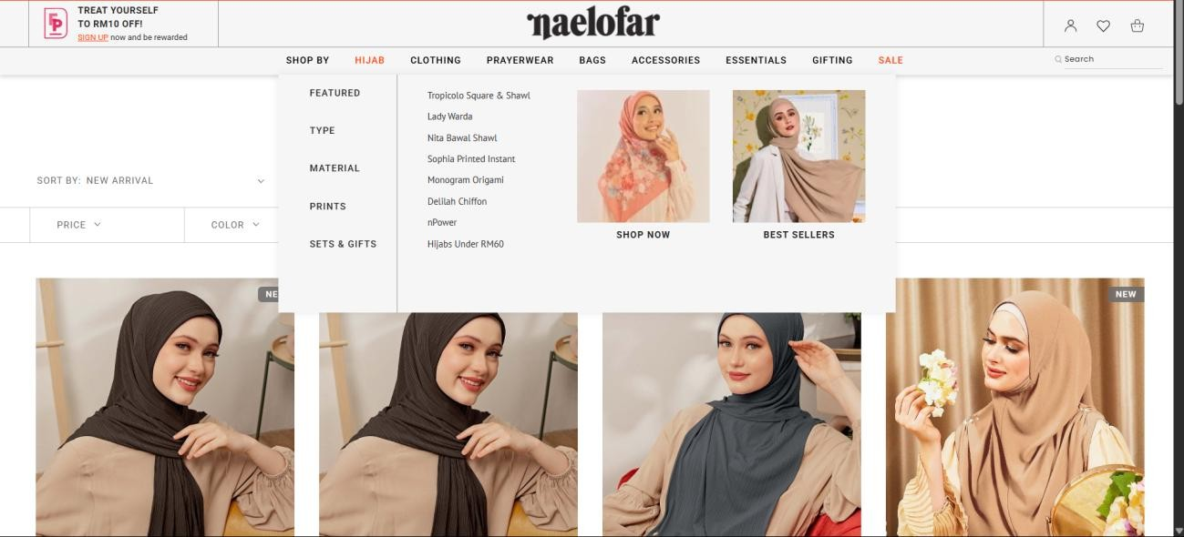

Figure 2.1 : Naelofar.com homepage with efficient hijab categorization
Source : https://my.naelofar.com/home

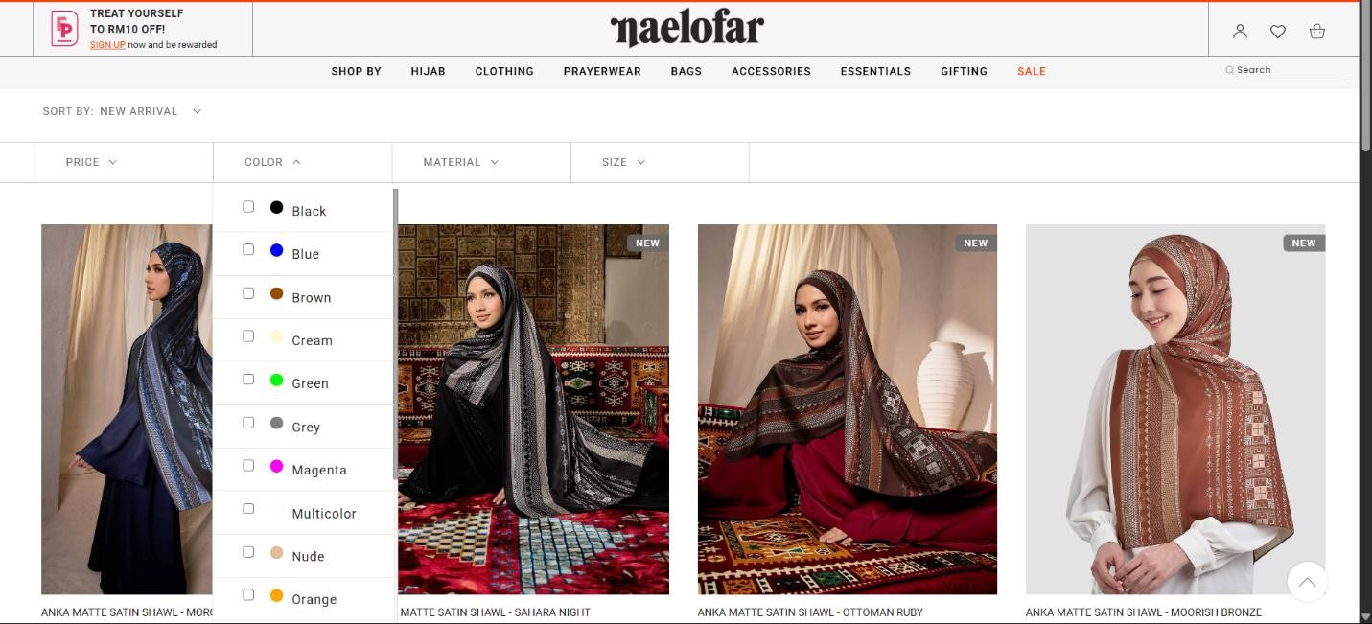

Figure 2.2 : Global filter function for products

Source : https://my.naelofar.com/hijab?product_list_dir=desc

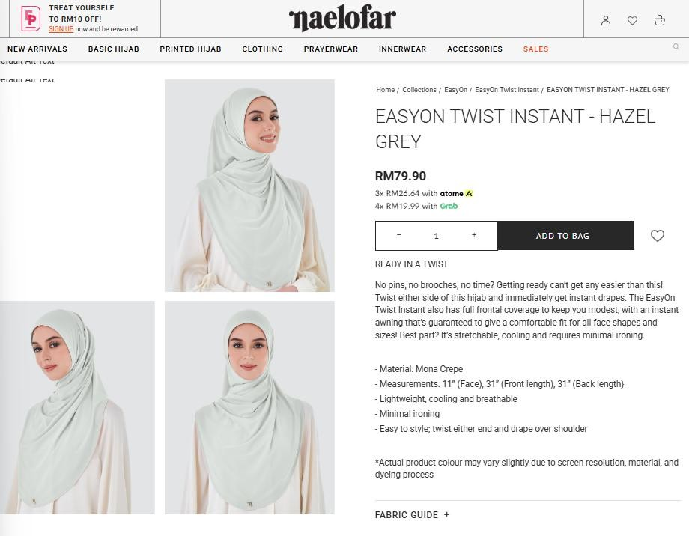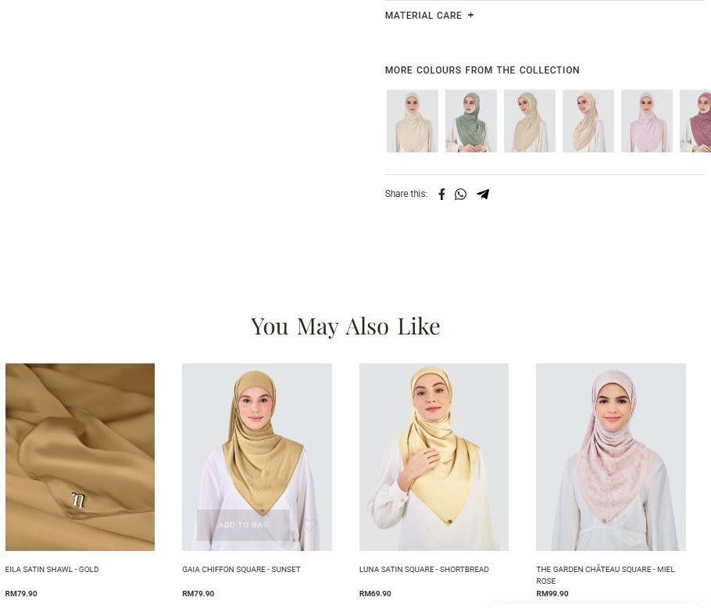

Figure 2.3 : Hijab recommendation for EasyOn Twist Instant hijab.
Source : https://my.naelofar.com/easyon-twist-instant-hazel-grey

In contrast, another brand, Tudung Ruffle offers the same display for product categorization, yet its filter lacks meaningful criteria for users to choose from as shown in Figure 2.4 and Figure 2.5. The only available criteria are availability, price and collection which might indicate the product schema does not have comprehensive attributes to fully describe the product. Though the product did offer product recommendations, it is only limited to the products within the same brand as shown in Figure 2.6.

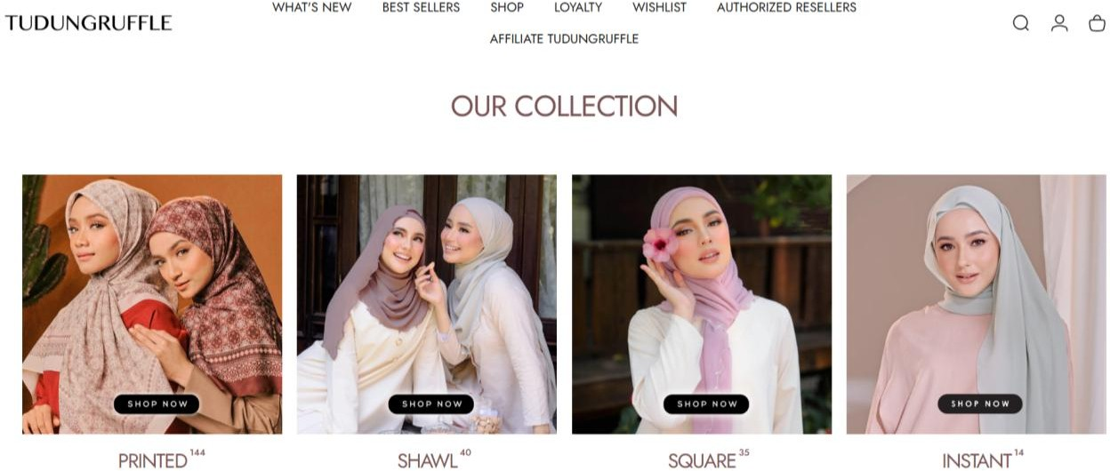

Figure 2.4 : Categorization of hijab by type in Tudung Ruffle’s website
Source : https://www.tudungruffle.com/
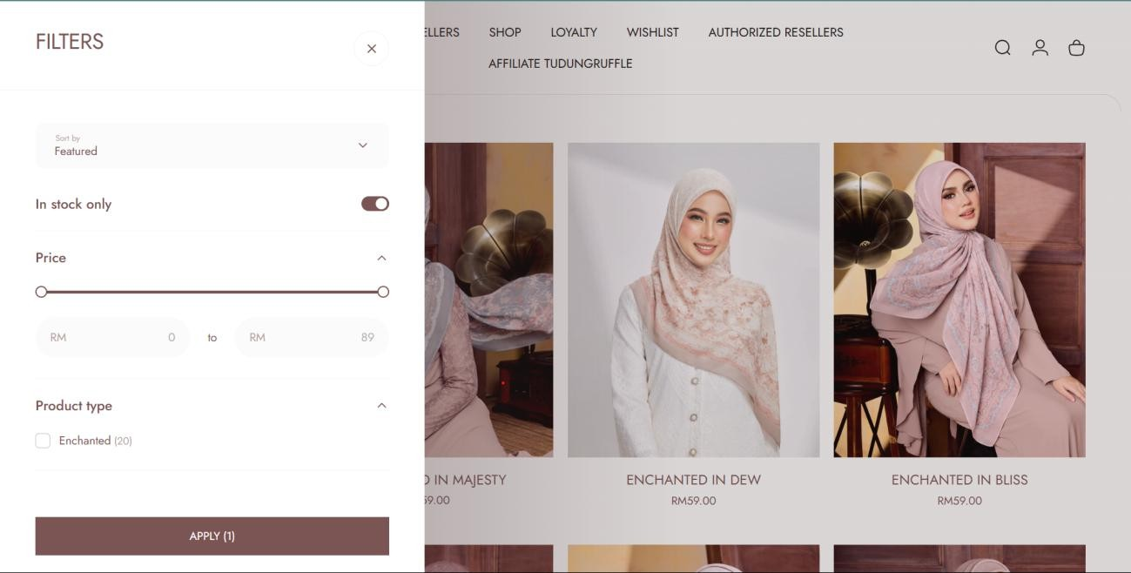

Figure 2.5 : Limited filter in Tudung Ruffle website which are availability, price and product type.
Source : https://www.tudungruffle.com/

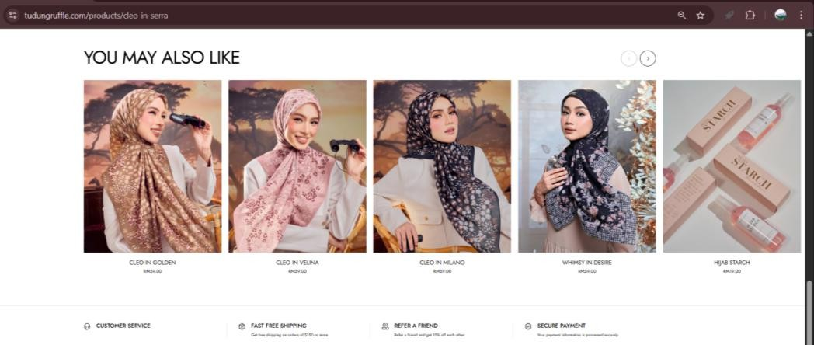

Figure 2.6 : Similar products recommendation in Tudung Ruffle website that is only limited to Tudung Ruffle products.
Source : https://www.tudungruffle.com/products/cleo-in-serra

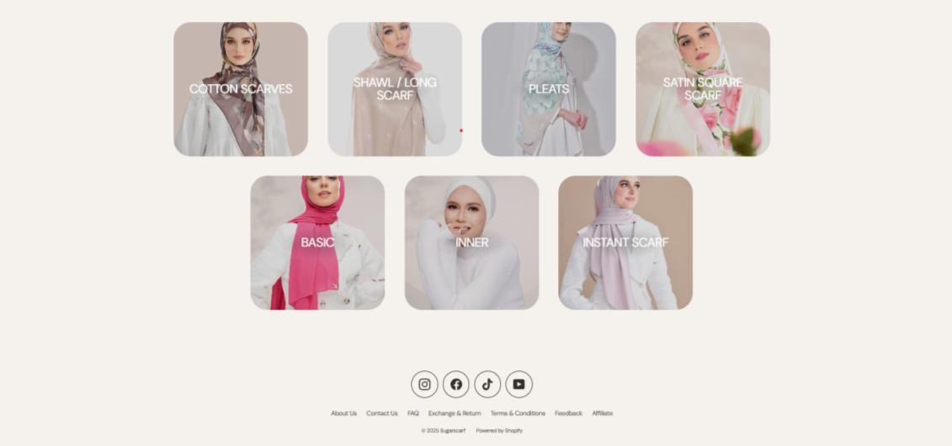
Meanwhile, SugarScarf is another hijab brand which also offers limited categories to filter hijab which are types of hijabs as shown in Figure 2.7. In Figure 2.8, it is observed that the sorting feature does offer a lot of options, yet the option to filter products are limited to availability and price constraint. There is also no product recommendation system as shown in Figure 2.9. This gap in its database design could point to resource limitations or reliance on platform without advanced filtering support, requiring manual tagging or image analysis to extract necessary attributes.

Figure 2.7 : Categorization of hijab by type in SugarScarf website

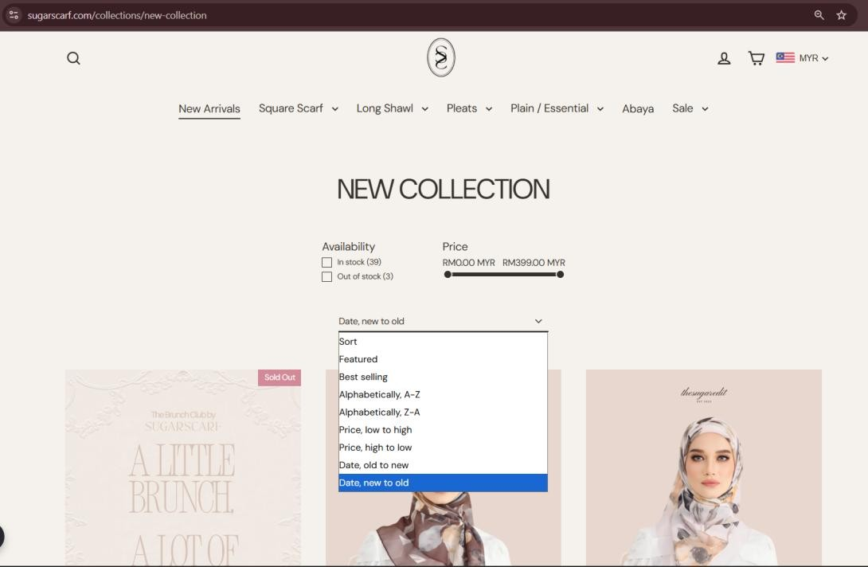
Source : https://sugarscarf.com/?srsltid=AfmBOop5MtHFP4kqOVhPN21zs56x5ABw5tagq xXGURE8We5n2ukPghFL

Figure 2.8 : Sorting and filtering feature in Sugarscarf website.
Source : https://sugarscarf.com/collections/new-collection
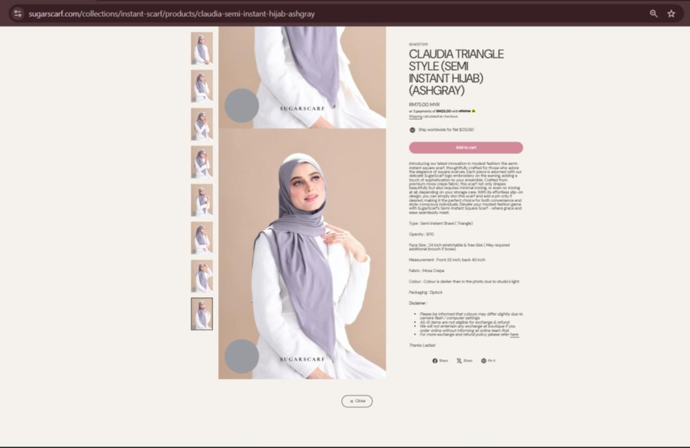

Figure 2.G : Lack of product recommendation system in Sugarscarf website. Source : https://sugarscarf.com/collections/instant-scarf/products/claudia-semi-instant-hijab-ashgray

Online Marketplace

Online marketplaces such as Lazada, Shopee and TiktokShop accumulate thousands of products from various categories including hijab, all under one infrastructure. Although it is viewed as convenient due to its variety of products, one of its shortcomings is that sellers upload products by batch instead of individually. Deductively, this can be a strategy to display higher number of sales to attract consumers as the accumulated sales of the whole collection is higher and ranks better than a single product.

Despite having broad keyword matching for an efficient search function, this encourages impractical data organization practices. Brands would not tag products with proper defining attributes and instead only uses product name to differentiate hijab variations in a collection. As a result, specific keywords such as “black printed bawal” will return a mixture of black and non-black printed square hijabs as there is no “black” keywords being to describe the product. Figure 2.10 demonstrates the search results with “black printed bawal” as a search query on Shopee web application.
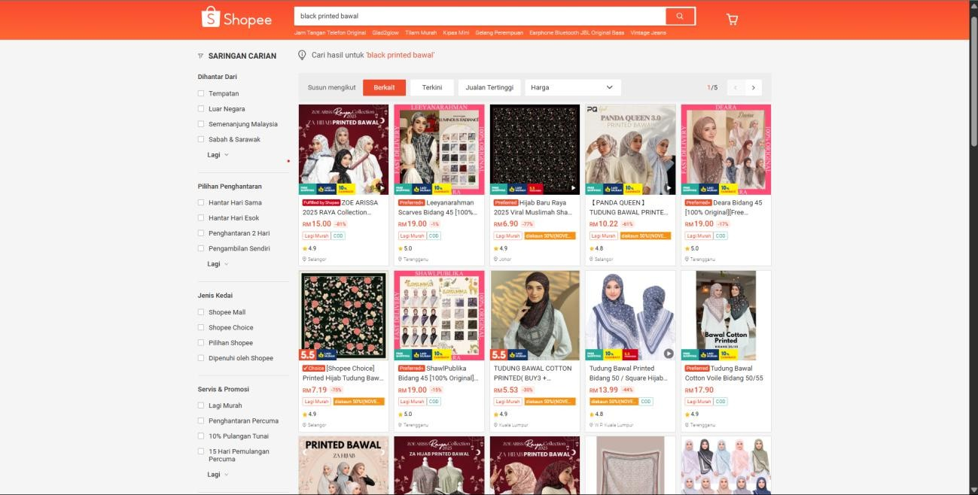

Figure 2.10 : Search results for “black printed bawal” in Shopee marketplace Source : https://shopee.com.my/BLOOM-(2-Helai-RM50)-Bawal-Printed-Cotton-Voil-LunalookxHeejab-i.996287220.26222384508?sp_atk=8526e5e1-08f4-4b6b-a795-edf635554e15Cxptdk=8526e5e1-08f4-4b6b-a795-edf635554e15

The lack of visual clustering by colour or pattern in product listings further indicates the absence of colour metadata indexing. Figure 2.11 shows that users must manually click on each variation from a singular product listing due to the absence of image labelling and unstandardized variation listing (by colour or pattern). This shows ineffective product query listings as users cannot filter by color or pattern at a first glance due to small icons used and extensive listing of products.

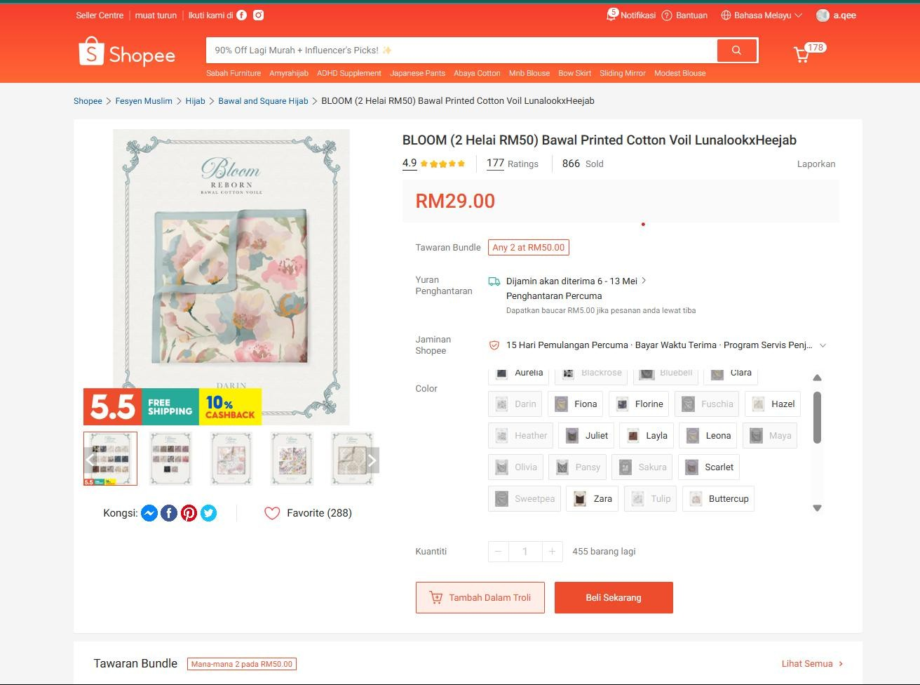

Figure 2.11 : One of the results from previous query showing featuring BLOOM hijab collections with various colour and pattern
Source : https://shopee.com.my/BLOOM-(2-Helai-RM50)-Bawal-Printed-Cotton-Voil-LunalookxHeejab-i.996287220.26222384508?sp_atk=8526e5e1-08f4-4b6b-a795-edf635554e15&xptdk=8526e5e1-08f4-4b6b-a795-edf635554e15

Another issue with platforms hosting huge database of products is the broad generalization of product recommendations. In Figure 2.12, it is observed that product recommendations are grouped in together by collections and not individual item, requiring users to check collections one by one to find relevant products. To retrace previously viewed products, manual backtracking is the only way available aside from adding product to cart which can be limited to product quantity. This problem stems from too many product variations that made individual item recommendation not possible.

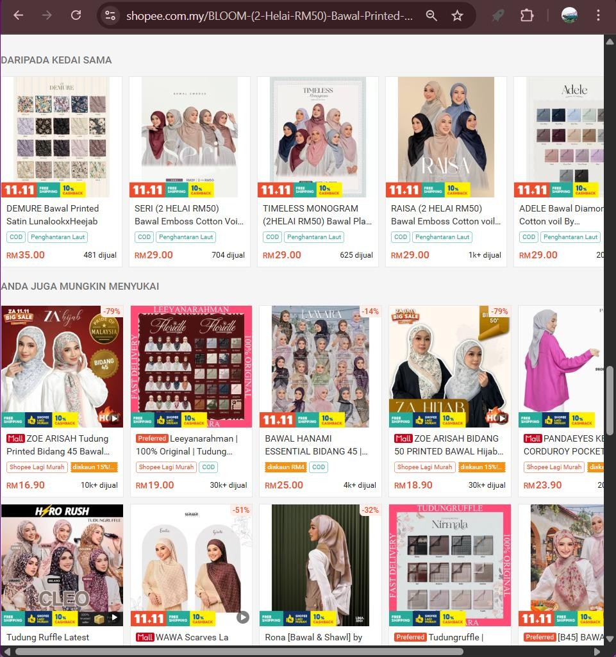

Figure 2.12 : Product recommendations for BLOOM hijab product listing showing grouped products instead of individual hijab product.
Source : https://shopee.com.my/BLOOM-(2-Helai-RM50)-Bawal-Printed-Cotton-Voil-LunalookxHeejab-i.996287220.26222384508?sp_atk=8526e5e1-08f4-4b6b-a795-edf635554e15&xptdk=8526e5e1-08f4-4b6b-a795-edf635554e15

From these observations, it can be concluded that general shopping platforms such as Shopee and brand-specific websites both have technical limitations that affect the quality of product search results and data integrity. While brand websites have underdeveloped data models and listings, huge marketplaces are too broad to allow specific search for a niche hijab criterion. This also affects the lack of personalization and product review quality respectively.

A centralized platform specifically for hijab products can be made to resolve these issues. Data architecture will utilize relational schema while still supporting scalability and integration from diverse sources and formats for better data organization and integrity.

Comparisons between available online platform

Further observations are done with other filtering feature in products listings from various hijab brand websites. The brand, price range, grouping of products in the homepage and criterions included in filter function are noted as below:

Table 2.1: Comparison of product organization and filter in various hijab websites
Brand | Price Range | Product Grouping | Filter criterion
Naelofar | Premium | Category | Colour, Price, Material, Size
Moon&Stella | Mid-range | Collection | Availability, Price
Calaqisya | Premium | Category | Colour, Price
TudungPeople | Mid-range | Category | Type, Colour, Material, Shape,Availability
TudungRuffle | Mid-range | Category,  Collection | Availability, Price, Type, Colour
Imallis | Mid-range | Collection | Price, Collection
CoversCloset | Premium | Collection | No Filter
Kekaboo | Mid-range | Collection | No Filter
Maejestica | Mid-Range | Collection | No Filter
Sugarscarf | Mid-Range | Category | Availability, Price
Alhumaira | Premium | Category,  Collection | No Filter
Minaz | Budget | Collection | Colour, Size, Price, Availability

To summarize the difference in hijab brands’ websites and online shopping platforms, Table 2.2 shows the contrasts based on their general features such as scope of products, product discovery, filter system, data consistency and quick access for selected product.

Table 2.2: Comparison of features between online marketplaces and hijab brand’s website
Feature | Online Marketplaces | Hijab Brands Website
Scope of products | Broad range of products form electronics, to food where  hijab is a tiny category. | Contains hijab products only in its respective brands.
Product Discovery | Generalized search results cluttered with other sellers from the same brand and irrelevant items from  different product category. | Easy discovery for hijabs with a dedicated recommendation system but limited to a single brand.
Filtering system | Filters are too general such  as price, shipping area and delivery option. | Filters have limited criteria  that returns less precise results.
Data  consistency | Product listing have  inconsistent title, tag and attributes showing low data  consistency. | Product listings have high data consistency such as attributes and titles yet  constrained to a single brand.
Quick access | Hijab bookmarked as preferred are mixed up with products from all categories. | Items can be marked by adding to cart, yet its  fragmented across different  brands.

Web Application Usability

Web application usability refers to the efficiency of how users can interact with a web application to achieve their goals. For ecommerce and product catalogue platform, usability plays an important role in ensuring that web application becomes a successful channel of communication between customer and suppliers, promoting (Aziz et al., 2021). This can be achieved by applying Human-Computer Interaction (HCI) principles in web application design by prioritizing user needs.

Navigation and Information Design

Web applications with a clear navigation and goo information organization can strongly affect customer satisfaction and loyalty (Guo et al., 2023). This study shows that bycognitive load and introducing intuitive navigation, users can easily find their path to achieve their goals easily.

Search Interface

A catalogue web application that hosts a huge volume of product listing must expect its users to need a feature that allows search or filter feature. This makes finding desired information easier and increase user satisfaction and purchase intentions in e-commerce platforms (Utami et al., 2021). To achieve this a responsive filter and effective search functionality are needed to help customer reach the information they want. (Jayaraman & Sharma, 2025)

Product Categorization

To guide users through their browsing process, the categorization system implemented on product listings should be reasonable and accurate. This helps avoid confusion and allow users to make informed decision quickly and effectively (Fadliyani & Satya, 2024). It is also noted that proper product categorization can also plays a role in providing targeted advertising and personalized recommendations (Pawłowski, 2021).

CHAPTER 3

METHODOLOGY

Introduction

This chapter explores the project methodology used in this research by explaining how the web application is developed. This includes the procedures of collecting data, designing the system, developing modules and evaluating the system, as well as the hardware and software specifications used in this project. This stage aim to provide a tangible outline of project management for efficient web application development.

Development Methodology

Development methodology is a systematic approach to solve a research problem which involves but not limited to requirement planning, data collection and data analysis. In this project, a software development method called Agile will be adopted to develop the hijab catalogue web application.
Research done by Alsaqqa et al. (2020) defines the Agile as the lightweight approach of software development method with adaptive, incremental and iterative working methods. Compared to traditional software development methods with strict rule-based development cycle, Agile is broken down into iterations or sprints, with each sprint highlights clear and achievable goal. Adopting Agile method in developing this web application has several reasons, such as:

Time constraint

Since this project has a short time constraint of one year with only one developer working on it, Agile method seems as the best suit. Prioritizing working software over extensive planning requirements, developers can allocate more time to developing features and rapid delivery to contribute to work progress.

Adaptability

Feedback from users is important throughout the development process, thus modifications are unavoidable in a software project. Agile’s iterative and incremental nature allows changes to be applied more effectively throughout the development process instead of only in the final stages.

Lower risk

As projects are delivered in small increments, it is easier to identify bugs and errors and take actions for risk mitigation early on. This enables the project to avoid bigger complications if errors are only determined in the final build, as fixing errors at that point would require more time and effort.

Implementation of Selected Methodology

In general, most software development methods including Agile consist of six main phases which are planning, designing, developing, testing, deploying and review as illustrated in Figure 3.1. The detailed description of activities conducted in each phase are as follows:

Review
Plan
Deploy
Design
Test
Develop













Figure 3.1 : The main phases in Agile Development Cycle

Phase 1: Planning
In this phase, the main objective is to clearly define the goals and direction of the research. To achieve that, preliminary research and analysis study are conducted such as studying the current online marketplace and hijab brands' websites. This helps identify technical challenges and determine user requirements in the framework of the problem statement discussion. Critical analysis is conducted such as defining problems and objectives, literature review and rough planning of project time frame.

Phase 2: Design
This phase focuses on designing the system architecture, interface and core modules for the catalogue web application based on requirements gathered. To further illustrate the system, activity flowchart and data flow diagrams are created. The core modules are proposed to be implemented in the project. This phase produces an outcome of software prototype to guide the next phase which is development.

Phase 3: Development
Agile method breaks down software development into iterations or sprint cycles, where each sprint focuses on a specific feature to be delivered at the end of each sprint cycles. Software coding done by modules while integrating version control using GitHub to manage changes. At the end of the sprint, the modules are then evaluated using expert evaluation such as academic supervisors for improvement.

Phase 4: Testing
Each sprints will have testing done to the individual features to allow functionality at a modular level. This helps to avoid major errors maintenance when the codebase had reached its final stages, where it is harder to fix errors and implement modifications. Compatibility testing will also be done on various devices to allow seamless operability.

Phase 5: Deployment
After all modules had been developed and tested thoroughly, this phase executes the deployment of the software to online web using Vercel as a hosting platform. Other activities include ensuring smooth integration of interface and database, polishing the user interface and resolving any remaining bugs, deeming the web application to be stable for public release.

Phase 6: Review
In this final phase, the software undergoes further usability testing and expert evaluation to ensure continuous improvement. Developer will monitor the progress of the web application and implement any feedback received or fix arising bugs.

Software Requirements for System Development

After determining the project methodology and the architecture system, the next step is to choose the environment and tools that would be appropriate for the system development. The software and hardware used must be able to handle the functionalities of this project, which will be specified in this section.

Software and Tools

The hijab web application is built using the Microsoft Windows 11 64-bits operation system. The system is built using Visual Studio Code as the Integrated Development Environment (IDE) to build the web application on Windows Operating System (OS).
The database management utilizes PostgreSQL hosted on Neon, a serverless PostgreSQL platform, providing strong data integrity and scalability for handling complex product relationships. Prisma ORM is used as the database interface, providing type-safe queries and automatic migration management. Sanity CMS serves as the headless content management system for product catalogues, orders,, and promotional campaigns, offering a real-time content studio and CDN-cached queries. Authentication is handled by Better Auth, a lightweight authentication library with email/password support and role-based access control (user, seller, admin). For payments, Stripe Checkout Sessions and webhooks process transactions in Malaysian Ringgit (MYR) with support for Malaysia, Singapore and Brunei. Resend is used for transactional email notifications such as shipping updates and order confirmations. Client-side cart state is managed by Zustand with local persistence and server synchronisation. The web application is hosted on Vercel, which offers native integration with Next.js for serverless deployment and Incremental Static Regeneration (ISR).

Framework

In this project, the framework used consists of Windows 11 for the operating system. Next.js 16 with React 19 is used as the full-stack framework, providing server-side rendering, API routes and file-based routing. Tailwind CSS v4 is used for utility-first styling, combined with shadcn/ui and Radix UI for accessible, reusable interface components. Prisma 7 with the PostgreSQL adapter handles database operations, while Sanity v5 provides headless CMS capabilities. Better Auth manages user authentication with role-based access control, and Stripe handles payment processing. Zustand is used for client-side state management, and Resend provides transactional email services. Table 3.1 shows the software requirements of the hijab web application.

Hardware Requirements

The hardware used for developing the system is a laptop with Intel® Core™ i5-10400 CPU processor with 4.00GB RAM and 64-bit Windows 11 operating system. Meanwhile, the hardware for accessing the hijab web application is any devices with access to internet and a browser.

Key Milestones

Table 3.1: Key milestones for FYP 1

Num | Milestone | Completion Week
1 | Title selection and project registration | Week 1
2 | Problem Identification | Week 1
3 | Proposal Submission | Week 6
4 | Proposal Defense | Week 8
5 | Requirement Planning | Week 9
6 | Initial Interface Prototyping (Design) | Week 11
7 | Final Interface Prototyping (Design) | Week 12
8 | Environment setup | Week 13
9 | Module 1: Product Catalog | Week 14
10 | Progress Report Submission | Week 14
11 | Progress Presentation | Week 15

= General Key Milestone
= Specific Key Milestone

Table 3.2: Key milestones for FYP 2

Num | Milestone | Completion Week
1 | Module 2: Product Filter | Week 1
2 | Module 3: User and Seller Dashboard | Week 2
3 | Module 4: User Authentication | Week 5
4 | Module 5: User Profile | Week 6
5 | Progress Report | Week 6
6 | Progress Presentation | Week 7
7 | Module 6: Favorites module | Week 7
8 | Module 7: Recommendation Module | Week 9
9 | Module 8: Cart Module | Week 10
10 | Module 9: Payment Gateway | Week 10
11 | System Testing | Week 11
12 | Usability Testing | Week 12
13 | Final Report Submission | Week 14
14 | Final Project Presentation | Week 15

= General Key Milestone
= Specific Key Milestone

Gantt Chart

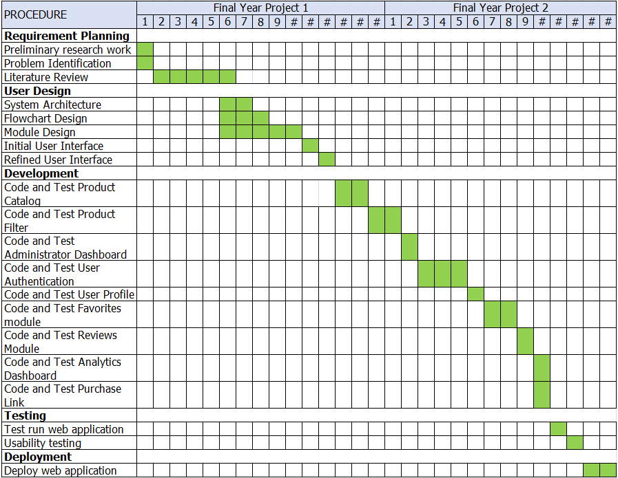

Figure 3.2: Gantt chart for project key activities

Conclusion

In summary, the project methodology outlines the approach taken to develop the hijab catalogue web application, from requirement gathering through to reviewing the deployed system. The development leveraged Next.js with React for the full-stack framework, Tailwind CSS and shadcn/ui for styling, PostgreSQL on Neon with Prisma ORM for data management, Sanity CMS for product and order content, Better Auth for authentication, Stripe for payment processing, and Resend for email notifications. This iterative approach ensured the project's objectives were met within the set timeframe.

CHAPTER 4

SYSTEM ANALYSIS AND DESIGN

Introduction

In this chapter, the proposed system will use questionnaires and observation to gather requirements needed to build the web application. Next, the design of the system will be drafted using structured approach. The study of a system under investigation is known as systems analysis (which may be real or imagined). Its goal is to comprehend and document the system's key characteristics. Its ultimate purpose is to produce a specification for the system being researched. Analysts express the data of the system under investigation in terms of metadata concepts and relationships during analysis. Metadata allows analysts to concentrate more easily on matching the data representation to the requirements of the system under consideration. We look at three types of data representations that are frequently used in systems analysis: conceptual data modelling, knowledge representation, and ontologies.

Requirement Elicitation Techniques

In order to determine what kind of features needed for the web application, the project necessitates the requirement elicitation techniques. This can be done by
observing how similar systems work and handing out questionnaires to people who often shop for hijab for their insights. This can help discover important features needed by users and ensuring the technical implementation aligns well with the business goals.

Questionnaire

Questionnaires are a set of structured questions used to gather information from respondents regarding a specific topic. Data collected can be in quantitative or qualitative or a combination of both. The project collects both data as it asks respondents to rate and rank answers as well as providing a subjective answer for feedback. The questionnaire is made and hosted using Google Form and distributed randomly among Universiti Malaysia Sabah (UMS) hijab-wearing students and some hijab-related Facebook pages. A total of 20 responses are recorded.

Observation

Another requirement elicitation technique is by conducting observation on similar systems as the hijab web application. This is done by evaluating the process and user experience interacting with the systems and how effective it is for them to achieve their specific goal. Chapter 2 discusses more on these observations by highlighting the weakness and strength of e-commerce platform and hijab brands’ websites and comparing them. This helps validate the functional and non-functional requirements to be improved.

Requirements

Software requirements are features that must be implemented in the system, whether it is functional or non-functional. The term functional refers to a tangible service provided to the user while non-functional requirements are specifications of system’s operational abilities and constraints that improve its functionality. This includes speed, security and reliability.

Table 4.1: Functional Requirements for Hijab Web Application

ID | Functional Requirement | Description
User
FR_U_01 | User Authentication | User can create an account or login
FR_U_02 | Save Items to Favourites | User can mark products to save into the ‘Favorites’ list
FR_U_03 | Add to cart | User can add selected products to cart, view and edit it.
FR_U_04 | Make payment | User can check out the cart and pay through payment gateway
FR_U_5 | View Order | User can view the order that has been made for tracking purposes.
Seller
FR_S_01 | Seller Authentication | Seller can make an account and login into their profile
FR_S_02 | Add, Edit, Delete Products | Seller can add, edit, and delete listing of their products with  details
FR_S_03 | View and Manage Orders | Seller can view orders they got after payment has been made

Table 4.2: Non-functional Requirements for Hijab Web Application

ID | Non-Functional Requirement | Description
NF_01 | Availability | The system will be able to be accessed 24/7
NF_02 | View Product | Products will be displayed in the homepage as default
NF_03 | See product recommendations | Product recommendations will be shown for every product
NF_04 | Security (Authentication) | The use of authentication system and secure payment gateway for  the system at all times.

Activity Diagram

An activity diagram is used to illustrate the flow of actions in this web application. It outlines the different paths users can take as they interact with the system. For example, the diagram shows that in the case user fails to log in, the system will allow them to register an account. This helps exploring various scenarios to ensure users have a smooth experience when using the web application. Figure 4.1 below shows the activity diagram for Hijab Web Application.
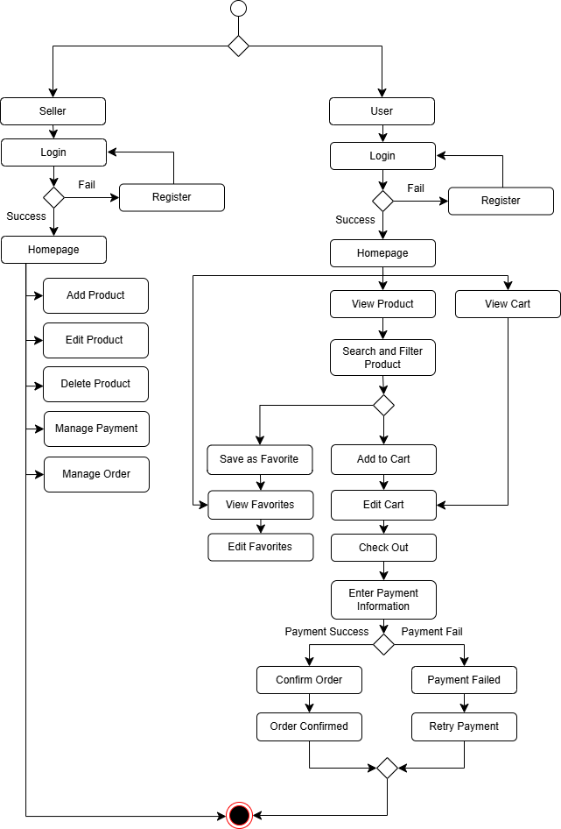

Figure 4.1: Activity Diagram for Hijab Web Application

Structured Approach

A methodical system design that breaks down the system into smaller modules is called the structured approach to system design. This approach uses logical modelling such as Context Diagram and Entity Relationship Diagram to highlight the functionalities of the models instead of the method of developing the system itself. This section provides related diagrams used to visualize the system in a structured approach.

Context Diagram

Next, context diagram is a high-level visual model used to represent the system as a central process with entities communicating with it using labeled data flows. This helps give a clear picture of the scope and main data flow of the system without going too deep into detail. It consists of the system itself, entities (such as user and seller) and data flows (customer details) illustrated using arrows.

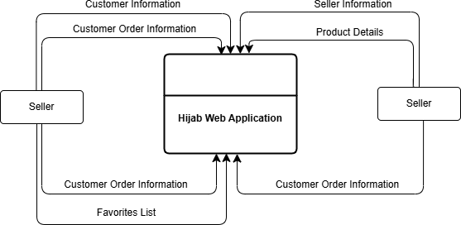

Figure 4.2: Context Diagram for Hijab Web Application

Data Dictionary

Data dictionary is a record of data items and its description used within a system. It can act like a dictionary as a point of reference as it includes details such as variable names, its meanings, data type, and acceptable values. By providing a detailed reference for the data items and its attributes, this ensures a consistent usage of data for better data querying. The tables below specifies the data dictionary used in the system’s database.

Table 4.3: Data Dictionary for User Class

No | Field | Data Type | Description
1 | userID (PK) | Int (10) | ID for User
2 | userEmail | Varchar (50) | User’s email address
3 | userPassword | Varchar(20) | User’s unique password
4 | userPhone | Varchar (12) | User’s phone number
5 | UserUsername | Varchar (20) | User’s username
6 | userAddress | Longtext | User’s shipping address

Table 4.4: Data Dictionary for Seller Class

No | Field | Data Type | Description
1 | sellerID (PK) | Int (10) | Seller’s ID
2 | sellerEmail | Varchar (50) | Seller’s email address
3 | sellerPassword | Varchar(20) | Seller’s account password
4 | sellerPhone | Varchar(12) | Seller’s phone number
5 | slellerUsername | Varchar(20) | Seller’s account suername
6 | sellerAddress | Longtext | Seller’s shop address

Table 4.5: Data Dictionary for Products Class

No | Field | Data Type | Description
1 | productID (pk) | int (10) | ID for product
2 | productName | varchar (100) | Products name
3 | productDescription | varchar (250) | Product’s description
4 | category | varchar (20) | Product’s category
5 | price | decimal (6) | Product’s price

6 | imageURL | longtext | URL link for product’s images
7 | releaseDate | datetime | The date of product release
8 | material | varchar (10) | Material/fabric of product
9 | size | varchar (10) | Size of product
10 | colour | varchar (20) | Colour of product
11 | brand | varchar (20) | Brand of product

Table 4.6: Data Dictionary for Orders Class

No | Field | Data Type | Description
1 | orderID (pk) | Int (10) | ID for each order made
2 | orderDate | Datetime | Date of the order made
3 | Status | Varchar (10) | Order status; shipped, cancelled, refunded or delivered.
4 | Qty | Int (10) | Quantity of item ordered
5 | totalPrice | Int (10) | Total price of items purchased

Table 4.7: Data Dictionary for Saved Items Class

No | Field | Data Type | Description
1 | SavedItemID (pk) | Int (10) | Id of items marked as favorite
2 | timeSave | Datetime | Timestamp of when item is marked as favorite

Entity Relationship Diagram
Entity Relationship Diagram (ERD) are one of the visuals in Unified Model Language. This relational database model visualizes the relationship between entities, attributes and values of the data in this hijab web application to understand how each data interacts with each other. Every table represent an entity with their attributes, while the lines connecting these boxes describes its relationship with other entities. The ERD for the web application can be seen in Figure 4.4 below.

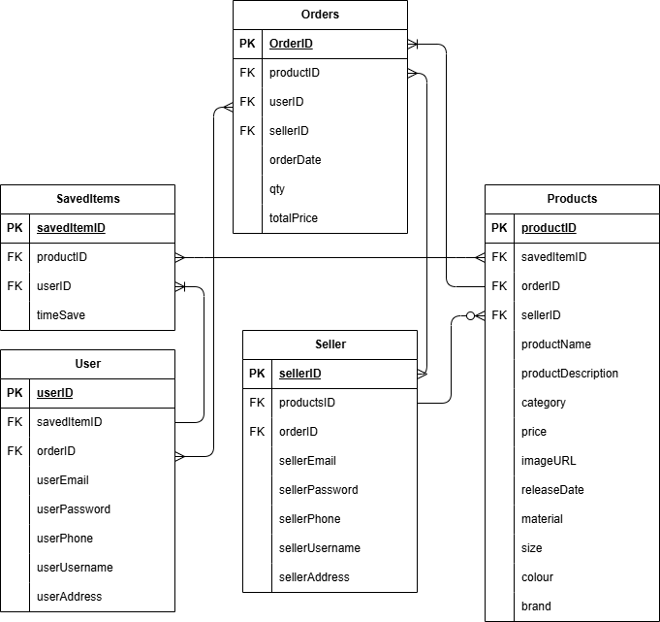

Figure 4.3: Entity Relationship Diagram (ERD) for Hijab Web Application

Architecture Design

This project applies the three-tier Client-Server Architecture where multiple client devices can request information from a server, which provides the requested information promptly. The application is divided into three main layer which consists of interface layer (client side), backend layer (server and API side) and data layer (Database). Figure 4.1 below illustrates the system architecture for the web application.

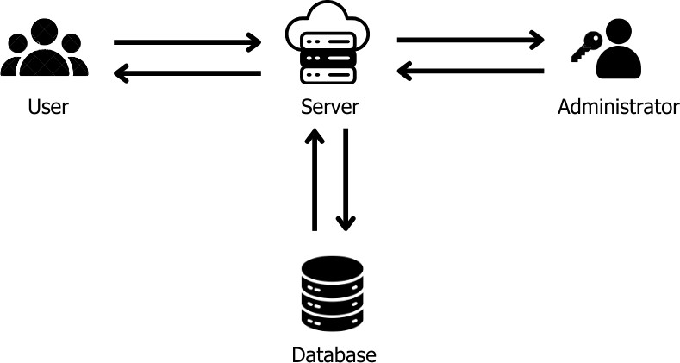

Figure 4.4: System architecture of Hijab Catalogue web application

This client-server architecture is deployed on a web hosting platform, Vercel due to its native integration with Next.js framework. This simplifies scaling and infrastructure management such as it is more practical compared to building dedicated machines and hosting them in a data center. Meanwhile, the database is hosted on another opensource platform, NHost which provides easy management with PostgreSQL database, storage, server functions, authentication API and security features. Choosing this architecture allows for better scalability and maintenance as it allows independent development without affecting the other tiers. Separating the user and database layer helps to ensure security as the database hosted on NHost are not directly exposed to the users. Routing data requests and transactions through Next.js API route helps manage the multi-tenant dashboard which consists of users and seller using Role-Based Access Control (RBAC).
Based on Figure 4.4, clients will start communication by connecting to the internet browser and requesting webpage from the web server. After getting the webpage, products are displayed on the homepage and users can browse through the product listings. Users can also use features such as filtering the product listing, see similar hijab recommendations and shop through the purchase link. Meanwhile, registered users can have additional access to saving products as favorites and view it from the user dashboard.

User Interface Design

User interface design refers to the initial proposed design for how the front-end of the web application will look like to users. This process put more focus on aesthetic design of the system, aiming to appeal to potential users with smooth navigation and visually appealing design. Since the hijab web application is related to fashion, the design aims to capture user’s attention with bright and sophisticated colours and crisp images to showcase the products. The arrangement of the product must also be neat and appropriate so as to avoid crowding the homepage with too many information at once. Below is the proposed design for the web application.

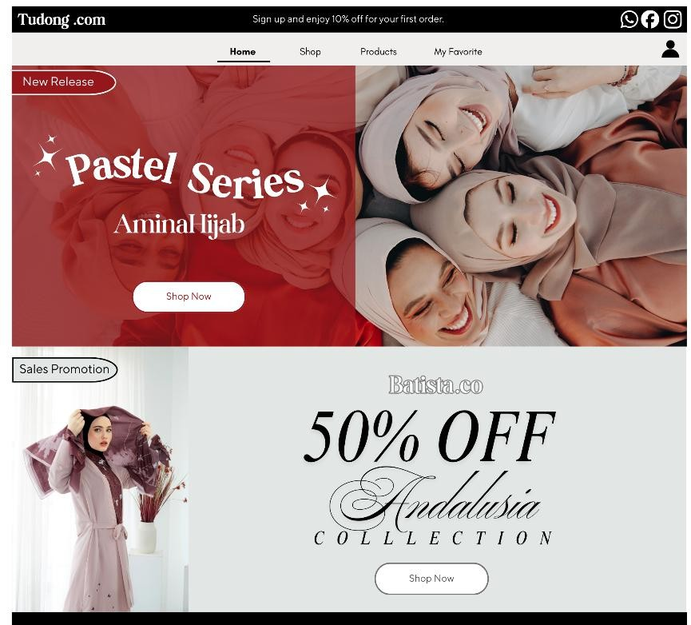

Figure 4.5: Home Page for Hijab Web Application

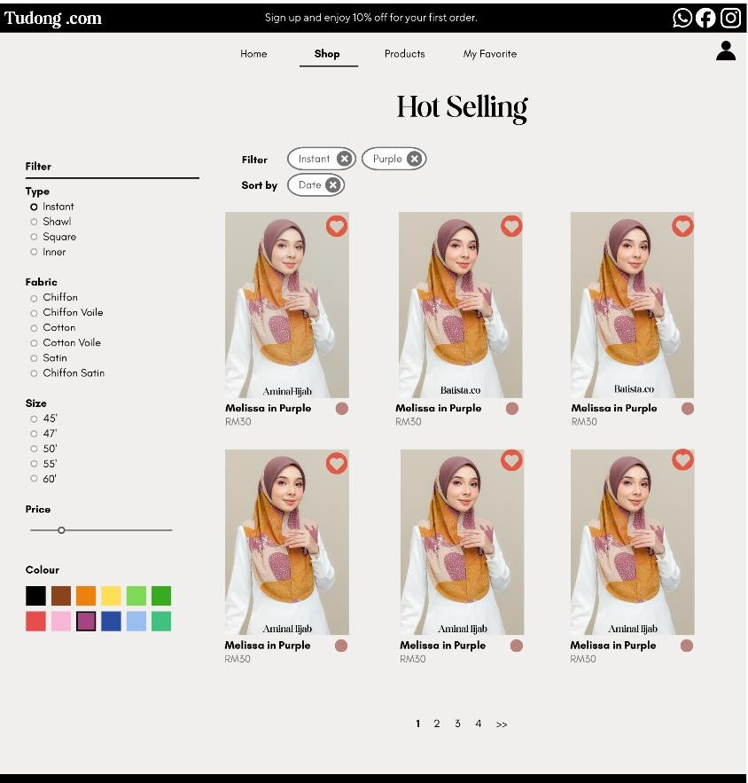

Figure 4.6: ‘Shop’ Page for Hijab Web Application

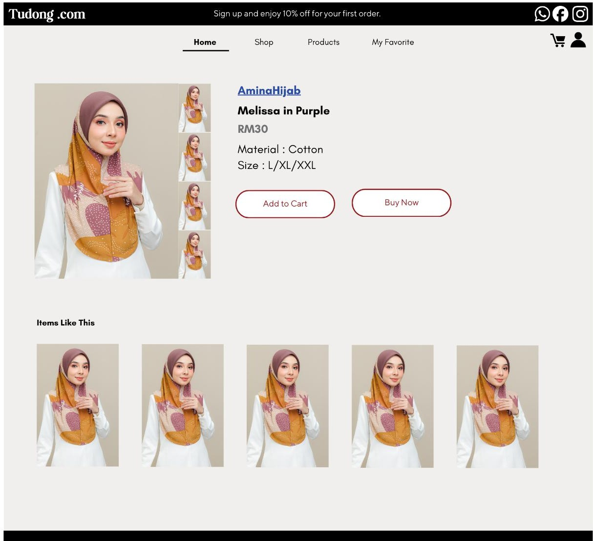

Figure 4.7: Products Page for Hijab Web Application

Conclusion

This chapter explained in detail regarding the approach taken to construct the web application. Using structured approach will help ensure the features of the system to work seamlessly together with proper planning. The architecture system is also outlined to show how the system can be accessed while the data dictionary helps establish the database structure for the system to rely on.

CHAPTER 5

IMPLEMENTATION

Introduction

After designing the hijab web application, this chapter will implement the system by developing the web application. Further details will also be explained on how the system work and how each module fulfills the requirements drafted in previous chapters.

System Implementation

This project is a web-based system that is developed using React.js and Next.js. The system is at initial stage where only some modules are developed, namely the product display module. Figure 5.1 shows the homepage of the web application with product listing, search and filtering options.

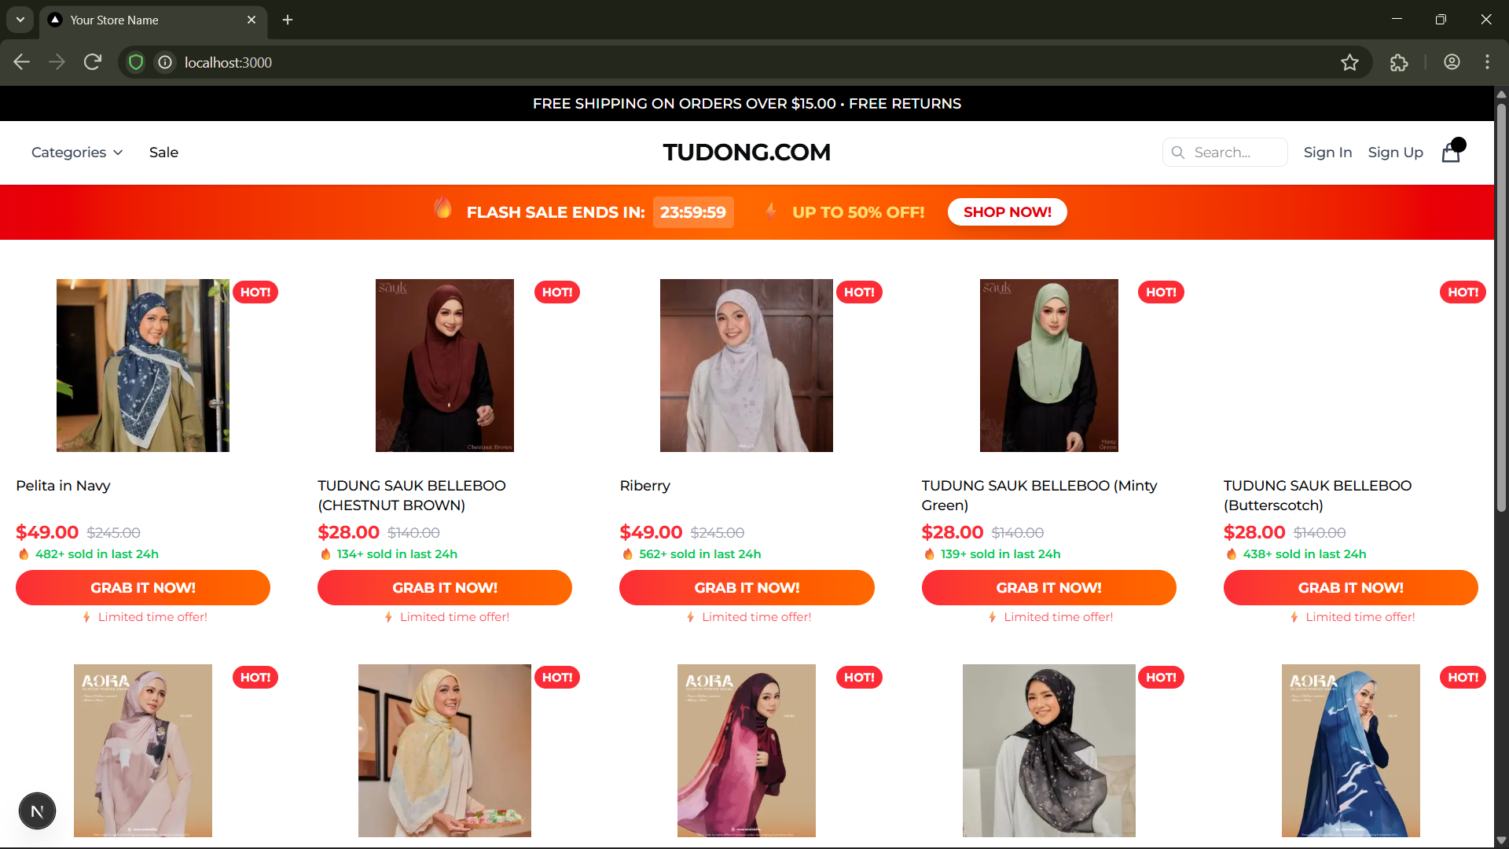

Figure 5.1: Home Page for Hijab Web Application

The figure above shows the home page, which also acts as a product catalogue to all users. It lists out all available product and brief details such as product name, images, price and add to cart button. All user can access this page without needing to login or signup, but they must do so for other actions such as add to cart, add to favorites and more.

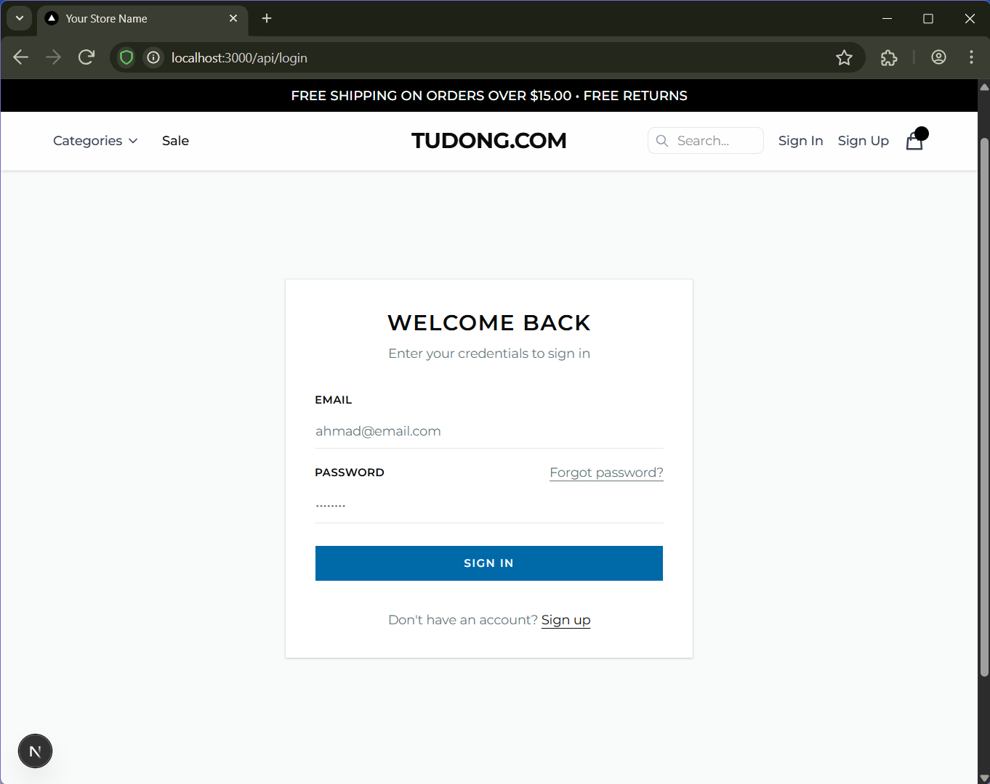

Figure 5.2: Login Page
The figure shown above is the login page for all users including admin. The authentication method used for now is email authentication, where each user will be assigned a role by the admin. The default role is user role.

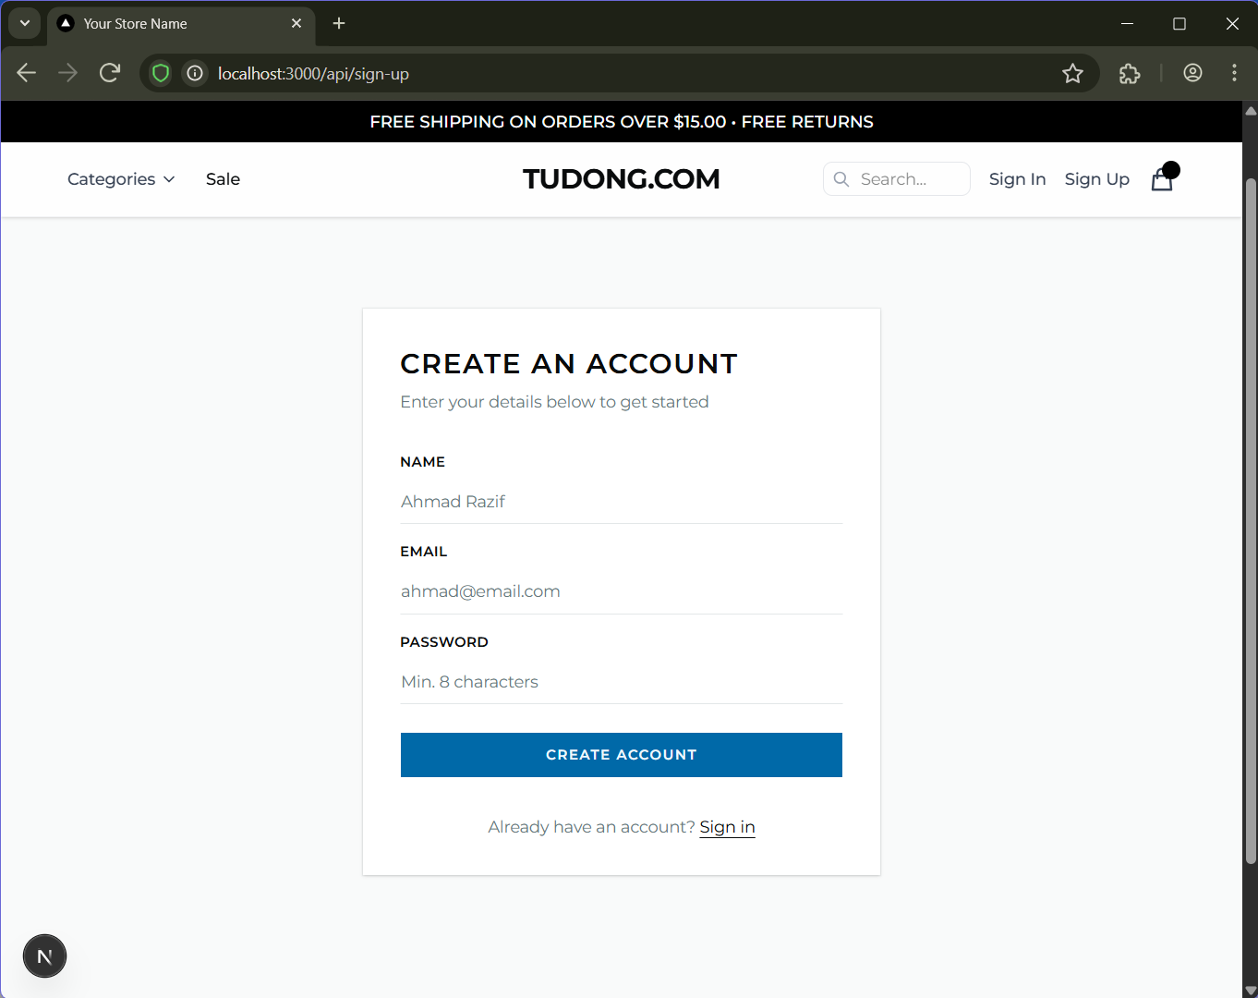
Figure 5.3: Sign-up Page

In case there are no account created yet, site visitors can create an account using their email and password. This will then be stored in the Prisma database which is only available to the admin only. Afterwards, user can proceed to the log in page to continue browsing the site.

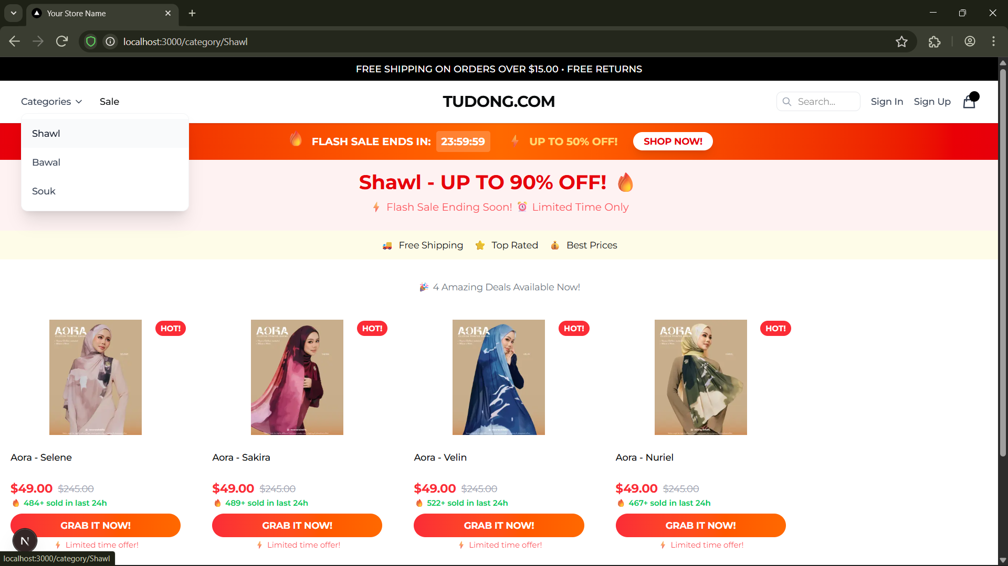

Figure 5.4: Category Page

This page filters product based on category. For now, the categories are Shawl, Bawal and Souk hijab. Only products with the selected category will be shown so that user can have an easier time browsing.

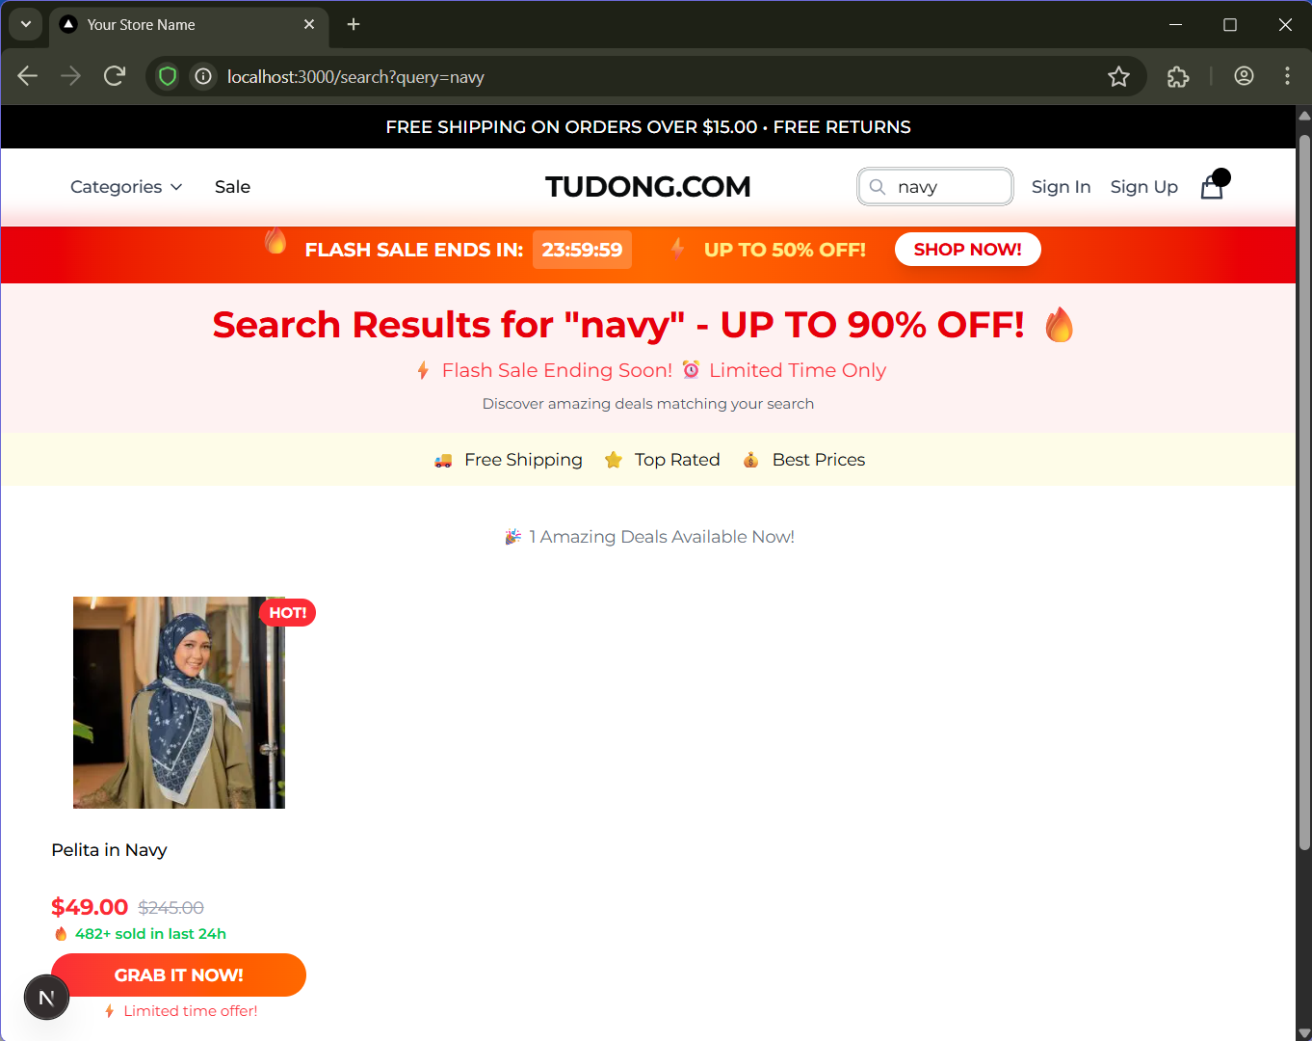
Figure 5.5: Search Page

The search page above is where user can search a hijab by its colour or other attributes. This page will filter products and only show results related to the query. For now, the query only takes in “string”, meaning it filters based on text metadata instead or image metadata.

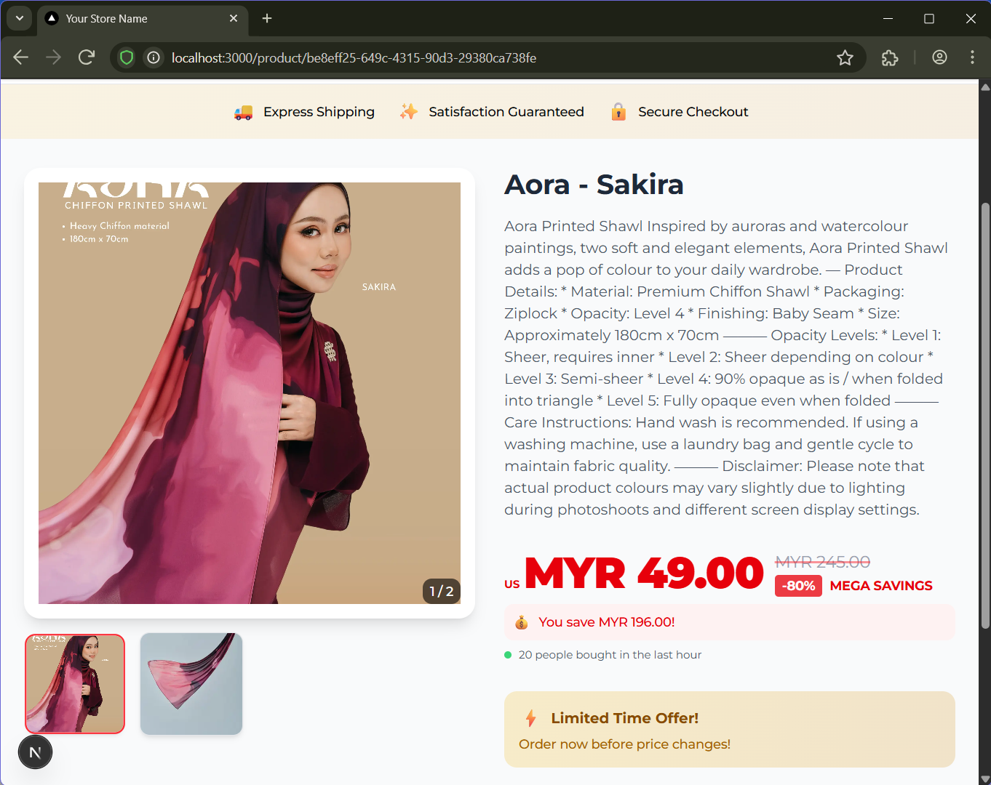
Figure 5.6: Product Detail Page

After clicking on a product, a product detail page will appear to give user more information of the selected product. In this page, user should be able to view product attributes such as colour, or view other images of the products. In the next iteration, this page should allow user to add products into their cart to purchase product.

CHAPTER 6

TESTING AND EVALUATION

Introduction

In the previous chapter, all modules are implemented into the system according to the outlines and system design. Next, comprehensive testing and evaluation are carried out to ensure it meets all the necessary requirements and provides smooth user experience. This chapter will focus on functional testing to validate whether the system functions according to the requirements specified in the system analysis and design.

System testing is carried out after the development stage to test overall system functionality and integration, while User Acceptance Testing (UAT) are done afterwards to gain potential users’ perspective on the web application’s efficiency and user-friendliness.

System Testing

A system that has been developed will undergo system testing to ensure that every separate module and components works efficiently together and meet functional requirements. This method is chosen as it validates end-to-end user workflow across the whole web application, including integrations between the frontend, backend, database, and third party services such as Stripe, Vercel and Resend.

The testing environment is the same as development environment, where the hardware used is a laptop with Intel® Core™ i5-10400 CPU processor with 4.00GB RAM and 64-bit Windows 11 operating system. Various internet browsers are used, which are Ecosia, Google Chrome and Brave browsers, to ensure seamless compatibility.

All the functional requirements previously listed in TABLE X will be tested, with pre-conditions and its outcomes. A “pass” outcome states that the module works effectively and can be forwarded to user acceptance testing. The environment held to conduct unit testing are as below:

As the system implements multi-role users, different accounts are created. All accounts are mock accounts with mock products data and purchases, with no relation to real world entity. Details about the account created for the system testing are listed in the table below.

Role | Email | Password | Details
Admin | admin@gmail.com | admin12345 | Admin Account
Seller | imallis@gmail.com | imallis1234 | Approved seller account with established product
Customer | user@gmail.com | user1234 | Standard customer account

Authentication and Account

ID | Use Case | Preconditions | Steps | Test Data | Result | Status
1 | Register new account | Logged out | 1. Go to Sign Up  2. Enter details  3. Submit | New email and password | Account created, user is authenticated and redirected to homepage. User data is recorded in database | Pass
2 | Register with existing email | An account already uses the email | 1. Sign Up with previous email  2. Submit | Previously created email | Registration rejected with an "email already in use" error | Pass
3 | Register with invalid input | Logged out | 1. Sign Up  2. Enter invalid email and short password  3. Submit | email | Validation error shown; account not created | Pass
4 | Login with valid credentials | Registered account exists | 1. Go to Sign In 2. Enter credentials 3. Submit | Valid email + password | Login succeeds; header shows Sign Out & Dashboard | Pass
5 | Login with wrong password | Registered account exists | 1. Sign In with wrong password | Valid email + wrong password | Login rejected with an error; no session created | Pass
6 | Logout | Logged in | 1. Click Sign Out | — | Session ends; header shows Sign In / Sign Up | Pass

Product Search and Browsing

Shopping Cart

Favorites Button

Checkout and Orders

Analytics Dashboard

Admin Dashboard

Seller Dashboard

User Dashboard

Access Control

REFERENCES

Agnihotri, Durgesh;Chaturvedi, Pallavi. (2014). A study on impact of Shopper Navigation & E-service quality on Ecommerce Conversion. International Journal in Management & Social Science, 4(1), 189–196. https://www.indianjournals.com/ijor.aspx?target=ijor:ijmss&volume=4&issue
=1&article=022
Adiningrat Gede Pradiva, Nur, F. R., Kusuma, I., & Ayu, I. (2023). DEVELOPMENT OF A DIGITAL MARKETING MODEL THROUGH E-CATALOGUE BASED ON QR-CODES FOR INCREASING THE COMPETITIVENESS OF SMES WITH
DISABILITY IN DENPASAR CITY. Russian Journal of Agricultural and Socio-Economic Sciences, 142(10). https://cyberleninka.ru/article/n/development-of-a-digital-marketing-model-through-e-catalogue-based-on-qr-codes-for-increasing-the-competitiveness-of-smes-with
Alsaqqa, S., Sawalha, S., & Abdel-Nabi, H. (2020). Agile Software Development: Methodologies and Trends. International Journal of Interactive Mobile Technologies, 14(11), 246–270. https://doi.org/10.3991/ijim.v14i11.13269
Aziz, N. S., Sulaiman, N. S., Hassan, W. N. I. T. M., Zakaria, N. L., & Yaacob, A. (2021). A Review of Website Measurement for Website Usability Evaluation. Journal of Physics: Conference Series, 1874(1), 012045. https://doi.org/10.1088/1742-6596/1874/1/012045
Chalkiadakis, G., Ziogas, I., Koutsmanis, M., Streviniotis, E., Panagiotakis, C., & Papadakis, H. (2023). A novel hybrid recommender system for the tourism domain. Algorithms, 16(4), 215. https://doi.org/10.3390/a16040215
Che Nooryohana Zulkifli, & Kumaran Rajandran. (2024). Islamic fashion in Malaysia: the commodification of religious values on Instagram. Asian Journal of Communication, 1–21. https://doi.org/10.1080/01292986.2024.2314775
Chen, G. (2021). Multi-retailer Cold Chain Management with Multi-stage Quality Degradation and Stochastic Demand (Doctoral dissertation, Toronto Metropolitan University).
Choosing the Right Database for Your Applications. (n.d.). PingCAP. Retrieved April 20, 2025, from https://www.pingcap.com/case-study/choosing-right-database-for-your-applications/
Creativity, Innovation and Shariah Compliance by the Malay Middle Class Women Entrepreneurs in Muslimah Fashion Industry in Selangor, Malaysia. (2023). IntechOpen eBooks. https://doi.org/10.5772/intechopen.109655
Ehrlinger, L., Schrott, J., Melichar, M., Kirchmayr, N., & Wöß, W. (2021). Data Catalogs: A Systematic Literature Review and Guidelines to Implementation. Communications in Computer and Information Science, 148–158. https://doi.org/10.1007/978-3-030-87101-7_15
Fadliyani Nawir, & Satya Arisena Hendrawan. (2024). The Impact of Website Usability and Mobile Optimization on Customer Satisfaction and Sales Conversion Rates in E-commerce Businesses in Indonesia. The Eastasouth Journal of Information System and Computer Science, 2(01), 15–30. https://doi.org/10.58812/esiscs.v2i01.324
Fira, D., Politeknik, S., Malang, N., Dwi, J., & Politeknik, P. (2023). Designing E-Catalogue as Promotional Media on Instagram Using Adobe Express Application at Khaw Box Malang. Jurnal Filsafat, Sains, Teknologi, Dan Sosial Budaya, 29(4). https://core.ac.uk/download/pdf/599373626.pdf
Garg, V., & Jain, A. (2024). Scalable Data Integration Techniques for Multi-Retailer E-Commerce Platforms. International Journal of Computer Science and Engineering, 13(2), 525-570.
Gökarıksel, B., & Secor, A. J. (2009). New transnational geographies of Islamism, capitalism and subjectivity: the veiling-fashion industry in Turkey. Area, 41(1), 6–18. https://doi.org/10.1111/j.1475-4762.2008.00849.x
Grine, F., & Saeed, M. (2017). Is Hijab a fashion statement? A study of Malaysian Muslim women. Journal of Islamic Marketing, 8(3), 430–443. doi:10.1108/jima-04-2015-0029
Guo, J., Zhang, W., & Xia, T. (2023). Impact of Shopping Website Design on Customer Satisfaction and Loyalty: The Mediating Role of Usability and the Moderating Role of Trust. Sustainability, 15(8), 6347. mdpi. https://doi.org/10.3390/su15086347
Handayani, R. S., Hendarwan, H., Siahaan, S., Purnamasari, T., Despitasari, M., Yulianto, A., Setiawan, A. B., Yuniar, Y., Nurhayati, Suryatma, A., Su’udi, A., & Raharni. (2025). E-catalogues strategies for ensuring access to medicines as a vital component of universal health coverage. Digital Healthcare, Digital Transformation and Citizen Empowerment in Asia-Pacific and Europe for a
Healthier Society, 273–285. https://doi.org/10.1016/b978-0-443-30168-1.00022-0
Hendra Hadiwijaya, Didiek Prasetya, Andika Widyanto, Kristian, B., Rahman, A. A., & Muhamad Arie Mahardika. (2023). Transformasi Digital di Industri Kerajinan: Pendekatan Praktis Dedy Gerabah melalui Adopsi E-Katalog. Jurnal Pengabdian Masyarakat Bangsa, 1(10), 2487–2492. https://doi.org/10.59837/jpmba.v1i10.538
Hassan, S. H., & Ara, H. (2021). Hijab Fashion Consciousness Among Young Muslim Women in Malaysia. Studies of Applied Economics, 39(4). https://doi.org/10.25115/eea.v39i4.4312
Jayaraman, K. D., & Sharma, P. (2025). Exploring CQRS patterns for improved data handling in web applications. International Journal of Research in All Subjects in Multi Languages, 13(1), 91.
Khan, N. J., Razzaque, M. A., & Hazrul, N. M. (2017). Intention of and commitment towards purchasing luxury products. Journal of Islamic Marketing, 8(3), 476–
495. https://doi.org/10.1108/jima-12-2015-0091
Ko, H., Lee, S., Park, Y., & Choi, A. (2022). A survey of recommendation systems: recommendation models, techniques, and application fields. Electronics, 11(1), 141. https://doi.org/10.3390/electronics11010141
Mohamad, S. M., & Hassim, N. (2019). Hijabi celebrification and Hijab consumption in Brunei and Malaysia. Celebrity Studies, 12(3), 498–522. https://doi.org/10.1080/19392397.2019.1677164
Nicklas, D., Schwarz, T., & Mitschang, B. (2017). A Schema-Based Approach to Enable Data Integration on the Fly. International Journal of Cooperative Information Systems, 26(01), 1650010. https://doi.org/10.1142/s0218843016500106
Osakue-Omoera, N. I., & Okoro, F. M. (2017). A Web-Based Garment Configuration for Mass Customization. 84, 1–113. http://yadda.icm.edu.pl/yadda/element/bwmeta1.element.psjd-a70a279e-4992-4e09-bc81-e4cf3c70a4f7
Pawłowski, M. (2021). Machine Learning Based Product Classification for eCommerce.Journal of Computer Information Systems, 1–10. https://doi.org/10.1080/08874417.2021.1910880
Rety Reka Merlins. (2024). The Hijab Transformed: A Shifting Social Identity in Bauman’s Liquid Modernity. Jurnal Sosiologi Reflektif, 19(1), 47–72. https://doi.org/10.14421/ckhdtn58
Salaam Gateway. (2023). The State of the Global Islamic Economy 2023/24 Report | Salaam Gateway - Global Islamic Economy Gateway. Salaam Gateway - Global Islamic Economy Gateway. https://salaamgateway.com/reports/state-of-the-global-islamic-economy-2023-report
Salem, S. F., & Alanadoly, A. B. (2022). What drives Malaysian online fashion shopping? The mediating role of perceived value. Journal of Global Fashion Marketing, 13(1), 75-89.
Shanmugam, S., & Seshadri, G. (2016). Aspects of Data Cataloguing for Enterprise Data Platforms. 2016 IEEE 2nd International Conference on Big Data Security on Cloud (BigDataSecurity), IEEE International Conference on High Performance and Smart Computing (HPSC), and IEEE International Conference on Intelligent Data and Security (IDS), 134–139. https://doi.org/10.1109/bigdatasecurity-hpsc-ids.2016.52
Spiliotopoulos, D., Giannakopoulos, Τ., Vassilakis, C., Wallace, M., Lantzouni, M., Poulopoulos, V., & Margaris, D. (2021). An Interface for User-Centred Process and Correlation Between Large Datasets. Lecture Notes in Computer Science, 477–494. https://doi.org/10.1007/978-3-030-78221-4_32
Utami, A. F., Ekaputra, I. A., Japutra, A., & Van Doorn, S. (2021). The role of interactivity on customer engagement in mobile e-commerce applications. International Journal of Market Research, 64(2), 269–291. https://doi.org/10.1177/14707853211027483

