READ ME
- Explanation of files attached:
- BM-LBIT Application software (To run this and give a location of IMAGE files containing photos of BookShelf containing lots of Books… )
- Bhadresh Mehta -20260920-video recording
- Images (Mobile photo of Books in a Bookshelf)
- BM_LBIT Report…(2 XL sheets). Examples of Output (XL files are auto-created – even if you delete – it will be auto-created by the APPLICATION
- Project Summary document– Gives Summary of the Project
- My Prompt -- the Prompt I gave to Claude
- Bhadresh Mehta -video TRANSCRIPT - it is transcript of my video
- Read.me -- it is this file

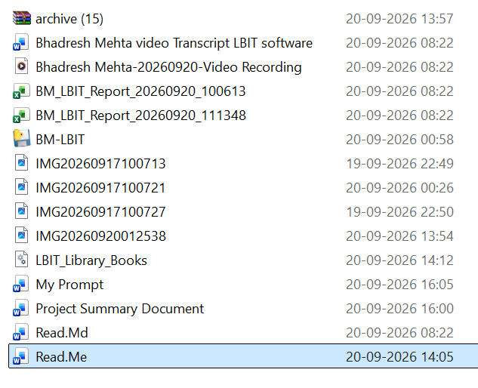

- How To Run:
Run the Application Software, Give the Path of the Images as per pojnt no.C above and it will generate XL output – Viewable / Printable
“BM-LBIT” – A tool for Automatic Listing of the Books based on Racks Photo - by Bhadresh Mehta, student of AI level 2 batch number 88, completed on 11th September 2026 at Ahmedabad.
The Problem statement, In libraries, there are thousands of books, and the books are arranged vertically in a variety of shelves or Racks. Now, if you want to prepare a fresh list of all the books manually by writing the name of the book and all other details, it will take...hours and hours.
This software, Library Book Image Tool, LBIT, automatically prepares a fresh list of all the books based on the photos, captured on mobile and stored in a folder.
It gives list in an Excel file along with image of the book.

