ASIAN PAINTS LIMITED
Fundamental Valuation Using Discounted Cash Flow (DCF)
Capstone Project | Valuation Date: 28 August 2026

Company | Asian Paints Limited
Ticker | NSE: ASIANPAINT
Method | FCFF Enterprise DCF
Forecast | FY2027E-FY2031E
Terminal Method | Gordon Growth
Currency | ₹ Crores except per-share data

Executive Summary
This capstone estimates the intrinsic equity value of Asian Paints Limited using a five-year Free Cash Flow to Firm (FCFF) model. The analysis is anchored to FY2025-26 audited results and incorporates the strong Q1 FY2026-27 trading update while normalising growth and margins over the explicit forecast period. The base case produces an indicative intrinsic value of approximately ₹886 per share compared with the 28 August 2026 market price of ₹2,608.7, implying a valuation gap of -66.0%. Under the stated assumptions, the shares appear overvalued. This conclusion reflects valuation rather than business quality: the prevailing market price appears to embed lower required returns and/or stronger long-term operating assumptions than the conservative base case.

1. Objective and Scope
The objective is to estimate the intrinsic value of Asian Paints using an enterprise DCF. The analysis forecasts consolidated operating performance for five years, calculates FCFF, discounts those cash flows using WACC, estimates continuing value using the Gordon Growth Model, and bridges enterprise value to equity value. The project is designed to demonstrate financial-statement analysis, forecasting, cost-of-capital estimation, valuation mechanics, sensitivity analysis and professional communication.

2. Company Overview
Asian Paints is India’s leading paint company with a broad decorative coatings franchise, international operations, industrial coatings exposure and an expanding home décor ecosystem. Its competitive advantages include brand equity, distribution reach, manufacturing scale, product innovation, dealer relationships and supply-chain execution. FY2025-26 consolidated net sales were ₹35,516 crore, up 5.1%, while the consolidated PBDIT margin improved to 18.9%.

3. Industry and Competitive Context
The Indian decorative paints market benefits from urbanisation, housing formation, premiumisation, repainting cycles and rising household incomes. The sector is exposed to crude-linked raw material prices, titanium dioxide and other inputs, competitive intensity, dealer economics and housing demand. New capacity and aggressive competitors can pressure pricing and marketing expenditure. Asian Paints’ scale remains a structural advantage, but valuation must reflect the possibility that future returns moderate as competition increases.

4. Historical Financial Analysis
Net sales expanded materially from FY2021-22 through FY2023-24, declined in FY2024-25 and recovered in FY2025-26. Margin performance has been cyclical: raw-material inflation compressed FY2021-22 profitability, FY2023-24 benefited from strong gross-margin recovery, FY2024-25 softened, and FY2025-26 improved again. The business remains cash generative and capital efficient, although recent capacity additions have increased depreciation and capital expenditure.
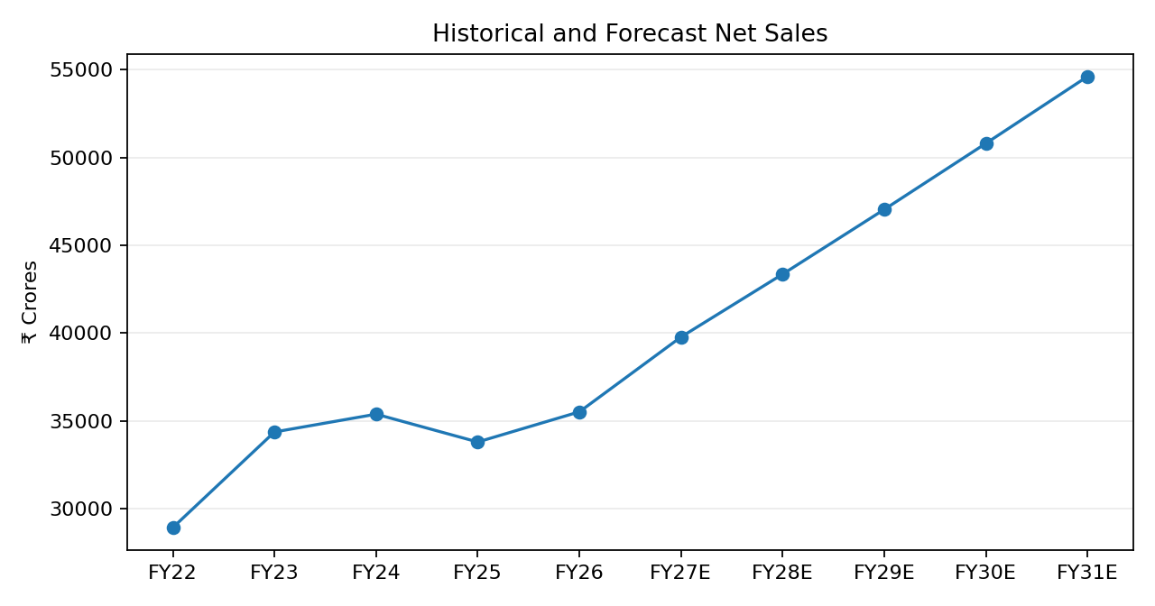
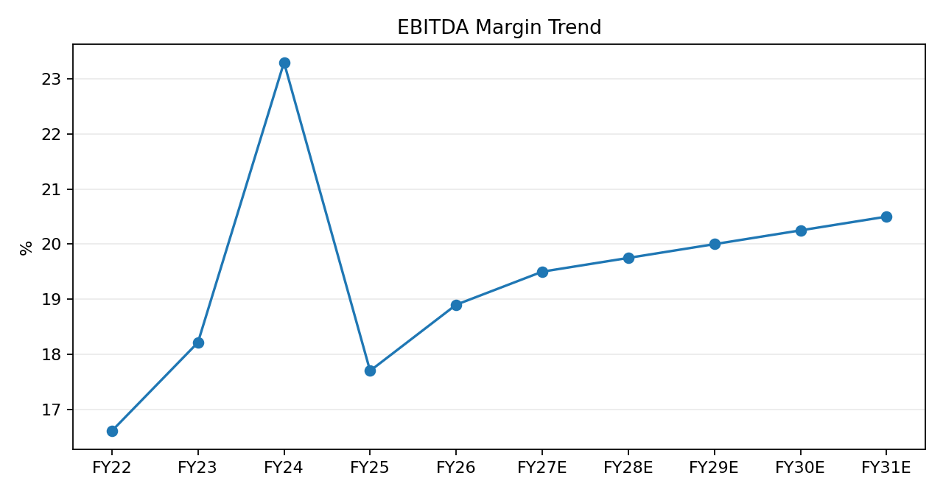

5. Forecast Assumptions
- FY27 revenue growth 12.0%, tapering to 7.5% by FY31.
- EBITDA margin improves from 19.5% to 20.5%.
- Normalized tax rate: 25.5%.
- D&A: 3.4% of sales; capex: 4.0% of sales.
- Change in NWC: 8% of incremental revenue.

6. FCFF Methodology
FCFF = EBIT × (1 − Tax Rate) + D&A − Capital Expenditure − Change in Net Working Capital.
₹ Cr | FY27E | FY28E | FY29E | FY30E | FY31E
Net Sales | 39,778 | 43,358 | 47,043 | 50,807 | 54,617
FCFF | 4,192 | 4,735 | 5,241 | 5,772 | 6,325

7. Weighted Average Cost of Capital
The CAPM framework uses a 6.913% India 10-year government bond yield, beta of 0.85 and a 5.5% normalized equity risk premium. The resulting cost of equity is about 11.59%. A 7.5% pre-tax cost of debt, 25.5% tax rate and 1% debt weight produce a base-case WACC of approximately 11.5%. Asian Paints’ debt-light capital structure means the cost of equity is the dominant WACC driver.

8. Terminal Value
Terminal value is calculated using TV = FCFFₙ₊₁ / (WACC − g), with terminal growth of 5.5%. This is a long-run nominal growth assumption intended to reflect inflation plus sustainable real growth while remaining below WACC. Terminal value accounts for roughly 77% of enterprise value, making sensitivity analysis essential.

9. DCF Valuation
Valuation Bridge | ₹ Crores
PV of explicit FCFF | 18,739
PV of terminal value | 64,158
Enterprise value | 82,897
Less: debt / lease liabilities | (2,369)
Add: cash & investments | 4,500
Equity value | 85,028
Shares outstanding | 95.92 Cr
Intrinsic value / share | ₹886

10. Sensitivity Analysis
The accompanying Excel workbook contains a 5×5 sensitivity matrix. WACC and terminal growth are the two most influential variables. Lower WACC and higher perpetual growth produce materially higher values. The matrix demonstrates why a premium-quality company may still screen as expensive when the market capitalisation already discounts exceptional future performance.

11. Scenario Analysis
The model presents bear, base and bull cases. The bear case assumes weaker growth and margins and a more demanding discount rate. The bull case assumes stronger growth, better margins and a lower WACC. Scenario analysis is intended to provide a valuation range and avoid false precision.

12. Key Value Drivers
- Decorative paint volume growth and premiumisation
- Raw-material costs and gross margin
- Competitive pricing and dealer retention
- Home décor execution
- Capacity utilisation and return on incremental capital
- WACC and terminal growth

13. Key Risks
- Sustained competitive pressure
- Crude-linked raw-material inflation
- Slower housing or repainting demand
- Execution risk in adjacencies
- International and currency risk
- Valuation multiple compression

14. Conclusion
The base-case DCF estimates intrinsic value at approximately ₹886 per share, materially below the 28 August 2026 market price of ₹2,608.7. Asian Paints remains a high-quality franchise, but quality and valuation are distinct. The market price appears to require more optimistic long-term economics than the conservative base case. The capstone therefore concludes that the shares are overvalued under the stated assumptions, while recognising that the conclusion changes materially under lower WACC and higher terminal-growth combinations.

15. Limitations
DCF outputs depend on assumptions and are not observable facts. Some historical line items are normalised for comparability, while the cash/debt bridge is an academic modelling estimate based on public financial information. A transaction-grade valuation would require detailed note-level adjustments for leases, investments, minority interests, contingent liabilities, pensions and other non-operating items, together with a fully market-observed beta and equity-risk-premium study.

References
- Asian Paints FY26 Integrated Annual Report — https://www.asianpaints.com/content/annualreport/annual-report-25-26.html
- Asian Paints Q4 & FY26 Results — https://www.asianpaints.com/content/dam/asianpaints/website/secondary-navigation/investors/financial-results-2/2025-2026/Q4/APL%20Q4%20and%2012M%20FY26%20Results.pdf
- Asian Paints FY25 Annual Report — https://static.asianpaints.com/content/dam/annual-folder-2425/pdf/Asian%20Paints%20IR%202024-25.pdf
- Asian Paints Annual Reports FY22-FY24 — Asian Paints Investor Relations
- Asian Paints Investor Relations Q1 FY27 — https://www.asianpaints.com/more/investors.html
- StockAnalysis market price history — https://stockanalysis.com/quote/nse/ASIANPAINT/history/
- Investing.com India 10Y government bond yield — https://in.investing.com/rates-bonds/india-10-year-bond-yield-historical-data
Academic capstone project only. Not investment advice or a recommendation to buy or sell securities.

