Miles2Collect: Step-by-Step User Guide
ICAI AICA Level 2 Capstone | CA Dipti Kothari | Revised 43

1. What the tool does
Miles2Collect controls construction-linked billing for a Maharashtra real estate project, from the architect’s certificate to the demand letter, bank matching, overdue chase and the RERA 70% account. It runs as one HTML file in the browser, with no installation and no server. AI is used for two narrow jobs only (reading the certificate, suggesting a flat for an unclear bank narration). All GST, interest and RERA figures come from fixed rules, and a Manager approves before any demand is raised.
Design principle: AI reads and suggests, rules verify, a human approves.

2. What you need
Item | Detail
Computer and browser | Windows PC with Chrome or Edge (latest).
The app | Miles2Collect.html (double-click, or use OPEN_Miles2Collect.bat).
Demo files | The demo_flow folder (master Excel, certificates, bank statements, agreements).
Internet | Needed only for the n8n calls (AI reading, emails). The rest works offline.
Browser rule | Accountant and Manager must use the same browser and profile (not Incognito), because the approval record is shared through browser storage.
All data in the demo is fictional.

3. Opening the tool and signing in
Open Miles2Collect.html. Choose a user from the drop-down and enter the password. The app opens empty on every launch; use Backup / Restore to keep work.
User | Password | Tabs
Accountant | Acc@2026 | Upload Master Data, Demand Workflow, Overdue Reminders, Upload Bank Statement, Reports
Projects & CRM Manager | Mgr@2026 | Sales & Inventory, Demand Schedule, Bank & Collections
Director (MD) | Dir@2026 | Dashboard, Profit & Loss (view only)
These passwords are for demonstration only. Production use needs server-side login. Switch user (top right) changes role without losing the loaded data.
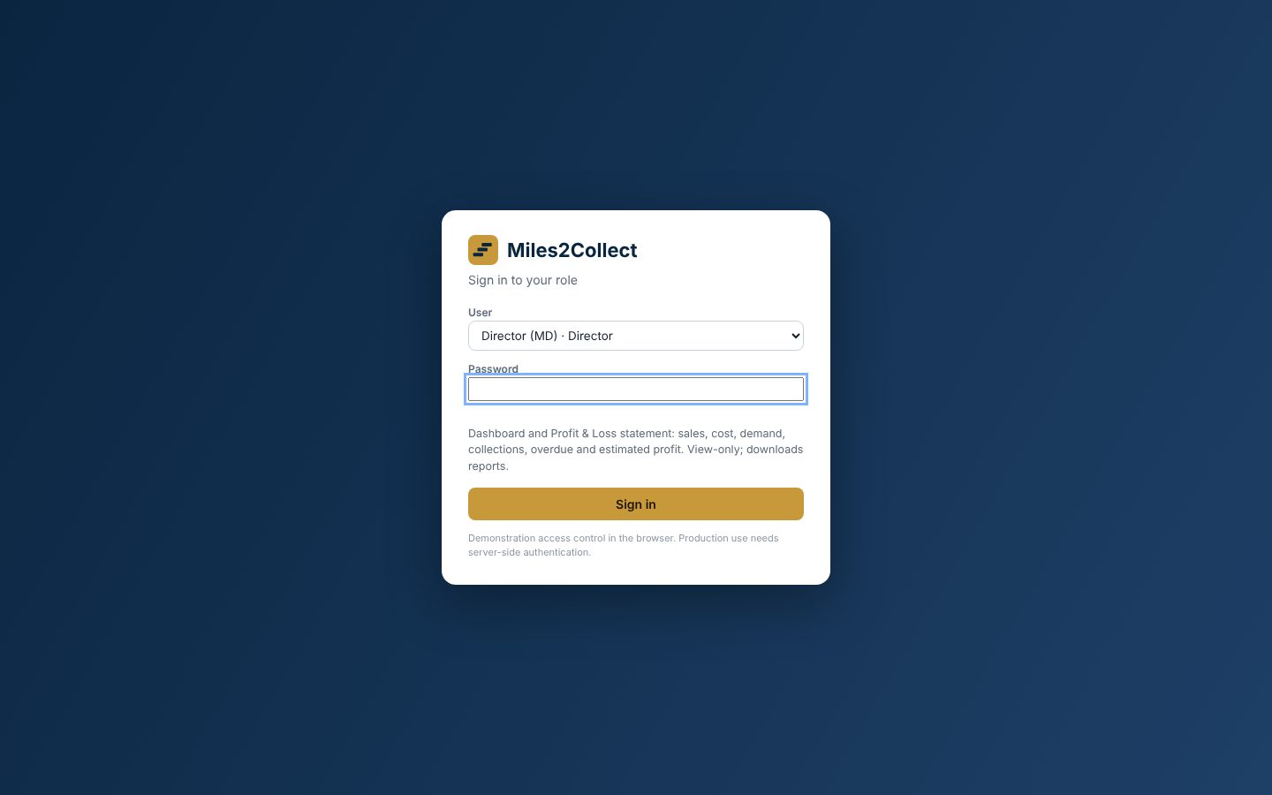
Sign-in screen

4. The demo, step by step

Step 1. Accountant: load the master data
Upload Master Data > Upload master Excel > choose 01_Miles2Collect_Demo_Master.xlsx.
Expected: agreement value Rs 55,06,59,896; outstanding Rs 5,77,65,989.60; overdue Rs 27,00,000 (flats 1102 and 1801, dishonoured cheques); interest Rs 88,767 (12% p.a. simple, 100 days); buyer TDS not recorded Rs 4,51,642.
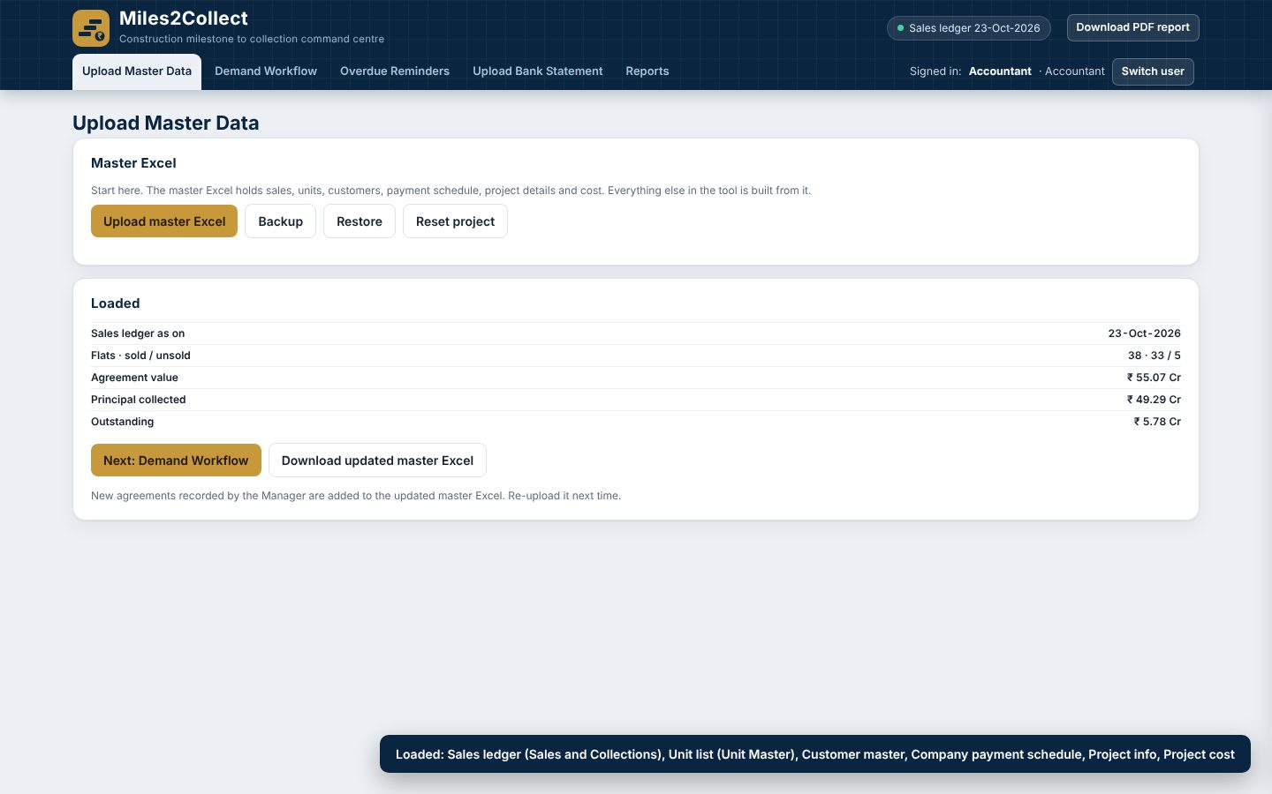
Master loaded

Step 2. Accountant: overdue reminders
Overdue Reminders shows each overdue customer with interest. View letter previews the reminder; Send reminders emails the two test inboxes only (live n8n call).
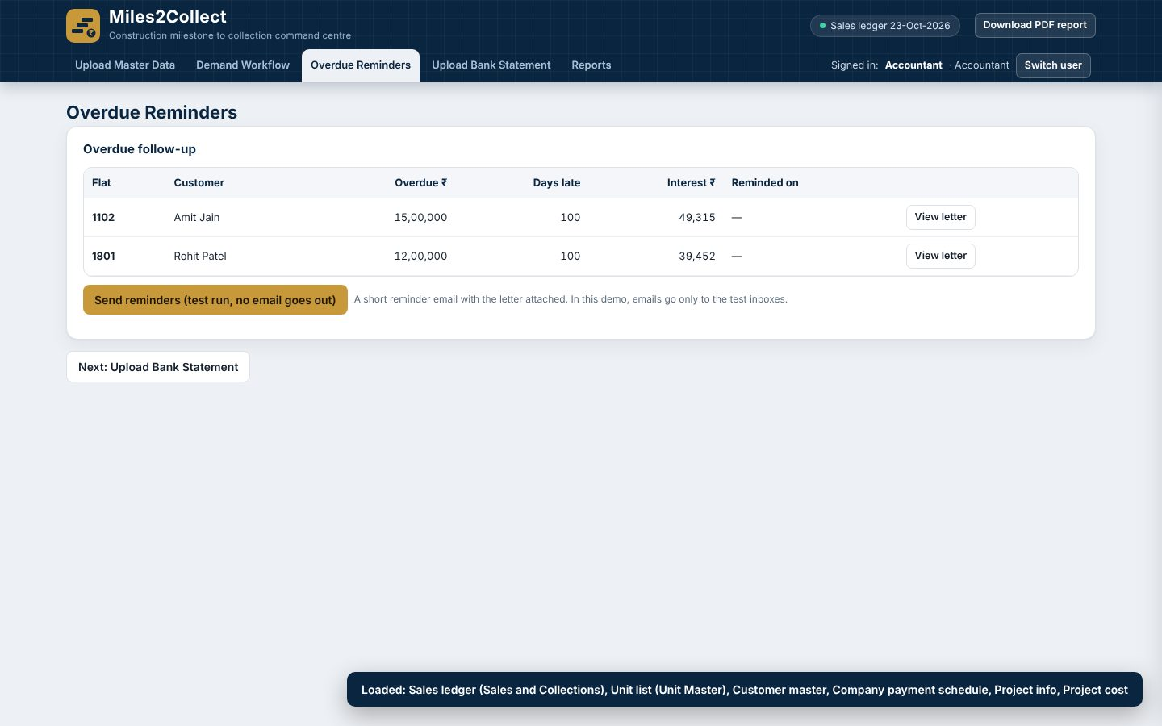
Overdue reminders

Step 3. Accountant: upload a wrong certificate first
Demand Workflow > Upload architect PDF > 02b_Wrong_Certificate_Milestone_8.pdf. The tool stops: the certificate is out of sequence (next pending is milestone 7) and future-dated. The stepper turns red at “Certificate read”. Click Remove certificate.
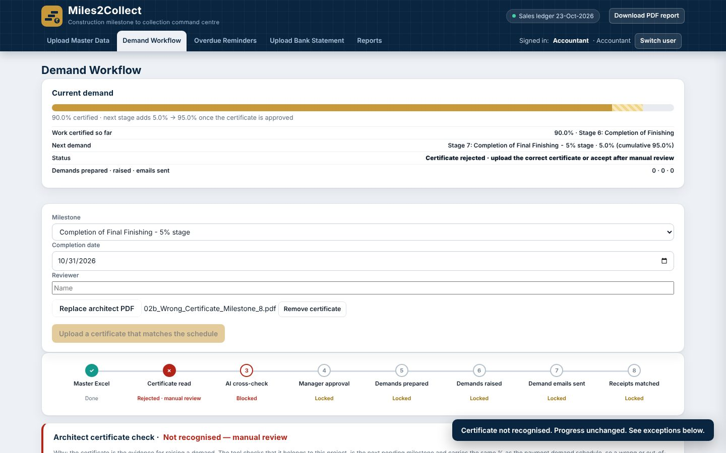
Wrong certificate rejected

Step 4. Accountant: upload the correct certificate, cross-check and submit
Upload 02_Architect_Certificate_5_Percent.pdf. Progress previews 95%. Enter the reviewer name, then:
- Run AI cross-check (required). If the AI service is down, the reviewer may record “proceed on rule-based reading”.
- Submit for Manager approval. The stepper shows “Awaiting Manager”.
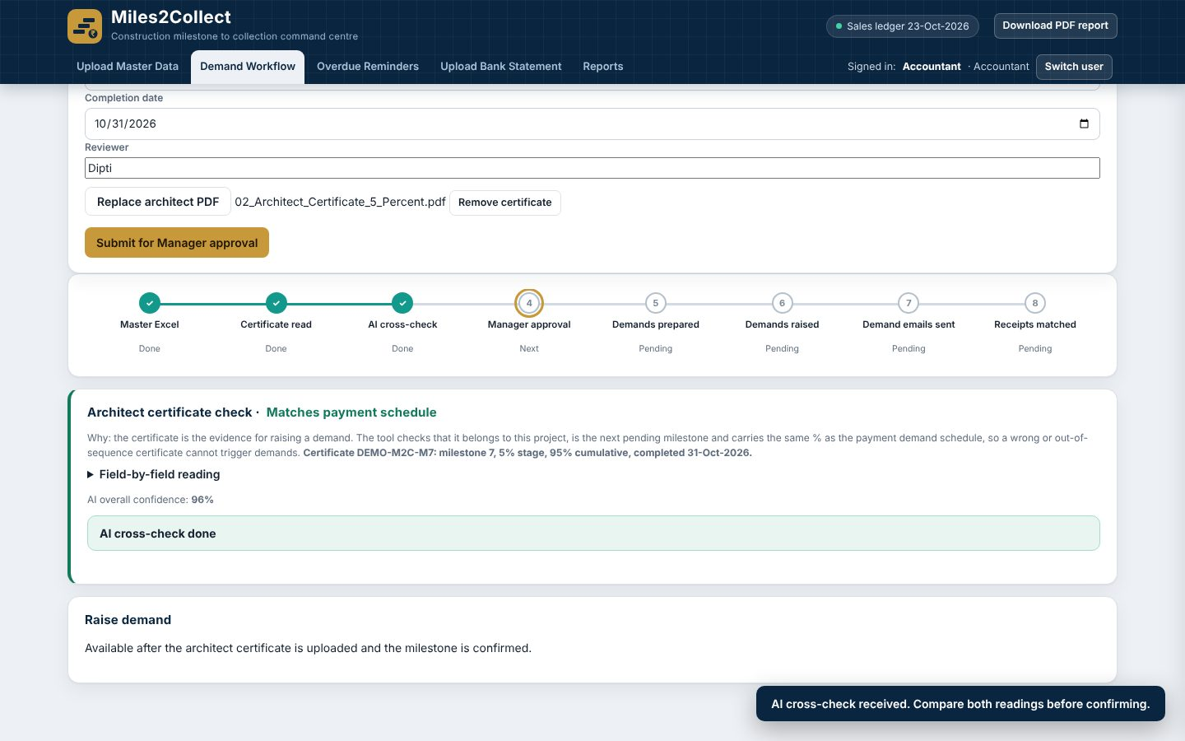
Certificate read and AI cross-check
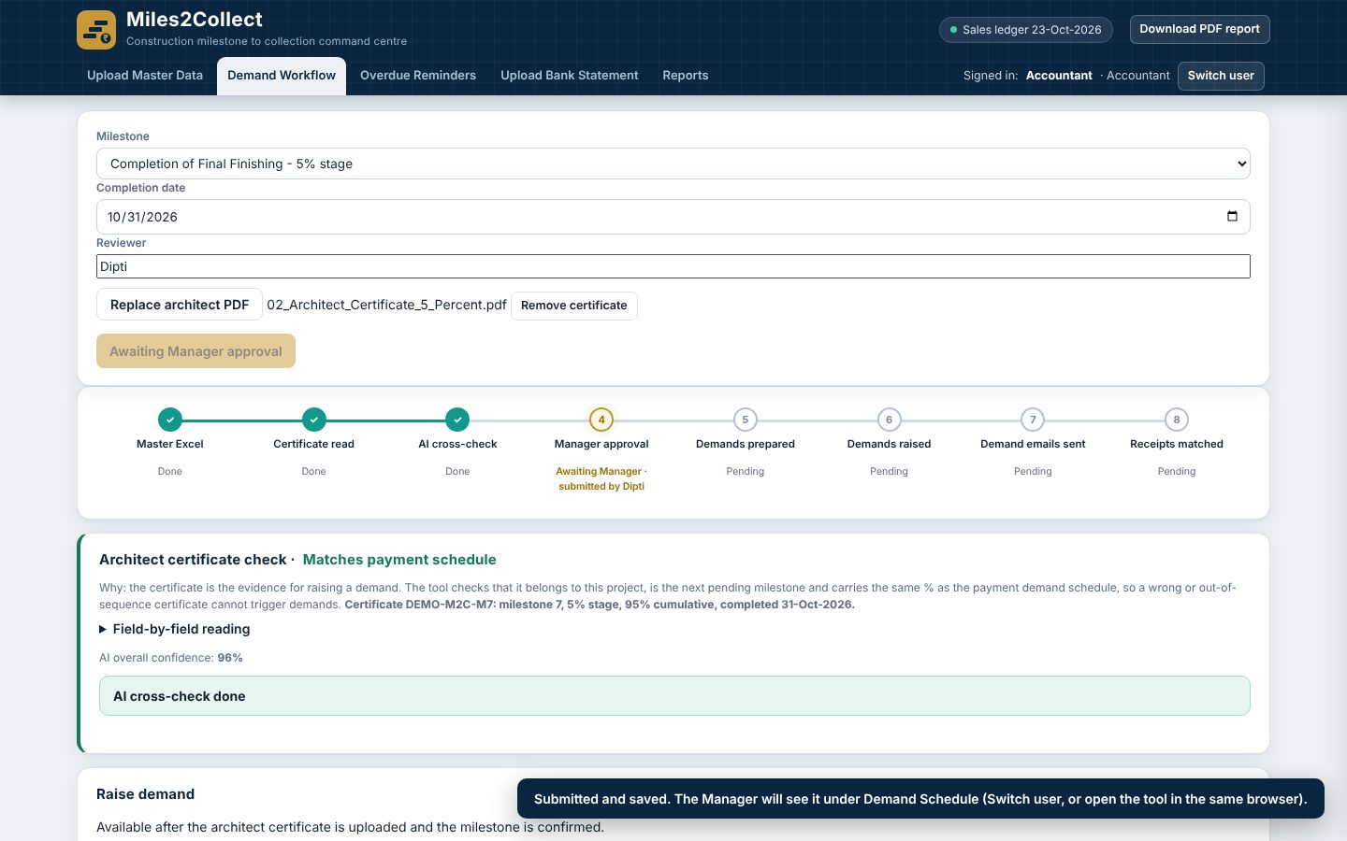
Submitted for approval

Step 5. Manager: approve (maker-checker)
Switch user > Manager. A banner and the Demand Schedule tab show “1 pending”. Review the rule-based reading against the AI reading, customers, principal, GST and the certificate PDF. Approve, or Return with a remark.
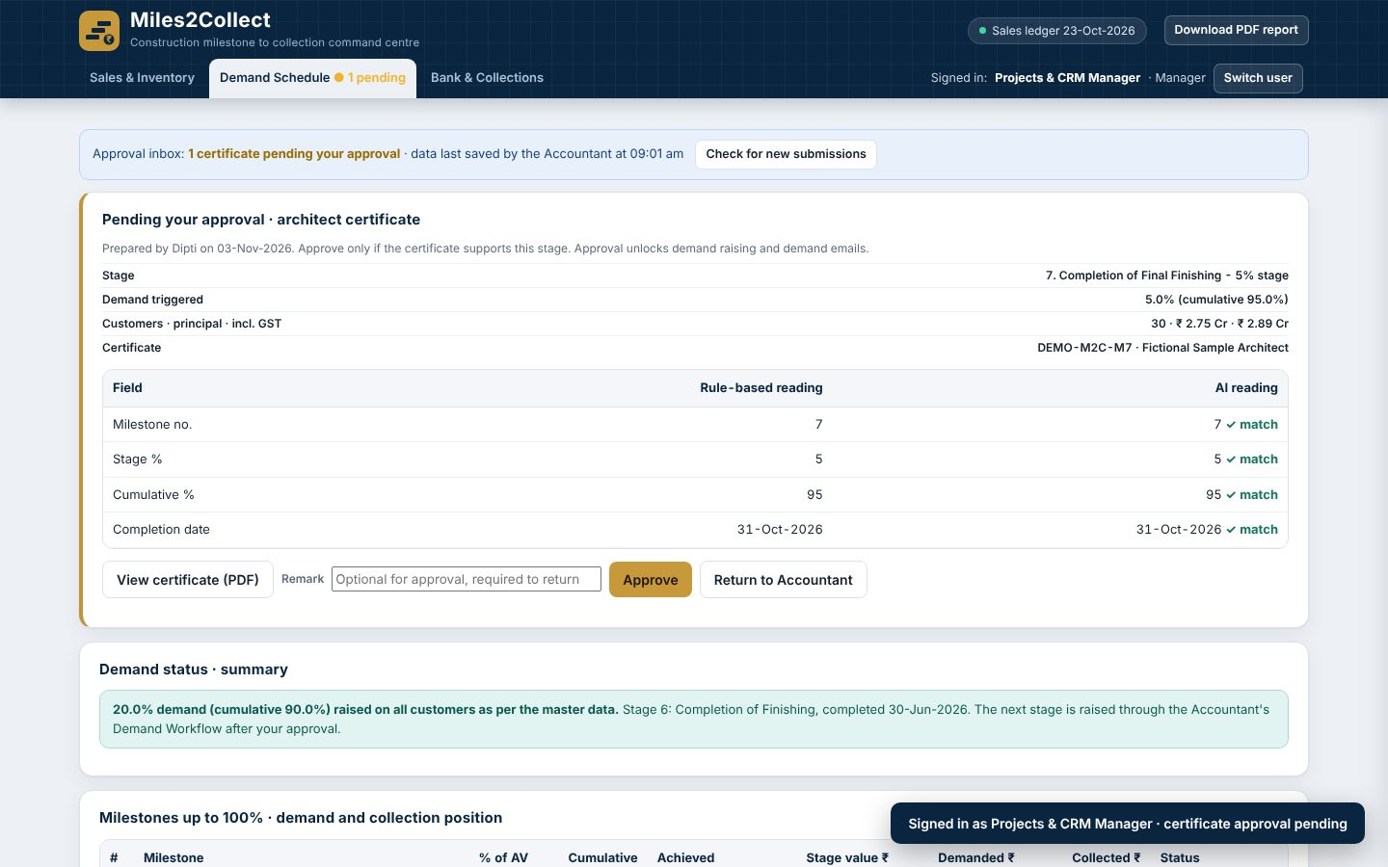
Manager approval

Step 6. Accountant: prepare and raise demands
Switch user > Accountant > Prepare demands (approved). Tick Select all customers and click Raise demand for N customers (test run) or Raise demand and send emails (live, test inboxes only).
Expected: 30 demands, principal Rs 2,75,32,994.80, with GST Rs 2,89,09,644.58. The invoice date is the milestone completion date (CGST s.31(5)(c)). The letter is a Tax Invoice-cum-Demand with the virtual account printed on it.
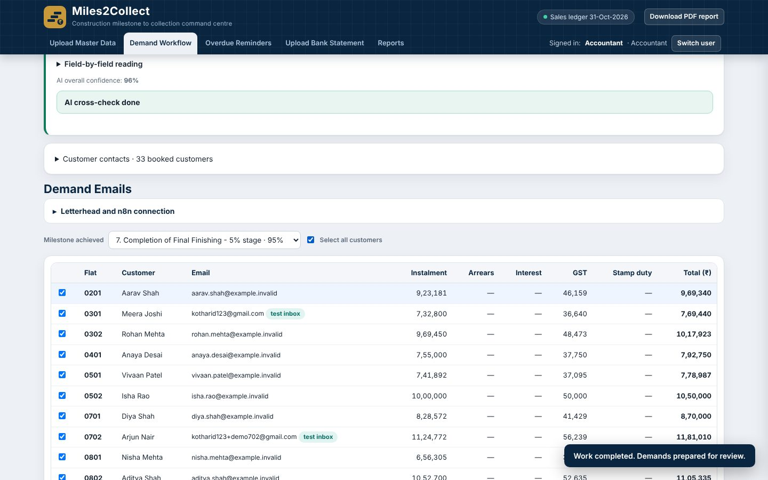
Prepare demands
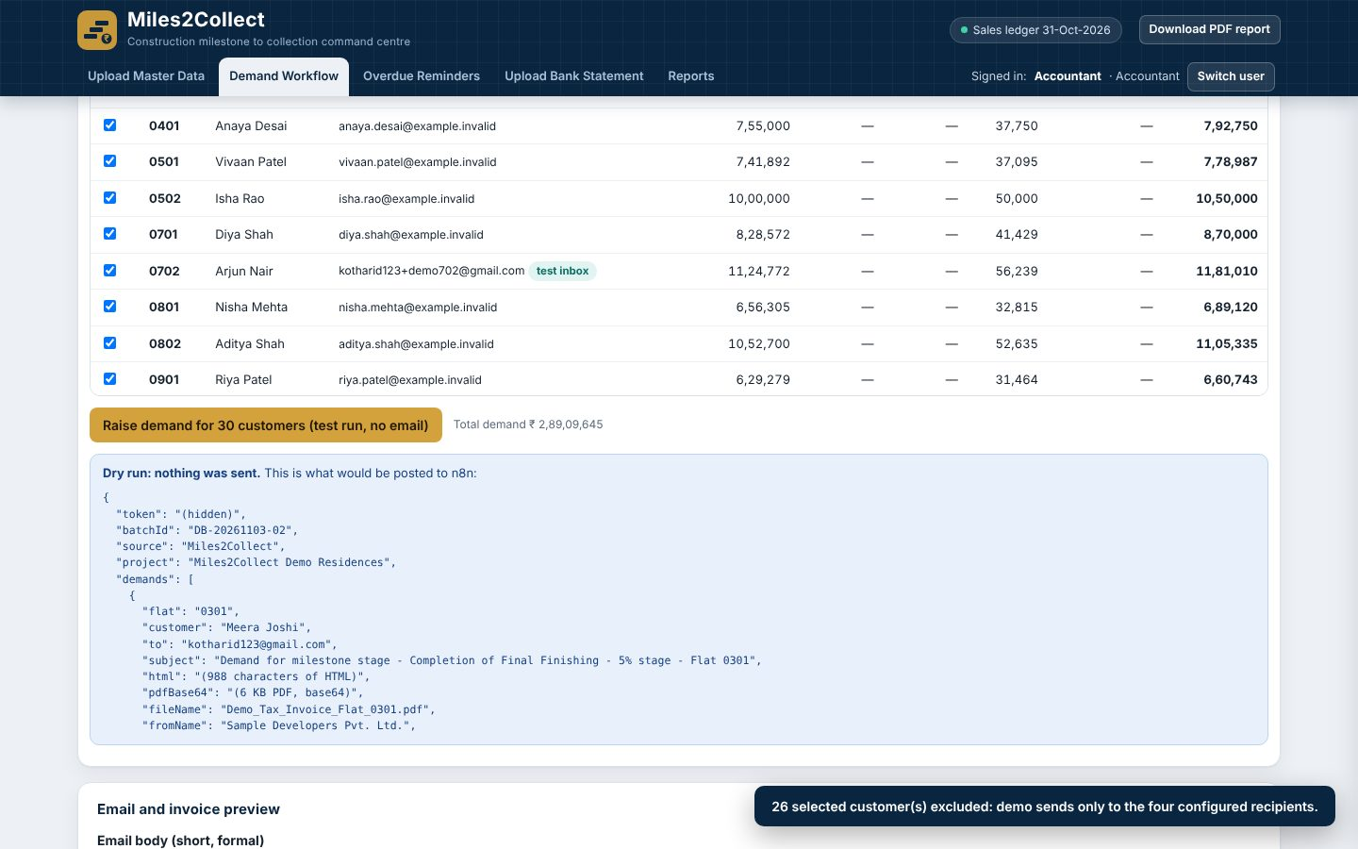
Demands raised
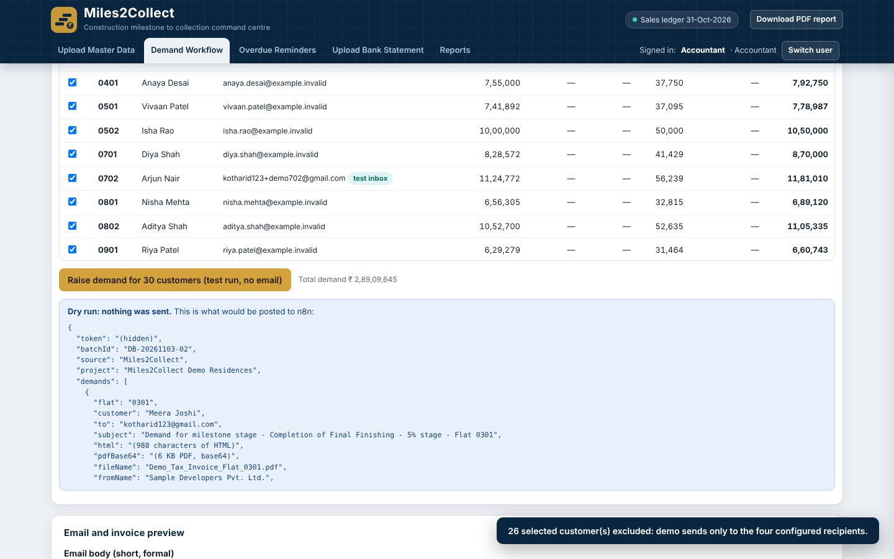
Demand letter (GST invoice-cum-demand)
If demands are raised for only some customers, every status reads “Partly · n of 30”, never “Done”.

Step 7. Accountant: upload bank statements
Upload Bank Statement accepts CSV, Excel or PDF with one upload box. Several statements can be added, and any single one can be removed, or all at once.
- Upload 05_Bank_Statement_All_Stage_Payments: 30 receipts matched; RERA 70% transfer recognised; collected Rs 52,04,26,901.20 (94.51%).
- Upload 06_Bank_Statement_Realistic_Narrations: Rs 15 L matched by virtual account (M2CVA1102), Rs 12 L by customer name; Rs 2.5 L from SUNRISE ENTERPRISES stays “Needs attention”. Final: collected 95.00%, overdue nil.
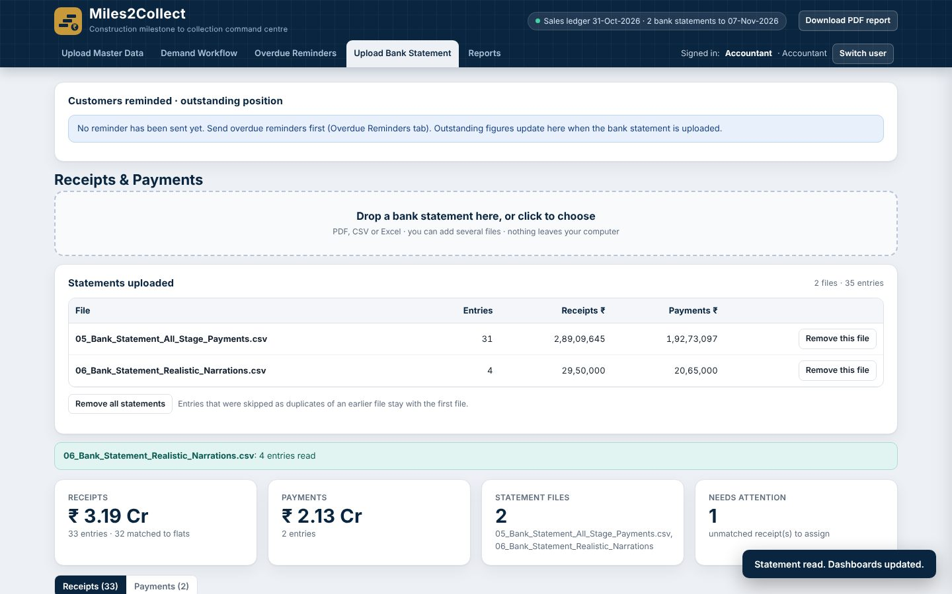
Bank statements

Step 8. Accountant: AI narration suggestion
Upload 09_Bank_Statement_AI_Narration_Matching.csv. For unmatched receipts click AI suggest (or AI suggest for all unmatched). The AI only proposes a flat with a reason and confidence. It must be at least 70%, the flat must be on the sold list, and nothing is applied until you click Accept. Vague names return no match. Expected: 3 AI matches, 3 correct refusals.
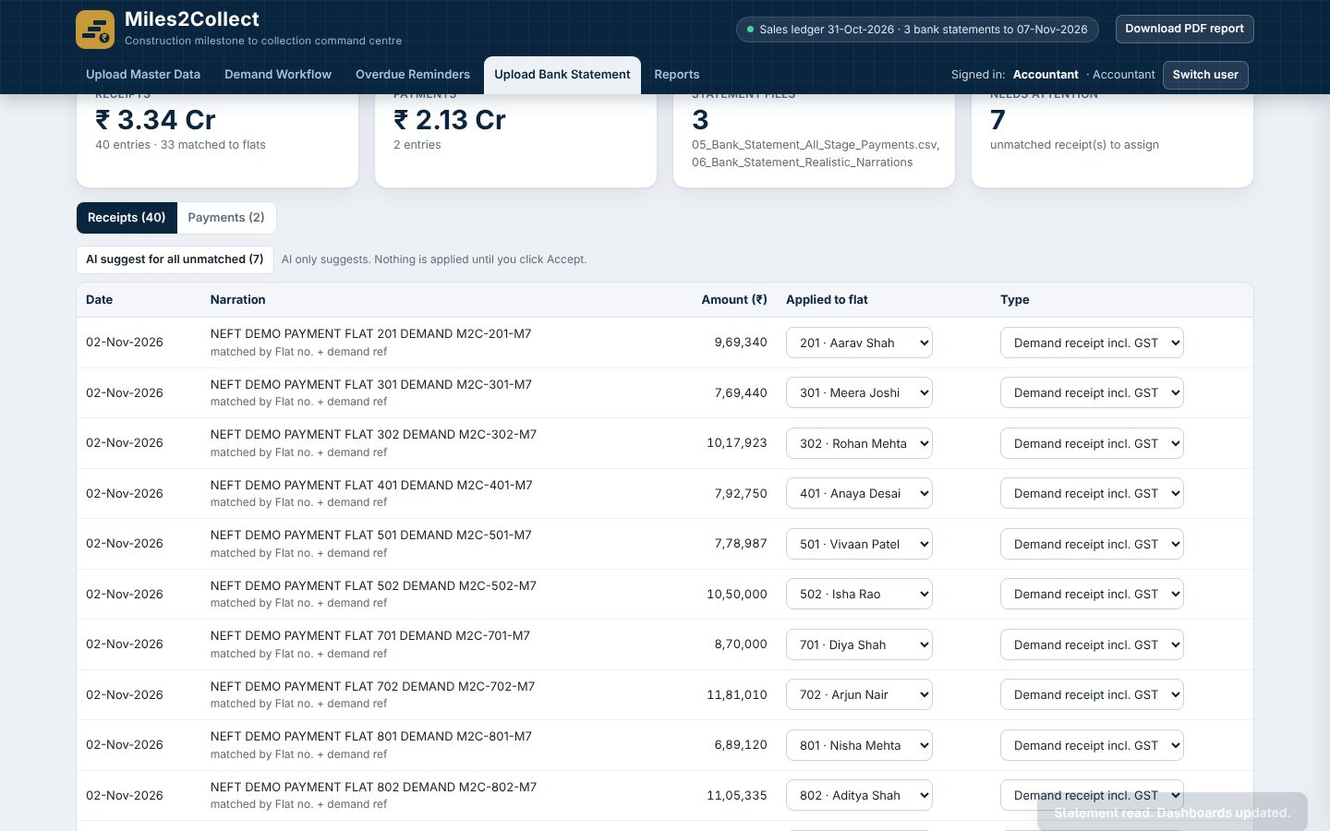
AI narration suggestion
For a receipt you know is genuine but unmatched, use the manual Mark received assignment.

Step 9. Accountant: reports
Reports gives the Demand Register and the Receipt Register (Excel, PDF or CSV), so the Accountant has an output for every task performed.
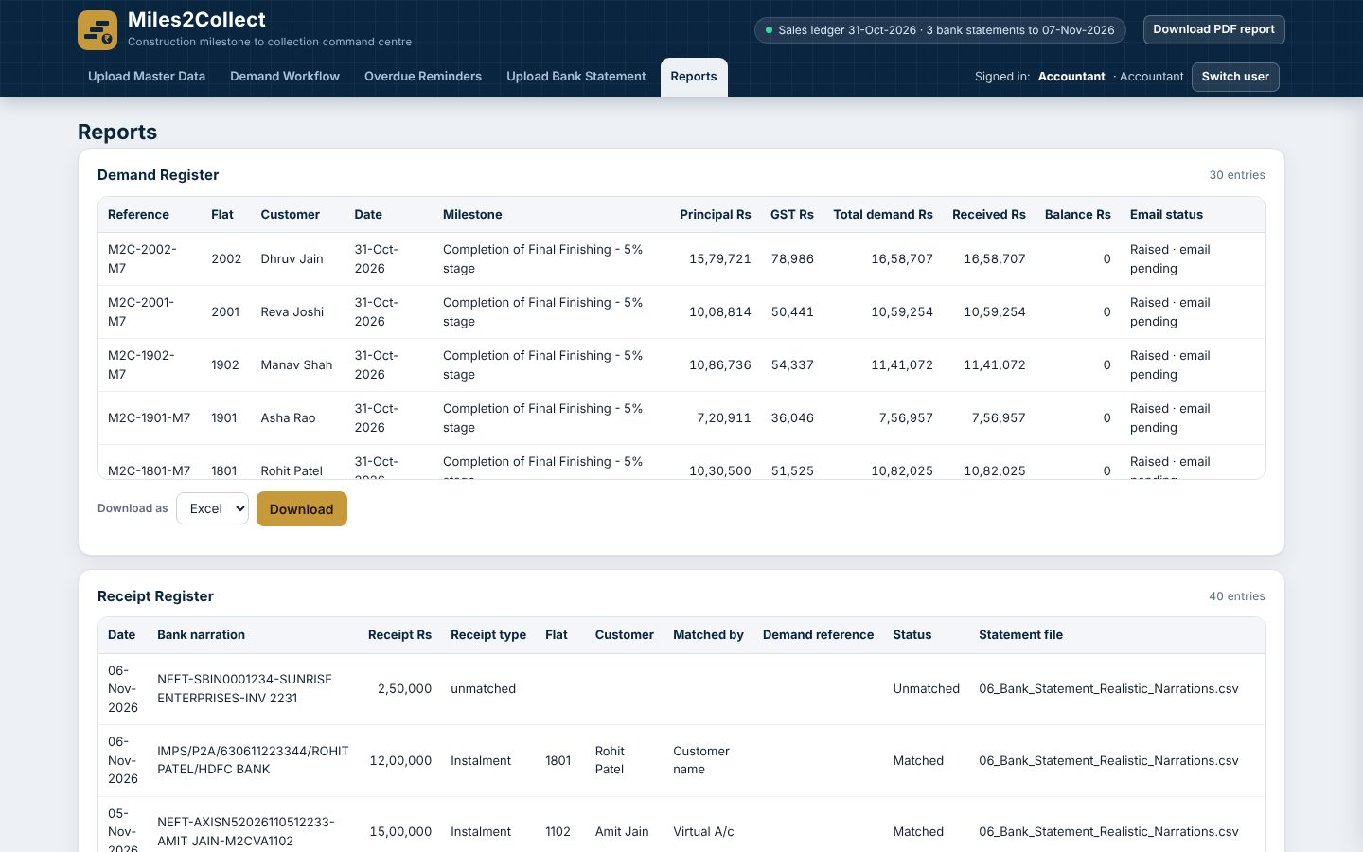
Reports

Step 10. Manager: sales, agreements and collections
Sales & Inventory shows the inventory map and red flags. Upload an agreement PDF:
- 07c (flat 0301 already sold): blocked.
- 07a (new sale of 0102): Confirm; 34 sold, 4 unsold; catch-up demand Rs 2,47,77,900 (principal Rs 2,35,98,000 = 95% x Rs 2,48,40,000, plus GST Rs 11,79,900), due 14-Nov-2026.
- 07b (flat 1202 agreement value): Confirm; catch-up Rs 55,12,980 after advance Rs 1,63,81,043.
Then Accountant uploads 08_Bank_Statement_Agreement_Catch_up (both catch-ups matched, collected 95.00% of the revised AV Rs 59,82,69,896). Bank & Collections shows ageing, collection efficiency and the RERA 70% account.
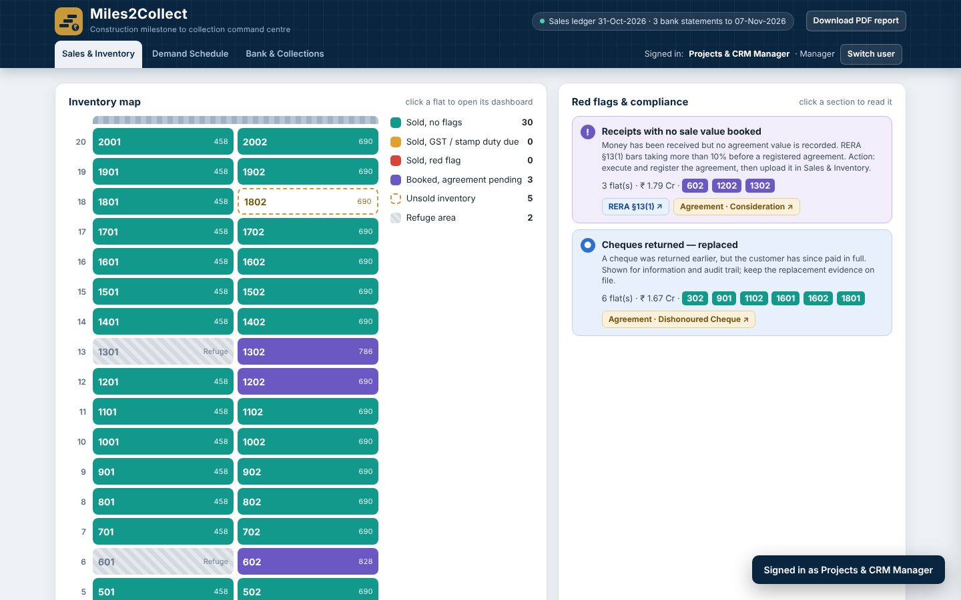
Sales and inventory
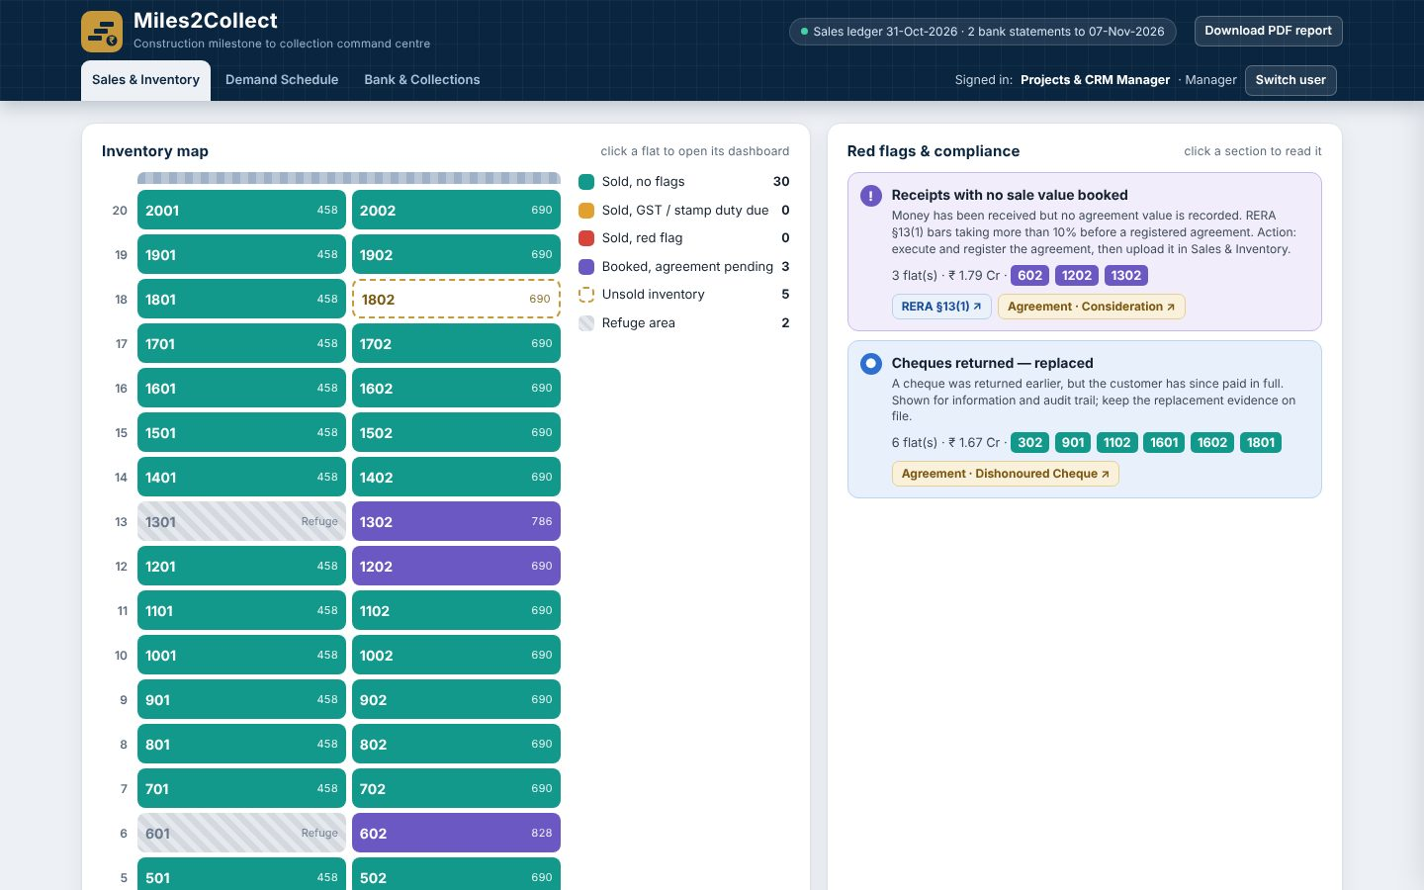
Duplicate agreement blocked
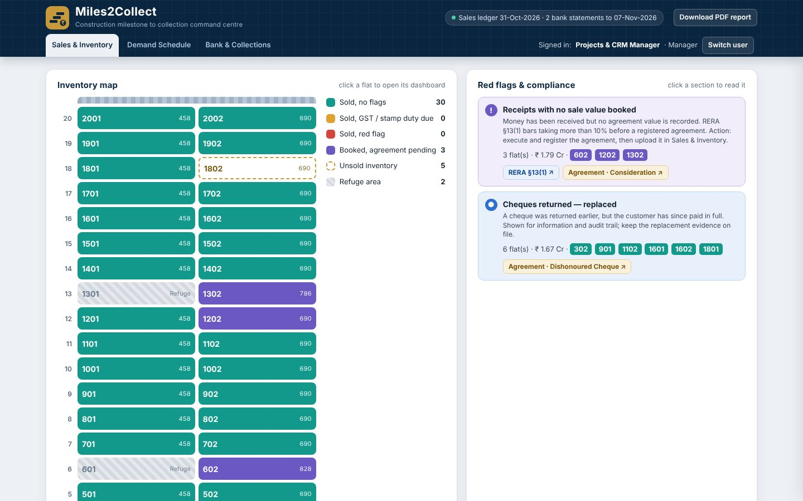
Agreement catch-up demand
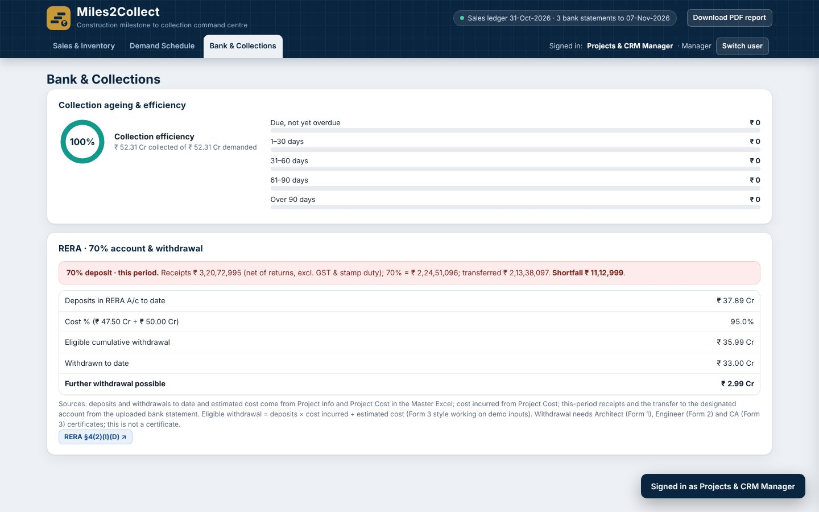
Bank and collections

Step 11. Director: view only
The Director sees the Dashboard and Profit & Loss. No editing is possible.
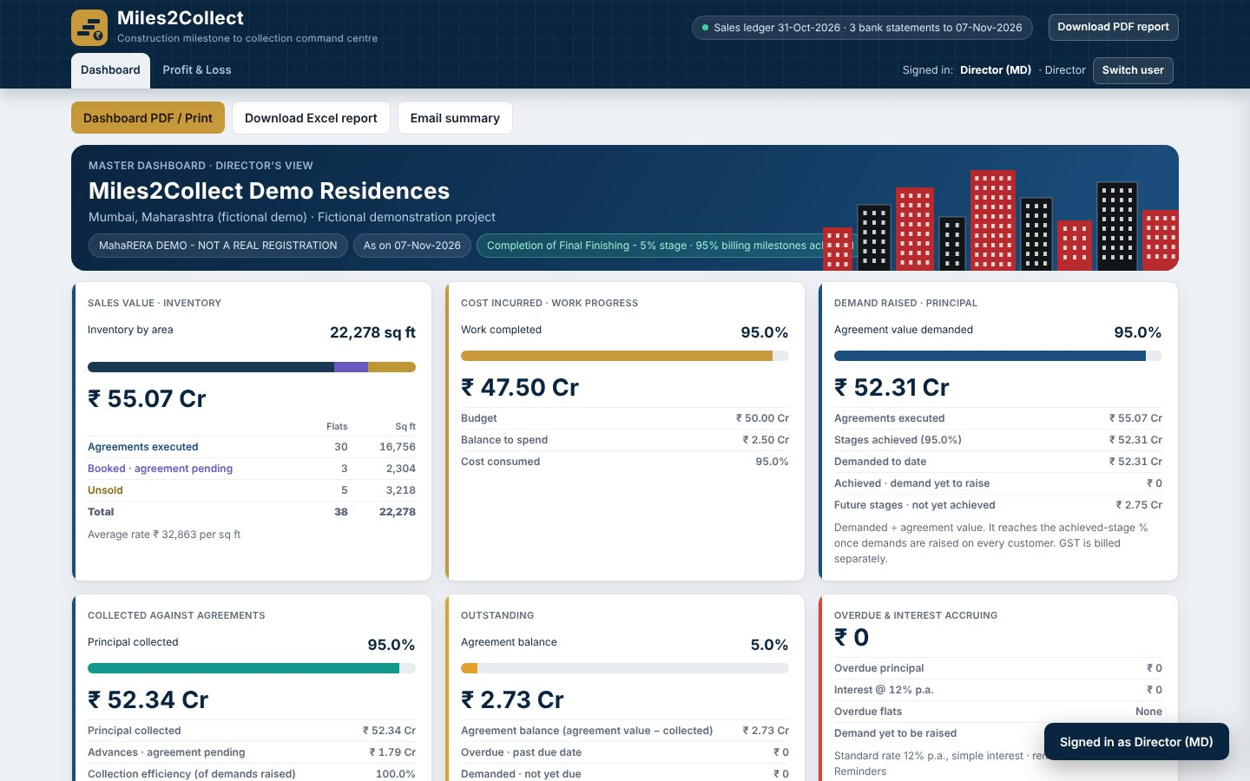
Director dashboard
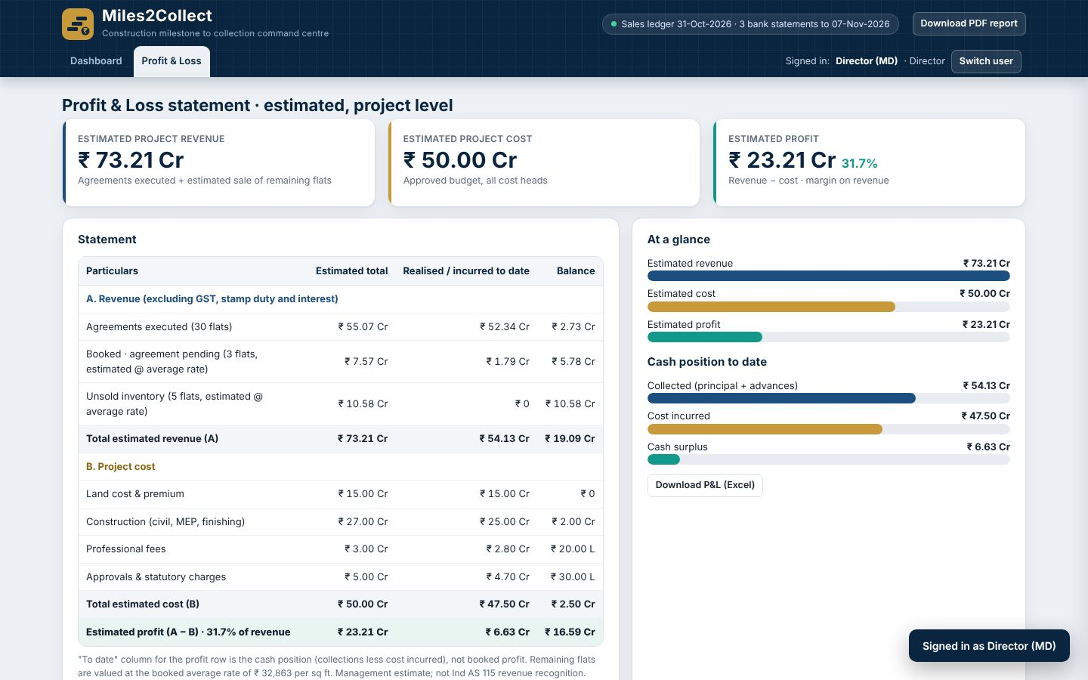
Profit and loss

Step 12. Save the work
Accountant > Upload Master Data > Download updated master Excel (new agreements written back to the sales ledger and customer master). Use Backup to save the whole session as JSON and Restore to load it later.

5. Expected figures at a glance
Stage | Result
After master upload | AV Rs 55,06,59,896; outstanding Rs 5,77,65,989.60; overdue Rs 27,00,000
Demands raised | 30 demands; principal Rs 2,75,32,994.80; with GST Rs 2,89,09,644.58
After statement 05 | Collected 94.51%
After statement 06 | 95.00%; overdue nil; outstanding Rs 2,75,32,994.80
After agreements 07a and 07b | 34 sold, 4 unsold; catch-ups Rs 2,47,77,900 and Rs 55,12,980
After statement 08 | Collected Rs 56,83,56,401.20 of AV Rs 59,82,69,896 = 95.00%

6. Settings
Demand Workflow > Letterhead and n8n connection holds the letterhead details, the webhook addresses (demand letters, certificate AI reader, narration matcher) and the dry run switch. In dry run nothing is emailed. Interest rate is read from the Project Info row of the master (standard 12% p.a. simple). Reset clears the session; use it only for the demo.

7. Business rules built in
- Demand only after the milestone is certified, in sequence, and not future-dated.
- GST 5% without ITC on the whole instalment (CGST 2.5% + SGST 2.5%; IGST 5% if the customer’s State is not Maharashtra), as per the GST Council FAQ of 7 May 2019 on Notification 11/2017-CT(Rate) as amended. Verify the current position before production use.
- Interest 12% p.a. simple on overdue principal.
- Receipts are applied to the oldest unpaid stage first.
- RERA 70% of receipts to be transferred to the designated account (RERA s.4(2)(l)(D)).

8. Troubleshooting
Problem | Cause and fix
Manager sees no approval | Use the same browser and profile as the Accountant, not Incognito; click Check for new submissions.
AI cross-check fails | n8n or the AI service is unavailable; the reviewer can record “proceed on rule-based reading”.
Emails not received | Only the four test inboxes are allowed; check dry run is off and the n8n workflow is published.
Statement lines unmatched | Check the virtual account and flat number; use AI suggest or manual assignment.
Save warning | Browser storage is full; take a Backup and clear old data.

9. Limits of the demo
Role passwords are demonstration-only. Data lives in the browser, not a database. Emails go to test inboxes only. The webhook token is a demo token and should be rotated after the capstone. Legal and tax rules must be re-verified for live use, and TDS on property purchase (buyer deduction, Income-tax Act 2025 s.393 and Form 141) is shown for information only.

