AICA LEVEL 2 (ICAI) · CAPSTONE PROJECT
Munshi AI
Smart Bank Statement Analyzer for CA Offices
Installation & User Guide
Reads a client’s bank statements from any bank (PDF, Excel or CSV), categorises every transaction, flags compliance red flags, and produces a reviewed working paper in minutes.

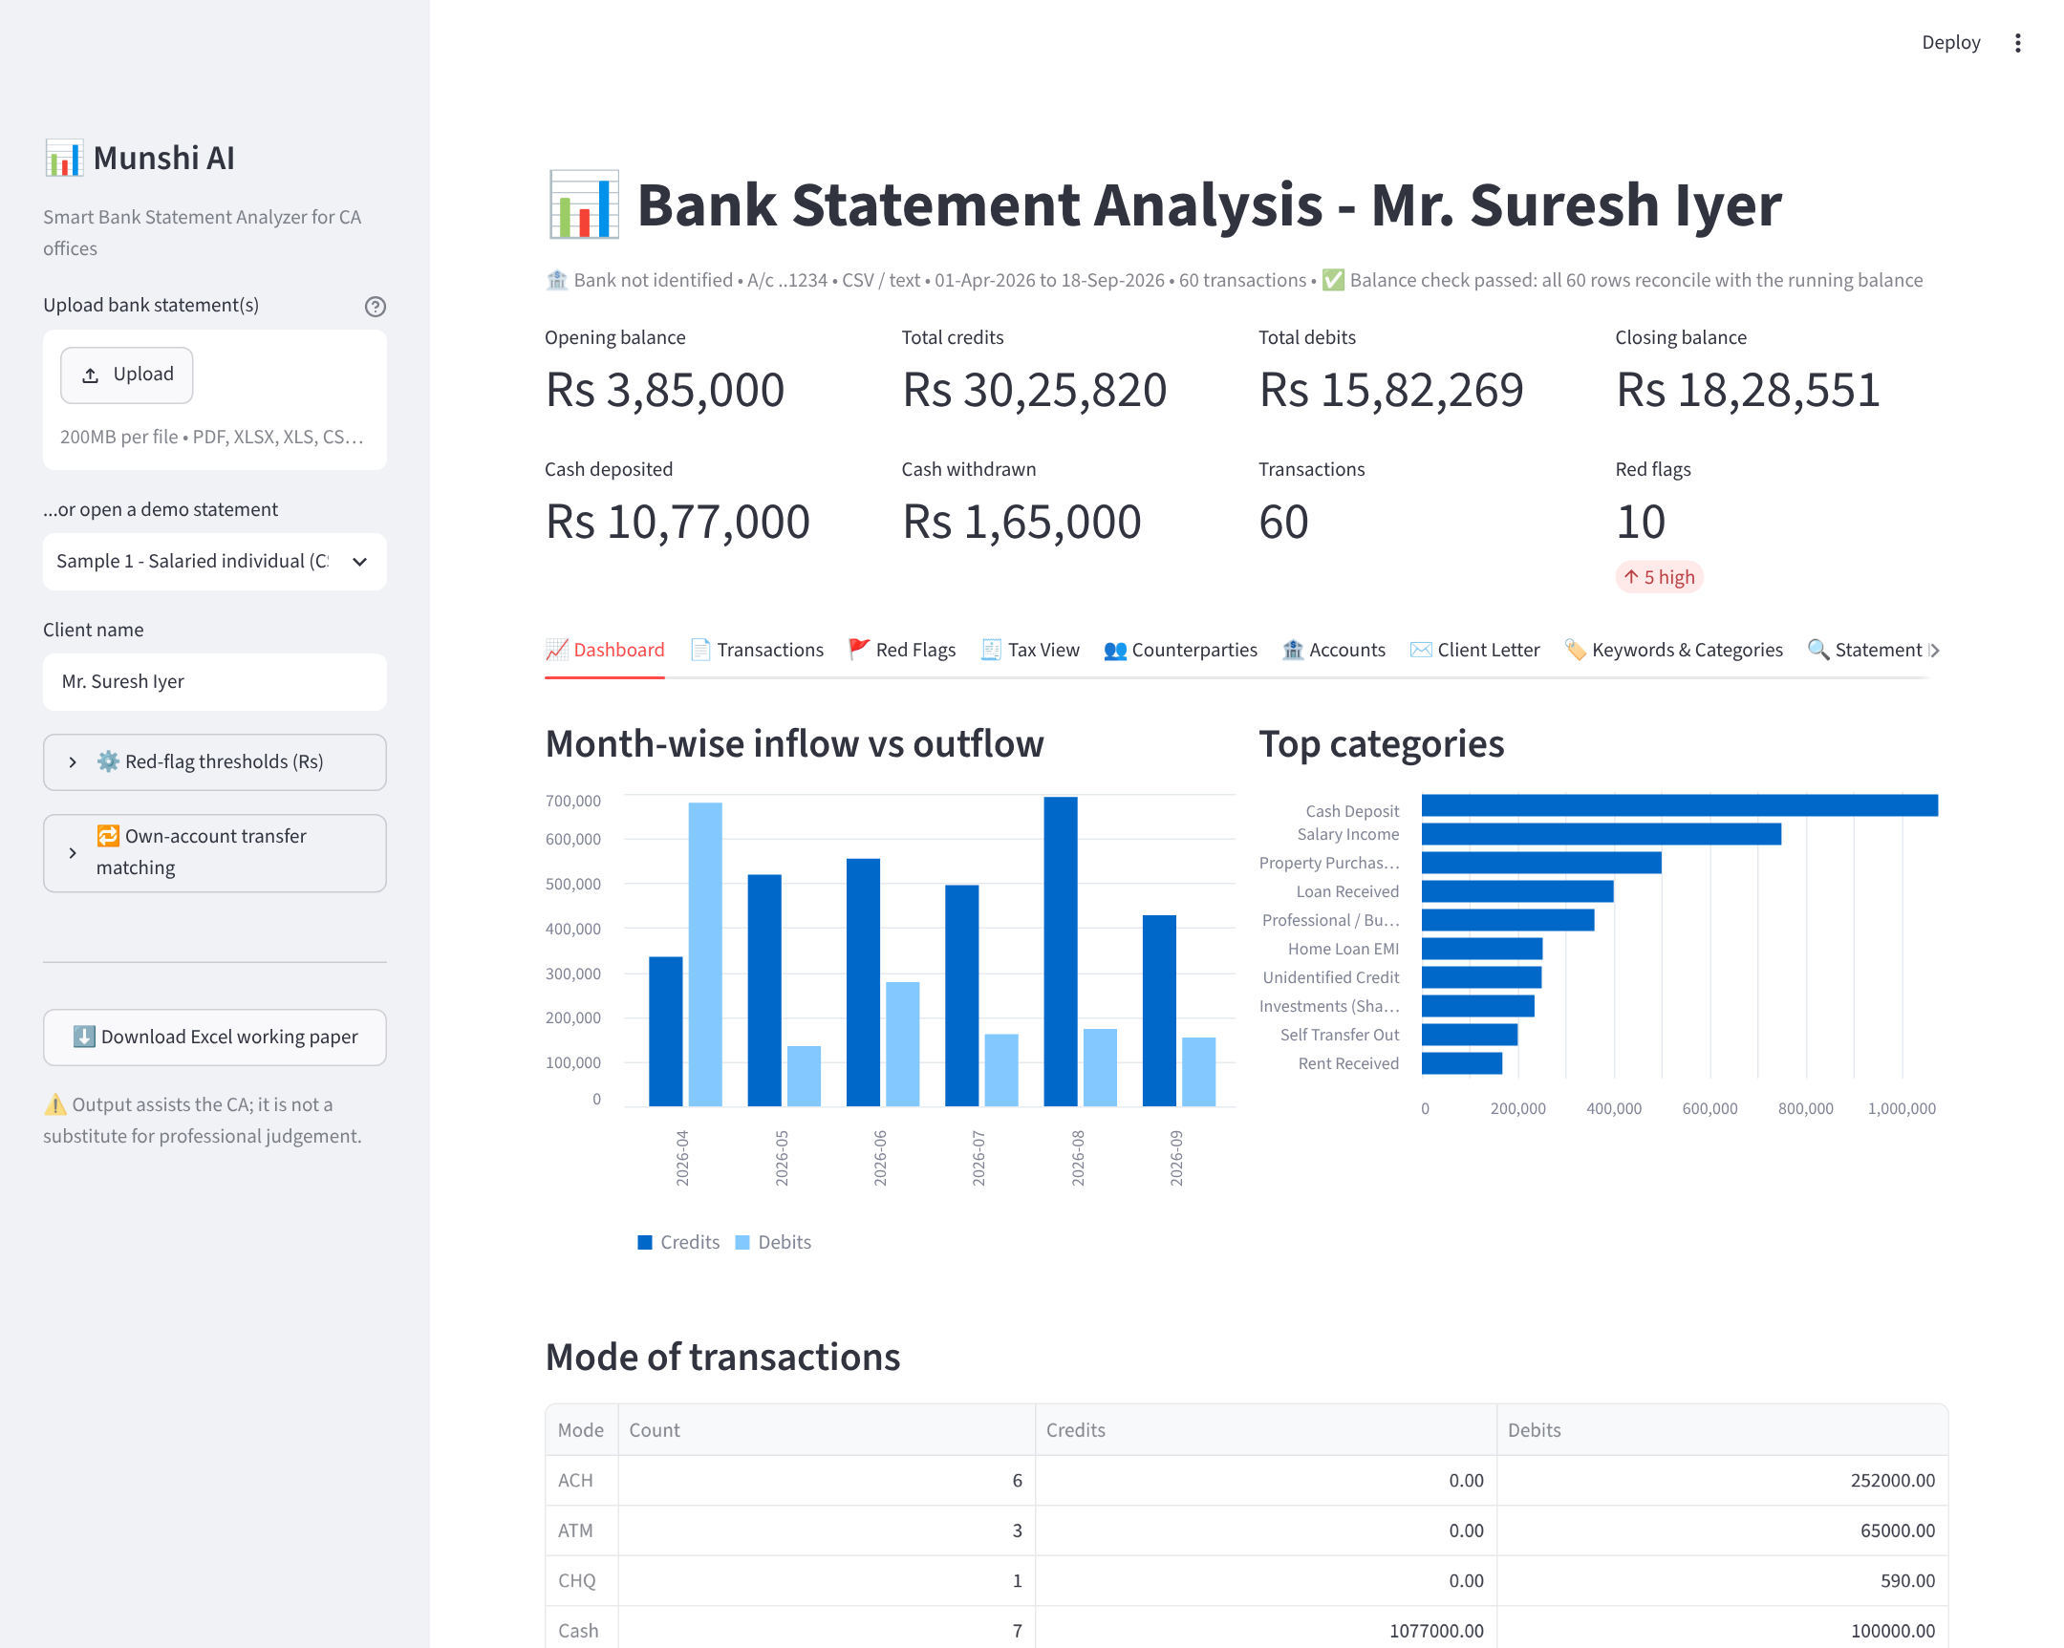

Group | Members
Group No. 1 | CA ABHISHEK KAWAD BATCH L2B101
October 2026

Contents
1. About the project and its features
2. What you need before installing
3. Installation, step by step (with screenshots)
4. Using the app
5. Troubleshooting
6. Project files and how it was built

Quick start (for those already comfortable with computers)
1. Install Python 3.10 or later from python.org, ticking Add python.exe to PATH.
2. Extract Munshi_AI_Bank_Analyzer.zip to a folder.
3. Double-click Run_Munshi_AI.bat. The first run installs everything (2-5 minutes, needs internet) and opens the app in your browser.

1. About the project and its features

Objective
Every CA office spends hours reading client bank statements for ITR preparation, tax audit, scrutiny replies and loan or visa reviews. Entries are tagged by hand in Excel and important items, such as large or split cash deposits and unexplained credits, are easily missed until they appear in the AIS or in a notice.
Munshi AI turns a raw bank statement into a reviewed working paper in minutes. It reads statements from any bank, checks them against the running balance, categorises every transaction, flags compliance red flags and prepares the client query letter and an Excel working paper. It runs entirely on your own computer, so client data is not sent anywhere.

Who can use it
- CA offices: ITR preparation, tax audit and bank verification, scrutiny and notice replies, loan and visa financial reviews.
- Clients: a self-check before sending papers to the CA - where money came from and went, and which entries need explaining.

Key features
# | Feature | What it does
1 | Reads any bank statement | PDF (with or without table borders), Excel (.xlsx / .xls) and CSV. Finds the header row and understands the column names used by Indian banks; recognises 40 banks from the name or IFSC code.
2 | Password-protected PDFs | A password box appears automatically for locked bank PDFs; a wrong password gets a clear message.
3 | Balance check | Every row is checked against the running balance, so you know the statement was read correctly. Newest-first statements are handled.
4 | Summary on the main screen | Opening balance, total credits, total debits, closing balance, cash deposited, cash withdrawn and number of red flags.
5 | Automatic categorisation | Salary, rent, interest, EMI, insurance, investments, taxes, cash and more, using a keyword database of 110+ keywords that you control.
6 | Change any category | Pick a new category in the Transactions tab, add new categories, and tick “Remember” to save a keyword so future statements are categorised the same way.
7 | Compliance red flags | Large and split cash deposits, total cash above the reporting limit, unexplained credits, loans received, high-value items, large cash withdrawals and cheque bounces - each rated High / Medium / Low with the reason and suggested action. Limits are editable.
8 | Tax view | Income heads seen in the bank for the ITR, and possible deductions and tax credits (insurance, tuition, home loan, investments, TDS, advance tax).
9 | Counterparty summary | Total received from and paid to each party, read from the narrations. Parties that both paid and received money are highlighted for related-party review.
10 | Several accounts per client | Upload all accounts together for one combined view. Transfers between the client’s own accounts are matched so they are not counted as income, expense or unexplained credit.
11 | Client query letter | A ready draft listing every entry that needs the client’s explanation, editable and downloadable.
12 | Excel working paper | One click exports Summary, Accounts, Transactions, Counterparties, Own Transfers, Category Totals, Income Heads, Deduction Hints, Monthly and Red Flags sheets.
13 | Fix-it tools | If an unusual format is read wrongly, the Statement Info tab lets you choose the header row and map the columns yourself.
14 | Private and offline | Runs on your own computer. After the first installation no internet is needed and no statement data leaves the machine.

Technology used
Python · Streamlit (screens) · pandas (data) · pdfplumber and pypdf (PDF reading and passwords) · SQLite (keyword database) · openpyxl (Excel export).

2. What you need before installing
Item | Requirement
Computer | Windows 10 or Windows 11. (Mac and Linux also work - see “Manual installation” in section 3.)
Python | Version 3.10 or later (free from python.org). Step 1 shows how to install it.
Internet | Needed only for the first run, to download the required packages (about 150 MB).
Disk space | About 500 MB including Python and packages.
Browser | Chrome, Edge or Firefox. The app opens in your browser but runs on your own computer.
Project file | Munshi_AI_Bank_Analyzer.zip

Note about the pictures in this guide
Pictures of the app itself are real screenshots. Pictures of Windows and the Python installer are illustrations: your screen may look slightly different depending on your Windows and Python version, but the buttons to click are the same.

3. Installation, step by step

Step 1 - Install Python (one time only)
If Python 3.10 or later is already installed, skip to Step 2. (To check: press Windows key, type cmd, press Enter, type python --version and press Enter. A number like 3.12.4 means it is installed.)
- Open https://www.python.org/downloads/ and click the yellow Download Python 3.x.x button.
- Open the downloaded file to start the installer.
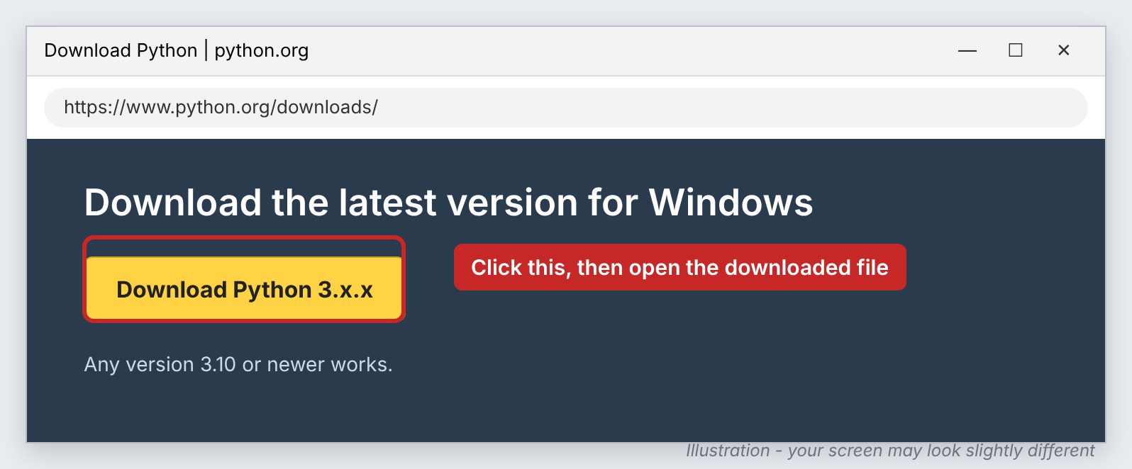
Figure 1 - Download Python from python.org
- On the first screen of the installer, tick “Add python.exe to PATH” at the bottom. This is the most important step.
- Click Install Now and wait for “Setup was successful”, then click Close.
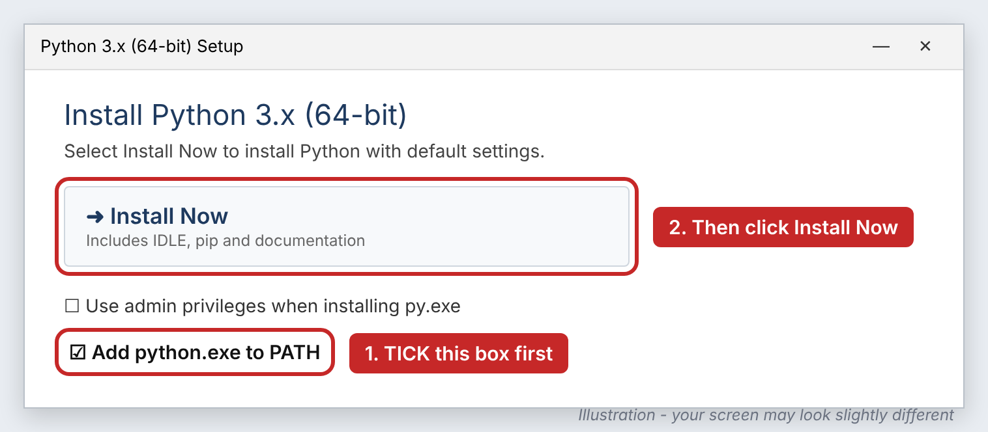
Figure 2 - Tick “Add python.exe to PATH”, then click Install Now
Forgot to tick “Add python.exe to PATH”?
Run the Python installer again, choose Modify (or Repair), and make sure the PATH option is ticked. Or uninstall Python from Settings > Apps and install it again with the box ticked.

Step 2 - Extract the project
- Copy Munshi_AI_Bank_Analyzer.zip to a convenient place, for example Desktop or Documents.
- Right-click it and choose Extract All..., then click Extract.
- A folder named ca_bank_analyzer is created. Open it.
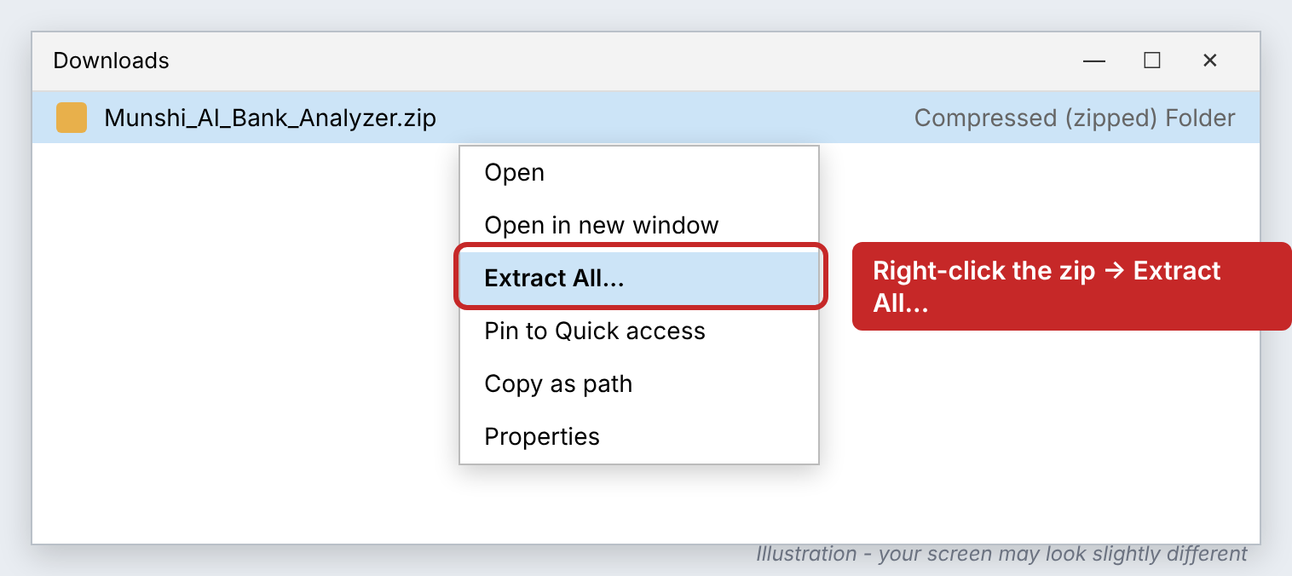
Figure 3 - Right-click the zip file and choose Extract All
Important
Do not run the app from inside the zip file without extracting it - Windows would open a temporary copy and the app could not save your keywords.

Step 3 - Start the app
- In the ca_bank_analyzer folder, double-click Run_Munshi_AI.bat.
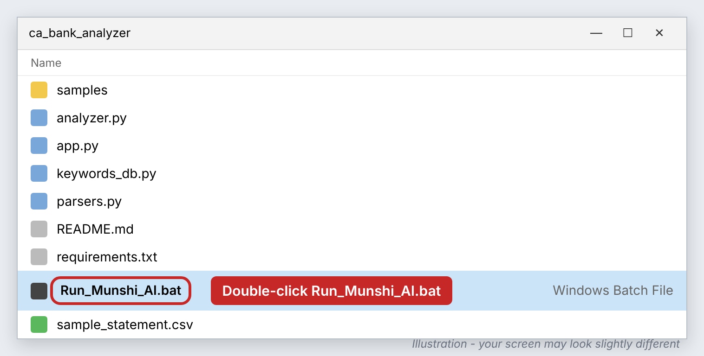
Figure 4 - The project folder; double-click Run_Munshi_AI.bat
- If Windows shows a blue box “Windows protected your PC”, click More info and then Run anyway. This appears because the file was downloaded and is not signed by a software publisher; it is the project’s own start-up file.
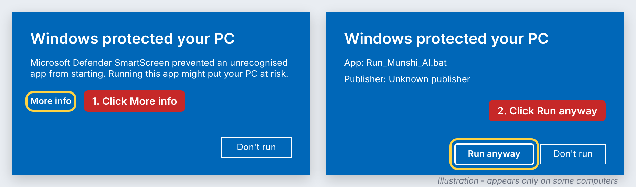
Figure 5 - Only if this warning appears: More info, then Run anyway

Step 4 - First run installs the required packages
A blue window opens. On the first run only, it downloads and installs the packages the app needs. This takes 2-5 minutes and needs internet. Let it finish - do not close the window.
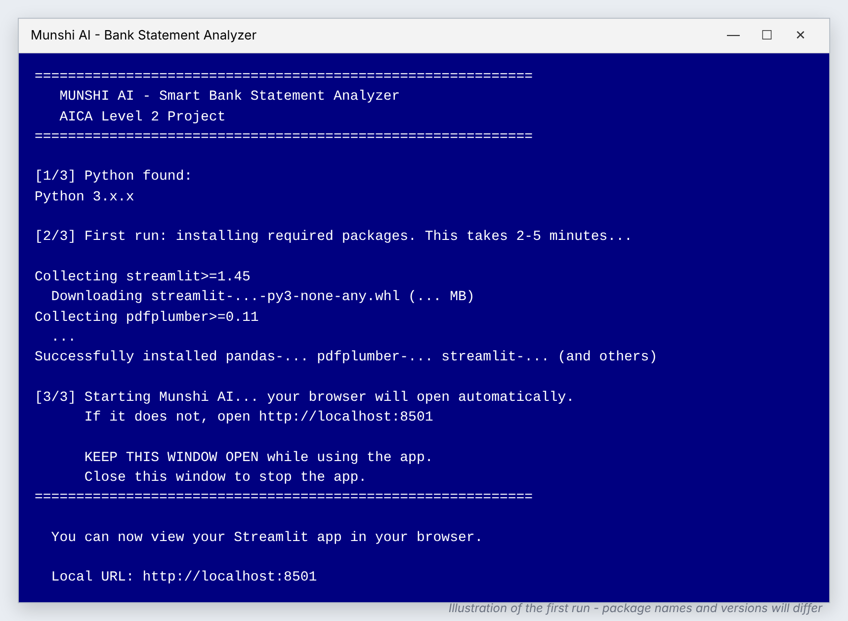
Figure 6 - The start-up window during the first run
When it shows Local URL: http://localhost:8501, the app is running and your browser opens automatically.

Step 5 - The app opens in your browser
The main screen opens with a demo statement already loaded, so you can see the app working straight away.
Figure 7 - Munshi AI running in the browser (real screenshot)
Keep the blue window open
The blue window is the app’s engine. Keep it open (you can minimise it) while using the app. Closing it stops the app. If the browser does not open by itself, open it and go to http://localhost:8501.

Every time after that
Just double-click Run_Munshi_AI.bat. It skips the installation and opens the app in a few seconds. No internet is needed.
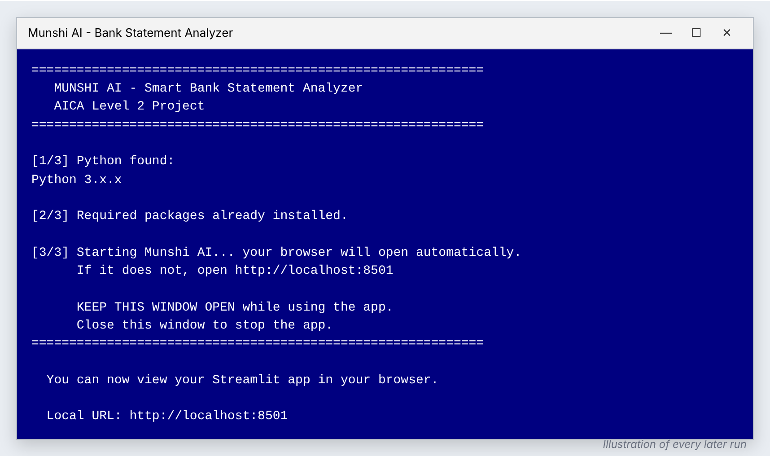
Figure 8 - The start-up window on every later run

Tip: create a desktop shortcut
Right-click Run_Munshi_AI.bat > Show more options > Send to > Desktop (create shortcut). You can then start the app from the desktop.

Manual installation (Mac, Linux, or if the .bat file is blocked)
Open a terminal (Command Prompt on Windows), go to the extracted folder and type:
cd path\to\ca_bank_analyzer
pip install -r requirements.txt
streamlit run app.py
On Mac use pip3 and python3 -m streamlit run app.py if the commands above are not found.

4. Using the app

4.1 Open a statement
- Your own statement: click Upload in the left panel and choose the PDF, Excel or CSV file downloaded from net banking.
- Several accounts of one client: select all the files together in the upload window. They are combined into one view.
- Demo statements: if nothing is uploaded, choose one from “...or open a demo statement”. All demo data is fictitious.
- Type the Client name in the left panel; it is used on the screen, in the letter and in the Excel file.
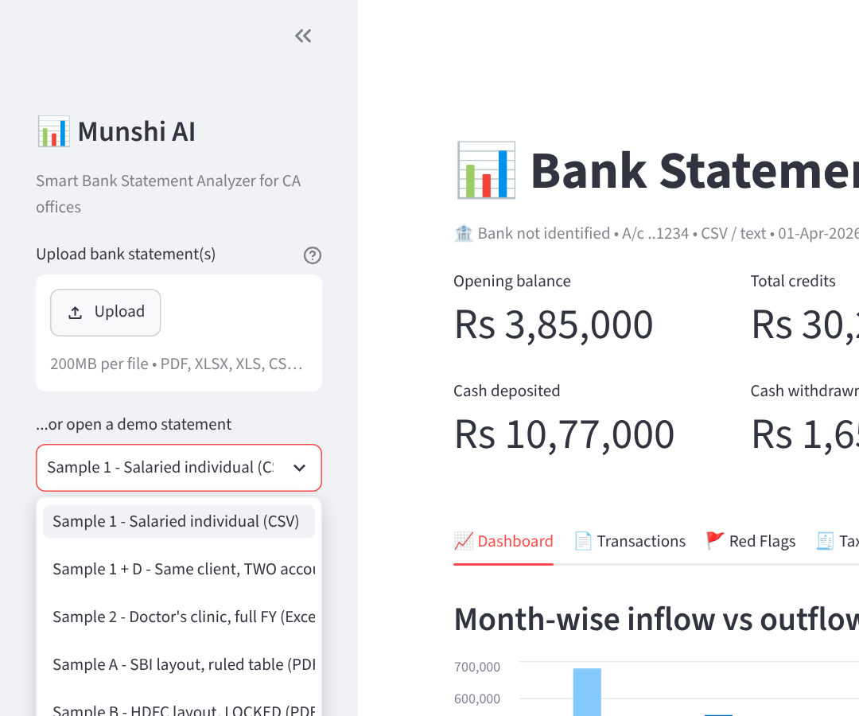
Figure 9 - Upload button and the list of demo statements

4.2 Password-protected PDF
Bank PDFs are often locked. The app notices this and shows a password box in the left panel. Type the password and press Enter. (For the demo file Sample B the password is AICA2026.)
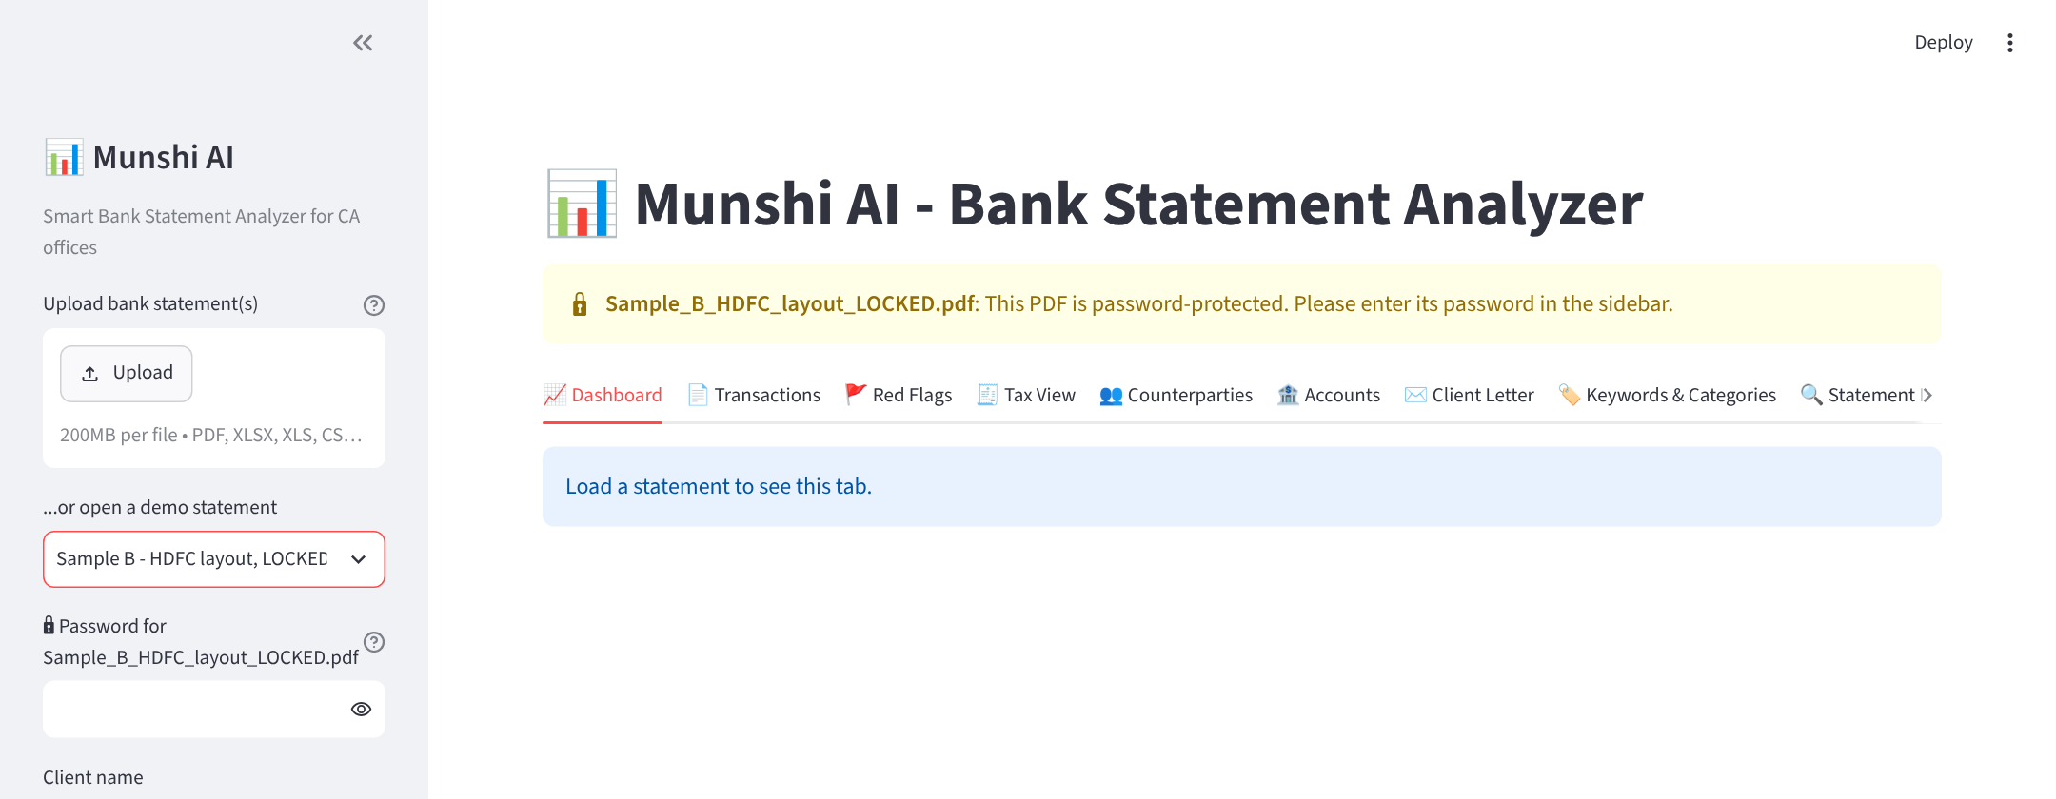
Figure 10 - The app asks for the PDF password

4.3 The summary at the top
Every statement opens with the key figures: opening balance, total credits, total debits, closing balance, cash deposited, cash withdrawn and red flags. The line under the title shows the bank, account, period and the balance check result. With several accounts, the own-account transfers matched are also shown.
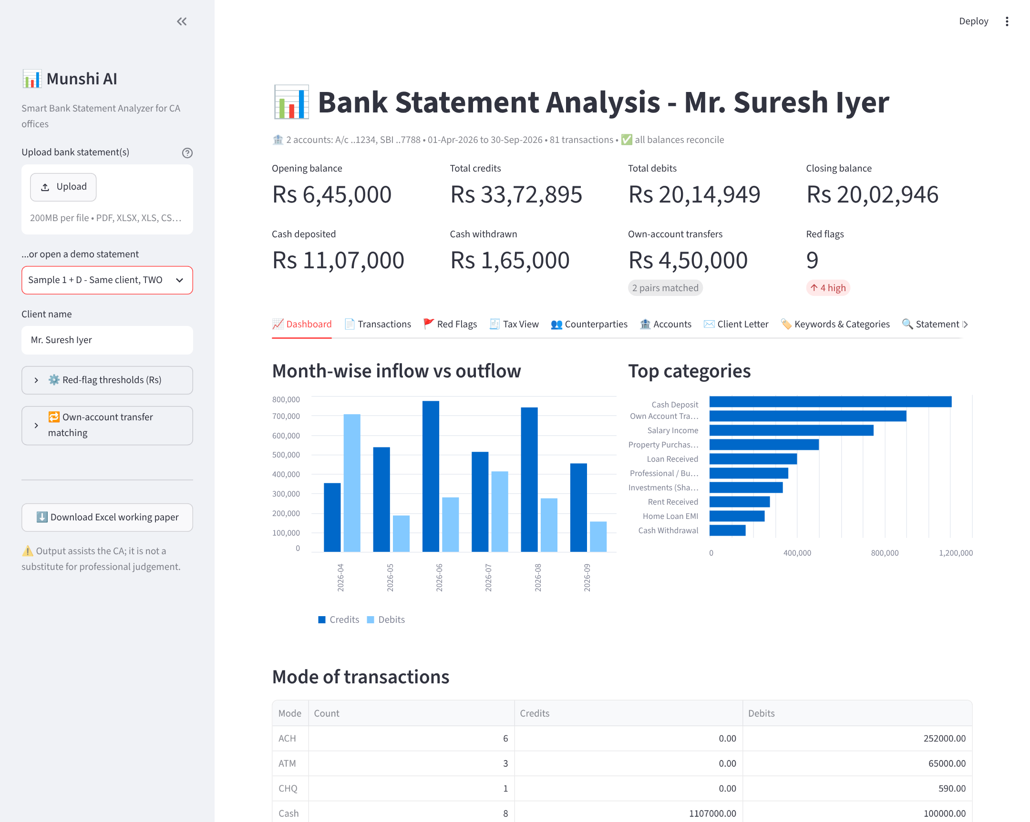
Figure 11 - Two accounts of one client combined (demo “Sample 1 + D”)

4.4 Transactions - and changing a category
Lists every transaction with its category, the keyword that decided it, and the party name. Filter by account, category, text or amount.
To change a category:
- Double-click the Category cell and pick a new category (start typing to search).
- Need a name that is not in the list? Type it in “Need a category that is not in the list?” and click Add category first.
- Tick Remember to save the Keyword shown (edit it if needed). Future statements will then get this category automatically.
- Click Save category changes. Use Undo manual changes to go back.
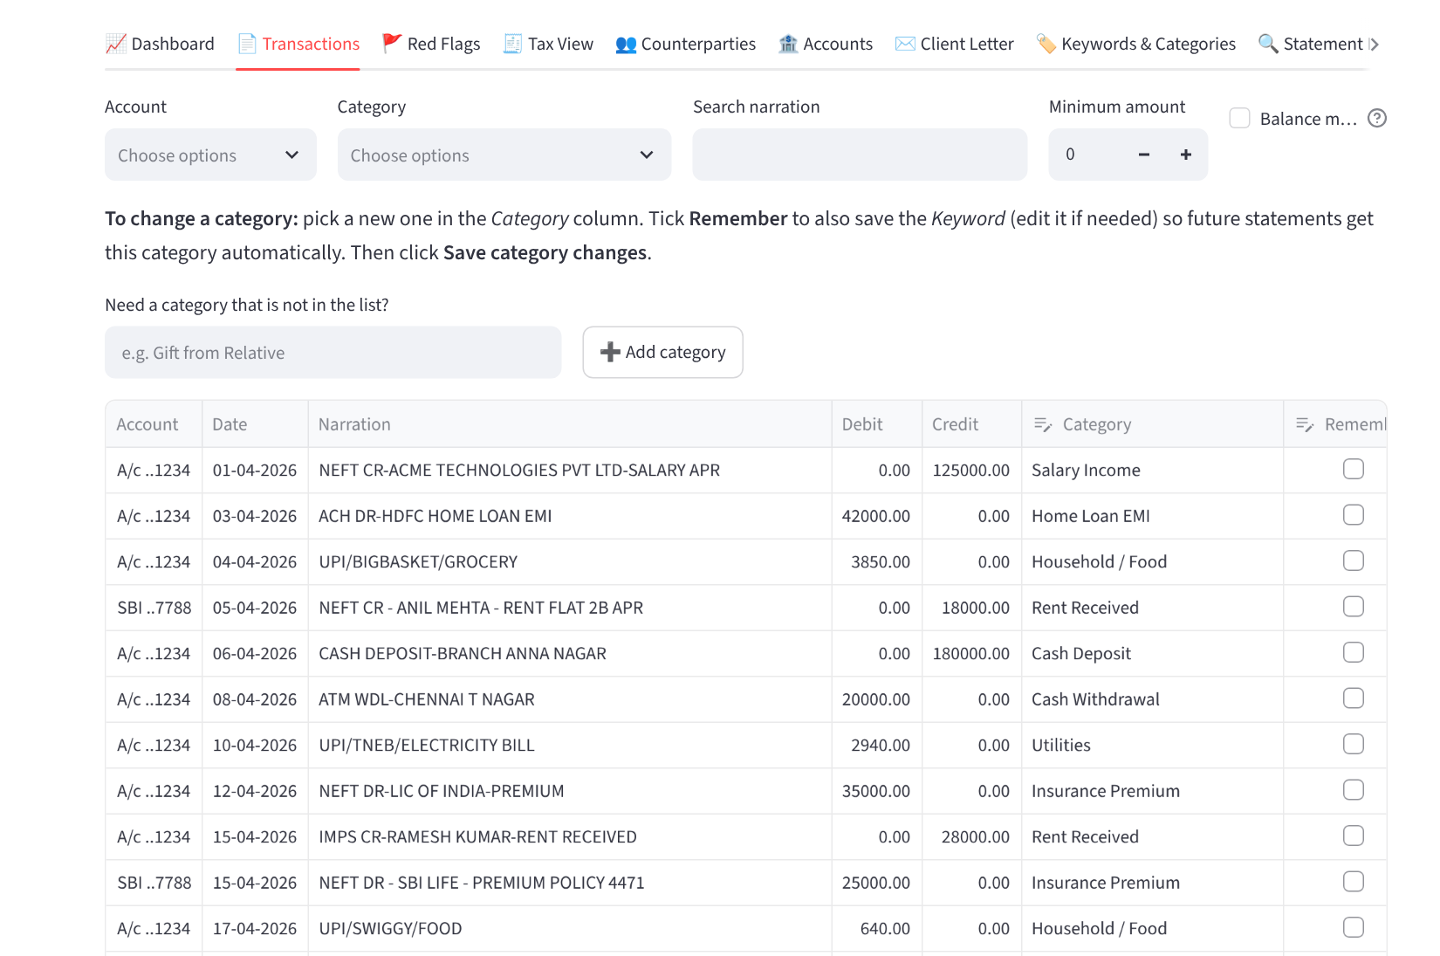
Figure 12 - Transactions tab with editable categories

4.5 Red Flags
Items that need attention, grouped as High, Medium and Low, each with the reason it matters and the suggested action. The limits used (PAN limit, cash receipt limit, reporting limit and others) can be changed under “Red-flag thresholds” in the left panel.
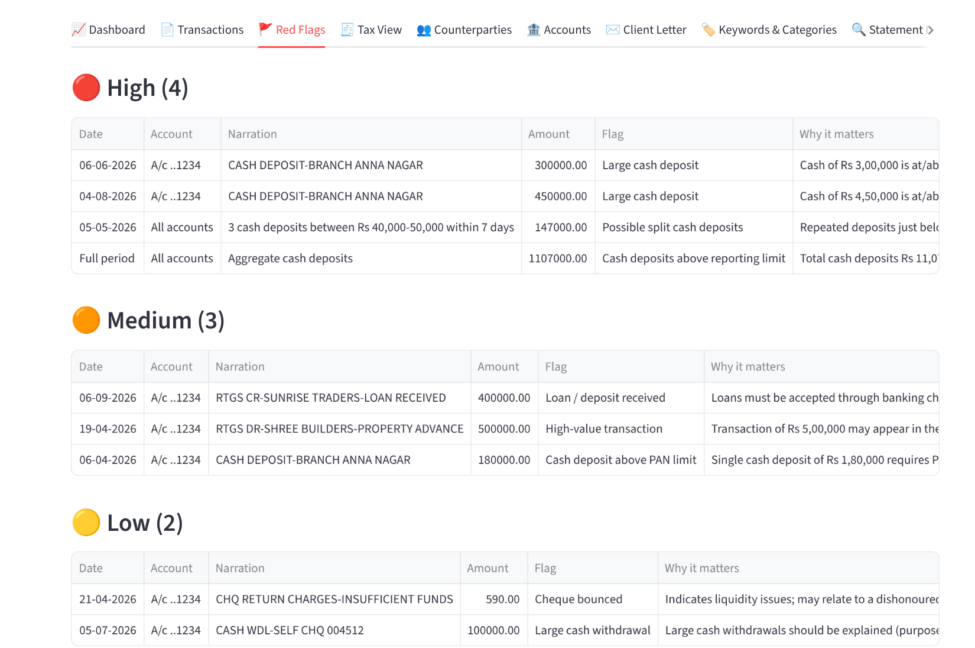
Figure 13 - Red Flags tab

4.6 Tax View
Income heads seen in the bank (salary, rent, professional receipts, interest, dividend) to match with Form 26AS / AIS, and possible deductions and tax credits.
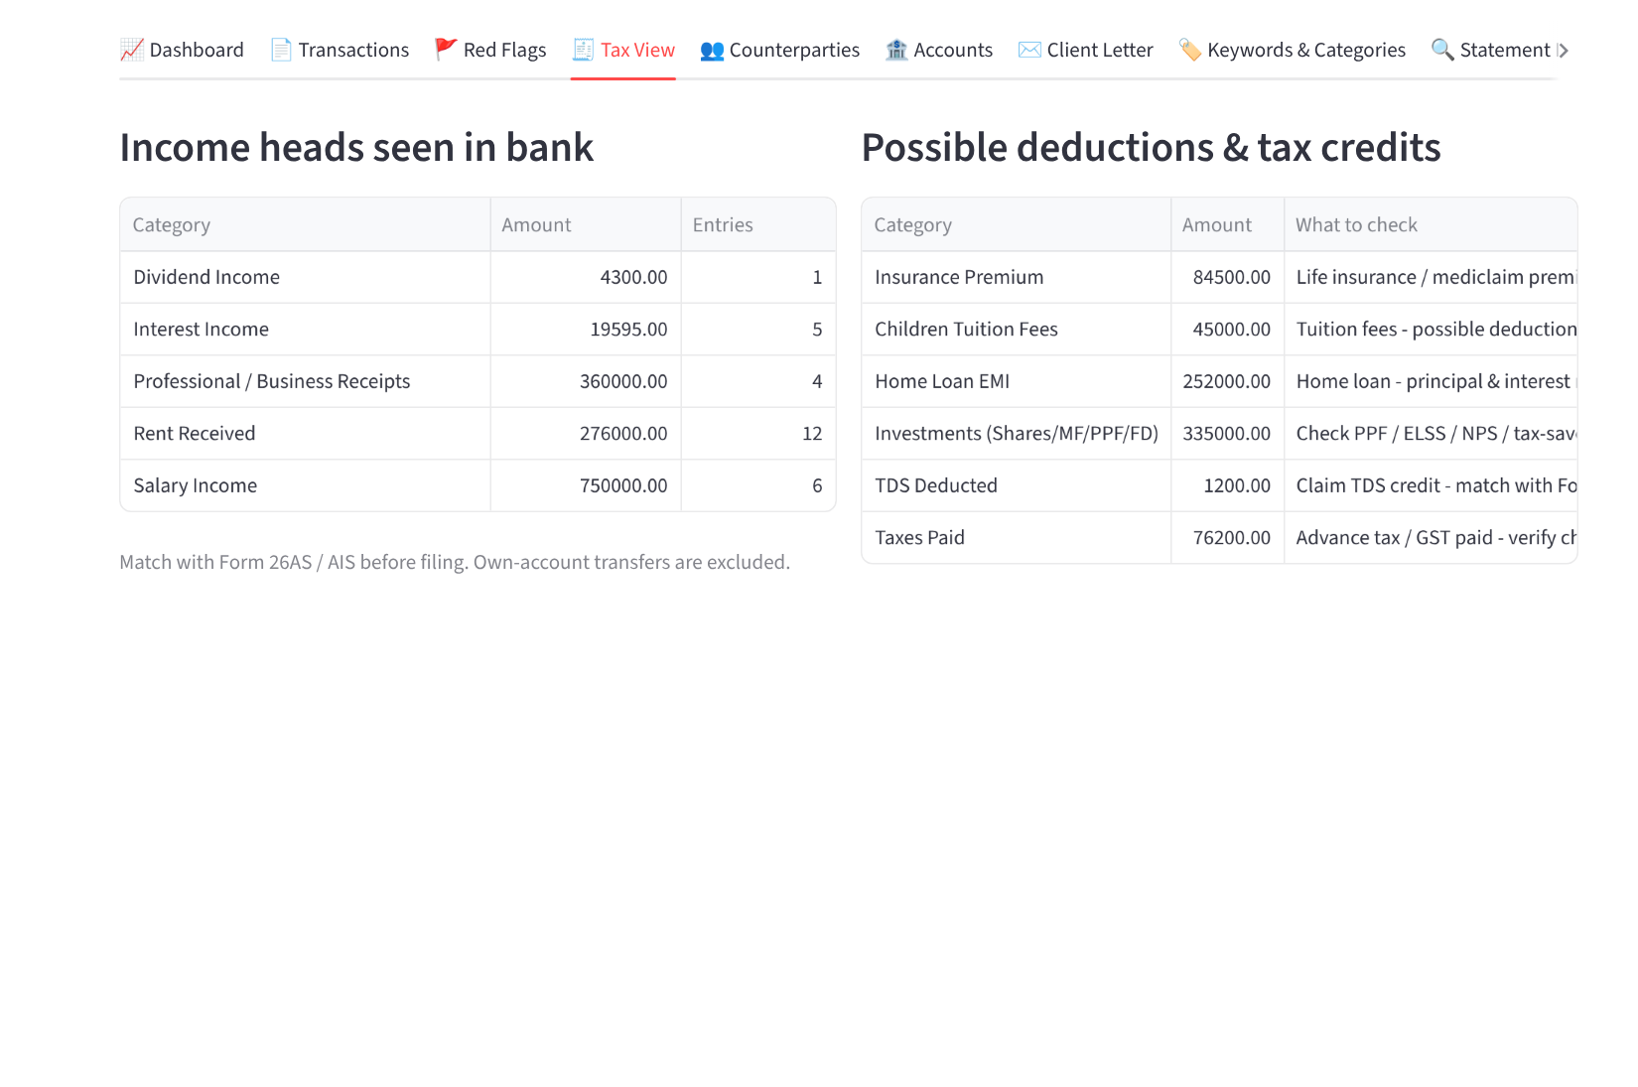
Figure 14 - Tax View tab

4.7 Counterparties
Total received from and paid to each party. Parties that both paid and received money are listed separately at the top for review as possible related parties, loans or circular movement. Choose a party at the bottom to see all its transactions.
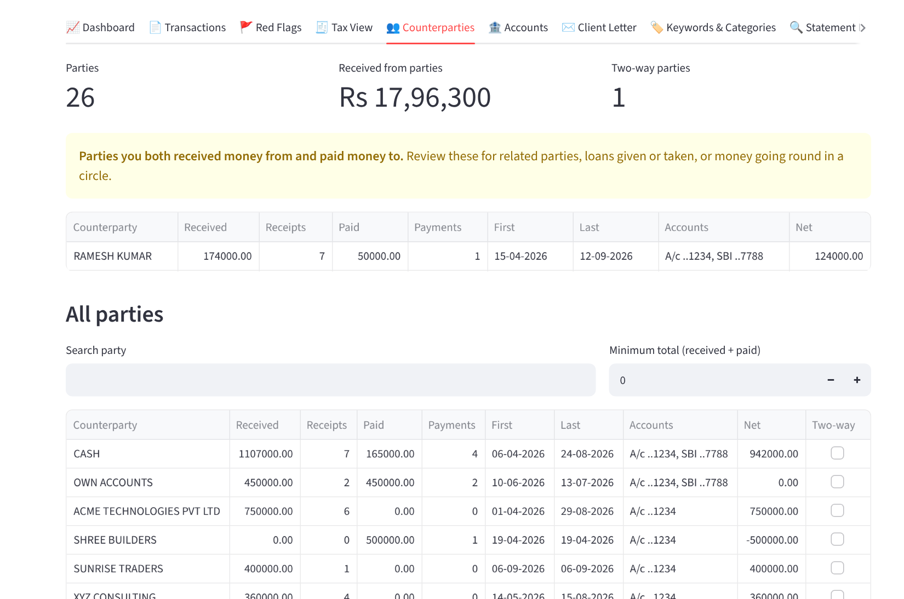
Figure 15 - Counterparties tab

4.8 Accounts
Each account’s period, opening balance, credits, debits, closing balance and balance check, the transfers matched between the client’s own accounts, and a balance chart per account. If a matched pair is wrong, change its category in the Transactions tab. Matching settings are in the left panel under “Own-account transfer matching”.
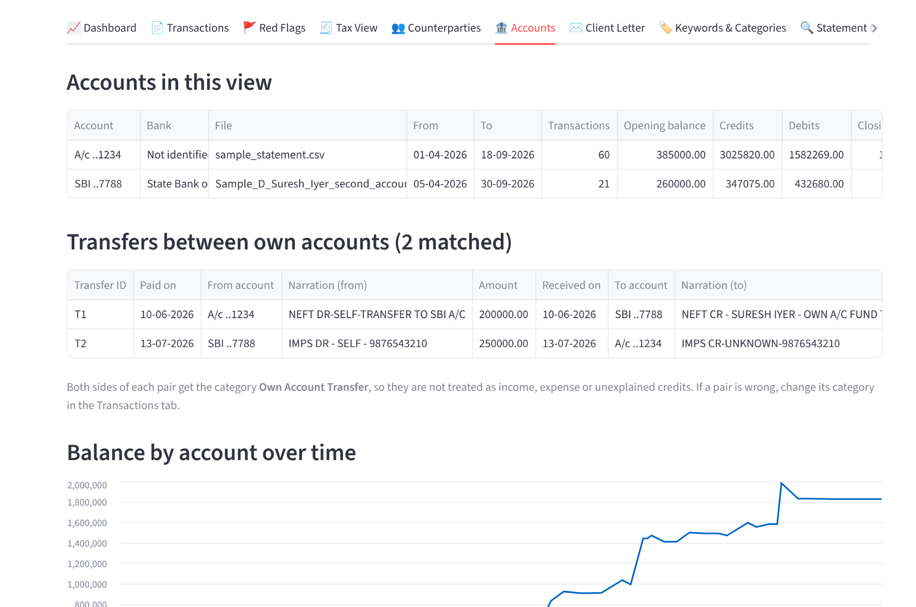
Figure 16 - Accounts tab

4.9 Client Letter
A draft letter to the client listing every flagged entry and what is needed. Edit it on screen and download it.
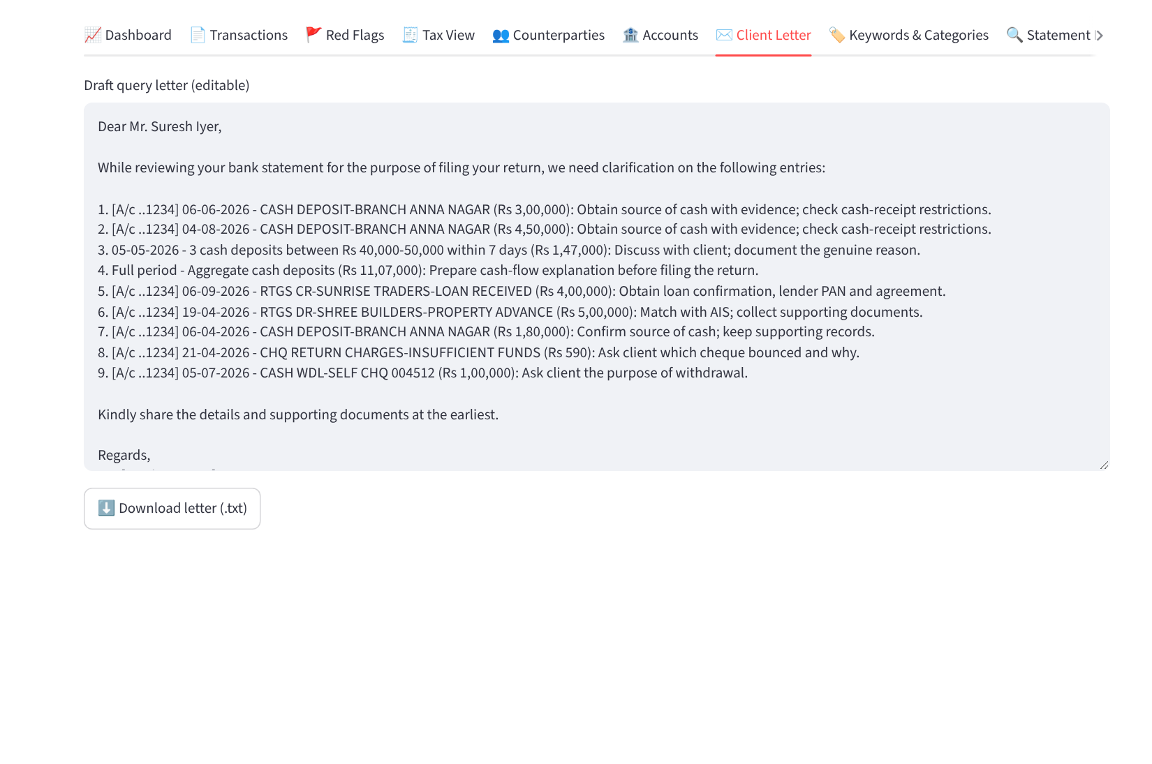
Figure 17 - Client Letter tab

4.10 Keywords & Categories
The keyword list that decides categories. You can:
- see and edit the full list, add or delete rows, and click Save;
- upload your own keyword list from Excel or CSV (columns: Keyword, Category, Applies To, Priority) - a ready example is in samples\Sample_Keywords_Upload.xlsx;
- see narrations in the current statement that matched no keyword, and add a keyword for them in one click;
- test any narration to see which category it would get.
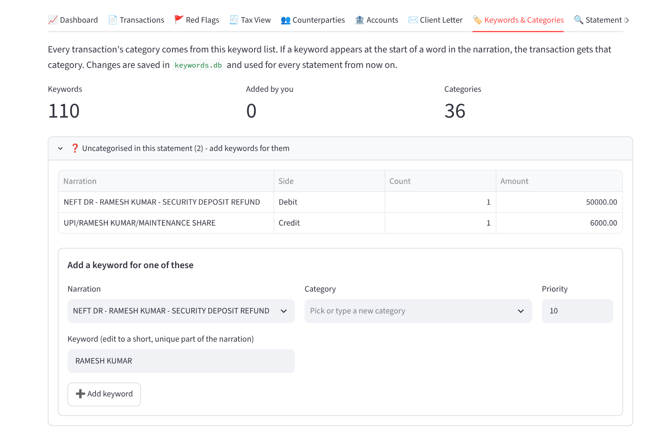
Figure 18 - Keywords & Categories tab

4.11 Statement Info - when a file is read wrongly
Shows how the file was read: the bank detected, account number, reading method, balance check and which column was used for date, narration, debit, credit and balance. If an unusual format is read wrongly, use “Fix column mapping” to choose the columns yourself, or tell the app which row holds the column headings.
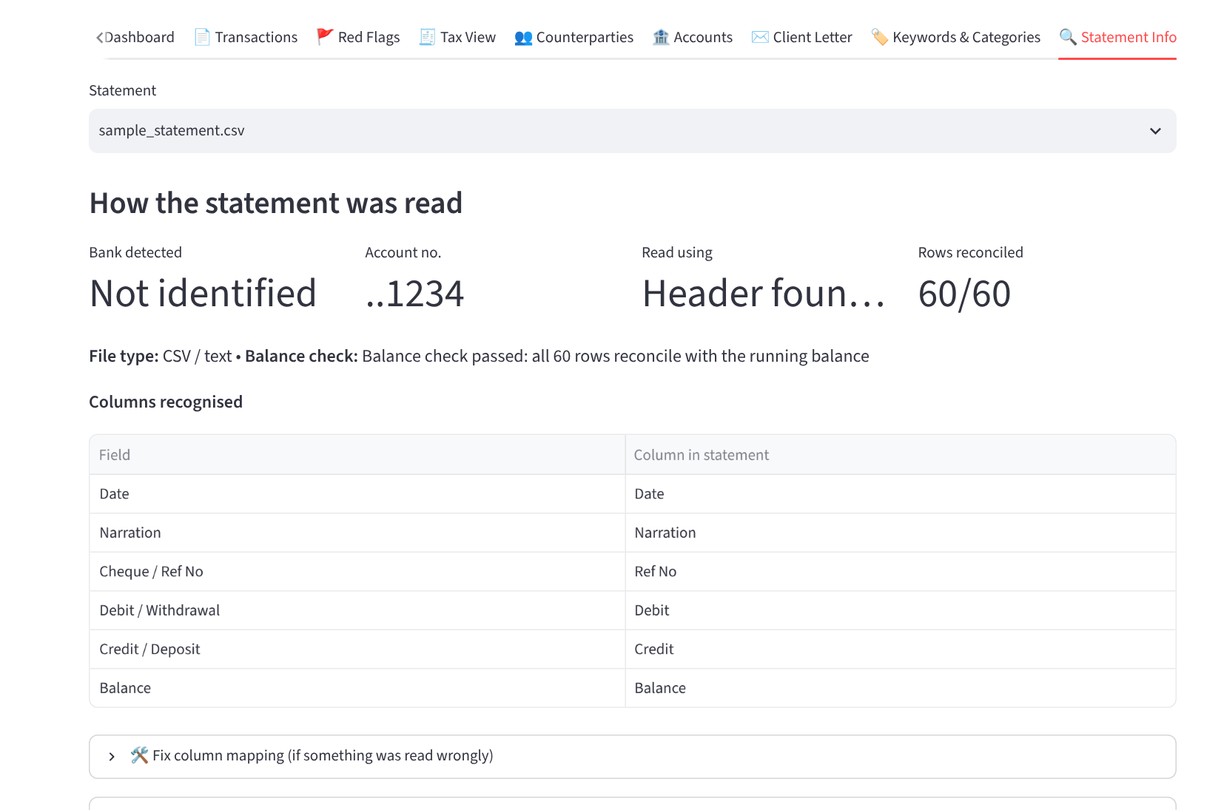
Figure 19 - Statement Info tab

4.12 Download the Excel working paper
Click Download Excel working paper in the left panel. The file has these sheets: Summary, Accounts, Transactions, Counterparties, Own Transfers, Category Totals, Income Heads, Deduction Hints, Monthly and Red Flags.

4.13 Demo statements included
Demo | What it shows
Sample 1 (CSV) | Salaried individual, 6 months, 10 red flags.
Sample 1 + D | Same client with two accounts; transfers between them are matched and an unexplained credit is explained.
Sample 2 (Excel) | Doctor’s clinic, full financial year, bank-style column names.
Sample A (PDF) | PDF with table borders, SBI-style layout.
Sample B (PDF, locked) | PDF without borders, HDFC-style layout; password AICA2026.
Sample C (Excel) | Account details above the table, single Amount column with Dr/Cr, newest first. Upload samples\Sample_Keywords_Upload.xlsx in the Keywords tab to see uncategorised entries get categorised.

Suggested 5-minute demonstration
1. Open Sample 1 and walk through the summary, Red Flags and Tax View.
2. Open Sample B to show a locked PDF (password AICA2026).
3. Open Sample 1 + D to show two accounts combined - the unexplained Rs 2.5 lakh credit is matched to the client’s own account and the red flag disappears.
4. In Transactions, change a category and tick Remember; show Counterparties.
5. Download the Excel working paper and show the Client Letter.

5. Troubleshooting
Problem | What to do
The black/blue window says “Python is not installed” | Install Python (Step 1) with “Add python.exe to PATH” ticked, then double-click Run_Munshi_AI.bat again. If Python was installed without that tick, run its installer again and choose Modify.
“Package installation failed” | Check the internet connection and run the .bat again. Office networks with a firewall may block downloads - try another network once; after that no internet is needed.
Windows protected your PC | Click More info, then Run anyway (Step 3).
The window opens and closes immediately | Make sure the zip was extracted (Step 2) and that Run_Munshi_AI.bat is in the same folder as app.py.
Browser does not open | Open Chrome or Edge and go to http://localhost:8501 while the blue window is open.
“This PDF is password-protected” | Enter the password in the left panel. Bank e-mails usually explain the password format.
“This PDF is a scanned image” | The PDF is a picture, not text. Download the statement again from net banking as PDF or Excel.
Columns read wrongly or header not found | Open the Statement Info tab: choose the header row, or map the date, narration, debit, credit and balance columns yourself.
Balance check shows rows that do not reconcile | Tick “Balance mismatches only” in Transactions to see those rows; check them against the original statement.
Want to start the keyword list fresh | Keywords & Categories tab > Reset to built-in. Your keywords and manual changes are kept in keywords.db in the project folder - copy this file to keep them when moving to a new computer.
Port already in use / app opens on another number | The app may already be running in another window. Close the other blue window, or use the address shown in the window (e.g. http://localhost:8502).

6. Project files and how it was built

Files in the project folder
File | Purpose
Run_Munshi_AI.bat | One-click start for Windows: checks Python, installs packages on first run, starts the app.
app.py | The screens: left panel, summary, and all tabs.
parsers.py | Reads PDF, Excel and CSV statements of different banks; detects bank, account, header and columns; runs the balance check.
analyzer.py | Categorisation, counterparties, combining accounts and matching transfers, red flags, summaries, client letter and Excel export.
keywords_db.py | The keyword database, your own categories and saved manual changes (stored in keywords.db).
requirements.txt | List of Python packages the app needs.
README.md | Short technical notes.
sample_statement.csv, samples\ | Fictitious demo statements and the example keyword upload file.
make_*.py | Scripts used to create the demo statements.

How it works
- Read: the file is opened (asking for a password if locked); the bank, header row and columns are recognised; wrapped narrations are joined; every row is checked against the running balance.
- Categorise: cash entries are detected from the narration; every other entry is matched against the keyword database in priority order; manual changes override.
- Combine: several accounts are merged and same-amount debit/credit pairs between them are matched as own-account transfers.
- Analyse: red-flag rules, income heads, deduction hints and counterparty totals are calculated.
- Output: screens, client letter and the Excel working paper.

Disclaimer
Red-flag limits are configurable review triggers, not legal conclusions; verify them against the law in force (including the Income-tax Act, 2025 where applicable). The output assists the Chartered Accountant and does not replace professional judgement. All demo statements are fictitious specimens.

