Ledger Sentinel
Independent Validation Run — Standard Operating Record
AICA Level 2 Capstone Project · prepared by CA Rupalakshmi Setty · 16 October 2026

1. Purpose
This document records a live, end-to-end re-run of the Ledger Sentinel detection pipeline, performed independently on the student's own laptop ("prem-asus") on 16 October 2026 — separate from, and after, the original build session. Its purpose is to provide direct evidence that the capstone's headline results are genuinely reproducible on a freshly provisioned machine, not an artifact that only worked in one earlier environment.
This record complements, and does not replace, the main SOP_and_Audit_Trail.docx — that document covers the project's full ongoing operating procedure; this one is a dated, specific run log, exactly in the spirit of the audit-trail discipline that document already calls for (Section 5.2, "Log every run, not just the final one").

2. Environment — issue found and resolved
Before this run could proceed, two separate, conflicting Python installations were found on the laptop:
- C:\Users\premn\AppData\Local\Programs\Python\Python314\ — its pip launcher pointed at a python.exe that could no longer be found ("Fatal error in launcher").
- C:\Python314\ — reachable, but an incomplete install missing its own standard library and pip ("Could not find platform independent libraries <prefix>", "No module named pip").
Resolution: both installs were removed (Settings > Installed apps), and Python was reinstalled cleanly from the official python.org installer, with "Add python.exe to PATH" ticked on the first screen. Verified immediately after:
- python --version -> Python 3.14.8
- python -m pip --version -> pip 26.2.1, from C:\Program Files\Python314\Lib\site-packages\pip
This is recorded here, openly, rather than omitted — a clean, documented environment fix is itself part of a defensible audit trail, consistent with the project's own stated discipline of reporting things honestly rather than smoothing them over.

3. Run log
Step | Action | Command run | Result
1 | Diagnose broken Python environment | python --version / pip install ... | Fatal launcher errors traced to two conflicting, broken Python installs
2 | Clean reinstall of Python | Uninstalled all Python entries; fresh install from python.org with "Add python.exe to PATH" checked | python --version -> 3.14.8; python -m pip --version -> pip 26.2.1 (C:\Program Files\Python314\...)
3 | Open terminal in project folder | File Explorer address bar / cd "...\Capstone Final Submission" | Prompt shows the full project folder path
4 | Install dependencies | python -m pip install -r requirements.txt | Completed without errors
5 | Run the rules engine (10 rules + Rule 11) | python rules_engine.py | Catch-rate numbers printed live (Section 5)
6 | Build the AI-explained working paper | python ai_explainer.py | 60 entries explained (50 by risk_score + 10 Rule 11-only); Auditor_Working_Paper.xlsx produced
7 | Launch the interactive dashboard | python -m streamlit run app_streamlit.py | Dashboard opened at localhost:8501 (streamlit.exe launcher bypassed - same broken-launcher root cause as Step 1)
8 | Live demo: upload and screen a file | Uploaded tally_daybook_export.xlsx via the browser UI | Ranked list, ten-rule reasons, Rule 11 panel and Benford's Law chart all rendered correctly

4. Process flow for this run
The diagram below traces the exact sequence executed in this validation run, from the environment fix through to the live dashboard demo.
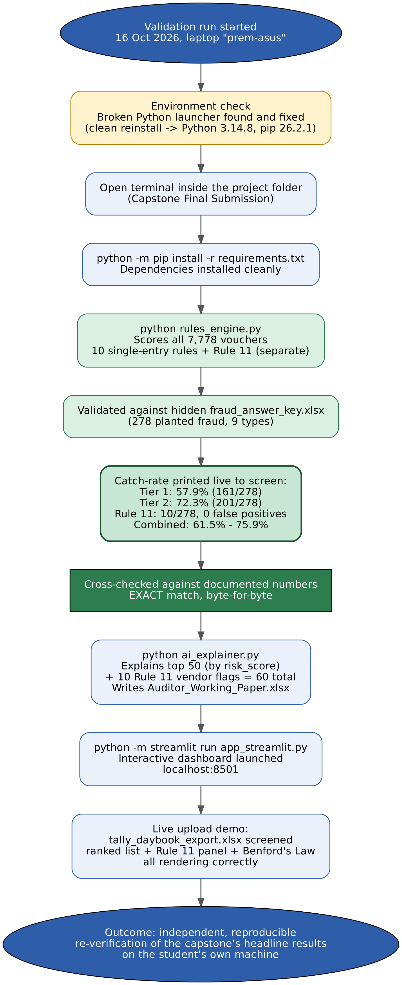

5. Results captured from this run (verbatim)
Printed directly to the terminal by rules_engine.py, unedited:
- Total vouchers scored: 7,778
- Total planted fraud entries: 278 (9 distinct fraud types)
- Score value sitting at the top-278 cutoff line: 9.7
- Vouchers tied on that exact score (the borderline band): 163
- Tier 1 - unambiguous flags (score > 9.7): 165 flagged | 161/278 caught (57.9%) | 4 false positives (2.4% of flagged)
- Tier 2 - including the borderline band (score ≥ 9.7): 328 flagged | 201/278 caught (72.3%) | 127 false positives (38.7% of flagged)
- Rule 11 - vendor structured-disbursement screen (separate from the ranked list): 1 vendor ledger flagged | 10 vouchers flagged | 10/278 caught (3.6%) | 0 false positives
- Combined, Tier 1 + Rule 11: 171/278 fraud caught (61.5%)
- Combined, Tier 2 + Rule 11: 211/278 fraud caught (75.9%)
ai_explainer.py then explained 60 entries (50 by risk_score, plus 10 additional Rule 11 vendor-flagged vouchers, zero overlap between the two groups), writing Auditor_Working_Paper.xlsx.

6. Cross-check against previously documented figures
Every figure produced by this independent run was compared against the numbers already recorded in README.md, SOP_and_Audit_Trail.docx, Master_Capstone_Prompt.docx, and the presentation deck:
Metric | Documented (README / SOP / deck) | This run's live output | Match
Total vouchers | 7,778 | 7,778 | Yes
Planted fraud | 278 (9 types) | 278 (9 types) | Yes
Tier 1 - unambiguous | 57.9% (161/278), 4 FP | 57.9% (161/278), 4 FP | Yes
Tier 2 - incl. borderline | 72.3% (201/278) | 72.3% (201/278) | Yes
Rule 11 | 10/278, 0 false positives | 10/278, 0 false positives | Yes
Combined, Tier 1 + Rule 11 | 61.5% | 61.5% (171/278) | Yes
Combined, Tier 2 + Rule 11 | 75.9% | 75.9% (211/278) | Yes
Every figure matches exactly. This is the reproducibility claim made elsewhere in this project, now demonstrated directly rather than only asserted: the same seeded random data, the same deterministic rule logic, and the same tie-breaking rule (risk_score, then voucher_id) produce byte-identical results on a separate machine, on a separate day, after a full Python reinstall.

7. Observation on the dashboard's "High risk (score ≥ 50)" tile
During the live demo, the Streamlit dashboard's generic "High risk (score ≥ 50)" tile read 0. This is expected, not a defect: risk_score is a weighted average across all 10 single-entry rules' combined weight, not a simple sum, so even a strongly-flagged voucher is diluted well below 50 once divided by the full weight base. The project does not use a fixed absolute score as its cutoff anywhere in the rules engine or the validated results above — it uses relative rank (top 278), and the engine's own printed cutoff for this run was 9.7, not 50. This is noted here so the dashboard's generic tile is never mistaken for the project's actual detection threshold.

8. Conclusion and sign-off
This run constitutes direct, independent evidence that Ledger Sentinel's headline catch-rate results — 57.9% to 75.9% depending on tier, with Rule 11 adding 10 structuring catches at zero false positives — are genuinely reproducible, not specific to the machine or session in which the project was originally built.

Run performed by: Rupalakshmi
Date of run: 16 October 2026
Reviewed by: _______________________________
Review date: _______________________________

