AICA LEVEL 2 – CAPSTONE PROJECT
Bank Statement Analyser PRO
An in-house, rule-based, zero-cost tool for bank statement analysis in Banks and NBFCs
Project Summary Document

Item | Details
Submitted by | CA Vinod H Dandwani
Course | ICAI – Artificial Intelligence for Chartered Accountants (AICA) Level 2
Membership / registration no. | 120168 | AICA Level 2 Batch 102
Organisation (optional) | Aarambh Securities Limited  Role: Chief Risk Officer and Independent Director
Date of submission | 20 October 2026
Version | 1.0
Executable | bank_analyser.html (single-file web application)
Demo video | https://drive.google.com/file/d/1Gh4RnH28y0Gayc2JHNLsQEug-LRLGZ6E/view
GitHub link | https://github.com/CAVINODHDANDWANI/AICA-Level-2-Projects  Project folder: AICA_L2_Capstone_VinodDandwani  Pull Request: https://github.com/aiinicai/AICA-Level-2-Projects/pull/457

1. Executive Summary
Banks and NBFCs receive customer bank statements mainly as PDFs, including scanned copies, and today usually pay outside agencies to analyse each one. This is costly, slow and exposes customer data to third parties.
Bank Statement Analyser PRO is a web-based tool that an operations executive can use to upload one or many statements (PDF, scanned PDF, Excel, CSV or image), confirm key details, and receive a professional dashboard and an Excel workbook within minutes. It computes the average bank balance, monthly credits and debits, EMI and bounce behaviour, risk flags, fraud indicators and policy deviations, and it reports missing periods when statements are supplied monthly or quarterly.
The analysis is entirely rule-based. No AI model runs while the tool is used, no API key is needed, no statement data leaves the user's browser, and using the tool carries no cost.

2. Problem Statement
- High cost: agencies charge per statement, which is expensive at volume.
- Turnaround delay: credit decisions wait for external reports.
- Data privacy: customer statements are shared with third parties, which is a concern under the Digital Personal Data Protection (DPDP) Act.
- Poor presentation: existing outputs are plain Excel numbers that are hard to read and explain.
- Incomplete files: statements arrive as monthly or quarterly files, scanned copies, or merged PDFs with several accounts, and gaps often go unnoticed.
- Fraud risk: manipulated PDFs and suspicious entries are hard to detect by eye.

3. Objectives
- Replace outsourced statement analysis with an in-house automated tool.
- Accept statements in any common format, singly or in multiple files.
- Apply the organisation's banking-policy rules and mark deviations automatically.
- Detect missing periods and suspicious or manipulated statements.
- Present results in a clear, graphical, professional dashboard and an Excel workbook.
- Keep all processing local and aligned with the DPDP Act, at zero cost.

4. Users and Workflow
Primary user: operations executive. Secondary users: credit analyst, approver and FCU (fraud control) team. The operations executive uploads the statements, confirms the details shown on a small validation screen, enters the account type and proposed EMI, and clicks Confirm & Analyse. The credit officer then reviews the dashboard and the Excel workbook. The tool supports the decision; it does not take it.

5. Process Flow
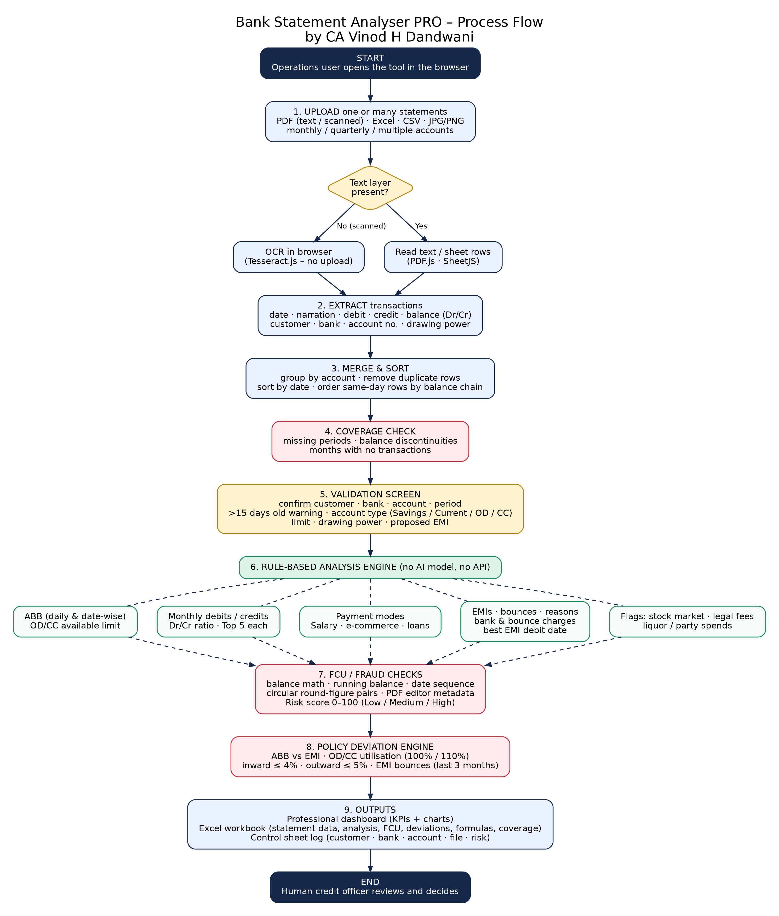

6. Features
Area | What the tool does
Input | PDF (text or scanned, using in-browser OCR), Excel, CSV, JPG/PNG. Several files can be selected together.
Validation screen | Shows customer name, bank, account number and statement period for confirmation. Warns when the statement is more than 15 days old. Asks for account type, limit, drawing power and proposed EMI.
Multi-file handling | Merges files by account, removes duplicate and overlapping rows, sorts by date, orders same-day entries by balance continuity, and lets the user pick one account when a file holds several.
Missing periods | Flags periods not covered by any file, distinguishes gaps where balances do not reconcile (missing transactions) from quiet periods, lists balance discontinuities, and lists months with no transactions.
Balances | Average bank balance (ABB) by daily method and on selected dates. OD/CC accounts use available limit instead of raw balance; overdrawn accounts are highlighted.
Turnover | Monthly credits, debits, counts and debit/credit ratio. Top 5 credits and top 5 debits for the full period.
Payment modes | NEFT, UPI, IMPS, RTGS, cash and cheque, on both the credit and the debit side.
EMIs and bounces | Lender-wise EMI grid by month, cheque and EMI bounces with reason (insufficient funds or other), bounce percentage of debits, bank charges and bounce charges, and the best EMI debit date from 1, 3, 5, 10 and 15.
Behaviour flags | Stock-market transactions, legal-fee payments, liquor and party spends, e-commerce and gateway credits, salary credits, loan disbursements.
Fraud / FCU checks | Balance-math and running-balance checks, debits with no balance change, date sequence, circular round-figure transfers, PDF editing-software metadata, and a risk score from 0 to 100.
Policy deviations | Automatic marking against the banking-policy rules in Section 8.
Outputs | Dashboard with KPI cards and charts; Excel workbook with the statement converted into one table, analysis sheets, FCU report, deviations, coverage and formulas; a control sheet recording every analysis.

7. Rule Logic and Formulas
All logic is deterministic and is also written into the Formulas sheet of every workbook so that each figure can be verified by hand.
Metric | Formula / rule | Notes
Debit / credit ratio | Total debits ÷ Total credits | Monthly and overall
ABB (daily) | Sum of daily closing balances ÷ Days in period | Balance carried forward on days without transactions
ABB (dates) | Average balance on the 1st, 3rd, 5th, 10th and 15th of each month | Matches the date-wise method in the policy
OD/CC available balance | Lower of limit and drawing power, minus debit balance | Example: limit ₹1,00,000, debit balance ₹15,000 gives ₹85,000
Utilisation % | Peak debit balance ÷ limit × 100 | OD/CC only
Cheque bounce % | Bounced cheques ÷ Number of debits × 100 | Monthly and period
Running-balance check | Previous balance ± amount = current balance (tolerance ₹1) | Per row
Balance continuity | Same check across the whole merged series | Finds missing transactions between files
EMI date coverage | Months where previous-day balance ≥ EMI ÷ Months × 100 | For 1, 3, 5, 10, 15
Risk score | 8 per running-balance break (max 40) + 25 per debit or credit with no balance change (max 50) + 10 date order + 20 PDF editor + 5 per circular pair (max 15) + 5 stock-market + 5 legal + 3 per EMI bounce (max 10) | Capped at 100. Low below 25, Medium below 55, High from 55

8. Banking Policy Rules Implemented
# | Parameter | Rule | Action
1 | ABB vs proposed EMI | ABB lower than the proposed EMI | Deviation
2 | OD/CC utilisation | Above 100% of limit | Excess utilisation; up to 110% accepted only with nil inward returns
3 | Inward returns | Maximum 4% of cheques | Deviation above 4%
4 | Outward returns | Maximum 5% of cheques | Deviation above 5%
5 | EMI bounces | Up to 1 in the latest 3 months is acceptable | Deviation if more than 1; flagged separately when bounces are for insufficient funds
Assumptions: a cheque return is treated as inward unless the narration says outward (O/W); percentages are measured against cheque debits, or all debits when no cheque debits exist. The 30-day clearance exception for EMI bounces is not yet applied. These can be changed to match the institution's exact policy.

9. Technology and Architecture
The application is a single HTML file with JavaScript that runs in the user's browser (Chrome or Edge). There is no server, database or account. The control sheet is stored in the browser's local storage.
Component | Library | Licence* | Purpose
PDF reading | PDF.js 3.11.174 | Apache-2.0 | Extracts text and renders pages for OCR
Excel / CSV | SheetJS 0.18.5 | Apache-2.0 | Reads spreadsheets and writes the Excel workbook
Charts | Chart.js 4.4.1 | MIT | Dashboard charts
OCR | Tesseract.js 5.1.1 | Apache-2.0 | Reads scanned statements in the browser
Licence information is supplied for attribution. Third-party licence terms continue to apply.
Why a rule-based design and no local AI model: a local model would slow daily work, may need heavy hardware, and is less predictable. Keyword and pattern rules are fast, explainable and easy to audit.

10. Use of AI in Developing the Project
This project was built with AI assistance ("vibe coding"). The requirements, banking logic and policy rules came from my work in the NBFC sector. AI tools helped to shape the requirements and to write and test the code under my direction.
Stage | AI tool and role
Concept and requirement prompt | Gemini – initial feasibility discussion and requirement prompt, including the forensic-auditor prompt for statement verification
Design and build | Claude (Anthropic) – requirement organisation, application code, OCR, multi-file merging, missing-period detection, dashboard design
Testing and fixes | Development samples identified issues addressed through further prompts. Staff subsequently tested CSV, Excel and PDF uploads and approved the tool as working satisfactorily, as confirmed by the project author on 20 October 2026.
At run time | No AI model is used. The tool is rule-based.
The exact prompts used are provided in the Prompts file in this submission.

11. Data Privacy and Cost
- All statement processing happens inside the browser; no statement is uploaded to any server.
- Account numbers are masked on screen and in the control sheet.
- No personal data is kept except the local control sheet, which the user can clear.
- Only public, open-source libraries are loaded, with no accounts or API keys.
- The tool has no running cost: no API, subscription or hosting fee is needed. It can also be kept on a local drive or intranet.
- Submission examples use dummy or anonymised statements only.

12. Testing

12.1 Development testing
- Text PDF, scanned PDF (OCR), Excel and CSV statements.
- A 90-page sample statement containing two accounts (a cash credit account with a drawing power of ₹8 crore and a current account), with overlapping downloads and balances shown with Dr/Cr suffixes.
- Monthly files uploaded in random order with one month missing, to test merging and gap detection.
- Mixed-account CSV, Excel and PDF files, each holding a savings, a current and a cash-credit account, to test account selection, automatic account type and limit, and overdrawn detection.
- Problems found and fixed during testing: amounts without commas, newest-first statements, Dr/Cr balances, overlapping downloads, same-day ordering, multi-file merging.

12.2 Pilot testing by staff
Test group | File type | Result | Issues found | Action taken
Staff pilot | CSV | Working satisfactorily | No outstanding issue reported | Staff approved; author confirmation dated 20 October 2026
Staff pilot | Excel | Working satisfactorily | No outstanding issue reported | Staff approved; author confirmation dated 20 October 2026
Staff pilot | PDF | Working satisfactorily | No outstanding issue reported | Staff approved; author confirmation dated 20 October 2026
CA Vinod H Dandwani confirms that two files were manually checked and the checked results were 100% accurate. This is the author's reported result for those two files, not a claim of universal accuracy. No agency comparison is recorded.

13. Limitations
- Scanned statements may contain OCR misreads, especially phone photos and skewed pages; rows with balance breaks should be checked against the original.
- PDF layouts differ between banks; unusual layouts may need parser tuning.
- Each account is analysed separately; there is no combined view across accounts yet.
- Keyword rules can give false positives or miss unusual narrations.
- The tool supports human review and does not replace it. The fraud score is an indicator, not proof.
- Libraries load from public servers, so internet access is needed unless the libraries are bundled into the file.

14. Future Scope
- Consolidated view across several accounts of one customer.
- Bank-specific readers for the most common banks.
- Offline version with all libraries bundled.
- Shared control sheet with login and audit trail.
- Editable keyword and policy settings for each institution.
- Account Aggregator data input.

15. How to Run
- Open bank_analyser.html in Google Chrome or Microsoft Edge (internet is needed for the libraries).
- Select one or more statement files.
- Check the validation screen, choose the account type and enter the proposed EMI.
- Click Confirm & Analyse, then review the dashboard.
- Click Download Excel workbook to save the report.

16. Submission Contents
Folder | Contents
1_Project_Summary | This document and the process flow diagram
2_Prompts | The exact AI prompts used, with the purpose of each
3_Examples_and_Support | Dummy statements, sample outputs, screenshots, test results
4_Executable | bank_analyser.html and the run instructions

Declaration
I declare that this project is my own work, built with the AI assistance described in Section 10, and that no real customer data is included in this submission.

CA Vinod H Dandwani
Date: 20 October 2026

