DPDP Readiness Report
Sunrise Public School (demonstration)
http://127.0.0.1:8931/
Scanned 2026-09-21T16:48:21+00:00 · Report 21 September 2026 · Prepared by Demo reviewer
Evidence file: Sunrise_Public_School_demonstration_20260921T164821Z.json
Readiness score | 8 / 100 (Critical)
What that means | The institution has little of the DPDP framework in place. Treat this as a project, not a task list.
Catalogue coverage | 62% of the weighted obligation set could be assessed
Obligations met | 0
Partly met | 2
Gaps | 12
Not assessed | 11
Authorisation | Authorised by SurakshaScan self-test.
AI layer | not used; all ratings are from the deterministic rules engine
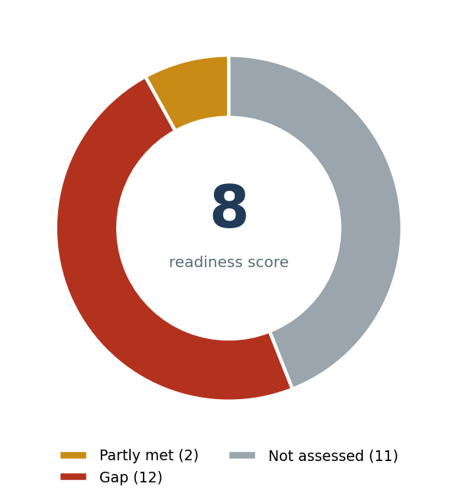
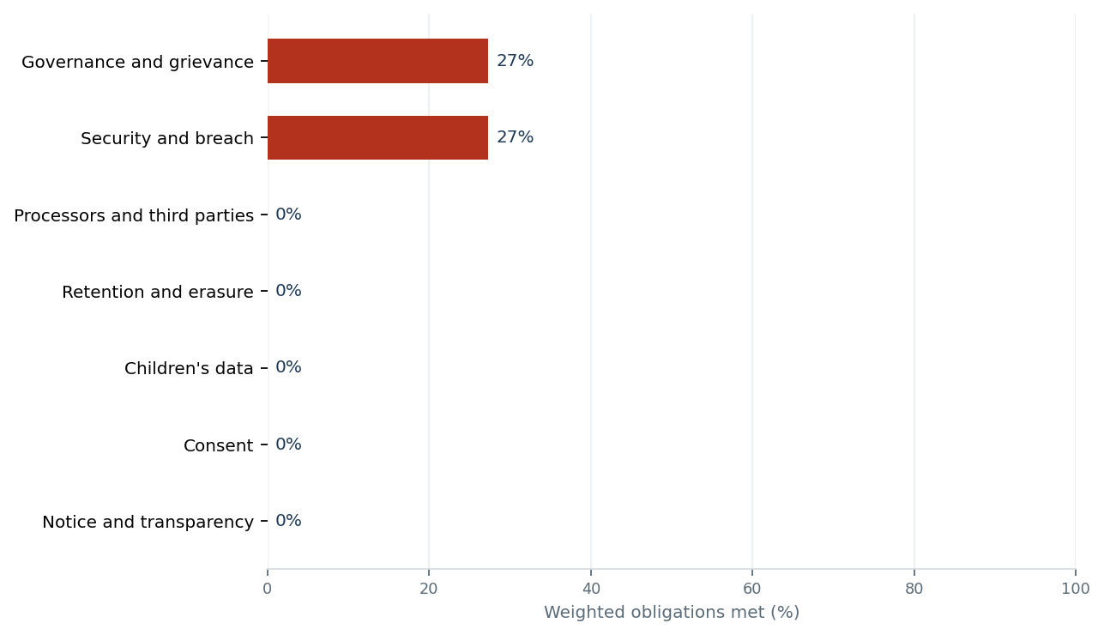
This report records a point-in-time readiness review. It is not a certificate of compliance with the Digital Personal Data Protection Act, 2023 or the Digital Personal Data Protection Rules, 2025, and it is not legal advice. Automated checks cover publicly accessible pages only; they do not reach logged-in areas, internal systems, or documents that are not published. Absence of a finding is not evidence of absence. Every legal reference should be verified against the notified text before the institution acts on it.

1. What to do first
Ordered by the improvement each action makes to the readiness score, with the cheapest action first where the impact is equal.
# | Obligation | Provision | Status | Effort | Score gain
1 | C2 No tracking, behavioural monitoring or targeted advertising to children | s.9(3), Act (from 14 May 2027) | Gap | Low | +10.1
2 | C1 Verifiable parental consent before processing a child's data | s.9(1), Act; Rule 10 (from 14 May 2027) | Gap | High | +10.1
3 | A1 A privacy notice is published and reachable from the website | s.5, Act; Rule 3, Rules (in force) | Gap | Low | +7.6
4 | E1 A retention schedule exists and data is erased when the purpose ends | s.8(7), Act; Rule 8 (from 14 May 2027) | Gap | High | +7.6
5 | G1 A written contract is in place with every data processor | s.8(2), Act (in force) | Gap | High | +7.6
6 | D1 The site and its forms are served over HTTPS | s.8(5), Act; Rule 6(1) (in force) | Gap | Low | +6.3
7 | B1 Consent is collected by clear affirmative action, not assumed | s.6(1), Act (in force) | Gap | Medium | +6.3
8 | C4 Student photographs and names are not published without consent | s.6(1), s.9(1), Act (in force) | Gap | Medium | +6.3
9 | G2 Third-party trackers on the website are disclosed and justified | s.5, s.6, s.9(3), Act (in force) | Gap | Medium | +6.3
10 | F3 A record of processing activities exists | s.8(1), Act (accountability) (in force) | Gap | High | +6.3
11 | B2 Only data necessary for the stated purpose is collected | s.6(1) proviso, Act (in force) | Gap | Low | +5.1
12 | B3 Consent records are kept and are auditable | s.6(1), s.8(1), Act (in force) | Gap | Medium | +5.1
13 | F1 Contact details of the person answering data questions are published | s.5(1)(iii), s.8(9), Act; Rule 9 (in force) | Partly met | Low | +3.8
14 | D2 Reasonable security safeguards are in place and documented | s.8(5), Act; Rule 6 (from 14 May 2027) | Partly met | High | +3.8

Actions in detail
- C2 — No tracking, behavioural monitoring or targeted advertising to children. Remove advertising and social pixels from all pages. Keep only analytics that is necessary and configured without advertising features, and document the safety or academic purpose relied on.
s.9(3), Act · from 14 May 2027 · effort: low · domain: Children's data
- C1 — Verifiable parental consent before processing a child's data. Capture parental consent against a verified parent identity - details already held in the admission record, or a virtual token from an authorised entity such as a DigiLocker provider - and retain the verification evidence.
s.9(1), Act; Rule 10 · from 14 May 2027 · effort: high · domain: Children's data
- A1 — A privacy notice is published and reachable from the website. Publish a DPDP notice at /privacy-policy and link it from the footer of every page, the admission enquiry form and the fee portal.
s.5, Act; Rule 3, Rules · in force · effort: low · domain: Notice and transparency
- E1 — A retention schedule exists and data is erased when the purpose ends. Set a period per record class - unsuccessful enquiries, withdrawn students, alumni, CCTV, biometric attendance - and schedule the deletion. Keep only what a records rule requires.
s.8(7), Act; Rule 8 · from 14 May 2027 · effort: high · domain: Retention and erasure
- G1 — A written contract is in place with every data processor. Add a data-processing addendum to each vendor agreement covering purpose limitation, security, sub-processing, breach reporting and deletion on exit.
s.8(2), Act · in force · effort: high · domain: Processors and third parties
- D1 — The site and its forms are served over HTTPS. Install a TLS certificate, redirect HTTP to HTTPS, and confirm no form posts to an http:// action.
s.8(5), Act; Rule 6(1) · in force · effort: low · domain: Security and breach
- B1 — Consent is collected by clear affirmative action, not assumed. Replace any implied-consent banner with an unticked checkbox beside a link to the notice, and log the consent artefact.
s.6(1), Act · in force · effort: medium · domain: Consent
- C4 — Student photographs and names are not published without consent. Take a separate, revocable media consent at admission, keep a do-not-publish list, and honour it across website, brochures and social media.
s.6(1), s.9(1), Act · in force · effort: medium · domain: Children's data
- G2 — Third-party trackers on the website are disclosed and justified. Inventory the scripts, remove what is not needed, name the rest in the notice, and gate non-essential ones behind consent.
s.5, s.6, s.9(3), Act · in force · effort: medium · domain: Processors and third parties
- F3 — A record of processing activities exists. Build a register of every system holding student or staff data - ERP, transport GPS, biometric, CCTV, LMS, WhatsApp groups, exam portal - with owner, purpose, categories and vendor.
s.8(1), Act (accountability) · in force · effort: high · domain: Governance and grievance
- B2 — Only data necessary for the stated purpose is collected. Review every public form field against its purpose and delete the fields that cannot be justified.
s.6(1) proviso, Act · in force · effort: low · domain: Consent
- B3 — Consent records are kept and are auditable. Add a dated, signed DPDP consent block to the admission form and keep a register mapping student to consent version.
s.6(1), s.8(1), Act · in force · effort: medium · domain: Consent
- F1 — Contact details of the person answering data questions are published. Name a role - not an individual's personal mobile - publish a dedicated address such as dpo@school.edu.in on the policy page and the contact page, and route it to a monitored inbox.
s.5(1)(iii), s.8(9), Act; Rule 9 · in force · effort: low · domain: Governance and grievance
- D2 — Reasonable security safeguards are in place and documented. Write a one-page security standard covering access control on the ERP, encryption of exports, a one-year log retention setting and a tested backup.
s.8(5), Act; Rule 6 · from 14 May 2027 · effort: high · domain: Security and breach

Open items under provisions already in force
- A1 - A privacy notice is published and reachable from the website
- G1 - A written contract is in place with every data processor
- D1 - The site and its forms are served over HTTPS
- B1 - Consent is collected by clear affirmative action, not assumed
- C4 - Student photographs and names are not published without consent
- G2 - Third-party trackers on the website are disclosed and justified
- F3 - A record of processing activities exists
- B2 - Only data necessary for the stated purpose is collected
- B3 - Consent records are kept and are auditable
- F1 - Contact details of the person answering data questions are published

Open items under provisions commencing 14 May 2027
- C2 - No tracking, behavioural monitoring or targeted advertising to children
- C1 - Verifiable parental consent before processing a child's data
- E1 - A retention schedule exists and data is erased when the purpose ends
- D2 - Reasonable security safeguards are in place and documented

2. Findings against each obligation

Notice and transparency
A1 A privacy notice is published and reachable from the website
Gap s.5, Act; Rule 3, Rules (in force) · weight 6 · confidence high · decided by rules
no privacy or data-protection page could be found on the site
Note for schools: Checked by locating a policy page during the crawl.
A2 The notice itemises the categories of personal data collected
Not assessed s.5(1)(i), Act; Rule 3(1)(a) (in force) · weight 5 · confidence low · decided by rules
no policy text could be read, so this could not be assessed from the website
A3 The notice states the specified purpose for each category
Not assessed s.5(1)(i), Act; Rule 3(1)(a) (in force) · weight 5 · confidence low · decided by rules
no policy text could be read, so this could not be assessed from the website
A4 The notice explains how to withdraw consent
Not assessed s.5(1)(ii), Act; Rule 3(1)(b) (in force) · weight 4 · confidence low · decided by rules
no policy text could be read, so this could not be assessed from the website
A5 The notice explains Data Principal rights and how to exercise them
Not assessed s.5(1)(ii), ss.11-14, Act; Rule 14 (in force) · weight 5 · confidence low · decided by rules
no policy text could be read, so this could not be assessed from the website
A6 The notice gives the route to complain to the Data Protection Board
Not assessed s.5(1)(iii), Act (in force) · weight 3 · confidence low · decided by rules
no policy text could be read, so this could not be assessed from the website

Consent
B1 Consent is collected by clear affirmative action, not assumed
Gap s.6(1), Act (in force) · weight 5 · confidence high · decided by rules
consent appears to be assumed rather than taken by a clear affirmative action; self-assessed: partly
- implied-consent wording found: by continuing to use
B2 Only data necessary for the stated purpose is collected
Gap s.6(1) proviso, Act (in force) · weight 4 · confidence high · decided by rules
3 public form field(s) ask for a sensitive or identifier category; each needs a stated purpose or removal
- dob (date of birth) on http://127.0.0.1:8931/
- aadhaar_number (government identifier) on http://127.0.0.1:8931/
- blood_group (health) on http://127.0.0.1:8931/
B3 Consent records are kept and are auditable
Gap s.6(1), s.8(1), Act (in force) · weight 4 · confidence high · decided by questionnaire
self-assessed: no

Children's data
C1 Verifiable parental consent before processing a child's data
Gap s.9(1), Act; Rule 10 (from 14 May 2027) · weight 8 · confidence high · decided by questionnaire
self-assessed: no. no policy text could be read, so this could not be assessed from the website
Note for schools: Rule 12 with Part A of the Fourth Schedule relieves an educational institution of s.9(1) for academic activities and student safety. It does not relieve the school for anything else - alumni marketing, photographs in promotional material, an EdTech app the school resells, or a third-party feed.
C2 No tracking, behavioural monitoring or targeted advertising to children
Gap s.9(3), Act (from 14 May 2027) · weight 8 · confidence high · decided by rules
2 advertising, social or session-recording scripts from 1 host load on a site aimed at children and their parents
- advertising pixel: https://connect.facebook.net/en_US/fbevents.js (on http://127.0.0.1:8931/)
- social / advertising: https://connect.facebook.net/x.png (on http://127.0.0.1:8931/gallery.html)
Note for schools: The Fourth Schedule exemption covers tracking and behavioural monitoring for academic activity and for the safety of enrolled students. A Meta or DoubleClick pixel on a public page serves neither purpose and sits outside the exemption.
C3 Reliance on the Fourth Schedule exemption is documented and purpose-limited
Not assessed Rule 12 read with Fourth Schedule, Part A (from 14 May 2027) · weight 5 · confidence low · decided by rules
this cannot be seen from a website; answer it in the internal-practices questionnaire
C4 Student photographs and names are not published without consent
Gap s.6(1), s.9(1), Act (in force) · weight 5 · confidence high · decided by questionnaire
the site carries pages or embeds likely to publish images of identifiable children; confirm a media consent covers each one; self-assessed: no
- pages likely to carry student images: http://127.0.0.1:8931/gallery.html
- social embeds present: connect.facebook.net

Security and breach
D1 The site and its forms are served over HTTPS
Gap s.8(5), Act; Rule 6(1) (in force) · weight 5 · confidence high · decided by rules
a form posts personal data to a plain http:// address
- http://127.0.0.1:8931/send
- http://sunrise.example/enquiry
D2 Reasonable security safeguards are in place and documented
Partly met s.8(5), Act; Rule 6 (from 14 May 2027) · weight 6 · confidence medium · decided by questionnaire
self-assessed: partly
D3 A personal data breach response procedure exists
Not assessed s.8(6), Act; Rule 7 (from 14 May 2027) · weight 6 · confidence low · decided by rules
this cannot be seen from a website; answer it in the internal-practices questionnaire

Retention and erasure
E1 A retention schedule exists and data is erased when the purpose ends
Gap s.8(7), Act; Rule 8 (from 14 May 2027) · weight 6 · confidence high · decided by questionnaire
self-assessed: no. no policy text could be read, so this could not be assessed from the website
E2 CCTV and biometric data are handled under a stated rule
Not assessed s.8(7), Act; Rule 6, Rule 8 (from 14 May 2027) · weight 4 · confidence low · decided by rules
this cannot be seen from a website; answer it in the internal-practices questionnaire

Governance and grievance
F1 Contact details of the person answering data questions are published
Partly met s.5(1)(iii), s.8(9), Act; Rule 9 (in force) · weight 6 · confidence high · decided by rules
contact addresses are published but none is identifiable as the data-protection or grievance contact
- office@sunrise.example
F2 A grievance redressal mechanism with a stated response period
Not assessed s.8(10), Act; Rule 9(2) (from 14 May 2027) · weight 5 · confidence low · decided by rules
this cannot be seen from a website; answer it in the internal-practices questionnaire
F3 A record of processing activities exists
Gap s.8(1), Act (accountability) (in force) · weight 5 · confidence high · decided by questionnaire
self-assessed: no
F4 Staff who handle student data have been trained
Not assessed s.8(1), s.8(5), Act (in force) · weight 4 · confidence low · decided by rules
this cannot be seen from a website; answer it in the internal-practices questionnaire

Processors and third parties
G1 A written contract is in place with every data processor
Gap s.8(2), Act (in force) · weight 6 · confidence high · decided by questionnaire
self-assessed: no
G2 Third-party trackers on the website are disclosed and justified
Gap s.5, s.6, s.9(3), Act (in force) · weight 5 · confidence high · decided by rules
2 third-party tracker host(s) load but none is named in the published policy
- detected: connect.facebook.net, www.googletagmanager.com
G3 Cross-border transfer position is known
Not assessed s.16, Act; Rule 15 (from 14 May 2027) · weight 3 · confidence low · decided by rules
this cannot be seen from a website; answer it in the internal-practices questionnaire

3. Two views of the same facts
The facts in each panel are identical and come from the findings above. Only the reading changes. This is the argument the institution can expect to have, set out before it happens.

C1 — Verifiable parental consent before processing a child's data
s.9(1), Act; Rule 10 · residual risk: high
Agreed facts
- self-assessed: no. no policy text could be read, so this could not be assessed from the website
The institution's position | The parent's or the Board's position
Part A of the Fourth Schedule relieves an educational institution of section 9(1) for academic activities and for the safety of enrolled students. Teaching a child and keeping them safe is the whole of what the school does with their data, and the obligation does not commence until 14 May 2027 in any event. | The exemption is conditional and purpose-bound. It does not reach a prospective student who has not enrolled, an alumni database, a promotional photograph, or an EdTech product the school resells. For anything outside those purposes the school needs verifiable parental consent, with due diligence under Rule 10 that the consenting adult is identifiable - not merely whoever filled in the form.
What decides it: Whether the school can name, for a given consent, how it knew the person consenting was the parent. 'The form came back signed' is not verification.

C2 — No tracking, behavioural monitoring or targeted advertising to children
s.9(3), Act · residual risk: high
Agreed facts
- 2 advertising, social or session-recording scripts from 1 host load on a site aimed at children and their parents
- advertising pixel: https://connect.facebook.net/en_US/fbevents.js (on http://127.0.0.1:8931/)
- social / advertising: https://connect.facebook.net/x.png (on http://127.0.0.1:8931/gallery.html)
The institution's position | The parent's or the Board's position
Analytics helps the school understand what parents look for on the site and improve it. The Fourth Schedule expressly permits tracking and behavioural monitoring by an educational institution. | The Fourth Schedule permits tracking for academic activity and for the safety of enrolled students. An advertising pixel serves neither: it exists to build an advertising profile of the visitor for a commercial third party. Section 9(3) is a prohibition, not a balancing exercise, and a school website's visitors are children and their parents.
What decides it: Look at what each script is for, not what the school uses it for. An advertising or social pixel cannot be brought inside 'academic' or 'safety' by intention. Removing it takes ten minutes and settles the point.

A1 — A privacy notice is published and reachable from the website
s.5, Act; Rule 3, Rules · residual risk: high
Agreed facts
- no privacy or data-protection page could be found on the site
The institution's position | The parent's or the Board's position
The school publishes its material information through the prospectus, the admission form and circulars. A parent who enrols has the information in practice, and the website is not the only notice channel. Rule 3, which prescribes the notice format, does not commence until 14 May 2027. | Section 5 is an obligation of the Act, in force since enactment, and the Rules do not defer it. Notice must accompany the request for consent. A prospectus handed over once at admission does not reach the enquirer who fills in a web form and never enrols - yet their data is collected all the same.
What decides it: Whether a parent or an enquirer can, today, open one document that says what is collected, why, how to withdraw and how to complain. If no such document exists, the argument does not survive contact with the question.

E1 — A retention schedule exists and data is erased when the purpose ends
s.8(7), Act; Rule 8 · residual risk: high
Agreed facts
- self-assessed: no. no policy text could be read, so this could not be assessed from the website
The institution's position | The parent's or the Board's position
School records must be retained. CBSE requirements, transfer certificates and the possibility of a former student needing a document years later all demand it. | Retention required by law is permitted; indefinite retention of everything is not. The records that matter here are the ones no rule requires - enquiries from parents who never enrolled, CCTV from three years ago, biometric templates of students who left. Section 8(7) requires erasure once the purpose is spent.
What decides it: Whether a written schedule exists naming a legal basis for each period, and whether anything has actually been deleted under it in the past year. A schedule never acted on is a document, not a control.

G1 — A written contract is in place with every data processor
s.8(2), Act · residual risk: high
Agreed facts
- self-assessed: no
The institution's position | The parent's or the Board's position
The school buys standard products from established vendors on the vendors' own terms. A school of this size has no bargaining power to rewrite a national vendor's contract. | Section 8(2) permits engagement of a processor only under a valid contract. Limited bargaining power is a commercial fact, not a legal defence - it is a reason to ask, to choose a different vendor, or to record the risk the school has knowingly accepted. Most vendors now have a data-processing addendum ready and will send it if asked.
What decides it: Whether a signed data-processing clause exists for each vendor holding student data. This is a document-production question, not an argument.

B1 — Consent is collected by clear affirmative action, not assumed
s.6(1), Act · residual risk: medium
Agreed facts
- consent appears to be assumed rather than taken by a clear affirmative action; self-assessed: partly
- implied-consent wording found: by continuing to use
The institution's position | The parent's or the Board's position
The admission process is consensual. Parents sign the admission form knowing the school will process the student's data, and the processing is necessary to deliver the service they sought. | A signature on an admission form is consent to admission, not specific and informed consent to each purpose. Section 6(1) requires a clear affirmative action. A pre-ticked box, a 'by continuing you agree' banner, and silence are each expressly not that. Bundled consent is the classic failure.
What decides it: Whether the school can produce, for a named student, the consent artefact and show which purposes it covered. If it cannot be produced, it cannot be relied on.

C4 — Student photographs and names are not published without consent
s.6(1), s.9(1), Act · residual risk: medium
Agreed facts
- the site carries pages or embeds likely to publish images of identifiable children; confirm a media consent covers each one; self-assessed: no
- pages likely to carry student images: http://127.0.0.1:8931/gallery.html
- social embeds present: connect.facebook.net
The institution's position | The parent's or the Board's position
Publishing achievements is what schools do, parents are proud of it, and nobody has ever objected. The photographs celebrate the children rather than exploiting them. | A named, identifiable child on a public web page is processing of a child's personal data for a promotional purpose. No academic or safety exemption reaches promotion. Absence of objection is not consent, and the one parent who does object - often for a reason they should not have to explain, such as a custody arrangement - needs the school to have a mechanism ready.
What decides it: Whether a separate, revocable media consent exists, and whether a do-not-publish list exists and is actually checked before a photograph goes up.

D1 — The site and its forms are served over HTTPS
s.8(5), Act; Rule 6(1) · residual risk: medium
Agreed facts
- a form posts personal data to a plain http:// address
- http://127.0.0.1:8931/send
- http://sunrise.example/enquiry
The institution's position | The parent's or the Board's position
The website is a brochure site hosted on a standard commercial package. It holds nothing sensitive and the hosting provider manages security. | The form on that brochure site collects a child's name, date of birth and a parent's phone number, and posts them across the network in the clear. Encryption in transit is the least that section 8(5) can mean, it costs nothing, and every browser now marks the page as not secure to the parent filling it in.
What decides it: Open the page and look at the address bar. This is the cheapest finding on the list to close and the most conspicuous to leave open.

F3 — A record of processing activities exists
s.8(1), Act (accountability) · residual risk: medium
Agreed facts
- self-assessed: no
The institution's position | The parent's or the Board's position
The school knows what systems it runs. The ERP, the biometric machine and the transport app are hardly secret, and listing them changes nothing about how they operate. | Section 8(1) makes the school accountable for all processing, including through processors. Nothing can be governed that has not been listed, and the systems that surface only when the list is drawn up are the dangerous ones - the exam portal a teacher signed up for, the WhatsApp groups holding parent numbers, the old laptop with the fee database on it.
What decides it: Sit down and write the list. What you discover in the last twenty minutes of writing it is the reason the obligation exists.

G2 — Third-party trackers on the website are disclosed and justified
s.5, s.6, s.9(3), Act · residual risk: medium
Agreed facts
- 2 third-party tracker host(s) load but none is named in the published policy
- detected: connect.facebook.net, www.googletagmanager.com
The institution's position | The parent's or the Board's position
The scripts on the website are standard tools that every site uses. The school did not choose them individually; the web designer installed them. | Every third-party script loading on a school page discloses the visitor's data to that third party. Sections 5 and 6 require them to be named in the notice and consented to, and the school - not the web designer - is the Data Fiduciary answerable for them.
What decides it: Compare the list of scripts the scan found against the list named in the policy. The difference is the finding.

4. Internal practices working paper
10 of 26 lines completed (38% of assessable lines).
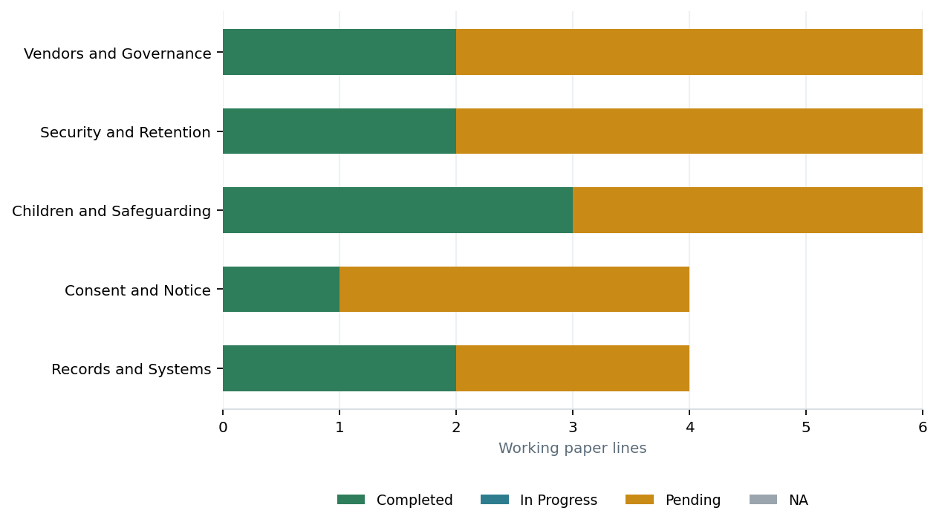

Records and Systems
Ref | Question | Status | Evidence to see
Q01 | Does a written list exist of every system that holds student, parent or staff personal data? |  | The register itself - ERP, LMS, fee gateway, transport GPS, biometric attendance, CCTV, exam portal, WhatsApp groups.
Q02 | For each system, is the purpose, the data categories and the owner recorded? |  | The completed columns of the register.
Q03 | Can the school produce, for a named student, the consent it relies on and show which purposes it covers? |  | One sample admission file, picked by the reviewer, not by the school.
Q04 | Have teaching and office staff been briefed on handling student data in the last twelve months? |  | Attendance sheet or circular with dates.

Consent and Notice
Ref | Question | Status | Evidence to see
Q05 | Does the admission form carry a distinct data protection consent clause, separate from the general terms? |  | The current admission form.
Q06 | Has every field on the admission and enquiry forms been tested against a stated purpose, with unjustified fields removed? |  | The field-by-field purpose mapping.
Q07 | Is there a working channel by which a parent can withdraw consent, and has it ever been used? |  | The channel, and the register of withdrawals.
Q08 | Is there a dated register of data-related requests and grievances with the response given? |  | The register.

Children and Safeguarding
Ref | Question | Status | Evidence to see
Q09 | Is parental consent taken against a verified parent identity, rather than from whoever filled in the form? |  | The verification step - identity document held, or the parent record already on file, matched at the time of consent.
Q10 | Has each processing activity been classified as academic, safety, or neither? |  | The classification list.
Q11 | Is a separate, revocable media consent taken before a student's photograph or name is published? |  | The media consent form and the do-not-publish list.
Q12 | Is the school satisfied that no advertising or profiling tool processes student data? |  | The tag list from the website and the ERP's integrations page.
Q13 | Is there a stated rule for CCTV footage - who may view it, who may export it, and when it is overwritten? |  | The CCTV policy and the DVR retention setting.
Q14 | Is a do-not-publish list maintained and checked before a photograph goes out? |  | The list, and whoever checks it.

Security and Retention
Ref | Question | Status | Evidence to see
Q15 | Is access to the student database restricted by named user accounts rather than a shared login? |  | The ERP user list.
Q16 | Are exports of student data - Excel downloads, mark sheets, address lists - controlled and logged? |  | The export log, or the absence of one.
Q17 | Are backups taken and has a restore been tested in the last year? |  | The backup schedule and the date of the last restore test.
Q18 | Is there a written procedure saying who declares a data breach and who must be told? |  | The procedure and the breach register.
Q19 | Is there a retention schedule fixing how long each class of record is kept, with the reason? |  | The schedule.
Q20 | Has anything actually been deleted under that schedule in the last year? |  | The deletion log.

Vendors and Governance
Ref | Question | Status | Evidence to see
Q21 | Does every vendor holding student data have a signed contract with data protection terms? |  | The contracts, listed against the system register.
Q22 | Is it known, for each vendor, where the student data is hosted? |  | The vendor's written answer.
Q23 | Has a person been named to answer data protection questions, with a published address that is monitored? |  | The published address and evidence that mail to it is read.
Q24 | Does the management committee receive a periodic report on data protection? |  | Minutes referring to it.
Q25 | When a vendor contract ends, is deletion of the school's data confirmed in writing? |  | The last exit confirmation, if any.
Q26 | Are the ERP's integrations known - SMS gateway, payment gateway, biometric device, transport GPS? |  | The integrations or API settings page of the ERP.

5. Chatbots and the AI layer
The AI layer was not requested for this run.
Every rating in this report is therefore reproducible: the same website and the same working paper will always produce the same score.

Appendix A — Scan evidence
Pages fetched | 4
robots.txt | robots.txt read
Policy pages read | 0
Policy source | none found
Site served over HTTPS | No
Third-party hosts | 2
Trackers detected | 3
Trackers engaging s.9(3) | 2
Contact addresses found | office@sunrise.example
Scanner version | 2.0.0

Trackers
Host | Category | Found on
www.googletagmanager.com | tag manager | http://127.0.0.1:8931/
connect.facebook.net | advertising pixel | http://127.0.0.1:8931/
connect.facebook.net | social / advertising | http://127.0.0.1:8931/gallery.html

