**Heaven’s Light is Our Guide**



**Rajshahi University of Engineering and Technology**

**Department of Computer Science and Engineering**

**Course No:** CSE.3110

**Course Title:** Sessional based on CSE.3109(Microprocessors & Assembly Language)

**Assignment No:** 01

**Submitted By** **Submitted To**

Md. Ariful Islam Tasmia Jannat

Roll No: 1803046 Lecturer

Section: A Dept. of CSE,RUET

Department: CSE

**Date:** 23/06/2022

**Problem:**  Write a code that will take an input from the user and print the ASCII code of the input in hexadecimal form.

**Code:**

|  |
| --- |
| Title: HEXA CODE OF INPUT  .MODEL SMALL  .STACK 100H  .DATA  MSG1 DB 'ENTER A KEY: $'  MSG2 DB 'THE HEXA OF THE ASCII VALUE OF THE INPUT IS: $'    .CODE  MAIN PROC  MOV AX,@DATA  MOV DS,AX    ;Print MSG1  LEA DX,MSG1  MOV AH,9  INT 21H    ;Character Input  MOV AH,1  INT 21H  MOV BL,AL    ;Line-Break  MOV AH,2  MOV DL,0DH  INT 21H  MOV DL,0AH  INT 21H    ;Print MSG2  LEA DX,MSG2  MOV AH,9  INT 21H    ;Keep copy of BL in BH  MOV BH,BL    ;Right-Shift BL 4 times  SHR BL,4  MOV DL,BL    ;Compare if DL & 9  CMP DL,9  ;Jump to CHAR part if Greater than 9  JG CHAR1  ;Add 30H for 0-9  ADD DL,30H  JMP PRINT1    CHAR1:  ;Add 31H for A-F  ADD DL,31H    PRINT1:  ;Print First Value  MOV AH,2  INT 21H    ;Get the Copyed value of Input  MOV BL,BH  ;AND '00001111' for last 4 bits  AND BL,0Fh    MOV DL,BL  ;Compare if DL & 9  CMP DL,9  ;Jump to CHAR part if Greater than 9  JG CHAR2  ;Add 30H for 0-9  ADD DL,30H  JMP PRINT2    CHAR2:  ;Add 31H for A-F  ADD DL,31H    PRINT2:  ;Print Second Value  MOV AH,2  INT 21H      MOV AH,4CH  INT 21H    MAIN ENDP  END MAIN |

**Output:**

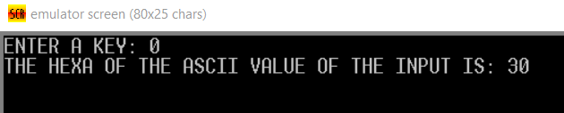

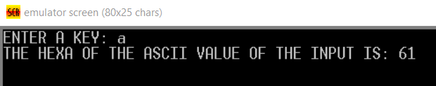

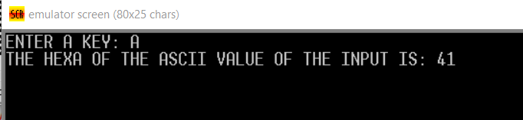

**# END #**