Experiment No.1
Aim: To install Ubuntu on machines to understand the popular virtualization software.

Download any popular virtualization software for this experiment we will stick to VMware Workstation or VMware player that allows you to run multiple instances of different operating systems simultaneously. Below are the steps to install Ubuntu on VMware:
- Download the Ubuntu ISO File: Go to the official Ubuntu website (https://ubuntu.com/download) and download the ISO file for the version of Ubuntu you wish to install.
- Create a New Virtual Machine: Click on "Create a New Virtual Machine" or "File" > "New Virtual Machine" from the menu. Choose the "Typical (recommended)" option and click "Next".
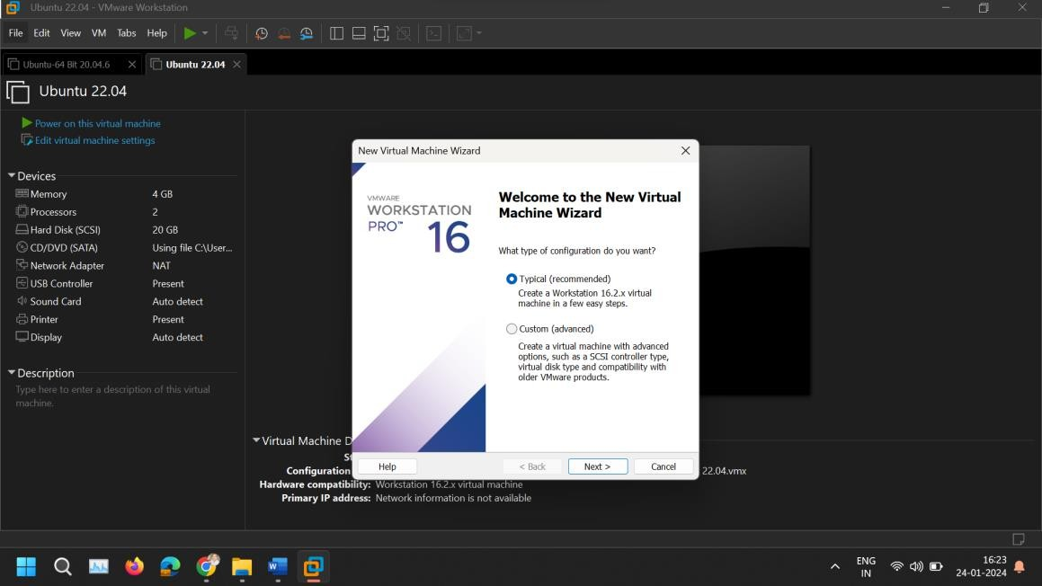
- Select the Installation Media: Select "Installer disc image file (iso)" and browse to the location where you saved the Ubuntu ISO file. Select the file and click "Next".
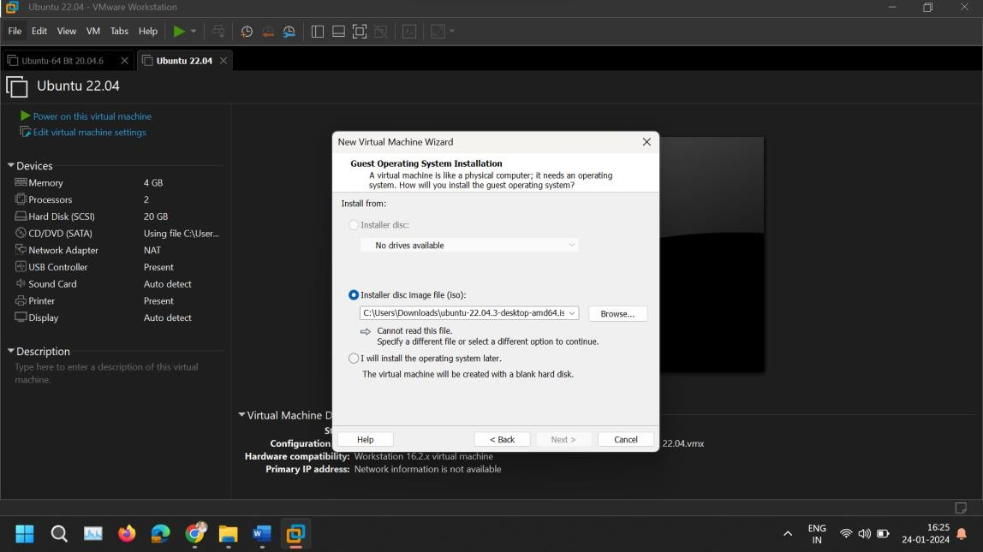

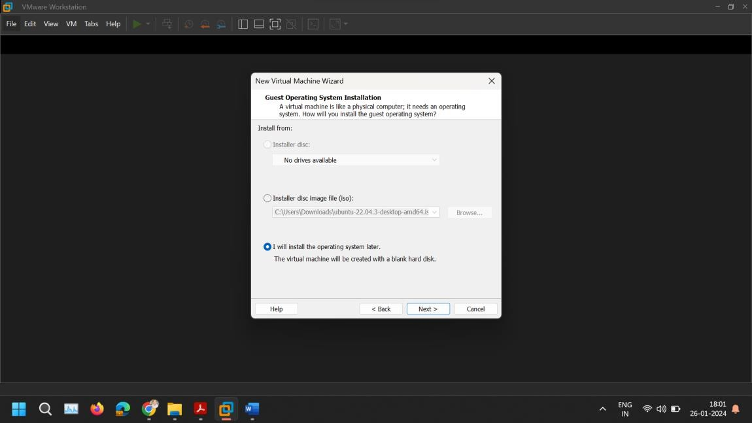
Select I will install the operating system later.

- Choose a Guest Operating System: Select "Linux" as the Guest Operating System and choose "Ubuntu" from the version dropdown. VMware is quite good at detecting the version from the ISO, but ensure the correct version is selected. Click "Next".
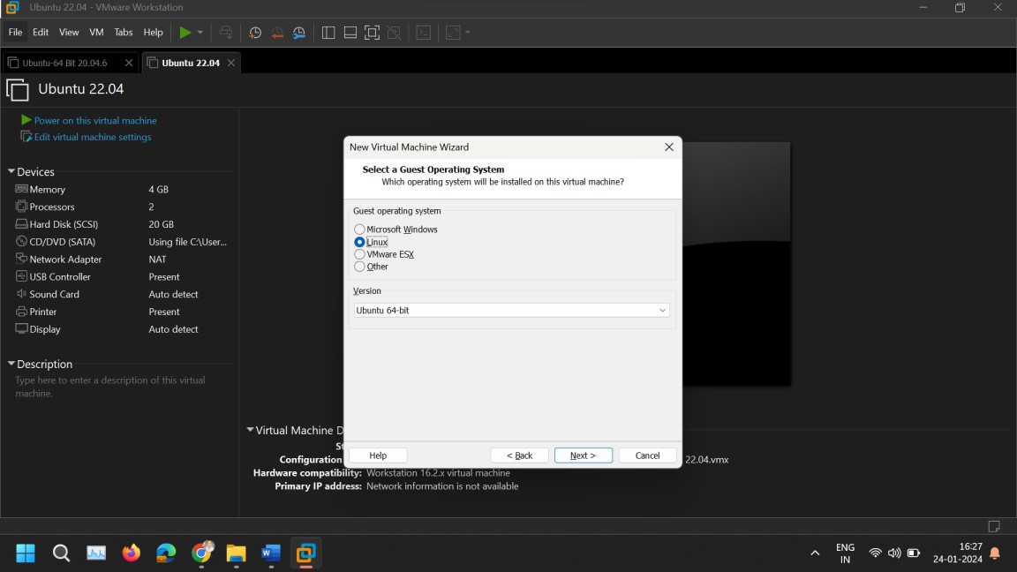
- Name Your Virtual Machine: Enter a name for your virtual machine and choose where you want to store the VM files. Click "Next".

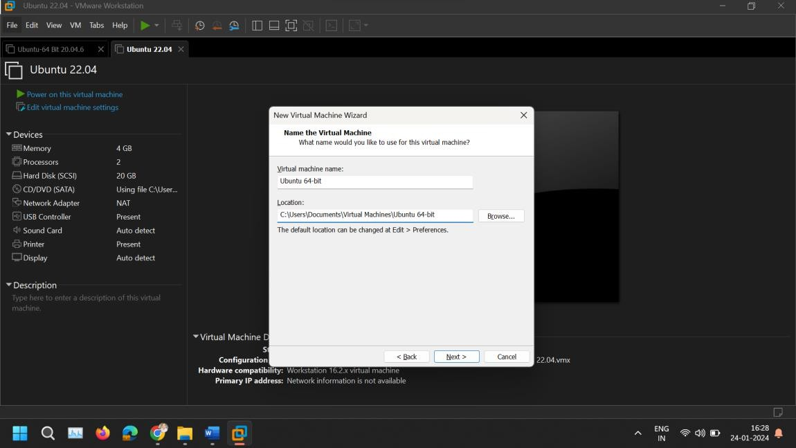
- Specify Disk Capacity Specify the amount of disk space to allocate to the Ubuntu installation. 20GB is usually the minimum recommended, but you may allocate more if you plan on using the VM for applications that require more space. Select "Store virtual disk as a single file" for better performance. Click "Next".
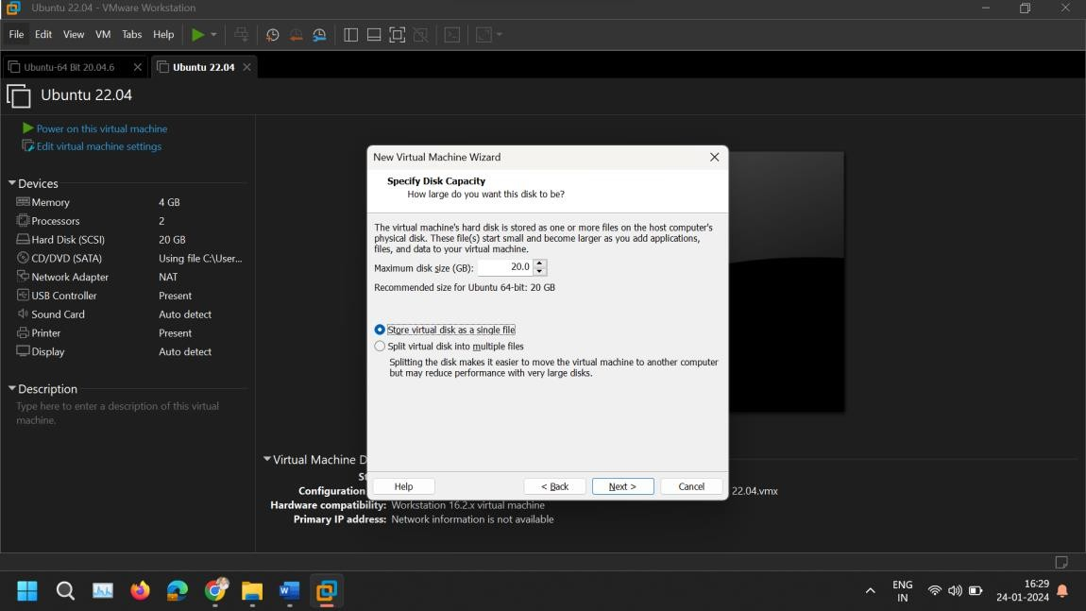
- Customize Hardware (Optional): Before finishing, you have the option to customize the hardware specifications of your virtual machine, like the amount of memory and the number of CPU cores. Adjust these based on your host system's resources and your needs. Click "Close" once done, and then click "Finish".

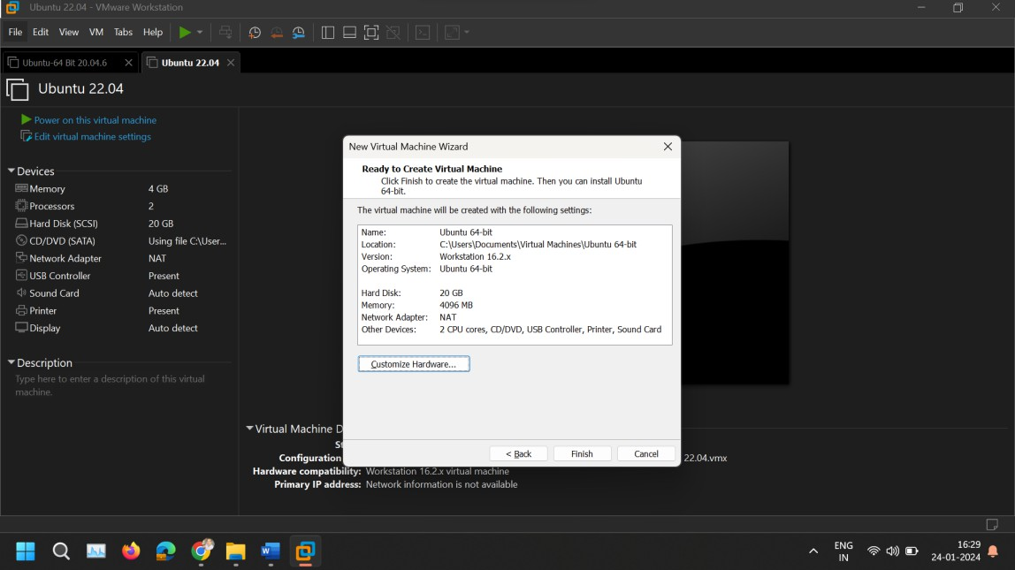
- Auto Detect SATA Drive: On Customize Hardware, go to New CD/DVD (SATA) tab and browse for ISO Image.
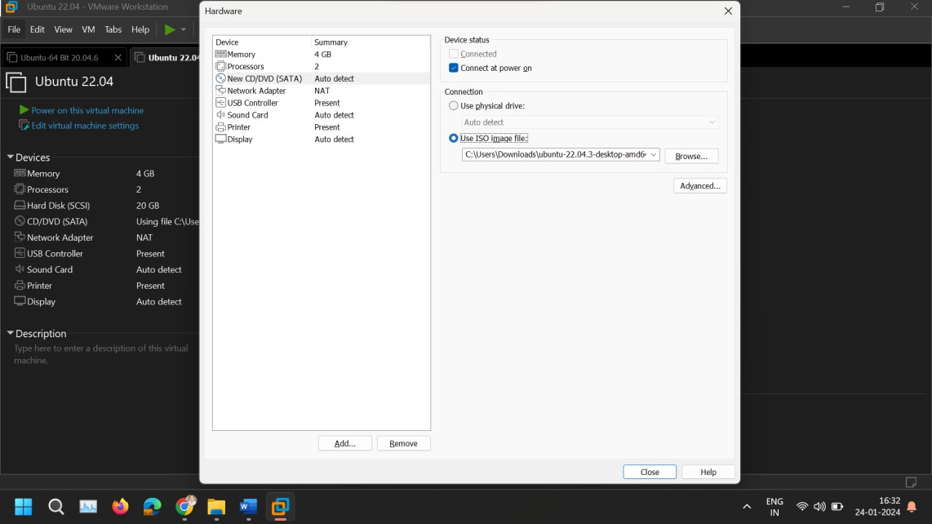
- Start the Virtual Machine: With the virtual machine created, click on the "Power on this virtual machine" option. The Ubuntu installer should start, guiding you through the process of installing Ubuntu.
- Install Ubuntu: Follow the on-screen instructions to complete the Ubuntu installation. You'll need to choose your language, location, keyboard layout, and create a user account. The installation process may take some time.
- Update the Ubuntu Software: Open Terminal and paste following command.
sudo apt-get update
sudo apt-get upgrade

- Install VMware Tools (Optional but Recommended): Once Ubuntu is installed, it's a good idea to install VMware Tools, which improves the integration and performance of the virtual machine. Open Terminal and paste following command.
sudo apt-get install open-vm-tools-desktop -y
- Restart the Virtual Machine: After the installation is complete and VMware Tools are installed, restart the virtual machine. You should now have a fully functional Ubuntu system running in VMware.

