

Vidyavardhini’s
College of Engineering & Technology
Vasai Road (W)

Department of Information Technology

Lab Manual Student Copy

Semester | VIII | Class | BE
Course Code | ITL801 | Academic Year | 2023-24
Course Name | Blockchain Lab
Name of Faculty | Ms. Vaishali Shirsath
Suppoting Staff | Mr. Nitin Shingane

1
Prepared by Mrs.Vaishali A. Shirsath


Vidyavardhini’s College of Engineering & Technology

Vision
To be a premier institution of technical education, aiming at becoming a valuable resource for industry and society.

Mission
- To provide technologically inspiring environment for learning.
- To promote creativity, innovation and professional activities.
- To inculcate ethical and moral values.
- To cater personal, professional and societal needs through quality education.

Department Vision:
To foster and maintain excellence by orienting the captivating minds of the aspiring engineers towards IT- driven technological solutions for the benefits of the society.

Department Mission:
- To provide quality education, by employing best and diversified teaching practices and tools, and teaching beyond the confines of the university syllabus.
- To keep students abreast with latest technological advancements in the market.
- To prepare students to troubleshoot and solve IT system problems.

Program Education Objectives (PEOs):
- To produce skilled IT Professional to cater social/industrial needs.
- To inculcate an ability to implement modern practices with ethical and professional responsibilities.
- To establish graduate as Business Analyst, System Analyst, Data Scientist, Project Leader.

Program Specific Outcomes (PSOs):
The graduates will be able to
  - Apply and implement IT solutions in allied fields of engineering to solve real word problems.
  - Identify social and industrial problems, provide creative solutions and become quality asset for society and industry.
  - Deploy secured solution using Information Technology practices and strategies.

Program Outcomes (POs):
Engineering Graduates will be able to:
- PO1. Engineering knowledge: Apply the knowledge of mathematics, science, engineering fundamentals, and an engineering specialization to the solution of complex engineering problems.
- PO2. Problem analysis: Identify, formulate, review research literature, and analyze complex engineering problems reaching substantiated conclusions using first principles of mathematics, natural sciences, and engineering sciences.
- PO3. Design/development of solutions: Design solutions for complex engineering problems and design system components or processes that meet the specified needs with appropriate consideration for the public health and safety, and the cultural, societal, and environmental considerations.
- PO4. Conduct investigations of complex problems: Use research-based knowledge and research methods including design of experiments, analysis and interpretation of data, and synthesis of the information to provide valid conclusions.
- PO5. Modern tool usage: Create, select, and apply appropriate techniques, resources, and modern engineering and IT tools including prediction and modeling to complex engineering activities with an understanding of the limitations.
- PO6. The engineer and society: Apply reasoning informed by the contextual knowledge to assess societal, health, safety, legal and cultural issues and the consequent responsibilities relevant to the professional engineering practice.
- PO7. Environment and sustainability: Understand the impact of the professional engineering solutions in societal and environmental contexts, and demonstrate the knowledge of, and need for sustainable development.
- PO8. Ethics: Apply ethical principles and commit to professional ethics and responsibilities and norms of the engineering practice.
- PO9. Individual and teamwork: Function effectively as an individual, and as a member or leader in diverse teams, and in multidisciplinary settings.
- PO10. Communication: Communicate effectively on complex engineering activities with the engineering community and with society at large, such as, being able to comprehend and write effective reports and design documentation, make effective presentations, and give and receive clear instructions.
- PO11. Project management and finance: Demonstrate knowledge and understanding of the engineering and management principles and apply these to one’s own work, as a member and leader in a team, to manage projects and in multidisciplinary environments.
- PO12. Life-long learning: Recognize the need for and have the preparation and ability to engage in independent and life-long learning in the broadest context of technological change.

Course Objectives

Sr. no | The Lab experiments Aims:
1 | To get acquainted with the concept of Distributed ledger system and Blockchain.
2 | To learn the concepts of consensus and mining in Blockchain through the Bitcoin  network.
3 | To understand Ethereum and develop-deploy smart contracts using different tools  and frameworks.
4 | To understand permissioned Blockchain and explore Hyperledger Fabric.
5 | To understand different types of crypto assets.
6 | To apply Blockchain for different domains IOT, AI and Cyber Security.

Course Outcomes

Sr.no | On successful completion, of course, learner/student will be able to: | Cognitive levels of attainment as per Bloom’s Taxonomy
1 | Describe the basic concept of Blockchain and Distributed Ledger  Technology. | L6
2 | Interpret the knowledge of the Bitcoin network, nodes, keys, wallets  and transactions. | L6
3 | Implement smart contracts in Ethereum using different development frameworks. | L3
4 | Develop applications in permissioned Hyperledger Fabric network | L3
5 | Interpret different Crypto assets and Crypto currencies. | L3
6 | Analyze the use of Blockchain with AI, IoT and Cyber Security using case studies. | L3

Mapping of Experiments with Course Outcomes

Experiment | Course Outcomes
Experiment | ETL  801.1 | ETL  801.2 | ETL  801.3 | ETL  801.4 | ETL  801.5 | ETL  801.6
To install Ubuntu on machines to understand the popular virtualization software. | 3
To install Geth on machines to understand the basics of blockchain technology. |  | 3
To install Truffle, a popular development framework for Ethereum blockchain. |  |  | 3
To demonstrate the basics of Ethereum smart contract development, deployment, and interaction using a simple "Hello World"  example |  |  | 3
To Run a simple smart contract like HelloWorld in Remix IDE |  |  |  | 3
To implement a basic voting mechanism within a smart contract, allowing users to vote for predefined candidates. |  |  |  | 3
To create a simple auction contract where users can place bids and the highest bidder wins at the auction's conclusion. |  |  |  | 3
To develop a fungible token using the ERC-20 standard, familiarizing with token creation and manipulation on the Ethereum blockchain. |  |  |  | 3
To implement access control mechanisms within a smart contract to restrict function execution to authorized addresses. |  |  |  |  | 3
Mini Project | 3 | 3 | 3 | 3 | 3 | 3

Experiment No.1
Aim: To install Ubuntu on machines to understand the popular virtualization software.

Download any popular virtualization software for this experiment we will stick to VMware Workstation or VMware player that allows you to run multiple instances of different operating systems simultaneously. Below are the steps to install Ubuntu on VMware:
- Download the Ubuntu ISO File: Go to the official Ubuntu website (https://ubuntu.com/download) and download the ISO file for the version of Ubuntu you wish to install.
- Create a New Virtual Machine: Click on "Create a New Virtual Machine" or "File" > "New Virtual Machine" from the menu. Choose the "Typical (recommended)" option and click "Next".
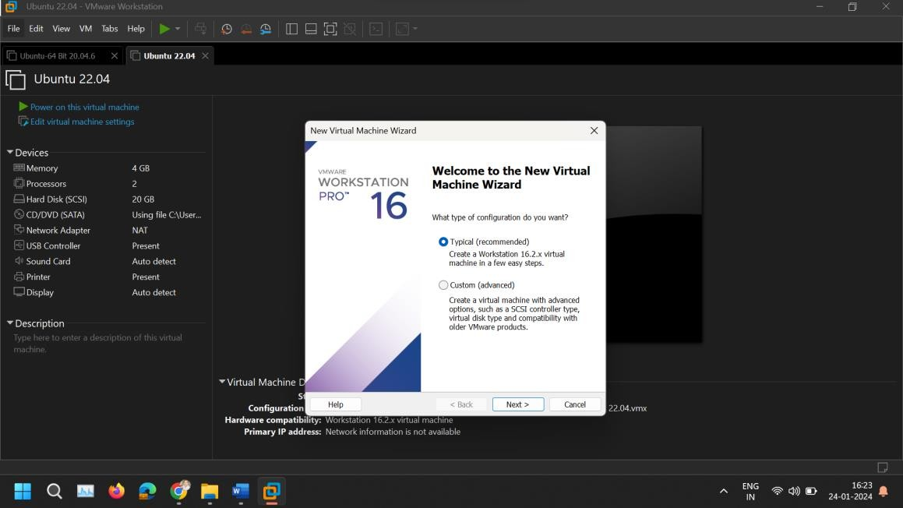
- Select the Installation Media: Select "Installer disc image file (iso)" and browse to the location where you saved the Ubuntu ISO file. Select the file and click "Next".
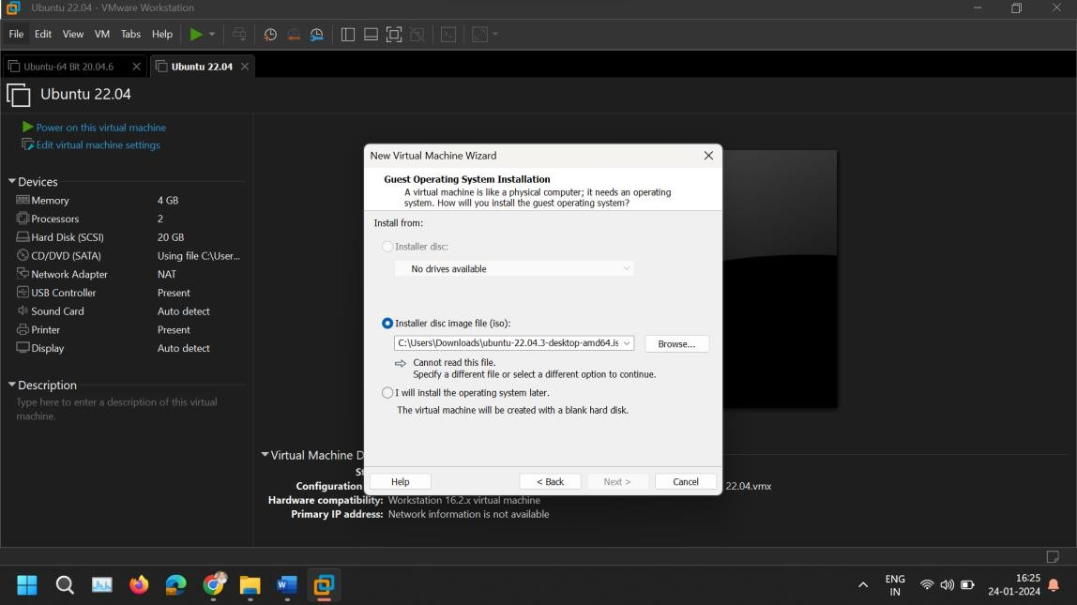

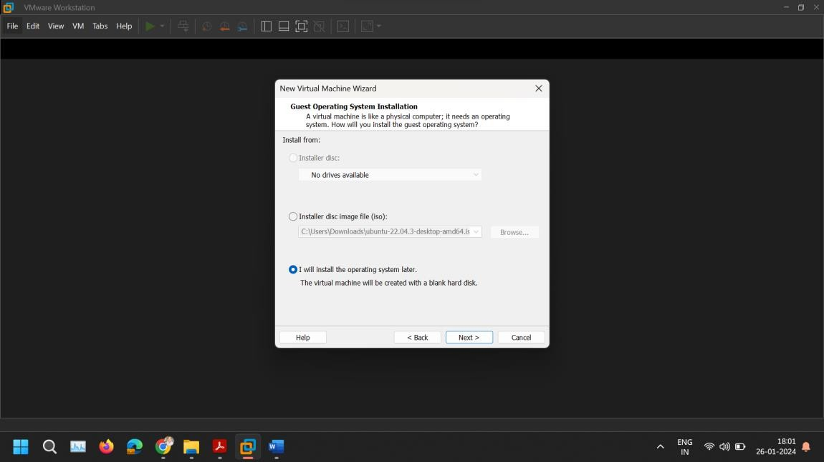
Select I will install the operating system later.

- Choose a Guest Operating System: Select "Linux" as the Guest Operating System and choose "Ubuntu" from the version dropdown. VMware is quite good at detecting the version from the ISO, but ensure the correct version is selected. Click "Next".
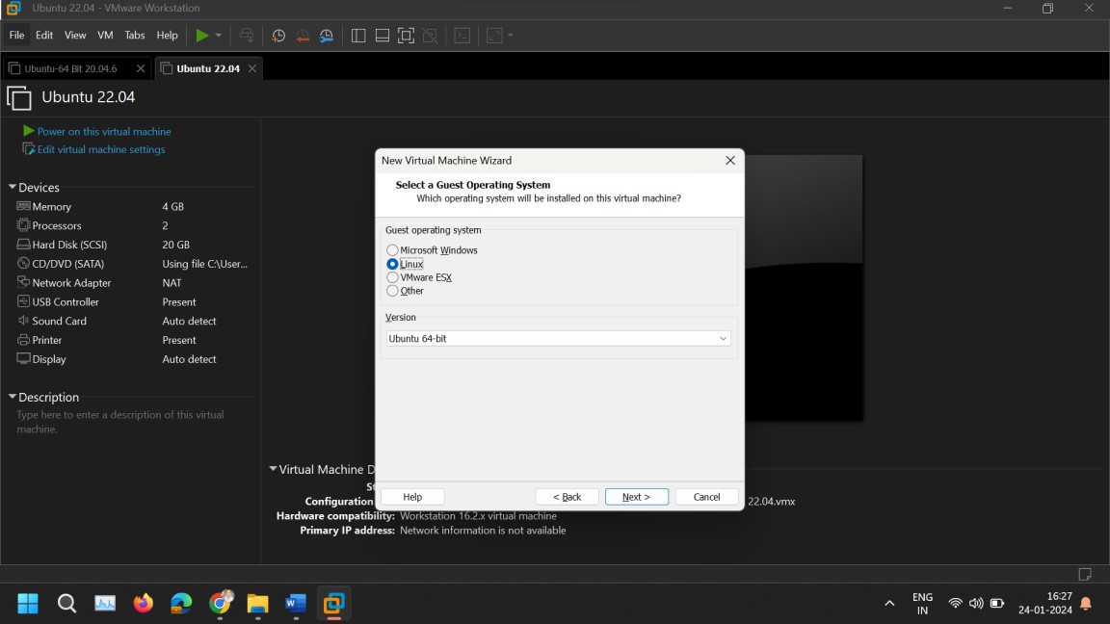
- Name Your Virtual Machine: Enter a name for your virtual machine and choose where you want to store the VM files. Click "Next".

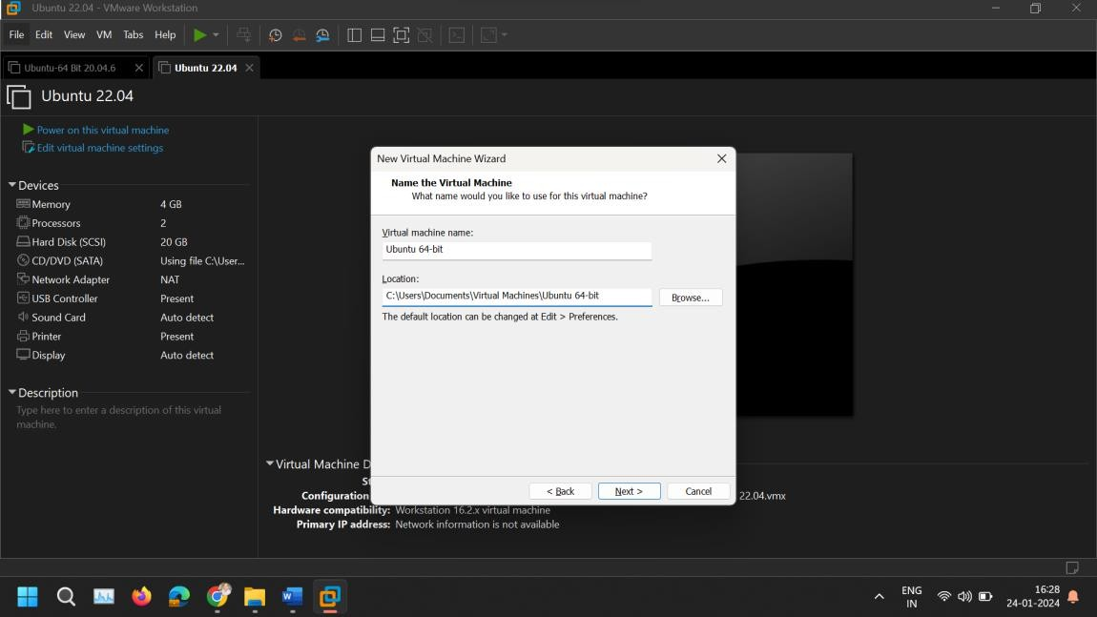
- Specify Disk Capacity Specify the amount of disk space to allocate to the Ubuntu installation. 20GB is usually the minimum recommended, but you may allocate more if you plan on using the VM for applications that require more space. Select "Store virtual disk as a single file" for better performance. Click "Next".
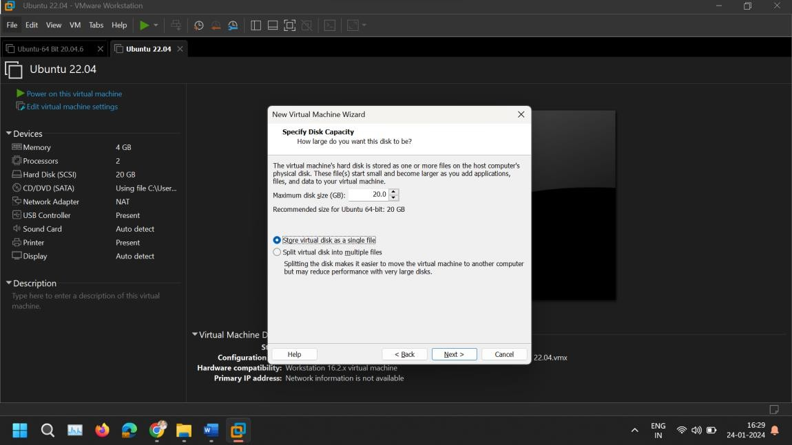
- Customize Hardware (Optional): Before finishing, you have the option to customize the hardware specifications of your virtual machine, like the amount of memory and the number of CPU cores. Adjust these based on your host system's resources and your needs. Click "Close" once done, and then click "Finish".

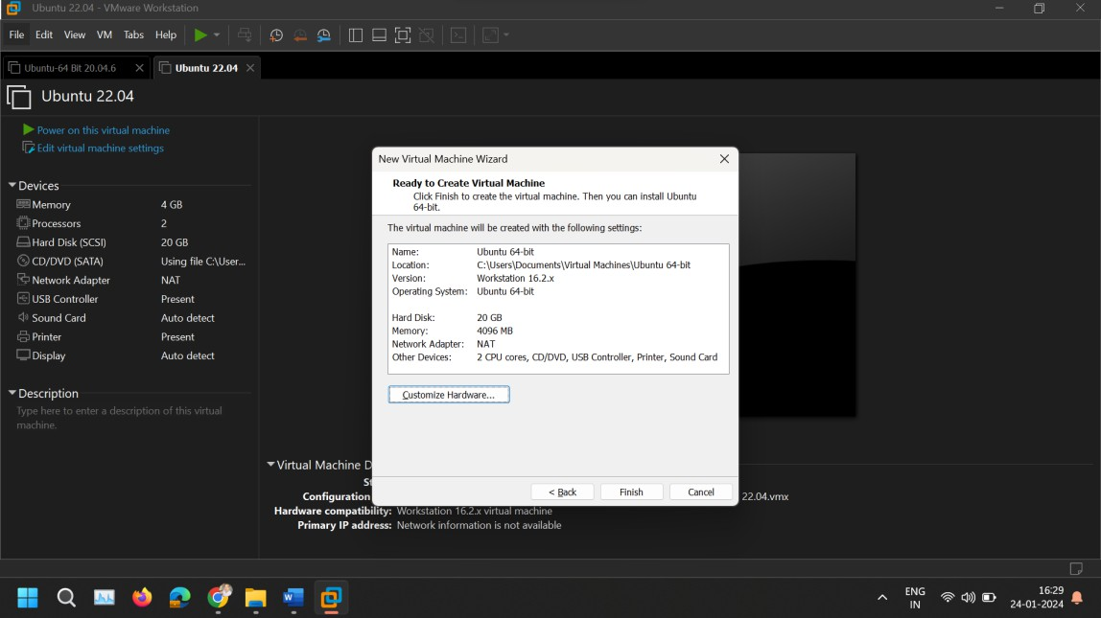
- Auto Detect SATA Drive: On Customize Hardware, go to New CD/DVD (SATA) tab and browse for ISO Image.
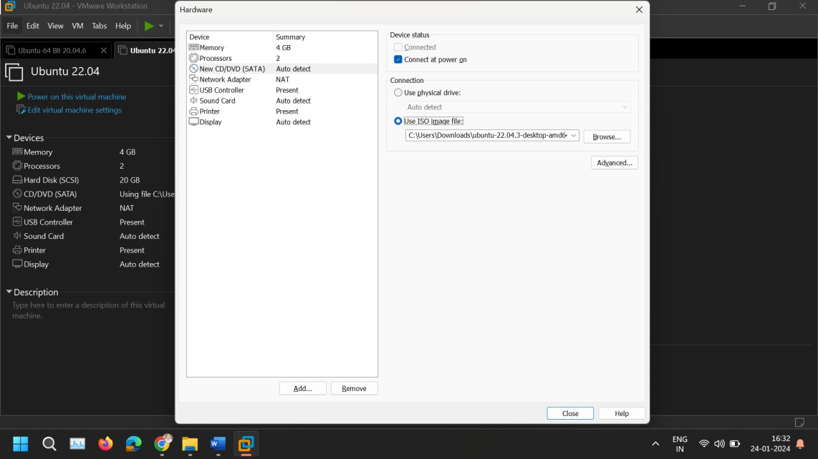
- Start the Virtual Machine: With the virtual machine created, click on the "Power on this virtual machine" option. The Ubuntu installer should start, guiding you through the process of installing Ubuntu.
- Install Ubuntu: Follow the on-screen instructions to complete the Ubuntu installation. You'll need to choose your language, location, keyboard layout, and create a user account. The installation process may take some time.
- Update the Ubuntu Software: Open Terminal and paste following command.
sudo apt-get update
sudo apt-get upgrade

- Install VMware Tools (Optional but Recommended): Once Ubuntu is installed, it's a good idea to install VMware Tools, which improves the integration and performance of the virtual machine. Open Terminal and paste following command.
sudo apt-get install open-vm-tools-desktop -y
- Restart the Virtual Machine: After the installation is complete and VMware Tools are installed, restart the virtual machine. You should now have a fully functional Ubuntu system running in VMware.

Experiment No.2
Aim: To install Geth on machines to understand the basics of blockchain technology.

Geth is an official command-line interface (CLI) tool that is used to run an Ethereum node with the Go programming language it’s a short form of "Go Ethereum". It serves as a client for the Ethereum blockchain and is one of the three original implementations (along with C++ and Python) of the Ethereum protocol. Being an essential part of the Ethereum network, Geth allows users to mine Ether, transfer funds between addresses, create smart contracts, and explore block history.

Steps:
- Open a Terminal Window: First, open a terminal window on your Ubuntu system. You can do this by searching for "Terminal" in your applications menu or by pressing Ctrl + Alt + T on your keyboard.
- Add the Ethereum PPA (Personal Package Archive): Ethereum provides a PPA to make it easy to install Geth. You can add this PPA to your system with the following command.
sudo add-apt-repository -y ppa:ethereum/ethereum

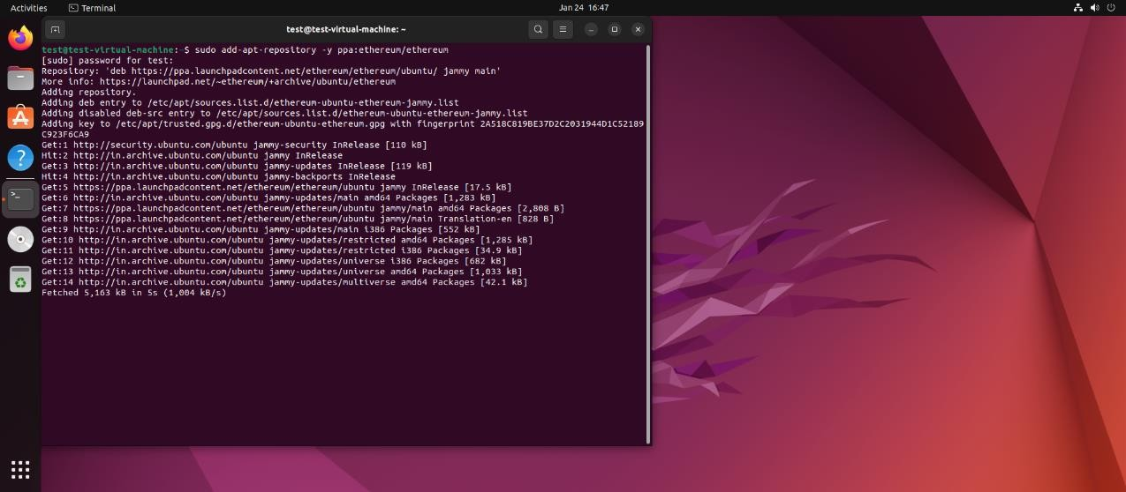
- Update the Package List: After adding the PPA, update your package list to ensure your system knows about the packages available in the newly added repository.
sudo apt-get update

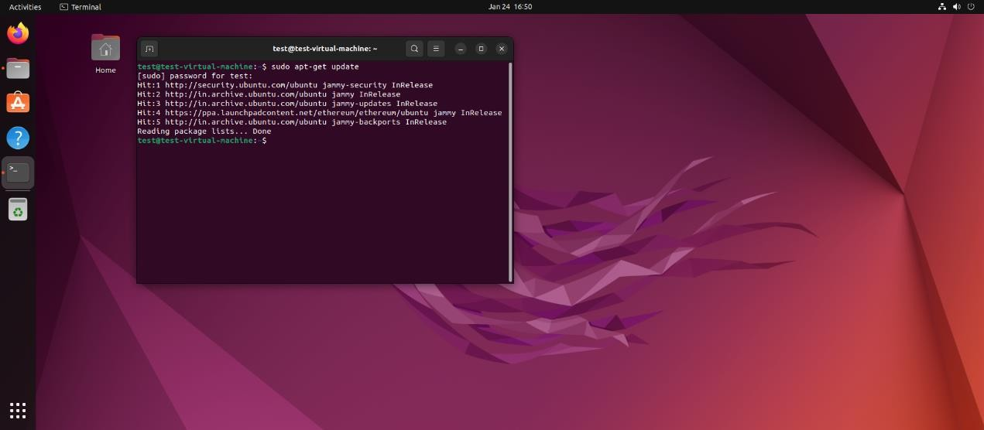
- Install Geth: Now, you can install Geth using the following command.
sudo apt-get install Ethereum
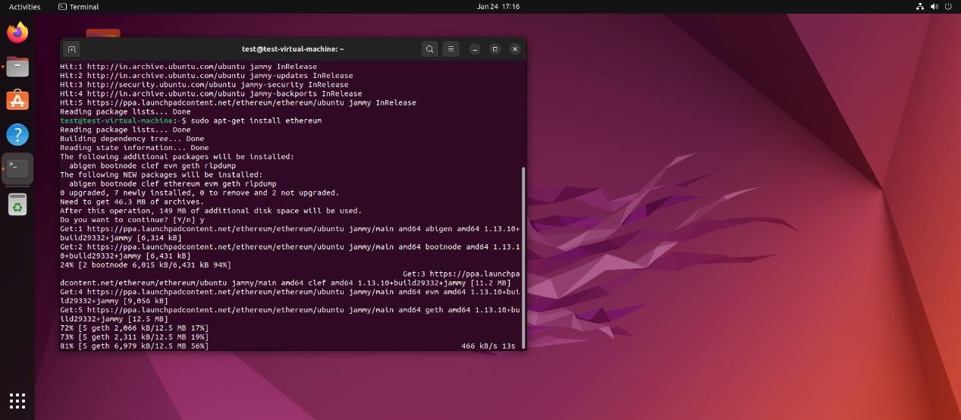
- Verify the Installation: Once the installation process is complete, you can verify that Geth has been installed correctly by checking its version with the following command.
geth version

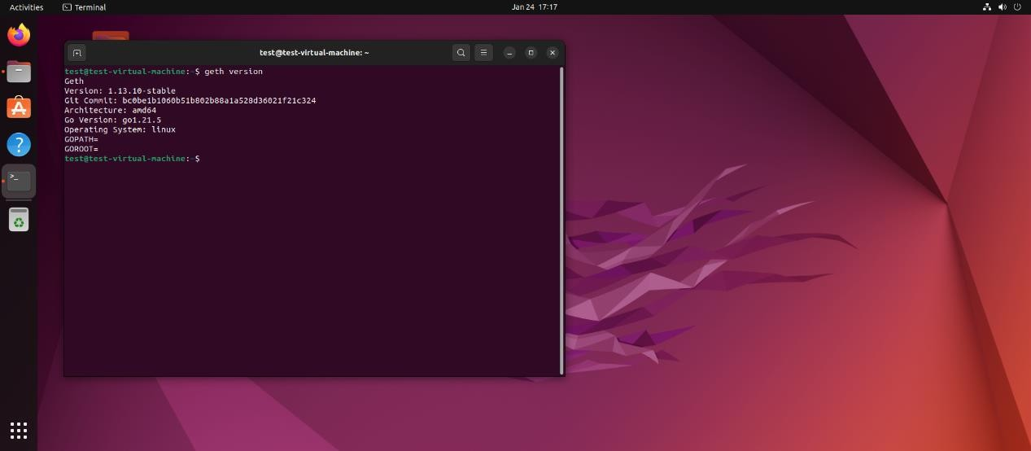
- Run Geth: To start running a Geth node that connects to the Ethereum network, you can simply run.

Geth
- Synchronization: Geth offers several synchronization modes. The default mode is "fast", but you can specify a different mode using the --syncmode flag. For example, to start Geth in light mode, which requires less disk space.
geth --syncmode "light"

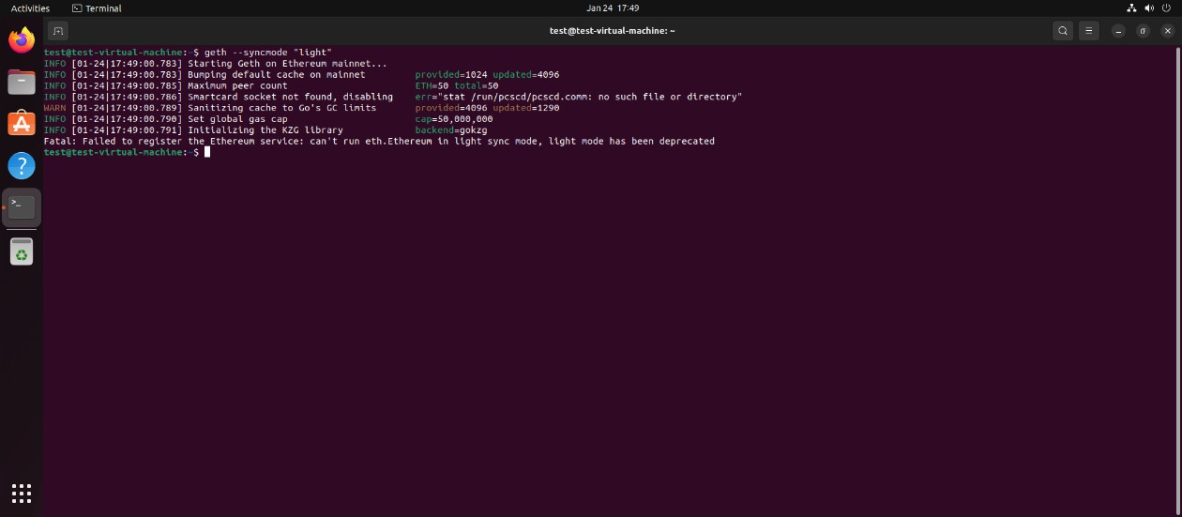
Testing Geth

Testnet Steps: 'Ropsten' is crucial testnet for developers, as it provides an environment that mimics/ simulates the Ethereum mainnet but uses free, valueless Ether for testing purposes. This allows developers to deploy and test their smart contracts and applications without risking real money.

Example Use:
- Start Geth in goerli Testnet Mode: To connect to the Ropsten testnet using goerli, you need to start Geth with specific flags that tell it to connect to goerli instead of the main Ethereum network. Use the following command:
geth --goerli --syncmode "full" --http --http.api "eth,net,web3,personal"
- Wait for Synchronization: After running the command, Geth will start synchronizing the Gerli blockchain. This process can take some time, depending on your internet connection and the chosen sync mode. Geth needs to download the entire blockchain to be fully operational.

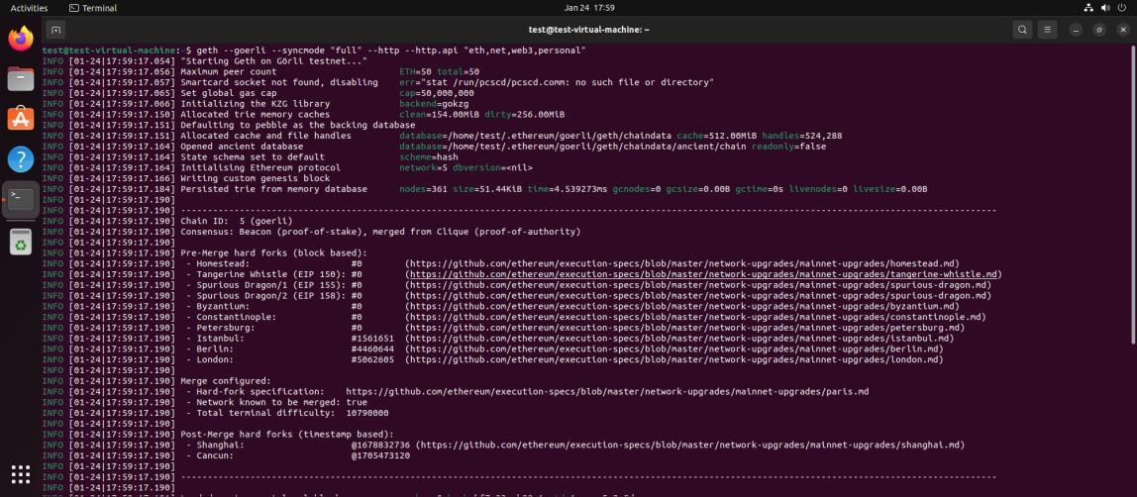
- Interact with Geth: Once the synchronization is complete, you can start interacting with Geth and the Ropsten testnet. You can use the Geth JavaScript console to directly interact with the network by opening another terminal window and running.
geth attach http://127.0.0.1:8545

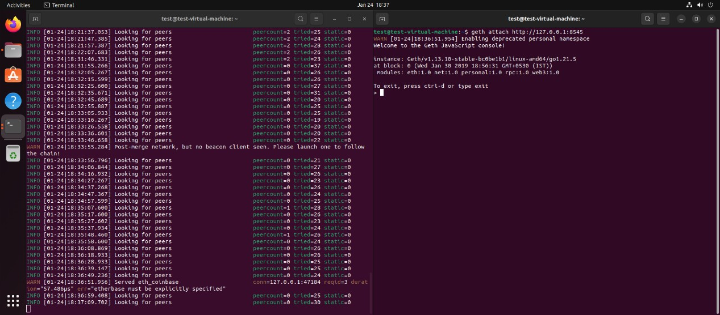
- Obtain Test Ether: To conduct transactions on the Ropsten testnet, you'll need test Ether. You can obtain it from a Ropsten faucet, which distributes free test Ether. Search for "Ropsten faucet" online and follow the instructions on the website to receive your test, Ether.
- Perform Transactions: With test Ether in your account, you can start deploying contracts, making transactions, or testing your applications without spending real Ether.

Experiment No.3
Aim: To install Truffle, a popular development framework forEthereum blockchain.

Truffle is a development framework and toolset for building decentralized applications (dapps) on the Ethereum blockchain. It provides developers with a suite of tools to write, compile, test, and deploy smart contracts efficiently using the Solidity programming language. Truffle also simplifies the integration of smart contracts with user interfaces using a front-end library called Drizzle. With Truffle, developers can create robust and secure dapps that leverage the power and transparency of blockchain technology.

Truffle Installation:

Installing Truffle, a development framework for Ethereum, allows you to compile, deploy, and test your smart contracts easily. It requires Node.js and npm (Node Package Manager) to be installed.

- Install Node.js and npm: Installed Node.js and npm, by executing the following commands in your terminal. These commands install Node.js and npm using the NodeSource repository, which often has more up-to-date versions than the official Ubuntu repositories.

Install Curl:
sudo apt update && sudo apt install curl
  - Download Node.js (This will install Node.js and npm): You can install the LTS (Long-Term Support) version of Node.js for stability. Node.js LTS version is 16.x, but you should check the current LTS version for Node.js.
curl -sL https://deb.nodesource.com/setup_16.x | sudo -E bash -

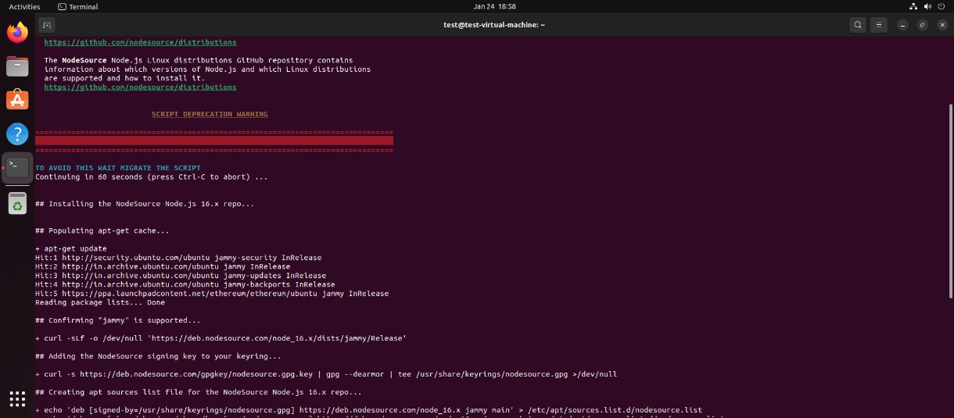
Install Node.js and npm:
sudo apt-get install -y nodejs

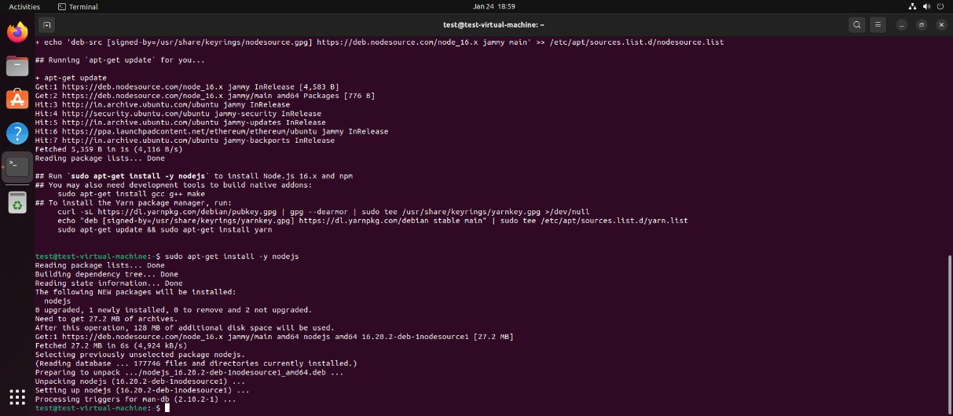
- Install Truffle: With Node.js and npm installed, you can now install Truffle using npm. Run the following command in your terminal:
sudo npm install -g truffle

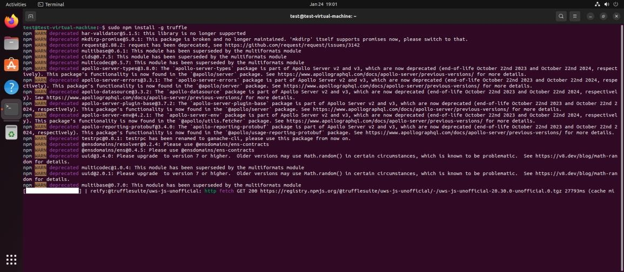
- Verify the Installation: After installation, you can verify that Truffle is installed correctly by checking its version:
truffle version

Experiment No.4
Aim: To demonstrate the basics of Ethereum smart contract development, deployment, and interaction using a simple "Hello World" example.
Once the Truffle is installed, you can start experimenting with it to develop, test, and deploy your smart contracts. Here's a simple experiment to get you started by creating a basic project:

Objective:
  - Learn how to write a basic smart contract in Solidity.
  - Understand the process of compiling and deploying a smart contract using Truffle.
  - Practice interacting with the smart contract through the Truffle console.

Steps:
- Create a New Directory for Your Project: Create a new directory for your Truffle project and navigate into it.
mkdir MyTruffleProject
cd MyTruffleProject

- Initialize a New Truffle Project: Initialize a new Truffle project within the directory.
truffle init
This command sets up a new Truffle project with the necessary configuration files and directories. You'll see folders like contracts/, migrations/, and test/, along with a truffle- config.js configuration file.
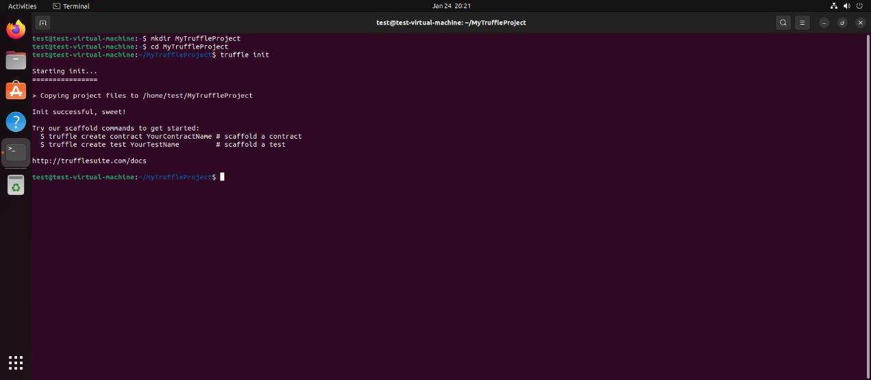

- Create a Simple Smart Contract: Create a new file within the contracts/ directory to hold your smart contract. You can use a simple contract like a HelloWorld contract. For example, create HelloWorld.sol.
// contracts/HelloWorld.sol pragma solidity ^0.8.0; contract HelloWorld {

function sayHello() public pure returns (string memory) { return "Hello, World!";
}
}

- Compile Your Smart Contract: Compile your smart contract using Truffle.
truffle compile
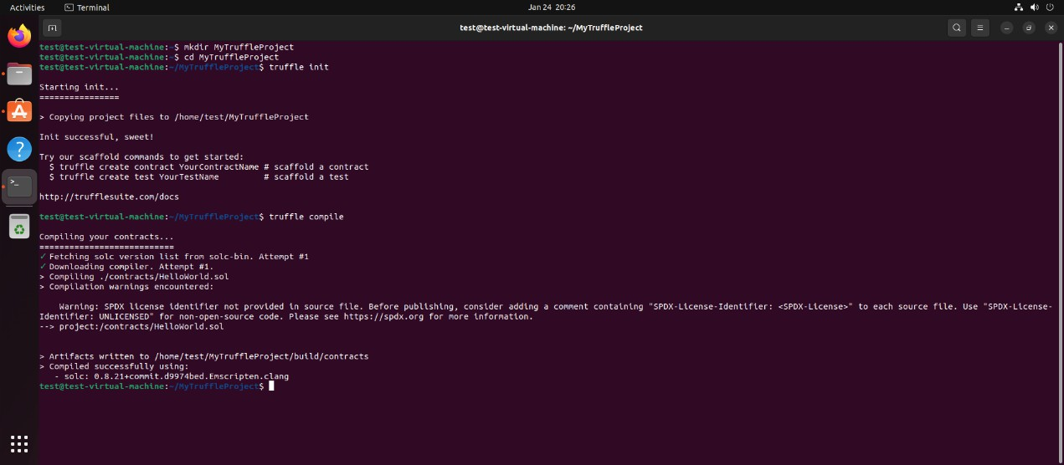

- Write a Migration Script: Migrations are JavaScript files that help you deploy contracts to the Ethereum network. Create a new file in the migrations/ directory to deploy your HelloWorld contract, for example, 2_deploy_contracts.js.
const HelloWorld = artifacts.require("HelloWorld"); module.exports = function (deployer) {
deployer.deploy(HelloWorld);
};
- Start a Local Ethereum Blockchain: Truffle Develop provides a built-in blockchain for development purposes.
truffle develop

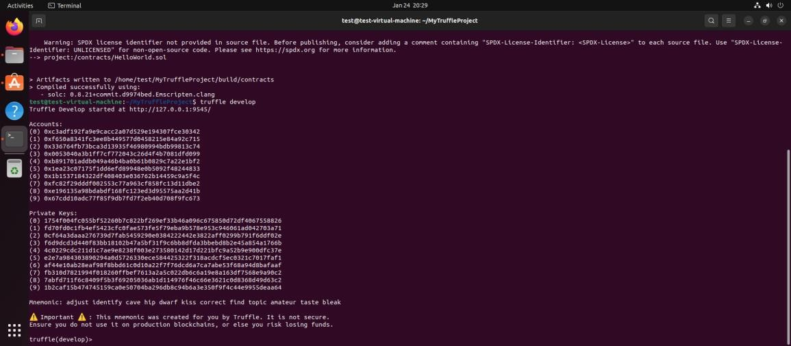

- Deploy Your Contract: Inside the Truffle Develop console, deploy your contract to the local blockchain.
Migrate

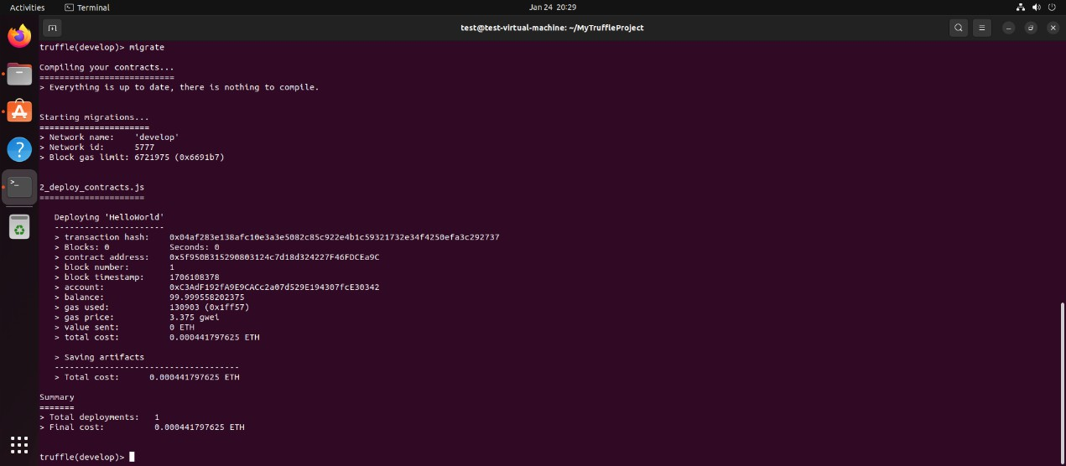
- Conclusion: This basic experiment introduces you to the process of developing with Truffle, including writing, compiling, deploying, and interacting with a smart contract. From here, you can explore more complex contracts, write tests in JavaScript or Solidity, and deploy to public testnets or the main Ethereum network.

Experiment No.5
Aim: To Run a simple smart contract like HelloWorld in Remix IDE. ( Online IDE)
There are several online Integrated Development Environments (IDEs) that can be used to develop, deploy, and test Ethereum smart contracts without the need to set up a local development environment. These online IDEs are useful for experimenting with smart contracts, learning Solidity (the programming language for Ethereum smart contracts), and testing functionalities in a sandbox environment.
- Remix (https://remix.ethereum.org): Remix is a powerful, open-source web and desktop application that is widely used for Ethereum smart contract development. It supports Solidity and Vyper and allows developers to write, compile, debug, and deploy smart contracts directly in the browser. Remix also provides plugins for various tasks, including static analysis, testing, and deployment on various networks, including testnets and the mainnet.
- Ethereum Studio (ttps://studio.ethereum.org): Ethereum Studio is a web-based IDE provided by the Ethereum Foundation. It offers a quick and easy way to get started with Ethereum development, providing templates for various projects, including smart contracts and decentralized applications (DApps). It's integrated with web3 environments and allows for immediate deployment and testing on the Ethereum test networks.
- EthFiddle (https://ethfiddle.com): EthFiddle is a simpler tool compared to Remix but serves as an efficient Solidity code sharing and testing platform. It allows for quick coding and compilation of smart contracts, and although it's more limited in features, it's great for sharing snippets and small contracts.

Running Simple Contract in Remix
Running a simple smart contract like HelloWorld in Remix IDE is a great way to quickly test and deploy smart contracts on the Ethereum network. Here are the steps to do so.
- Access Remix IDE: Open your web browser and go to Remix IDE. Remix is a powerful, open-source tool that helps you write Solidity contracts straight from the browser.

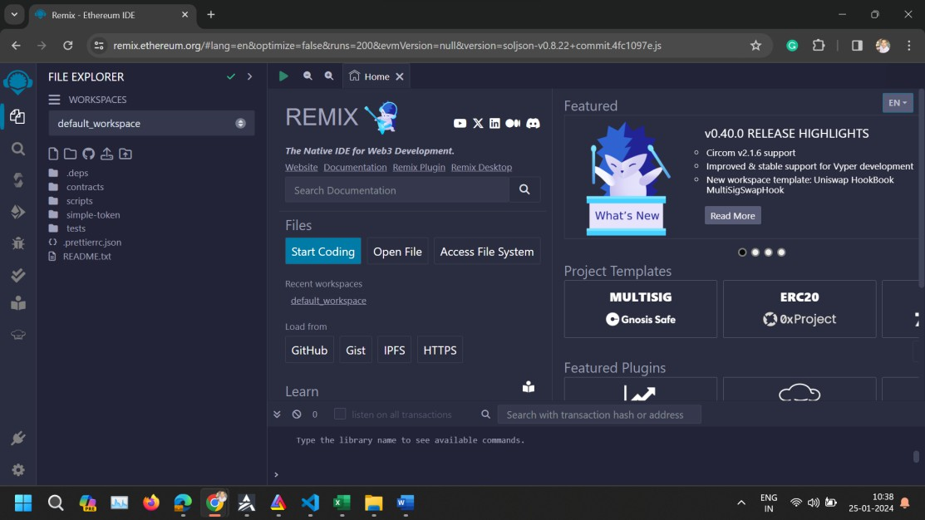
- Create the Contract File
  - Once in Remix, click on the "File Explorers" icon on the left sidebar.
  - Click the "Create New File" icon at the top of the File Explorers pane. Name your file HelloWorld.sol.
  - Copy and paste your smart contract code into the new file you've just created.
// SPDX-License-Identifier: MIT pragma solidity ^0.8.22; contract HelloWorld {
function sayHello() public pure returns (string memory) { return "Hello, World!";
}
}

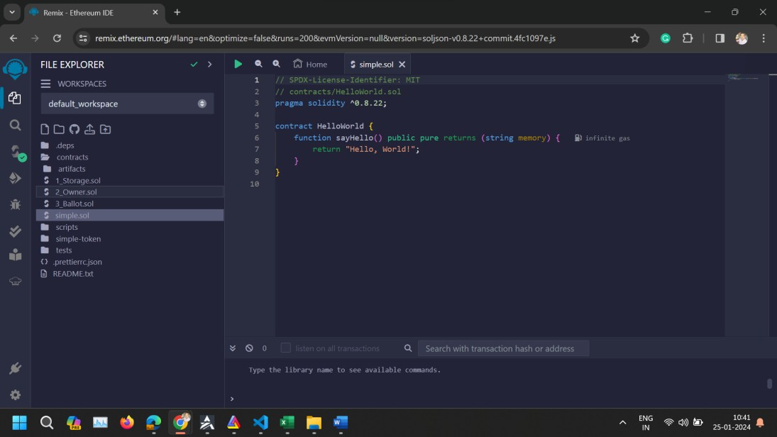

Compile the Contract:
  - Click on the "Solidity compiler" icon on the left sidebar.
  - Select the correct compiler version that matches the version specified in your contract (0.8.22 or newer) from the "Compiler" dropdown menu.
  - Click the "Compile HelloWorld.sol" button to compile your contract.
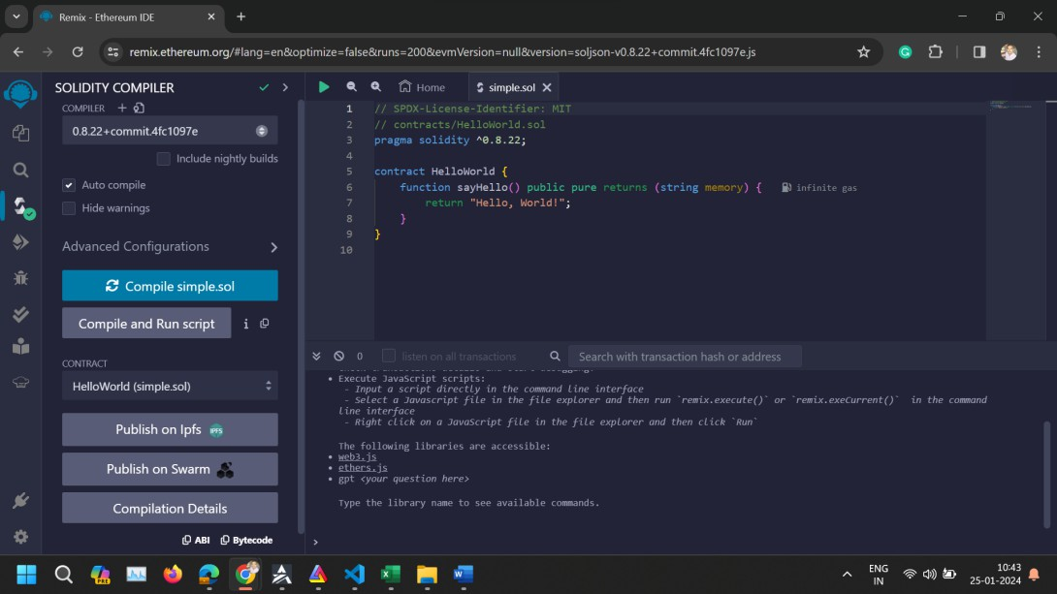

Deploy the Contract:
  - After compiling, click on the "Deploy & run transactions" icon on the left sidebar.
  - From the "Environment" dropdown, select an environment suitable for your needs. For testing purposes, "JavaScript VM" is a good choice as it simulates the Ethereum blockchain. For deployment to an actual network, you would select "Injected Web3" or "Web3 Provider" and connect to a wallet like MetaMask.
  - Under the "Contract" dropdown, make sure "HelloWorld" is selected.

  - Click the "Deploy" button. Your contract is now deployed to the selected environment, and you should see it under the "Deployed Contracts" section.
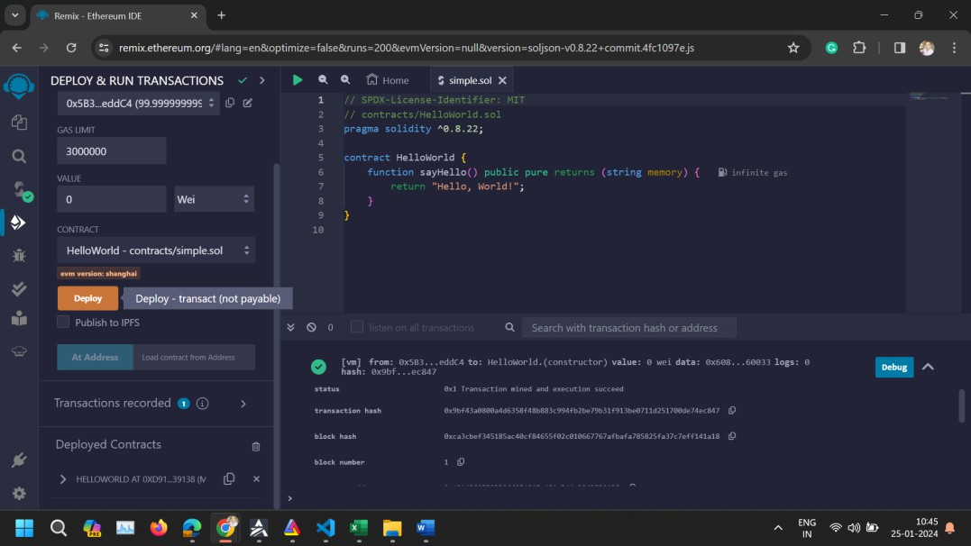

Interact with the Contract:
  - In the "Deployed Contracts" section, find your newly deployed HelloWorld contract. It should be expandable, revealing a button that represents your sayHello function.
Click the sayHello function button. This executes the function, and you should see the output "Hello, World!" in the Remix console.
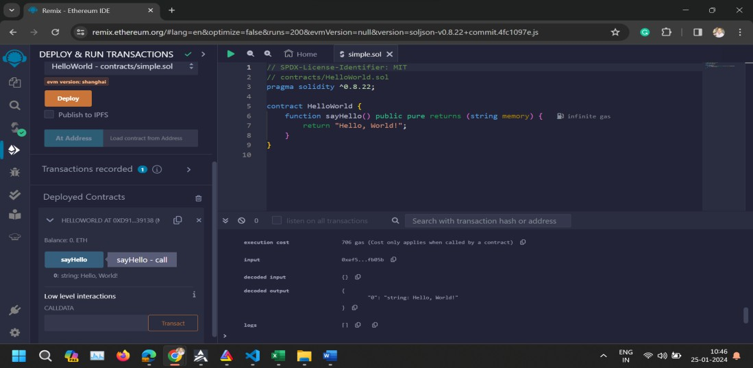

Experiment No.6
Aim: To implement a basic voting mechanism within a smart contract, allowing users to vote for predefined candidates. (Voting Contract)
- Objectives:
  - Introduce the concept of state variables and mappings in Solidity.
  - Demonstrate the use of functions to modify and retrieve the contract's state.
  - Highlight the importance of contract security and input validation.

Steps:
- Access Remix IDE: Navigate to Remix IDE using your web browser.

Create the Contract File:
  - In the "File Explorers" tab on the left sidebar, create a new file by clicking the "Create New File" icon. Name your file Voting.sol.
  - Paste the Voting contract code into Voting.sol:
// Specifies the license under which this contract is released, MIT in this case
// SPDX-License-Identifier: MIT

// Set the compiler version to be used for this contract pragma solidity ^0.8.22;

// Declares a new contract named Voting contract Voting {
// A mapping to keep track of each candidate's vote count, using their name (bytes32) as the key
mapping(bytes32 => uint256) public votesReceived;

// An array to store the list of candidates eligible for voting bytes32[] public candidateList;

// Constructor to initialize the contract with a list of candidate names
constructor(bytes32[] memory candidateNames) { candidateList = candidateNames;
}

// Function to record a vote for a candidate
function voteForCandidate(bytes32 candidate) public {
// Check if the candidate is valid before allowing a vote require(validCandidate(candidate), "Not a valid candidate");
// Increment the vote count for the specified candidate votesReceived[candidate] += 1;
}

// Function to retrieve the total votes a candidate has received function totalVotesFor(bytes32 candidate) view public returns
(uint256) {
// Ensure the candidate is valid before fetching the vote count require(validCandidate(candidate), "Not a valid candidate");
// Return the vote count for the specified candidate return votesReceived[candidate];
}

// Helper function to check if a candidate is in the list of valid candidates
function validCandidate(bytes32 candidate) view public returns (bool) {
// Iterate over the list of candidates
for(uint i = 0; i < candidateList.length; i++) {
// If the candidate matches one in the list, return true if (candidateList[i] == candidate) {
return true;
}
}
// If no match is found, return false return false;
}
}

Compile the Contract:
  - Click on the "Solidity compiler" tab on the left sidebar.
  - Ensure the compiler version matches the version specified in your contract (^0.8.22). Remix usually auto-detects the correct version. If not, select it manually from the "Compiler" dropdown.
  - Click "Compile Voting.sol" to compile your contract.

Deploy the Contract:
  - Switch to the "Deploy & run transactions" tab.
  - Select an environment. "JavaScript VM" is suitable for testing; it simulates an Ethereum blockchain environment within Remix.
  - Before deploying, you need to provide candidate names as an array. Since Solidity expects bytes32[] for candidate names, you must format the input accordingly. For example, to input candidates "Alice" and "Bob", you would use:
["0x416c6963650000000000000000000000000000000000000000000000000 00000","0x426f6200000000000000000000000000000000000000000000000
00000000000"]

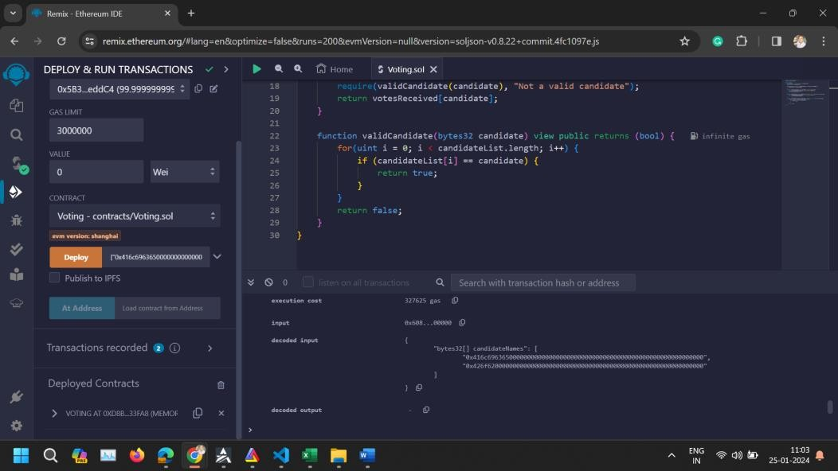
  - These are hexadecimal representations of "Alice" and "Bob" in bytes32 format. You can use online tools to convert strings to bytes32 hex format.
  - Paste the bytes32 array into the "Deploy" field that appears after selecting the "Voting" contract.
  - Click "Deploy". Your contract is now deployed, and you'll see it under "Deployed Contracts".

Interact with the Contract:
  - To vote for a candidate, expand your deployed contract in the "Deployed Contracts" section, find the voteForCandidate function, and input the bytes32 representation of the candidate's name. For example, to vote for Alice, you would input:
"0x416c69636500000000000000000000000000000000000000000000000000 0000"
  - Click the button to call voteForCandidate.
  - To check the total votes for a candidate, use the totalVotesFor function with the candidate's bytes32 representation as the argument.
  - To verify a candidate is valid, use the validCandidate function similarly.

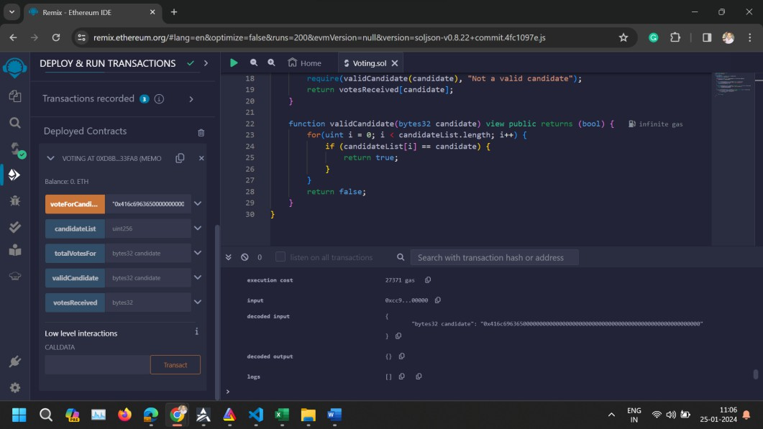
- Conclusion: The voting contract experiment illustrates how Ethereum can be used for decentralized decision-making processes. It demonstrates how to deploy and interact with contracts that require more complex inputs and how to manage state within a contract. By deploying this contract, you've taken a step further into Ethereum development, learning to work with mappings, arrays, and user inputs. It also underscores the critical aspects of smart contract development, such as data storage, function execution, and access control.

Experiment No.7
Aim: To create a simple auction contract where users can place bids and the highest bidder wins at the auction's conclusion (Auction Contract).

- Objectives:
  - Show how to manage Ethereum transactions and handle Ether within contracts.
  - Implement time-based logic to manage auction start and end times.
  - Utilize events to log important contract activities.

Steps:
  - Access Remix IDE: Open your web browser and navigate to Remix IDE.

Create and Prepare the Contract File
    - In the "File Explorers" tab, click on the "Create New File" icon and name your file SimpleAuction.sol.
    - Copy and paste the SimpleAuction contract code into SimpleAuction.sol.
// Specifies the license under which this contract is released; MIT in this case
// SPDX-License-Identifier: MIT

// Set the compiler version to be used for this contract pragma solidity ^0.8.22;

// Declares a new contract named SimpleAuction contract SimpleAuction {
// Address that will receive the funds of the auction address payable public beneficiary;
// Timestamp for when the auction ends uint public auctionEndTime;

// Address of the bidder with the highest bid address public highestBidder;
// Amount of the highest bid uint public highestBid;

// Mapping to keep track of funds each address has contributed,
// to be returned if they are outbid mapping(address => uint) pendingReturns;

// Events to emit when a bid is higher than the previous ones,
// and when the auction ends
event HighestBidIncreased(address bidder, uint amount); event AuctionEnded(address winner, uint amount);

// Constructor to initialize the auction with a bidding time

// and the beneficiary's address
constructor(uint _biddingTime, address payable _beneficiary) { beneficiary = _beneficiary;
auctionEndTime = block.timestamp + _biddingTime;
}

// Function to place a bid on the auction function bid() public payable {
// Requires that the auction has not yet ended require(block.timestamp <= auctionEndTime, "Auction already
ended.");
// Requires that the bid is higher than the current highest bid require(msg.value > highestBid, "There already is a higher
bid.");

// If there was a previous bid, it adds the previous highest bid to
// the pending returns of the previous highest bidder if (highestBid != 0) {
pendingReturns[highestBidder] += highestBid;
}

// Updates the state with the new highest bid and bidder highestBidder = msg.sender;
highestBid = msg.value;
emit HighestBidIncreased(msg.sender, msg.value);
}

// Function to withdraw a bid that was overbid by another bidder function withdraw() public returns (bool) {
uint amount = pendingReturns[msg.sender]; if (amount > 0) {
// Resets the pending return before sending to prevent re- entrancy attacks
pendingReturns[msg.sender] = 0;

// Attempts to send the amount back to the sender if (!payable(msg.sender).send(amount)) {
// If sending fails, reset the pending return to allow retrying pendingReturns[msg.sender] = amount;
return false;
}
}
return true;

}

// Function to end the auction, can only be called after the auctionEndTime
function auctionEnd() public {
// Requires that the current time is past the auction end time require(block.timestamp >= auctionEndTime, "Auction not yet
ended.");
// Requires that auctionEnd has not already been called require(!ended, "auctionEnd has already been called.");

// Sets the auction as ended and emits the AuctionEnded event ended = true;
emit AuctionEnded(highestBidder, highestBid);

// Transfers the highest bid to the beneficiary of the auction beneficiary.transfer(highestBid);
}

// State variable to keep track if the auction has ended bool ended = false;
}

Compile the Contract
    - Click on the "Solidity compiler" tab on the left sidebar.
    - Ensure the compiler version is set correctly to match the version specified in your contract (^0.8.22). Remix might automatically select the appropriate version based on your code. If not, select it manually.
    - Click "Compile SimpleAuction.sol" to compile your contract.

Deploy the Contract:
    - Switch to the "Deploy & run transactions" tab by clicking its icon on the left sidebar.
    - Select an environment from the "Environment" dropdown. For testing, "JavaScript VM" is recommended as it provides a simulated blockchain.
    - Before deploying, you need to provide initial parameters to the constructor. The SimpleAuction constructor requires:
    - _biddingTime: The duration of the auction in seconds. For testing, you can use a value like 300 (for 5 minutes).
    - _beneficiary: The address that will receive the funds of the auction. In the "JavaScript VM" environment, you can use one of the test accounts provided by Remix. Copy one of the account addresses from the account dropdown.
    - Enter these parameters in the "Deploy" field. It should look something like this (replace the address with one from your environment):

300, "0x5B38Da6a701c568545dCfcB03FcB875f56beddC4"
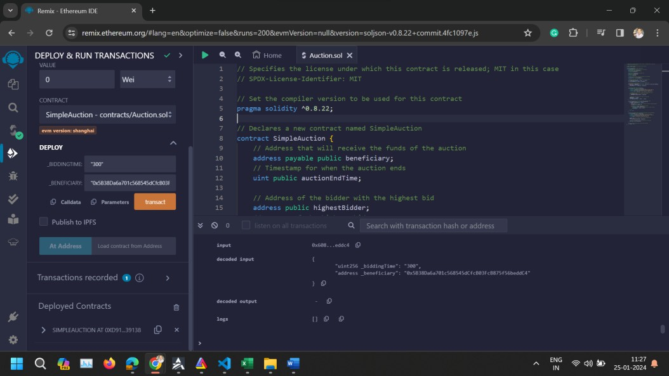
    - Click "Deploy" to deploy your contract. After deployment, the contract will appear under "Deployed Contracts".

Interact with the Contract
    - To Place a Bid: Find your deployed SimpleAuction contract in the "Deployed Contracts" section. Use the bid function to place a bid. Since bid is a payable function, you need to specify the value to send along with the transaction. In the "Value" field (above the "Deploy" button), enter the amount you want to bid and select the correct unit (e.g., ether). Then, click the bid button within your contract's UI in Remix.
    - To Withdraw: If a bidder has been outbid, they can withdraw their funds using the withdraw function. Simply click the withdraw button.
    - To End the Auction: Use the auctionEnd function after the bidding time has passed. Click the auctionEnd button to finalize the auction and transfer the funds to the beneficiary.
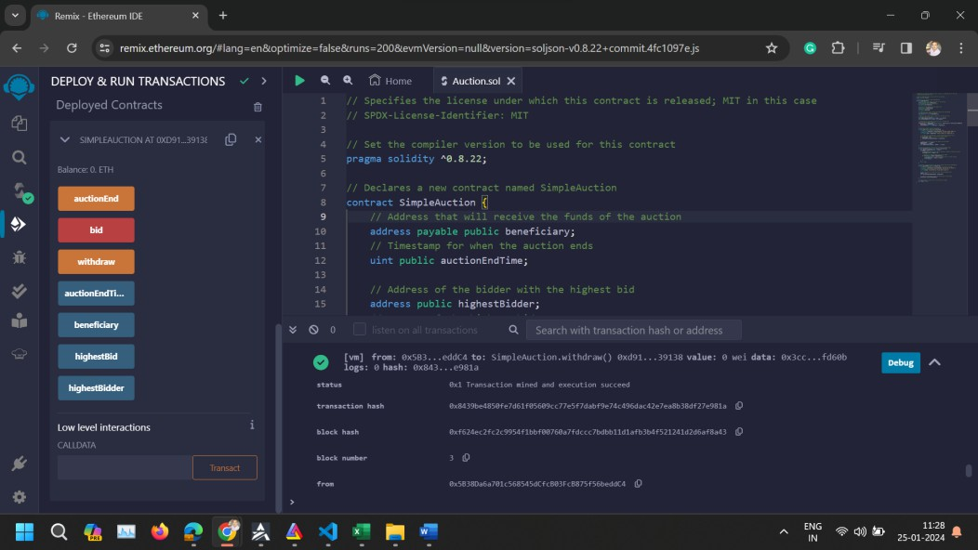

- Conclusion: This experiment demonstrates the dynamic and interactive capabilities of smart contracts, especially in handling financial transactions and time-dependent operations. It provides insights into building more complex decentralized applications (dApps) involving financial logic. It showcases the basics of creating a timed auction system on the Ethereum blockchain. By following these steps, you can deploy and test the auction contract in a simulated environment using Remix IDE. This process provides hands-on experience with contract deployment, interaction, and understanding key concepts like payable functions and time-based logic in Solidity.

Experiment No.8
Aim: To develop a fungible token using the ERC-20 standard, familiarizing with token creation and manipulation on the Ethereum blockchain. (Token Contract).

- Objectives:
  - Understand the ERC-20 token standard and its key functions. Such as totalSupply, balanceOf, transfer, approve, allowance, and transferFrom, as well as the Transfer and Approval events.
  - Gain experience in interacting with deployed smart contracts through the Remix IDE interface. This includes executing contract functions that change the state of the blockchain (such as transferring tokens) and querying the blockchain to retrieve current state information (such as token balances).
  - Prepare for the integration of the smart contract into decentralized applications (dApps) by adhering to the ERC-20 standard, facilitating the exchange and management of tokens within the Ethereum ecosystem.

Steps:
  - Open Remix IDE: Navigate to Remix IDE in your web browser.

Create the Contract File
    - In the "File Explorers" pane, click the "Create New File" icon.
    - Name your file MyToken.sol and paste the provided ERC-20 token contract code into it.

Compile the Contract
    - Click on the "Solidity Compiler" tab on the left sidebar.
    - Ensure the compiler version matches the version in your contract (^0.8.22). If necessary, select the correct version manually.
    - Click "Compile MyToken.sol".
// Specifies the license under which this contract is released; MIT in this case
// SPDX-License-Identifier: MIT

// Set the compiler version to be used for this contract pragma solidity ^0.8.22;

// ERC-20 interface containing the standard functions and events of an ERC-20 token
interface IERC20 {
// Returns the total token supply
function totalSupply() external view returns (uint256);

// Returns the account balance of another account with address
`account`
function balanceOf(address account) external view returns (uint256);

// Transfers `amount` tokens to address `recipient`, and MUST fire the `Transfer` event
function transfer(address recipient, uint256 amount) external returns (bool);

// Returns the amount of tokens approved by the owner that can be transferred to the spender's account
function allowance(address owner, address spender) external view returns (uint256);

// Sets `amount` as the allowance of `spender` over the caller's tokens, and MUST fire the `Approval` event
function approve(address spender, uint256 amount) external returns (bool);

// Transfers `amount` tokens from address `sender` to address
`recipient`, and MUST fire the `Transfer` event
function transferFrom(address sender, address recipient, uint256 amount) external returns (bool);

// Events declaration
event Transfer(address indexed from, address indexed to, uint256 value);
event Approval(address indexed owner, address indexed spender, uint256 value);
}

// MyToken contract implementing the IERC20 interface contract MyToken is IERC20 {
// Token metadata
string public constant name = "MyToken"; // Token name string public constant symbol = "MTK"; // Token symbol uint8 public constant decimals = 18; // Token decimals

// State variables
mapping(address => uint256) balances; // Mapping of token balances mapping(address => mapping (address => uint256)) allowed; //
Mapping of token allowances
uint256 totalSupply_ = 1000 ether; // Total supply of tokens, `ether` is used for simplicity to denote 18 decimals

// Constructor to initialize the contract with token supply assigned to the deployer

constructor() {
balances[msg.sender] = totalSupply_;
}

// Returns the total token supply
function totalSupply() public override view returns (uint256) { return totalSupply_;
}

// Returns the token balance of `tokenOwner`
function balanceOf(address tokenOwner) public override view returns (uint256) {
return balances[tokenOwner];
}

// Transfers `numTokens` from the caller to `receiver`
function transfer(address receiver, uint256 numTokens) public override returns (bool) {
require(numTokens
balance");
<=
balances[msg.sender], "Insufficient
balances[msg.sender] -= numTokens; balances[receiver] += numTokens;
emit Transfer(msg.sender, receiver, numTokens); return true;
}

// Approves `delegate` to spend `numTokens` on behalf of the caller function approve(address delegate, uint256 numTokens) public
override returns (bool) { allowed[msg.sender][delegate] = numTokens; emit Approval(msg.sender, delegate, numTokens); return true;
}

// Returns the number of tokens `delegate` is allowed to spend on behalf of `owner`
function allowance(address owner, address delegate) public override view returns (uint) {
return allowed[owner][delegate];
}

// Transfers `numTokens` from `owner` to `buyer`

function transferFrom(address owner, address buyer, uint256 numTokens) public override returns (bool) {
require(numTokens <= balances[owner], "Insufficient balance");
require(numTokens
"Insufficient allowance");
<=
allowed[owner][msg.sender],
balances[owner] -= numTokens; allowed[owner][msg.sender] -= numTokens; balances[buyer] += numTokens;
emit Transfer(owner, buyer, numTokens);
return true;
}
}

Deploy the Contract
    - Switch to the "Deploy & Run Transactions" tab.
    - In the "Environment" dropdown, select "JavaScript VM" for testing purposes.
    - Click "Deploy". The initial total supply is set in the contract constructor and will be assigned to the account that deploys the contract.

Interact with the Contract
    - Once deployed, you'll see the contract under "Deployed Contracts".
    - Use the provided functions to interact with your token:
    - balanceOf: Enter an account address to get its token balance.
    - transfer: Enter a recipient address and amount to transfer tokens.
    - approve and transferFrom: Use these to allow and then transfer tokens on behalf of another account.
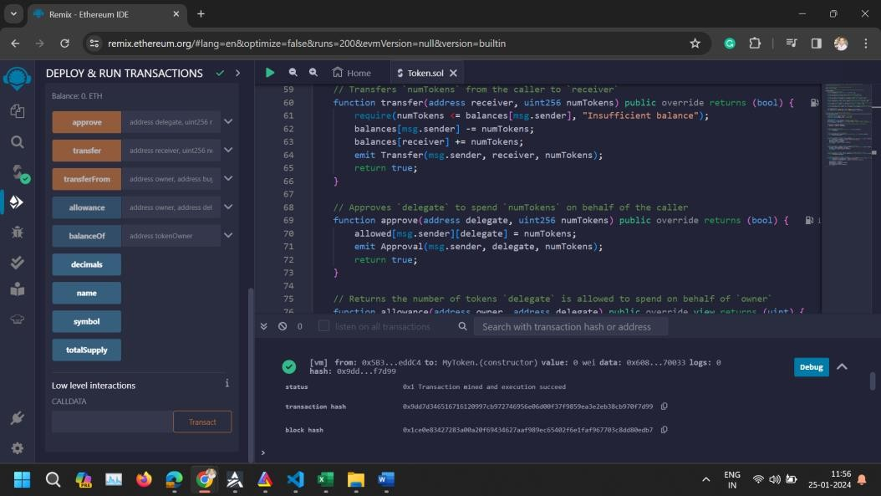
- Conclusion: This ERC-20 token contract demonstrates how to create and interact with a fungible token on the Ethereum blockchain. By following the steps above, you can deploy and test the token contract in Remix, providing a hands-on experience with the ERC-20

standard. This foundational knowledge is crucial for developing more complex decentralized applications and understanding the tokenomics within the Ethereum ecosystem.

Experiment No.9
Aim: To implement access control mechanisms within a smart contract to restrict function execution to authorized addresses. (Access Control).
- Objectives:
  - Introduce modifiers for function access control.
  - Develop functions that can only be executed by the contract owner.
  - Learn to transfer contract ownership in a secure manner.

Steps:
  - Access Remix IDE: Open Remix IDE in your web browser.

Create the Contract File
    - Click on the "Create New File" icon in the "File Explorers" tab on the left side.
    - Name your file AccessControl.sol and paste the provided Access Control contract code into it.
// SPDX-License-Identifier: MIT pragma solidity ^0.8.22;

// Define a contract named "AccessControl" contract AccessControl {
// Declare a state variable to store the address of the contract owner address public owner;

// Event declaration for ownership transfer
event OwnershipTransferred(address indexed previousOwner, address indexed newOwner);

// New state variable added for demonstration uint public restrictedData;

event RestrictedDataChanged(uint newValue);

// The constructor sets the deployer as the initial owner constructor() {
owner = msg.sender;
emit OwnershipTransferred(address(0), msg.sender);
}

// Modifier to restrict function access to only the owner modifier onlyOwner() {
require(msg.sender == owner, "Caller is not the owner");
_; // Continue execution
}

// Function to transfer ownership to a new address
function transferOwnership(address newOwner) public onlyOwner
{
require(newOwner != address(0), "New owner is the zero address");
emit OwnershipTransferred(owner, newOwner); owner = newOwner;
}

// Example function that is restricted to the owner
// This function changes the value of 'restrictedData'
function restrictedAction(uint _newValue) public onlyOwner { restrictedData = _newValue;
// Emit an event whenever 'restrictedData' is changed emit RestrictedDataChanged(_newValue);
}
}

Compile the Contract
    - Click on the "Solidity compiler" tab on the left sidebar.
    - Ensure the compiler version is set to match the version specified in your contract (^0.8.22). If necessary, select the correct version manually.
    - Click "Compile AccessControl.sol".

Deploy the Contract
    - Switch to the "Deploy & Run Transactions" tab.
    - In the "Environment" dropdown, select "JavaScript VM" for testing purposes.
    - Click "Deploy". The contract does not require any constructor parameters, so deployment should be straightforward.

Interact with the Contract
    - Once deployed, you'll see the contract under "Deployed Contracts".
    - You can interact with the owner variable to see the current owner.
    - Use the transferOwnership function to change the owner. Input a new address from the Remix accounts to simulate transferring ownership.
    - Try calling restrictedAction to see how the onlyOwner modifier works in practice. If you've transferred ownership, ensure you're interacting as the current owner.

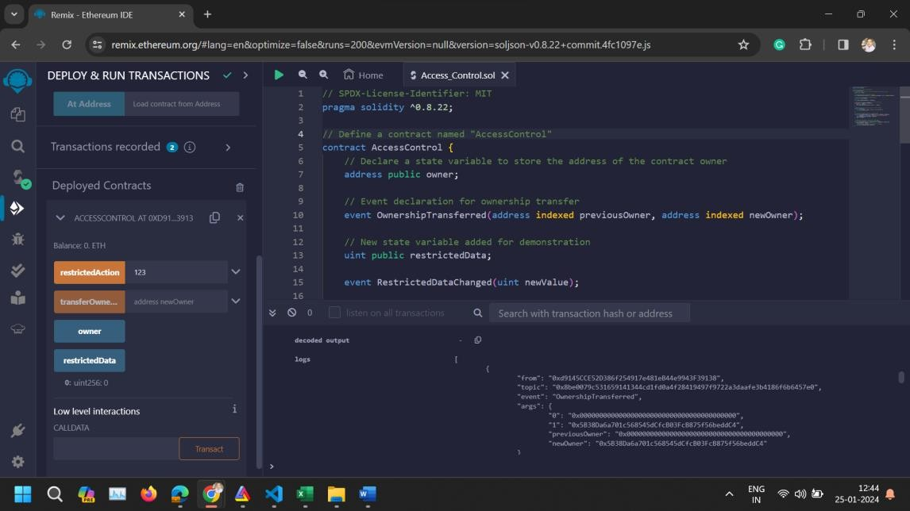
- Conclusion: The Access Control contract demonstrates a fundamental security pattern in smart contract development, ensuring that sensitive functions can only be executed by authorized accounts. By deploying and interacting with this contract in Remix, you gain practical experience with modifiers and event emissions, essential tools in the Ethereum developer's toolkit.

Experiment No.10 Mini project

Experiment No. 11
Aim To demonstrate contract-to-contract interaction within the Ethereum ecosystem, simulating complex dApp structures (Interacting with Other Contracts).
- Objectives:
  - Show how contracts can invoke functions of other contracts.
  - Outline best practices for managing contract dependencies.
  - Explore the potential for modular contract development.

Steps:
  - Access Remix IDE: Open Remix IDE in your web browser.

Create the Contract File
    - Click on the "Create New File" icon in the "File Explorers" tab on the left side.
    - Name your file CalledContract.sol and paste the provided Access Control contract code into it.
// SPDX-License-Identifier: MIT pragma solidity ^0.8.22;

// Contract to be called contract CalledContract {
uint public storedData; // State variable to store a number

// Function to store a value function set(uint x) public {
storedData = x; // Assigns value to the state variable
}

// Function to retrieve the stored value function get() public view returns (uint) {
return storedData; // Returns the value of the state variable
}
}

Compile the Contract
    - Click on the "Solidity compiler" tab on the left sidebar.
    - Ensure the compiler version is set to match the version specified in your contract (^0.8.22). If necessary, select the correct version manually.
    - Click "Compile CalledContract.sol".

Deploy the Contract
    - Switch to the "Deploy & Run Transactions" tab.
    - In the "Environment" dropdown, select "JavaScript VM" for testing purposes.
    - Click "Deploy". The contract does not require any constructor parameters, so deployment should be straightforward.
    - Copy CallerContract Address.

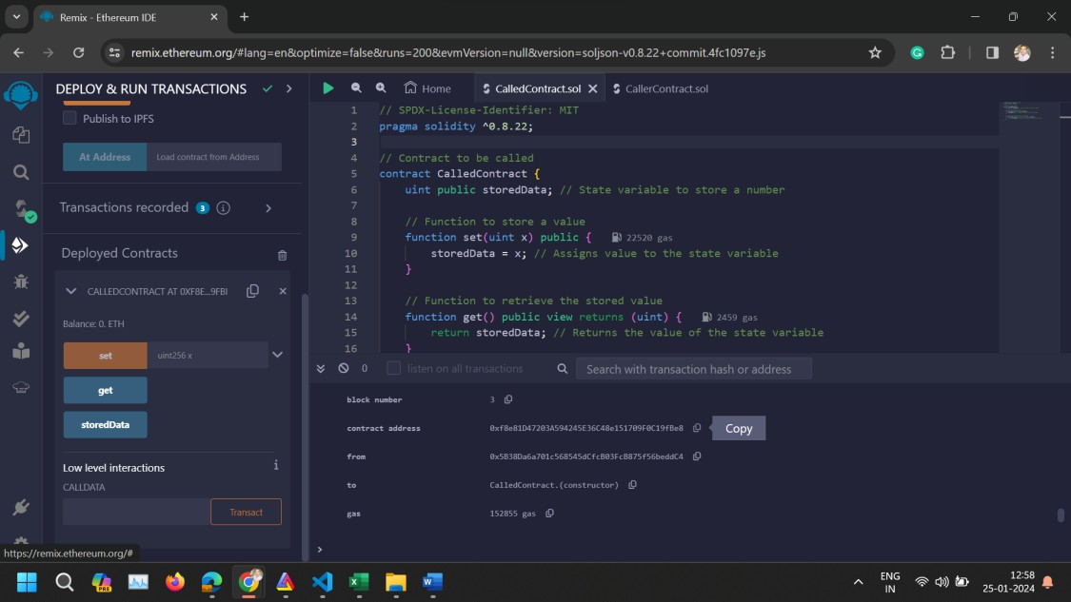

Deploy CallerContract with CalledContract's Address
    - Create a new file named CallerContract.sol and paste the CallerContract code.
// SPDX-License-Identifier: MIT pragma solidity ^0.8.22;

// Interface for CalledContract to interact with interface ICalledContract {
function set(uint x) external;
function get() external view returns (uint);
}

// Contract that calls CalledContract contract CallerContract {
address calledContractAddress; // Address of CalledContract

// Event to log the value retrieved from CalledContract event ValueRetrieved(uint value);

// Constructor to set the address of CalledContract constructor(address _calledContractAddress) {
calledContractAddress = _calledContractAddress;
}

// Function to call set function of CalledContract function callSet(uint _value) public {
ICalledContract(calledContractAddress).set(_value);
}

// Function to call get function of CalledContract and emit the retrieved value
function callGet() public {
uint value = ICalledContract(calledContractAddress).get(); emit ValueRetrieved(value); // Emitting event with the value
}
}
    - Compile CallerContract.sol.
    - In the "Deploy & Run Transactions" panel, paste the CalledContract's address as the _calledContractAddress parameter for the CallerContract constructor.
    - Deploy CallerContract.
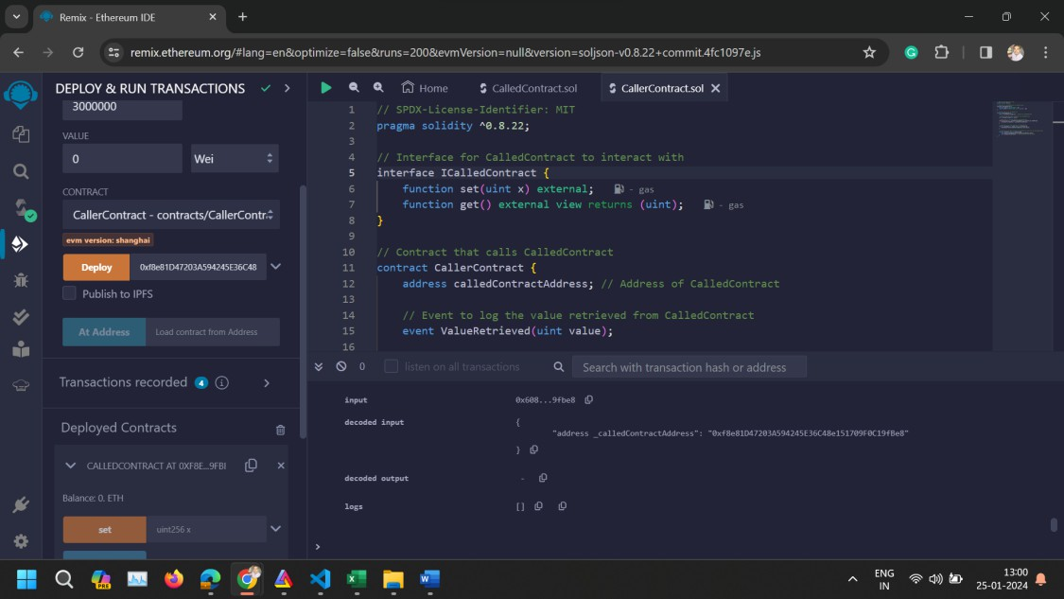

Interact with the Contracts
    - Call callSet: Use CallerContract's callSet function to store a value in CalledContract.
    - Call callGet: Then, use CallerContract's callGet function to retrieve and log the stored value.

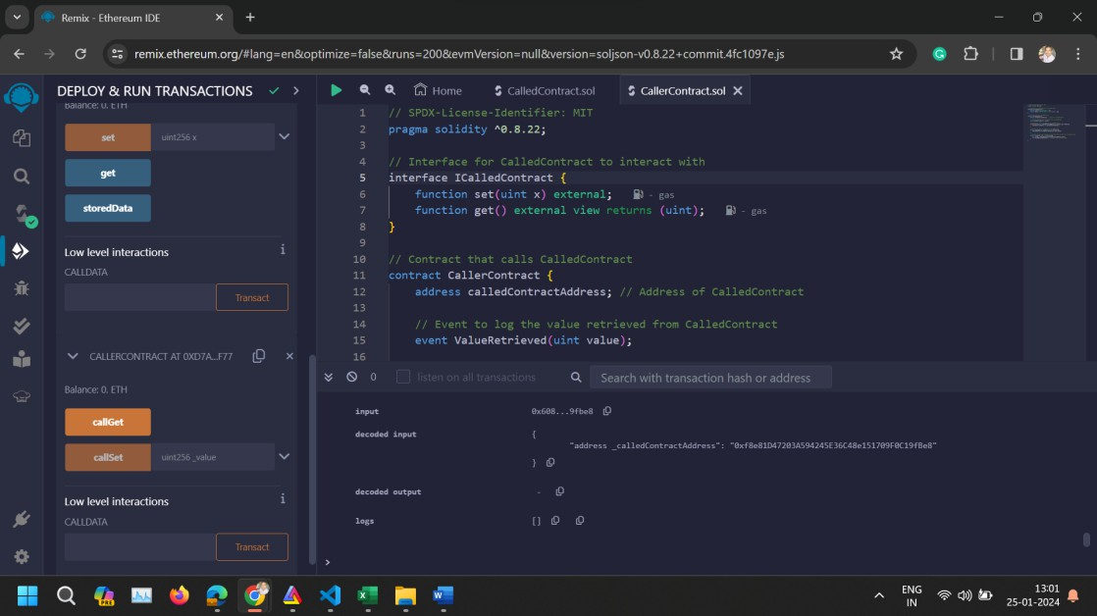
- Conclusion: This experiment demonstrates contract-to-contract interaction within the Ethereum blockchain using Remix IDE. This setup illustrates how contracts can leverage functionality of other contracts, a foundational concept for building complex decentralized applications.

